Submission ID #: 50969

Editor Name: Brigid Stadinski

Videographer name: Larry Warm

Film Date: 10/17/2013

Authors and Affiliations:

Walter G. Gonzalez¹ and Jaroslava Miksovska¹

¹Department of Chemistry and Biochemistry, Florida International University

Title: Sub-millisecond conformational changes in proteins resolved by photothermal beam deflection

Corresponding Author:

Jaroslava Miksovska
Department of Chemistry and Biochemistry
Florida International University
Miami FL 33199

miksovsk@fiu.edu
Phone: (305) 348-7406
Fax: (305) 348-3772

Authors, please fill out the brief questionnaire below.

- Will you require JoVE to record video microscopy, such as filming a complex dissection or microinjection technique? (Y/N) ___NO______ If yes, please list make and model of your microscope: ______________________________
**Note: This question is to get at whether or not you will need a camera hook-up to look into the microscope. However, if your microscope has a digital camera attached to a computer, you can gather these shots by collecting screen capture movies.
Does your protocol include microscopy steps that are visualized through a microscope with a digital camera/computer attached? (Y/N) _______
B. Does your protocol include detailed, step-by-step, descriptions of software usage? (Y/N)___NO_____
C. Which steps of your protocol will viewers benefit most from having filmed? Please list 4-6 steps____2.3; 2.4; 2.6; 2.8; 2.9 4.1 ______________
D. What is the single most difficult aspect of this procedure and what do you do to ensure success? ___Correct alignment and shaping of the pump and probe beams and probe beam focusing on the position sensor. __________________________

1. Introduction (Schematic Overview and Interview)

A. Schematic Overview (read by voice talent at JoVE):

Conceptual Narrative:
The overall goal of the following experiment is to characterize conformational changes associated with ligand binding to calcium transducers on the sub-millisecond timescale. (Intro)

The conformational transition between the apo-protein to the calcium bound protein is triggered by the photo-cleavage of a caged calcium compound, calcium-DM-nitrophen, that leads to the photo-release of free calcium. (C1)
Editors, please start with the left most image of C1. Then, as “photo-cleavage” is narrated, please bring in the orange arrow, lightening bolt, and “355 nm laser pulse.” Then bring in the right most image as “that leads to the photo-release of free calcium” is narrated. If possible, animate the objects moving around in the cuvettes.

The associated change in the index of reflection is measured as a displacement of the probe beam using a quadruple position sensitive detector. (C2)
Editors, please animate the red arrows going through the cuvette to the position sensitive detector.

Next, the photothermal beam deflection traces are measured as a function of temperature for both the sample and the reference compound. (C3)
Editors, please animate C3 by sequentially bringing in each of the curves from the bottom curve to the top curve.

Analysis of the photo-thermal beam deflection traces provides insight into the mechanism of calcium induced conformational switch in terms of reaction volume and enthalpy changes. (C4)
Editors, please animate C4 by sequentially bringing in the Ca2+ bound protein, the intermediate, and the apo-protein and corresponding arrows.

Paste a copy of your graphic overview here. The original file should be Adobe Illustrator (preferred) or Powerpoint (see instructions) and should be uploaded through your online submission on the JoVE website. Please keep all layers in the file (i.e., do not flatten the file).
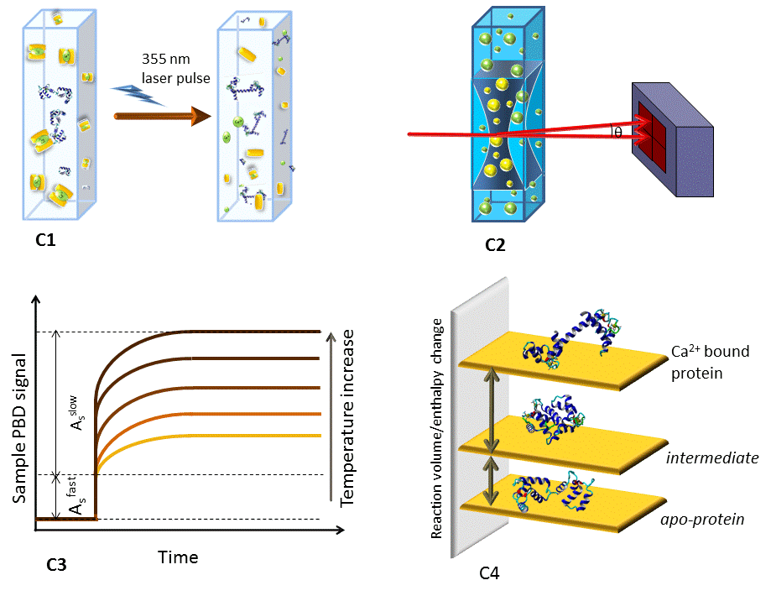

B. Interview: (Said by you on camera. Don’t forget to smile!)
  - J. Miksovska: The main advantage of this technique over existing methods, like stop flow, is that it allows simultaneous probing of dynamics and energetics of structural changes in proteins on sub-millisecond timescales.
    - MED: Dr. Miksovska speaks toward the camera, interview style.
  - J Miksovska: Visual demonstration of this method is critical as the precise instrumentation alignment steps are crucial for the recovery of thermodynamic parameters.
    - CU: Dr. Miksovska speaks toward the camera, interview style.
  - **J. Miksovska: Demonstrating the procedure will be Walter Gonzalez, a graduate student from my laboratory.
    - MED: Dr. Miksovska speaks toward the camera, interview style.
    - MED: Walter looks up from workbench or desk or microscope and acknowledges the camera.

Protocol (read by voice talent at JoVE):
- Experimental Setup
  - Carry out the sample preparation and all sample manipulations in a dark room to prevent any unwanted uncaging. In this video, steps are demonstrated in the light for filming purposes.
    - Title Card
  - To begin, solubilize DM-nitrophen in 50 mM HEPES buffer, 100 mM KCl, pH 7.0 to a final concentration of 400 µM. Add calcium chloride from the 0.1 M stock solution to achieve the desirable calcium to DM nitrophen concentration ratio.
    - MED: Talent adds DM-nitrophen to 50 mM HEPES buffer. Use labeled containers.
    - CU: Container of buffer as talent adds calcium chloride. Use labeled containers. TEXT: see text for details
  - Next, solubilize the reference compound, potassium ferricyanide or sodium chromate, in the same buffer as for the sample.
    - MED-over the shoulder: Talent adds the reference compound to a different container of the same buffer. Use labeled containers.
  - Refer to the text protocol for a schematic of the basic experimental configuration for the photothermal beam deflection.
    - LAB MEDIA: Figure 2_no inset.
  - When setting up the experiment, use a pin hole to adjust the diameter of the probe beam to 1 mm. Using a M₁ mirror, propagate the probe beam through the center of a cell placed in a temperature controlled cell holder. (delete and replace by the paragraph below)

2.5 When setting up the experiment, propagate the probe beam through the center of a cell placed in a temperature controlled cell holder. Then using a pin hole, adjust the diameter of the probe beam to 1 mm.
    - ECU: Pinhole and probe beam as talent adjusts the pinhole to achieve a probe beam diameter of 1 mm. Editors, please transition to this shot from the previous figure by zooming into P₂ of the figure. (delete and replace by the paragraph below)

2.5.1 CU: Photo-thermal beam deflection set-up with the probe beam on as talent inserts the M₁ mirror (or uses a pointer to point it out if it is already set-up) and then inserts the cell (with reference solution) into the temperature controlled holder.
    - CU: Photo-thermal beam deflection set-up with the probe beam on as talent inserts the M₁ mirror (or uses a pointer to point it out if it is already set-up) and then inserts the cell (with reference solution) into the temperature controlled holder. (delete and replace by the paragraph below)

2.5.2 ECU: Pinhole and probe beam as talent adjusts the pinhole to achieve a probe beam diameter of 1 mm. Editors, please transition to this shot from the previous figure by zooming into P₂ of the figure.
  - Use a second mirror behind the sample to center the probe beam on the center of the position sensitive detector.
    - MED-over the shoulder: Talent inserts/adjusts the second mirror to center the probe beam on the center of the position sensitive detector.
  - Focus the probe beam on the center of the detector so that the difference in the voltage between the top two diodes and bottom two diodes, as well as the difference in the voltage between the two diodes on the left and right side of the detector is zero.
    - CU: Oscilloscope display screen as talent monitors the position of the probe beam. Talent focuses the probe beam on the center of the detector so that the difference in the voltage between the top two diodes and bottom two diodes, as well as the difference in the voltage between the two diodes on the left and right side of the detector is zero.
  - Subsequently, shape the diameter of the pump beam, a 355 nm output of an Nd-YAG (pronounced as “n-d-yag”) laser, using a 3 mm pinhole placed between two 355 nm laser mirrors. Co-propagate the pump beam through the center of the cuvette.
    - MED-over the shoulder: Photo-thermal beam deflection set-up as talent sets up P₁ and the two M₃₅₅ mirrors. TEXT overlay: Nd:YAG = neodymium-doped yttrium aluminum garnet
    - CU: Cuvette as talent turns on the laser as the pump beam is co-propagated through the center of the cuvette.
  - It is important that both laser beams are propagated through the center of the optical cell in a nearly co-linear manner to obtain a measurable deflection angle and thus high amplitude of photothermal beam deflection, or PBD signal.
    - ECU: Center of cuvette with both laser beams being propagated through in co-linear manner.
    - LAB MEDIA: Figure 2_inset. Editors, please transition to this figure from 2.9.1 (the shot directly preceding this one) or show as a split screen. If it is hard to visualize shot 2.9.1, this can be used as a replacement.
  - Use a reference compound to align the probe and pump beam to achieve a satisfactory PBD signal, characterized by a good signal to noise ratio and stable PBD amplitude on longer time-scales.
    - MED-over the shoulder: Oscilloscope display screen as talent uses a reference compound to align the probe and pump beam to achieve a satisfactory PBD signal.
  - Then, position the pump beam with respect to the probe beam by incremental adjustment of the 355 nm laser mirrors.
    - CU: 355 nm laser mirrors as talent adjusts them to position the pump beam.
  - Measure the amplitude of the PBD reference signal as a difference in between two top and bottom photodiodes on the position sensitive detector.
    - MED-over the shoulder: Oscilloscope display screen as talent measures the amplitude of the PBD reference signal as a difference in between two top and bottom photodiodes on the position sensitive detector.
  - The PBD signal should exhibit a rapid increase in the amplitude on a fast time-scale and remain stable on the 100 ms timescale.
    - LAB MEDIA: Figure 3. Editors, please highlight the first part of the red curve as it is increasing up to about time 0.001 s on the x-axis as “exhibit a rapid increase in amplitude on a fast time-scale” is narrated. Then, highlight the rest of the red curve as it levels off after about time 0.001 s on the x-axis as “and remain stable on 100 ms timescale” is narrated.
  - Check the linearity in the PBD signal amplitude with respect to the released heat energy by measuring the linear dependence of the PBD signal on the excitation laser power and on the number of Einsteins absorbed.
    - CU: Screen as talent measures the linear dependence of the PBD signal on the excitation laser power and on the number of Einsteins absorbed. TEXT overlay: see text for details
  - Keep the laser power below approximately 1000 micro-joules to prevent multi-photon absorption. Also, keep the absorbance of the sample/reference compound at an excitation wavelength less than 0.5 to prevent decrease of the pump beam power. These steps will ensure linearity of the PBD signal.
    - MED-over the shoulder: Talent adjusts the laser power to below approximately 1000 µJ and the absorbance of the sample/reference compound at an excitation wavelength less than 0.5.
- PBD measurements
  - Start with the measurement of the PBD traces for the reference. Place the solution of the reference compound in a quartz cell, and position the cell in the temperature controlled holder.
    - MED-over the shoulder: Talent pipettes the reference solution into the quartz cell.
    - CU: Quartz cell as talent positions it into the temperature controlled holder.
  - Detect the reference PBD signal as a function of temperature in the temperature range from 16 to 35 ºC with a temperature increment of 3 ºC.
    - MED-over the shoulder: Talent detects the reference PBD signal as a function of temperature as described.
  - Upon each temperature change, check the position of the probe beam on the position sensitive detector and re-adjust the position to the center of the detector if necessary.
    - CU: Position sensitive detector as talent checks the position of the probe beam on the position sensitive detector and re-adjusts the position to the center of the detector.
  - Check the linearity of the PBD signal as described in the text protocol.
    - MED-over the shoulder/MED: Multiple takes as talent checks the linearity of the PBD signal as a function of the [(dn/dt)/Cpρ] term. Use MED-over the shoulder here. MED shot will be reused once.
  - Then, place the sample solution in the same optical cell as used for the reference compound keeping the same orientation of the optical cell for the reference measurement.
    - CU: Sample solution in cell as talent inserts it into the temperature controlled holder.
  - Proceed to detect the sample PBD traces in the same temperature range as for the reference… and check the linearity of the sample PBD amplitude.
    - MED-over the shoulder: Talent detects the sample PBD traces in the same temperature range of the reference.
    - Shot 3.4.1 – MED shot as talent checks the linearity of the PBD signal.
- Data analysis

Editors, for the screen capture movies, please use a zoom bubble to highlight the actions that are being described/performed.
  - Take the amplitude of the reference PBD signal as the difference between the pre-trigger and post trigger PBD signal. In a similar way, determine the amplitude of the fast and slow phase of the sample PBD signal.
    - SCREEN: Screen capture movie as talent takes the amplitude of the reference PBD signal as the difference between the pre-trigger and post trigger PBD signal.
    - MED/WIDE: Multiple shots of talent working at data analysis computer. Editors, these shots can be used as needed throughout this section of the protocol.
    - SCREEN: Screen capture movie as talent determines the amplitude of the fast and slow phase of the sample PBD signal.
  - To eliminate the instrument response parameter, scale the amplitude of the sample PBD signal by the amplitude of the PBD signal for the reference.
    - SCREEN: Screen capture movie as talent scales the amplitude of the sample PBD signal by the amplitude of the PBD signal for the reference.
  - The ratio of the sample signal to the reference signal… gives an equation from which the heat released to the solution… and nonthermal volume change associated with a photo-initiated reaction… can be determined from the slope and intercept of the plot of the amplitude ratio multiplied by energy… versus the temperature dependent term.
    - JoVE MEDIA: Editors, please put this equation on a text card. Please replace the slashes with a horizontal fraction line that has the variable before on top and the variable after on the bottom: (A_{s}/ A_{r}) E_{hν} =Q + [ρ(dn/dρ)ΔV_{nonth} + Δ_{abs}]/(dn/dt)(1/ρC_{p})

Please highlight “A_{s}/ A_{r}” as “the ratio of the sample signal to the reference signal” is narrated; “Q” as “the heat released to the solution” is narrated; and “ΔV_{nonth}” as “nonthermal volume change” is narrated. Then highlight the “(A_{s}/ A_{r}) E_{hν}” term as “amplitude ratio multiplied by energy” is narrated and the “[(dn/dt)(1/ρC_{p})]” term as “temperature dependent term” is narrated.
  - To determine the reaction volume and enthalpy change for the fast and the slow process, scale the observed volume and enthalpy change to the appropriate quantum yield according to the equations found in the text protocol.
    - MED-over the shoulder: Talent works to scale the observed volume and enthalpy change to the appropriate quantum yield.
  - The amplitudes and lifetimes for the individual steps are analyzed by fitting the data to the time dependent function that describes the volume and enthalpy changes. The amplitude of the fast step corresponds to the amplitude of the prompt phase of the sample PBD signal and the amplitude of the subsequent step corresponds to the amplitude of the slow phase of the sample PBD signal for each individual process.
    - JoVE MEDIA: Editors, please put this equation on a title card. Highlight “F(t)” as “time dependent function” is narrated, “α₀” as “amplitude of the fast step” is narrated, and “α_{I}” as “amplitude of the subsequent step” is narrated.
  - From the temperature-dependence of the rate constant for individual processes, the activation enthalpy and entropy parameters can be readily determined using Eyring plots.
    - MED-over the shoulder: Talent works at computer to make an Eyring plot.
- Results: Representative PBD traces
  - A representative example of PBD traces for calcium photo-release from calcium-DM-nitrophen is shown here. The fast phase corresponds to the photo-cleavage of calcium-DM-nitrophen and calcium liberation, whereas the slow phase reflects calcium binding to the non-photolysed cage.
    - LAB MEDIA: Figure 3 Editors, please highlight the red double sided arrow and label A_{s}^{fast} as “fast phase corresponds to the photo-cleavage…” is narrated and highlight the red double sided arrow and label A_{s}^{slow} as the “slow phase reflects calcium binding to the non-photolysed cage” is narrated.
  - The PBD trace for the calcium association to the C-terminal domain of the neuronal calcium sensor Downstream Regulatory Element Antagonist Regulator, or DREAM, is shown here.
    - LAB MEDIA: Figure 4
  - Upon calcium photo-dissociation, photo-released ligand associates to the C-terminal domain of DREAM with the time constant of 1.3 plus or minus 0.3 ms at 20°C.
    - LAB MEDIA: Figure 4_inset. Editors, please highlight the τ = 1.3 ± 0.3 ms as narrated.
  - From the temperature dependence of the observed rate constant, the activation barrier for calcium binding to the C-terminal domain of DREAM was determined to be 9.2 plus or minus 0.4 kcal per mol.
    - LAB MEDIA: Figure 4_inset. Editors, please highlight the E_{a} = 9.2 ± 0.4 kcal mol⁻¹ term as narrated.

- Conclusion (said by authors on camera)
  - J Miksovska: While attempting this procedure, it’s important to remember to measure the PBD traces under conditions identical to those for reference compound.
    - MED: Dr. Miksovska speaks toward camera, interview style.
  - J Miksovska: After watching this video, you should have a good understanding of how to prepare samples and align instrumentation to obtain reproducible thermodynamic and kinetic data.
    - MED: Dr. Miksovska speaks toward camera, interview style.

Provided Media

Authors, Please list all images, movie files, or 3-D rendered animations that can be included in the video per editor’s request. The step in the script/video where these images will be inserted should be specified. For example:

6.2 – 0123_PIname_Figure1.tif - dual color imaging of tumor angiogenesis at 40X
6.2 – 0123_PIname_Figure2.tif - dual color imaging of tumor angiogenesis at 100X

Formats: For static images we prefer .tiff, .eps, Illustrator, Powerpoint or Photoshop files at dimensions of at least 720X480 pixels and 300 dpi. The higher resolution, the better. Likewise any exported movie files should have at minimum these dimensions and be rendered to .mov, .mp4, or .avi files.

Insert your media filenames here.

Graphic overview.pptx

Figure 2_no inset

Figure 2 inset

Figure 3

Figure 4

Figure 4 inset

SCREEN capture movies:

50969_Miksovska_SCREEN_4.1.1: Screen capture movie as talent takes the amplitude of the reference PBD signal as the difference between the pre-trigger and post trigger PBD signal.

50969_Miksovska_SCREEN_4.1.3: Screen capture movie as talent determines the amplitude of the fast and slow phase of the sample PBD signal.

50969_Miksovska_SCREEN_4.2.1: Screen capture movie as talent scales the amplitude of the sample PBD signal by the amplitude of the PBD signal for the reference.

General Preparation

It’s critical for a smooth and organized shoot that all reagents are accounted for, in advance.

Any overnight or long incubation steps should be recognized and specimens/samples be prepared in advance so that prior steps can be recorded and shooting can continue with pre-prepared specimens/samples.

All tubes/flasks should be pre-labeled neatly before we arrive.

Ex. Luciferase assay done in 96 well plates should be labeled with negative/positive control wells and experimental samples are labeled accordingly.

You will receive more detailed preparation instructions, as well as an introduction to your videographer, closer to your filming date.

