Submission ID #: 50891

Editor Name: Melissa Ceo

Videographer name:

Film Date:

Authors and Affiliations:
Xiao Hu^{1,2,3}, Solomon Duki¹, Joseph Forys¹, Jeffrey Hettinger^{1,2}, Justin Buchicchio¹, Tabbetha Dobbins^{1,2}, Catherine Yang^{2,4}

¹Department of Physics & Astronomy, Rowan University, Glassboro, NJ 08028, USA
²Department of Biomedical Engineering and Sciences, Rowan University, Glassboro, NJ 08028, USA
³Department of Biomedical Sciences, Cooper Medical School of Rowan University, Camden, NJ 08103, USA
⁴Department of Chemistry and Biochemistry, Rowan University, Glassboro, NJ 08028, USA

Title: Designing Silk-Silk Protein Alloy Materials for Biomedical Applications

Corresponding Author:

Xiao Hu: hu@rowan.edu

A. Will you require JoVE to record video microscopy, such as filming a complex dissection or microinjection technique? (Y/N) ___N___ If yes, please list make and model of your microscope: ______________________________
**Note: This question is to get at whether or not you will need a camera hook-up to look into the microscope. However, if your microscope has a digital camera attached to a computer, you can gather these shots by collecting screen capture movies.
Does your protocol include microscopy steps that are visualized through a microscope with a digital camera/computer attached? (Y/N) ___ N ___
B. Does your protocol include detailed, step-by-step, descriptions of software usage? (Y/N) __N__
C. Which steps of your protocol will viewers benefit most from having filmed? Please list 4-6 steps_________N/A___________
D. What is the single most difficult aspect of this procedure and what do you do to ensure success? _____________N/A_____________

1. Introduction (Schematic Overview and Interview)

A. Schematic Overview (read by voice talent at JoVE):

Procedural Narrative:
The overall goal of this procedure is to demonstrate how to fabricate various protein alloy materials, using silk-silk composite films with electronic circuits as an example. (Intro)

This is accomplished by first regenerating individual protein solutions from two different species of silkworm cocoons. (P1, show left the two black squares in image A. Then make yellow arrows appear followed by the right two test tube images.)

The second step is to mix two protein solutions with different ratios and generate a series of blending solutions. (P2, show the two test tube images from P1. If possible, make them overlap to combine into one test tube. Then make image B appear.)

Next, a thin film fabrication technique is used to fabricate electronic circuits on glass substrates. (P3, show image C. Show the top black square followed by the bottom white square containing the electrical circuit.)

The final step is to coat the blending solutions onto the glass substrates and transfer the electronic circuits to the dried protein composite films. (P4, show image D. Show the top white square followed by the bottom white square containing the electrical circuit.)

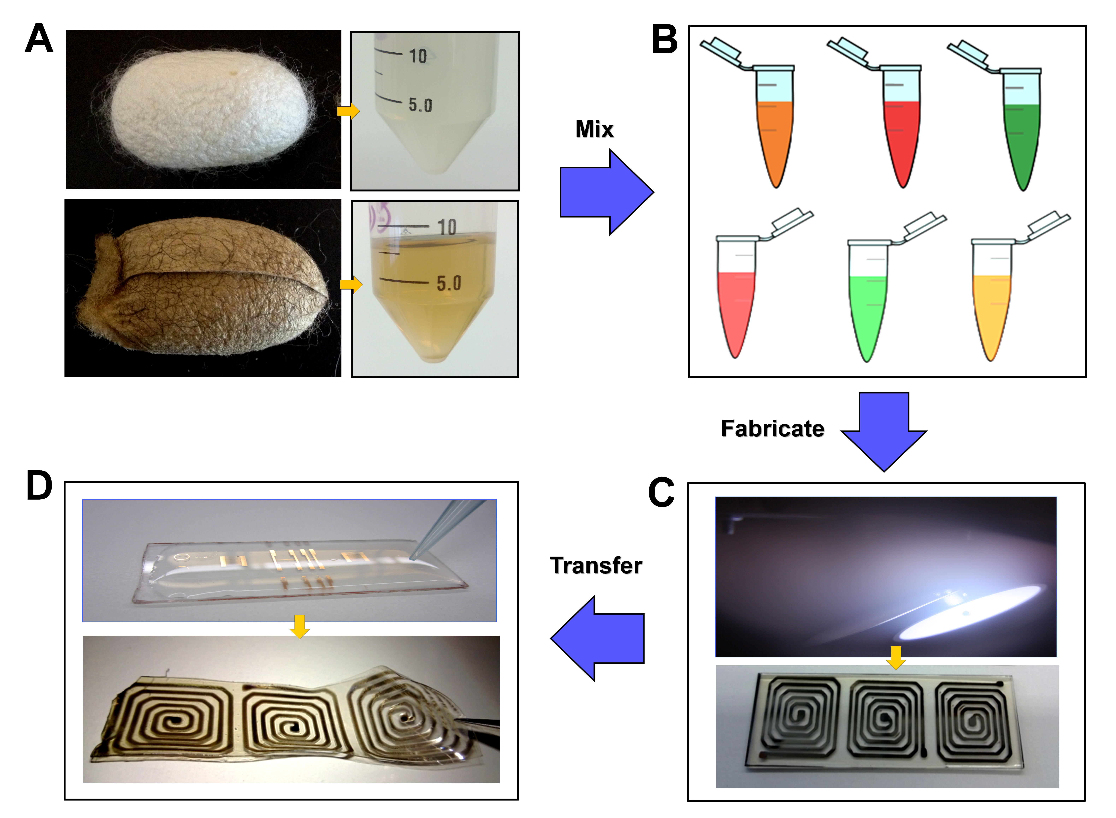

B. Interview: (Said by you on camera. Don’t forget to smile!)
  - Xiao Hu: Compared with the traditional synthetic polymer materials, protein materials can provide better biocompatibility, biodegradability, and tenability in the human body. Blending different proteins with specific ratios is a simple technological approach to generate alloy material systems with tunable physical, chemical, and biological properties.
  - Jeffrey Hettinger: Extending this technique to implanted biomedical systems can provide electronic monitoring enhancing diagnosis and therapy in medical treatments. Further, the techniques can be used to develop devices that can be absorbed by the human body after it is no longer needed.
  - Joseph Forys: In this video, we will use the protein blends of wild tussah silk and domestic mulberry silk as an example to provide useful protocols regarding to this topic, including how to produce protein alloy solutions, and how to fabricate alloy materials with electronic circuits.
  - Justin Buchicchio: The major advantage of our circuits coating technique over other methods, like evaporation, is that the protein materials are not subjected to high temperatures directly or through radiation during the coating process.

Protocol (read by voice talent at JoVE):
- Production of Protein Alloy Solutions
  - To begin this procedure, cut raw wild tussah silk cocoons at a weight of 3g.
    - MED: Talent walks up to balance with wild tussah silk cocoons in hand and places them on the balance.
  - Fill a 2L glass beaker with distilled water. Then, place the glass beaker on a hot stage, cover it with aluminum foil, and heat to boiling.
    - MED-over the shoulder: Talent fills glass beaker with distilled water.
    - MED: Talent places the glass beaker on the hot stage, covers the top with aluminum foil, and turns the hot stage on.
  - Remove the aluminum foil cover and add 3g of sodium dicarbonate slowly into the boiling water, allowing it completely to dissolve (TEXT: Sodium dicarbonate is the “soap” to clean off soluble sericin proteins and other impurities attached on wild silk fiber surface). Once the sodium dicarbonate has completely dissolved, add the wild silk cocoons into the boiling water and allow the mixture to boil for 2-3 hours.
    - MED-over the shoulder: Talent removes the aluminum foil from the beaker and adds sodium dicarbonate to the boiling water.
    - MED: Talent adds the wild silk cocoons to the boiling water.
    - CU: Beaker containing wild silk cocoon mixture as it boils.
  - After boiling, carefully remove the protein fibers from the solution with a spatula and squeeze them to remove the excess water.
    - MED-over the shoulder: Talent removes the protein fibers from the solution with a spatula and squeezes them.
  - Next, immerse the fibers in a 2L beaker with cold distilled water, and wash the fibers twice for 30 minutes each to completely remove the impure residues from the fiber surface. After washing, dry the fibers in a fume hood for at least 12 hours.
    - CU: Beaker as talent immerses fibers in cold water.
    - MED-over the shoulder: Talent removes fibers from beaker of cold water and places them in another beaker of cold water.
    - MED: Talent places fibers in fume hood to dry.
  - Melt 45.784g of calcium nitrate in a glass beaker to form a liquid at 65 °C for dissolving the wild silk protein fibers. Then, combine the fibers and solvent at a ratio of 1g of fiber to 10mL of solvent.
    - MED-over the shoulder: Talent places beaker containing calcium carbonate on a hot plate and turns the temperature control on.
    - MED: Talent mixes fibers and calcium nitrate solvent together.
  - After allowing the fibers to dissolve at 95 °C for 5 to 12 hours, inject the wild silk solution into 12 mL dialysis cassettes (TEXT: Maximum 1,000 MW as cutoff size) using syringes, and dialyze against 2L of distilled water. Change the distilled water frequently to remove the calcium nitrate solvents in the solution.
    - CU: One of the dialysis cassettes as talent injects wild silk solution into it with a syringe.
    - MED-over the shoulder: Talent places dialysis cassettes in distilled water.
    - MED: Talent removes the distilled water from the vessel and replaces it with fresh water.
  - After 3 days, collect the protein solutions from the dialysis cassettes and place them into 13,000 rpm rated tubes.
    - MED-over the shoulder: Talent removes protein solutions from the dialysis cassettes and places them into tubes.
  - Following this, centrifuge the solutions for 1hour at 3,500 rpm at 4°C three times to remove deposits. When finished, store the final solutions in a 4 °C refrigerator.
    - MED: Talent places tubes in centrifuge, programs the appropriate settings, and turns it on.
    - MED-over the shoulder: Talent places tubes containing final solutions in the refrigerator.
  - After collecting another natural protein such as domesticated mulberry silk, repeat the above process with an appropriate “soap” and dissolving solvent, until the final protein water solution with measured concentration is obtained.
    - CU: One tube containing mulberry silk cocoon in the talent’s left hand and one tube containing a 50 mL mulberry silk solution tube in the talent’s right hand (side-by-side comparison).
  - Next, slowly mix a 1 wt% wild silk solution with a 1 wt% domesticated silk solution using a pipette. Store the final solution at 4 °C to avoid protein aggregation (TEXT: Mix proteins with mass ratio of 90:10, 75:25, 50:50, 25:75, 10:90 to obtain broad spectrum of alloy solutions).
    - MED-over the shoulder: Talent slowly mixes the wild silk solution and domesticated silk solution together with a pipette.
    - MED: Talent places tube containing final solution in the refrigerator.
- Fabrication of Variable Protein Alloy Materials
  - To fabricate an electrical circuit pattern on a glass substrate, first clean a glass slide using some degreasing solvent such as Alconox in an ultrasonic cleaner for 5 minutes. Then, clean the glass slide for 5 minutes in acetone and 5 minutes in methanol. Blow the glass slide dry using dry nitrogen gas, which is generated by the boil-off from a 180L liquid nitrogen dewar.
    - MED-over the shoulder: Talent places glass slide in ultrasonic cleaner containing Alconox.
    - CU: Glass slide as talent places it in ultrasonic cleaner containing the appropriate solvent.
    - MED: Talent dries slide with nitrogen gas from the dewar.
  - At this point, introduce the substrate materials into the deposition chamber and evacuate the loadlock to a pressure of 30mT. Then, open the gate valve between the loadlock and the main deposition chamber and introduce the substrate into the chamber.
    - MED-over the shoulder: Talent places substrate into deposition chamber and opens pneumatic valve connecting the vacuum pump to the loadlock chamber.
    - MED: Talent uses push buttons on panel connected to pneumatic valve to open gate valve.
    - MED-over the shoulder: Talent introduces substrate into the chamber.
  - Turn on the argon gas and the pressure regulator and control the pressure to the desired deposition pressure (TEXT: Range of pressures generally between 3 and 60mT, with 20mT working well). In order to remove oxide layers and contaminants from the target, pre-sputter for several minutes.
    - MED: Talent opens argon gas valve and pressure regulator and turns the pressure regulator knob to control the pressure.
    - SCREEN: Computer screen as talent programs the appropriate settings for pre-sputtering. (Not a screen, but a shot of real time numbers on system tower, still adjusting for appropriate settings)
  - After opening the shutter, sputter the metal onto the substrate, using a deposition rate to achieve the desired thickness (TEXT: Rate depends on working distance, pressure, magnet strength in magnetron cathode, target thickness and metal). Once the sputtering process is complete, remove the coated glass slide from the chamber.
    - SCREEN: Computer screen as talent programs the appropriate settings for sputtering.(again not a screen, took shot of button presses and knob turns, still adjusting for appropriate settings)
    - CU: Coated glass slide as talent removes it from the chamber.
  - Using a spinner, spin a positive photoresist coating onto the surface of the film. After the resist is spun onto the film, soft bake at 90 °C for 5 minutes to dry the resist.
    - MED: Talent places film on spinner, adds positive photoresist to film and programs appropriate settings on spinner.
    - MED-over the shoulder: Talent places film in a small hotplate oven.
  - When finished, place a contact mask with an image of the device firmly against the resist. Expose the photoresist to a 1,000 W UV light source for 10 seconds.
    - CU: Photoresist as talent places a contact mask with an image of the device on it.
    - MED: Talent places photoresist under the UV light source and turns the light on.
  - Following this, place the film in the photoresist developer until the projected image appears. Immediately after the image appears, dip the film in deionized water to stop the developer from working on the unexposed photoresist. Then, blow the film dry with dry nitrogen gas.
    - CU: Film as talent places it in photoresist developer to see the projected image appear.
    - MED-over the shoulder: Talent dips the film in deionized water.
    - MED: Talent dries the film with nitrogen gas.
  - Place the film into an oven at 120 °C for 15 minutes to “hard bake” the photoresist. After the film has cooled, place it in an etching solution until the metal not protected by the photoresist lifts off. Dip the film in water to stop the etching.
    - MED-over the shoulder: Talent places the film in the oven.
    - CU: Film as talent places it in etching solution to see how it appears after unprotected metal is removed.
    - MED-over the shoulder: Talent removes film from etching solution and dips it in water.
  - Next, rinse the film with acetone to remove the hardened photoresist. Then, rinse the film with methanol and blow-dry them with dry nitrogen.
    - MED: Talent rinses the film with acetone using a squirt bottle.
    - CU: Film as talent rinses it with methanol using a squirt bottle.
    - MED-over the shoulder: Talent dries film with nitrogen gas.
  - Once the coated glass is ready, drop different protein alloy solutions onto the glass surface using a pipette. Dry it for at least 12 hours in the fume hood to obtain protein alloy films on the glass.
    - CU: Coated glass as talent adds protein alloy solutions onto it with a pipette.
    - MED: Talent places glass in the fume hood to dry.
  - Following this, peel off the protein alloy films with the thin metal patterns from the glass substrate using forceps.
    - CU: Glass substrate as talent peels off the protein alloy films using forceps.
  - To obtain insoluble protein alloy materials, place the dry film into a 60 °C vacuum oven at 25 kPa with a water dish on the bottom of the chamber. Pump out the air in the oven, allowing the water vapors to anneal the samples for at least 2 hrs.
    - MED-over the shoulder: Talent places the dry film into the oven.
    - MED: Talent turns on vacuum pump connected to the oven.
  - Once the vacuum has been released and the samples have been removed from the oven, peel off the water insoluble film from the substrate using forceps.
    - CU: Glass substrate as talent peels off the water insoluble film using forceps.
  - Finally, test the electrical resistance of the metal pattern on the protein alloy films and compare it to the original pattern on the glass.
    - MED: Talent uses a two-terminal multifunction voltmeter to test the electrical resistance.
    - MED-over the shoulder: Talent compares the electrical resistivity values of the two patterns.
- Results: Generation of Silk-silk Protein Alloy Biomaterials and Their Properties
  - Typical protein-protein interactions could contain electrostatic attractions, hydrogen bonding, hydrophobic-hydrophilic interactions, as well as dipole, solvent, counter ion, and entropic effects between the protein’s specific domains. The effects of these interactions can be predicted by computational simulations.
    - LAB MEDIA: Figure 2 (Figure 2_JOVE.tif) (Video Editor: Highlight or point to “Positive-Negative Charge Interactions” box when electrostatic attractions is mentioned, “Hydrogen-bond Interactions” box when hydrogen bonding is mentioned, and “Hydrophobic-Hydrophilic Interactions” box when hydrophobic-hydrophilic interactions is mentioned.)
  - During the stretching simulation, one protein can form an elastic network like springs providing super-elasticity for the materials, while another can serve as particles with strong physical crosslinkers for the materials. Dynamic structural transitions can be induced in different domains for storing and releasing energy or providing additional mechanical support.
    - LAB MEDIA: Figure 3 (Figure 3_JOVE.tif) (Video Editor: Highlight blue colored triangles for first part of first sentence and green triangles for second part of first sentence.)
  - The protein alloy solutions can be formed into various biomaterials with tunable properties, including material matrixes for thermal, mechanical, optical, electrical, chemical, or biomedical application.
    - LAB MEDIA: Figure 4 (Jove_Figure4_new.tif) (Video Editor: Show top image only followed by green arrow. Then make each bottom square appear when mentioned in the voiceover.)
  - In this demonstration, the room temperature electrical resistivity of the electric circuits on the protein films was measured using two-terminal and four-terminal techniques. In the two-terminal measurement, the films had a resistivity of 3.6x10⁻⁷Ω-m (pronounced ohm-meters), approximately 20 times larger than the bulk. A higher resistivity measured in films in comparison to the bulk is typical, due to the already constrained current path, and inability of charge carriers to avoid defects.
    - LAB MEDIA: Figure 5B (Figure 5_JOVE_new062013) (Video Editor: Make left rectangular image of protein film and right blue rectangle appear on graph for the first sentence. If possible, make “3.6x10⁻⁷Ω-m” appear on the graph for the second sentence.)

- Conclusion (said by authors on camera)
  - Xiao Hu: Through controlling the mixing components of protein alloys, various biophysical properties, such as elasticity, strength, surface roughness, surface charge, and chemical activity can be manipulated in the final materials. These properties would ultimately impact the tissue functions and cellular behaviors attached to these materials. Therefore, protein alloy systems offer a new pathway to produce implantable medical materials and devices with tunable functions and properties in the body.
  - Jeffrey Hettinger: After watching this video, you should have a good understanding of how to fabricate these materials, and we hope the protocols we provided in the article would benefit both research scientists and clinical doctors in multiple biomedical fields in the future.

Provided Media

Authors, Please list all images, movie files, or 3-D rendered animations that can be included in the video per editor’s request. The step in the script/video where these images will be inserted should be specified. For example:

6.2 – 0123_PIname_Figure1.tif- dual color imaging of tumor angiogenesis at 40X
6.2 – 0123_PIname_Figure2.tif - dual color imaging of tumor angiogenesis at 100X

Formats: For static images we prefer .tiff, Illustrator, Powerpoint or Photoshop files at dimensions of at least 720X480 pixels and 300 dpi. The higher resolution, the better. Likewise any exported movie files should have at minimum these dimensions and be rendered to .mov, .mp4, or .avi files.

Insert your media filenames here.

SchematicFig –authors, please include a schematic figure to correlate with the narrative
overview text in section 1A. See attached instructions.

General Preparation

It’s critical for a smooth and organized shoot that all reagents are accounted for, in advance.

Any overnight or long incubation steps should be recognized and specimens/samples be prepared in advance so that prior steps can be recorded and shooting can continue with pre-prepared specimens/samples.

All tubes/flasks should be pre-labeled neatly before we arrive.

Ex. Luciferase assay done in 96 well plates should be labeled with negative/positive control wells and experimental samples are labeled accordingly.

You will receive more detailed preparation instructions, as well as an introduction to your videographer, closer to your filming date.

