Submission ID #: 50868

Editor Name: Linda DiBella

Videographer name:

Film Date:

Authors and Affiliations:

Daniel P. Vang¹, Gregory T. Wurz¹, Stephen M. Griffey², Chiao-Jung Kao¹, Audrey M. Gutierrez¹, Gregory K. Hanson¹, Michael Wolf³, Michael W. DeGregorio¹*

¹Department of Internal Medicine, Division of Hematology and Oncology, University of California, Davis, Sacramento, CA USA.
²Comparative Pathology Laboratory, UC Davis School of Veterinary Medicine, University of California, Davis, Davis, CA USA.
³Merck Serono Research, Merck KGaA, Darmstadt, Germany

*Corresponding author:
Michael W. DeGregorio, Professor of Medicine
Department of Internal Medicine,
Division of Hematology and Oncology
University of California, Davis
4501 X Street Suite 3016
Sacramento, CA 95817 USA
Tel: 916-734-2360
Fax: 916-734-2070
E-mail: mwdegregorio@ucdavis.edu

Title: Induction of Invasive Transitional Cell Bladder Carcinoma in Immune Intact Human MUC1 Transgenic Mice: A Model for Immunotherapy Development

Authors, please fill out the brief questionnaire below.

A. Will you require assistance with video microscopy, such as filming a complex dissection or microinjection technique (Y/N, please specify steps by number. Also, please list make and model of your microscope)? No
B. Does your protocol include detailed, step-by-step, descriptions of software usage (Y/N, please specify steps by number)? No
C. Which steps of your protocol will viewers benefit most from having filmed? Please list 4-6 steps: 2.4, 2.5, 3.6, 4.8, 5.3, 5.6
D. What is the single most difficult aspect of this procedure? Multiplex Flourometric Microbead Immunoassay.

1. Introduction (Schematic Overview and Interview)

A. Schematic Overview (read by voice talent at JoVE):
Authors, please select from “Procedural Narrative” or “Conceptual Narrative” and complete the statements below. Please do not add additional steps. Then, attach your finished graphic overview. See accompanying instructions for details and examples.

Conceptual Narrative:
The overall goal of the following experiment is to effectively induce a cytotoxic T-lymphocyte response targeting a tumor associated antigen in bladder cancer.(Intro).

This is achieved by inducing bladder cancer in mice that express the human tumor associated antigen, MUC1 (Pronounced as “muck one”), (C1, Editor, bring in the top mouse and then the syringe and place the syringe into the mouse’s mouth, then remove the syringe and then add in the bladder tumor as seen in the mouse below).

Next, a peptide vaccine is injected into the mice and a MUC1 specific cytotoxic T-lymphoctye response is generated (C2, Editor, bring in the syringe as in C2 and inject and then zoom into the injected site to show the group of structures and pathway below the mouse).

Then, the serum, tumor and spleen are isolated and the tissues are analyzed for cytokines, antigens and immune response, respectively, (C3, Editor, zoom back out to show the mouse, then expand the bladder tumor and eliminate the mouse).

Utilizing Western blot, multiplex fluorometric microbead immunoassay, immunohistochemistry, and ELISpot analyses allows us to test the efficacy of a peptide vaccine against bladder cancer. (C4, Editor, use C3 here)

Paste a copy of your graphic overview here. The original file should be adobe illustrator (preferred) or powerpoint (see instructions) and should be uploaded through your online submission on the JoVE website.

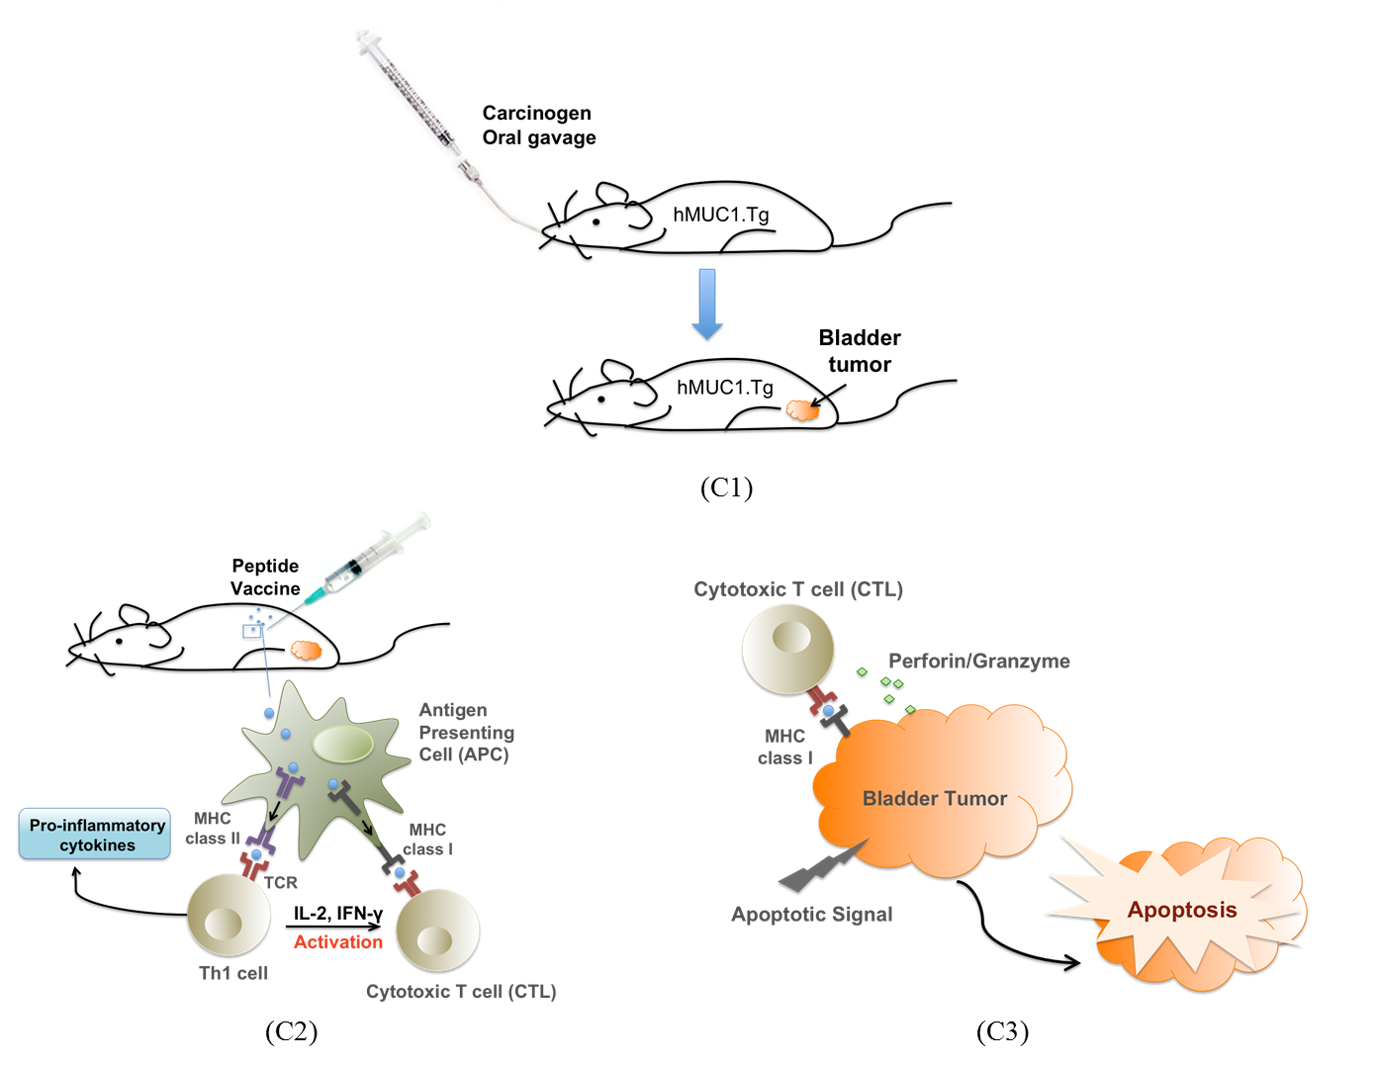

B. Interview: (Said by you on camera. Don’t forget to smile!)

Authors: Below are statements we would like you to complete that are complementary to the information contained within the schematic overview. Only one statement should be chosen and completed per author who will be on camera demonstrating the protocol. In addition to choosing and filling out the appropriate statement, please enter the name of the individual who will say each line. **If individuals will be doing the demonstrations but not speaking in the introduction, please use statement 1.8 to introduce these demonstrators (ex PI introducing students).

  - Author name Gregory Wurz: Hello, I am Dr. Gregory Wurz, a research scientist at the University of California, Davis Health System in Sacramento, California. The main advantage of this technique over existing methods, like xenografts, is that xenografts require immunocompromised hosts, whereas our model utilizes an immune intact transgenic mouse that carries a human TAA that is the target of the peptide vaccine.

  - **Author name Gregory Wurz: Demonstrating the techniques with me will be Daniel Vang, and Drs Chiao-Jung Kao and Audrey Gutierrez, all of whom are fellow research scientists in Dr. Michael DeGregorio’’s laboratory in the UC Davis Health System.

Protocol (read by voice talent at JoVE):

Authors: In order to ensure that your protocol can be filmed in a single day, the protocol text must be limited to 30 steps – each step being defined as 3 lines of 12 pt text in our formatting style below. This amounts to 3 pages of protocol text. The scope of the scripted protocol text should include only those aspects of the procedure that require visualization in order to be well understood.

- Bladder Cancer Induction and Vaccination Treatments (will remove red or introduce)

  - TEXT on WHITE BACKGROUND: All animal studies and experiments were conducted under a protocol approved by the University of California, Davis Institutional Animal Care and Use Administrative Advisory Committee.
    - TEXT of the above statement

  - Before administering the first dose of N-butyl-N-(4-hydroxybutyl) nitrosamine, or OH-BBN, to induce bladder cancer, perform a submandibular bleed on each mouse to collect whole blood in blood clotting tubes and allow 30 minutes for the blood to clot (TEXT: refer to text protocol for serum preparation).
    - WIDE Talent approaches bench with mice and cage and sets down
    - MED/CU Talent picks up mouse and positions it for the bleed
    - CU Talent collects blood from mouse into blood clotting tube

  - Beginning at 8 weeks, using stainless steel, 20-gauge gavage needles, administer the OH-BBN orally, 5 days per week for 12 weeks.
    - MED/CU Talent holding a mouse picks up syringe with gavage and administers BBN

  - At week 20, use 600 µL of 0.9% sterile saline to reconstitute each vial of lyophilized peptide vaccine and thoroughly resuspend by drawing the solution through a 0.5-inch 27-gauge needle six times. Using saline, adjust the concentration so that the desired dose is delivered in a volume of 100 µL.
    - CU Talent injects sterile saline into a vial of lyophilized peptide vaccine (have other vaccine bottles visible)
    - CU Talent draws solution through needle to resuspend
    - CU Talent adds saline to vaccine solution

  - After the last dose of OH-BBN, administer the vaccine on a weekly basis for an eight-week cycle by using a 25-gauge needle to inject 100 ul of the vaccine (TEXT: monitor mice weekly for presence of tumors).
    - MED/CU Talent picks up a mouse and cleans injection site
    - CU Talent picks up syringe and needle and injects animal with vaccine

- Monitoring and Sample Collection

  - Eight weeks after the last dose of OH-BBN, after euthanizing all the mice by CO₂ asphyxiation, place each mouse on a dissection board and pin down all four limbs.
    - MED Talent places euthanized mice in cage on bench
    - MED/CU Talent fixes mice to dissection board

  - Next, using forceps and scissors, make a horizontal incision in the upper abdominal region. Insert the scissors into the incision between the epidermal layer and abdominal wall and with the help of forceps, gently separate the skin from the underlying tissue.
    - CU Talent uses forceps and scissors to make horizontal incision in upper abdominal region
    - CU/ECU Talent separates the skin from the underlying tissue

  - Make a vertical incision from the horizontal incision following the middle axis towards the anterior end of the mouse. Then, separate the skin from the rib cage, and using a 1-mL syringe and a 22-gauge needle, puncture the heart and collect blood with a smooth and steady draw (TEXT: isolate serum and store according to text protocol).
    - CU Talent makes vertical incision toward anterior end of mouse
    - ECU Talent separates skin from rib cage
    - ECU Talent uses syringe and needle to puncture heart and collect blood with a smooth, steady draw

  - Using forceps and scissors, cut and peel back the rest of the epidermal layer. Inside a biological safety cabinet, cut through the abdominal wall and peritoneum and aseptically remove the bladder tumor for immunohistochemistry, or IHC, and Western blot. For IHC, place the bladder tumor specimen in a tissue cassette and fix it in chilled formalin overnight at room temperature.
    - CU Talent cuts and peels back rest of epidermal layer
    - CU Talent cuts through abdominal wall and peritoneum
    - CU/ECU Talent aseptically removes bladder tumor and places in a plate
    - CU Talent removes the spleen and places in a nylon tissue sieve in a Petri plate.
    - CU Talent places tissue cassette in jar of chilled formalin

  - Collect the spleen for cell viability analysis and ELISpot.
    - CU Talent removes the spleen and places in a nylon tissue sieve in a Petrie plate. [Comment: This is the only shot remaining in step 3.5.]
    - CU Talent transfers tumor from plate to cassette
    - CU Talent places tissue cassette in jar of chilled formalin

- Multiplex Fluorometric Microbead Immunoassay

  - To carry out the multiplex fluorometric microbead immunoassay, use 200 ul of Assay buffer to pre-wet a 96-well filter bottom plate, allowing the filter to completely soak. Then use a 96-well plate vacuum apparatus to gently drain the filter and use paper towels to blot dry the bottom of the plate.
    - MED Talent at bench opening Assay buffer
    - CU Talent pipettes up Assay buffer and pipettes into 96-well, filter bottom plate - show the plate soaking up the buffer
4.1.2.1 Shot was added as a close-up of the plate to show soaking of the filter.
    - CU Talent uses vacuum to drain filter
    - CU Talent blot dries plate on paper towels

  - Using a multi-channel pipette, pipette 25 µL of serum matrix into the wells assigned for the blanks and standards and pipette 25 µL of Assay Buffer into the wells assigned for the controls and unknowns.
    - MED/CU Talent pipettes serum matrix into wells for blanks and standards with plate map visible
    - MED/CU Talent pipettes Assay buffer into wells for controls and unknowns

  - Next, pipette 25 µL of the blank, standards, controls, and unknowns to the respective assigned wells. Vortex the bead mix for 20 seconds and transfer the beads to a reservoir.
    - CU Talent pipettes 25 ul of solutions into assigned wells, beginning with blanks
    - MED/CU Talent vortexes bead mix
    - CU Talent transfers beads to a reservoir

  - Then, pipette 25 µL of the bead mix into each well. Cover the plate to protect it from light and shake the plate on a shaker at 500 rpm for two hours at room temperature. Drain the plate and use 200 µL of PBS-T to wash it twice before draining and blotting it dry.
    - CU Talent pipettes 25 ul of bead mix into each well
    - MED Talent covers plate and places on shaker and turns on; B need a version of talent removing plate for 4.6.1 below [Comment: Need this shot again to serve as shot 4.7.1.1.]

4.4.4 4.4.3 MED/CU Talent drains and blots the plate; B need another version for 4.6.3 here

4.4.3 4.4.4 MED/CU Talent adds 200 ul of PBS-T to wash - have PBS-T labeled and visible; B need another version for 4.6.2 below

[Comment: Repeat 4.4.3 after 4.4.4 as renumbered to drain the PBS-T and blot dry plate]

  - To prepare the detection antibody solution, combine the required amount of 0.1% PBS-T and detection antibody in a 15- mL tube and vortex for 10 seconds. Then pipette 25 µL into each well.
    - MED/CU Talent adds detection antibody to PBS-T in tube and vortexes
    - CU Talent pipettes 25 ul into each well from reservoir

  - Shake the plate at 500 rpm for one hour at room temperature, then drain and wash the plate with 200 µL of 0.1% PBS-T twice. Drain and blot dry.
    - MED Use 4.4.2B here
4.6.3 MED/CU Use 4.4.3B here
    - MED/CU Use 4.4.4B here [Comment: Shots 4.6.2 and 4.6.3 should appear in reverse order]
    - MED/CU Use 4.4.3B here

  - Pipette 25 µl of the freshly prepared streptavidin phycoerythrin, or SA-PE, to each well. Place the plate on the plate shaker and incubate for 30 minutes at room temperature at 500 rpm. Drain and wash with PBS-T twice.
4.7.0 Shot added here “CU Talent pipets 25 µl SA-PE solution into each well
    - MED/CU Talent places cover on plate - have SA-PE solution labeled and visible
      - Insert shot 4.4.2B. as a new shot here
    - CU Talent drains and blots dry the plate

  - To resuspend the beads, add 100 µL of 0.1% PBS-T to each well and shake at 500 rpm for at least two minutes. Use a Luminex Lx200 machine to read and analyze the plate.
    - SCREEN SHOT of 4.4.4 here
    - SCREEN SHOT of 4.4.2 here - Editor, bring in 4.8.1 first, then bring this shot in as a split screen with 4.8.1 with the VO ‘and shake at 500 rpm…’
    - MED Talent places plate into Luminex Lx200
    - Shot added here “screen shot of plate analysis.

- IFN-γ/IL-4 ELISpot Preparation and Analysis

  - In a biological safety cabinet, process the mouse spleens through 100-µm nylon tissue sieves into 5 mL of sterile PBS in sterile Petri dishes. Layer the splenocytes onto 3 mL of lymphocyte separation medium in sterile 15-mL tubes.
    - WIDE Talent sitting at cabinet processing mouse spleens
    - CU Talent processes a spleen through sieve into dish of PBS
    - CU Talent layers splenocytes into separation medium in 15 ml tube

  - Centrifuge the tubes at 600 x g for 15 minutes to separate the lymphocytes from the red blood cells. Transfer the layered lymphocytes above the gradient to new sterile 15-mL tubes.
    - MED Talent places tubes into centrifuge
    - MED/CU Talent removes a tube and shows the separation to the camera
      - Shot was added here to show layering, which was not possible in shot 5.2.3
    - CU Talent transfers layered lymphocytes above gradient to a new 15 ml tube - Videographer, have talent point out the level on the gradient where to stop pipetting from; Editor, point out this level on the tube

  - In 1.5-mL screw cap centrifuge tubes, use Count and Viability Reagent to make serial dilutions (TEXT: ex: 1:10, 1:20, and 1:40) of the lymphocytes. Then analyze on the Muse.
    - CU Talent adds Count and Viability Reagent to tubes
    - CU Talent adds lymphocytes to tubes
    - MED/CU Talent adds a sample tube into the Muse

  - Prepare a plate map of the samples and conditions for the ELISpot plate by preparing the plate according to the manufacturer’s protocol, and pipette 100 µL of medium, peptide or scramble peptide into each well.
    - CU Talent prepares plate map of samples and conditions
    - CU Talent pipettes 100 μl of solution into respective wells

  - Add 100 µL of cell suspension (TEXT: ~1.0 x 10⁶ cells/well) and incubate the plate at 37°C overnight. Follow the manufacturer’s protocol for the ELISpot assay and use a dissection microscope to analyze the developed ELISpot plate.
    - MED/CU Talent adds cell suspension to each well
    - WIDE Talent places plate into incubator
    - MED Talent at microscope analyzing the developed ELISpot plate

  - Quantify the results by counting the number of colored spots corresponding to each analyte in each well. The spots correspond to the number of spot-forming cells in each well.
    - LAB MEDIA Figure 6A

- Representative Transitional Cell Bladder Carcinoma Induction Results-(second to last section)

  - In our transgenic mouse model, induction with the chemical carcinogen OH-BBN resulted in a high rate of bladder cancer incidence of predominantly transitional cell carcinoma, or TCC, with some squamous cell carcinoma, or SCC, which is similar to bladder cancer in humans. As shown in this figure, eight weeks following OH-BBN induction, bladder cancer incidence rate for both MUC1 transgenic, or Tg and wild type mice was 67%.
    - LAB MEDIA Figure 1, Editor, please focus on the internal organs while leaving as much of the head and limbs out of site as possible

  - Hematoxylin and Eosin staining confirmed the presence of both TCCs and SCCs, with TCCs predominating at a 2:1 ratio. Among these, we observed a range of low and high-grade non-invasive to high-grade invasive tumors. All MUC1.Tg bladder cancer specimens were positive for MUC1 expression by IHC.
    - LAB MEDIA Figure 2, Editor, for TCCs, point out ‘C’ and for SCCs, point out ‘B’

  - During model development, the serum levels of inflammatory cytokines were monitored serially between Weeks 8-28. We observed that inflammatory cytokine levels increased over time from induction through the end of the study. This cytokine pattern is very similar to what we observed previously in our lung cancer model, which strongly suggests that increasing inflammatory cytokine levels may correlate with tumor development.
    - LAB MEDIA Figure 3

  - To assess the Th1 serum cytokine response to the peptide vaccine, 15 vaccinated and 14 placebo-treated MUC1.Tg mice were euthanized and blood was collected at the end of the study, twenty-four hours after the last vaccine treatment. Multiplex analysis shows increased Th1 serum cytokine levels of TNF-α, IFN-γ, IL-2, IL-12 (p70), and IL-17 in the vaccine group compared to the placebo group. Levels of TNF-α, IFN-γ and IL-17 were significantly higher in the vaccine-treated mice. These results suggest a Th1 polarized cytokine response to the peptide vaccine.
    - LAB MEDIA Figure 4

  - In order to evaluate the Th1/Th2 immune response to the peptide vaccine, splenocytes were assessed by IFN-γ/IL-4 ELISpot. Shown here is an assessment of isolated lymphocytes for viability.
    - LAB MEDIA Figure 5

  - After seeding ELISpot plates with viable lymphocytes, the results in this experiment were a clear and specific IFN-γ response to the peptide, which confirms a Th1 immune response to the peptide vaccine.
    - LAB MEDIA Figure 6

INSTRUCTIONS FOR AUTHORS:
Please ensure that the representative results narration is appropriate and correctly describes your images, movies, or figures. Our editors have ensured that the results are written in our format.

We consider this section a critical aspect of the video, because here is where you provide validation for your experiments. For example, if this is a cell culture preparation, this section is where the video will show your cells at various time points following culturing. If this is an imaging prep, then this part is where you will show examples of your imaging experiments.

Please limit the extent of narration to no more than 2-3 lines of text per image or movie file being described. Figures with multiple panels submitted with the original protocol should be broken up so that each panel is a separate image. Like the schematic, each image or movie file supplied in the results should be referenced by annotation in parenthesis, however for the results, the specific filename should be given in parenthesis.

Below is an example of results text:

EXAMPLE REPRESENTATIVE RESULTS

5. Evaluation of Morpholino Injection and Knockdown
5.1 Representative results of both morpholino injection and mRNA injection are shown here. The
uninjected control at 48 hours post fertilization looks normal, as expected
-LAB MEDIA: 0123_PIname_Figure1.tif (Replace 0123 with your jove video #)

5.2 However, embryos injected with the morpholino heg_e3i3_egfr1, which knocks down Heg isoforms
containing the first of two EGF-like repeats, exhibit brain edema.
-LAB MEDIA: 0123_PIname_Figure2.tif

5.3 Injection of heart of glass mRNA also produced an obvious phenotype. At 24 hours post fertilization,
the heads of the uninjected controls look normal
-LAB MEDIA: 0123_PIname_Figure3.tif

5.4 Conversely, some of the embryos injected with the mRNA exhibit cyclopia
-LAB MEDIA: 0123_PIname_Figure4.jpg

Please visit the following URL to see an example of how the results will look when complete:
http://www.jove.com/index/Details.stp?ID=1597

7. Conclusion (said by authors on camera

Authors: Below are statements we would like you to complete that summarize and conclude the video. Only one statement should be chosen and completed per author who will be on camera demonstrating the protocol. In addition to choosing and filling out the appropriate statement, please enter the name of the individual who will say each line.

7.1 Author name Gregory Wurz: After its development, this technique paved the way for researchers in the field of cancer immunology to explore new immunotherapeutics in a preclinical model of advanced bladder cancer.

Provided Media

Authors, Please list all images, movie files, or 3-D rendered animations that can be included in the video per editor’s request. The step in the script/video where these images will be inserted should be specified. For example:

6.2 – 0123_PIname_Figure1.tif - dual color imaging of tumor angiogenesis at 40X
6.2 – 0123_PIname_Figure2.tif - dual color imaging of tumor angiogenesis at 100X

Formats: For static images we prefer .tiff files at dimensions of at least 720X480 pixels and 300 dpi. The higher resolution, the better. Likewise any exported movie files should have at minimum these dimensions and be rendered to .mov, .mp4, or .avi files.

Insert your media filenames here.

General Preparation

It’s critical for a smooth and organized shoot that all reagents are accounted for, in advance.

Any overnight or long incubation steps should be recognized and specimens/samples be prepared in advance so that prior steps can be recorded and shooting can continue with pre-prepared specimens/samples.

All tubes/flasks should be pre-labeled neatly before we arrive.

Ex. Luciferase assay done in 96 well plates should be labeled with negative/positive control wells and experimental samples are labeled accordingly.

