Submission ID #: 50847

Editor Name:BrigidStadinski

Videographer name: Paul Donahue

Film Date: TBD

Authors and Affiliations:

Amir Rosenthal¹, Stephan Kellnberger¹, Murad Omar¹, Daniel Razansky¹, Vasilis Ntziachristos¹

¹Institute for Biological and Medical Imaging (IBMI), Technical University of Munich and Helmholtz Center Munich

Title: Wideband optical detector of ultrasound for medical imaging applications

Corresponding Author:
Amir Rosenthal
Institute for Biological and Medical Imaging (IBMI),
Technical University of Munich and Helmholtz Center Munich,
Ingoldstädter Landstraße 1, 85764 Neuherberg, Germany
eeamir@tum.de
Phone: +49(0)-89-3187-3850
Fax: +49(0)-89-3187-3063

Authors, please fill out the brief questionnaire below.

- Will you require JoVE to record video microscopy, such as filming a complex dissection or microinjection technique? (Y/N) _N______ If yes, please list make and model of your microscope: ______________________________
**Note: This question is to get at whether or not you will need a camera hook-up to look into the microscope. However, if your microscope has a digital camera attached to a computer, you can gather these shots by collecting screen capture movies.
Does your protocol include microscopy steps that are visualized through a microscope with a digital camera/computer attached? (Y/N) __Y___
B. Does your protocol include detailed, step-by-step, descriptions of software usage? (Y/N)___N___
C. Which steps of your protocol will viewers benefit most from having filmed? Please list 4-6 steps_ 2.3, 3.2 3.4, 4.3, 4.4 ___________________
D. What is the single most difficult aspect of this procedure and what do you do to ensure success?
The laser light used will light up the room and probably saturate the camera. We will try to use light in the NIR which is less visible by the camera. If that doesn’t work, we could simply perform the experiments twice. First, we do a mock experiment with light powers kept low to enable the camera film the objects illuminated by the laser. Then, we repeat the experiment with full power and film only the screen showing the result in real time. We would have to explain that the laser is kept on low power for visualization purposes. Authors/Editor, I wrote in the shots below using the lower power laser and included some Text overlays on screen explaining that this is for filming purposes. However, the on screen shots can be performed with the regular laser. If on the day of filming, you and the videographer decide that the full laser power is appropriate, please remove these TEXT overlays. The narration itself will not change.

1. Introduction (Schematic Overview and Interview)

A. Schematic Overview (read by voice talent at JoVE):

Conceptual Narrative:
This video will demonstrate the use of an optical sensor of ultrasound based on a pi-phase-shifted fiber Bragg grating, or pi-FBG, as a sensing element, and a pulse interferometry read-out system. (Intro)

This is achieved by embedding a dark microscopic sphere in transparent agar and using it to generate a wideband point-like acoustic source by illuminating it with high power light pulses. (P1)
Editors, please use P1 of graphic overview.pptx. Animate the light coming out of the lasers and flashing on and off to indicate light pulses illuminating the sphere as this point is narrated.

As a second step, the pi-FBG is scanned in three dimensions, which enables characterization of its spatially dependent and frequency dependent response to ultrasound. (P2)
Editors, please use P2 of graphic overview.pptx. Continue to have the light from the labels pulsing on and off. Animate the addition of the lines and π-FBG waves and label as this point is narrated.

Next, a water pump is used in order to generate a mechanical disturbance in the vicinity of the ultrasound sensor and evaluate the robustness of the sensor (P3)
Editors, please use P3 of graphic overview.pptx. Animate the arrows pointing into the water pump by having them flash on and off and do the same for the blue arrow pointing toward the optical fiber.

Results are obtained that show that the optical sensor is appropriate for “real-world” imaging applications based on its spatio-temporal acoustic response and its robustness to mechanical disturbances. (P4)

Paste a copy of your graphic overview here. The original file should be Adobe Illustrator (preferred) or Powerpoint (see instructions) and should be uploaded through your online submission on the JoVE website. Please keep all layers in the file (i.e., do not flatten the file).

graphic overview.pptx

(P1)
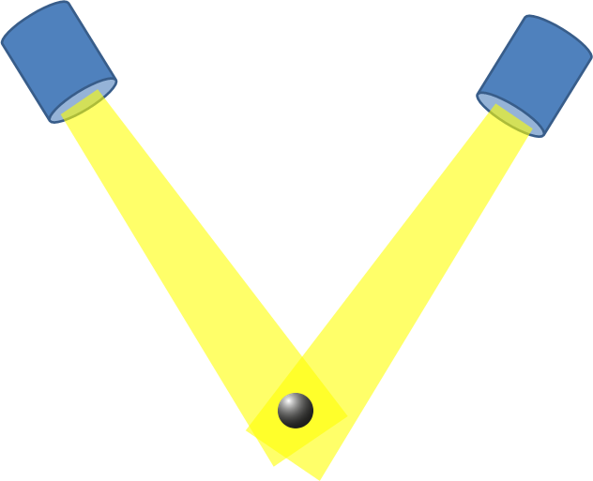

(P2)
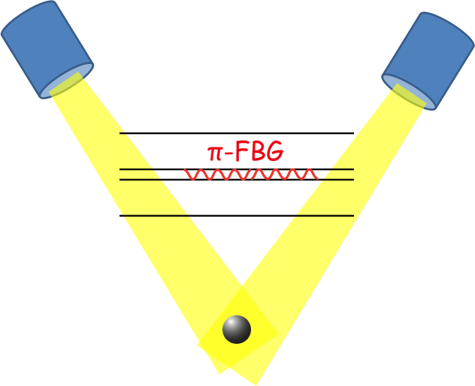
(P3)

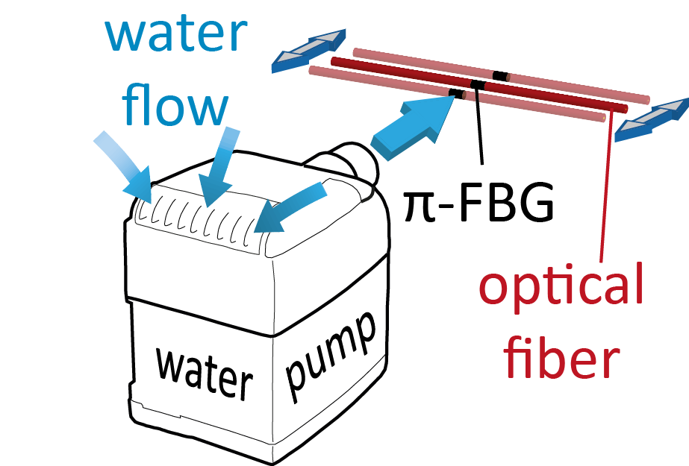

B. Interview: (Said by you on camera. Don’t forget to smile!)

  - Amir Rosenthal: The main advantage of this technique over existing optical methods for ultrasound detection, like the combination of micro-rings with continuous wave interferometry, is that this technique offers a high robustness against mechanical vibrations, which enables its application in the clinical environment. Additionally, our detector is based on a whole-fiber design with a form-factor compatible with the strictest of catheter applications.
    - MED: Amir speaks toward camera, interview style.
  - Stephan Kellnberger: The implications of this technique extend toward minimally invasive imaging techniques, because of the small dimensions of the fiber detector.
    - MED: Stephen speaks toward camera, interview style.
  - Murad Omar: Generally, individuals new to this method will struggle because of the non-standard interferometric design and the complex acoustic response of the detector at frequencies below 6 MHz.
    - MED: Murad speaks toward camera, interview style.

Protocol (read by voice talent at JoVE):
- Preparation of a microscopic sphere suspended in agar
  - To begin, mix agar powder with distilled water in a glass beaker. Use a hot-plate magnetic-stirrer device to heat the solution close to boiling temperature and dissolve the agar powder until the solution becomes clear and free of air bubbles.
    - MED: Talent adds agar a beaker of distilled water.
    - CU: Stirring mixture on hot-plate as the agar dissolves to a clear solution. A hand turning the knob on the hotplate to turn on stirring
    - CU: Beaker as the agar dissolves
    - Cooling down of the agar mixture. Solution becomes clear.
  - Sprinkle a small amount of microscopic spheres on the agar solution and wait until the solution fully solidifies. Take the solid agar phantom out of the mold by pushing the plunger.
    - MED-over the shoulder: Talent sprinkles a small amount of microscopic spheres on the agar solution.
    - CU: Solid agar phantom as talent pushes out of the mold with the plunger.
  - View the phantom under a stereoscopic microscope. Cut a small piece of agar that contains a single microscopic sphere.
    - MED: Talent views the phantom under a stereoscopic microscope.
    - LAB MEDIA: Agarcuttingmovie1 - Microscope movie of phantom under the stereoscopic microscope as talent cuts a small piece of agar that contains a single microscopic sphere. (will be provided by us)
  - Repeat agar preparation and add the solid agar piece containing the single microscopic sphere to the agar solution.
    - MED or CU: A second beaker of prepared agar as talent adds a single microscopic sphere to the agar solution. Talent adds sphere to a second syringe filled with an agar solution.
  - After solidification, cut the agar phantom under the microscope such that the microscopic sphere is located close to the phantom’s surface.
    - LAB MEDIA: Agarcuttingmovie2 - Microscope movie as talent cuts the agar phantom under the microscope such that the microscopic sphere is located close to the phantom’s surface. (will be provided by us)
- Optoacoustic measurement
  - These experiments use a pi-phase-shifted fiber Bragg grating as a resonator. Use two v-groove fiber holders to hold the fiber tightly on both sides of the pi-FBG. Connect the holder to a three dimensional translation computer-operated stage.
    - CU: π-FBG as talent uses two v-groove fiber holders to hold the fiber tightly on both sides.
    - MED-over the shoulder: Talent connects the holder to a three dimensional translation computer-operated stage. (important that we see the transition of the fiber from above the water level to being underwater)
  - Ensure that the fiber is submerged in a water tank to enable the propagation of ultrasound.
    - MED-over the shoulder: Fiber as talent pushes down into the water tank.
  - Find the approximate location of the sensing pi-FBG element by illuminating different parts of the fiber with the high-power nanosecond-pulse laser beam. The optical absorption of the coating, however weak, will create a signal when the illumination is performed on the pi-FBG.
    - CU: Fiber as talent illuminates with the laser beam. Use the lower power laser here for filming purposes and we will include the text overlay on screen. TEXT overlay: low power laser used for filming purposes
    - MED-over the shoulder: Screen showing the signal when the illumination is performed. (use high power laser to get the signal)
  - Next, place the agar-embedded microscopic sphere directly underneath the pi-FBG. The microscopic sphere should be visible to the naked eye.
    - MED: Talent places the agar-embedded microscopic sphere directly underneath the pi-FBG. Match action in next shot.
    - ECU: Microscopic sphere in agar as talent places directly underneath the pi-FBG. Fiber moves to the right position above the dark microsphere. (Ideally, the microsphere should be visible in this shot as a dark dot in the agar)
  - Using the translation stage, perform a 2D scan of the pi-FBG in the plane parallel to the ground to find the location where the signal from the microscopic sphere is strongest and its corresponding time delay is shortest.
    - MED: Using the translation stage, talent begins the 2D scan using low power laser (for filming purposes). (Ideally, the microsphere should be visible in this shot as a dark dot in the agar)
    - MED-over the shoulder: Screen showing the signal as talent finds the place with the signal is the strongest and its corresponding delay time is the shortest. – Screen-shot video. Please add arrows to the video as shown in the file “screenshot-instructions.jpg”
  - Perform the last adjustments to the illumination to deliver maximum power to the microscopic sphere.
    - MED: Fiber as talent delivers the last adjustments of illumination to the microscopic sphere.
  - Using the translation stage, perform a 3D scan of the pi-FBG and record the signal for each position.
    - CU: π-FBG as talent uses the translation stage perform a 3D scan using lower power laser. ). (Ideally, the microsphere should be visible in this shot as a dark dot in the agar).
  - To obtain the spatially dependent frequency response of the ultrasound detector, perform the Fourier transform on the recorded time-domain ultrasound signal.
    - MED-over the shoulder: Screen of recorded time-domain ultrasound signal as talent performs the Fourier transform.
- Estimation of robustness and sensitivity of the π-FBG detector’s performance
  - Use two v-groove fiber holders to hold the fiber tightly on both sides of the pi-FBG and proceed to submerge it.
    - MED-over the shoulder: Talent uses two v-groove fiber holders to hold the fiber tightly on both sides of the π-FBG. and submerge the π-FBG.
  - Place a dark plate sturdily in the water tank and illuminate it with the high-power nanosecond-pulse laser beam to create a strong acoustic field. Then, position the pi-FBG above the illuminated region.
    - CU: pi-FBG as talent places a dark plate or a graphite rod sturdily to face the pi-FBG and illuminates it with the laser beam to create a strong acoustic field. Use the lower power laser here for filming purposes and we will include the text overlay on screen. TEXT overlay: low power laser used for filming purposes
    - π-FBG is positioned to face the dark metal plate.
  - Place a water pump inside the water tank and turn it on in order to create rapid variations in the environmental conditions.
    - MED-over the shoulder: Talent places a water pump inside the water tank and turns it on.
  - To estimate the robustness of the system, measure the output with the locking circuit turned both on and off. When no locking is performed, it is not possible to accurately detect the ultrasound signal.
    - MED-over the shoulder or CU: Screen as talent measures the output with the locking circuit turned both on and off. Captions should be added to the video. First, the caption should read “Locking circuit on”. Then when the baseline of the signal starts changing randomly, the caption should read “Locking circuit off”. Finally, the baseline returns to zero, and the caption should read again “Locking circuit on”.
  - After turning the water pump off, estimate the benefit in sensitivity due to the high coherence of the source by replacing the wideband pulse laser with a low coherence source.
    - MED: Talent removes the wideband pulse laser. (talent turns pulse laser off)
    - CU: System as talent places a low coherence source in place.
  - Then, repeat the acoustic measurement. A decrease of over an order of magnitude in sensitivity is expected when the low-coherence source is used.
    - MED-over the shoulder: Screen as talent repeats the acoustic measurement, showing a decrease in over an order of magnitude.
- Results: Analysis of optoacoustic signal and spectra
  - Shown here are the signals… and their corresponding spectra from the microscopic sphere at a distance of 1 mm from the fiber for three offsets from the center of the pi-FBG. The spectra are compared to the spectrum of an ideal spherical source with a diameter of 100 µm.
    - LAB MEDIA: Figure 4. Editors, please highlight the left plot as “the signals” is narrated and the right plot as “their corresponding spectra” is narrated. Then highlight the black dotted line in the right plot as the last sentence is narrated
  - Clearly, the optical detector’s sensitivity to high frequency ultrasound is anisotropic and is highest when the center of the pi-FBG is directly above the microscopic sphere.
    - LAB MEDIA: Figure 4. Editors, please highlight the blue line in each plot as this point is narrated.
  - Despite the high acoustic impedance mismatch between the silica fiber and water, the sensor exhibits a relatively regular, resonance-free acoustic spectrum at frequencies above 6 MHz, leading to a well-defined, sharp optoacoustic signal suitable for imaging applications.
    - LAB MEDIA: Figure 4B. Editors, please transition to this figure from the previous figure by zooming into the right plot. On 4B, please highlight or zoom into the right side of the plot that is greater than 6 MHz on the x-axis as narrated.
  - A comparison between ultrasound signals measured using a low-coherence source… and a pulse source is shown here. Because of the low sensitivity obtained by the low-coherence source, an optoacoustic source with a high magnitude was used for generating the acoustic signal.
    - LAB MEDIA: 50847fig5. Editors, during the first sentence, please highlight the top red signal as “a low-coherence source” is narrated and the bottom blue signal as “a pulse source” is narrated.
  - A significant reduction in sensitivity of a factor of 18 is observed for the signals detected with the low-coherence source.
    - LAB MEDIA: 50847fig5. Editors, please highlight the top red signal as this point is narrated.
  - This lower sensitivity is inherent to the low-coherence source as the wideband optical spectrum is generated by a random process, as opposed to a deterministic process for the coherent pulse source.
    - LAB MEDIA: 50847fig5

- Conclusion (said by authors on camera)
  - Murad Omar: Once mastered, this sensor characterization technique can be done in a few hours if it is performed properly.
    - MED: Murad speaks toward camera, interview style.
  - Stephan Kellnberger: While attempting this procedure, it’s important to remember to distinguish between the acoustic response of the sensor at frequencies below and above 6 MHz. Only at higher frequencies is the response relatively resonance-free and suitable for imaging applications.
    - MED: Stephen speaks toward camera, interview style.
  - Amir Rosenthal: After its development, this technique paved the way for researchers in the field of optoacoustic imaging to explore new designs for minimally invasive imaging devices for clinical use.
    - MED: Amir speaks toward camera, interview style.

Provided Media

Authors, Please list all images, movie files, or 3-D rendered animations that can be included in the video per editor’s request. The step in the script/video where these images will be inserted should be specified. For example:

6.2 – 0123_PIname_Figure1.tif- dual color imaging of tumor angiogenesis at 40X
6.2 – 0123_PIname_Figure2.tif - dual color imaging of tumor angiogenesis at 100X

Formats: For static images we prefer .tiff, .eps, Illustrator, Powerpoint or Photoshop files at dimensions of at least 720X480 pixels and 300 dpi. The higher resolution, the better. Likewise any exported movie files should have at minimum these dimensions and be rendered to .mov, .mp4, or .avi files.

Insert your media filenames here.

graphic overview.pptx

Agarcuttingmovie1 - Microscope movie of phantom under the stereoscopic microscope as talent cuts a small piece of agar that contains a single microscopic sphere.

Agarcuttingmovie2 - Microscope movie as talent cuts the agar phantom under the microscope such that the microscopic sphere is located close to the phantom’s surface.

Figure 4 – Authors, please provide a version of this figure without the a) and b) labels for the video.

Figure 4B - Authors, please provide a separate version of this figure without the b) label for the video.

50847fig5

General Preparation

It’s critical for a smooth and organized shoot that all reagents are accounted for, in advance.

Any overnight or long incubation steps should be recognized and specimens/samples be prepared in advance so that prior steps can be recorded and shooting can continue with pre-prepared specimens/samples.

All tubes/flasks should be pre-labeled neatly before we arrive.

Ex. Luciferase assay done in 96 well plates should be labeled with negative/positive control wells and experimental samples are labeled accordingly.

You will receive more detailed preparation instructions, as well as an introduction to your videographer, closer to your filming date.

