Submission ID #:50845
Editor Name: Shanelle Ko
Videographer name:
Film Date: 7/26/13

Authors and Affiliations:

Kathrin Schüller
Institute for Stroke and Dementia Research (ISD)
University of Munich Medical Center
Munich, Germany
kathrin.schueller@med.uni-muenchen.de
mailto:kathrin.schueller@med.uni-muenchen.de
Dominik Bühler
Institute for Stroke and Dementia Research (ISD)
University of Munich Medical Center
Munich, Germany
dominik.buehler@med.uni-muenchen.de

Nikolaus Plesnila
Institute for Stroke and Dementia Research (ISD)
University of Munich Medical Center
Munich, Germany
nikolaus.plesnila@med.uni-muenchen.de
+49-89-7095-8363

Title: A Murine Model of Subarachnoid Hemorrhage

Corresponding Author:

Nikolaus Plesnila

Authors, please fill out the brief questionnaire below.

A. Will you require JoVE to record video microscopy, such as filming a complex dissection or microinjection technique? (Y/N) _Y_ If yes, please list make and model of your microscope: Leica M 80 dissection microscope with leica DFC 290HD camera
B. Does your protocol include detailed, step-by-step, descriptions of software usage? (Y/N)__N__
C. Which steps of your protocol will viewers benefit most from having filmed? Please list 4-6 steps: intubation, ICP monitoring, vessel preparation, induction subarachnoid hemorrhage
D. What is the single most difficult aspect of this procedure and what do you do to ensure success? Induction subarachnoid hemorrhage

1. Introduction (Schematic Overview and Interview)

A. Schematic Overview (read by voice talent at JoVE):
Authors, please select from “Procedural Narrative” or “Conceptual Narrative” and complete the statements below. Please do not add additional steps. Then, attach your finished graphic overview. See accompanying instructions for details and examples.

Procedural Narrative:

The overall goal of this procedure is to induce a standardized subarachnoid hemorrhage in mice.

This is accomplished by first connecting the anaesthetized animal to monitoring devices to supervise physiologic conditions during surgery. (P1)

The second step is to apply sensors for cerebral perfusion and intracranial pressure measurement as key parameters for bleeding induction. (P2)

Next, the subarachnoid hemorrhage is induced by endovascular filament perforation. (P3)

The final step is to perfuse the animal and isolate the brain to visualize the extravasated blood distribution. (P4)

P1: LAB MEDIA: p1.physiology.ai, animate from image 1 – 5
P2: LAB MEDIA: p2 head icpldf.ai, animate from image 1- 6
P3: LAB MEDIA: p3 vessel+filament.ai, animate in the blue line and then the red blob of blood
P4: LAB MEDIA: p4 blood distribution.ai, if possible use the key of the image as a guide to trace the bleeding locations in the brain

Paste a copy of your graphic overview here. The original file should be Adobe Illustrator (preferred) or Powerpoint (see instructions) and should be uploaded through your online submission on the JoVE website. Please keep all layers in the file (i.e., do not flatten the file).

(P1)

(P2)

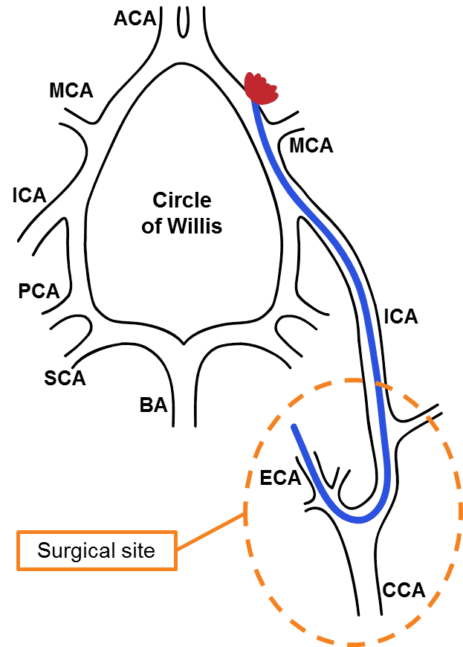(P3)

(P4)

B. Interview: (Said by you on camera. Don’t forget to smile!)

Authors: Below are statements we would like you to complete that are complementary to the information contained within the schematic overview.
- Only one statement should be chosen and completed per author who will be on camera demonstrating the protocol.
- Enter the name of the individual who will say each line.
- Please choose and fill out the statement(s) that convey the most important fact(s) about your protocol. You may revise the given prompts as necessary to improve the sentence flow.
- If any individuals will be doing demonstrations on camera but are not assigned a speaking part in this interview section, please use statement 1.8 to introduce these demonstrators (for example, the PI introduces students)

  - Plesnila: The implications of this technique extend toward the therapy of early brain injury after subarachnoid hemorrhage. The main advantage of performing this technique in mice instead of rats is that we can make use of transgenic animals.
  - Bühler: Generally, individuals new to this method will struggle because intubation, multimodal physiology monitoring as well as vessel preparation are quite challenging to perform in mice. Visual demonstration of this method is critical as the surgical steps are difficult to learn.
  - Plesnila: Demonstrating the procedure will be Kathrin Schüller a PhD student from my laboratory. She has more than two years experience in performing this SAH model.
    - Interview style: Author saying the above
    - The named technician, post doc, student looks up from workbench or desk or microscope and acknowledges the camera.

Protocol (read by voice talent at JoVE):

Authors: In order to ensure that your protocol can be filmed in a single day, the protocol text must be limited to 30 steps – each step being defined as 3 lines of 12 pt text in our formatting style below. This amounts to 3 pages of protocol text. The scope of the scripted protocol text should include only those aspects of the procedure that require visualization in order to be well understood.

- Animal Preparation
  - To begin, place an anesthetized animal on a slanted platform.
    - MED: Talent places anesthetized animal on platform. Text overlay (Induction: 5% isoflurane, Maintenance: fentanyl (0.05 mg/kg), midazolam (5 mg/kg) and medetomidine (0.5 mg/kg), i.p.)

  - Working under a microscope, retract the tongue with bent forceps to locate the vocal cords. Once visualized, intubate during inspiration with a tube made from a 20G venous catheter.
    - MED: Side shot of talent working under a microscope and retracting tongue
    - SCOPE: Talent intubates animal

  - Next, place the mouse in a supine position and check for the correct placement of the tube with a piece of cotton or a microcapnograph.
    - MED: With mouse in supine position, talent checks for the correct placement of the tube
  - If correctly placed, connect the intubation tube to the respirator. Ventilate the mouse with room air supplemented with 25% oxygen.
    - MED: Talent sets values on respirator. Text Overlay (Frequency: 180- 220 breaths/min, Stroke volume: 200 µl).
    - MED: Talent connects tube to respirator.

  - Connect the intubation tube to the microcapnograph. Maintain the end-expiratory pCO₂ (Partial Pressure of Carbon Dioxide) at 30 mm Hg by adjusting the ventilation frequency.
    - CU: Talent connects tube to microcapnograph
    - CU: Microcapnograph screen
    - MED: Talent adjusts settings

  - After inserting a rectal temperature probe, place the animal on a heating pad to maintain the body temperature at 37 °C.
    - CU: Temperature screen

  - Next, place an annular pulsoximeter sensor on the right hind paw.
    - CU: Talent places pulsoximeter on hind paw
    - CU: Pulsoximeter screen

  - Place the mouse in a prone position and make an incision from eye to ear.
    - CU: With mouse in prone position, talent makes incision
    - SCOPE: talent makes incision

  - Retract the skin and dissect the left temporal muscle from the temporal bone.
    - SCOPE: Talent dissects the muscle from bone

  - Once exposed, glue a Laser Doppler Flowmeter (LDF) probe onto the left temporal bone. Hold the probe in a fixed position until the glue hardens.
    - MED: Talent holds probe in position
    - SCOPE: Talent glues probe in place. Text overlay (Laser Doppler Flowmeter: LDF)

  - Drill a hole of approximately 1.5 mm in diameter into the left temporal bone. While drilling, cool the bone with saline to prevent heat damage.
    - CU: Talent begins drilling hole and applies saline during drilling

  - Insert the intercranial pressure probe into the cranial cavity and push it forward as dorsally as possible to prevent tissue damage and bleeding.
    - CU+ SCOPE: Talent inserts probe into cranial cavity. Text Overlay (Intercranial Pressure) and Talent pushes the probe forward into the correct position

  - Once the probe is placed correctly, fix and seal with cement and let it dry for 5 min.
    - CU: Shot of the probe once fixed and sealed in the correct location

  - When the cement is dry, turn the mouse carefully to a supine position.
    - MED: Talent turns mouse over.

  - Using standard techniques, catheterize the left femoral artery for continuous blood pressure monitoring. Once in place, connect the femoral catheter to the blood pressure monitoring device.
2.15.1 SCOPE: Talent places catheter in artery
    - MED: Talent connects catheter to blood pressure monitoring device

- Subarachnoid Hemorrhage (SAH) Induction

  - First, open the skin with a pair of scissors from the sternum to chin. Blunt dissect through the connective tissue and push the salivary glands aside to expose the left common carotid artery.
    - MED: Talent opens the skin
    - SCOPE: Talent blunt dissects through tissue (pushes salivary glands aside) to locate the CCA. Text overlay (Common Carotid Artery: CCA)

  - Isolate the CCA from the surrounding tissue, taking care not to damage the vagal nerve located in the same connective tissue sheath.
    - SCOPE: Talent isolates the CCA, vagal nerve is visible

  - Next, carefully expose and isolate the internal carotid artery (ICA) and the external carotid artery (ECA).
    - SCOPE: Talent isolates ICA. Text overlay ( Internal Carotid Artery: ICA)
    - SCOPE: Talent isolates ECA. Text overlay (External Carotid Artery: ECA).

  - Once isolated, ligate the ECA as far cranially as possible. Prearrange two additional ligations around the ECA for later use.
    - SCOPE: Talent ligates ECA
    - CU: Talent arranges two additional ligations

  - Using an applicator, occlude the CCA and ICA temporarily with microclips. Gently pull the clips back to make sure that they are applied correctly.
    - MED: Talent uses applicator to apply microclips
    - SCOPE/CU: Talent pulls back clip to confirm it is applied correctly

  - Cut a small hole into the ECA using vessel scissors and insert a 12mm long Prolene 5-0 filament.
    - CU: Filament
    - SCOPE: Talent inserts filament into vessel

  - Once the filament is in place, close the insertion site using one of the prearranged ligations.
    - SCOPE: Talent closes suture around filament
    - SCOPE: Talent cuts ECA

  - Next, remove the microclips with the microclip applicator.
    - CU/ SCOPE: Talent removes microclips

  - To induce bleeding, advance the filament into the ICA until the ICP rises. A sudden rise of the ICP indicates bleeding induction.
    - SCOPE: Talent advances filament to induce bleeding
    - CU: Shot of the ICP readout rising

  - Withdraw the filament immediately and ligate the ECA by closing both prearranged ligations consecutively. This prevents bleeding out of the insertion site.
    - SCOPE: Talent withdraws filament and tightens both ligations (one long shot)

  - Suture the skin wound and monitor the physiologic parameters of the animal for another 20 min.
    - MED: Talent closes wound
    - Image of physiological parameters: Shot of ICP, blood pressure or some other physiological parameter

  - At the end of this period, remove both the ICP and LDF probes.
    - MED: Talent removes probes

  - After transcardial perfusion, remove the brain and evaluate the blood distribution in the subarachnoid space.
    - CU: dissected brain in dish; probably to be replaced by pictures
    - Pictures of blood distribution

- Results:

  - Before bleeding, the ICP is around 4 mmHg (4.1.1). Bleeding results in a sharp increase of the ICP up to 120 mmHg (4.1.2). ICP values then stabilize within 5 min at approximately 30 mmHg (4.1.3).
    - LAB MEDIA: figure 1, Overlay 4mmHg and place and arrow at the location on the y axis at time 0
    - LAB MEDIA: figure1, draw an arrow at 120 mmHg
    - LAB MEIDA: figure 1, draw an arrow at 30 mmHg

  - In addition, blood pressure rises immediately after bleeding induction.
    - LAB MEDIA: figure 2, circle or highlight the point where the blood pressure increases
  - Representative laser doppler flowmeter values after bleeding induction show a dramatic decrease in cerebral perfusion. Reperfusion to an individually different level occurs within 5 min after the insult.
    - LAB MEDIA: figure 3, circle or highlight the change in values at bleeding induction and then draw a line to show that they even out over time

  - In this example, blood distribution along brain supplying arterioles and cerebellar fissures are observed 3 hours after the hemorrhage. Red lines indicate blood distribution along brain supplying arterioles. The side ipsilateral to the hemorrhage was covered with more blood than the contralateral hemisphere.
    - LAB MEDIA: show the left image first then the right, if possible animate in the red lines showing blood distribution

  - Seen here is the survival curve following SAH in 49 male C57BL/6 mice.
    - LAB MEDIA: figure 5

INSTRUCTIONS FOR AUTHORS:
Please ensure that the representative results narration is appropriate and correctly describes your images, movies, or figures. Our editors have ensured that the results are written in our format.

We consider this section a critical aspect of the video, because here is where you provide validation for your experiments. For example, if this is a cell culture preparation, this section is where the video will show your cells at various time points following culturing. If this is an imaging prep, then this part is where you will show examples of your imaging experiments.

Please limit the extent of narration to no more than 2-3 lines of text per image or movie file being described. Figures with multiple panels submitted with the original protocol should be broken up so that each panel is a separate image. Like the schematic, each image or movie file supplied in the results should be referenced by annotation in parenthesis, however for the results, the specific filename should be given in parenthesis.

- Conclusion (said by authors on camera)

Authors: Below are statements we would like you to complete that summarize and conclude the video. Only one statement should be chosen and completed per author who will be on camera demonstrating the protocol. In addition to choosing and filling out the appropriate statement, please enter the name of the individual who will say each line. You may revise the given prompts if necessary to better fit your protocol.

  - Schüller: Once mastered, this technique can be done in one hour if it is performed properly. While attempting this procedure, it’s important to monitor the physiologic conditions to secure a reproducible amount of bleeding.
  - Plesnila: After its development, this technique paved the way for researchers in the field of subarachnoid hemorrhage to explore the pathomechanisms of cerebral ischemia early after the insult.

Provided Media

Authors, please list all additional images, movie files, or 3-D rendered animations that can be included in the video per editor’s request. The step in the script/video where these images will be inserted should be specified. For example:

6.2 – 0123_PIname_Figure1.tif - dual color imaging of tumor angiogenesis at 40X
6.2 – 0123_PIname_Figure2.tif - dual color imaging of tumor angiogenesis at 100X

Formats: For static images we prefer .tiff, Illustrator, Powerpoint or Photoshop files at dimensions of at least 720X480 pixels and 300 dpi. The higher resolution, the better. Likewise any exported movie files should have at minimum these dimensions and be rendered to .mov, .mp4, or .avi files.

Insert your media filenames here.

P1 physiology.ai

P2 head icp ldf.ai

P3 vessel + filament.ai (example for animation in ppt)

P4 blood distribution.ai

General Preparation

It’s critical for a smooth and organized shoot that all reagents are accounted for, in advance.

Any overnight or long incubation steps should be recognized and specimens/samples be prepared in advance so that prior steps can be recorded and shooting can continue with pre-prepared specimens/samples.

All tubes/flasks should be pre-labeled neatly before we arrive.

Ex. Luciferase assay done in 96 well plates should be labeled with negative/positive control wells and experimental samples are labeled accordingly.

You will receive more detailed preparation instructions, as well as an introduction to your videographer, closer to your filming date.

