Submission ID #: 50820

Editor Name: Linda DiBella

Videographer name:

Film Date:

Authors and Affiliations:

Linlin Gu¹, Stewart W. Schneller² and Qianjun Li¹ *

¹Division of Infectious Diseases, Department of Medicine, University of Alabama at
Birmingham, AL 35294, USA

²Molette Laboratory for Drug Discovery, Department of Chemistry and Biochemistry, Auburn University, Auburn, AL 36849

*Corresponding Author
Qianjun Li, Ph. D
Division of Infectious Diseases
Department of Medicine
University of Alabama at Birmingham
Birmingham, AL 35294
Phone: 205-975-7601, Fax: 205-934-5600, Email: liq@uab.edu

Title: Assays for the Identification of Novel Antivirals against Bluetongue Virus

Authors, please fill out the brief questionnaire below.

A. Will you require assistance with video microscopy, such as filming a complex dissection or microinjection technique (Y/N, please specify steps by number. Also, please list make and model of your microscope)? N
B. Does your protocol include detailed, step-by-step, descriptions of software usage (Y/N, please specify steps by number)? N
C. Which steps of your protocol will viewers benefit most from having filmed? Please list 4-6 steps 2.6, 3.1, 3.3, 3.6, 3.8, 4.1
D. What is the single most difficult aspect of this procedure? 4.3

1. Introduction (Schematic Overview and Interview)

A. Schematic Overview (read by voice talent at JoVE):
Authors, please select from “Procedural Narrative” or “Conceptual Narrative” and complete the statements below. Please do not add additional steps. Then, attach your finished graphic overview. See accompanying instructions for details and examples.

Procedural Narrative:
The overall goal of this procedure is to identify and characterize small molecule antivirals against Bluetongue virus, or BTV, using the CPE-based cell-viability assay (Intro).

This is accomplished by first screening a library of antiviral compounds using the cytopathic effect, or CPE-based assay with the CellTiterGlo reagent (P1, Editor, begin with the brown and white bottles. Pour the white bottle into the brown bottle, then remove the white bottle. Bring in the gray pipettor with the handle and tips, pipette from the brown bottle into the black rectangle, then bring in the luminometer and place the black rectangle into the opening of the machine).

Next, the antiviral efficacy is confirmed and the cytotoxicity of selected antivirals is evaluated using the dose response assay. (P2, Editor, show the matrix in C2).

Finally, the time-of-addition assay is carried out to determine the possible viral lifecycle stage of selected antivirals leading to the possible mechanisms of action (P3, Editor, show C3 here).

Ultimately results can be obtained that show novel antivirals with potent antiviral efficacies and low cytotoxicity based on the dose response assay and time-of-addition assay (P4, Editor, show the two graphs side-by-side in C4).

Paste a copy of your graphic overview here. The original file should be adobe illustrator (preferred) or powerpoint (see instructions) and should be uploaded through your online submission on the JoVE website.

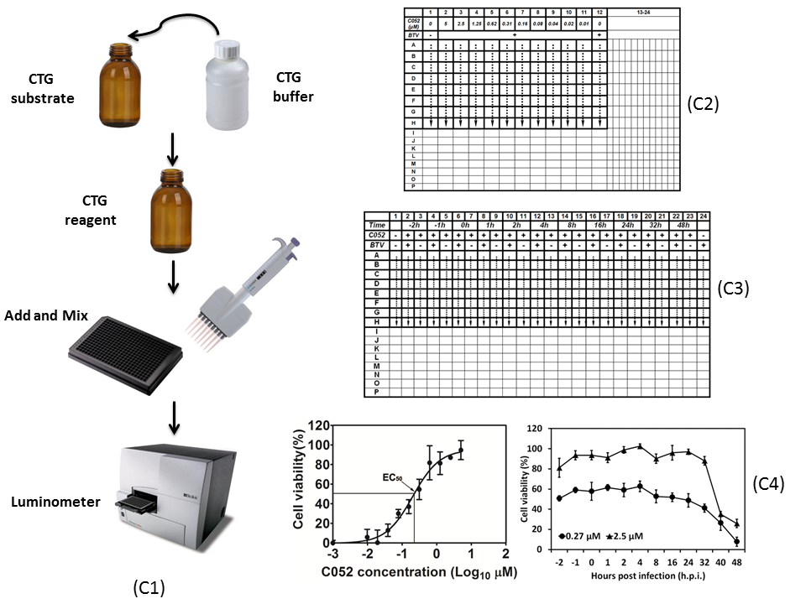

B. Interview: (Said by you on camera. Don’t forget to smile!)

Authors: Below are statements we would like you to complete that are complementary to the information contained within the schematic overview. Only one statement should be chosen and completed per author who will be on camera demonstrating the protocol. In addition to choosing and filling out the appropriate statement, please enter the name of the individual who will say each line. **If individuals will be doing the demonstrations but not speaking in the introduction, please use statement 1.8 to introduce these demonstrators (ex PI introducing students).

  - Author name Linlin Gu: The main advantage of this technique over existing methods, like TCID50 assay and plaque assay, is that it provides a sensitive, robust, and highly reproductive and measurable method to screen and characterize antivirals against certain viruses, including Bluetongue virus which induces measurable CPE in infected cells.

Protocol (read by voice talent at JoVE):

Authors: In order to ensure that your protocol can be filmed in a single day, the protocol text must be limited to 30 steps – each step being defined as 3 lines of 12 pt text in our formatting style below. This amounts to 3 pages of protocol text. The scope of the scripted protocol text should include only those aspects of the procedure that require visualization in order to be well understood.

- Cytopathic Effect Based Assay Using the CellTiterGlo Kit

  - In preparation for the CPE-based assay, from BSR cells maintained in supplemented DMEM medium (TEXT: DMEM, 1% FCS, 100U/mL penicillin, 100 µg/mL streptomycin), use a Microflo select dispenser to seed 20 µl of cells at 5,000 cells/well into a 384-well microplate.
    - WIDE Talent at hood pipetting BSR cells from flask to transfer to a 50 ml tube.
    - MED/CU Talent uses select dispenser to seed 20 µl of BSR cells into 384 well microplate

  - Incubate the cells for 2-3 hours to allow them to fully adhere to the plate. Then add antiviral compounds at a final concentration of 10 µM to each well and mix completely.
    - WIDE Talent places cells in incubator; B need another version for 2.4.1 below; C need another version for 3.8.1 below; D need a version of removing a 384-well plate for 4.5.2 below
    - CU Talent pipettes anti-viral compounds to wells and mixes - have compound containers visible and labeled

  - Use assay medium to dilute plaque purified and propagated BTV to the desired titer and add 5 µl of BTV with denoted MOI to each well. For the control well, add 5µl of assay medium.
    - MED/CU Talent adds assay medium to BTV virus
    - CU Talent adds BTV to each well

  - Put a wet box containing the assay plate into the incubator and incubate the infected cells for 72 hours at 37ºC, with 5% CO₂ and 80-95% humidity, then take the assay plate out of the incubator.
    - WIDE Use 2.2.1B here. The video in 2.4.1 has two movements: plate in incubator and plate out of incubator. This video can also be applied in 3.8.1 and 4.5.2.

  - Next, thaw and equilibrate CTG buffer and the lyophilized CTG substrate to room temperature. Then reconstitute the homogeneous CTG reagent solution by mixing the lyophilized enzyme/substrate and the buffer reagent according to the manufacturer’s instructions.
    - MED/CU Talent places CTG buffer and CTG substrate onto bench to come to room temp
    - CU Talent adds the enzyme substrate into the buffer reagent

  - After equilibrating the assay plates to room temperature for 15 min, use a dispenser to add 25 µl of CTG reagents to each well. Incubate for 15 minutes in the dark before using a multi-mode reader with an integration time of 0.1s to measure luminescence signals.
    - WIDE/MED Talent sits down at the hood where the plates are set to come to room temperature
    - CU Talent pipettes CTG reagents in to each well
    - CU Talent covers the plate to place it in dark
    - MED Talent places plate into multi-mode reader to measure luminescence signals

- Dose Response Assay

  - Seed 5000 BSR cells/well in 384-well micro plates for the dose response assay, using 20 µl for the antiviral efficacy assay and 25 µl for the cytotoxicity assay.
    - MED/CU Talent pipettes BSR cells in to 384 well microplates for antiviral efficacy assay and cytotoxic assay - have at least one plate per assay visible

  - After a two- to three-hour incubation, allocate eight replicates for each concentration of compound per assay, as shown here (Table 1). Assign the first column as the positive control without adding compound or virus, and the last column as the negative control by adding virus only.
    - LAB MEDIA Table 1, Editor, point out the column #1 (for first column) and column #12 (for last column) with the VO

  - For the antiviral efficacy assay, dilute compounds to 50µM in assay medium and to the 2nd column, add 20µl/well. Using an 8-channel semi-automatic pipette, mix the compound five times to a concentration of 25µM.
    - CU Talent adds compounds to assay medium
    - CU Talent adds 20 ul/well to second column
    - CU Talent mixes wells five times

  - Next, transfer 20µl of the mixture in the 2nd column to column 3 and mix well, resulting in a concentration of 12.5µM. Repeat this two-fold serial dilution up to the 11th column, which will have a final concentration of 0.04µM.
    - CU Talent pipettes up 20 ul from column 2 and transfers to column 3 and mixes
    - CU Talent transfers from column 10 to column 11 and mixes

  - Then add 5µl of medium to column 1 as the cell only positive control and 5µl/well of BTV to column 12 as a BTV infection only negative control. Add 5µl/well of BTV from column 2 through column 11.
    - CU Talent adds 5 ul of medium to column 1
    - CU Talent adds 5 ul of BTV to column 12
    - CU Talent adds 5 ul of BTV from column 2 through column 11.

  - For the cytotoxicity assay, dilute the compounds to an initial concentration of 200µM. Add 25µl/well of compound to column 2 and mix five times to bring the concentration to 100µM (TEXT: do not add BTV).
    - MED/CU Talent adds assay medium to compounds to 200 uM
    - CU Talent pipettes up 25 ul with multi-pipettor and pipettes into column 2 and mixes five times

  - Carry out the two-fold series dilution by transferring 25µl from column 2 to the neighboring column 3, and continue through column 12. After mixing column 12, aspirate and discard 25 µl of the mixture. Column 1 is the cell-only control. (Note to editor: there is a screen snapshot regarding layout of cytotoxicity assay)
    - CU Talent transfers 25 ul from column 2 to 3
    - CU Talent finishes mixing column 12 then aspirates and discards 25 ul - Editor, with the VO, please point out column 1 - the ‘cell only’ control

  - For both the antiviral and cytotoxicity assays, put wet box containing assay plate in the incubator for 72 hours and take the plate out afterward, then use the CTG kit to measure cell viability.
    - WIDE use 2.2.1C here (Note to editor: you can copy the video in 2.4.1)

  - Use a biostatic and graphic software to calculate the mean value, standard deviation (STDEV), coefficient variations (CV) and percentage of cell viability for each compound concentration, and carry out non-linear regression analysis to determine the EC₅₀ and CC₅₀ of each compound.
    - LAB MEDIA/SCREEN Mean value, STDEV, CV and % viability per compound concentration
    - LAB MEDIA/SCREEN EC₅₀ and CC₅₀, Editor, bring in this figure with the VO, ‘and carry out non-linear regression…’

- Time-of-Addition Assay

  - Prepare for the Time-of-Addition, or ToA assay by seeding 5000 cells per well in 15 µl in columns 1 through 24 of a 384-well micro plate. For each compound, utilize all twenty-four columns with eight replicas for each time-point. (Table 2)
    - MED/CU Talent pipettes 15 ul of cells into 8 replicates for 24 columns
    - LAB MEDIA Table 2

  - Assign column 1 as a cells only control by adding 10µl/well of assay medium. Mark column 24 as a BTV infection only, negative control by adding 5µl/well of assay medium and 5µl/well of virus at an MOI of 0.01 in a final volume of 25µl/well.
    - CU Talent adds 10 ul to wells in column 1
    - CU Talent adds 5 ul of assay medium to column 24 and then 5 ul of virus - Editor point out column 24

  - Select the even-numbered columns from column 2 to 22 as antiviral efficacy evaluation columns at different hours post infection, or h.p.i.. In these columns, infect cells with 5µl/well of BTV at an MOI of 0.01. At different h.p.i., also add 5µl/well of diluted compound at a final volume of 25µl/well.
    - LAB MEDIA Table 2 - Editor, point out columns numbered 2, 4, 6, etc., that have ‘+’ signs in both the C052 and BTV rows
    - LAB MEDIA Table 2 - Editor, for “At different hpi’s’, point out the C052 row that has ‘+’ signs

  - For the denoted -2 and -1 h.p.i., add the compound to BSR cells prior to BTV infection. For 0 h.p.i. add the compound and BTV to the culture simultaneously. In parallel, designate the odd-numbered columns from column 3 through 23 as compound only controls corresponding to the different time points.
    - LAB MEDIA Table 2, Editor, point out columns 2-5 for the first sentence
    - LAB MEDIA Table 2, Editor, for ‘For 0 hpi, point out columns 6 and 7
    - LAB MEDIA Table 2, Editor, for ‘In parallel’, point out columns 3,5,7 9, etc. up to 23

  - In these columns, add 5µl/well of assay medium and 5µl/well of diluted compound in a final volume of 25µl/well. After incubating the cells to 72 h.p.i. in the incubator, take the assay plate out and use the CellTiter-Glo kit to determine cell viability.
    - MED/CU Talent adds assay medium to columns odd columns beginning with 3
    - WIDE Use 2.2.1D here (Note to editor: you can copy the video in 2.4.1)

  - Finally, use software that processes luminescent signals obtained via the multi-mode reader to determine the mean value, STDEV, CV and percentage of protection/cell viability for each treatment.
    - LAB MEDIA/SCREEN Talent determines mean value, STDEV, CV, and % protection/cell viability per treatment

- Representative Antiviral Compound Assay Results-(second to last section)

  - Using the CPE assay to quantify cellular ATP in living cells, we previously identified several promising lead compounds with potent antiviral efficacy, low toxicity and high selectivity. For example, compound 052 (C052) was determined to have an EC₅₀ of 0.27±0.12μM and a CC₅₀ of 82.69μM, both showing typical regressive curves under the non-linear regression analyses. The SI₅₀ of C052 was determined at 306 based on its EC₅₀ and CC₅₀ values.
    - LAB MEDIA The antiviral efficacy of C052 _Qianjun Li_Figure1.tif

  - The nano-molar scale antiviral efficacy, low toxicity, and consequently high SI₅₀ indicated that C052 might be a potent and selective antiviral against BTV. As seen here, cells were infected with BTV at an MOI of 0.01 in the presence of ten different concentrations of C052, and cell viability was determined at 72 hpi, using the CTG kit. Each data point represents means and SD from five replicates.
    - LAB MEDIA: The antiviral efficacy of C052 _Qianjun Li_Figure1.tif

  - The ToA assay was used to determine the possible stage(s) of the viral life-cycle targeted by compounds. When C052 was added at 1 or 2 hours prior to BTV infection, the antiviral efficacies remained at the nano-molar scale as seen in this figure. In addition, cell viability decreased further when C052 was added at 32 and 48 hpi, indicating that C052 might act beyond the early stage of the viral life-cycle, such as virus entry. Since the first cycle of BTV viral replication is usually complete in infected cells within 24 hpi, our results suggested that C052 might act at the late stages of the BTV viral life-cycle, such as virus replication, packaging, maturation and egress. Meanwhile, it is also possible that C052 acts on host cellular machinery that functions during later stages of the viral life-cycle.
    - LAB MEDIA: The time-of-addition assay for C052_Qianjun Li_Figure2.tif

6. Conclusion (said by authors on camera)

Authors: Below are statements we would like you to complete that summarize and conclude the video. Only one statement should be chosen and completed per author who will be on camera demonstrating the protocol. In addition to choosing and filling out the appropriate statement, please enter the name of the individual who will say each line.

6.1 Author name Linlin Gu: After watching this video, you should have a good understanding of how to utilize CPE-based assay to identify and characterize the potential antivirals against viruses that induce measurable CPE post infection.

Provided Media

Authors, Please list all images, movie files, or 3-D rendered animations that can be included in the video per editor’s request. The step in the script/video where these images will be inserted should be specified. For example:

6.2 – 0123_PIname_Figure1.tif - dual color imaging of tumor angiogenesis at 40X
6.2 – 0123_PIname_Figure2.tif - dual color imaging of tumor angiogenesis at 100X

Formats: For static images we prefer .tiff files at dimensions of at least 720X480 pixels and 300 dpi. The higher resolution, the better. Likewise any exported movie files should have at minimum these dimensions and be rendered to .mov, .mp4, or .avi files.

Insert your media filenames here.

-LAB MEDIA: The plate layout for dose-response assay _Qianjun Li_Table1.tif

-LAB MEDIA: The plate layout for the Time-of-Addition assay_Qianjun Li_Table2.tif

-LAB MEDIA: The antiviral efficacy of C052 _Qianjun Li_Figure1.tif

-LAB MEDIA: The time-of-addition assay for C052_Qianjun Li_Figure2.tif

General Preparation

It’s critical for a smooth and organized shoot that all reagents are accounted for, in advance.

Any overnight or long incubation steps should be recognized and specimens/samples be prepared in advance so that prior steps can be recorded and shooting can continue with pre-prepared specimens/samples.

All tubes/flasks should be pre-labeled neatly before we arrive.

Ex. Luciferase assay done in 96 well plates should be labeled with negative/positive control wells and experimental samples are labeled accordingly.

