Submission ID #: 50809
Editor Name: Pallavi R. Devchand
Videographer name: Patric Sleightholm
Film Date: 29 May, 2013
Authors and Affiliations: Birte Kalveram, Olga Lihoradova, Sabarish V. Indran, Jennifer A. Head, Tetsuro Ikegami
Department of Pathology, Sealy Center for Vaccine Development, Center for Biodefense and Emerging Infectious Diseases, University of Texas Medical Branch, 301 University Blvd.
Galveston, TX 77555-0436
Title: Using click chemistry to measure the effect of viral infection on host-cell RNA synthesis
Corresponding Author: teikegam@utmb.edu

Authors, please fill out the brief questionnaire below.

A. Will you require JoVE to record video microscopy, such as filming a complex dissection or microinjection technique? (Y/N) _____N____ If yes, please list make and model of your microscope: ______________________________
B. Does your protocol include detailed, step-by-step, descriptions of software usage? (Y/N)___N_____
C. Which steps of your protocol will viewers benefit most from having filmed? Please list 4-6 steps__2.9, 2.10, 2.11, 2.12, 2.14________________________
D. What is the single most difficult aspect of this procedure and what do you do to ensure success? to prevent loss of fluorescence signal due to RNA degradation: we use nuclease-free solutions and perform the click reaction immediately after fixation and permeabilization______________________________

1. Introduction (Schematic Overview and Interview)

A. Schematic Overview (read by voice talent at JoVE):
Authors, please select from “Procedural Narrative” or “Conceptual Narrative” and complete the statements below. Please do not add additional steps. Then, attach your finished graphic overview. See accompanying instructions for details and examples.

Conceptual Narrative:

The overall goal of the following experiment is to analyse transcriptional activity in virus-infected cells. (Intro) First infect the 293 cells with RVFV MP-12 (LAB MEDIA: P1). Then label the cells with the uridine analog 5-ethynyluridine, which gets incorporated into nascent RNA (LAB MEDIA: P2). Next, couple the incorporated 5-ethynyluridine to a fluorescent azide, in order t visualize newly synthesized RNA (LAB MEDIA: P3). Results obtained assess differences in the amount of newly synthesized RNA between infected and uninfected cells based on either fluorescent microscopy or flow cytometry (LAB MEDIA: P4).

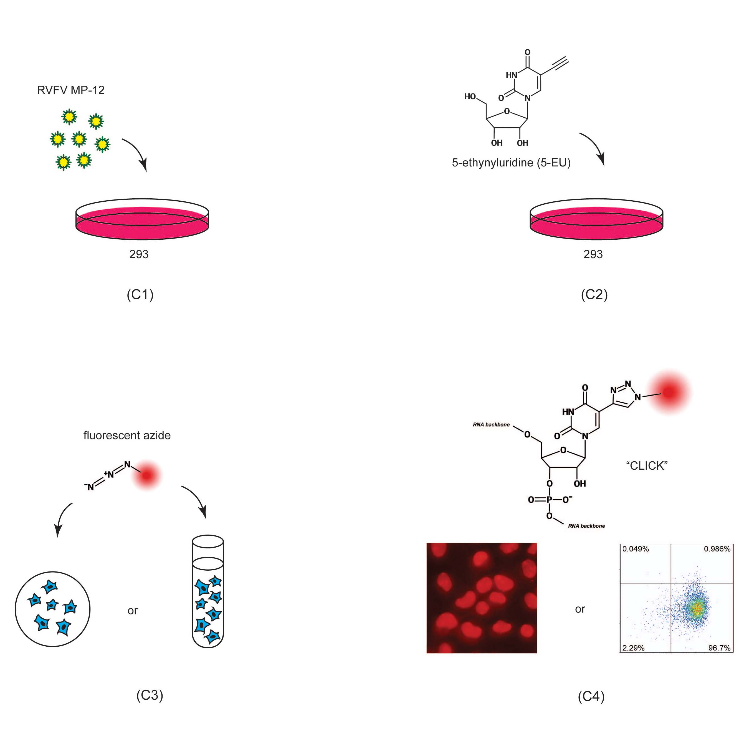

B. Interview: (Said by you on camera. Don’t forget to smile!)

Authors: Below are statements we would like you to complete that are complementary to the information contained within the schematic overview.
- Only one statement should be chosen and completed per author who will be on camera demonstrating the protocol.
- Enter the name of the individual who will say each line.
- Please choose and fill out the statement(s) that convey the most important fact(s) about your protocol. You may revise the given prompts as necessary to improve the sentence flow.
- If any individuals will be doing demonstrations on camera but are not assigned a speaking part in this interview section, please use statement 1.8 to introduce these demonstrators (for example, the PI introduces students)

  - Birte Kalveram: Unlike labeling with ³H-uridine or 5-bromouridine, this click chemistry approach does not require the use of radioactive isotopes. It is also faster and more sensitive than anti-5-bromouridine immunostaining.
  - Olga Lihoradova: The idea for this method, stemmed from our needed for a quick and reliable way to measure transcriptional suppression in cells infected with different RVFV MP-12 mutants.

Protocol (read by voice talent at JoVE):

Authors: In order to ensure that your protocol can be filmed in a single day, the protocol text must be limited to 30 steps – each step being defined as 3 lines of 12 pt text in our formatting style below. This amounts to 3 pages of protocol text. The scope of the scripted protocol text should include only those aspects of the procedure that require visualization in order to be well understood.

- Analysis of transcription by fluorescence microscopy
  - Place 12-mm round coverslips into each well of a12-well tissue culture plate. Then seed 293 cells in 1 ml complete DMEM medium [Text over video: 5x10⁴ cells/ml]. Incubate the cells in a humidified incubator at 37ºC and 5% CO₂ overnight.
    - ECU: Talent places 12-mm round coverslips into each well of a 12-well tissue culture plate.
    - CU: Then seed 293 cells in 1 ml complete DMEM medium.
    - MED-over-the-shoulder: Incubate the cells in a humidified incubator at 37ºC and 5% CO₂ overnight.

  - As per experimental design, dilute the virus stock so that infection of the cells with MP-12 is at a multiplicity of infection of 3, in a total volume of 200 μl per well.
    - MED/CU: Talent dilutes the virus stock – show label indicating multiplicity of infection of 3, in a total volume of 200 μl per well.

  - Assign one well as the uninfected control, and another as a control for transcriptional suppression. Now remove the growth medium, add the viral inoculum and incubate for one hour in the humidified incubator.
    - CU: Talent labels one well as the uninfected control, and another as a control for transcriptional suppression.
    - ECU: Talent removes the growth medium and adds the viral inoculum to a few wells.
    - MED: Talent plaees plate in the humidified incubator.

  - Aspirate the inoculum, add 1 ml fresh growth medium per well and incubate at 37ºC.
    - ECU: Talent aspirates the inoculum and adds 1 ml fresh growth medium per well
    - MED-over-the-shoulder: Talent incubates plate at 37ºC.

  - At 15 hours post infection, replace the growth medium with medium containing 1mM of the uridine analog, 5-ethynyluridine.
    - ECU: Talent replaces the growth medium with medium containing 1mM of the uridine analog, 5-ethynyluridine.

  - To one of the mock infected wells, also add 5 μg/ml of the inihibitor of DNA-dependent RNA synthesis, Actinomycin D. Return the cells to the incubator.
    - ECU: To one of the mock infected wells, Talent adds 5 μg/ml Actinomycin D.
    - CU: Return the cells to the incubator.

  - At 16 hours post infection, remove the medium and wash the coverslips once with 1 ml PBS per well. Fix the cells wth 1 ml of 4% paraformaldehyde per well [Text over video: 30 mins @ RT]. Rinse once with 1 ml of PBS per well.
    - ECU: Talent removes the medium and washes the coverslips once with 1 ml PBS per well.
    - ECU: Talent fixes the cells wth 1 ml of 4% paraformaldehyde per well
    - CU: Talent rinses once with 1 ml of PBS per well.

  - To assemble the humid chamber, line the bottom of a cell culture or petri dish with a 10 cm diameter with plastic paraffin film. Line the inside of the edge of the dish with damp paper towels..
    - MED-over-the-shoulder/CU: Talent lines the bottom of a cell culture or petri dish with a 10 cm diameter with plastic paraffin film
    - CU: Talent lines the inside of the edge of the dish with damp paper towels..

  - Now to permeabilize the cells, add 1 ml of 0.2% Triton X-100 in PBS. Incubate for 10 minutes at room temperature [Text over video: nuclease free]. After three PBS washes, transfer the coverslips into the humid chamber.
    - ECU: Talent adds 1 ml of 0.2% Triton X-100 in PBS to the cells.
    - MED/CU:Talent sets aside cells at RT (show timer 10 minutes in background)
    - ECU: Talent transfers the coverslips into the humid chamber.

  - For the click reaction to detect labeled RNA, cover each coverslip with 50 to 100 μl of freshly-prepared click staining solution. Incubate for 1 hour at room temperature, in the dark.
    - ECU: Talent covers each coverslip with 50 to 100 μl of freshly-prepared click staining solution.
    - CU: Talent incubates humid chamber at room temperature, in the dark.

  - Add 1 ml PBS to the wells of a fresh 12-well plate and transfer the coverslips into the wells. Wash two more times with 1 ml PBS per well.
2.11.2. Move this shot before 2.11.1 : Talent adds PBS to wells
    - MED: Talent transfers the coverslips into a fresh 12-well plate
    - CU/ECU: Talent starts first 1 ml PBS wash.

  - To mount cells for fluorescence microscopy, place one drop [Text over video: 15 μl] of Fluoromount-G onto a microscope slide.
    - ECU: Talent places one drop [of Fluoromount-G onto a microscope slide.

  - Dip the coverslip into water, remove the excess water, place the coverslip cell-side down into the drop of Fluoromount-G, and air dry for 5 minutes.
    - CU: Talent dips the coverslip into water, remove the excess water by touching the side against a paper towel, places the coverslip cell-side down into the drop of Fluoromount-G, and starts timer for 5 minutes (show slide in timer shot).

- Analysis of transcription by flow cytometry
  - As per experimental design, infect the 293 cells with MP-12 at an m.o.i. of 3. Remove the growth medium and add diluted virus stock [Text over video: 400 μl / well] and incubate for 1 h in a humidified incubator at 37ºC and 5% CO₂.
    - MED/CU: Talent approaches hood with MP-12 cells.
    - CU: Talent removes the growth medium and adds diluted virus stock (show label on tube)
    - MED: Talentplace cells in a humidified incubator at 37ºC and 5% CO₂.

  - Replace the inoculum with 2 ml of fresh growth medium per well, and incubate at 37ºC for optimal time for viral labeling and harvesting [Text over video: 12 h for MP-12]
    - ECU: Talent replaces the inoculum with 2 ml of fresh growth medium per well.
    - MED/CU: Talent places culture at 37ºC.

  - Then replace the growth medium with medium containing 0.5 mM 5-ethynyluridine. To one of the mock infected wells, also add 5 μg/ml Actinomycin D. Return the cells to the incubator for 1 hour.
    - ECU: Talent replaces the growth medium with medium containing 0.5 mM 5-ethynyluridine.
    - CU: To one of the mock infected wells, Talent adds 5 μg/ml Actinomycin D.
    - MED: Talent returns the cells to the incubator.

  - After one PBS wash, harvest the cells by trypsinization. Wash the harvested cells three times with PBS containing 1mM EDTA [Text over video: 500-1000g for 1-2 mins].
    - MED: Talent adds trypsin to harvest the cell (show label on tube).
    - CU: Talent adds PBS containing 1mM EDTA to cell pellet .

  - To fix the cells, resuspend the pellets in 1 ml of 4% PFA and incubate for 30 mins at room temperature.. Wash once with 1 ml PBS-EDTA per tube.
    - ECU: Talent resuspends the pellets in 1 ml of 4% PFA and incubates at room temperature.
    - CU: Talent washes tube once with 1 ml PBS-EDTA.

  - Then permeabilize the cells in 0.5 ml of 0.2% Triton X-100 in PBS for 10 minutes at room temperature.Wash once with 1ml of nuclease-free PBS.
    - CU/ECU: Talent adds 0.5 ml of 0.2% Triton X-100 in PBS.
    - MED: Talent adds 1ml of nuclease-free PBS to pellet.

  - For the click reaction, resuspend the cell pellets in 200 μl click staining solution containing the fluorescent dye [ Text over video: excitation/emission maximum: 650/665 nm ]. If the cells clump together, resuspend by pipetting. Incubate for 1 h at room temperature in the dark. Wash twice with FACS buffer.
    - ECU: Talent resuspends a cell pellet in 200 μl click staining solution containing the fluorescent dye .
    - MED: Talent resuspends by pipetting.
    - CU/ECU: Talent incubates samples at room temperature in the dark.
    - CU/ECU: Talent resuspends cells in FACS buffer.

- Results: Infecting 293 cells with MP-12
  - In this experiment, 293 cells were infected with MP-12 and a deletion mutant virus that lacks the ability to suppress host cell transcription.
    - LAB MEDIA: Figure 1

  - In the mock infected cells, nuclei appear bright red due to ongoing transcription. Since cells have only been labeled with EU for 1h, followed by immediate fixation, most RNAs remain in the nucleus.
    - LAB MEDIA: Figure 1 first row

  - In contrast, when cells have been treated with ActD to pharmacologically inhibit transcription, the red fluorescence of nuclei is markedly reduced.
    - LAB MEDIA: Figure 1 first and second rows

  - This fluorescence is similarly reduced when cells are infected with MP-12, but not with the deletion mutant that does not suppress host transcription.
    - LAB MEDIA: Figure 1 top three rows, then add last row.

  - Here, the cells were transfected with in vitro synthesized mRNA instead of infection with live virus.
    - LAB MEDIA: Figure 2.

  - The red fluorescence signal in the nuclei indicates that compared to untransfected cells, cells transfected with mRNA encoding green fluorescence protein did not change transcriptional activity.
    - LAB MEDIA: Figure 2, first and third rows.

  - Only transfection with mRNA encoding the RVFV virulence factor NSs results in decreased red fluorescence.
    - LAB MEDIA: Figure 2, last two rows.

  - When quanitfied, the flow cytometry data obtained can be represented as scatter plots with the fluorescent signal for EU incorporation into nascent RNA plotted on the y-axis, and that for anti-RVFV staining plotted on the x-axis.
    - LAB MEDIA: Figure 3A.

  - The quadrant gates were set so that the majority of mock infected cells was situated in the upper left quadrant, the majority of ActD-treated cells was situated in the lower left quadrant and the majority of infected cells was situated in the right half of the plot.
    - LAB MEDIA: Figure 3A , first box, second box then last two boxes together.

  - When the cells were infected with MP-12, 81.5% of total cells, or 93% of anti-RVFV positive cells, showed reduced transcriptional activity.
    - LAB MEDIA: Figure 3A third box – circle 81.5%

  - In contrast, when cells were infected with rMP12-C13type, 91.6% of total cells, or 97% of anti-RVFV positive cells showed transcriptional activity which was comparable to that of mock infected cells.
    - LAB MEDIA: Figure 3A last box – circle 91.6%

  - These data can also be depicted in the form of a histogram for fluorescence RNA labeling with EU incorporation.
    - LAB MEDIA: Figure 3B.

INSTRUCTIONS FOR AUTHORS:
Please ensure that the representative results narration is appropriate and correctly describes your images, movies, or figures. Our editors have ensured that the results are written in our format.

We consider this section a critical aspect of the video, because here is where you provide validation for your experiments. For example, if this is a cell culture preparation, this section is where the video will show your cells at various time points following culturing. If this is an imaging prep, then this part is where you will show examples of your imaging experiments.

Please limit the extent of narration to no more than 2-3 lines of text per image or movie file being described. Figures with multiple panels submitted with the original protocol should be broken up so that each panel is a separate image. Like the schematic, each image or movie file supplied in the results should be referenced by annotation in parenthesis, however for the results, the specific filename should be given in parenthesis.

Below is an example of results text:

EXAMPLE REPRESENTATIVE RESULTS

5. Evaluation of Morpholino Injection and Knockdown
5.1 Representative results of both morpholino injection and mRNA injection are shown here. The
uninjected control at 48 hours post fertilization looks normal, as expected
-LAB MEDIA: 0123_PIname_Figure1.tif (Replace 0123 with your jove video #)

5.2 However, embryos injected with the morpholino heg_e3i3_egfr1, which knocks down Heg isoforms
containing the first of two EGF-like repeats, exhibit brain edema.
-LAB MEDIA: 0123_PIname_Figure2.tif

5.3 Injection of heart of glass mRNA also produced an obvious phenotype. At 24 hours post fertilization,
the heads of the uninjected controls look normal
-LAB MEDIA: 0123_PIname_Figure3.tif

5.4 Conversely, some of the embryos injected with the mRNA exhibit cyclopia
-LAB MEDIA: 0123_PIname_Figure4.jpg

Please visit the following URL to see an example of how the results will look when complete:
http://www.jove.com/video/1597/results-example-mably?access=ksw0bprj

- Conclusion (said by authors on camera)
Authors: Below are statements we would like you to complete that summarize and conclude the video. Only one statement should be chosen and completed per author who will be on camera demonstrating the protocol. In addition to choosing and filling out the appropriate statement, please enter the name of the individual who will say each line. You may revise the given prompts if necessary to better fit your protocol.

  - Olga Lihoradova: Following this procedure, other methods like intracellular immunostaining can be performed in order to visualize the expression of viral proteins in these cells.
  - Birte Kalveram: After watching this video, you should have a good understanding of how to utilize click-chemistry to measure transcriptional activity in virus-infected cells; either by fluorescence microscopy or by flow cytometry.
  - Jennifer Head: Don't forget that working with infectious virus can be extremely hazardous. So use precautions such as wearing appropriate PPE and avoiding inhalation of aerosols.

Provided Media

Authors, Please list all images, movie files, or 3-D rendered animations that can be included in the video per editor’s request. The step in the script/video where these images will be inserted should be specified. For example:

6.2 – 0123_PIname_Figure1.tif - dual color imaging of tumor angiogenesis at 40X
6.2 – 0123_PIname_Figure2.tif - dual color imaging of tumor angiogenesis at 100X

Formats: For static images we prefer .tiff, Illustrator, Powerpoint or Photoshop files at dimensions of at least 720X480 pixels and 300 dpi. The higher resolution, the better. Likewise any exported movie files should have at minimum these dimensions and be rendered to .mov, .mp4, or .avi files.

Insert your media filenames here.

General Preparation

It’s critical for a smooth and organized shoot that all reagents are accounted for, in advance.

Any overnight or long incubation steps should be recognized and specimens/samples be prepared in advance so that prior steps can be recorded and shooting can continue with pre-prepared specimens/samples.

All tubes/flasks should be pre-labeled neatly before we arrive.

Ex. Luciferase assay done in 96 well plates should be labeled with negative/positive control wells and experimental samples are labeled accordingly.

You will receive more detailed preparation instructions, as well as an introduction to your videographer, closer to your filming date.

