Submission ID #: 50801

Editor Name: Brigid Stadinski

Videographer name: Charlie Baker

Film Date: 06/18/2013

Authors and Affiliations:

Orel A. Zaninovich¹, Susy M. Kim¹, Cory R. Root², David S. Green³, Kang I. Ko⁴ and Jing W. Wang¹
- Neurobiology Section, Division of Biological Sciences, University of California-San Diego, La Jolla CA 92093, USA.
- Department of Neuroscience, Columbia University, New York, NY 10032, USA.
- Dart NeuroScience, San Diego, CA 92121
- School of Dental Medicine, University of Pennsylvania, Philadelphia, PA 19104-6030

Title: A Single-Fly Assay for Foraging Behavior in Drosophila

Corresponding Author:

Jing W. Wang at jw800@ucsd.edu

Authors, please fill out the brief questionnaire below.

- Will you require JoVE to record video microscopy, such as filming a complex dissection or microinjection technique? (Y/N) ____Y – authors, I changed this reply to yes so that we can include some information on sexing the flies_____ If yes, please list make and model of your microscope: ______________________________
**Note: This question is to get at whether or not you will need a camera hook-up to look into the microscope. However, if your microscope has a digital camera attached to a computer, you can gather these shots by collecting screen capture movies.
Does your protocol include microscopy steps that are visualized through a microscope with a digital camera/computer attached? (Y/N) ___N____
B. Does your protocol include detailed, step-by-step, descriptions of software usage? (Y/N)___Y_____
C. Which steps of your protocol will viewers benefit most from having filmed? Please list 4-6 steps______ Fly starvation, fly loading into the testing plates, positioning the testing plate in “Positioning Tool.vi.”, and recording the fly position during the experiment in “Fly Tracking--Six Zones.vi.” ____________________
D. What is the single most difficult aspect of this procedure and what do you do to ensure success? _______ Handling the flies very gently._______________________

1. Introduction (Schematic Overview and Interview)

A. Schematic Overview (read by voice talent at JoVE):

Procedural Narrative:
The overall goal of this procedure is to quantify behavioral changes triggered by food deprivation in the adult fly Drosophila melanogaster. (Intro)

This is accomplished by first starving flies for 18 to 24 hours. (P1)

The second step is to load individual flies into behavior chambers, each of which contains an attractive odor source at its center. (P2)

Next, a computer system with a digital camera tracks the position of each fly over time and records its coordinates for later data analysis. (P3)

The final step is to determine the latency of each fly to reach the odor source using custom software. (P4)

Ultimately, this high-throughput food search behavior assay can be used to study the relationship between neural circuit function and behavioral responses. (P5)

Paste a copy of your graphic overview here. The original file should be Adobe Illustrator (preferred) or Powerpoint (see instructions) and should be uploaded through your online submission on the JoVE website. Please keep all layers in the file (i.e., do not flatten the file).

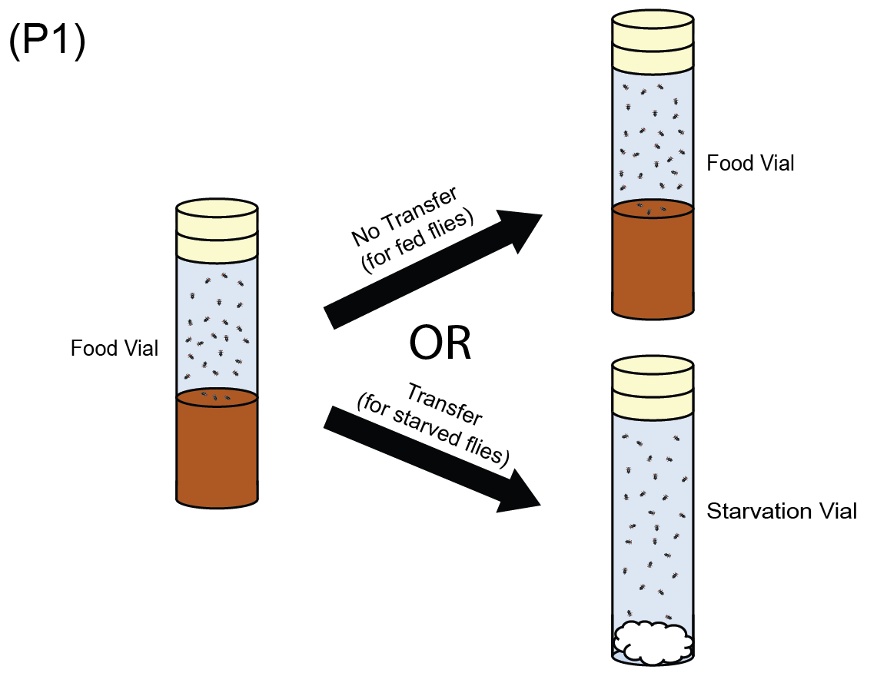

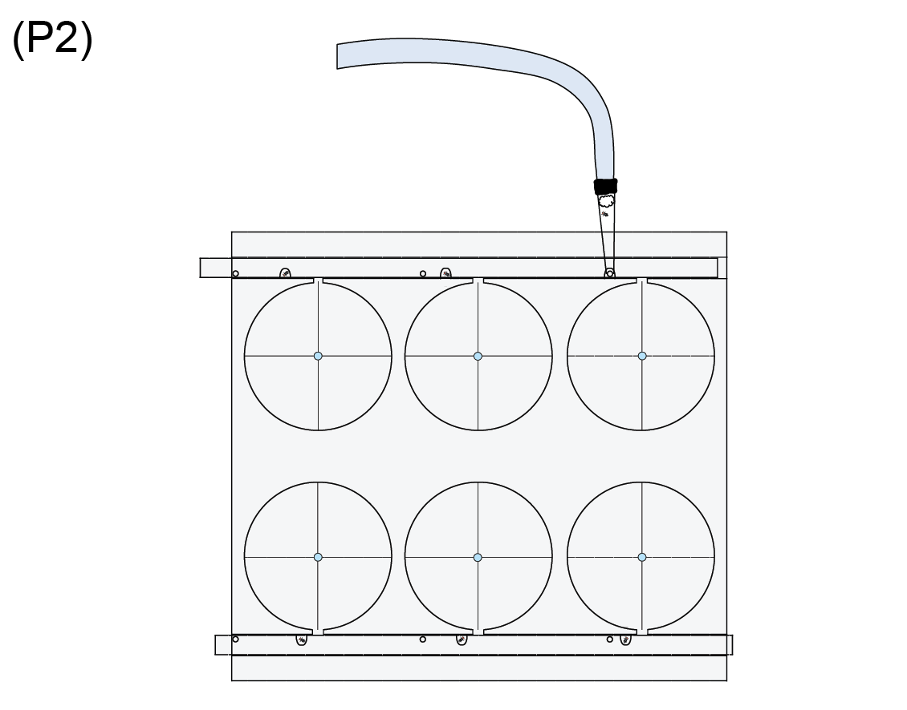

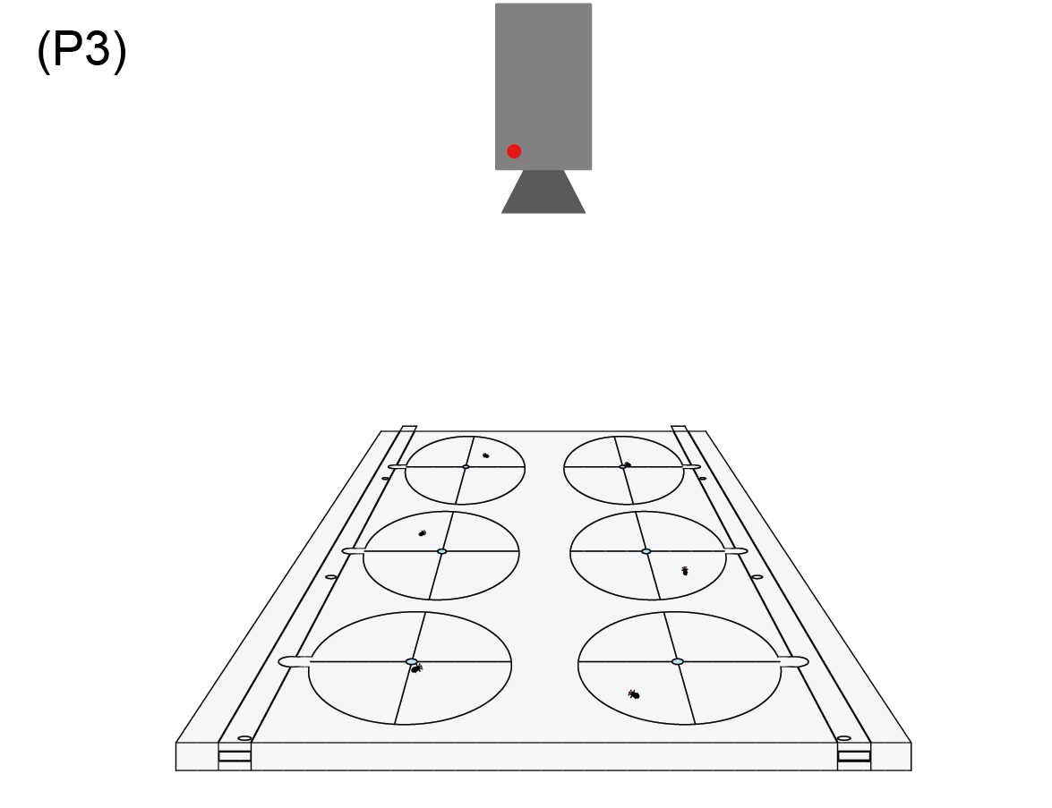

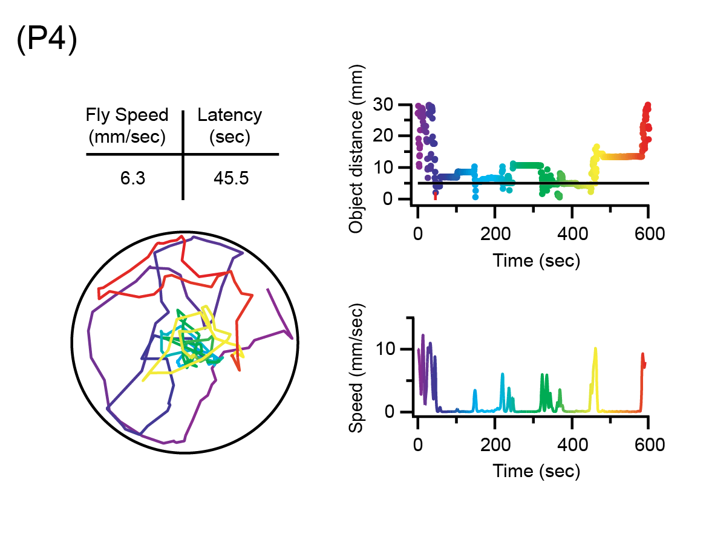
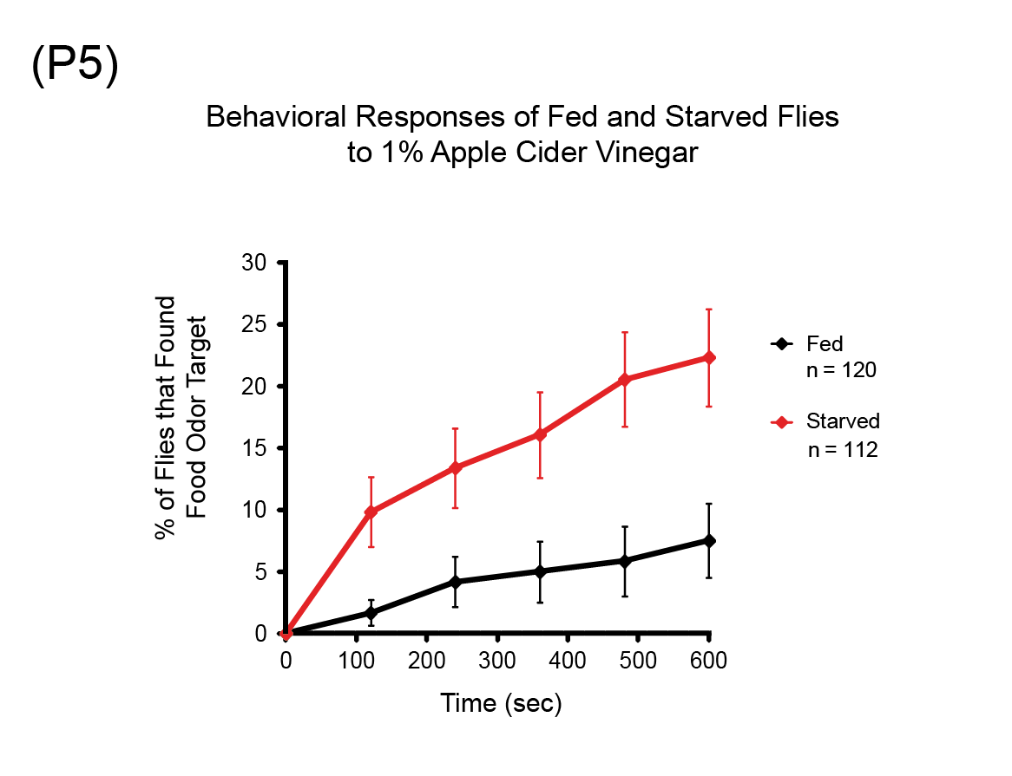

B. Interview: (Said by you on camera. Don’t forget to smile!)
  - Jing Wang: The main advantage of this assay over existing methods, like the t-maze, is that it quantifies chemotactic behaviors in single flies. This method can help answer key questions in the neurobiology field, such as which specific neural circuits are important for chemotaxis and how these circuits are modulated by the animal’s internal physiological state.
    - MED: Jing speaks toward camera, interview style.
  - Jing Wang: This method was created to obtain large datasets on chemotactic behaviors in single flies. Though this method can provide insight into foraging behavior, it can also be applied to other fly behaviors, such as mate localization.
    - CU: Jing speaks toward camera, interview style.
  - Jing Wang: Visual demonstration of this method is critical because proper fly handling is essential to the success of the experiment and also because the steps for using the software to track the fly position must be done properly and in a specific order. Generally, individuals new to this method will struggle because it takes some time and patience to learn how to handle the flies gently.
    - MED: Jing speaks toward camera, interview style.
  - Jing Wang: Demonstrating the procedure will be Orel Zaninovich, a technician from my laboratory.
    - MED: Jing speaks toward camera, interview style.
    - MED: Orel looks up from workbench or desk or microscope and acknowledges the camera.

Protocol (read by voice talent at JoVE):
- Fly collection and starvation
  - Before fly collection, rear the experimental flies under controlled temperature and humidity conditions on a 12-hour light/dark cycle.
    - CU: Drosophila flying around the chamber during a light cycle.
  - On the day of eclosion, anesthetize the flies under carbon dioxide before sexing them under a microscope.
    - MED: Talent approaches the microscope with anesthetized flies.
  - Several basic criteria can be used to differentiate between males and females. Males have a patch of black bristles on their forelegs called “sex combs” that females do not have. Also, the tip of the male abdomen is covered by a dark cuticle and displays genitalia not seen in females.
    - SCOPE: Microscope shot of male fly as talent uses a pointer to first point out the sex combs and then to point out the tip of the abdomen covered by a dark cuticle and displaying genitalia. If possible, include an adjacent female fly in the shot for contrast.
  - Collect female flies and place them, along with 4 to 5 white-eyed males, into new food vials with a maximum of 30 flies per vial. Age the flies for 2 to 5 days.
    - MED-over the shoulder: Talent collects the female flies and places them along with 4-5 white-eyed males into new food vials. Match/continue action in next shot.
    - CU: New food vial as talent transfers the flies there.
    - MED-over the shoulder: Talent leaves the vial of flies to age.
  - Prepare the chambers for fly starvation by first pushing a single tissue down to the bottom of an empty plastic vial. Completely soak the tissue with distilled water. Then, use an object to push down on the tissue and gently squeeze out excess water.
    - CU: Fly starvation chamber as talent pushes a single tissue down to the bottom of the empty plastic vial.
    - MED-over the shoulder: Talent completely soaks the tissue with distilled water.
    - CU: Chamber as talent uses an object to push down on the tissue and gently squeeze out excess water.
  - Invert the vial to discard the extra water. There should be enough water to keep the flies hydrated and the starvation chamber moist, but not enough to drown the flies.
    - MED: Talent motions to invert the vial. Continue action in next shot.
    - CU: Vial as talent inverts it.
  - About 18 to 24 hours before the experiment begins, transfer the flies from the food vial into a starvation chamber and plug the vial. Store the vials under controlled temperature and humidity conditions overnight until the experiment begins.
    - MED or MED-over the shoulder: Talent begins to transfer the flies from the food vial into the starvation chamber.
    - CU: Starvation chamber as talent continues to transfer the flies there and then plugs the vial.
    - MED-over the shoulder: Talent leaves the vial at controlled temperature and humidity conditions.
- Preparation of the food odor
  - Prepare a 1% agarose solution by adding 100 milligrams of low melting temperature agarose to 10 mL of distilled water in a glass flask. Heat the agarose solution in a microwave just until it begins to boil but well before it boils over.
    - CU: Glass flask (with 10 mL of distilled water) as talent adds 0.1 g of low melting temperature agarose from a weigh boat or weigh paper.
    - MED-over the shoulder: Talent places the flask in the microwave, shut door and starts cycle.
  - Stop the microwave and swirl the flask once. Repeat this step twice more until the agarose has completely dissolved. Maintain the agarose solution in a liquid state by keeping the flask warm on a hotplate set at 50° C.
    - CU: Flask as talent picks flask with boiling liquid using a hot pad, and swirls.
    - MED: Talent puts back the flask back in the microwave and starts again.
    - MED-over the shoulder: Talent places the flask on a hotplate set to 50° C.
  - Add 990 μL of the 1% agarose solution and 10 μL of apple cider vinegar to a 1.5mL Eppendorf tube to make a 1% apple cider vinegar solution. Vortex the solution until mixed before placing in a dry bath incubator set to 50° C.
    - CU: Workspace as talent uses a pipette to add 990 μL of the 1% agarose solution and 10 μL of apple cider vinegar to a 1.5mL Eppendorf tube.
    - MED-over the shoulder: Talent vortexes the solution until mixed.
- Testing room and behavior chamber setup
  - Set the testing room to the desired conditions, such as temperature and humidity. Turn on the 660 nm LED panel.
    - MED-over the shoulder: Talent sets the control panel for the testing room to the desired temperature and humidity.
    - CU: 660 nm LED panel as talent turns on.
  - Rinse the sieves and testing plates with hot water… and heat them in a drying oven until all moisture has evaporated. Cool the sieves and plates down to the testing room temperature before beginning experiments.
    - MED: Talent rinses the sieves and testing plates with hot water.
    - CU: Drying oven as talent places the sieves and testing plates in.
    - MED-over the shoulder: Talent leaves the sieves and plates at room temperature.
  - Position a shallow dish on top of the diffuser plate, and fill it with water to increase the local humidity and to mask the water in the agarose droplet.

4.3.2. Move 4.3.2 above 4.3.1: MED-over the shoulder: Talent positions the dish on top of the diffuser plate.
    - CU: Shallow dish as talent fills with water.
    - MED-over the shoulder: Talent positions the dish on top of the diffuser plate.

Please move shot 4.3.2 above shot 4.3.1. This will show placing the dish on the diffuser plate first, followed by adding water to the dish.
  - Finally, position the sieves over the water dish.
    - CU: Sieves as talent places over the water dish.
- Fly loading into the testing plates
  - The testing plate is made of clear acrylic and consists of 6 testing arenas. A slider contains holding chambers that permit fly loading, temporary containment, and simultaneous release of 6 flies into their respective chambers at the start of the experiment. Cross-hairs etched at the center of each arena in the plate indicate where odorants should be pipetted.
    - LAB MEDIA: Testing Plate – Top view with sliders. Editors, please highlight the 6 circles as the 1st sentence is narrated. Then sequentially highlight the slider and the holding chambers during the 2nd sentence. Finally, zoom into the top left testing arena circle and, where the cross hairs meet in the center of the circle, please overlay a circle or x to highlight that spot.
  - Insert the sliders into the acrylic testing plate. Gently slide the aspirator into the vial past the cotton plug and allow about 6 flies to walk into the aspirator. It is critical to be as gentle as possible in handling them.
    - MED-over the shoulder: Talent inserts the sliders into the acrylic testing plate.
    - CU: Plate as talent gently slides the aspirator into the vial past the cotton plug.
    - ECU: Flies as the walk into the aspirator.
  - One may take advantage of phototactic fly behavior to induce flies to walk towards the aspirator by pointing the vial opening towards a dim light source. If necessary, gentle suction can be applied to aspirate approximately 6 female flies. Avoid selecting white-eyed male flies.
    - MED: Talent points the vial opening toward a dim light source.
    - CU: Female flies as talent uses suction to aspirate them.
  - Insert the tip of the aspirator into the first hole of the testing plate. Allow a single fly to pass into the holding cell and gently advance the slider forward to load another fly into the next hole. Continue until flies occupy all 6 holding cells of the plate.
    - MED-over the shoulder: Talent inserts the tip of the aspirator into the first hole of the testing plate.
    - ECU: Testing plate as talent allows a single fly to pass into the holding cell and gently advances the slider forward to load another fly into the next hole. Talent continues until all 6 flies are loaded.
  - Then, pipette 5 µL of a 1% apple cider vinegar agarose solution directly onto the center of the cross-hairs on the inside face of the testing plate.
    - MED-over the shoulder: Talent motions to pipette 5 µL of a 1% apple cider vinegar agarose solution directly onto the center of the cross-hairs on the inside face of the testing plate. Continue action in next shot.
    - CU or ECU: Center of cross-hairs as talent pipettes 5 µL of a 1% apple cider vinegar agarose solution in.
- Positioning the testing plate
  - To center the testing plate, open the file named “Positioning Tool.vi” (pronounced “positioning tool dot V-I”). Run the file by clicking on the white arrow in the upper-left corner of the screen.
    - MED-over the shoulder: Talent opens the file named “Positioning Tool.vi.”
    - SCREEN: Screen capture movie as talent runs the file by clicking on the white arrow in the upper-left corner of the screen.
  - Place the testing plate on top of the sieve such that the arena opening faces the sieve floor and the odor target is on the ceiling of the plate. Align the crosshairs of the testing plate with the cross hairs on the monitor screen.
    - CU: Testing plate as talent places on top of the sieve such that the arena opening faces the sieve floor and the odor target is on the ceiling of the plate.
    - MED-over the shoulder: Talent aligns the crosshairs of the testing plate with the cross hairs on the monitor screen
  - When alignment has been completed, abort execution by clicking on the red dot located near the upper-left corner of the monitor.
    - SCREEN: Screen capture movie as talent aborts execution by clicking on the red dot located near the upper-left corner of the monitor.
- Record the fly position during the experiment
  - To track and record the coordinates of the fly during each food search trial, open the acquisition software file “Fly Tracking--Six Zones.vi” (pronounced “fly tracking six zones dot V I”). Run the file by clicking on the white arrow in the upper-left corner of the monitor. Assign the file a name and then click “OK.”
    - SCREEN: Screen capture movie as talent opens the acquisition software file “Fly Tracking--Six Zones.vi.” Talent runs the file by clicking on the white arrow in the upper-left corner of the monitor. Talent assigns the file a name and clicks “OK.”
  - Advance the sliders in the testing chambers to release the flies into the testing arenas. Be careful not to move the testing chambers as this will lead to improper recording of the coordinates.
    - CU: Testing plate as talent advances the slider in the testing chambers to release the flies into the testing arena without moving the testing chambers.
  - Click on “Start” and ensure that the only source of light in the testing chamber is the LED panel.
    - SCREEN: Screen capture movie as talent clicks on “start” and ensures that the only source of light in the testing chamber is the LED panel.
  - When the trial is finished, remove the sieve and behavior chamber. Lift the testing plate from the sieve and remove the flies by submerging the plate in ice. Gently clean the plate with hot water and remove any agarose debris. Place the testing plates in a drying oven to remove moisture.
    - MED-over the shoulder: Talent removes the sieve and behavior chamber.
    - CU: Testing plate as talent lifts from the sieve and removes the flies by submerging the plate in ice.
    - MED: Talent gently cleans the plate with hot water and removes any agarose debris.
    - MED-over the shoulder: Talent places the testing plates in a drying oven.
  - Ventilate the testing area by turning on a small fan for approximately 2 minutes. Turn the fan off and load the next group of flies into the next testing plate.
    - MED: Talent turns on small fan and walks away.
    - WIDE: Talent approaches fan, turns fan off, and begins to load the next group of flies.
  - Proceed to perform data analysis using custom software as described in the text protocol.
    - MED: Talent at data analysis computer analyzing data.
- Results: Data Analysis and Quality Control
  - The data analysis software and the layout are used to evaluate each fly’s performance during its 10 minute trial according to a set of analysis criteria. These criteria are used to determine whether data from each fly will be used for data analysis and are designed to eliminate those flies that are unable to perform the food search task due to injury, illness, stress, or lack of motivation.
    - LAB MEDIA: Figure 2
  - Flies that are inactive for more than 300 seconds are considered 'inactive' and are rejected from the data set… unless they already have succeeded in locating the food source… or exhibit an average speed greater than 10 millimeter per second for at least 100 seconds following the inactive period.
    - LAB MEDIA: Figure 2A. Editors, please transition to figure 2A by zooming into the top left panel during the previous point.
    - LAB MEDIA: Figure 2B. Editors, please switch to this figure as “unless they already have succeeded in locating the food source” is narrated.
    - LAB MEDIA: Figure 2C. Editors, please switch to this figure as “or exhibit an average speed of greater than 10 mm/sec for at least 100 sec following the inactive period” is narrated.
  - To select only those flies that exhibit healthy speeds during the early stages of active odor search, only flies that move within a certain range of speeds for the first 50 seconds of the trial are accepted for data analysis.
    - LAB MEDIA: Figure 2D+E+F.
  - Flies that do not move through all four quadrants in the arena and head straight for the food source after the trial begins are rejected.
    - LAB MEDIA: Figure 2D+E+F. Editors, please zoom into the leftmost panel.
  - Flies that weave towards and away from the food source within a 10 mm radius for a minimum of 50 seconds are considered to have successfully found the food source. The plot depicting distance of the fly from the odor source over time can be used to evaluate this rare case.
    - LAB MEDIA: Figure 2D+E+F. Editors, staying zoomed in, please slide over to the center panel. Then highlight the center image (top plot) as the second sentence is narrated.
  - Arenas with visible artifacts in fly position trace are also rejected. Artifacts can be created by any event where the data acquisition software detects an object other than the fly. They often appear as long, straight lines that span across the arena or radiate from its center.
    - LAB MEDIA: Figure 2D+E+F. Editors, staying zoomed in, please slide over to the right panel.
  - Adult flies starved 18 to 24 hours exhibit a higher olfactory sensitivity to food related odors than their fed counterparts. A graphical plot of the cumulative percentage of flies that successfully locate a food odor source shows 30% of all starved flies succeed within a 10 minute window; in contrast only 7% of all fed flies do so.
    - LAB MEDIA: Figure 3. Editors, please highlight the last point of the red curve as “shows 30% of all starved files succeed within a 10 minute window” is narrated. Then highlight the last point on the black curve as “in contrast only 7% of all fed flies do so” is narrated.
  - Starved flies should exhibit a significantly greater attraction to vinegar than to an agarose vehicle alone, and this observation can be used to troubleshoot testing conditions.
    - LAB MEDIA: Figure 4
  - For example, when this food search experiment that was performed at 32 °C with an environmental humidity of 35% using wild type flies, no significant difference between fly attraction to vinegar… and the agarose control was detected. This is likely due to an increasing attraction to the water found in the agarose droplet under warmer testing temperatures.
    - LAB MEDIA: Figure 4A. Editors, please highlight the red curve as “attraction to vinegar” is narrated, and the black curve as “and the agarose control” is narrated.
  - By increasing testing humidity to between 50 and 60%, this behavioral shift was corrected and the significant difference between attraction to vinegar and the agarose vehicle was restored.
    - LAB MEDIA: Figure 4B. Editors, please highlight the four stars as “the significant difference between attraction to vinegar and the agarose was restored” is narrated.

INSTRUCTIONS FOR AUTHORS:
Please ensure that the representative results narration is appropriate and correctly describes your images, movies, or figures. Our editors have ensured that the results are written in our format.

We consider this section a critical aspect of the video, because here is where you provide validation for your experiments. For example, if this is a cell culture preparation, this section is where the video will show your cells at various time points following culturing. If this is an imaging prep, then this part is where you will show examples of your imaging experiments.

Please limit the extent of narration to no more than 2-3 lines of text per image or movie file being described. Figures with multiple panels submitted with the original protocol should be broken up so that each panel is a separate image. Like the schematic, each image or movie file supplied in the results should be referenced by annotation in parenthesis, however for the results, the specific filename should be given in parenthesis.

Below is an example of results text:

EXAMPLE REPRESENTATIVE RESULTS

5. Evaluation of Morpholino Injection and Knockdown
5.1 Representative results of both morpholino injection and mRNA injection are shown here. The
uninjected control at 48 hours post fertilization looks normal, as expected
-LAB MEDIA: 0123_PIname_Figure1.tif (Replace 0123 with your jove video #)

5.2 However, embryos injected with the morpholino heg_e3i3_egfr1, which knocks down Heg isoforms
containing the first of two EGF-like repeats, exhibit brain edema.
-LAB MEDIA: 0123_PIname_Figure2.tif

5.3 Injection of heart of glass mRNA also produced an obvious phenotype. At 24 hours post fertilization,
the heads of the uninjected controls look normal
-LAB MEDIA: 0123_PIname_Figure3.tif

5.4 Conversely, some of the embryos injected with the mRNA exhibit cyclopia
-LAB MEDIA: 0123_PIname_Figure4.jpg

Please visit the following URL to see an example of how the results will look when complete:

http://www.jove.com/video/1597/results-example-mably?access=ksw0bprj

- Conclusion (said by authors on camera)
  - Orel Zaninovich: Once mastered, this technique can be done in 12 minutes, including the 10 minute experimental trial if it is performed properly. While attempting this procedure, it’s important to remember to handle the flies extremely gently to avoid disturbing or injuring them. Don't forget that the sieves and testing plates can be extremely hot when in the drying oven, and should therefore be removed with oven mitts.
    - MED: Orel speaks toward camera, interview style.
  - Orel Zaninovich: After its development, this technique paved the way for researchers in the field of neurobiology to explore chemotactic behaviors in Drosophila melanogaster. This protocol may also be adapted for the study of the fly’s ability to locate other odor objects. For example, it may be applied toward the study of mate localization behavior in male flies.
    - CU: Orel speaks toward camera, interview style.
  - Orel Zaninovich: After watching this video, you should have a good understanding of how to prepare for the experiment; how to properly adjust the experimental conditions; how to run the experiment; and how to analyze the performance of each fly, which will ultimately provide you with a cumulative plot showing the percentage of flies that successfully located an odor source.
    - MED: Orel speaks toward camera, interview style.

Provided Media

Authors, Please list all images, movie files, or 3-D rendered animations that can be included in the video per editor’s request. The step in the script/video where these images will be inserted should be specified. For example:

6.2 – 0123_PIname_Figure1.tif - dual color imaging of tumor angiogenesis at 40X
6.2 – 0123_PIname_Figure2.tif - dual color imaging of tumor angiogenesis at 100X

Formats: For static images we prefer .tiff, .eps, Illustrator, Powerpoint or Photoshop files at dimensions of at least 720X480 pixels and 300 dpi. The higher resolution, the better. Likewise any exported movie files should have at minimum these dimensions and be rendered to .mov, .mp4, or .avi files.

Insert your media filenames here.

Video Script Schematic Overview Final Version.ai

Testing Plate – Top view with sliders

Figure 2 – Editors, please provide a version on this figure without the A-F labels for the video.

Figure 2A – Editors, please provide a version on this figure without the A label for the video.

Figure 2B – Editors, please provide a version on this figure without the B label for the video.

Figure 2C – Editors, please provide a version on this figure without the C label for the video.

Figure 2D+E+F – Editors, please provide a version on this figure without the D - F labels for the video.

Figure 3

Figure 4 – Editors, please provide a version on this figure without the A and B labels for the video.

Figure 4A – Editors, please provide a version on this figure without the A label for the video.

Figure 4B – Editors, please provide a version on this figure without the B label for the video.

SCREEN Capture Videos

50801_Wang_SCREEN_6.1.2: Screen capture movie as talent runs the file by clicking on the white arrow in the upper-left corner of the screen.

50801_Wang_SCREEN_6.3.1: Screen capture movie as talent aborts execution by clicking on the red dot located near the upper-left corner of the monitor.

50801_Wang_SCREEN_7.1.1: Screen capture movie as talent opens the acquisition software file “Fly Tracking--Six Zones.vi.” Talent runs the file by clicking on the white arrow in the upper-left corner of the monitor. Talent assigns the file a name and clicks “OK.”

50801_Wang_SCREEN_7.3.1: Screen capture movie as talent clicks on “start” and ensures that the only source of light in the testing chamber is the LED panel.

General Preparation

It’s critical for a smooth and organized shoot that all reagents are accounted for, in advance.

Any overnight or long incubation steps should be recognized and specimens/samples be prepared in advance so that prior steps can be recorded and shooting can continue with pre-prepared specimens/samples.

All tubes/flasks should be pre-labeled neatly before we arrive.

Ex. Luciferase assay done in 96 well plates should be labeled with negative/positive control wells and experimental samples are labeled accordingly.

You will receive more detailed preparation instructions, as well as an introduction to your videographer, closer to your filming date.

