Submission ID #: 50800

Editor Name: Melissa Ceo

Videographer name:

Film Date:

Authors and Affiliations:
Carla Gimkiewicz & Falk Harnisch*

UFZ – Helmholtz-Centre for Environmental Research Department of Environmental Microbiology, Permoserstrasse 15, 04318 Leipzig, Germany

Title: Waste Water Derived Electroactive Microbial Biofilms: Growth, Maintenance and Basic Characterization

Corresponding Author:

Falk Harnisch: falk.harnisch@ufz.de

Authors, please fill out the brief questionnaire below.

A. Will you require JoVE to record video microscopy, such as filming a complex dissection or microinjection technique? (Y/N) No If yes, please list make and model of your microscope: ______________________________
B. Does your protocol include detailed, step-by-step, descriptions of software usage? (Y/N) Yes, for measurement (EC-Lab® software V10.30, Bio-Logic) and data analysis (OriginPro 8.6, OriginLab)
C. Which steps of your protocol will viewers benefit most from having filmed? Please list 4-6 steps Reactor set-up/ Biofilm growth & maintenance/ Application of cyclic voltammetry to biofilms of different age/ data analysis
D. What is the single most difficult aspect of this procedure and what do you do to ensure success? Having biofilms ready on the day that’s why we thoroughly pre-grow enough replicates in advance.

1. Introduction (Schematic Overview and Interview)

A. Schematic Overview (read by voice talent at JoVE):
Authors, please select from “Procedural Narrative” or “Conceptual Narrative” and complete the statements below. Please do not add additional steps. Then, attach your finished graphic overview. See accompanying instructions for details and examples.

Procedural Narrative:
The overall goal of this procedure is to grow an anodic electroactive microbial biofilm from wastewater inoculate and to characterize its bioelectrocatalytic properties. (Intro)

This is accomplished by first setting up, inoculating and starting a potentiostatically controlled bioelectrochemical fed-batch reactor. (P1, position beaker above 4-neck round bottom flask and turn it on its side to make it look like the blue solution is being poured into the flask. As solution is being poured into flask, make it disappear from the beaker and appear in the flask)

The second step is to monitor the current production using chronoamperometry. (P2, show left-hand flask followed by green arrow and right-hand graph)

Next, the medium is exchanged regularly after substrate exhaustion until a reproducible maximum current density is reached, representing a steady-state biofilm formation. (P3, make “Medium exchange” and black arrows appear followed by “Stable steady-state biofilm formation”)

The final step is to study the extracellular electron transfer of electroactive bacteria using cyclic voltammetry during the presence and absence of the substrate. (P4, make “Presence of substrate” and “Absence of substrate” with green arrows appear over relevant graphs)

Ultimately, data analysis provides fundamental insights into the microbial electron transfer thermodynamics and allows the formal potential of possible and actual extracellular electron transfer sites to be determined. (P5)

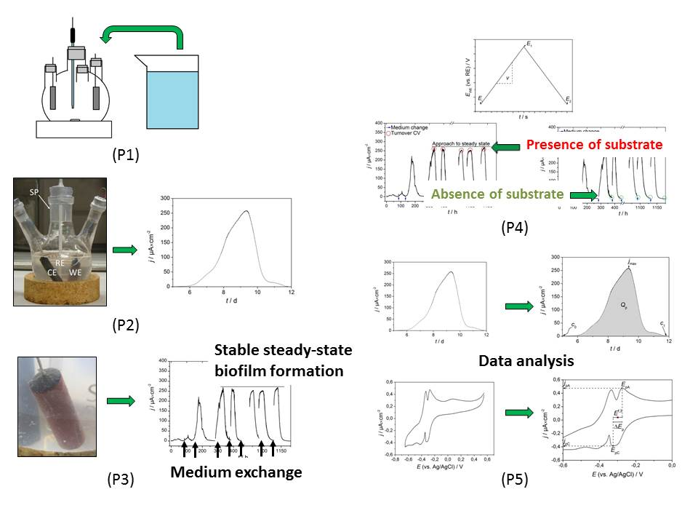
Figure: Schematic overview.
B. Interview: (Said by you on camera. Don’t forget to smile!)

Authors: Below are statements we would like you to complete that are complementary to the information contained within the schematic overview.
- Only one statement should be chosen and completed per author who will be on camera demonstrating the protocol.
- Enter the name of the individual who will say each line.
- Please choose and fill out the statement(s) that convey the most important fact(s) about your protocol. You may revise the given prompts as necessary to improve the sentence flow.
- If any individuals will be doing demonstrations on camera but are not assigned a speaking part in this interview section, please use statement 1.8 to introduce these demonstrators (for example, the PI introduces students)

  - Falk Harnisch: The main advantage of this technique is that one can obtain direct insight into the electron transfer between living microorganisms and electrodes and thus derive fundamental information on the microbial extracellular electron transfer.
  - Carla Gimkiewicz: Generally, individuals new to this method will struggle with the right parameter choice for cyclic voltammetry and the correct interpretation of the derived plots. During data acquisition and analysis, severe mistakes can be made.

Protocol (read by voice talent at JoVE):

Authors: In order to ensure that your protocol can be filmed in a single day, the protocol text must be limited to 30 steps – each step being defined as 3 lines of 12 pt text in our formatting style below. This amounts to 3 pages of protocol text. The scope of the scripted protocol text should include only those aspects of the procedure that require visualization in order to be well understood.
- Preparation of Growth Medium and Set-up of Fed-batch Reactor
  - Before starting this procedure, prepare a suitable amount of the growth medium by using a phosphate buffer and 10 mM sodium acetate according to the following reference (TEXT: Kim, J. R., Min, B. & Logan, B. E. Applied Microbiology and Biotechnology 2005, 68, 23-30). Add 1 mL of primary wastewater per 20 mL of growth medium as inoculum. Then, insert a needle in the medium and flush it with nitrogen for at least ½ h to deaerate it. While flushing with nitrogen, measure the size of the electrode.
    - MED: Talent walks up to bench/hood with flask containing growth medium in hand.
    - MED-over the shoulder: Talent adds primary wastewater to flask containing growth medium.
    - CU: Growth medium as talent inserts needle into it to observe the gas bubbling through it.
    - MED: Talent measures size of the electrode.
  - For the three-electrode set-up, insert the reference electrode (TEXT: reference electrode: Ag/AgCl, sat. KCl, 0.197 V vs. SHE), the working electrode and the counter electrode in a modified 4-neck 250 mL round bottom flask via siliconee plugs. Wrap the silicone plugs with parafilm to seal the system.

2.2.0 Talent inserts electrodes in siliconee plugs
    - MED-over the shoulder: Talent inserts electrodes in siliconee plugs of 4-neck round bottom flask.
    - MED: Talent wraps silicone plugs with parafilm.
    - WID: Talent wraps silicone plugs with parafilm
  - While flushing with nitrogen, pour 250 mL of the growth medium and inoculum mixture through the sampling port into the reactor. Close the sampling port with a siliconee plug and seal it airtight with parafilm.
    - MED: Talent inserts nitrogen needle into sampling port and pours growth medium mixture into flask.
    - MED-over the shoulder: Talent inserts siliconee plug into sampling port and wraps it with parafilm.
- Chronoamperometric Biofilm Growth
  - Place the vessel in a 35 °C temperature-controlled chamber in order to ensure constant environmental conditions. Next, connect the electrodes to the respective cables of the potentiostat.
    - MED: Talent places vessel in temperature-controlled chamber.
    - MED-over the shoulder: Talent connects electrodes to respective cables of potentiostat.
  - Open the software to control the potentiostat and choose the technique chronoamperometry. Set the constant working electrode E_{WE} (pronounced E-w-e) to 0.2 V for a duration time of 500 h.

3.2.0 Talent goes to the screen
    - SCREEN: Computer screen as talent opens software and selects chronoamperometry.
    - SCREEN: Computer screen as talent sets constant working electrode parameters.
  - Following this, start the chronoamperometry and observe the graph of the measured current over time. After calculating the preferentially current densities, plot the measured current density as a function of time.
    - SCREEN: Computer screen as talent starts chronoamperometry.
    - LAB MEDIA: CA full.mp4
    - SCREEN: Computer screen as talent plots measured density as a function of time.
- Biofilm Maintenance and Application of Cyclic Voltammetry
  - After the oxidative current reaches a plateau and returns to zero current, pause the chronoamperometric measurement. Then, transfer the vessel to a laminar flow box and flush the system with nitrogen. Carefully discharge the medium and replenish with fresh de-aerated medium.
    - MED-over the shoulder: Talent pauses chronoamperometric measurement.
    - MED: Talent transfers vessel to laminar flow box, opens sampling port and inserts nitrogen needle.
    - CU: Important! Do not insert the needle into the medium
    - MED-over the shoulder: Talent removes medium from flask and adds fresh medium to it.
  - Following replenishment of the medium, close the sampling port and seal it with parafilm. Repeat the previous steps until the maximum oxidative current reaches a steady-state.
    - Talent adds fresh medium. Talent removes nitrogen needle, inserts siliconee plug and wraps it with parafilm
    - Talent puts flask into the incubator
    - Reuse shot 4.1.1.
  - Once steady-state has been attained, take 1 mL samples of the fresh and the exchanged medium solutions for substrate analysis by HPLC.
    - MED-over the shoulder: Talent transfers fresh and exchanged medium solutions to vials/tubes and sets them aside.
    - Talent puts samples into HPLC
  - To study extracellular electron transfer, select the technique CV in the potentiostat controlling software. Then, set the initial potential E_{i} of the working electrode to -0.5 V versus the reference electrode, the vertex potential E₁ to 0.3 V versus the reference electrode and the final potential E₂ to -0.5 V. Use a scan rate of 1 mV×s⁻¹ (pronounced milli-volt per second) (TEXT: E_{i}: -0.5 V, E₁: 0.3 V, E₂: -0.5 V, scan rate: 1 mV×s⁻¹).
    - SCREEN: Computer screen as talent selects CV in potentiostat controlling software.
    - SCREEN: Computer screen as talent sets the appropriate parameters.
  - Start the experiment and record at least 3 cycles to obtain a reproducible CV. After calculating the preferentially current densities, plot the measured current density as a function of the potential of the working electrode E_{WE}.
    - LAB MEDIA: CV_NTO.mp4
    - SCREEN: Computer screen as talent plots measured current density as a function of working electrode potential.
- Results: Characterization of Electroactive Microbial Biofilms using Cyclic Voltammetry
  - From the chronoamperometric measurements the maximum current density and the coulombic efficiency can be measured. Shown here is a typical chronoamperometric biofilm growth curve of several growth cycles using a fed-batch reactor. After the initial lag-phase a first current density maximum commences. Then the current decreases to nearly zero current flow due to substrate depletion. Following substrate replenishment, the current density increases again with a higher maximum current density. After several growth cycles the maximum current density is constant, which indicates a steady-state biofilm formation. As the steady state maximum current density value is dependent on several parameters it is often considered as a characteristic of electroactive microbial biofilm electrode systems.
    - LAB MEDIA: 50800_PIname_Figure4.tif (Video Editor: Please highlight part of curve labeled “lag-phase” and left part of curve or first increase for 3rd sentence. Highlight the right part of first curve or first decrease and up to the third blue arrow for 4th sentence. Highlight second curve for 5th sentence and point to top of curve or make red circle appear when “higher maximum current density” is mentioned. Highlight last three curves for 6th sentence).
  - The second operational characteristic is the coulombic efficiency, which is the number of electrons recorded as electric current flow per fed-batch cycle related to the theoretical maximum number of electrons. See the text protocol for details on how to calculate the coulombic efficiency, the electric current flow and the theoretical maximum number of electrons.
    - LAB MEDIA: 50800_PIname_Figure6.tif
  - Shown here are typical CVs for non-turnover conditions. The CV of a biofilm for high scan rates where only one peak pair and thus one formal potential E^{f} can be identified is pictured here. In general, the formal potential of a redox couple can be calculated from the peak potential of the oxidation peak E_{pA} and the reduction peak of the respective species E_{pC} by forming the arithmetic mean. See the text protocol for details on how to calculate the formal potential.
    - LAB MEDIA: 50800_PIname_Figure7.tif (Video Editor: Please highlight, or point to, E^{f,2’} point for 2nd sentence).
  - When applying a low enough scan rate to the identical biofilm, up to four redox pairs can be identified. However, the non-turnover CV only shows all redox-active compounds at the electrode and thus the E^{f} of the possible extracellular electron transfer sites. Only analysis of the turnover CV provides the E^{f} of the actual EET sites.
    - LAB MEDIA: 50800_PIname_Figure8.tif (Video Editor: Please highlight four E^{f} points for 1st sentence. Alternatively, make E^{f} labels and arrows appear for 1st sentence).
  - When further analyzing the non-turnover CVs, other characteristic parameters like peak separation, maximum peak current and minimum peak current can be analyzed. These parameters, especially when recorded for different scan rates, can be used for mechanistic and kinetic analyses of electron transfer processes at electrodes. However, this kinetic analysis that is well established for chemical systems is not straightforward for electroactive microbial biofilms.
    - LAB MEDIA: 50800_PIname_Figure9.tif
  - When performing the CV measurement in the presence of substrate, a turnover CV is obtained. After plotting the data the typical s-shaped bioelectrocatalytic curve is observed.
    - LAB MEDIA: 50800_PIname_Figure10.tif (Video Editor: Please highlight curves for 2nd sentence).
  - When further analyzing the data, the maximum of the first derivative, or the inflection point of the curve, provides the formal potential E^{f} of the actual EET sites. In the case of a thin Geobacteraceae-dominated biofilm, two inflection points can be observed. Subsequently the derivative shows two maxima corresponding to the formal potential of the bioelectrocatalytic active EET sites, which are denominated as E^{f,2} and E^{f,3}, respectively. This finding also shows that the redox processes associated with the formal potentials E^{f,1} and E^{f,4} are not related to bioelectrocatalysis.
    - LAB MEDIA: 50800_PIname_Figure11.tif (Video Editor: Please highlight E^{f,2} and E^{f,3} points 3rd sentence).
    - LAB MEDIA: 50800_PIname_Figure8.tif (Video Editor: Please overlay this figure with Figure 11 for last sentence).
  - As the biofilm grows and gets thicker the CV shows only one inflection point. This formal potential E^{f}, -0.32 V vs. Ag/AgCl (pronounced silver, silver chloride reference electrode), is roughly equal to the arithmetic mean of the two formal potentials assigned to the EET of the thin biofilm. This result shows that the fundamental CV analysis does provide insights into the EET thermodynamics in a fast and non-invasive way.
    - LAB MEDIA: 50800_PIname_Figure12.tif (Video Editor: Please highlight E^{f} point in bottom graph for 2nd sentence. If possible, highlight the point on the curve in top graph where end of arrow is located for 1st sentence. Make dotted arrow appear from top graph to bottom graph and then highlight E^{f} point for 2nd sentence).

INSTRUCTIONS FOR AUTHORS:
Please ensure that the representative results narration is appropriate and co rrectly describes your images, movies, or figures. Our editors have ensured that the results are written in our format.

We consider this section a critical aspect of the video, because here is where you provide validation for your experiments. For example, if this is a cell culture preparation, this section is where the video will show your cells at various time points following culturing. If this is an imaging prep, then this part is where you will show examples of your imaging experiments.

Please limit the extent of narration to no more than 2-3 lines of text per image or movie file being described. Figures with multiple panels submitted with the original protocol should be broken up so that each panel is a separate image. Like the schematic, each image or movie file supplied in the results should be referenced by annotation in parenthesis, however for the results, the specific filename should be given in parenthesis.

Below is an example of results text:

EXAMPLE REPRESENTATIVE RESULTS

5. Evaluation of Morpholino Injection and Knockdown
5.1 Representative results of both morpholino injection and mRNA injection are shown here. The
uninjected control at 48 hours post fertilization looks normal, as expected
-LAB MEDIA: 0123_PIname_Figure1.tif (Replace 0123 with your jove video #)

5.2 However, embryos injected with the morpholino heg_e3i3_egfr1, which knocks down Heg isoforms
containing the first of two EGF-like repeats, exhibit brain edema.
-LAB MEDIA: 0123_PIname_Figure2.tif

5.3 Injection of heart of glass mRNA also produced an obvious phenotype. At 24 hours post fertilization,
the heads of the uninjected controls look normal
-LAB MEDIA: 0123_PIname_Figure3.tif

5.4 Conversely, some of the embryos injected with the mRNA exhibit cyclopia
-LAB MEDIA: 0123_PIname_Figure4.jpg

Please visit the following URL to see an example of how the results will look when complete:
http://www.jove.com/video/1597/results-example-mably?access=ksw0bprj
- Conclusion (said by authors on camera)
Authors: Below are statements we would like you to complete that summarize and conclude the video. Only one statement should be chosen and completed per author who will be on camera demonstrating the protocol. In addition to choosing and filling out the appropriate statement, please enter the name of the individual who will say each line. You may revise the given prompts if necessary to better fit your protocol.
  - Carla Gimkiewicz: Once mastered, this technique can be easily tailored to different systems of interest and, depending on the data, does allow a different depth of data analysis if performed properly.
  - Falk Harnisch: Following this procedure and learning the basics of microbial biofilm voltammetry, other methods like square wave voltammetry or electrochemical impedance spectroscopy as well as in-depth data analysis can be understood and applied.

Provided Media

Authors, Please list all images, movie files, or 3-D rendered animations that can be included in the video per editor’s request. The step in the script/video where these images will be inserted should be specified. For example:

6.2 – 0123_PIname_Figure1.tif - dual color imaging of tumor angiogenesis at 40X
6.2 – 0123_PIname_Figure2.tif - dual color imaging of tumor angiogenesis at 100X

Formats: For static images we prefer .tiff, Illustrator, Powerpoint or Photoshop files at dimensions of at least 720X480 pixels and 300 dpi. The higher resolution, the better. Likewise any exported movie files should have at minimum these dimensions and be rendered to .mov, .mp4, or .avi files.

6.1.1. – 50800_PIname_Figure4.tif
6.1.2. - 50800_PIname_Figure6.tif
6.2.1. – 50800_PIname_Figure7.tif
6.3.1. – 50800_PIname_Figure8.tif
6.3.2. – 50800_PIname_Figure9.tif
6.4.1. – 50800_PIname_Figure10.tif
6.4.2. – 50800_PIname_Figure11.tif
6.4.3. – 50800_PIname_Figure8.tif
6.5.1. – 50800_PIname_Figure12.tif

General Preparation

It’s critical for a smooth and organized shoot that all reagents are accounted for, in advance.

Any overnight or long incubation steps should be recognized and specimens/samples be prepared in advance so that prior steps can be recorded and shooting can continue with pre-prepared specimens/samples.

All tubes/flasks should be pre-labeled neatly before we arrive.

Ex. Luciferase assay done in 96 well plates should be labeled with negative/positive control wells and experimental samples are labeled accordingly.

You will receive more detailed preparation instructions, as well as an introduction to your videographer, closer to your filming date.

