

4/16/2014
To the Editor,
We would like to resubmit our video proposal, “Dissection and Culture of Rat Skull Base Ganglion Neurons—trigeminal, vestibular, geniculate, and spiral ganglion,” for consideration to the Journal of Visualized Experiments.
The neurons in these ganglia have critical importance in many clinical and research phenomena, and yet their dissection and culture can prove tricky or impossible without proper instruction. Due to the need for high magnification of these tiny structures to allow dissection, it can be difficult to instruct learners to perform these techniques without a video. Additionally, successful culture of these specialized neurons necessitates different techniques and reagents than those used for commonly cultured neurons (cortical and hippocampal neurons) that are unknown to researchers unfamiliar with these protocols. We had previously submitted this video and protocol and have now made extensive revisions to the video portion per the recommendations of the reviewing editors.rt
We feel that our video will make these techniques readily available to interested researchers who do not have the time or resources to go to an outside lab to learn these techniques. Our video may also serve as a tool for instruction for those who would want to perform these techniques in labs in which these techniques are already performed.
Thank you for considering our proposal.
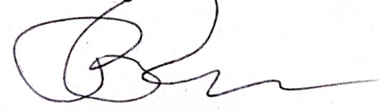
Sincerely,

Pamela C. Roehm, M.D., Ph.D.
Assistant Professor
Associate Residency Director
New York University School of Medicine

