Submission ID #: 50633

Editor Name: Brigid Stadinski

Videographer name: Matt Lenz

Film Date: 05/01/2013

Authors and Affiliations:
Jason D. Vevea*, Dana M. Alessi Wolken*, Theresa C. Swayne, Adam B. White and Liza A. Pon

*JDV and DMAW contributed equally to this work.

Vevea, Jason D.
Department of Pathology and Cell Biology
Columbia University
630 W. 168 Street, P&S 14-442
New York, NY 10032 USA
Email: jdv2108@columbia.edu

Alessi Wolken, Dana M.
Department of Pathology and Cell Biology
Columbia University
630 W. 168 Street, P&S 14-442
New York, NY 10032 USA
Email: dma2141@columbia.edu

Swayne, Theresa C.
1130 Saint Nicholas Ave., Room 222A
Herbert Irving Comprehensive Cancer Center
Columbia University
New York, NY 10032 USA
Email: tcs6@columbia.edu

White, Adam B.
1130 Saint Nicholas Ave., Room 222A
Herbert Irving Comprehensive Cancer Center
Columbia University
New York, NY 10032 USA
Email: aw2659@columbia.edu

Pon, Liza A.
Department of Pathology and Cell Biology
Columbia University
630 W. 168 Street, P&S 14-442
New York, NY 10032 USA
Phone: 212-305-1947
lap5@columbia.edu

Title: Ratiometric biosensors that measure mitochondrial redox state and ATP in living yeast cells

Corresponding Author:

Pon, Liza A.
Department of Pathology and Cell Biology
Columbia University
630 W. 168 Street, P&S 14-442
New York, NY 10032 USA
Phone: 212-305-1947
lap5@columbia.edu

Authors, please fill out the brief questionnaire below.

- Will you require JoVE to record video microscopy, such as filming a complex dissection or microinjection technique? (Y/N) No If yes, please list make and model of your microscope: ______________________________
**Note: This question is to get at whether or not you will need a camera hook-up to look into the microscope. However, if your microscope has a digital camera attached to a computer, you can gather these shots by collecting screen capture movies.
Does your protocol include microscopy steps that are visualized through a microscope with a digital camera/computer attached? (Y/N) Yes
B. Does your protocol include detailed, step-by-step, descriptions of software usage? (Y/N) Yes
C. Which steps of your protocol will viewers benefit most from having filmed? Please list 4-6 steps
- Slide preparation
- Optimizing imaging settings (exposure and z series for widefield imaging of mito-roGFP1
- Optimizing imaging settings (spectral bands, laser power, gain scan speed, z series) for confocal imaging of mitGO-ATeam2
- Thresholding
- Calculating the ratio image
- Use of drug treatment controls to validate the method
D. What is the single most difficult aspect of this procedure and what do you do to ensure success? Thresholding the image is the most difficult aspect of the procedure. To ensure success define optimal thresholding parameters and adhere to appropriate guidelines. Specifically, define thresholding parameters such that the thresholded image maintains the actual size of the fluorescent object in the original image. Using exactly the same exposure conditions for each experiment will help to produce consistently thresholded images throughout image processing.

1. Introduction (Schematic Overview and Interview)

A. Schematic Overview (read by voice talent at JoVE):

Conceptual Narrative:
The overall goal of this procedure is to measure mitochondrial function in living yeast cells using two green fluorescent protein, or GFP, variants.

Redox-sensing GFP contains surface-exposed cysteines which undergo reversible and environment-dependent oxidation and reduction, altering the excitation spectrum of the protein. Reduced roGFP has an excitation maximum at 470 nm… whereas oxidized roGFP has an increased efficiency of excitation at 365 nm.
Editors, please show the first image (roGFP graphical abstract) as this point is narrated. If possible, animate the transition of the two SH groups (reduced form) to the disulfide bond (oxidized form) on the GFP protein. This reaction is reversible, so it can be animated to go back and forth if time allows. Then, highlight the light blue arrow and 470 nm label under the reduced figure and the adjacent green emission arrow as “has an excitation maximum of 470 nm” is narrated. Then highlight the dark blue arrow and 365 nm label under the “oxidized” figure and the adjacent green arrow as “whereas oxidized roGFP has an increased efficiency of excitation at 365nm” is narrated.

The redox state is measured as roGFP emission at 470 nm excitation… over the roGFP emission at 365 nm excitation.
Editors, please show the second image (roGFP equation) as this point is narrated. Highlight “Redox ratio” as “redox state” is narrated. Highlight “roGFP emission at 470 nm ex” as narrated and highlight roGFP emission at 365 nm ex” as narrated.

GO-ATeam is a FRET probe in which the epsilon subunit of the F_{o}F₁-ATP synthase is sandwiched between a FRET donor GFP and a FRET acceptor orange fluorescent protein, or OFP. Binding of ATP to the epsilon subunit results in conformation changes in the protein that bring the FRET donor and acceptor in close proximity, allowing for energy transfer from the donor to the acceptor.
Editors, please show the third image (GO-ATeam graphical abstract) as this point is narrated. If possible, animate the transition between the ATP unbound state to the ATP bound state and highlight the FRET label and arrow as the second sentence is narrated.

ATP levels are then measured as the OFP emission upon excitation at 488 nm over GFP emission upon excitation at 488 nm.
Editors, please show the fourth image (GO-ATeam equation) as this point is narrated. Highlight “ATP levels” as narrated. Then highlight OFP emission upon excitation at 488 nm as narrated and GFP emission upon excitation at 488 nm as narrated.

Results are obtained that monitor changes in redox state… or ATP levels, that occur under physiological conditions.
Editors, please show figure 3 and then bring in figure 6D as “or ATP levels” is narrated.

Paste a copy of your graphic overview here. The original file should be Adobe Illustrator (preferred) or Powerpoint (see instructions) and should be uploaded through your online submission on the JoVE website. Please keep all layers in the file (i.e., do not flatten the file).

Conceptual Narrative images (in order of appearance)–

1. roGFP graphical abstract.psd
2. roGFP equation.psd
3. GO-ATeam graphical abstract.psd
4. ATP equation.psd

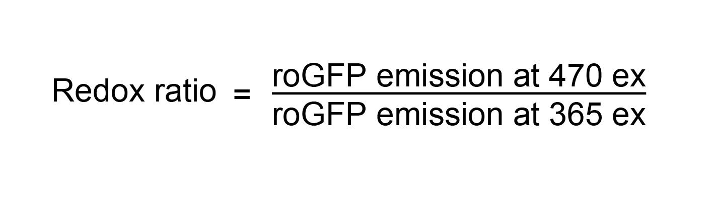

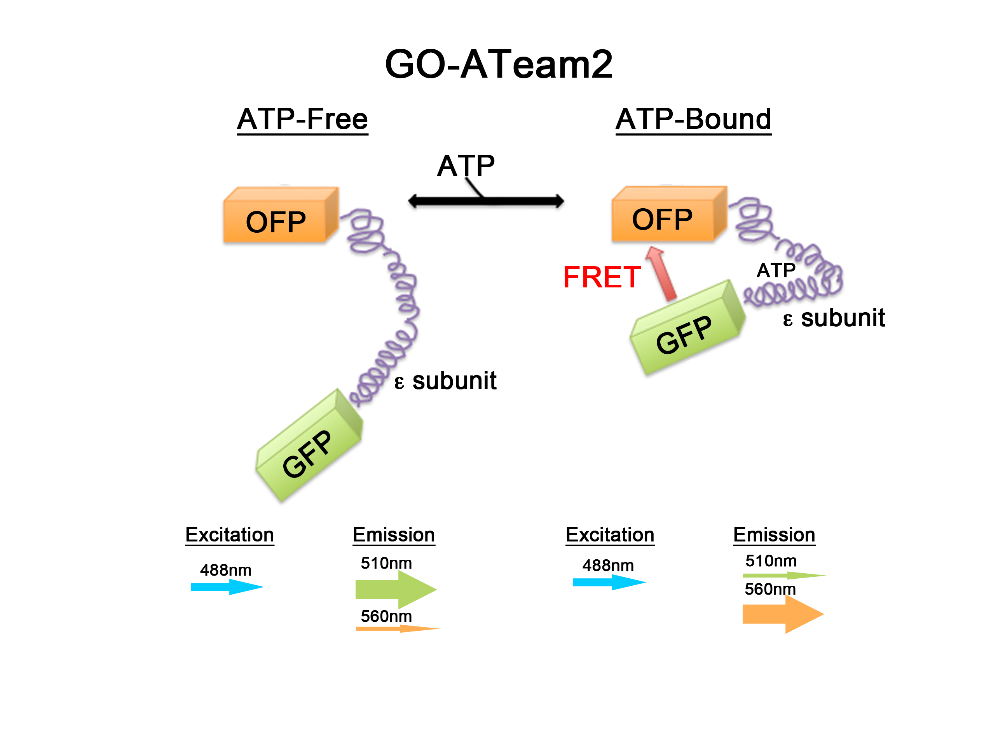

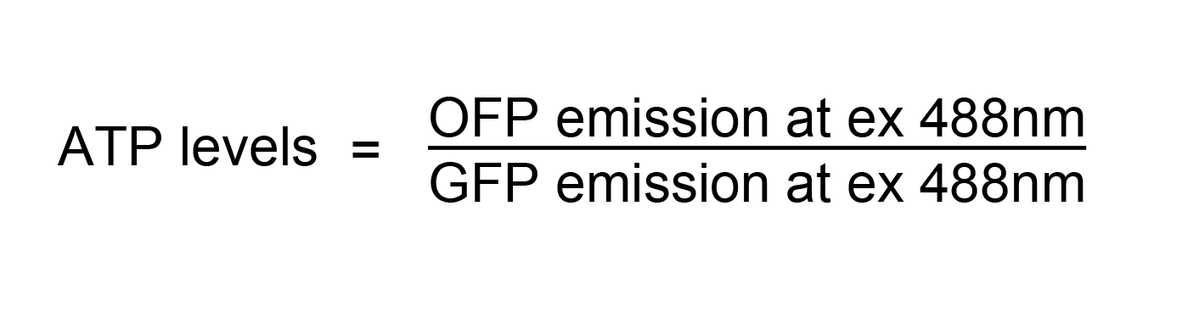

B. Interview: (Said by you on camera. Don’t forget to smile!)
  - Liza Pon: The main advantage of this technique over existing methods is that roGFP and GO-ATeam are both genetically encoded and can be stably introduced into yeast. As a result, they provide information on redox state or ATP levels in individual, living cells without affecting the function or fitness of cells or mitochondria.
    - MED: Liza speaks toward camera, interview style.
  - Dana Alessi Wolken: Both biosensors monitor changes in redox state or ATP levels that occur under physiological conditions.
    - MED: Jason speaks toward camera, interview style.
  - Dana Alessi Wolken: Both probes are also ratiometric. As a result, measurements made with these probes are not affected by changes in biosensor concentration or sample illumination or thickness.
    - MED: Dana speaks toward camera, interview style.
  - Jason Vevea: Both biosensors provide subcellular spatial resolution. In fact, roGFP variants have been targeted to mitochondria, ER, endosomes and peroxisomes, and can detect changes in redox state, largely independent of pH.
    - MED: Jason speaks toward camera, interview style.
  - Jason Vevea: This method can help answer key questions in the field regarding mitochondrial quality control and how mitochondria change with age.
    - MED: Dana speaks toward camera, interview style.
  - Jason Vevea: Visual demonstration of this method is critical useful as the thresholding and ratio steps in image analysis are difficult and need to be carried out using defined, objective guidelines.
    - MED: Jason speaks toward camera, interview style.

Protocol (read by voice talent at JoVE):
- Growth of cells and preparation for imaging
  - To begin this procedure, perform transformation of yeast with biosensors as described in the text protocol. Grow cells to mid-log phase in 5 ml of selective complete drop-out media in a 50 ml conical-bottom tube. Use the same batch of media for all experiments.
    - Title card
    - MED-over the shoulder: Talent removes the cells grown to mid-log phase from the incubator. If possible, include the display showing the correct temperature and shaking parameters in the shot. TEXT overlay (this text overlay can continue to the next shot): ~0.5 – 1 x 10⁷ cells/ml
    - CU: Labeled falcon tube containing the cells as talent displays to camera.
  - After concentrating 1 ml of culture to 20 µl, apply 2 µl of the resuspended cells to a slide and cover the cells with a coverslip. Then, melt a small amount of valap on a metal spatula… and spread along the coverslip edges to seal. Alternatively, clear nail polish can be used.

2.2.0. (not sure if this was slated) Added shot: CU: microcentrifuge spinning, concentrating cells.
    - MED: Talent places tipped pipette into the eppendorf tube containing the concentrated sample.
    - CU: Slide as talent applies 2 µl of the resuspended cells to a slide and covers the cells with a coverslip.
    - MED: Talent melts a small amount of valap on a metal spatula.
    - ECU: Coverslip as talent spreads a small amount of valap around the edges.
  - Maintain the cells at 30°C during imaging with an objective heater on the 100x oil immersion lens. Under these conditions, mitochondrial morphology, redox state and ATP levels remain unchanged during imaging for 10 to 15 minutes.
    - MED: Talent applies the objective heaters to the 100x/1.3NA EC PlanNeofluar objective lens and 100x/1.49 Apo-TIRF objective lens. Match action in next shot.
    - CU: Objectives as the heaters are placed onto them. {This was done during section 3 and 4}
- Mito-roGFP1 imaging
  - For mito-roGFP1 (pronounced “might-o-rho-GFP-one”) imaging on a wide-field fluorescent microscope, use an objective with the highest numerical aperture possible that transmits light at 365 nm, such as the 100x/1.3NA EC PlanNeofluar (pronounced “100 x, one point three N-A, E-C Plan-Neo-Floor”) objective lens.
    - MED: Talent attaches the 100x/1.3NA EC PlanNeofluar lens to the wide-field fluorescent microscope with objective heater on it. Match action in next shot.
    - CU: 100x/1.3NA EC PlanNeofluar lens as talent places it onto the wide-field fluorescent microscope.
    - Added shot: MED: objective heater was attached
  - Configure the microscope to excite at 365 and 470 nm to detect oxidized and reduced mito-roGFP, respectively. Use LEDs to change the excitation wavelength, and an emission filter cube suitable for GFP, with the excitation filter removed. Set the camera to 1 by 1 binning for optimal spatial resolution.
    - SCREEN: Screen capture movie as talent configures the microscope to excite at 365 and 470 nm for mito-roGFP1 imaging. Talent then sets up the LED filter and the emission filter. Talent sets the camera to 1x1 binning.
  - Next, set the software to acquire a z stack consisting of 11 slices with 0.5 µm spacing, collecting both channels at each z position.
    - SCREEN: Screen capture movie as talent sets the software to acquire a z stack consisting of 11 slices with 0.5 µm spacing, collecting both channels at each z position for mito-roGFP1 imaging.
  - Image several cells to determine an appropriate exposure time, producing a strong but not saturating signal. It is important to maintain the ratio of exposure times for oxidized and reduced mito-roGFP1 for all experiments.
    - SCREEN: Screen capture movie as talent images several cells to determine an appropriate exposure time for mito-roGFP1 imaging.
  - Locate the focal plane of cells using transmitted light to minimize bleaching of the fluorescent probe. Then, collect a z-series through the whole depth of a typical cell using a step size of 0.5 µm.
    - SCREEN: Screen capture movie as talent locates the focal plane of cells with mito-roGFP1 using transmitted light. Then talent collects a z-series through the whole depth of the cell using a step size of 0.5 µm for mito-roGFP1 imaging.
    - Added Shot: CU: Colibri system switching between 365 excitation and 470 excitation. Cut to during z-series in SCREEN 3.5.1
- MitGO-ATeam2 imaging
  - To setup for imaging mitGO-ATeam2 (pronounced “might-go-A-team”) on a spectral confocal microscope, use the highest numerical aperture lens available; here a 100x/1.49 Apo-TIRF (pronounced “100-X, one point four nine Ape-O-Turf”) lens is used.
    - MED: Talent attaches a 100x/1.49 Apo-TIRF lens to a spectral confocal microscope. Match action in next shot.
    - CU: 100x/1.49 Apo-TIRF lens as talent attaches to the spectral confocal microscope.
  - Configure the microscope to excite mitGO-ATeam2 at 488 nm and collect emission from 500 to 520 nm for ATP-bound, and from 550 to 580 nm for ATP-unbound forms. Actual optimal values may vary with characteristics of the imaging system.
    - SCREEN: Screen capture movie as talent configures the microscope to excite at 488nm and collect emission at one of the emission ranges for mitGO-ATeam2 imaging.
  - Set the pinhole to 1.0 Airy units. Then, set scan zoom to approach the Nyquist sampling limit.
    - SCREEN: Screen capture movie as talent prepares for mitGO-ATeam2 imaging by setting the pinhole to 1.0 Airy units. Then talent sets the scan zoom to approach the Nyquist sampling limit.
  - To increase imaging speed, crop the field to 512 by 256 pixels. Use scan averaging if needed to reduce noise.
    - SCREEN: Screen capture movie as talent prepares for mitGO-ATeam2 imaging by cropping the field to 512 x 256 pixels. Then talent uses scan averaging to reduce noise.
  - Use as little laser power as possible while still producing an interpretable image. Use an internal or external power meter to monitor changes in the laser power, which occur normally over time in any optical system.
    - SCREEN: Screen capture movie as talent uses as little laser as possible to produce an interpretable image for mitGO-ATeam2 imaging. Then talent uses cursor to point out the power meter used to monitor changes in the laser power.
  - Adjust detector gain and illumination intensity to maximize the dynamic range but avoid saturation. Do not analyze any cells containing more than 1% saturated pixels.
    - SCREEN: Screen capture movie as talent adjusts the detector gain and illumination intensity to maximize the dynamic range but avoid saturation for mitGO-ATeam2 imaging.
  - Locate the focal plane of cells using transmitted light before collecting a z-series through the whole depth of a typical cell using a step size of 0.5 µm. Image all samples using the same objective, laser power, scan zoom, pixel size, gain, and offset.
    - SCREEN: Screen capture movie as talent locates the focal plane of cells with mitGO-ATeam2 using transmitted light. Then talent collects a z-series through the whole depth of the cell using a step size of 0.5 µm.
    - Added shot: Dana sits at microscope computer and looks through an acquired image.
- ImageJ analysis Included screen caps from both rogfp and goateam analysis, same protocol; we added either “rogfp” or “ATeam” to the end of the screen shot file name to clarify which is which.
  - Open the acquired images and change type to 32 bit.
    - MED-over the shoulder: Talent opens the acquired images and changes type to 32 bit.
  - To determine the background, draw a region of interest, or ROI, in an area where there are no cells. Choose Analyze … Measure to add the mean intensity in this ROI to the Results window. To subtract this value from the stack, choose Process … Math … and Subtract. Then enter the background mean intensity … and choose Preview … Okay … and Yes.
    - SCREEN: 50633_Pon_5.2.1_SCREEN_roGFP.mov :
00:25 – 00:48 -- Talent determines the background by drawing an ROI in an area where there are no cells.
00:53 – 01:07 -- Talent calculates the mean intensity in this ROI and subtracts this value from the stack.
  - Thresholding the image is the most difficult aspect of the procedure. To ensure success define thresholding parameters such that the resulting image maintains the actual size of the fluorescent object in the original image. Using exactly the same exposure conditions for each experiment will help to produce consistently thresholded images throughout image processing.
    - MED: Talent at microscope speaks toward camera, interview style.
  - A threshold that is too low will include background pixels. A threshold that is too high will eliminate parts of the mitochondria from the analysis.
    - LAB MEDIA: Figure 1B, bottom panel.
  - Using the subtracted z-stack, find the middle slice and select Image … Adjust … and Threshold, and then threshold the mitochondria …. After finding an appropriate threshold value, click Apply to apply this threshold to all slices in the stack. Then, check Set Background Pixels to “NaN” or “not a number” … and click OK … and Yes. Repeat this process for the other image.
    - SCREEN: 50633_Pon_5.5.1_SCREEN_roGFP.mov
00:10 – 00:18 Screen capture movie as talent uses the subtracted z-stack to find the middle slice and threshold the mitochondria
00:53 - 01:07-- Talent clicks “apply” on the threshold window. Talent applies to all slices in the stack. Then talent checks “set background pixels to NaN.
  - Create the ratio z stack by clicking on Process, and then Image Calculator. Divide the reduced stack by the oxidized z stack for mito-roGFP1 analysis. Divide the ATP bound 560 nm image by the ATP unbound 510 nm image for mitGO-ATeam2 analysis.
    - SCREEN:
50633_Pon_5.6.1_SCREEN_roGFP.mov -- 00:03 – 00:18 – First two sentences: Screen capture movie as talent creates the ratio z stack by clicking on Process and then Image Calculator.
50633_Pon_5.6.1_SCREEN_ATeam.mov – 00:05 -- 00:35 -- Final sentence.
    - SCREEN: Screen capture movie as talent divides the reduced stack by the oxidized z stack. {same action as in 5.6.1}
    - SCREEN: Screen capture movie as talent divides the ATP bound 560 nm image by the ATP unbound 510 nm image. Editors, if possible, bring this screen capture movie in as a split screen with the 5.6.2.
  - Draw an ROI around the area of interest. Choose Analyze… Tools… ROI Manager, and click Add to record the ROI, then choose More … Multi Measure … and Okay.
    - SCREEN: 50633_Pon_5.7.1_SCREEN_roGFP.mov -- Screen capture movie as talent draws an ROI around the area of interest. Talent chooses “Analyze,” then “tools,” and then “ROI Manager.” Then talent clicks Add to record the ROI.

  - Finally, copy the Slice number, Area and Mean and export the data to a spreadsheet for analysis. Use the spreadsheet to calculate the Area times Mean … the Weighted Sum … and the Weighted Average.
    - SCREEN: 50633_Pon_5.8.1_SCREEN_roGFP.mov
00:05-00:15
~00:30 – Area x Mean
~00:35 – Weighted Sum
~00:45 – Weighted Average
Talent then exports the data to a spreadsheet for analysis. (For ATeam processing, this step is done in Part A and Part B, labeled as such in the file name)
- Results: Measuring mitochondrial redox state and ATP with mito-roGFP1 and mitGO-ATeam2
  - Cells expressing mitochondria-targeted GFP and roGFP1 grow at normal rates. The maximum growth rate is similar in cells expressing mito-GFP and mito-roGFP1.
    - LAB MEDIA: Fig. 1A. Editors, please transition to figure 1A by zooming into the left side of the previous figure. Then as “cells expressing mito-GFP” is narrated, highlight the curve made of black squares. As “and mito-roGFP1” is narrated, highlight the curve made of gray triangles.
  - Furthermore, mitochondria in yeast expressing mito-roGFP1 are tubular, align along the mother-bud axis, and accumulate at the tips of mother and daughter cells. This normal morphology indicates that mito-roGFP1 does not perturb mitochondrial function.
    - LAB MEDIA: Fig. 1B – top panel
  - To assess the dynamic range of mito-roGFP1, mid-log phase wild-type yeast cells were treated with hydrogen peroxide and dithiothreitol, and the mean mitochondrial reduced to oxidized ratio was measured to assess mitochondrial redox state.
    - LAB MEDIA: Fig. 2A. Editors, please highlight the left column as “hydrogen peroxide” is narrated. Then highlight the right column as “dithiothreitol” is narrated.
  - Titration with hydrogen peroxide or DTT from 0 to 10 mM results in a dose-dependent change in mean mitochondrial reduced to oxidized ratio with a measured range from 0.6 under oxidizing conditions… to 1.23 under reducing conditions. Thus, mito-roGFP1 is an effective biosensor for analysis of mitochondrial redox state in living cells.
    - LAB MEDIA: Fig. 2B. Editors, please highlight the square at 0.6 on the y-axis as “0.6 under oxidizing conditions” is narrated. Then highlight the last square on the right as “to 1.23 under reducing conditions” is narrated.
  - Mito-roGFP1 also offers subcellular resolution of mitochondrial redox state. This subcellular resolution reveals that mitochondria within individual yeast cells differ in relative redox state.
    - LAB MEDIA: Fig. 3. Editors, as the second sentence is narrated, please sequentially highlight the 3 pointers and corresponding numbers in the figure (not the mean value at the top of the figure).
  - Light can induce changes in the GFP chromophore. Upon exposure to high intensity 400 nm light, roGFP1 undergoes photoconversion to a species with a different emission spectrum.
    - LAB MEDIA: Fig. 4B
  - Using low-intensity excitation, there is no significant photoconversion during the period analyzed. The preferred way to reduce photoconversion is to excite the oxidized form of roGFP at 365 nm.
    - LAB MEDIA: Fig. 4C. Editors, please highlight the line made up of black squares as the first sentence is narrated. Then highlight the curve made up of gray diamonds as the second sentence is narrated.
  - MitGO-ATeam2 colocalizes with DAPI-stained mitochondrial DNA in yeast, and is found in tubular structures typical of wild-type yeast mitochondria.
    - LAB MEDIA: Figure 5A
  - Additionally, the growth rate of cells expressing mitGO-ATeam2 is similar to that of cells expressing mitochondria-targeted GFP in both glucose… and glycerol media. Thus, expression of mitGO-ATeam2 does not appear deleterious to the cell or mitochondria.
    - LAB MEDIA: Fig. 5B. Editors, please highlight the curve made up of purple and green as “glucose” is narrated. Then highlight the curve made up of blue and orange as “and glycerol media” is narrated.
  - To test whether mitGO-ATeam2 responds to changes in mitochondrial ATP levels, cells were treated with antimycin A, an agent that inhibits mitochondrial ATP production. The median FRET ratio decreases in cells treated with Antimycin A.
    - LAB MEDIA: Fig. 6C. Editors, please highlight “Antimycin A” on the x-axis as the last sentence is narrated.
  - Interestingly, the preliminary data indicates that there may be differences in ATP levels in different mitochondria within the same cell.
    - LAB MEDIA: Fig. 6D. Editors, as the second sentence is narrated, please sequentially highlight the 3 pointers and corresponding numbers in the figure (not the mean value at the top of the figure).

INSTRUCTIONS FOR AUTHORS:
Please ensure that the representative results narration is appropriate and correctly describes your images, movies, or figures. Our editors have ensured that the results are written in our format.

We consider this section a critical aspect of the video, because here is where you provide validation for your experiments. For example, if this is a cell culture preparation, this section is where the video will show your cells at various time points following culturing. If this is an imaging prep, then this part is where you will show examples of your imaging experiments.

Please limit the extent of narration to no more than 2-3 lines of text per image or movie file being described. Figures with multiple panels submitted with the original protocol should be broken up so that each panel is a separate image. Like the schematic, each image or movie file supplied in the results should be referenced by annotation in parenthesis, however for the results, the specific filename should be given in parenthesis.

Below is an example of results text:

EXAMPLE REPRESENTATIVE RESULTS

5. Evaluation of Morpholino Injection and Knockdown
5.1 Representative results of both morpholino injection and mRNA injection are shown here. The
uninjected control at 48 hours post fertilization looks normal, as expected
-LAB MEDIA: 0123_PIname_Figure1.tif (Replace 0123 with your jove video #)

5.2 However, embryos injected with the morpholino heg_e3i3_egfr1, which knocks down Heg isoforms
containing the first of two EGF-like repeats, exhibit brain edema.
-LAB MEDIA: 0123_PIname_Figure2.tif

5.3 Injection of heart of glass mRNA also produced an obvious phenotype. At 24 hours post fertilization,
the heads of the uninjected controls look normal
-LAB MEDIA: 0123_PIname_Figure3.tif

5.4 Conversely, some of the embryos injected with the mRNA exhibit cyclopia
-LAB MEDIA: 0123_PIname_Figure4.jpg

Please visit the following URL to see an example of how the results will look when complete:

http://www.jove.com/video/1597/results-example-mably?access=ksw0bprj

- Conclusion (said by authors on camera)
  - Jason Vevea: Once mastered, this technique can be done in several hours if it is performed properly.
    - MED: Jason speaks toward camera, interview style.
  - Jason Vevea: While attempting this procedure, it’s important to remember to keep imaging parameters constant, monitor cells for mitochondrial fragmentation and other signs of phototoxicity, avoid photobleaching, and develop consistent criteria for thresholding.
    - MED: Dana speaks toward camera, interview style.
  - Dana Alessi Wolken: These biosensors can be used to assess mitochondrial function in live plant and mammalian cells, and. They can also be used to monitor mitochondrial changes in neurodegeneration, metabolic disease, and other diseases that are associated with defects in mitochondrial function.
    - MED: Jason speaks toward camera, interview style.
  - Liza Pon: After watching this video, you should have a good understanding of how to use mitochondrially targeted ratiometric fluorescent biosensors to quantify mitochondrial redox state and ATP levels in living cells.
    - MED: Liza speaks toward camera, interview style.

Provided Media

Authors, Please list all images, movie files, or 3-D rendered animations that can be included in the video per editor’s request. The step in the script/video where these images will be inserted should be specified. For example:

6.2 – 0123_PIname_Figure1.tif - dual color imaging of tumor angiogenesis at 40X
6.2 – 0123_PIname_Figure2.tif - dual color imaging of tumor angiogenesis at 100X

Formats: For static images we prefer .tiff, .eps, Illustrator, Powerpoint or Photoshop files at dimensions of at least 720X480 pixels and 300 dpi. The higher resolution, the better. Likewise any exported movie files should have at minimum these dimensions and be rendered to .mov, .mp4, or .avi files.

Insert your media filenames here.

Conceptual Narrative images (in order of appearance)–

1. roGFP graphical abstract.psd
2. roGFP equation.psd
3. GO-ATeam graphical abstract.psd
4. ATP equation.psd

Figure 1A – Authors, please provide a separate version of figure 1A without the A label

Figure 1B – top panel – Authors, please provide a separate version of the top panel of figure 1B without the B label

Figure 1B, bottom panel – Authors, please provide a separate version of the bottom panel of figure 1B without the B label

Figure 2A – Authors, please provide a separate version of figure 2A without the A label

Figure 2B – Authors, please provide a separate version of figure 2B without the B label

Figure 3

Figure 4B – Authors, please provide a separate version of figure 4B without the B label

Figure 4C – Authors, please provide a separate version of figure 4C without the C label

Figure 5A – Authors, please provide a separate version of figure 5A without the A label

Figure 5B – Authors, please provide a separate version of figure 5B without the B label

Figure 6C – Authors, please provide a separate version of figure 6C without the C label

Figure 6D – Authors, please provide a separate version of figure 6D without the D label

SCREEN Capture Movies
Please note that for the processing steps, we have made screen captures for both probes.

50633_Pon_3.2.1_SCREEN: Screen capture movie as talent configures the microscope to excite at 365 and 470 nm for mito-roGFP1 imaging. Talent then sets up the LED filter and the emission filter. Talent sets the camera to 1x1 binning.

50633_Pon_3.3.1_SCREEN: Screen capture movie as talent sets the software to acquire a z stack consisting of 11 slices with 0.5 µm spacing, collecting both channels at each z position for mito-roGFP1 imaging.

50633_Pon_3.4.1_SCREEN: Screen capture movie as talent images several cells to determine an appropriate exposure time for mito-roGFP1 imaging.

50633_Pon_3.5.1_SCREEN: Screen capture movie as talent locates the focal plane of cells with mito-roGFP1 using transmitted light. Then talent collects a z-series through the whole depth of the cell using a step size of 0.5 µm for mito-roGFP1 imaging.

50633_Pon_4.2.1_SCREEN: Screen capture movie as talent configures the microscope to excite at 488nm and collect emission at one of the emission ranges for mitGO-ATeam2 imaging.

50633_Pon_4.3.1_SCREEN: Screen capture movie as talent prepares for mitGO-ATeam2 imaging by setting the pinhole to 1.0 Airy units. Then talent sets the scan zoom to approach the Nyquist sampling limit.

50633_Pon_4.4.1_SCREEN: Screen capture movie as talent prepares for mitGO-ATeam2 imaging by cropping the field to 512 x 256 pixels. Then talent uses scan averaging to reduce noise.

50633_Pon_4.5.1_SCREEN: Screen capture movie as talent uses as little laser as possible to produce an interpretable image for mitGO-ATeam2 imaging. Then talent uses cursor to point out the power meter used to monitor changes in the laser power.

50633_Pon_4.6.1_SCREEN: Screen capture movie as talent adjusts the detector gain and illumination intensity to maximize the dynamic range but avoid saturation for mitGO-ATeam2 imaging.

50633_Pon_4.7.1_SCREEN: Screen capture movie as talent locates the focal plane of cells with mitGO-ATeam2 using transmitted light. Then talent collects a z-series through the whole depth of the cell using a step size of 0.5 µm.

50633_Pon_5.2.1_SCREEN: Talent determines the background by drawing an ROI in an area where there are no cells. Talent calculates the mean intensity in this ROI and subtracts this value from the stack.

50633_Pon_5.5.1_SCREEN: Screen capture movie as talent uses the subtracted z-stack to find the middle slice and threshold the mitochondria. Talent clicks “apply” on the threshold window. Talent applies to all slices in the stack. Then talent checks “set background pixels to NaN.

50633_Pon_5.6.1_SCREEN: Screen capture movie as talent creates the ratio z stack by clicking on Process and then Image Calculator.

50633_Pon_5.6.2_SCREEN: Screen capture movie as talent divides the reduced stack by the oxidized z stack.

50633_Pon_5.6.3_SCREEN: Screen capture movie as talent divides the ATP bound 560 nm image by the ATP unbound 510 nm image.

50633_Pon_5.7.1_SCREEN: Screen capture movie as talent draws an ROI around the area of interest. Talent chooses “Analyze,” then “tools,” and then “ROI Manager.” Then talent clicks Add to record the ROI.

50633_Pon_5.8.1_SCREEN: Screen capture movie after selecting all ROIs as talent chooses “More,” then “Multi-measure” to measure all stack slices. Talent then exports the data to a spreadsheet for analysis.

General Preparation

It’s critical for a smooth and organized shoot that all reagents are accounted for, in advance.

Any overnight or long incubation steps should be recognized and specimens/samples be prepared in advance so that prior steps can be recorded and shooting can continue with pre-prepared specimens/samples.

All tubes/flasks should be pre-labeled neatly before we arrive.

Ex. Luciferase assay done in 96 well plates should be labeled with negative/positive control wells and experimental samples are labeled accordingly.

You will receive more detailed preparation instructions, as well as an introduction to your videographer, closer to your filming date.

