Submission ID #: 50628

Editor Name: Melissa Ceo

Videographer name:

Film Date:

Authors and Affiliations:
Guido Breuer^{1,3}, Wendy A.C. Evers^{1,3}, Jeroen H. de Vree^{1,3}, Dorinde M. M. Kleinegris^{2,3}, Dirk E. Martens^{1,3}, René H. Wijffels^{1,3}, Packo P. Lamers^{1,3}

Wageningen University and Research Center, The Netherlands
¹Bioprocess Engineering, P.O. Box 8129, 6700 EV Wageningen
²Food and Biobased Research, P.O. Box 17, 6700 AA Wageningen
³Wageningen University and Research Center, AlgaePARC, Bornsesteeg 10, 6721 NG Bennekom

Title: Analysis of fatty acid content and composition in microalgae

Corresponding Author:

Guido Breuer: guido.breuer@wur.nl

Authors, please fill out the brief questionnaire below.

A. Will you require JoVE to record video microscopy, such as filming a complex dissection or microinjection technique? (Y/N) ___N______ If yes, please list make and model of your microscope: ______________________________
B. Does your protocol include detailed, step-by-step, descriptions of software usage? (Y/N)____N____
C. Which steps of your protocol will viewers benefit most from having filmed? Please list 4-6 steps____3.4.1 3.5 3.8.2 3.10.1 4.5.3______________________
D. What is the single most difficult aspect of this procedure and what do you do to ensure success? 3.4/3.5 It is not necessarily the most difficult step , but it is the most critical step since the internal standard is mixed with the sample in this step. Mistakes in this step (incomplete transfer) lead to errors in the final results.

1. Introduction (Schematic Overview and Interview)

A. Schematic Overview (read by voice talent at JoVE):
Authors, please select from “Procedural Narrative” or “Conceptual Narrative” and complete the statements below. Please do not add additional steps. Then, attach your finished graphic overview. See accompanying instructions for details and examples.

Procedural Narrative:
The overall goal of this procedure is to measure the total fatty acid content and composition in microalgae. (Intro)

This is accomplished by first preparing a sample containing a known amount of lyophilized algae biomass. (P1, show left flasks only then have arrow and left tube from P2 appear)

The second step is to disrupt the microalgal biomass. (P2, show left tube only and have the green circles turn into the dotted circles seen in right tube)

Next, the lipophilic components are extracted and isolated. (P3, show right tube from P2 and have arrow and right tube appear)

The final step is trans-esterification of the acyl lipids to fatty acid methyl esters. (P4, show top molecule only, then have lines connecting 3 long chains disappear and have 3 “H₃C-” groups appear in their place)

Ultimately, gas chromatography is used to quantify the fatty acids. (P5)

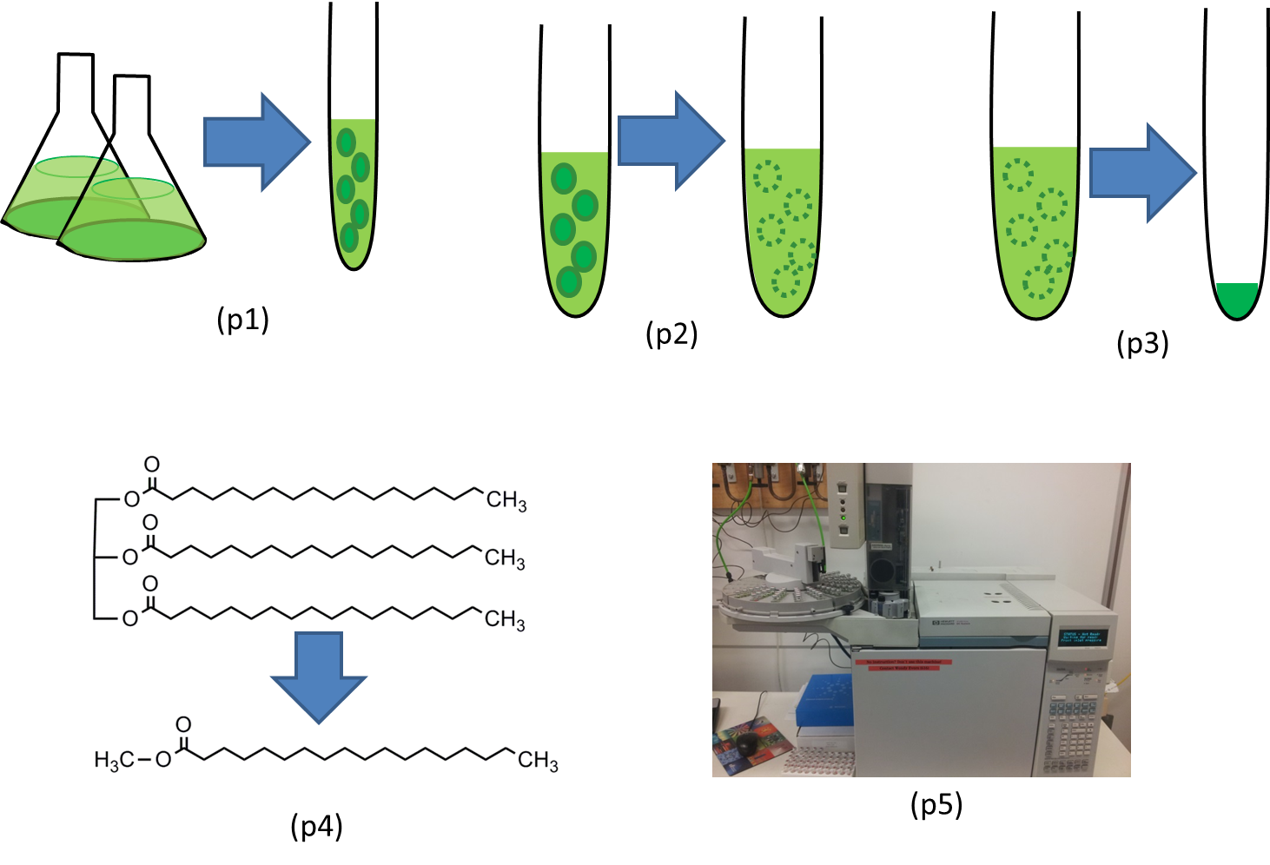

B. Interview: (Said by you on camera. Don’t forget to smile!)

Authors: Below are statements we would like you to complete that are complementary to the information contained within the schematic overview.
- Only one statement should be chosen and completed per author who will be on camera demonstrating the protocol.
- Enter the name of the individual who will say each line.
- Please choose and fill out the statement(s) that convey the most important fact(s) about your protocol. You may revise the given prompts as necessary to improve the sentence flow.
- If any individuals will be doing demonstrations on camera but are not assigned a speaking part in this interview section, please use statement 1.8 to introduce these demonstrators (for example, the PI introduces students)

  - Author name Guido: The main advantage of this technique over existing methods, like gravimetric determinations, is that this method is very accurate and specifically measures all the fatty acids and no other lipophilic components. (Video Editor: Note from Author: “This shot is filmed at two different locations. One in the lab (this one is called 1.1B) but maybe this shot is too noisy, the other is filmed in an office (and called 1.1).”)
  - **Author name Guido: Demonstrating the procedure will be Wendy Evers, a technician from our laboratory.
    - Interview style: Author saying the above
    - The named technician, post doc, student looks up from workbench or desk or microscope and acknowledges the camera.

Protocol (read by voice talent at JoVE):

Authors: In order to ensure that your protocol can be filmed in a single day, the protocol text must be limited to 30 steps – each step being defined as 3 lines of 12 pt text in our formatting style below. This amounts to 3 pages of protocol text. The scope of the scripted protocol text should include only those aspects of the procedure that require visualization in order to be well understood.

- Sample Preparation
  - Before starting this procedure, determine the algae dry weight concentration in g/L in the culture broth as detailed in the listed reference (TEXT: Breuer, G. et al. Bioresource Technology 2012, 124(0), 217). Transfer a volume of culture broth that contains 5-10 mg of algae dry weight to a glass centrifuge tube. Calculate the exact amount of biomass transferred using the biomass concentration determined previously.
    - WID: Talent walks up to lab bench with culture broth in hand.
    - MED: Talent transfers culture broth to glass centrifuge tube.
    - MED-over the shoulder: Talent calculates amount of biomass transferred.
  - Centrifuge the sample for 5 minutes at 1200g. Discard part of the supernatant, leaving approximately 0.25 mL in the tube.
    - MED: Talent places tube into centrifuge, programs appropriate settings and turns it on. Videographer: Multiple takes, second part of shot will be reused (see also 2.2.1settings).

2.2.1settings: An added shot of only the settings.

2.2.2a. MED-over the shoulder: Talent removes tube from centrifuge

2.2.2b. Talent pours off some of the supernatant.
  - Next, re-suspend the algae in the remaining supernatant by gently pipetting the pellet up and down and transfer the cell mixture to a bead beater tube using a 200 μl pipet.
    - & 2.3.2 CU: Tube as talent gently pipettes pellet up and down, and Talent pipettes cell mixture into bead beater tube.
  - Rinse the centrifuge tube and pipet tip with plus or minus 0.15 mL of MilliQ water and transfer the liquid to the bead beater tube.
    - MED: Talent rinses tube and glass pipet with MilliQ water and transfers liquid to bead beater tube.
  - Centrifuge the bead beater tube for one minute at maximum rpm to make sure no air bubbles remain in the bottom of the tube. When finished, lyophilize the material in the tube.
    - turning the centrifuge on.
    - MED: Talent walks up to lyophilizer with tube in hand.
- Cell Disruption and Lipid Extraction
  - Following this, prepare a 50 mg/L solution of tripentadecanoin in a 4:5 volume ratio of chloroform:methanol.

3.1.1a. Talent weights of an amount of tripentadecanoin.

3.1.1b. talent registers the weighted amount and calculates concentration.

3.1.1c. talent adds weighted tripentadecanoin to the chloroform methanol solution
  - Using a positive displacement pipet, add 1 mL of the tripentadecanoin solution to the beating tube. Check that there are no beads remaining inside the cap of the bead beater tube, as this will result in leaking of the tubes.
    - MED-over the shoulder: Talent pipettes tripentadecanoin solution into bead beater tube.
    - CU: Tube cap as talent checks it for beads.
  - Bead beat the beater tube 8 times at 2500 rpm for 60 seconds, each time with a 120 second interval between each beating (TEXT: 2500 rpm, 60 seconds, 120 second interval).
    - MED: Talent places beater tube in beadbeater instrument, programs the appropriate settings and turns it on.
  - Next, transfer the solution and beads from the bead beater tube to a clean heat-resistant 15 mL glass centrifuge tube with a Teflon insert screw cap.
    - CU: Glass centrifuge tube as talent adds solution and beads from bead beater tube to it.
  - Wash the bead beater tube with 1 mL of the tripentadecanoin solution and transfer the wash to the glass centrifuge tube. Repeat two more times. .
    - MED: Talent washes bead beater tube with tripentadecanoin solution and transfers washes to centrifuge tube.
  - Vortex the sample for 5 seconds and then sonicate it for 10 minutes.
    - MED: Talent places sample on vortexer and turns it on.
    - MED-over the shoulder: Talent places sample in sonicator and turns it on.
  - Following sonication, add 2.5 mL of a pH 7 MilliQ water solution containing 50 mM Tris and 1 M sodium chloride to the centrifuge tube.
    - CU: Centrifuge tube as talent adds MilliQ water solution and sodium chloride to it.
  - Once the sample has been vortexed and sonicated a second time, centrifuge it for 5 minutes at 1200 g. When finished, carefully transfer the bottom chloroform phase to a clean glass tube using a glass Pasteur pipette.
    - Programming the appropriate settings and turning centrifuge on.
    - CU: Centrifuge tube as talent removes bottom chloroform phase to transfer to glass tube.
  - Repeat the extraction with 1 mL of chloroform. When finished, collect the chloroform phase using a glass Pasteur pipette and pool with the first chloroform fraction (TEXT: Repeat previous steps if difficulties experienced in collecting chloroform fraction).
    - MED: Talent adds chloroform to centrifuge tube.
    - MED-over the shoulder: Talent transfers chloroform phase from centrifuge tube to glass tube containing first chloroform fraction.
  - Evaporate the chloroform using a nitrogen gas stream to afford the dried extracted lipids.
    - MED: Talent places tube under nitrogen gas stream. (Video Editor: Author’s Note: “4 takes are recorded. These 4 takes do not represent identical content but instead show the chronological order of the evaporation step. Take 1: putting the samples in the evaporator, take 2 and 3: solvent being evaporated, take 4: solvent completely evaporated.”)
- Transesterification to Fatty Acid Methyl Esters
  - Next, add 3 mL of methanol containing 5% sulfuric acid to the tube containing the dried extracted lipids and close it tightly. Vortex the sample for 5 seconds.
    - CU: Tube as talent adds methanol solution and closes it.
    - MED-over the shoulder: Talent places sample on vortexer and turns it on.
  - Incubate the sample for 3 hours at 70°C in a block heater. Periodically ensure that the samples are not boiling and vortex the tube after each time the samples are checked.
    - MED: Talent places sample in heat block and turns it on.
    - MED-over the shoulder: Talent removes sample from heat block and looks at it, and places it on vortexer to observe mixing.
  - Once the sample has cooled to room temperature, add 3 mL of MilliQ water and 3 mL of n-hexane to the tube.
    - MED: Talent adds MilliQ water and n-hexane to tube.
  - Following vortex mixing, agitate the sample for 15 minutes with a test tube rotator.
    - MED: Talent places sample in test tube rotator and turns it on.
  - After removing the samples from the test tube rotator, centrifuge them for 5 minutes at 1200 g. Using a glass Pasteur pipette, collect 2 mL of the top hexane phase and transfer it to a fresh glass tube.
    - Programming the appropriate settings and turning centrifuge on.
    - MED-over the shoulder: Talent removes tube from centrifuge.
    - MED: Talent transfers 2 mL of hexane phase to glass tube.
  - To wash the collected hexane phase, add 2 mL of MilliQ water to the glass tube. Then, vortex the sample for 5 seconds and centrifuge it for 5 minutes at 1200 g.
    - CU: Tube as talent adds MilliQ water to it.
    - MED-over the shoulder: Talent places sample on vortexer and turns it on.
    - Reuse shot – use the part that shows programming the appropriate settings and turning centrifuge on.
- Quantification of Fatty Acid Methyl Esters Using Gas Chromatography
  - Transfer the hexane phase from the glass tube to a GC vial using a glass Pasteur pipette. Then, place a cap on the GC vial and tighten it to prevent solvent evaporation.
    - MED: Talent pipettes hexane phase from glass tube into GC vial.
    - MED-over the shoulder: Talent places cap on GC vial and closes it tightly.
  - Place the sample vial in the auto-sampler of the GC-FID instrument. (TEXT: Run 2 hexane blanks prior to running sample).
    - MED: Talent places sample in auto-sampler of GC-FID instrument.
  - Finally, run the sample on the instrument with a Nukol column using a total flow rate of 20 mL/min and an injection volume of 1 μl. See the text protocol for column specifications and chromatographic conditions.
    - SCREEN: Computer screen as talent sets the flow rate and injection volume. (Author’s Note: “We have made several computer screen shot showing the different steps to setup the computer software. They are named 5.3.1 A-D”)
- Results: Fatty Acid Content and Composition of Microalgae as Determined by Gas Chromatography
  - A typical chromatogram that is obtained via this process is shown here. Fatty acid methyl esters are separated by size and degree of saturation by the GC column and protocol used. Shorter chain length fatty acids and more saturated fatty acids have shorter retention times. The used GC column and protocol do not intend to separate fatty acid isomers, but this could be achieved by using a different GC column and protocol.
    - LAB MEDIA: Figure 1
  - The fatty acid content and composition of Scenedesmus obliquus (pronounced scene–dess–muss obliq–u–us) UTEX393 (pronounced Utex three-nine-three) under both nitrogen sufficient and deprived conditions are displayed here. The total fatty acid contents were 8.6 plus or minus 0.5% and 44.7 plus or minus 1.7% under nitrogen replete and nitrogen deprived cultivation conditions, respectively. These values demonstrate that fatty acid composition and content are highly affected by nitrogen starvation. In S. obliquus palmitic acid, and oleic acid, are the two most abundant fatty acids. See the text protocol for details on calculating the fatty acid content and composition.
    - LAB MEDIA: Figure 2 (Video Editor: Please highlight, or point to, the C16:0 bars when palmitic acid is mentioned and the C18:1 bars when oleic is mentioned in last sentence).
  - The fatty acid content and composition of Phaeodactylum tricornutum (pronounced fay–o–dak–til–um Tri-corn–u-tum) UTEX640 (pronounced Utex six-four-zero) under both nitrogen sufficient and deprived conditions are shown here. Similar to S. obliquus, the fatty acid content and composition are highly affected by nitrogen starvation. Under nitrogen sufficient and deprived conditions, the total fatty acid contents were 11.7 plus or minus 0.9% and 30.5 plus or minus 1.1%, respectively. P. tricornutum also produces substantial amounts of highly unsaturated fatty acids such as eicosapentaenoic acid. In addition very long chain fatty acids such as lignoceric acid, can also be detected by this method.
    - LAB MEDIA: Figure 3 (Video Editor: Please highlight, or point to, the C20:5 bars for fourth sentence, and the C24:0 bars for last sentence).

INSTRUCTIONS FOR AUTHORS:
Please ensure that the representative results narration is appropriate and correctly describes your images, movies, or figures. Our editors have ensured that the results are written in our format.

We consider this section a critical aspect of the video, because here is where you provide validation for your experiments. For example, if this is a cell culture preparation, this section is where the video will show your cells at various time points following culturing. If this is an imaging prep, then this part is where you will show examples of your imaging experiments.

Please limit the extent of narration to no more than 2-3 lines of text per image or movie file being described. Figures with multiple panels submitted with the original protocol should be broken up so that each panel is a separate image. Like the schematic, each image or movie file supplied in the results should be referenced by annotation in parenthesis, however for the results, the specific filename should be given in parenthesis.

Below is an example of results text:

EXAMPLE REPRESENTATIVE RESULTS

5. Evaluation of Morpholino Injection and Knockdown
5.1 Representative results of both morpholino injection and mRNA injection are shown here. The
uninjected control at 48 hours post fertilization looks normal, as expected
-LAB MEDIA: 0123_PIname_Figure1.tif (Replace 0123 with your jove video #)

5.2 However, embryos injected with the morpholino heg_e3i3_egfr1, which knocks down Heg isoforms
containing the first of two EGF-like repeats, exhibit brain edema.
-LAB MEDIA: 0123_PIname_Figure2.tif

5.3 Injection of heart of glass mRNA also produced an obvious phenotype. At 24 hours post fertilization,
the heads of the uninjected controls look normal
-LAB MEDIA: 0123_PIname_Figure3.tif

5.4 Conversely, some of the embryos injected with the mRNA exhibit cyclopia
-LAB MEDIA: 0123_PIname_Figure4.jpg

Please visit the following URL to see an example of how the results will look when complete:
http://www.jove.com/video/1597/results-example-mably?access=ksw0bprj

- Conclusion (said by authors on camera)
Authors: Below are statements we would like you to complete that summarize and conclude the video. Only one statement should be chosen and completed per author who will be on camera demonstrating the protocol. In addition to choosing and filling out the appropriate statement, please enter the name of the individual who will say each line. You may revise the given prompts if necessary to better fit your protocol.

  - Author name Guido: This procedure can be extended by including a lipid class separation between the lipid extraction and the transesterification step to obtain additional insight into the lipid class composition of microalgae as described in the references in the protocol text.

Provided Media

Authors, Please list all images, movie files, or 3-D rendered animations that can be included in the video per editor’s request. The step in the script/video where these images will be inserted should be specified. For example:

6.2 – 0123_PIname_Figure1.tif - dual color imaging of tumor angiogenesis at 40X
6.2 – 0123_PIname_Figure2.tif - dual color imaging of tumor angiogenesis at 100X

Formats: For static images we prefer .tiff, Illustrator, Powerpoint or Photoshop files at dimensions of at least 720X480 pixels and 300 dpi. The higher resolution, the better. Likewise any exported movie files should have at minimum these dimensions and be rendered to .mov, .mp4, or .avi files.

Insert your media filenames here.

General Preparation

It’s critical for a smooth and organized shoot that all reagents are accounted for, in advance.

Any overnight or long incubation steps should be recognized and specimens/samples be prepared in advance so that prior steps can be recorded and shooting can continue with pre-prepared specimens/samples.

All tubes/flasks should be pre-labeled neatly before we arrive.

Ex. Luciferase assay done in 96 well plates should be labeled with negative/positive control wells and experimental samples are labeled accordingly.

You will receive more detailed preparation instructions, as well as an introduction to your videographer, closer to your filming date.

