Submission ID #: 50622

Editor Name: Brigid Stadinski

Videographer name: Kai Jae Wang

Film Date: 4/30/2013

Authors and Affiliations:

Holly A. Richendrfer and Robbert Creton

Department of Molecular Biology, Cell Biology and Biochemistry, Brown University, Providence, Rhode Island, USA.
Title: Automated High-Throughput Behavioral Analyses in Zebrafish Larvae

Corresponding Author:

Holly Richendrfer, Ph.D.
Department of Molecular Biology, Cell Biology and Biochemistry
Brown University
Box G-L106C
185 Meeting Street
Providence, RI 02912
United States of America

Phone: 401-863-6512
Fax: 401-863-1941
E-mail: Holly_Richendrfer@brown.edu

Authors, please fill out the brief questionnaire below.

- Will you require JoVE to record video microscopy, such as filming a complex dissection or microinjection technique? (Y/N) ____N_____ If yes, please list make and model of your microscope: ______________________________
**Note: This question is to get at whether or not you will need a camera hook-up to look into the microscope. However, if your microscope has a digital camera attached to a computer, you can gather these shots by collecting screen capture movies.
Does your protocol include microscopy steps that are visualized through a microscope with a digital camera/computer attached? (Y/N) __N_____
B. Does your protocol include detailed, step-by-step, descriptions of software usage? (Y/N)____Y____
C. Which steps of your protocol will viewers benefit most from having filmed? Please list 4-6 steps___These are the steps that will probably serve the most benefit to being filmed: time-lapse photography/behavioral capture, making the agarose lanes, placing the larvae into the lanes, and importing the images into ImageJ. _______________________
D. What is the single most difficult aspect of this procedure and what do you do to ensure success? ________For most people, the most difficult step is placing the zebrafish larvae into the wells and making sure they do not get injured and that they do not swim out of the agarose lanes. ______________________

1. Introduction (Schematic Overview and Interview)

A. Schematic Overview (read by voice talent at JoVE):

Procedural Narrative:

The overall goal of this procedure is to identify behavioral defects in zebrafish larvae after treatment with toxicants or pharmaceuticals. (Intro)

This is accomplished by first collecting and treating the embryos or larvae with chemicals up to the first 7 days of development. (P1, show the upper left image: the fish swim over the collecting box, then the four round embryos appear. The four round embryos move into the bracket directly below it, then as the embryos “mature,” the middle bracket replaces the upper bracket, then the lower bracket replaces the middle one (these are the larvae.)

The second step is to make agarose swimming lanes using specially designed molds. (P2)

Next, the treated larvae are placed in the agarose lanes for behavioral analysis using time-lapse photography. (P3, the larvae from P1 move into the swimming lanes of P2, resulting in the P3 figures.)

The final step is to import the images into ImageJ and use a specific macro written in-house in order to gather x,y coordinate data of the larvae in the lanes (P4)

Ultimately, the high-throughput behavioral assay is used to find differences in avoidance and thigmotaxis behavior as well as in swim speed and rest between the treatment groups. (P5, figure 5)

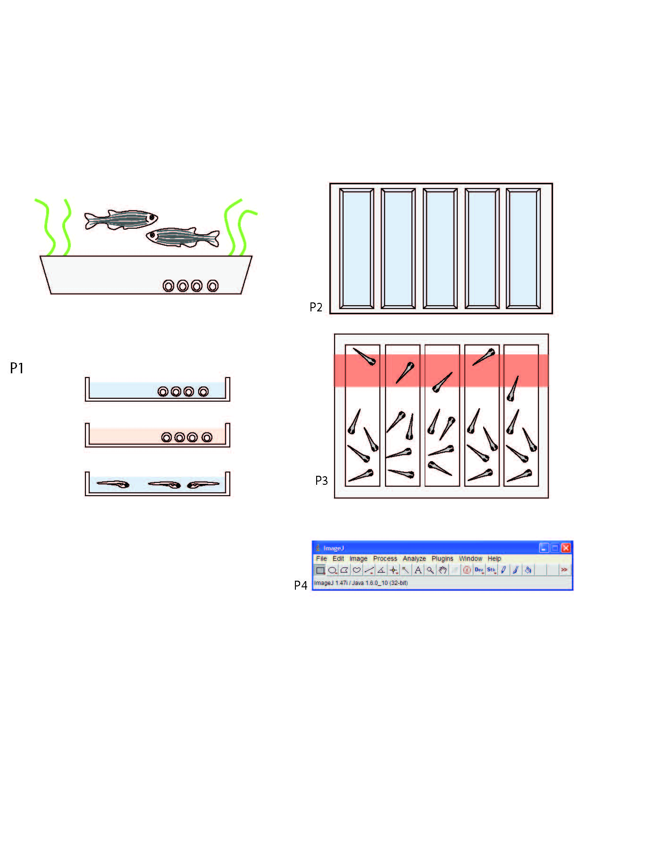

B. Interview: (Said by you on camera. Don’t forget to smile!)

  - Holly: The main advantage of this technique over existing methods, like those commercially available, is that we can use our method to observe more complex behaviors. It is also inexpensive to build and easy to set up.
    - MED: Talent speaks to the camera, interview style.
  - Holly: This method can help answer key questions in the field of behavioral neuroscience, such as how toxicants affect brain development and behavior during early embryonic exposure. It can also provide insight into subtle brain defects in humans which cannot be found by other current toxicity screens
    - CU: Talent speaks to the camera, interview style.
  - Holly: Generally, individuals new to this method will struggle because catching the larvae can be difficult. Visual demonstration of this method is critical as the steps have a learning curve since the protocol involves custom built systems.
    - MED: Talent speaks to the camera, interview style.

Protocol (read by voice talent at JoVE):
- Collection of zebrafish embryos and raising larvae
  - To begin this procedure, insert glass Pyrex dishes with “fake” grass made from green yarn into the tanks at dawn. Leave the dishes in the tanks for two hours in order to collect zebrafish embryos.
    - MED: Talent motions to insert glass Pyrex dishes with “fake” grass made from green yarn into the tanks. Continue action in next shot.
    - CU: Pyrex dish with fake grass as talent inserts into tank.
  - Pour the glass dishes containing the embryos over a handheld strainer and rinse with deionized water.
    - MED-over the shoulder: Talent pours the embryos over the handheld strainer.
    - CU: Embryos as talent rinses with deionized water.
  - Next, grow the embryos in egg water, containing 60mg/L of Instant Ocean in deionized water and 0.25mg/L of methylene blue, which is used as a mold inhibitor. Embryos can be housed at 50-60 larvae per 50mL… or in larger breeding tanks until embryos are ready to be treated with toxicants.
    - MED-over the shoulder: Talent transfers embryos into prepared egg water at 50-60 larvae per 50mL.
    - CU or MED: Scan a larger breeding tank with embryos.
  - Depending upon the hypothesis of the individual experiment, embryos can be treated immediately or during specific stages of development using toxicants or pharmaceuticals, which are usually dissolved in DMSO and then further diluted directly in the egg water medium. The blue color is used for video demonstration purposes.
    - MED: Talent aspirates the prepared toxicants or pharmaceuticals from a labeled container into a pipette to treat the embryos.
    - CU: Pipette tip contained with treatment in it as it is applied to the embyros.
  - During embryonic and larval treatment, the larvae and embryos can be housed in deep petri dishes at a density of about 50-60 larvae per 50mL until the behavioral analyses at 7 days-post-fertilization.
    - MED/CU: Multiple takes of the larvae and embryos in deep petri dishes at a density of about 50-60 larvae per 50mL. Use shots to cover narrated point.
  - Change the egg water solution at least every other day to avoid fungal or bacterial growth from the dead embryos.
    - MED-over the shoulder or MED: Talent changes the egg water solution.
- Preparing molds for behavioral analyses
  - Plastic molds were fabricated to create lanes using agarose which is poured into single well plastic plates from Thermo Scientific. The molds contain five lanes in which the sides are angled at 60°. See the text protocol accompanying this video for the dimensions of the molds and the plates.
    - CU: Talent displays the molds and plates to the camera.
    - ECU: Talent points out the 5 lanes of the mold and their angled sides.
  - First, prepare the agarose by melting 0.8% agarose in deionized water with 60 mg/L Instant Ocean.
    - MED-over the shoulder: Talent removes the prepared agarose from the hot plate.
  - Next, generate the lanes by pouring 50mL of the melted agarose into a single well plate. Then, very slowly place the mold on top of the liquid agarose to eliminate any bubble formation.
    - CU: Single well plate as talent pours 50mL of melted agarose in.
    - ECU: Plate as talent very slowly places the mold on top of the liquid agarose to eliminate any bubble formation.
  - Remove the mold when the agarose has cooled. The agarose lanes can be stored at room temperature with the lids on the dishes for up to 36 hours.
    - MED-over the shoulder: Talent removes the mold when the agarose has cooled.
    - MED: Talent places the lids on the dishes in order to store at room temperature.
- Preparation of imaging cabinet
  - For high-throughput behavioral analysis, imaging cabinets are prepared with a 15 megapixel digital camera attached to the top of the cabinet facing downward.
    - MED: Talent opens cabinet door with digital camera already in place. Continue action in next shot.
    - CU: Digital camera as it is attached to the cabinet facing downward.
  - At the bottom of the cabinet, a 15.6 inch screen laptop is placed with the screen facing up. In order to avoid overheating the larvae, it is best to use a laptop with a screen temperature that does not go above 28°C.
    - MED-over the shoulder: Talent next to cabinet turns the laptop on that is already in the cabinet. Continue action in next shot.
    - CU: Laptop as it is put into place at the bottom of the cabinet.
  - Place a plastic diffuser on top of the laptop screen on which the agarose plates will be placed. The diffuser will prevent moiré patterns in the images collected.
    - CU or MED-over the shoulder: Same shot of the laptop as talent places a plastic diffuser on top of the laptop screen.
- Image capture
  - To begin image capture, carefully move the larvae from the petri dish to the agarose lane to help reduce larvae stress. Up to 20 larvae can be placed in each lane, but 5 larvae per lane are typically used to facilitate the most accurate tracking of swim speed and to reduce the number of larvae that are needed per experiment.
    - MED: Talent efficiently moves the larvae from the petri dish to the first 2 agarose lanes at 5/lane.
    - CU: Lanes as talent moves larvae to the remaining 3 lanes at 5 per lane.
  - Fill the lanes with egg water with or without pharmaceuticals or toxicants depending upon the experiment. Do not fill up the lanes all the way until they are placed in the imaging cabinets to prevent overflow. Allow ten minutes for the larvae to acclimate. (TEXT: Wait 10 min)
    - MED or MED-over the shoulder: Talent partially fills the first 2 lanes with egg water. Continue action in next shot.
    - CU: Lanes as talent partially fills the remaining 3 lanes with egg water.
  - For consistency, allow an acclimatization period of ten minutes after the larvae are placed in the agarose molds. Note to editors: Use a text overlay that states waiting 10 minutes for acclimatization.
    - MED: Talent sets a timer for ten minutes next to the lanes filled with larvae and leaves the larvae to acclimate.
  - After the acclimatization period, position four plates by hand directly on top of the laptop screen. At this time the lanes can be topped off with egg water or chemical treatment so that it is level with the top of the lane to eliminate shadows on the edges of the lanes in the images.
    - MED-over the shoulder: Talent positions four plates by hand directly on top of the laptop screen.
    - CU: Plates as lanes are topped off with egg water or chemical treatment so that it is level with the top of the lane.
  - Program the computer for time-lapse photography, taking pictures every 6 seconds for a total of 300 images per experiment.
    - MED: Talent removes the camera from cabinet.
    - MED-over the shoulder or CU: Camera as talent sets to take picture every 6 seconds for a total of 300 images.
  - Set the camera at a lower resolution for imaging at video speed. While the lower resolution limits the recordings to a single multiwell plate, the video recordings are appropriate for imaging rapid swimming events.
    - CU: Camera as talent zooms in on only one agarose plate.
    - MED or MED-over the shoulder: Talent returns the camera to the cabinet.
  - Use a PowerPoint presentation as an aversive stimulus for the larvae. In this demonstration, the PowerPoint starts with a blank white background for 15 minutes… followed by 15 minutes of a moving red bar on the top half of the plate. To avoid evaporation of the liquid within the agarose lanes, keep the maximal imaging time to below one hour.
    - MED or MED-over the shoulder: Talent starts the PowerPoint presentation.
    - CU: Laptop screen with larvae on top as the PowerPoint begins with a white background.
    - CU: Laptop screen with larvae on top as the PowerPoint shows the moving red bar on the top half of the plate. Editors, please switch to this movie as ‘followed by 15 minutes of a moving red bar…” is narrated.
- Image Analysis

Editors, for the SCREEN shots, please use a zoom bubble to highlight the performed action.
  - Open the images with ImageJ. In this demonstration, an in-house macro for five lane larval analysis is used and can be made available to any user. Use the prompts in the macro to set the parameters such as number of images and color to be subtracted.
    - SCREEN: Screen capture movie as talent imports the images with ImageJ software.
    - SCREEN: Screen capture movie as talent uses the prompts in the macro to set the parameters, including number of images and color to be subtracted. TEXT overlay (as “in-house macro” is narrated): Zebrafish_macro25k
  - The macro then automatically splits the color channels so that the red color can be removed… subtracts the background… applies a threshold… and identifies the larvae by particle analysis.
    - SCREEN: Screen capture movie as Zebrafish_macro25k automatically splits the color channels so that the red color can be removed, subtracts the background, applies a threshold, and identifies the larvae by particle analysis. Editors, please correlate the narrated text with each action.
  - After all of the images are run through the ImageJ macro, a results file will be displayed and will contain the x,y coordinates of the individual larvae for each image along with the image number and the lane number.
    - SCREEN: Screen capture movie of the results file. Talent uses cursor to point out the the x,y coordinates of the individual larvae for each image along with the image number and the lane number.
  - Save the results file in an Excel format and sort based upon blank background versus the moving bar background, and then the well number.
    - SCREEN: Screen capture movie as talent saves the results file in an Excel format and sorts based upon blank background versus the moving bar background, and then the well number.
  - Use an Excel template that has equations built in to automatically determine placement of larvae in the wells… distance between larvae… speed of movement… and amount of rest. The most current Excel template created in the Creton lab is available upon request.
    - SCREEN: Screen capture movie as talent uses a curser in the Excel template to point out the equations to determine placement of larvae in the wells, distance between larvae, speed of movement, and amount of rest. TEXT overlay (as “excel template” is narrated): 25ib
  - Build graphs showing various treatment groups into the Excel sheet along with t-tests for comparison between treatment groups and controls. Further statistical analysis can be performed using SPSS statistics program.
    - SCREEN: Screen capture movie as talent builds graphs showing the various treatment groups into the Excel sheet along with t-tests for comparison between treatment groups and controls.
    - MED-over the shoulder: Talent uses SPSS statistics program to perform further statistical analysis.
- Results: Example of behaviors that can be quantified in the high-throughput assay
  - Results are shown for larvae treated with egg water and DMSO as controls, and varying concentrations of an organophosphate pesticide commonly found in non-organic foods.
    - LAB MEDIA: Figure 5
  - Here, the white bars show data from larvae exposed to a blank background and the red bars show data from the larvae exposed to the red moving bar.
    - LAB MEDIA: Figure 5. Editors, please highlight the white and red bars as narrated.
  - Control larvae grown in egg water show an increased preference to be down in the dish after they are presented with the moving red bar. Similar results are obtained when larvae are grown in egg water containing 1µg/ml DMSO, a solvent that is commonly used to dissolve various pharmaceuticals and toxicants as 1000x stock solutions.
    - LAB MEDIA: Figure 5. Editors, please zoom into the top, left figure. Highlight the first red bar as the first sentence is narrated. Then highlight the 2nd red bar as the second sentence is narrated.
  - The graphs indicate the measurements that can be obtained from behavioral analysis, including percentage of larvae down in the lane… percentage of larvae on the end of the lane… percentage of larvae on the edge of the lane… distance between fish… swim speed of the larvae… and percentage of time the larvae are at rest.
    - LAB MEDIA: Figure 5. Editors, please stay zoomed into the top, left figure as “percentage of larvae down in the lane” is narrated. Then slide over to the top, middle figure as “percentage of larvae on the end of the lane” is narrated. Next, slide over to the top, right figure as “percentage of larvae on the edge of the lane” is narrated. Then, slide over to the bottom, left figure as the “distance between fish” is narrated. Slide to the bottom, middle figure as “swim speed of the larvae” is narrated. Finally, slide over to the bottom, right figure as “percentage of time the larvae are at rest” is narrated.
  - The results shown are a sampling from one experiment. However, when repeated, the results indicate that swim speed and thigmotaxis behavior is altered by low concentrations of organophosphate pesticides, which mimic levels in human food consumption.
    - LAB MEDIA: Figure 5. Editors, please zoom back out to the full figure as this point is narrated.

INSTRUCTIONS FOR AUTHORS:
Please ensure that the representative results narration is appropriate and correctly describes your images, movies, or figures. Our editors have ensured that the results are written in our format.

We consider this section a critical aspect of the video, because here is where you provide validation for your experiments. For example, if this is a cell culture preparation, this section is where the video will show your cells at various time points following culturing. If this is an imaging prep, then this part is where you will show examples of your imaging experiments.

Please limit the extent of narration to no more than 2-3 lines of text per image or movie file being described. Figures with multiple panels submitted with the original protocol should be broken up so that each panel is a separate image. Like the schematic, each image or movie file supplied in the results should be referenced by annotation in parenthesis, however for the results, the specific filename should be given in parenthesis.

Below is an example of results text:

EXAMPLE REPRESENTATIVE RESULTS

5. Evaluation of Morpholino Injection and Knockdown
5.1 Representative results of both morpholino injection and mRNA injection are shown here. The
uninjected control at 48 hours post fertilization looks normal, as expected
-LAB MEDIA: 0123_PIname_Figure1.tif (Replace 0123 with your jove video #)

5.2 However, embryos injected with the morpholino heg_e3i3_egfr1, which knocks down Heg isoforms
containing the first of two EGF-like repeats, exhibit brain edema.
-LAB MEDIA: 0123_PIname_Figure2.tif

5.3 Injection of heart of glass mRNA also produced an obvious phenotype. At 24 hours post fertilization,
the heads of the uninjected controls look normal
-LAB MEDIA: 0123_PIname_Figure3.tif

5.4 Conversely, some of the embryos injected with the mRNA exhibit cyclopia
-LAB MEDIA: 0123_PIname_Figure4.jpg

Please visit the following URL to see an example of how the results will look when complete:

http://www.jove.com/video/1597/results-example-mably?access=ksw0bprj
- Conclusion (said by authors on camera)
  - Holly: Once mastered, the imaging and imaging analysis can be done in an hour and a half if it is performed properly. The most important part of While attempting this procedure, it’s important is to remember to keep the culture medium clean by replacing with new medium daily.
    - MED: Talent speaks toward camera, interview style.

Provided Media

Authors, Please list all images, movie files, or 3-D rendered animations that can be included in the video per editor’s request. The step in the script/video where these images will be inserted should be specified. For example:

6.2 – 0123_PIname_Figure1.tif - dual color imaging of tumor angiogenesis at 40X
6.2 – 0123_PIname_Figure2.tif - dual color imaging of tumor angiogenesis at 100X

Formats: For static images we prefer .tiff, .eps, Illustrator, Powerpoint or Photoshop files at dimensions of at least 720X480 pixels and 300 dpi. The higher resolution, the better. Likewise any exported movie files should have at minimum these dimensions and be rendered to .mov, .mp4, or .avi files.

schematic diagram Richendrfer 2013.ai

Figure 5 – Authors, please provide a version of this figure without the panel labels (A,B,C,D,E,F)

SCREEN Capture Movies

50622_Richendrfer_SCREEN_6.1.1: Screen capture movie as talent imports the images with ImageJ software.

50622_Richendrfer_SCREEN_6.1.2: Screen capture movie as talent uses the prompts in the macro to set the parameters, including number of images and color to be subtracted.

50622_Richendrfer_SCREEN_6.2.1: Screen capture movie as Zebrafish_macro25k automatically splits the color channels so that the red color can be removed, subtracts the background, applies a threshold, and identifies the larvae by particle analysis.

50622_Richendrfer_SCREEN_6.3.1: Screen capture movie of the results file. Talent uses cursor to point out the the x,y coordinates of the individual larvae for each image along with the image number and the lane number.

50622_Richendrfer_SCREEN_6.4.1: Screen capture movie as talent saves the results file in an Excel format and sorts based upon blank background versus the moving bar background, and then the well number.

50622_Richendrfer_SCREEN_6.5.1: Screen capture movie as talent uses a curser in the Excel template to point out the equations to determine placement of larvae in the wells, distance between larvae, speed of movement, and amount of rest.

50622_Richendrfer_SCREEN_6.6.1: Screen capture movie as talent builds graphs showing the various treatment groups into the Excel sheet along with t-tests for comparison between treatment groups and controls.

General Preparation

It’s critical for a smooth and organized shoot that all reagents are accounted for, in advance.

Any overnight or long incubation steps should be recognized and specimens/samples be prepared in advance so that prior steps can be recorded and shooting can continue with pre-prepared specimens/samples.

All tubes/flasks should be pre-labeled neatly before we arrive.

Ex. Luciferase assay done in 96 well plates should be labeled with negative/positive control wells and experimental samples are labeled accordingly.

You will receive more detailed preparation instructions, as well as an introduction to your videographer, closer to your filming date.

