Submission ID #: 50617
Editor Name: Shanelle Ko
Videographer name:
Film Date:

Authors and Affiliations:

Monica E. Embers*, Britton J. Grasperge, Mary B. Jacobs, and Mario T. Philipp
Division of Bacteriology & Parasitology, Tulane National Primate Research Center, Tulane University Health Sciences Center, Covington, LA 70433

Title: Feeding of Ticks on Animals for Transmission and Xenodiagnosis in Lyme disease Research

Corresponding Author:

Monica E. Embers, Ph.D., Division of Bacteriology and Parasitology, Tulane National Primate Research Center (TNPRC), Tulane University Health Sciences Center, 18703 Three Rivers Road, Covington, LA 70433. Phone: (985) 871-6607, E-mail: members@tulane.edu

Authors, please fill out the brief questionnaire below.

A. Will you require JoVE to record video microscopy, such as filming a complex dissection or microinjection technique? (Y/N) __Y______ If yes, please list make and model of your microscope: _Fisher Stereomaster dissecting scope_____________________________
B. Does your protocol include detailed, step-by-step, descriptions of software usage? (Y/N)_____N___
C. Which steps of your protocol will viewers benefit most from having filmed? Please list 4-6 steps____selected for each of 3 protocols—see attached appendix______________________
D. What is the single most difficult aspect of this procedure and what do you do to ensure success? ________see appendix______________________

1. Introduction (Schematic Overview and Interview)

A. Schematic Overview (read by voice talent at JoVE):
Authors, please select from “Procedural Narrative” or “Conceptual Narrative” and complete the statements below. Please do not add additional steps. Then, attach your finished graphic overview. See accompanying instructions for details and examples.

Procedural Narrative:

The overall goal of this procedure is to utilize a natural vector, the deer tick, for experimental transmission and xenodiagnosis of the Lyme disease agent, Borrelia burgdorferi. (Intro)

This is accomplished by first producing ticks that harbor the bacteria. (P1)

Once inoculated, the ticks are applied to the shaved area of a mouse and then housed in specialized caging. Fed ticks are then retrieved from the cage water (P2)

For non-human primates, a specialized containment device is constructed and applied before the ticks are placed on the skin. After 5 days, the device is opened and fed ticks are collected (P3)

Ultimately, samples can be collected and analyzed by various methods to confirm infection after tick feeding. Tissues can also be cultured, sectioned and stained for immunofluorescence (P4).

P1: LAB MEDIA: Schematic overview.pptx, slide 1, start with the panel to the far left and then bring in the middle and right panel
P2: LAB MEDIA: Schematic overview.pptx, slide 2, start with the panel to the far left and then bring in the middle and right panel, ending the with bottom panel
P3: LAB MEDIA: Schematic overview.pptx, slide 3, start with the panel to the far left and then bring in the middle and right panel, ending with the bottom
P4: LAB MEDIA: Schematic overview.pptx, slide 4, start with the panels to the right “Mice and Monkeys” and then show the “tick” panel

Paste a copy of your graphic overview here. The original file should be Adobe Illustrator (preferred) or Powerpoint (see instructions) and should be uploaded through your online submission on the JoVE website. Please keep all layers in the file (i.e., do not flatten the file).
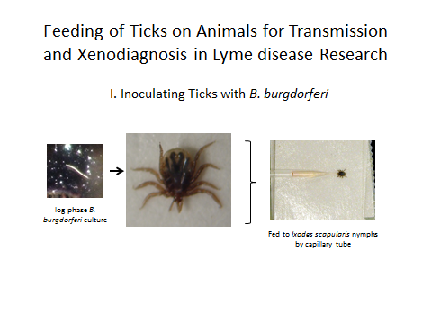
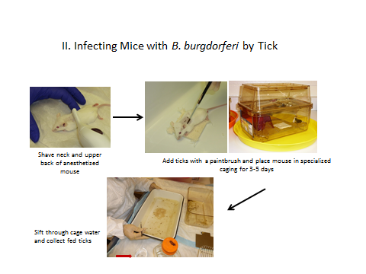
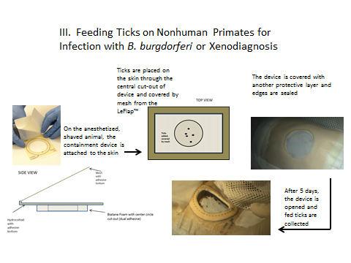
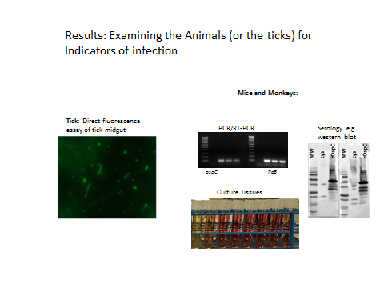

B. Interview: (Said by you on camera. Don’t forget to smile!)

Authors: Below are statements we would like you to complete that are complementary to the information contained within the schematic overview.
- Only one statement should be chosen and completed per author who will be on camera demonstrating the protocol.
- Enter the name of the individual who will say each line.
- Please choose and fill out the statement(s) that convey the most important fact(s) about your protocol. You may revise the given prompts as necessary to improve the sentence flow.
- If any individuals will be doing demonstrations on camera but are not assigned a speaking part in this interview section, please use statement 1.8 to introduce these demonstrators (for example, the PI introduces students)

Video Editor: FYI: The authors ended up filming this themselves, and their shot numbering is unconventional at times.
  - Monica Embers: Visual demonstration of these methods is critical as the multiple steps are quite different between the animal models used.
- 2.1.x Monica Embers: Demonstrating the procedure will be myself, Dr. Britton Grasperge and Mary Jacobs.
- 2.2_1 The named technician, post doc, student looks up from workbench or desk or microscope and acknowledges the camera. I think this is Britton Grasperge
- 2.2_2 The named technician, post doc, student looks up from workbench or desk or microscope and acknowledges the camera. … because this looks more like a Mary Jacobs.

Protocol (read by voice talent at JoVE):

Authors: In order to ensure that your protocol can be filmed in a single day, the protocol text must be limited to 30 steps – each step being defined as 3 lines of 12 pt text in our formatting style below. This amounts to 3 pages of protocol text. The scope of the scripted protocol text should include only those aspects of the procedure that require visualization in order to be well understood.

- Inoculating Ticks with B. burgdorferi

  - White lab coats with elastic sleeves, gloves, and disposable bouffant caps should be worn when working with ticks.
    - WIDE: Talent walks in wearing appropriate personal protective equipment

  - To begin, retrieve Nymphal ticks that have been stored at 23 ºC for 4-6 weeks post-larval molt.
    - WIDE: Talent retrieves ticks from where they are stored

  - Place double-sided tape on the bottom of a small petri dish and secure the ticks, ventral-side up, on the tape.
    - CU: Talent places ticks in dish

  - For inoculation, B. burgdorferi are grown to mid-log phase in BSK-H medium containing 6% rabbit serum.
    - MED: Talent retrieves culture. Text Overlay (mid-log phase = 2-8 x 10⁷/mL)

  - Glass capillary tubes are prepared using a tube standardized to the tick mouthpart as a sizing guide.
    - CU: Talent places a prepared capillary tube next to the guide tube, confirming that it is the correct size.

  - When ready, mix the B. burgdorferi culture and insert the tip of the capillary tube. With the aid of a dissecting scope, place the tube over the hypostome of the tick mouth. Next, fix the tube in place with molding clay.
    - CU: Talent mixes culture and inserts tube (drawing up the culture)
    - SCOPE: Talent places tube over the tick mouth
    - CU: Talent fixes tube in place with modeling clay

  - Insert the petri dish, with affixed ticks, inside a large clear plastic tub for an added level of containment and add wet paper towels to provide moisture. Place the ticks in a 37ºC incubator until defecation is apparent. This indicates that the media containing spirochetes has passed through the tick.
    - MED: Talent places dish inside a plastic tub and adds moist paper towels
    - MED: Talent places ticks in incubator
    - CU: Talent points at defecation in the dish. Video Editor: Please add an arrow pointing to defecation on tick

  - All the ticks are kept for 2-4 weeks at 23 ºC to adapt to their environment before feeding them on animals.
    - MED: Talent places the ticks at 23C

- Infecting Mice with B. burgdorferi by Tick

  - After administering anesthesia, shave the mouse from the ears to the middle back using an electric trimmer.
    - MED: Talent shaves mouse. Text overlay (10 mg/kg ketamine, i.p.)

  - In a white pan, with no other objects nearby, use a moistened paintbrush to transfer the inoculated ticks to the hairless area of the mouse.
    - MED: Talent transfers tick to mouse
- 3.2.1_2 CU: Talent transfers tick to mouse

  - Once the ticks are in place, transfer the animal to a specialized cage.
    - CU: Shot of mouse with all ticks in place
    - MED: Talent transfers animal to special cage

  - This cage consists of a stainless steel grill elevated from the bottom. The cage top was modified in-house to elevate the water bottle holder enough to allow free movement of the mouse underneath.
    - CU: Shot of the grill at the bottom of the cage
    - CU: Talent assembles cage with modifications in place

  - To trap any ticks that may fall from the mouse, the cage bottom is filled with just enough water to cover the surface but is low enough to prevent limbs from submersion.
    - CU: Shot demonstrating the water level at the bottom of the cage and that the animal’s limbs are not submerged

  - Heating pads are placed underneath the cage until the mouse is fully recovered.
    - MED: Talent points to heating pad under the cage

  - The cage is also placed inside a tray that has been lined with Tangle trap paste and tape for further measures of containment.
    - MED: Talent places cage on tray with tangle trap paste and tape in view and points to tangle trap on edges (Video Editor: if it’s not obvious what the talent is pointing to, please add a label saying “Tangle trap paste”.)

  - When the mouse has fully recovered from anesthesia, water is poured into the cage to a depth of ~1/2 inch, and food and water are replaced.
- 3.8.1 & 3.8.2 (combined) MED: Talent pours water into cage to the correct depth, Talent replaces food and water

  - After 3, 4, and 5 days, check the mouse, cage and cage water for fed ticks. Sift the cage water through a white metal pan. Rinse the fed ticks in clean water and store them in plastic jars.
    - MED: Talent checks cage for ticks and sifts water
    - CU: Talent sifts and inspects cage water and points out fed tick
    - MED: Talent rinses fed ticks and places them in jars

  - On days 3 and 4, replace the water in the cage with clean water. On day 5, check not only the cage, but the mouse thoroughly for ticks. Usually by this point all ticks have fed and the mice can be returned to regular caging.
    - MED: Talent replaces water in cage
    - MED: Talent checks mouse thoroughly for ticks
    - MED: Talent returns mouse to normal cage

  - Place all waste from the mouse cages, including liquids, in biohazard containers for autoclaving and disposal.
    - MED: Talent disposes of waste properly in bag, and disposes of bag in biohazard receptacle (2 shots)

  - Keep a log of the number of ticks placed on the mice and those recovered at all times.
    - MED: Over the shoulder of talent recording log

- Feeding Ticks on Nonhuman Primates for Infection with B. burgdorferi or Xenodiagnosis

  - The first step is to prepare the tick containment device. Cut a 1 ¾” inch diameter circle in the 3” x 3”LeFlap (flap) using a clean scalpel and the measurement guide.
    - MED: Talent walks up to bench were materials are laid out
    - MED: Talent cuts circle from the LeFlap

  - Use the cut-out as a template to cut circles of identical size in the Biatane foam and Duoderm. The foam is used to elevate the flap over the surface of the skin and prevent possible crushing of the tick. The Duoderm adds another layer of cushioning and overlays the edges of the containment device for added security from tick escape.
    - MED: Talent demonstrates cutting circle of foam
    - MED: Talent holds up foam circle, demonstrating its width and cushioning properties
    - MED: Talent cuts the circle of duoderm

  - After administering anesthesia, an electric trimmer is used to shave all the areas that will be covered by the jacket.
4.4.1_1 CU: Talent shaves area with electric trimmer

  - Next, closely shave an area of approximately 25 x 20 cm, then clean and dry the area.
- 4.4.1_2 CU: Talent shaves area with shaving cream and straight razor
- 4.4.1_3 CU: Talent cleans area with wet paper towel and dries thoroughly with hair dryer

  - After cleaning and drying the skin, place the flap on the animal’s dorsum, just below the scapula, on either side of the spine. Use a marker to trace the circle in that spot. After wiping the skin to remove oils, apply a layer of skin glue.
    - Use 4.5-4.7.mov

  - Remove the adhesive backing from the Biatane foam and affix it to the skin in the appropriate spot. Seal the edges with skin glue and Hypafix tape. Remove the adhesive backing from the Leflap and affix on top of the Biatane.
    - Use 4.5-4.7.mov

  - Place skin glue and Hypafix tape around the edges. After taping down the mesh flap, place the jacket on the animal.

- 4.5-4.7.mov: CU: Talent places flap on animal, Talent traces the circles, Talent applies skin glue, Talent applies biatiane foam, Talent seals the edges, Talent applies the leflap, Talent applies skin glue and tape, Shot of the jacket once placed on animal (not showing face)

  - Twenty four hours later, check the security of the device and reinforce if needed. When the device is secure, use a paintbrush to place approximately 20 unfed ticks on the skin.
- 4.8.1 4.8.2_MED/CU: Talent checks the security of the device and transfers ticks
- 4.8.2_MED: Talent transfers ticks

  - After transferring the ticks, remove the adhesive backing from the mesh of the flap and seal it in place. Remove the Duoderm backing and place it on top of the containment device. Seal the edges with Hypafix tape. Lastly, add a piece of Hypafix tape across the open mesh circle and replace the jacket.
4.9.mov CU: Talent places mesh and seals it in place, places the duoderm on top and seals edges, shot of the jacket after it is put back in place

  - Five days later, the animal is anesthetized and the jacket is removed. Remove the tape first so that tick feeding can be viewed through the mesh.
    - MED: Talent removes jacket
    - CU: Talent removes tape and points out ticks through mesh

  - After carefully peeling the Duoderm away from the flap, pull the mesh portion back at the edges to provide access to the ticks. Fed ticks are frequently found near or under the foam circle. Remove the ticks with a paintbrush and place them in clean water.
- 4.10.3 4.11.1 4.11.2 CU: Talent peals away duoderm, pulls mesh back, points at a tick on mesh
- 4.11.3 CU: Talent removes ticks with paintbrush

  - Once all visible fed ticks are collected, remove the device and wipe the skin.
- 4.12.1 4.13.1 CU: Talent removes the device and wipes the skin

  - Finally, store the ticks at 23ºC for future use.
- 4.13.2 MED: Talent places ticks in storage

- RESULTS: B. burgdorferi Infected Ticks

  - Using the capillary-feeding technique, over 90% of fed ticks are found to harbor B. burgdorferi as demonstrated here by antibody staining and fluorescent microscopy.
    - LAB MEDIA: figure 2, B and C

  - Mouse infection rates with a low passage strain are near 100%. A combination of serology, as shown here and culture are used to determine if each mouse has become infected.
    - LAB MEDIA: Figure 3C

INSTRUCTIONS FOR AUTHORS:
Please ensure that the representative results narration is appropriate and correctly describes your images, movies, or figures. Our editors have ensured that the results are written in our format.

We consider this section a critical aspect of the video, because here is where you provide validation for your experiments. For example, if this is a cell culture preparation, this section is where the video will show your cells at various time points following culturing. If this is an imaging prep, then this part is where you will show examples of your imaging experiments.

Please limit the extent of narration to no more than 2-3 lines of text per image or movie file being described. Figures with multiple panels submitted with the original protocol should be broken up so that each panel is a separate image. Like the schematic, each image or movie file supplied in the results should be referenced by annotation in parenthesis, however for the results, the specific filename should be given in parenthesis.

Below is an example of results text:

EXAMPLE REPRESENTATIVE RESULTS

5. Evaluation of Morpholino Injection and Knockdown
5.1 Representative results of both morpholino injection and mRNA injection are shown here. The
uninjected control at 48 hours post fertilization looks normal, as expected
-LAB MEDIA: 0123_PIname_Figure1.tif (Replace 0123 with your jove video #)

5.2 However, embryos injected with the morpholino heg_e3i3_egfr1, which knocks down Heg isoforms
containing the first of two EGF-like repeats, exhibit brain edema.
-LAB MEDIA: 0123_PIname_Figure2.tif

5.3 Injection of heart of glass mRNA also produced an obvious phenotype. At 24 hours post fertilization,
the heads of the uninjected controls look normal
-LAB MEDIA: 0123_PIname_Figure3.tif

5.4 Conversely, some of the embryos injected with the mRNA exhibit cyclopia
-LAB MEDIA: 0123_PIname_Figure4.jpg

Please visit the following URL to see an example of how the results will look when complete:
http://www.jove.com/index/Details.stp?ID=1597

- Conclusion (said by authors on camera)
Authors: Below are statements we would like you to complete that summarize and conclude the video. Only one statement should be chosen and completed per author who will be on camera demonstrating the protocol. In addition to choosing and filling out the appropriate statement, please enter the name of the individual who will say each line. You may revise the given prompts if necessary to better fit your protocol.

  - Mary Jacobs: While attempting the capillary-feeding procedure, it’s important to remember to keep checking the ticks periodically for evidence of feeding or displacement of tubes from mouthparts.
  - Monica Embers: After its development, the techniques for feeding ticks on mammals paved the way for researchers in the field of Lyme disease to explore both host and pathogen responses following natural infection
  - Britton Grasperge: After watching this video, you should have a good understanding of how to generate ticks of the Ixodes species that harbor B. burgdorferi and feed ticks on mice or monkeys for studies of Lyme disease.

Video Editor: Please add the following to the video at this point:
Acknowledgements: The authors thank John R. Caskey for videography

Provided Media

Authors, Please list all images, movie files, or 3-D rendered animations that can be included in the video per editor’s request. The step in the script/video where these images will be inserted should be specified. For example:

6.2 – 0123_PIname_Figure1.tif - dual color imaging of tumor angiogenesis at 40X
6.2 – 0123_PIname_Figure2.tif - dual color imaging of tumor angiogenesis at 100X

Formats: For static images we prefer .tiff, Illustrator, Powerpoint or Photoshop files at dimensions of at least 720X480 pixels and 300 dpi. The higher resolution, the better. Likewise any exported movie files should have at minimum these dimensions and be rendered to .mov, .mp4, or .avi files.

Insert your media filenames here.
Figure2JoVE.tif
Figure3JoVE.tif
Figure5JoVE.tif
Schematic Overview.pptx

General Preparation

It’s critical for a smooth and organized shoot that all reagents are accounted for, in advance.

Any overnight or long incubation steps should be recognized and specimens/samples be prepared in advance so that prior steps can be recorded and shooting can continue with pre-prepared specimens/samples.

All tubes/flasks should be pre-labeled neatly before we arrive.

Ex. Luciferase assay done in 96 well plates should be labeled with negative/positive control wells and experimental samples are labeled accordingly.

You will receive more detailed preparation instructions, as well as an introduction to your videographer, closer to your filming date.

Appendix I. Keys steps for filming

2. Inoculating ticks with B. burgdorferi
2.2 Setup of ticks on petri dish
2.5
2.6A incubation chamber
2.6B tick defecation
3. Infecting Mice with B. burgdorferi by tick
3.1
3.2
3.3 & 3.4 combined
3.5
3.6 & 3.7 combined
3.8
3.11 & 3.9A sifting through cage water for ticks
3.9B rinsing ticks
3.10
4. Feeding ticks on nonhuman primates (mannequin)
4.1 show all pieces; cut LeFlap
4.2 & 4.3 combined-show tools and area to be shaved
4.4
4.5
4.6
4.7 & 4.8 also refer to Fig. 5A
4.9 & 4.10, combined; also refer to Fig. 5 C, D

