Submission ID #: 50584

Editor Name: Steven Nilsen

Videographer name: TBD

Film Date: TBD

Authors and Affiliations:
Josh Titlow¹, Zana R. Majeed^{1,2}, H. Bernard Hartman³ Ellen Burns¹ and Robin L. Cooper¹

¹Department of Biology, 675 Rose St., University of Kentucky, Lexington, KY 40506, USA;
²Department of Biology, College of Sci, Univ. of Salahaddin, Erbil, Iraq.
³Oregon Institute of Marine Biology, University of Oregon, Charleston, OR 97420, USA

Corresponding Author: Robin Cooper, RLCOOP1@email.uky.edu

Title: Neural Circuit Recording from an Intact Cockroach Nervous System

Schematic Overview (read by a voice talent at JoVE)

This technique demonstrates how an organism detects its environment through mechanosensory stimuli (intro) and how the information is integrated and transformed in higher centers of the CNS by exposing the ventral nerve cord and the cercal nerves. (P1)
First, one records from the connectives in the ventral nerve cord, which demonstrates the type of signals the CNS is conveying. (P2)
Next, one records from the primary sensory neurons to compare the activity of primary neurons with the activity in the connectives. (P3)
The results show how movement of the fine hairs by air vibration relates electrical signals to the CNS and how those signals are processed. (P4)

Video editor, using this single illustration, animate the narration as follows:

P1 – show just the animal on the left, only the bold line, then add the dashed line in a clockwise fashion, and, then, animate the area within the dashed line peeling away to reveal the details within.

P2 – now add the bottom arrow and the bottom jagged line, with the 0.5 sec bar, add the jagged line left to right over 1.5 seconds

P3 – just like before but add the top arrow and line

P4 – fade to showing figure 8C1 and then fade to figure 8C2
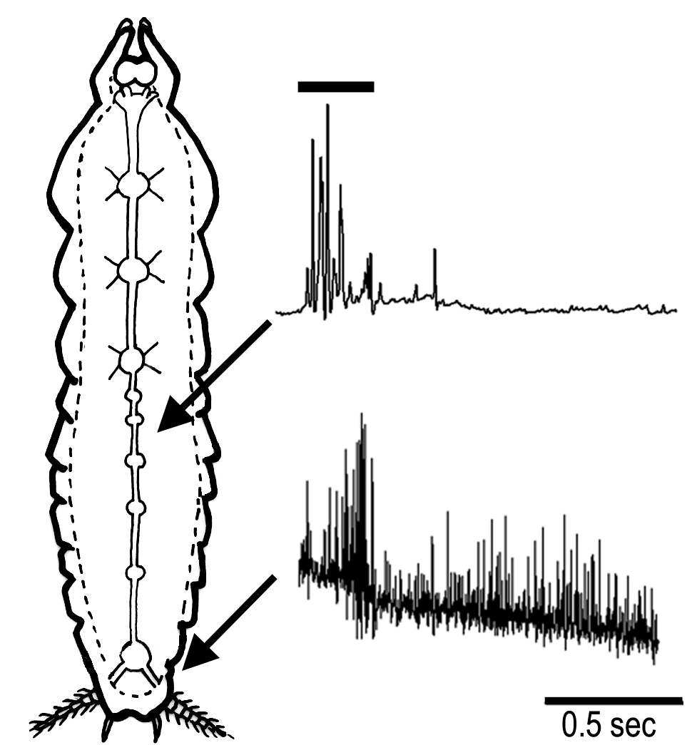
- Introductory Interview (spoken by you on camera. Don’t forget to smile!)

  - Josh Titlow: This method can provide insight into the integration of sensory neuron activity in the cock roach, it can also be applied to motor circuits, and to other model organisms.
  - Ellen Burns: Generally, individuals new to this method will struggle because the dissection is a bit challenging to dissect the animal just right to keep the sensory hairs dry and record from the primary sensory nerves.
  - Zana Majeed: Visual demonstration of this method is critical, as it is difficult to learn because it is easy to damage the nerve bundles.

Protocol Chapters (read by a voice talent at JoVE):

Authors, I’ve edited the narration to our style. It must remain concise.
- Preparing P. Americana for Electrophysiology
  - Select a male cockroach from the holding tank that has robust cerci.
    - WID: talent arrives at roach tank
  - The last segments of the male are narrow and have no ovaries and egg mass, unlike the female. The P. americana males also have a pair of short styli between the cerci, not observed in the females.
    - ECU: talent selects male from the tank

LAB MEDIA: COOPER Figure 1- male (top panel) and female (bottom panel) cockroaches.
  - Cut off the wings, legs and head. Then, pin the body, ventral side up, to a dish lined with silicone elastomer.
    - ECU: cutting off appendages and pinning the body to the silicon
  - With forceps, pick up the ventral plates and cut them off with fine scissors, starting at the posterior end and working anteriorly.
    - SCOPE: picking off the plates
  - Always keep the internal organs moist with Ringer's while trying to keep the cerci dry. This is done by using wax or rubber to raise the abdomen.
    - ECU: adding solution to the roach
    - ECU: using wax/rubber to raise the abdomen
  - If the cerci do get wet, dry them with a piece of tissue paper.
    - SCOPE: patting the cerci dry with paper
  - Next, push aside the internal organs and white matter. The VNC should now be visible between the shiny tracheae - it runs the length of the abdomen. The lighting may need to be adjusted to see the VNC.
    - SCOPE: moving tissues, hen adjusting light to show the VNC at the best level of contrast

LAB MEDIA: Cooper Figure 2 – ventral nerve cord
  - DO NOT handle the VNC with forceps or insect pins; instead manipulate it using glass probes.
    - SCOPE: VNC is pointed out with glass probe
  - Clear away the animal’s tracheae system from the nerve cord, as best as possible, with forceps.
    - SCOPE: trachea removed with forceps
  - With a pair of fine glass needles, very carefully split the VNC connectives longitudinally between the A6 and A5 or the A5 and A4 ganglia.
    - SCOPE: pointing out the two possible locations to spit the connectives and then proceeding to do so

LAB MEDIA: Cooper Figure 3- Split ventral nerve cord
  - Now, cradle the cerci and abdomen so they can be cut to fit the preparation. Use shortened insect pins and wax or a wedge of the silicone elastomer.
    - SCOPE: moving the cerci out of the saline bath with pins/wax/rubber

LAB MEDIA: Figure 4B- caudal view
  - Be extra careful in the last abdominal segment to avoid damaging the cercal nerves, which project into the ganglion.

LAB MEDIA: Figure 2D-cercal nerves
- Making Extracellular Recordings
  - The dissected preparation, microscope, and recording apparatus should be setup inside a Faraday cage to block external electric fields that could override signals from the neurons.
    - WID: talent arrives at Faraday cage

LAB MEDIA: Figure 6
  - Position the microscope so that it is overlooking the stage. Then, adjust the position of the high intensity illuminator beam to best visualize the preparation.
    - MED: talent seated at scope, adjusting its position to be over the stage
    - CU: positioning the light to shine on stage, begins with light off than talent turns it on to check the positioning
  - Connect the AC/DC differential amplifier to the integrated data recording unit. (TEXT: See Leksrisawat, B et. al. J Vis Exp, 3791, for details)
    - MED: securing the connection between the amp and recording unit
  - The headstage holding a microelectrode should be connected to the amplifier.
    - MED: securing connection between micorelectode and amp
  - To stabilize the recordings, ground the abdomen with a silver wire coated with chlorine.
    - ECU: inserting wire into abdomen of roach
  - Zana Majeed: The reason for the silver ground wire is if the solution in the body cavity looses contact with the bathing fluid in the dish, the fluid associated with the recording electrode remains grounded.
    - MED: interview shot of Zana at scope/computer, she He finishes by changing her focus to the computer
  - Next, set the recording frequency to 4 kHz.
    - SCREEN CAPTURE: dialing in the 4 kHz setting
  - Then, start the voltage scale on the trace at 500 mV. Adjust this as needed …
    - SCREEN CAPTURE: starting trace and adjusting the scale to 500 mV
  - … and set the software to run in either continuous or oscilloscope mode.
    - SCREEN CAPTURE: setting the software’s mode to continuous mode and then to oscilloscope mode, so both modes are seen
  - To the preparation, cut one of the VNC connectives close to A5. Then, place the cut end attached to A6 into a suction electrode pre-filled with Ringer's solution.
    - SCOPE: cutting the VNC close to A5, sucking solution into electrode, then placing suction electrode on A6 side of cut on VNC,
  - With a dry pipette, blow air on to the hairs located on each cercus. Check if stimulating the hairs on the cercus ipsilateral to the recorded connective gives a different response than the contralateral one.
    - ECU: pipette blows air on hairs on one side
    - MED: talent turns attention from preparation/pipette to screen, screen showing the trace in the background, then switches the pipette to the other side of the preparation
    - ECU: pipette blows air on hairs on the other side
  - Take note of the response amplitude and the frequency of the spikes.
    - MED: like 3.11.2, talent makes note in lab book of responses
  - Then, move the suction electrode to a cercal nerve for recording.
    - SCOPE: placing suction electrode on nerve
  - If the fit isn’t good, switch to an electrode tip with a smaller opening.
    - ECU: like 3.13.1 but with electode with smaller diameter tip
  - Next, cut the cercal nerve close to A6 and suck up the nerve leading to the cercus. This should result in spontaneous action potentials.
    - SCOPE: cutting nerve close to A6, and sucking up nerve leading to cercus
  - Now, blow air onto the cercus and note the responses.
    - SCOPE/ECU: blowing air on cercus (chose the shot type that is most illustrative here)
- Electrically Stimulating the Sensory Nerves to Determine Recruitment 29 to here
  - Switch the recording software to sweep mode, so that it records traces each time a stimulus is triggered. These traces should be between one and five hundered milliseconds.
    - WID: talent at computer next to Faraday cage
    - SCREEN CAPTURE: changing the software to sweep mode and then setting the length of the trace recordings
  - Connect the stimulating electrode to the output of the stimulator.
    - MED: securing the connections from the electrode to the output of the stimulator
  - Connect the stimulator cable with the two mini-hook leads or clips.
    - MED: attaching one of the mini-hook leads of stim cable {OMIT 4.3, as 4.2 and 4.4 have everything needed.
  - And connect the BNC trigger output from the stimulator to the trigger input on the recording unit.
    - MED: securing the BNC cable from the stimulator to the recording unit
  - Now, certain stimulation parameters should evoke a response. (TEXT: Duration: 0.3 sec; Delay: 10 msec; Frequency: 1 Hz) Adjust the stimulating voltage to obtain a signal just over the threshold and able to obtain a maximal response.
    - SCREEN CAPTURE: recordings being made, voltage is adjusted so the recording peaks over the threshold
  - Zana Majeed: There is no reason to go to voltages much higher than maximal threshold for recruitment, as a high voltage can be damaging to the nerve.
    - MED/WID: interview shot of Zana at computer by Faraday cage, traces being collected in background on the computer screen
  - Cut the cercal nerve as distal as possible so that a long nerve root can be pulled into the stimulating suction electrode.
    - SCOPE: cutting cercal nerve and pulling the long nerve root into stim electrode

LAB MEDIA: Figure 7
  - Now, the connective between the A6 and A5 ganglia or in a more anterior segment may be used. Draw saline into the suction electrode and then pull up a cut connective into the electrode.
    - SCOPE: cutting the connective between A6 and A5 and then attaching the suction electrode
  - Ensure that the stimulating electrode is grounded in the bath saline.
    - ECU: checking the ground condition of the stim electrode
  - Ideally, the recording electrode should be in the abdomen near A3.
    - SCOPE: position of recording electrode near A3
  - Now, deliver a series of single stimuli of increasing voltage until an action potential appears on the screen.
    - MED: applying stimuli, control is done via computer, so talent working on the computer, with screen in view, until an action potential appears
  - Make note of the minimal stimulating voltage and duration to recruit a response. Start low and increase the intensity until a synaptic response in the connectives is observed.
    - MED: talent writes down some information into lab book
    - Like 4.10.1, {I think they meant 4.11.1} only now the responses on the screen get progressively more dramatic
  - The large spike, an extracellular action potential, from the giant axons will appear first, and then other smaller action potentials may also be observed.
    - SCREEN CAPTURE: the large spike and other smaller action potentials
- Recordings from Connectives Between A3 and A4
  - By puffing air at the cerci, large spikes were observed in the connectives.

LAB MEDIA: Figure 8A
  - Using this stimulating paradigm, recordings from the connectives between A3 and A4 typically showed a large spike characteristic of the giant interneurons. Recording from a cercal nerve while physically rubbing the cerci with tweezers produced a strong burst of activity.

LAB MEDIA: Figure 8B₁
  - In another recording, 2 puffs of air each produced a rapid bursting response in the cercal nerve.

LAB MEDIA: Figure 8B₂
  - When electrically stimulating the cercal nerve with a suction electrode and recording in the connective between A3 and A4, a threshold in the stimulation to evoked responses was recorded.

LAB MEDIA: Figure 8C₁
  - Electrical stimulation of the cercal nerve clearly elicits a response in connectives that can be quantified for manipulative studies with pharmacological agents or with local environmental parameters.

LAB MEDIA: Figure 8C₂

- Conclusion Interview (spoken by you on camera)
  - Ellen Burns: Once mastered, this technique can be done in about an hour if it is performed properly.
  - Zana: While attempting this procedure, it’s important to remember to not to pinch the nerves with the tweezers or pull too hard with the suction electrode.
  - Josh Titlow: After watching this video, you should have a good understanding of how to dissect the leech cockroach nervous system and collect extracellular recordings.

All the provided file names are as listed in the above steps, which also provide their description.

General Preparation

It’s critical for a smooth and organized shoot that all reagents are accounted for, in advance.

Any overnight or long incubation steps should be recognized and specimens/samples be prepared in advance so that prior steps can be recorded and shooting can continue with pre-prepared specimens/samples.

All tubes/flasks should be pre-labeled neatly before we arrive.

Ex. Luciferase assay done in 96 well plates should be labeled with negative/positive control wells and experimental samples are labeled accordingly.

