TITLE:
Imaging of Biological Tissues by Desorption Electrospray Ionization Mass Spectrometry

AUTHORS:
Rachel V. Bennett,†¹ Chaminda M. Gamage,†¹ Facundo M. Fernández¹

†These authors made equal contributions to the body of work.
¹School of Chemistry and Biochemistry, Georgia Institute of Technology, Atlanta, GA 30332 (USA)

CORRESPONDING AUTHOR:
Facundo M. Fernández
School of Chemistry and Biochemistry
Georgia Institute of Technology
901 Atlantic Dr. NW
Atlanta, GA 30332

E-mail: facundo.fernandez@chemistry.gatech.edu
Ph: 404 385 4432
Fax: 404 385 6447
KEYWORDS:
Desorption electrospray ionization
Ambient mass spectrometry
Imaging
Tissue

SHORT ABSTRACT:
Desorption electrospray ionization mass spectrometry (DESI-MS) is an ambient method by which samples, including biological tissues, can be imaged with minimal sample preparation. By rastering the sample below the ionization probe, this spray-based technique provides sufficient spatial resolution to discern molecular features of interest within tissue sections.

LONG ABSTRACT:
Mass spectrometry imaging (MSI) provides untargeted molecular information with the highest specificity and spatial resolution for investigating biological tissues at the hundreds to tens of microns scale. When performed under ambient conditions, sample pre-treatment becomes unnecessary, thus simplifying the protocol while maintaining the high quality of information obtained. Desorption electrospray ionization (DESI) is a spray-based ambient MSI technique that allows for the direct sampling of surfaces in the open air, even in vivo. When used with a software-controlled sample stage, the sample is rastered underneath the DESI ionization probe, and through the time domain, m/z information is correlated with the chemical species’ spatial distribution. The fidelity of the DESI-MSI output depends on the source orientation and positioning with respect to the sample surface and mass spectrometer inlet. Herein, we review how to prepare tissue sections for DESI imaging and additional experimental conditions that directly affect image quality. Specifically, we describe the protocol for the imaging of rat brain tissue sections by DESI-MSI.

INTRODUCTION:
Untargeted imaging by mass spectrometry facilitates the acquisition of chemical information for discovery and hypothesis-generating applications. Targeted imaging of a known chemical of interest, on the other hand, can facilitate increased sensitivity and selectivity through specific method development. Mass spectrometry imaging (MSI) is most commonly performed on tissues using MALDI,¹ secondary ion mass spectrometry (SIMS),² and ambient ionization techniques, including desorption electrospray ionization (DESI),³ laser ablation-electrospray ionization (LAESI),^{4,5} and liquid micro-junction-surface sampling probe (LMJ-SSP).⁶ In MALDI and SIMS, samples have to be physically removed from the specimen, and have to be flat and thin, as they are analyzed under high-vacuum. MALDI requires coating of the sample with a radiation-absorbing matrix, adding an additional and cumbersome step to the sample preparation. SIMS has the highest lateral resolution, but bombardment with highly energetic particles causes extensive molecular fragmentation. Therefore, MSI by ambient methods fill a niche where soft analysis with minimal sample preparation is desirable. However, to date, all methods are still limited by the requirement of flat sample surfaces.
DESI uses a pneumatically-assisted charged solvent spray directed at the sample surface to desorb and ionize analytes.⁷ The working model for desorption and subsequent ionization by DESI is known as the “droplet pick-up model”.⁸⁻¹⁰ The charged primary droplets produced by the DESI probe collide with the surface, wetting it and forming a thin film into which the analyte is dissolved by a solid-liquid microextraction mechanism.⁸ Subsequent droplet collisions result in momentum transfer and takeoff of secondary droplets containing the material extracted from the surface.^{9,10} Ultimately, gas phase ions are believed to be produced through ESI-like processes following the ion evaporation, charge residue models or other models,¹¹ however the precise ion formation process in DESI has yet to be experimentally proven.¹² DESI sensitivity is strongly dependent upon the solubility of the analyte in the spray solvent, as desorption relies on the localized microextraction.¹³
When used with a software-controlled sample stage, the sample is scanned unidirectionally with lane stepping underneath the DESI ionization probe, and through the time domain, m/z information is correlated with the chemical species’ spatial distribution (Figure 1). Since the first proof of principle DESI-MSI experiment reported by Van Berkel and Kertesz in 2006,¹⁴ the technique has matured considerably,¹⁵ with reported applications in the analysis of lipids,^{3,16} drug metabolites,^{17,18} disease biomarkers,¹⁹ brain tissue,^{3,18,20} lung tissue,¹⁸ kidney tissue,¹⁸ testis tissue,¹⁸ adrenal glands,¹⁷ thin layer chromatography plates,²¹ and algae surfaces.²² The routine resolution of images obtained by DESI-MSI is 100-200 μm, which is ultimately determined by the effective surface area extracted by the spray, but resolutions as low as 40 µm have been reported.²³⁻²⁵ Such resolution and ease of analysis makes DESI-MSI appropriate for the rapid and simple analysis of biological tissue samples with surface areas in the 0.5-5 cm² range, enabling the acquisition of valuable spatial information to better understand biological processes²⁶. Here, as an example of a typical DESI-MSI application, we review the procedural details of conducting a successful experiment involving imaging of lipids in rat brain tissues. The two most critical steps in the protocol are the tissue preparation²⁷ and DESI ion source optimization, as described below.

PROCEDURE:
- Tissue Sectioning

  - Store flash-frozen, whole tissue in -80 °C freezer until ready for sectioning.

  - Allow the tissue sample to reach the temperature in the cryomicrotome prior to sectioning (30 min). Set the blade and sample temperature to -30 °C.

  - Once tissue has reached the temperature, handling the specimen with tweezers, cut front or back of brain depending on what part of the brain is of interest for sufficient mounting surface (i.e. if the front of the brain is of primary importance, mount rear of brain on chuck).

    - Apply ~0.5 mL Optimal Cutting Temperature Compound (OCT, Tissue-Tek, Sakura) to chuck in center and, using tweezers, hold sample in place in OCT until it solidifies. Once OCT is completely frozen, mount chuck in sample holder.
    - A minimal amount of OCT used to mount the sample is preferred (in contrast to mounting the specimen in a block of OCT as is commonly done in other histological procedures) to minimize the contamination of the sample. Contamination of the sample by OCT is detrimental to the DESI and imaging process due to ion suppression.

  - Typical tissue sections necessary for MS imaging range from 12-18 µm in thickness. Section tissues at desired thickness within the recommended range. Thaw-mount each sectioned tissue by lightly touching a room-temperature microscope glass slide over section. Once a sample is mounted, use caution not to touch the tissue section as it will change the chemical distributions and compositions.
Note: We recommend mounting two sections per slide, using one section for optimization, and the other for imaging. If sections are not for immediate imaging, store slides in -80 °C freezer in a slide box until ready for analysis.

  - If analyzing stored sections, remove slide from freezer, immediately transfer to vacuum desiccator, and allow ~15-20 minutes to thaw. Leaving the specimen in the desiccator longer will dry the sample and reduce DESI efficiency. The optimization of the DESI ion source will be done with the tissue sample once it has thawed, however, in the interest of time, the period during which the sample is thawing serves as an ideal time for the initialization of the equipment.

    - Using acetonitrile with 1% acetic acid as the DESI solvent, turn on the syringe pump with a flow rate of 5 μL/min. A lower flow rate will reduce the impact spot side of the DESI spray and effective pixel size, but a higher flow rate may be necessary for sufficient sensitivity. Therefore the flow rate (typically 1-5 μL/min) should be optimized for each application and the desired sensitivity and resolution. Ensure that the syringe contains enough solvent for complete optimization and imaging at given flow rate.

    - Once the solvent appears dripping out of the source tip, turn on the nitrogen nebulizing gas with a pressure of 160 psi.

    - Turn on the high voltage power supply connected to ion source applying 3600 V.

  - Mount the slide on the motion stage and begin ion source and MS optimization

- DESI optimization

  - The DESI system consists of a source probe (see Figure 2), a syringe and pump or alternative solvent delivery system, compressed nitrogen, translation sample stage and mount. Proceed with DESI source optimization once the mass spectrometer has been tuned for the appropriate mass range and analytes of interest.

    - If the source components have not been turned on yet, refer to sections 1.7.1-3 for directions.

      - The variables discussed in these sections are recommended for imaging of biological tissues. However these variables should be optimized for different types of tissue or sample. Alternative solvents, flow rates, nebulizing gas pressures and voltages have been reported for imaging of biological tissues.¹⁶⁻¹⁸

  - Ensure that initially the DESI source is not touching the glass slide, and not directed at any part of the tissue section. This will ensure that the probe isn’t damaged in the initial optimization process and will not contaminate any part of the set up by coming into contact with the tissue sample.

      - A good starting position is with the tip 3 mm from the sample surface and 5 mm from the MS capillary inlet, with the probe at an angle of 55° with respect to the sample surface. The inner capillary of the DESI probe should extend ~1mm beyond the outer capillary. All of these parameters will be optimized.

  - The MS interface capillary should have a collection angle of ~15° with respect to the sample surface for optimal transfer of ions. Adjust the stage height so that the MS capillary hovers over the sample surface; the capillary should be <1 mm from the surface, as close as possible without touching.

  - Align the DESI probe in the x dimension with respect to the MS capillary inlet so that they are directly in line.

  - Adjust the y and z positions of the DESI source for optimal sensitivity using the extra tissue section. Note that as the DESI probe is directed at one sample area, it will eventually desorb and ionize all of the analytes in that area and signal will gradually decrease as this occurs. Performing this step as quickly as possible is important.

    - Therefore, throughout the optimization process, the sample needs to be moved underneath the spray head to ensure that fresh sample is being analyzed and that any changes in signal are due to source optimization, not sample depletion. However, considering that the varied chemical composition of different regions of the tissue, a direct comparison of ion intensity across the entire tissue section is not wholly accurate. The thalamus of the brain provides a reasonably large-sized area with more consistent chemical composition, but still not perfectly uniform. Alternatively, a marking of red Sharpie®, which contains the dye rhodamine 6G ([M]⁺, m/z 443), on the glass slide away from the sample provides a strong MS response by DESI and can also be used for optimization, but given the different sample form and analyte, these conditions may still not correlate to an ideal set-up for biological tissues.

    - Recommended y separation between source tip and capillary inlet: ~4 mm, recommended z separation between tip and sample surface: ~1.5 mm. Though these parameters will be slightly different for each experimental set-up.

    - Considering the geometry and angle of the probe, take into account that the y and z-dimension positions are inter-related with respect to the effective transmission of solvent and analyte-containing droplets. A change in one variable will require a subsequent modification in the other to maintain the same spray impact position and its transmission angles.

  - Adjust the distance the inner capillary extrudes from the outer capillary of the source for maximum sensitivity, and minimal impact spot size. Caution: Ensure that the high voltage is OFF while making this adjustment.

  - The source geometry will be considered optimal when the maximum signal is observed.

    - The variables optimized in sections 2.5-2.6 are inter-related, therefore the adjustment of one will inherently require the re-adjustment of the other to maintain the necessary source-sample-inlet geometry, or adjustment of conditions discussed in section 1.7.1-3.

  - Additionally, a heating element surrounding the transfer capillary to the mass spectrometer may improve sensitivity by facilitating desolvation of the charged analyte droplets produced during the ionization process. Here we use a rope heater coiled around the transfer capillary set to 100 °C.

- Tissue Imaging

  - During the imaging process, the sample stage moves the sample beneath the DESI probe and MS inlet capillary and all other components remain stationary. The motion parameters of the stage should be selected based on DESI impact plume size and optimal sensitivity.

    - A larger impact plume will result in a higher ion intensity, given that more sample is being desorbed, however for imaging, it will also result in a larger pixel size and thus worse image resolution.

  - The translation stage used in this experiment is home-built and controlled by a LabView program that allows for control of rastering speed and line spacing for an image of given dimensions. The stage motion control VI used in this experiment is available at omnispect.bme.gatech.edu. Alternatively, a commercially-available DESI source and stage could be used such as the 2-D automated Omni Spray source from Prosolia Inc. (Indianapolis, IN USA).

    - For brain tissues a typical image size is 10 x 15mm, and given the stage motion parameters used, the image will take approximately 3 hours.

      - Program the LabView VI or equivalent control software for desired imaging conditions, using a stage scan speed of 80 μm/s, and line spacing between rows of 200 μm. When using the Omni Spray source, motion parameters should be set for a scan speed of 100-200 μm/s and a line spacing of 200 μm. Note that these motion parameters can be changed depending on the number of desired pixels in each dimension and necessary sensitivity.
        - A smaller line spacing has been shown to improve the image quality, with the scan speed having less of an effect.²⁵ However, it is significant to note that this does not necessarily indicate and improved image resolution, as that is strongly dependent on impact spot size. A slower scan speed and smaller line spacing will significantly increase the time of analysis and must therefore be optimized for each type of tissue or sample.

      - With the MS spectral acquisition set at 1 scan/s, and the image created as 1 pixel/scan, the stage speed defines the pixel size in the x dimension, whereas the line spacing determines the pixel size in the y dimension. Although the true pixel size of the image is larger than this due to spray spreading, slower motion allows more time for desorption and detection of analytes.

    - Give directory path and file name for position and time files to be recorded during images within the LabView VI.

  - In preparation for mass spectral data acquisition, calculate the total time required for imaging. The Labview program used by our group automatically provides this value, but if alternative stage control is used, this calculation is necessary for the MS data acquisition settings.

    - When using an Omni Spray automated source and stage, each line of the image is acquired as individual runs. The time-per-line and number of lines necessary for given imaging dimensions are calculated using the Omni Spray control software to be input into the mass spectrometer software.

  - Ensure that the mass spectrometer scan speed is 1 spectrum/s, and set the instrument acquisition time to match the total time calculated.

    - Set spectral scan speed to 1 spectrum/s.

    - Acquire data in PROFILE mode and ensure that the m/z range is appropriate for the species of interest. Remember that DESI also produces multiply charged analytes, as in ESI.

    - Set acquisition time to match total image time given by LabView.

  - Position the spray impact spot in the top-left of the area to be imaged.

  - Begin acquisition of MS data and stage motion simultaneously.

  - Upon conclusion of the data acquisition, return mass spectrometer to STANDBY mode.

  - Turn off high voltage of DESI source.

  - Turn off nitrogen gas.

  - Turn off syringe pump.

- Image Processing

  - Mass spectral data, in combination with stage time and position data saved as text files through LabView must be “folded” into a 2D image correlating coordinates of pixels with the corresponding spectra. The images presented here were processed using Matlab-based software that is freely available at: omnispect.bme.gatech.edu. If data is acquired using the Omni Spray source, the Firefly data conversion software is used to create the data cube for image visualization in BioMAP (www.maldi-msi.org).

  - For data acquired on the Jeol AccuTOF mass spectrometer, the recorded chromatogram must be exported in .cdf format for further analysis.

    - Using the DataManager within MassCenter, first convert acquired data to centroided data (Tools →Convert Acquistion Data to Centroid). Then export data in .cdf format by using the keyboard combination Ctrl+Shift+E followed by Tools → Export.

  - Upload the raw .cdf mass spectral data and the two text files, position and time, to the OmniSpect website. Firefly-processed imaging data can be visualized in BioMAP.

    - Further processing of the data including statistical analysis by Non-Negative Matrix Factorization or plotting of a single ion of interest can be performed directly on the website.

    - Alternatively, the raw data cube can be exported for analysis in Matlab.

REPRESENTATIVE RESULTS:
Figure 3 shows a representative spectrum obtained from an untreated rat brain section. In the positive mode, the mass spectrum is dominated by phosphatidylcholines due to their high ionization efficiencies (attributed to the positively charged quaternary ammonium group). The total ion image of the tissue section is also shown in Figure 3, showing abundant signal across the entire brain section. Key lipids detected are identified in Table 1 through literature comparisons.
The spatial distribution of example lipids (Figure 4) show how the relative abundance of different phosphatidylcholine species varies between grey and white matter of the brain. For example, [PC 34:1 + K]⁺, m/z 798.5364, shows increased intensity in the cerebellar cortex (gray matter), whereas [PC 36:1 + K]⁺, m/z 826.5558, shows increased intensity in the cerebellar peduncle (white matter). The composite image obtained for the two ions (Figure 4c) highlights the contrast in lipid distribution across the tissue section. The spatial distributions of other key lipids in the brain are also listed in Table 1. These distributions agree with previous studies.²⁸⁻³⁰

Tables and Figures

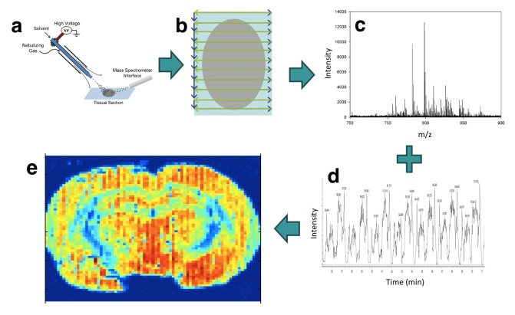
Figure 1. Schematic of the DESI-MSI imaging process. DESI (a) is used for the surface analysis of tissues, and when the sample is rastered in a controlled motion (b) below the source, mass spectral data, intensity vs m/z (c), as a function of time (d) is acquired. This data is then correlated through the time domain with the motion parameters to form a chemical image (e).

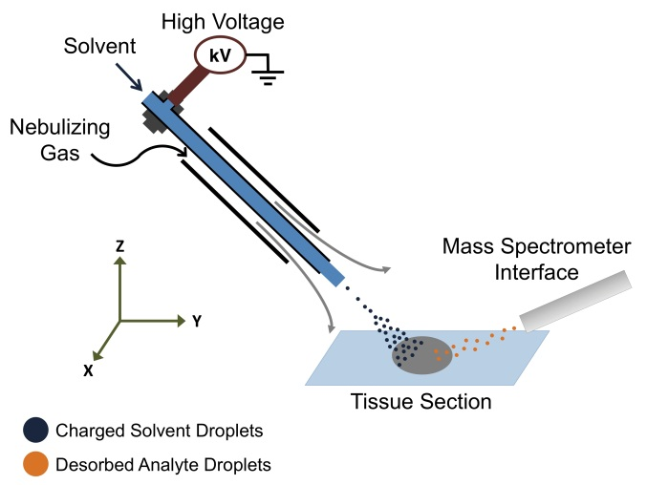
Figure 2. Schematic of DESI source.

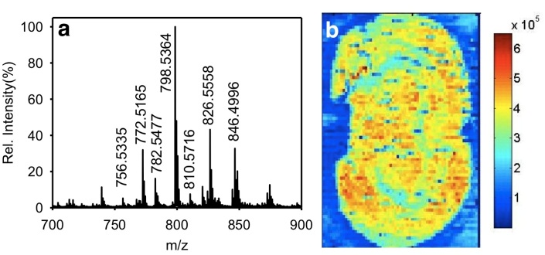
Figure 3. Average whole-tissue spectrum with more abundant m/z values labeled (a) and total ion image (b) acquired by DESI-MSI in positive ion mode.

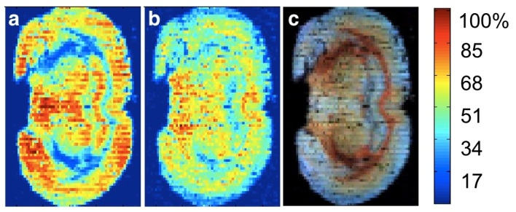
Figure 4. Selected ion images of key phosphocholines in rat brain tissue acquired by DESI-MSI in positive ion mode; (a) [PC 34:1 + K]⁺, m/z 798.5364; (b) [PC 36:1 + K]⁺, m/z 826.5558; (c) composite image of m/z 798, blue, and 826, red.

Table 1. Key lipid identities and localization within the brain section.
Species | m/z | Localization (matter)
[PC 32:0 + Na]⁺ | 756.5335 | Gray
[PC 32:0 + K]⁺ | 772.5165 | Gray
[PC 36:4 + H]⁺ | 782.5477 | White
[PC 34:1 + K]⁺ | 798.5364 | Gray
[PC 38:4 + H]⁺ | 810.5716 | White
[PC 36:1 + K]⁺ | 826.5558 | White

DISCUSSION:
The optimization of the DESI source geometry is critical for successful MSI experiments. The multiple variables contributing to the alignment of the system directly affect sensitivity and image resolution. If during optimization, the experimenter has difficulties obtaining signal, we recommend using red Sharpie® spot drawn on the slide as a benchmark; the dye, rhodamine 6G, m/z 443, produces a strong signal in the positive ion mode and can be used for initial optimization. Additionally, the solvent selection for DESI is crucial for sensitivity, as analyte transmission and ionization depends on the extraction of the analyte from the surface into the thin film formed.¹³ Many electrospray ionization-compatible solvents and mixtures can be used to assist in the desolvation and ionization process depending on the class of compound of interest during the analysis.

As previously mentioned, the resolution of the DESI-MS image depends primarily on the source geometry. Image resolution on the order of 200 μm is regularly obtained by DESI-MSI, though this is higher than laser-based and/or in vacuo imaging methods which can range from ~10-150 μm.^{5,31} Resolution as high as 40 μm has been reported using DESI,²⁴ however, 200 μm for routine imaging is sufficient for analysis of large biological tissue sections. The quality of the inner fused silica capillary of the DESI source will also affect image quality and resolution. The recommended inner diameter of the capillary is 50μm, as large i.d. capillaries produce larger sprays and larger image resolution.²⁵ If this capillary is not cut squarely or is cracked, the spray will not be conical resulting in irregularly shaped impact spot, poor-quality and irreproducible images.

Not only does the source geometry affect the resolution of DESI-MSI, it also plays a significant role in the sensitivity of the method. Therefore the geometry must be optimized and kept constant throughout the procedure. If the sample is not planar, or is not mounted perfectly horizontally, the source geometry will change, thus changing the response and creating an artifact within the image.²³ Although DESI-MSI is limited to planar samples, 3D imaging of biological tissues is made possible through the 2D imaging of serial tissue sections which are then stacked into a three dimensional image.³² This approach can also be employed for other MSI methods, including SIMS, MALDI, LAESI, etc. ³³ Three-dimensional mass spectrometry images can also be created by the gradual removal of layers of material, by laser pulses for example, and reimaging.³⁴

The positive mode analysis of rat brain tissues facilitates successful imaging of phosphatidylcholines and some drugs and metabolites.¹⁸ To complement this analysis, imaging in negative mode produces a spectrum with a greater diversity of classes of lipids,^{28,35} and can be used to provide a comprehensive analysis of the tissue sections. In cases where more than one lipid species can be attributed to a particular m/z value, tandem mass spectrometry can be used for identification. Tandem mass spectrometry also serves as an additional method of lipid identity confirmation.³⁵

Ambient mass spectrometry imaging by DESI has been shown to be effective in the imaging of lipid species in rat brain tissue. Information obtained through MSI experiments can provide insight into diseases associated with altered levels of phospholipids such as Alzheimer disease, Down syndrome, and diabetes, among others.³⁶⁻³⁸ Given the high abundance of lipids and their roles in biological processes, many biological systems exist that would benefit from the information obtained via mass spectrometry imaging. With many potential methods to image biological samples using mass spectrometry, ambient ionization methods, DESI in particular, provide a means to do so with reduced sample preparation and increased ease of analysis.

ACKNOWLEDGMENTS:
This work is supported by ARRA NSF MRI Instrument Development grant #0923179 to FMF. We thank Aqua Asberry, Lab Coordinator for the Parker H. Petit Institute for Bioengineering and Biosciences Histology Core, for assistance with tissue sectioning.

DISCLOSURES

The authors declare that they have no competing financial interests.

REFERENCES

1 Caprioli, R. M., Farmer, T. B. & Gile, J. Molecular Imaging of Biological Samples: Localization of Peptides and Proteins Using MALDI-TOF MS. Anal. Chem. 69, 4751-4760, doi:10.1021/ac970888i (1997).
2 Pacholski, M. L. & Winograd, N. Imaging with Mass Spectrometry. Chem. Rev. 99, 2977-3006, doi:10.1021/cr980137w (1999).
3 Wiseman, J. M., Ifa, D. R., Song, Q. & Cooks, R. G. Tissue Imaging at Atmospheric Pressure Using Desorption Electrospray Ionization (DESI) Mass Spectrometry. Angew. Chem. Int. Ed. 45, 7188-7192, doi:10.1002/anie.200602449 (2006).
4 Nemes, P. & Vertes, A. Laser Ablation Electrospray Ionization for Atmospheric Pressure, in Vivo, and Imaging Mass Spectrometry. Anal. Chem. 79, 8098-8106, doi:10.1021/ac071181r (2007).
5 Nemes, P. & Vertes, A. Atmospheric-pressure Molecular Imaging of Biological Tissues and Biofilms by LAESI Mass Spectrometry. J. Vis. Exp., e2097, doi:10.3791/2097 (2010).
6 Van Berkel, G. J., Kertesz, V., Koeplinger, K. A., Vavrek, M. & Kong, A.-N. T. Liquid microjunction surface sampling probe electrospray mass spectrometry for detection of drugs and metabolites in thin tissue sections. J. Mass Spectrom. 43, 500-508, doi:10.1002/jms.1340 (2008).
7 Takáts, Z., Wiseman, J. M., Gologan, B. & Cooks, R. G. Mass Spectrometry Sampling Under Ambient Conditions with Desorption Electrospray Ionization. Science 306, 471-473, doi:10.1126/science.1104404 (2004).
8 Venter, A., Sojka, P. E. & Cooks, R. G. Droplet Dynamics and Ionization Mechanisms in Desorption Electrospray Ionization Mass Spectrometry. Anal. Chem. 78, 8549-8555, doi:10.1021/ac0615807 (2006).
9 Costa, A. B. & Cooks, R. G. Simulation of atmospheric transport and droplet-thin film collisions in desorption electrospray ionization. Chem. Commun., 3915-3917 (2007).
10 Costa, A. B. & Graham Cooks, R. Simulated splashes: Elucidating the mechanism of desorption electrospray ionization mass spectrometry. Chem. Phys. Lett. 464, 1-8, doi:10.1016/j.cplett.2008.08.020 (2008).
11 Konermann, L., Ahadi, E., Rodriguez, A. D. & Vahidi, S. Unraveling the Mechanism of Electrospray Ionization. Anal. Chem. 85, 2-9, doi:10.1021/ac302789c (2012).
12 Kebarle, P. & Verkerk, U. H. Electrospray: From ions in solution to ions in the gas phase, what we know now. Mass Spectrom. Rev. 28, 898-917, doi:10.1002/mas.20247 (2009).
13 Green, F. M., Salter, T. L., Gilmore, I. S., Stokes, P. & O'Connor, G. The effect of electrospray solvent composition on desorption electrospray ionisation (DESI) efficiency and spatial resolution. Analyst 135, 731-737 (2010).
14 Van Berkel, G. J. & Kertesz, V. Automated Sampling and Imaging of Analytes Separated on Thin-Layer Chromatography Plates Using Desorption Electrospray Ionization Mass Spectrometry. Anal. Chem. 78, 4938-4944, doi:10.1021/ac060690a (2006).
15 Ifa, D. R., Wu, C., Ouyang, Z. & Cooks, R. G. Desorption electrospray ionization and other ambient ionization methods: current progress and preview. Analyst 135, 669-681 (2010).
16 Eberlin, L. S., Ferreira, C. R., Dill, A. L., Ifa, D. R. & Cooks, R. G. Desorption electrospray ionization mass spectrometry for lipid characterization and biological tissue imaging. Biochim. Biophys. Acta 1811, 946-960, doi:10.1016/j.bbalip.2011.05.006 (2011).
17 Wu, C., Ifa, D. R., Manicke, N. E. & Cooks, R. G. Molecular imaging of adrenal gland by desorption electrospray ionization mass spectrometry. Analyst 135, 28-32 (2010).
18 Wiseman, J. M. et al. Desorption electrospray ionization mass spectrometry: Imaging drugs and metabolites in tissues. Proc. Natl. Acad. Sci. 105, 18120-18125, doi:10.1073/pnas.0801066105 (2008).
19 Eberlin, L. S. et al. Classifying Human Brain Tumors by Lipid Imaging with Mass Spectrometry. Cancer Res. 72, 645-654, doi:10.1158/0008-5472.can-11-2465 (2012).
20 Wiseman, J. M., Ifa, D. R., Venter, A. & Cooks, R. G. Ambient molecular imaging by desorption electrospray ionization mass spectrometry. Nat. Protocols 3, 517-524 (2008).
21 Van Berkel, G. J., Ford, M. J. & Deibel, M. A. Thin-Layer Chromatography and Mass Spectrometry Coupled Using Desorption Electrospray Ionization. Anal. Chem. 77, 1207-1215, doi:10.1021/ac048217p (2005).
22 Lane, A. L. et al. Desorption electrospray ionization mass spectrometry reveals surface-mediated antifungal chemical defense of a tropical seaweed. Proc. Natl. Acad. Sci. 106, 7314-7319, doi:10.1073/pnas.0812020106 (2009).
23 Kertesz, V. & Van Berkel, G. J. Scanning and Surface Alignment Considerations in Chemical Imaging with Desorption Electrospray Mass Spectrometry. Anal. Chem. 80, 1027-1032, doi:10.1021/ac701947d (2008).
24 Kertesz, V. & Van Berkel, G. J. Improved imaging resolution in desorption electrospray ionization mass spectrometry. Rapid Commun. Mass Spectrom. 22, 2639-2644, doi:10.1002/rcm.3662 (2008).
25 Campbell, D., Ferreira, C., Eberlin, L. & Cooks, R. Improved spatial resolution in the imaging of biological tissue using desorption electrospray ionization. Anal. Bioanal. Chem. 404, 389-398, doi:10.1007/s00216-012-6173-6 (2012).
26 Chaurand, P., Cornett, D. S., Angel, P. M. & Caprioli, R. M. From Whole-body Sections Down to Cellular Level, Multiscale Imaging of Phospholipids by MALDI Mass Spectrometry. Mol. Cell. Proteomics 10, doi:10.1074/mcp.O110.004259 (2011).
27 Dill, A., Eberlin, L., Costa, A., Ifa, D. & Cooks, R. Data quality in tissue analysis using desorption electrospray ionization. Anal. Bioanal. Chem. 401, 1949-1961, doi:10.1007/s00216-011-5249-z (2011).
28 Jackson, S. N., Wang, H.-Y. J. & Woods, A. S. Direct Profiling of Lipid Distribution in Brain Tissue Using MALDI-TOFMS. Anal. Chem. 77, 4523-4527, doi:10.1021/ac050276v (2005).
29 Jackson, S. N. et al. MALDI-ion mobility-TOFMS imaging of lipids in rat brain tissue. J. Mass Spectrom. 42, 1093-1098, doi:10.1002/jms.1245 (2007).
30 Wang, H.-Y. J., Post, S. N. J. J. & Woods, A. S. A minimalist approach to MALDI imaging of glycerophospholipids and sphingolipids in rat brain sections. Int. J. Mass spectrom. 278, 143-149, doi:10.1016/j.ijms.2008.04.005 (2008).
31 Wu, B. & Becker, J. S. Imaging of elements and molecules in biological tissues and cells in the low-micrometer and nanometer range. Int. J. Mass spectrom. 307, 112-122, doi:10.1016/j.ijms.2011.01.019 (2011).
32 Eberlin, L. S., Ifa, D. R., Wu, C. & Cooks, R. G. Three-Dimensional Vizualization of Mouse Brain by Lipid Analysis Using Ambient Ionization Mass Spectrometry. Angew. Chem. Int. Ed. 49, 873-876, doi:10.1002/anie.200906283 (2010).
33 Seeley, E. H. & Caprioli, R. M. 3D Imaging by Mass Spectrometry: A New Frontier. Anal. Chem. 84, 2105-2110, doi:10.1021/ac2032707 (2012).
34 Nemes, P., Barton, A. A. & Vertes, A. Three-Dimensional Imaging of Metabolites in Tissues under Ambient Conditions by Laser Ablation Electrospray Ionization Mass Spectrometry. Anal. Chem. 81, 6668-6675, doi:10.1021/ac900745e (2009).
35 Pulfer, M. & Murphy, R. C. Electrospray mass spectrometry of phospholipids. Mass Spectrom. Rev. 22, 332-364, doi:10.1002/mas.10061 (2003).
36 Han, X., Holtzman, D. M. & McKeel, D. W. Plasmalogen deficiency in early Alzheimer's disease subjects and in animal models: molecular characterization using electrospray ionization mass spectrometry. J. Neurochem. 77, 1168-1180, doi:10.1046/j.1471-4159.2001.00332.x (2001).
37 Murphy, E. J., Schapiro, M. B., Rapoport, S. I. & Shetty, H. U. Phospholipid composition and levels are altered in down syndrome brain. Brain Res. 867, 9-18, doi:10.1016/s0006-8993(00)02205-8 (2000).
38 Han, X. et al. Alterations in Myocardial Cardiolipin Content and Composition Occur at the Very Earliest Stages of Diabetes: A Shotgun Lipidomics Study. Biochemistry 46, 6417-6428, doi:10.1021/bi7004015 (2007).

