Submission ID #: 50545

Editor Name: Roslyn A. Bauer

Videographer name: Danae Mauro

Film Date: 4/29/2013

Authors:
Lorenzo Albertazzi, Barbara Storti, Marco Brondi, Giovanni Signore, Sebastian Sulis Sato, Gian Michele Ratto and Fabio Beltram

Authors: institution(s)/affiliation(s) for each author:
Lorenzo Albertazzi
Institute for Complex Molecular Systems & Laboratory of Macromolecular and Organic Chemistry, Eindhoven University of Technology &
NEST, Scuola Normale Superiore and Istituto Nanoscienze-CNR
L.Albertazzi@tue.nl

Barbara Storti
NEST, Scuola Normale Superiore and Istituto Nanoscienze-CNR & IIT@NEST, Center for Nanotechnology Innovation
barbara.storti@sns.it

Marco Brondi
NEST, Scuola Normale Superiore and Istituto Nanoscienze-CNR & IIT@NEST, Center for Nanotechnology Innovation
marco.brondi@sns.it

Sebastian Sulis Sato
NEST, Scuola Normale Superiore and Istituto Nanoscienze-CNR & IIT@NEST, Center for Nanotechnology Innovation
sebastian.sulissato@sns.it

Gian Michele Ratto
NEST, Scuola Normale Superiore and Istituto Nanoscienze-CNR
gianmichele.ratto@sns.it

Giovanni Signore
IIT@NEST, Center for Nanotechnology Innovation
giovanni.signore@iit.it

Fabio Beltram
NEST, Scuola Normale Superiore and Istituto Nanoscienze-CNR & IIT@NEST, Center for Nanotechnology Innovation
f.beltram@sns.it

Title: Synthesis, cellular delivery and in vivo application of dendrimer-based pH sensors

Authors, please fill out the brief questionnaire below.

A. Will you require assistance with video microscopy, such as filming a complex dissection or microinjection technique (Y/N, please specify steps by number. Also, please list make and model of your microscope)? No
B. Does your protocol include detailed, step-by-step, descriptions of software usage (Y/N, please specify steps by number)? No
C. Which steps of your protocol will viewers benefit most from having filmed? Please list 4-6 steps_1-Synthesis, 2- Cell Culture and Electroporation, 3- pH sensing in living HeLa cells, 4- In vivo sample preparation, 5- pH imaging in mouse brain
D. What is the single most difficult aspect of this procedure and what do you do to ensure success? The in vivo pH imaging. Success is strongly depending on the careful application of the protocol.

1. Introduction (Schematic Overview and Interview)

A. Schematic Overview (read by voice talent at JoVE):

- Conceptual Narrative:
  - The overall goal of the following experiment is to develop new fluorescent sensors based on dendrimers, with improved properties for pH imaging in vitro, in living cells and in vivo. (Intro).

  - This is achieved by first conjugating pH sensitive dyes to a dendritic scaffold together with other moieties such as targeting groups or pH insensitive dyes and in vitro measurements are taken to generate a pH curve. (TOP IMAGES and left image)

  - Next, to image pH in living cells, the sensor is delivered by electroporation, and pH maps are generated using confocal microscopy. (Bottom middle set)

  - To image pH in the extracellular space of the brain during physiological and pathological neural activity, the sensor is microinjected into the brain of anhestetized mice. Fluorescence data is then captured using confocal microscopy, as before. (Bottom Right Set).

  - Results obtained show that dendrimer-based sensors succeed to measure pH changes with high spatial and temporal resolution both in living cells and in vivo. (50545_Albertazzi_Figure4).

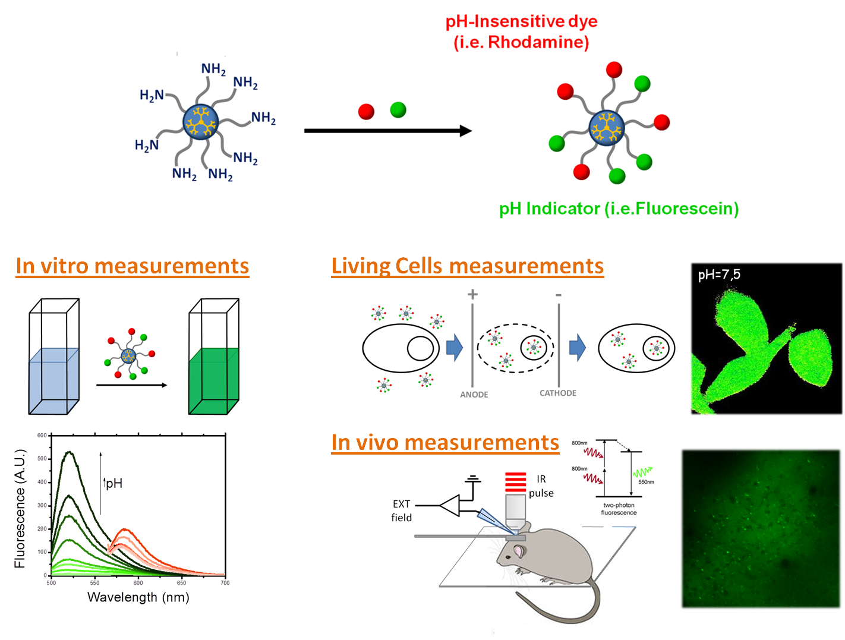

- Interview: (Said by you on camera. Don’t forget to smile!)
  - [Albertazzi]. Although several dyes with a pH-dependent fluorescence have already been employed, they suffer of several drawbacks such as poor solubility and cell leakage. Moreover, most do not allow for a ratiometric, absolute, measurement.

  - [Albertazzi]. Here, we demonstrate how the conjugation of pH-sensitive dyes to a dendritic scaffold enhances sensitivity, allowing accurate measurements with high spatial and temporal resolution.

  - [Albertazzi]: This method could be a useful tool the study of physiological and pathological processes regulated by pH in living cells.

  - [Brondi] The disruption of neural pH regulation is associated with many neurological disorders like stroke and epilepsy. Available commercial pH sensors need for study of these disorders proved to be poorly effective, leading to the design of the presented dendrimer-based ratiometric approach.

  - [Signore] Though this method has been here applied to pH imaging it is a general approach and can be applied to several ions or other biological relevant species by choosing the appropriate sensing dye. The ease and versatile synthetic approach makes this modification straight-forward.

  - [Albertazzi] Demonstrating the procedure today will be: Giovanni Signore, Barbara Storti Marco Brondi, and Sebastian Sulis Sato.
    - MED: Giovanni looks up from work area (in lab) and smiles
    - MED: Barbara Storti looks of from work area (in lab) and smiles
    - MED: Marco Brondi looks up from work area (in lab) and smiles
    - MED: Sebastian Sulis Sato looks up from work area (in lab) and smiles.

Protocol (read by voice talent at JoVE):
- Synthesis of the sensors
  - To conjugate pH indicators to PAMAM dendrimers, begin by dissolving the dendrimer in anhydrous DMSO at a final concentration of 50µM. Prepare 10mM stock solutions of fluorescein-NHS and tetramethyl-rhodamine-NHS also known as “TMR” in anhydrous DMSO.
    - (Ciak 2.1) MED: Talent, wearing a lab coat and nitrile gloves adds dendrimer to DMSO
    - CU: Talent places prepared fluorescein-NHS and TMR in a test tube rack with labels facing the viewer.

  - In a microcentrifuge tube, combine 1mL of G4 PAMAM dendrimer solution with 8eq or 40µL of fluorescein and 8eq or 40µL of TMR. The molar ratio in the mixture will reflect the amount of dyes loaded on the dendrimer. Stir the solution at room temperature for 12h.
    - CU: Talent adds G4, fluorescein and TMR to a microfuge tube, in that order.
    - CU: Talent places the microfuge tube in an appropriate mixing environment (e.g. rotator)

  - Next, diluite the mixture 1:10 with deionized water and load the reaction mixture in a dialysis bag with a molecular weight cutoff of 10KDa. Dialyze against deionized water, and replace the water in the reservoir 3 times over 24 hours.
    - CU: Dilutes the G4/ fluorescein/ TMR solution with di water
    - CU: Talent transfers mixture to dialysis bag
    - MED: Talent places bag in di water for dialysis

  - The next day, transfer the solution to a glass vial and freeze it at -80 for few hours. When the solution is completely frozen, transfer the vial to a lyophilizer and freeze-dry for 24h.
    - CU: Talent transfers the solution to glass vial
    - MED: Talent places the vial at -80
    - MED: Talent places vial in lyophilizer

  - A purple powder should be obtained. Weigh the obtained solid and dissolve it in milliQ water at a final concentration of 10μM. Dispense the solution in 50uL aliquots in 1.5mL microcentrifuge tubes and store at them -20⁰C.
    - CU: Talent rotates tube with purple powder
    - CU: Talent weighs out power
    - CU: Talent adds water to resuspend
    - MED: Talent places tubes in -20

- In vitro pH measurements
  - For in vitro calibration, prepare a 500nM solution of dendrimer in 2mM PBS in a quartz cuvette. A very dilute PBS buffer is used to avoid abrupt changes of pH during the titration.
    - CU: Talent adds dendrimer to quartz cuvette

  - Measure the emission spectra of fluorescein and TMR (Text overlay: 488 nm and 550nm) and optimize the optical settings of the fluorometer to achieve a good signal-to-noise ratio.
    - MED: Talent places the cuvette in a fluorometer and takes measurements

  - Next, perform a pH titration by adding small volumes of 0.1N NaOH and 0.1N HCl. After every addition, shake the cuvette to mix, wait 1 min for equilibration, and then measure the pH by means of a pH microelectrode. Emission spectra of Fluorescein and TMR should be recorded for every step without any change in the optical settings.
    - CU: Talent adds NaOH
    - MED: Talent shakes cuvette (Or instructs instrument)
    - CU: Talent uses pH meter to determine the pH
    - MED: Talent instructs the fluorometer to collect emission data

  - Plot the fluorescence intensity vs pH for the titration. The rhodamine signal should be unaffected by pH. The fluorescein signal should be a sigmoidal curve and should be fitted with a single-binding model with a pK of 6.4.
    - MED: Talent, seated at computer, plots data
    - SCREEN: Show that the rhodamine signal is not affected by pH
    - SCREEN: show that the fluorescein signal has a sigmoidal curve

- Cell Culture and Electroporation
  - For electroporation, transfer 6x10⁵ HeLa cells, in 72 µL, to a 1.5 ml microcentrifuge tube. To the resuspended cells, add dendrimer aqueous solution at a concentration of 2µM.
    - MED: Talent transfers HeLa cells in microporation buffer to a microfuge tube.
    - CU: Talent adds dendrimer solution to the resuspended cells

  - Add 3mL of electroporation buffer to a microporation tube. Then, using a 10 µL electroporation tip, aspirate the cell and dendrimer mixtures.
    - CU: Talent adds electroporation buffer to tube
    - CU: Talent aspirates cell and dendrimer mix

  - Next, insert the microporator pipette into the pipette station and set the microporation pulse conditions: here, the pulse voltage is set to 1005 V, the pulse width is set to 35 ms, and the pulse number is set to 2.
    - MED: Talent inserts microporator pipette into pipette station
    - CU Talent pulses cells (settings should be visible)

  - After the pulse, plate 20 µL of the electroporated cells onto glass-bottom dishes with fresh medium without antibiotics.
    - CU: Talent (in hood if appropriate) adds cells to plate

- pH sensing in living HeLa cells
  - 12h after electroporation, image the cells with a confocal microscope using a standard filter set for fluorescein and rhodamine. (Text overlay: if tunable filters are available, see text for details)
    - MED: Talent approaches and turns on confocal microscope

  - Focus on the specimen and adjust laser power and detector gain to maximize the signal-to-noise ratio. If the electroporation was successful, cells should be brightly fluorescent in both channels.
    - MED: Talent looks through eyepieces and focuses on specimen, then turns to computer to make adjustments in software
    - SCREEN: Talent adjusts laser power and detector gain and samples to improve signal to noise ration. Cells on screen should be brightly fluorescent in both channels.

  - The localization depends on the size and charge of the dendrimer used. Often some lysosomal localization, which is seen as small perinuclear vesicles, is present due to endocytosis or compartimentalization.
    - LAB MEDIA: A sample of a captured image in which lysosomal localization is seen

  - If lysosomal localization is predominant, in which most of the fluorescence is localized inside vesicles and poor signal is observed in the cytosol, this signifies toxicity and measurements should be discarded.
    - LAB MEDIA: A sample of a captured image in which the fluorescence is inde vesicles and poor signal is seen in cytosol

  - Acquire the two channels sequentially. Acquire several images and average the images to improve image quality.
    - SCREEN: Talent acquires the two channels sequentially
    - MED: Talent seated at computer captures several images of the same field

  - To generate a pH calibration curve, use buffers with ionophores at different pHs to clamp the intracellular and extracellular pH at the same value. Acquire at least 20 cell images per pH and measure at least 5 points from pH=5.5 to pH=7.5. (Text overlay: Method described in detail by Bizzarri et. al. 2006)
    - CU: Talent adds buffer to cells
    - MED: Talent acquires images (Re-use 5.5.2)

  - [Albertazzi] “Keep in mind that pH’s below 6 are toxic to the cells but can be tolerated for a short amount of time, so be sure to acquire the images as quick as possible. If cells demonstrate signs of apoptosis, discard the cells and restart.”
    - MED: Talent looks up from the microscope and says the above line

  - Following acquisition, use ImageJ or analogous software for data analysis. First determine the green to red-ratio. Then, plot the ratio vs pH to produce a linear trend that will give a calibration curve that can be used to convert ratio to pH in future experiments.
    - MED: Talent seated at computer analyzes data in imageJ.
    - SCREEN: Talent plots ratio vs pH

- In vivo sample preparation
  - For in vivo sample preparation, begin with C57Bl/6J male and female mice between postnatal day 28 and 70.
    - CU: Mice running around in their cages

  - After anesthetizing the mice with Urethane, perform a toe pinch to ensure that the animal is fully anesthetized and apply eye ointment.
    - CU: Talent performs toe pinch
    - CU: Talent applies eye ointment

  - To reduce the cortical stress response and cerebral edema during the surgery, inject 2mg/kg body weight of dexamethasone sodium phosphate, intramuscularly.
    - CU: Talent injects dexamethasone sodium phosphate

  - Next, using surgical shears, shave the animal’s head. Then, place a surgical drape and apply 2.5% lidocaine gel to the scalp. Use scissors to cut the flap of skin covering the skull of both hemispheres.
    - CU: Talent shaves head + jump cut for shaving (no ciak)
    - MED: Talent places surgical drape and applies lidocaine
    - ECU: Talent cuts flap of skin covering skull

  - Wash the exposed bone with saline and, with forceps, gently remove the periosteum. This will provide a better adhesion surface for glue and dental cement.
    - ECU: Talent washes the exposed bone with saline then uses forceps to remove the periosteum.

  - Apply a custom-made steel head post with a central imaging chamber and using cyanoacrylate, glue it into place in a plane approximately parallel with the skull, over the cortical region of interest. Fix it the post into place with white dental cement.
    - ECU: Talent applies head post and glues it into place. Talent then fixes it with dental cement. (splitted in two takes – no ciak)

  - Fix the head of the mouse, and perform a craniotomy of a 2–3mm diameter by drilling over the region of interest. Frequently throughout the drilling procedure, use a syringe to apply fresh sterile ACSF on the skull to minimize heating of the cortex during surgery.
    - ECU: Talent fixes the head of the mouse and performs a craniotomy
    - CU: Talent uses syringe to apply ACSF

- pH imaging in mouse brain
  - Following the craniotomy, transfer the animal to the imaging stage. To keep the head still under the objective, screw the imaging chamber to the adjustable post.
    - MED: Talent takes the animal and places it on the imaging stage
    - CU: Talent screws the imaging chamber to the adjustable post

  - Apply a custom-made plastic muzzle connected to oxygen. This will provide O₂-enriched air during the experiment to aid animal respiration.
    - CU: Talent puts the muzzle on the mouse

  - To inject the sensor in the brain cortex, load a glass pipette with a tip diameter of 4 mm and an AgCl electrode with the 1 μM dendrimer solution. The electrode will facilitate recording of extracellular field potentials.
    - CU: Talent loads a glass pipette tip with dendrimer solution

  - With a microinjection setup insert the pipette into the cortex at a depth of approximately 150μm. Inject for 1-2 minutes at a pressure of 0.5 psi.
    - MED: Talent prepares to insert pipette into cortex (show microinjection setup)
    - CU: Talent inserts the pipette into cortex and injects

  - To optimize the optical setup for imaging, adjust the laser power to minimize photobleaching and photo damage. Typically the laser power employed is around 20mW and the PMT gain is kept constant at 667 V.
    - SCREEN: Talent adjusts laser power, PMT gain is also shown on screen.

  - Set the laser wavelength to excite the sensor at 820nm and direct the software to detect fluorescein and rhodamine fluorescence simultaneously through standard FITC and TRITC filters. Also set the acquisition frequency to a frame rate of 2Hz.
    - SCREEN: Talent sets the laser wavelength to 820nm and sets up the software for simultaneous detection. Talent then

  - For background correction, acquire a dark frame with the laser shutter closed to measure the mean thermal noise arising in the PMTs and pedestal.
    - MED: Talent collects a dark frame image

  - Finally, acquire pH dependent fluorescence images and store them for subsequent analysis (Text overlay: Sacrifice animals following the experiment as indicated in the accompanying text.)
    - MED: Talent collects images

  - Analyze the data as before.
    - MED: Talent seated at computer analyzes data.

- Representative Analysis of Dendrimer-based pH sensor Fluorescence
  - To assess the in vitro behavior of fluorescein and rhodamine loaded on the dendrimer, a pH titration was performed using a fluorometer.
    - 50545_Albertazzi_Figure2

  - This figure shows a typical titration of a pH sensor. Fluorescein and rhodamine can be separately excited at 488nm and 550nm, respectively, allowing minimum cross-talk between the two channels.
    - 50545_Albertazzi_Figure2

  - As can clearly be seen, fluorescein shows a pH-dependent behavior while rhodamine signal does not change significantly in the physiological pH range. Therefore, the ratio of these two signals does not depend on sensor concentration but only on pH.
    - 50545_Albertazzi_Figure2

  - Next, to deliver the indicator intracellularly, HeLa cells were electroporated with the dendrimer sensors and confocal imaging was performed as described in this video.
    - 50545_Albertazzi_Figure3

  - These confocal images show the cells in the fluorescein channel on the left, the rhodamine channel in the middle, and displayed as a pH ratiometric map on the right.
    - 50545_Albertazzi_Figure3Aimages

  - Strong fluorescein and rhodamine signals are observed, which colocalize, demonstrating the integrity of the sensor structure. A ratiometric map is reconstructed by dividing the two images pixel-by-pixel and is represented with a pseudocolor scale.
    - 50545_Albertazzi_Fig. 3a_pHcalibration

  - To calibrate the sensor response inside cells, pH-clamping with ionophores was performed. As shown here, indicators readily respond to pH with a change of the green-to-red ratio.
    - 50545_Albertazzi_Figure 3B

  - The resulting data was used to generate a calibration curve for accurate pH measurements. The linear trend in the calibration demonstrates the ability of the sensor to respond to pH without any perturbation from the cellular environment.
    - 50545_Albertazzi_Fig. 3c

  - To demonstrate how dendrimer-based sensors can be employed for in vivo imaging, pH imaging was performed in the brain of a dendrimer-injected anesthetized mouse. Fluorescein and rhodamine signals were simultaneously obtained with 820nm excitation and the ratio map was built on a pixel-by-pixel basis, similar to live cell measurements.
    - 50545_Albertazzi_Figure 4A

  - Notably, the indicators localize in the extracellular space; the non-fluorescent areas in the image identify cellular bodies or small blood vessels.
    - 50545_Albertazzi_Figure4 A

  - To verify sensor response to pH, we employed the use of hypercapnia. Indeed, carbon dioxide is known to alter the equilibria of the carbonate buffers in blood and tissue, resulting in an acidification of the tissue.
    - 50545_Albertazzi_Figure 4b

  - As seen in this plot, the inhalation of 30% CO₂ is enough to induce a strong response of the sensor that is completely reversible upon re-ventilation of the mouse. These results demonstrate the potential of dendrimer-based sensors to highlight physiological and pathological changes of pH in living cells and in vivo.
    - 50545_Albertazzi_Figure4b

- Conclusion (said by authors on camera)
  - [L]: Our procedure is compatible with other methods like electrophysiological measurements. These can be performed simultaneously to achieve additional complementary information about ongoing biological processes.

  - [L]: After its development, this technique paved the way for researchers in the field of cell biology and neurobiology to explore pH-regulated processes in cultured cells or in vivo.

Provided Media

50545_Albertazzi_Figure2

50545_Albertazzi_Figure3

50545_Albertazzi_Figure3A images

50545_Albertazzi_Figure3A calibration

50545_Albertazzi_Figure3B

50545_Albertazzi_Figure3C

50545_Albertazzi_Figure4a

50545_Albertazzi_Figure4b

General Preparation

It’s critical for a smooth and organized shoot that all reagents are accounted for, in advance.

Any overnight or long incubation steps should be recognized and specimens/samples be prepared in advance so that prior steps can be recorded and shooting can continue with pre-prepared specimens/samples.

All tubes/flasks should be pre-labeled neatly before we arrive.

Ex. Luciferase assay done in 96 well plates should be labeled with negative/positive control wells and experimental samples are labeled accordingly.

