Submission ID #: 50536

Editor Name: Steven Nilsen

Videographer name: Craig Scrogie

Film Date: 5/22/2013

Authors and Affiliations:
Cheng S. Jin^{1,2,3}, Jonathan F. Lovell⁴, Gang Zheng^{1,2,3}.
¹Department of Pharmaceutical Sciences, Leslie Dan Faculty of Pharmacy, University of Toronto, Canada
²The Institute of Biomaterials and Biomedical Engineering, University of Toronto, Canada
³Ontario Cancer Institute, Campbell Family Institute For Cancer Research and Techna Institute, UHN, Canada
⁴ Department of Biomedical Engineering, University at Buffalo, The State University of New York, Buffalo, New York 14260, United States

Jin, Cheng S
TMDT 5-362, MaRS Centre, 101 College Street, Toronto. M5G 1L7
Department of Pharmaceutical Sciences
Leslie Dan Faculty of Pharmacy, University of Toronto
Toronto, Canada.
jinc@uhnres.utoronto.ca

Lovell, Jonathan F
Department of Biomedical Engineering
309 Bonner Hall
University at Buffalo
Buffalo, New York, 14260 United States.
jflovell@buffalo.edu

Zheng, Gang
TMDT 5-363, MaRS Centre, 101 College Street, Toronto. M5G 1L7
University of Toronto
Toronto, Canada.
gzheng@uhnres.utoronto.ca

Title: One Minute, Sub-One-Watt Photothermal Tumor Ablation Using Porphysomes, Intrinsic Multifunctional Nanovesicles

Corresponding Author: Jonathan F. Lovell at jflovell@buffalo.edu

1. Introduction (Schematic Overview and Interview)

A. Schematic Overview (read by voice talent at JoVE):

The overall goals of the following experiment are to demonstrate the synthesis of porphysomes using a high pressure extruder and the efficiency of porphysome-enabled photothermal therapy in treating tumors in a subcutaneous xenograft tumor model. (Intro) This is achieved by conjugating pyropheophorbide α to phospholipid to form the pyropheophorbide-lipid. (P1) As a second step, pyropheophorbide-lipids self-assemble into porphysomes by high-pressure extrusion and are characterized for quality control. (P2) Next, porphysomes are injected to animals bearing subcutaneous tumors to demonstrate their efficacy for photothermal therapy upon laser irradiation. (P3)
The results show that porphysomes are nanoparticles with high homogeneity and highly-quenched fluorescence, and that porphysomes are a potent photothermal agent based on the 100% survival rate of the in vivo animal study. (P4)

Video editor:
P1 –Using the supplied graphics make changes as follows. The blue structure should be apart from the other part of the structure initially. Then fade it on.
P2 – Animate the molecule getting smaller into a red ball touching a blue blob, and then make a whole bunch of these line up next to the first filling in to become the circle seen in P2. Then add the measurement of the circle size and finally fade to the photographic image.
P3 – show the mouse without the circle or syringe, animate the syringe coming in and injecting (pump moves down) and little circle grows out to size seen at end of P3 graphic.
P4 – now hold the image until “and that”. At this point, add the day title (which you will need to increment to Day 2 and Day 14 as needed) and add the green syringe. Then add the lighting bolt and its title. Now, make the circle fade to red while the thermometer shows the temp rising, the red bar climbs upward. Fade out the lightning bolt with the themometer. Lastly, fade out the red circle and increase the Day to 14.

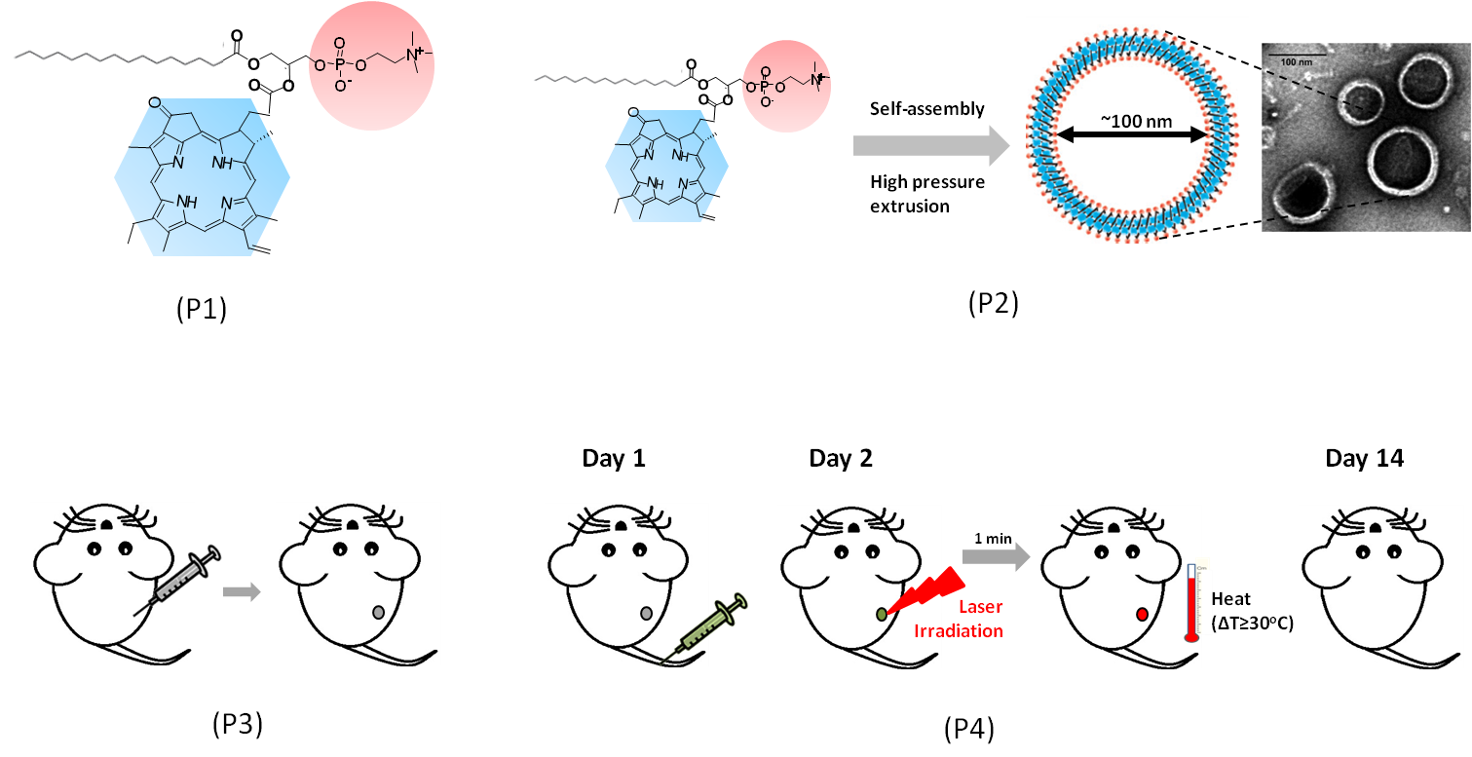

B. Interview: (Said by you on camera. Don’t forget to smile!)

  - Cheng S. Jin: Porphysomes are the first organic nanoparticles to serve as efficient photothermal enhancers while maintaining the drug delivery capacity and biocompatibility of conventional liposomes, and suitable for multimodal imaging and image-guided therapy. So, the implications of this technique extend toward therapy and diagnosis of tumors.

Protocol (read by voice talent at JoVE):
- Preparation of Porphysomes
  - Prior to this procedure, pyropheophorbide-lipid were previously synthesized according to the text protocol.
    - WID: the talent retrieves pyro-lipids from storage
  - Separately, dissolve pyropheophorbide-lipid, polyethylene glycol and cholesterol in chloroform. Record the concentrations of each solution.
    - WID: talent arrives at bench with lipids
    - MED: talent makes third solution, two already made, their stock bottles are visible in shot, well labeled and next to lipids bottle
  - In the fume hood at room temperature, prepare the porphysome lipid in a borosilicate test tube (TEXT: 12 x75 mm tube) for a total lipid weight of 5 mg per tube. Combine the porphyrin-lipid, PEG-2000-PE and cholesterol for a fractional molar concentration of 65, 5 and 30 percent, respectively.
    - MED: at fume hood, talent takes aliquot of one substance and prepares to add to test tube
    - CU: test tube, three substances added sequentially
    - MED: finishing third addition and disposing of pipette
  - Next, briefly dry the lipid films under a stream of nitrogen gas and, then, dry them under a vacuum for an hour.
    - MED: nitrogen gas applied to the tube
    - MED: talent loads tube into vacuum and starts vacuum
  - The lipid films can now be stored at -20 ºC under argon for future hydration and extrusion.
    - WID: loading tube(s) with film in argon chamber into -20 freezer
  - To begin the hydration and extrusion, add 1 mL of PBS to each lipid film tube. (TEXT: PBS, 150 mM NaCl, 10 mM phosphate, pH 7.4)
    - MED: taking aliquots of PBS and adding to tubes (we have “each tube” – it could be one tube or several being loaded)
  - Freeze each test tube, completely, in liquid nitrogen.
    - MED: loading tube into liq nitro tank/bath
  - Then, thaw them in a 65 ºC water bath.
    - MED: removing tube from liq nitro and transferring to water bath
  - Once no longer frozen, vortex each tube three times for 10 seconds with 5 seconds of reheating in the bath between vortex uses.
    - MED: removing tube form bath, vortexing and returning to bath
    - As above, 2nd angle
  - Repeat the freeze-thaw-vortex cycles five or more times, until no large aggregates can be observed in the hydrated solution.
    - ECU: tube content showing some aggregates
    - Reuse 2.10.1
    - ECU: tube content showing no aggregates
  - Finally, leave the porphysome suspension on ice.
    - CU: jamming tube into ice bath
  - Next, assemble a 10 mL high-pressure extruder with two stacked 100 nm polycarbonate filters.
    - MED: assembling the extruder, show filters
  - Connect the extruder to a regulated circulating water bath at 65 ºC.
    - MED: connection to water bath secured
  - Then, connect the extruder system to a nitrogen tank to provide pressure.
    - MED: connection to nitro tank secured
  - Now, use a 9-inch glass pipette to transfer the suspension to the extruder chamber.
    - MED: sucking up suspension and loading it into chamber
  - Dial up the initial extrusion pressure to between 200 and 300 psig.
    - CU: dial, cranking up pressure to 200-300 psig
  - Then, open the valve gradually until there is sufficient porphysome flow – do not apply more than 800 psig. (TEXT: max 5440 kPa)
    - CU: porphysome flow, wherever we can see it, rising to a sufficient flow speed
    - CU: dial, pressure gauge climbs to below 800 psig
  - After the first extrusion pass, close the pressure control valve and open the pressure relief valve.
    - CU: show the extrusion pass, whatever motion is visible, if any
    - MED: talent turns off pressure and opens release valve
  - Refill the extruder with the fresh solution, and repeat the process at least 10 times to ensure that the final extruded solution is totally homogeneous.
    - MED: loading extruder with more solution
    - ECU: completely homogenous solution after the 10 runs
  - Determine the concentration of the final porphysome solution by measuring the absorption of a diluted sample in methanol using a UV-Vis spectrometer. (TEXT: Consult text protocol for the equations.)
    - MED: taking aliquot of homogenous solution and adding it to methanol
    - WID: loading the spectrophotometer and taking a reading
  - Next, dilute the porphysome solution one part to sixty in PBS, then, take three measurements of the distribution of porphysomes via dynamic light scattering. Perform 15 independent runs and average the results.
    - MED: diluting some of the homogeneous solution in a vial of clear solution
    - WID: talent arrives at light-scattering device, loads diluted solution into the device
    - ECU: show the measurement of light scattering as its read out by the device
  - Lastly, diagnose the fluorescence quenching of porphysome by comparing the fluorescence emission of quenched porphysome at 1 mM in PBS to unquenched porphysome at 1 mM in 1% Triton X-100. (TEXT: excitation = 410 nm, emission = 600 - 800 nm)
    - MED: making solutions of porphysome in PBS at 1 mM and in 1% triton at 1 mM, show stock bottles on bench
    - WID: loading a solution into spec that measures the fluorescent emissions
    - CU: dialing in settings and taking a measurement with this instrument
  - Store the porphysome solution protected from light with foil and under argon at 4 ºC.
    - MED: wrapping solution tube in foil and loading it into the argon chamber
- in vivo Photothermal Therapy
  - This requires a culture the KB cells in RPMI-1640 with 10% FBS. Harvest the KB cells at 20,000 cells per mL in PBS and keep them on ice.
    - WID: removing flask/plates of cells from incubator
    - MED: talent measures out a aliquot of cells adds it to clear solution and sticks mix on ice
  - To an isofluorane-anesthetized, twenty gram, nude mouse, inject 100 microliters of cells subcutaneously into the right flank.
    - MED: talent loading syringe from vial of cells in solution, show if they’re mixed up first
    - ECU: injecting the cells into the mouse tissue

Videographer, see section 4 for a shot that needs to be taken now.
  - Ten days later, the resultant tumor will be 4 to 5 mm across and ready to treat.
    - ECU: tumor on mouse at 10 days, caliper placed in position to show size
  - Start the treatment by injecting 750 nmol of the porphysomes through the tail vein.
    - CU: injecting tail vein of same mouse
  - 24-hours later, laser-irradiate the porphysomes in an enclosed laser safety room, wearing laser safety goggles. The laser fiber and diffuser should be secured a stand.
    - WID: talent dons laser safety equipment (googles) in laser room
    - MED: securing laser to the stand or just checking firmness of secured laser
  - Set the laser power at low level and turn on the laser.
    - CU: setting the laser to low power and activating
  - Adjust the height of laser fiber to achieve an irradiation area 9 mm in diameter.
    - MED: laser spot visible and talent adjust height of laser to get spot to 9 mm
  - Use a power meter to calibrate the laser power to 750 mW for 1.18 Watts per square-cm.
    - MED: meter place at location of spot and talent dials in power of laser
  - Then, turn the laser off while anesthetizing the animal with isofluorane gas. (TEXT: 2% isofluorane v/v in 100% O₂)
    - MED: securing nose cone to animal and checking the gas flow
  - When the animal does not respond to a toe pinch document the tumor temperature using a tightly focused, infrared, thermal camera. Take a pre-PTT image as well as a regular white-light image.
    - ECU: toe pinch, no flinching
    - CU: taking temperature of tumor
    - MED: taking photos of the tumor, pre-PTT and then regular
  - Next, turn on the laser to 750 mW. Put the tumor in the centre of laser beam for a one minute and measure the tumor’s temperature every five seconds.
    - CU: turning on the laser, power at adjusted setting
    - CU: tumor centered under laser spot, talent takes temperature reading of tumor
  - After a minute, turn off the laser, stop the isofluorane gas and wait until the animal recovers from the anesthesia before returning it to its cage.
    - MED: turning off the laser, then stopping the gas
    - MED: animal begins stirring and talent moves it to cage
  - Going forward, every two days, photograph the tumor and measure its’ diameter with calipers. When it reaches 10 mm in diameter, humanely sacrifice the animal.
    - WID: talent, dressed differently, in room where mouse is caged, takes mouse cage down from shelf to examine the animal
    - MED: measuring the size of the tumor on animal and then photographing the tumor
- Porphysome Characterization and Tumor Treatment Results
  - Using this protocol, pyropheophorbide was conjugated to phospholipid as a stable lipid monomer and self-assembled to form porphysomes by high pressure extrusion.
    - LAB MEDIA: Fig. 1a
  - The resulting porphysomes have a high homogeneity of size distribution with a peak around 120 nanometers.
    - LAB MEDIA: Fig. 1 b
    - LAB MEDIA: Fig. 1c
  - They also have two main absorbance peaks at 410 nm and at 677 nm.
    - LAB MEDIA: Fig. 1d
  - The fluorescence of porphyrin was quenched as high as 99.8% when the nanostructure is intact.
    - LAB MEDIA: Fig. 1e
  - Using the outlined in vivo PTT protocol, porphysomes with laser irradiation caused tumor temperature to increase by over 35 ºC after 1 minute of irradiation, while the laser alone induced a temperature increase of less than 10 ºC.
    - LAB MEDIA: Fig.2d
  - Following the PTT irradiation, the tumors usually turned whitish because of the potent thermal effect.
    - ECU: tumor turning whitish after irradiation
  - Thermal ablation resulted in dark brownish eschar on tumors and a 100% reduction of tumor volume. Eschars were obvious 24-hour post-treatment and they gradually recover during the following 2 weeks.
    - LAB MEDIA: Fig.3a
  - Using porphysomes, subcutaneous tumors were completely eliminated without recurrence. By comparison, tumors injected with porphysome alone or treated with the laser alone continued to grow.
    - LAB MEDIA: Fig3b

- Conclusion (said by authors on camera)
  - Cheng S. Jin: After watching this video, you should have a good understanding of how to synthesize porphysomes using high pressure extruder and how to perform laser irradiation following porphysome administration for photothermal therapy.

Provided Media

4.1.1 - Fig. 1a

4.2.1 - Fig. 1 b

4.2.2 - Fig. 1c

4.3.1 - Fig. 1d

4.4.1 - Fig. 1e

4.5.1 - Fig.2d

4.7.1 - Fig.3a

4.8.1 - Fig3b

General Preparation

It’s critical for a smooth and organized shoot that all reagents are accounted for, in advance.

Any overnight or long incubation steps should be recognized and specimens/samples be prepared in advance so that prior steps can be recorded and shooting can continue with pre-prepared specimens/samples.

All tubes/flasks should be pre-labeled neatly before we arrive.

Ex. Luciferase assay done in 96 well plates should be labeled with negative/positive control wells and experimental samples are labeled accordingly.

