Submission ID #: 50525

Editor Name: Linda DiBella

Videographer name:

Film Date:

Authors and Affiliations:

Lisa Gfrerer, MD, Max Dougherty, Eric C. Liao, MD, PhD
185 Cambridge Street
MGH Center for Regenerative Medicine
185 Cambridge Street
02114 Boston , MA
USA
lisa.gfrerer@gmail.com

Tel. 617 4599106

Corresponding author:
Lisa Gfrerer, MD.

Title: Visualization of Craniofacial Development in the sox10: kaede Transgenic Zebrafish Line Using Time-lapse Confocal Microscopy

Authors, please fill out the brief questionnaire below.

A. Will you require assistance with video microscopy, such as filming a complex dissection or microinjection technique (Y/N, please specify steps by number. Also, please list make and model of your microscope)? Y Step 3
B. Does your protocol include detailed, step-by-step, descriptions of software usage (Y/N, please specify steps by number)? Y Step 4.1, 5, 6, 7,8
C. Which steps of your protocol will viewers benefit most from having filmed? Please list 4-6 steps
Steps 3.2, 3.3, 5, 6, 7,8
D. What is the single most difficult aspect of this procedure and what do you do to ensure its success?
Ensuring software settings are ideal for the recording and finding the right z-stack depth. Multiple test shots before starting the actual video.

1. Introduction (Schematic Overview and Interview)

A. Schematic Overview (read by voice talent at JoVE):
Authors, please select from “Procedural Narrative” or “Conceptual Narrative” and complete the statements below. Please do not add additional steps. Then, attach your finished graphic overview. See accompanying instructions for details and examples.

Conceptual Narrative:

The overall goal of the following experiment is to generate a live time-lapse recording of neural crest cell migration in order to show formation of developing craniofacial structures. (Intro)

This is achieved by first mounting an anesthetized, transgenic sox10: kaede (could have used pronunciation guidance on this) zebrafish in agarose in order to minimize movement throughout the experiment. (P1, Editor, begin with the ‘plate’, add the dark structure sitting in the center, then bring in the triangular tip on the left and drop some of the gray solution onto the dark structure in the plate)

Next, under a confocal microscope, UV photoactivation is carried out to convert kaede from green to red in neural crest cells. (P2, Editor, begin with the head of the embryo with the two bulging eyes and the green ‘x’ like structure. Bring in the cone with the red circle on the green x, then bring in the three green circles and the arrow with the three red ovals, remove the cone shape, and ‘fill in’ the red circle between the eyes as seen in the right hand panel.)

Then, focusing on the photoconverted neural crest cells, a z-stack is generated of the developing structure before a time-lapse video is recorded. (P3, Editor, transition to the fluorescent image under the three green circles)

Results are obtained that show the development of cranial neural crest cells into the zebrafish primary palate in a Tgsox10:kaede zebrafish embryo. (P4, Editor, bring in the image under the head with the red dot and place it next to the image in P3 for comparison.)

Paste a copy of your graphic overview here. The original file should be adobe illustrator (preferred) or powerpoint (see instructions) and should be uploaded through your online submission on the JoVE website.
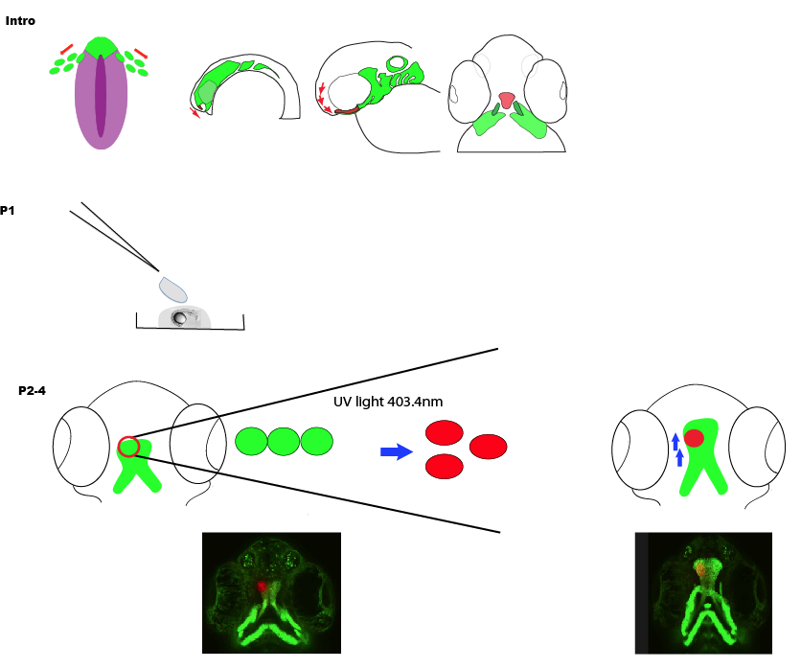

B. Interview: (Said by you on camera. Don’t forget to smile!)

Authors: Below are statements we would like you to complete that are complementary to the information contained within the schematic overview. Only one statement should be chosen and completed per author who will be on camera demonstrating the protocol. In addition to choosing and filling out the appropriate statement, please enter the name of the individual who will say each line. **If individuals will be doing the demonstrations but not speaking in the introduction, please use statement 1.8 to introduce these demonstrators (ex PI introducing students).

  - Author name _____Eric Liao____: The main advantage of this technique over existing methods, like static imaging, is that complex developmental migration processes can be visualized in real time. This makes the results more accessible to the scientific community in a broader audience.
PLEASE SEE RECORDING FOR EXACT WORDING

  - Author name ___Lisa Gfrerer_____ : This method can help answer key questions in the ___developmental biology______ field, such as how neural crest cell derived structures form physiologically and how perturbed genes influence their development.
PLEASE SEE RECORDING FOR EXACT WORDING

Protocol (read by voice talent at JoVE):

Authors: In order to ensure that your protocol can be filmed in a single day, the protocol text must be limited to 30 steps – each step being defined as 3 lines of 12 pt text in our formatting style below. This amounts to 3 pages of protocol text. The scope of the scripted protocol text should include only those aspects of the procedure that require visualization in order to be well understood.

- Mounting Embryos

  - To prepare for mounting embryos, use a 125 ml flask to mix E3 water with low melting point agarose. Microwave to dissolve solution. Then, add tricaine and place flask in a 50 degree C water bath to keep warm.
    - WIDE Talent approaches bench and places 125 ml flask down
    - MED/CU Talent adds E3 medium from labeled bottle then adds low melting point agarose
    - MED Talent places flask in microwave and turns it on
    - MED/CU Talent adds tricaine and swirls flask
    - MED Talent places flask in water bath

  - Anesthetize brightly fluorescent transgenic sox10:kaede zebrafish embryos at 60 hours post fertilization (TEXT: E3/0.015% tricaine). Then transfer them each to a chamber slide.
    - LAB MEDIA 60 hpf fluorescent embryos
    - SCOPE Anesthetized embryos not moving
    - SCOPE/ECU Talent transfers to a chamber slide

  - With tissue paper, soak up the excess E3 water and then use the agarose solution to cover the embryo. Use a microloader tip to position the embryo perfectly dorsal, ensuring that the embryo is completely submerged in agarose.
    - CU Talent soaks up excess E3 with tissue
    - CU/ECU Talent pipettes agarose from container and covers embryo with agarose
    - SCOPE/ECU Talent uses tip to position embryo dorsal, ensuring that embryo is submerged

  - After the agarose sets, use E3/0.015% tricaine to fill the chamber slide.
    - ECU Talent adds E3/tricaine to fill chamber

- Photoconversion using Confocal Microscopy

  - To carry out photoconversion, begin by using a 20x air immersion objective for focusing on the embryo. Then, press the L100 light button on the microscope and select ‘channels’ in the software. Open the icons view/acquisition, controls/A1 settings and click the confocal setup button.
    - CU/ECU 20x objective moves into working position
    - SCOPE Talent focuses on embryo
    - CU Talent presses L100 light button
    - SCREEN Talent selects channels in software
    - SCREEN Talent opens the icons view/acquisition, controls/A1 settings and clicks the confocal setup button.

  - Next click ‘auto’ and select DAPI, 488, and 561.9 for channels 1 through 3, respectively, before closing the window again.
    - SCREEN Talent clicks auto and selects DAPI, 488, and 561.9 then closes window

  - Then, turn off channels 1 and 3 before clicking the remove interlock button and pressing the scan button.
    - SCREEN Talent turns off channels 1 and 3 then presses the remove interlock button and presses scan

  - Starting at 1 frame/second and HV 200, begin to focus on cells of interest, gradually increasing the frames per second to 1/32 and reducing the voltage to 100-120, depending on the background noise.
    - SCREEN Talent sets 1 frame/second and HV 200
    - SCREEN Talent focuses on cells of interest
    - SCREEN Talent increases frames per second to 1/32 and reduces the voltage to 100-120

  - When the embryo is in focus, grab the green rim at the right edge of the screen and shrink it to fit the area to be photoconverted before right clicking with the mouse.
    - SCREEN Talent grabs green rim at right edge of screen and shrinks it to fit ROI then right clicks on the mouse

  - Change the frames/second to 1 and the HV to 200 and press scan. A zoomed in image of the photoconversion area will now be visible.
    - SCREEN Talent changes frames per second to 1 and HV to 200
    - SCREEN Zoomed in image of photoconversion area

  - Next, photoconvert cells by turning on channel 1 for anywhere from 5 to 60 seconds, until the green kaede signal is nearly absent. Then turn off the DAPI channel.
    - SCREEN Talent turns on channel 1
    - SCREEN Green signal bleaches and is almost completely absent
    - SCREEN Talent turns off the DAPI channel

  - Turn on channels 2 and 3. To return to the original zoom, right-click on the zoom window and choose ‘return to original size’ to check if desired cells were photoconverted adequately.
    - SCREEN Talent turns on channels 2 and 3
    - SCREEN Talent right clicks on zoom window and chooses return to original size

  - Set the limits of the Z stack, by choosing the ‘capture Z-series icon in the menu bar. Adjust the look up tables, or LUTs.
    - SCREEN Talent chooses capture Z-series then adjusts the LUTs

  - To set up a time lapse, choose the A1 Simple GUI box and tick the following settings: 1/32 frames/sec, size 1024, and average 4 or 8X depending on the number of Z-stacks that has to be taken in one loop.
    - SCREEN Talent chooses A1 Simple GUI box and ticks 1/32 frames/sec, size 1024, and 4 (or 8)X

  - Next, go to view/acquisition controls/ND sequence acquisition and set the time frame (TEXT: 8- 30 min). Then click continuous and then Z-stack. Set the borders as demonstrated earlier. Start the movie.
    - SCREEN Talent goes to view/acquisition controls/ND sequence acquisition and sets time frame
    - SCREEN Talent clicks continuous, then Z-stack
    - SCREEN Talent sets borders then starts movie

  - Add E3/0.015% tricaine solution to the chamber slide throughout the day and fill the chamber completely for overnight imaging.
    - CU Talent adds tricaine solution to the chamber slide

  - When imaging is complete, create a high quality video from the imaging file, by clicking ‘show maximum intensity projection’. Then right click on the image and create new document. Delete unnecessary frames and adjust the LUTs.
    - SCREEN Talent clicks ‘show maximum intensity projection’
    - SCREEN Talent right clicks on image, creates a new document,
    - SCREEN Talent deletes unnecessary frames and adjusts LUTs

- Representative Photoconversion Results-(second to last section)

  - In this movie showing palatogenesis in the zebrafish, the sox10:kaede transgenic line is used to follow cranial neural crest cells as they develop to form the primary palate. The most anterior cells of the forming palate are photoconverted from green to red at 60 hours post fertilization when the paired trabeculae have met to form the primary palate. These cells are then followed until they reach their final destination.
    - LAB MEDIA Video 1 (Ethmoid plate movie.wmv)

  - This movie demonstrates perturbed palate development leading to formation of an orofacial cleft. Morpholino mediated knock down of specc1lb, a gene involved in oblique facial clefting is used as an example. At 60 hpf, unilateral photoconversion of the most anterior ethmoid plate cells shows a failure of fusion between the median and the lateral ethmoid plate cells. This defect resembles the pathogenesis of oblique facial cleft development in humans, where failure of fusion between the lateral nasal process and maxillary prominence occurs.
    - LAB MEDIA Video 2 (specc1b photoconverted good 30 ms-MaxIP.avi)

INSTRUCTIONS FOR AUTHORS:
Please ensure that the representative results narration is appropriate and correctly describes your images, movies, or figures. Our editors have ensured that the results are written in our format.

We consider this section a critical aspect of the video, because here is where you provide validation for your experiments. For example, if this is a cell culture preparation, this section is where the video will show your cells at various time points following culturing. If this is an imaging prep, then this part is where you will show examples of your imaging experiments.

Please limit the extent of narration to no more than 2-3 lines of text per image or movie file being described. Figures with multiple panels submitted with the original protocol should be broken up so that each panel is a separate image. Like the schematic, each image or movie file supplied in the results should be referenced by annotation in parenthesis, however for the results, the specific filename should be given in parenthesis.

Below is an example of results text:

EXAMPLE REPRESENTATIVE RESULTS

5. Evaluation of Morpholino Injection and Knockdown
5.1 Representative results of both morpholino injection and mRNA injection are shown here. The
uninjected control at 48 hours post fertilization looks normal, as expected
-LAB MEDIA: 0123_PIname_Figure1.tif (Replace 0123 with your jove video #)

5.2 However, embryos injected with the morpholino heg_e3i3_egfr1, which knocks down Heg isoforms
containing the first of two EGF-like repeats, exhibit brain edema.
-LAB MEDIA: 0123_PIname_Figure2.tif

5.3 Injection of heart of glass mRNA also produced an obvious phenotype. At 24 hours post fertilization,
the heads of the uninjected controls look normal
-LAB MEDIA: 0123_PIname_Figure3.tif

5.4 Conversely, some of the embryos injected with the mRNA exhibit cyclopia
-LAB MEDIA: 0123_PIname_Figure4.jpg

Please visit the following URL to see an example of how the results will look when complete: http://www.jove.com/video/1597/results-example-mably?access=ksw0bprj

- Conclusion (said by authors on camera)

Authors: Below are statements we would like you to complete that summarize and conclude the video. Only one statement should be chosen and completed per author who will be on camera demonstrating the protocol. In addition to choosing and filling out the appropriate statement, please enter the name of the individual who will say each line.

  - Author name Eric Liao: After its development, this technique paved the way for researchers in the field of developmental biology to explore neural crest cell development in zebrafish.

  - Author name Lisa Gfrerer: After watching this video, you should have a good understanding of how to visualize your developmental biology experimental data in order to ensure better understanding in the scientific community and a broader audience.

Provided Media

Figure 1.
sox10:kaede photoconversion.
A. Ventral view of 60hpf sox10: Kaede transgenic zebrafish. The structure labeled green in the diagram and the corresponding real live image resembles the ethmoid plate. After exposure to UV light (at 403.4 nm) under the confocal microscope, the fluorescent protein kaede is photoconverted from green to red. B. The photoconverted cells can be followed as shown in Panel B.

Movie 1.
Time lapse video 60 hpf stage wildtype Tuebingen zebrafish embryo. Normal formation of the ethmoid plate. Ventral view. Recorded every 30 min starting 60hpf to 72hpf.

Movie 2.
Time lapse video 60hpf stage Specc1lb Morpholino injected embryo. Failure of fusion between median ethmoid plate cells and lateral ethmoid plate cells can be observed. Ventral view. Recorded every 30 min starting 60hpf to 72hpf.

Authors, Please list all images, movie files, or 3-D rendered animations that can be included in the video per editor’s request. The step in the script/video where these images will be inserted should be specified. For example:

6.2 – 0123_PIname_Figure1.tif - dual color imaging of tumor angiogenesis at 40X
6.2 – 0123_PIname_Figure2.tif - dual color imaging of tumor angiogenesis at 100X

Formats: For static images we prefer .tiff files at dimensions of at least 720X480 pixels and 300 dpi. The higher resolution, the better. Likewise any exported movie files should have at minimum these dimensions and be rendered to .mov, .mp4, or .avi files.

Insert your media filenames here.

General Preparation

It’s critical for a smooth and organized shoot that all reagents are accounted for, in advance.

Any overnight or long incubation steps should be recognized and specimens/samples be prepared in advance so that prior steps can be recorded and shooting can continue with pre-prepared specimens/samples.

All tubes/flasks should be pre-labeled neatly before we arrive.

Ex. Luciferase assay done in 96 well plates should be labeled with negative/positive control wells and experimental samples are labeled accordingly.

