Submission ID #: 50492
Editor Name: Pallavi R. Devchand
Videographer name: Kira/Zhao
Film Date: 5 February, 2013
Authors and Affiliations: Gregor Lang, Stephan Jokisch, Thomas Scheibel
University of Bayreuth, Germany.
Title: Air filter devices including nonwoven meshes of electrospun recombinant spider silk proteins
Corresponding Author: Thomas.Scheibel@fiberlab.de

Authors, please fill out the brief questionnaire below.

A. Will you require JoVE to record video microscopy, such as filming a complex dissection or microinjection technique? (Y/N) ____N____ If yes, please list make and model of your microscope:
B. Does your protocol include detailed, step-by-step, descriptions of software usage? (Y/N)____N___
C. Which steps of your protocol will viewers benefit most from having filmed? Please list 4-6 steps: 2.6, 2.8, 2.11, 3.3, 3.4, 4.3, (5.2, 6.1)
D. What is the single most difficult aspect of this procedure and what do you do to ensure success? The post treatment precedure. (Animation is uploaded).

1. Introduction (Schematic Overview and Interview)

A. Schematic Overview (read by voice talent at JoVE):
Authors, please select from “Procedural Narrative” or “Conceptual Narrative” and complete the statements below. Please do not add additional steps. Then, attach your finished graphic overview. See accompanying instructions for details and examples.

Conceptual Narrative:
The overall goal of the following experiment is to improve commercial filter materials by deposition of spider silk nonwoven meshes for filtration of small particle (Intro).
First dissolve the lyophilized, recombinant spider silk proteins in HFIP to produce an appropriate spinning dope (P1: LAB MEDIA: Fill syringe with blue polymer solution- Schematic figure A) .
Then electrospin the solution onto different filter materials (P2: LAB MEDIA: Full Schematic Figure A, have the blue come out of the syringe), which are thereby coated with a silken nonwoven layer (P3: LAB MEDIA: Schematic Figure B).
Next, treat the silk sub-micrometer fibers with ethanol vapor in order to induce stable, water insoluble structures (P4: LAB MEDIA: Schematic Figure C, can be animated as shown in 3.3_Post-treatment-Animation.wmv (or else 3.3_Post-treatment-Animation.wmv can be sped up and used here)).
Results indicate a clear dependency of spinning duration and thus layer thickness on the filter efficiency based on particle filtration measurements (P5: LAB MEDIA: Schematic Figure D).

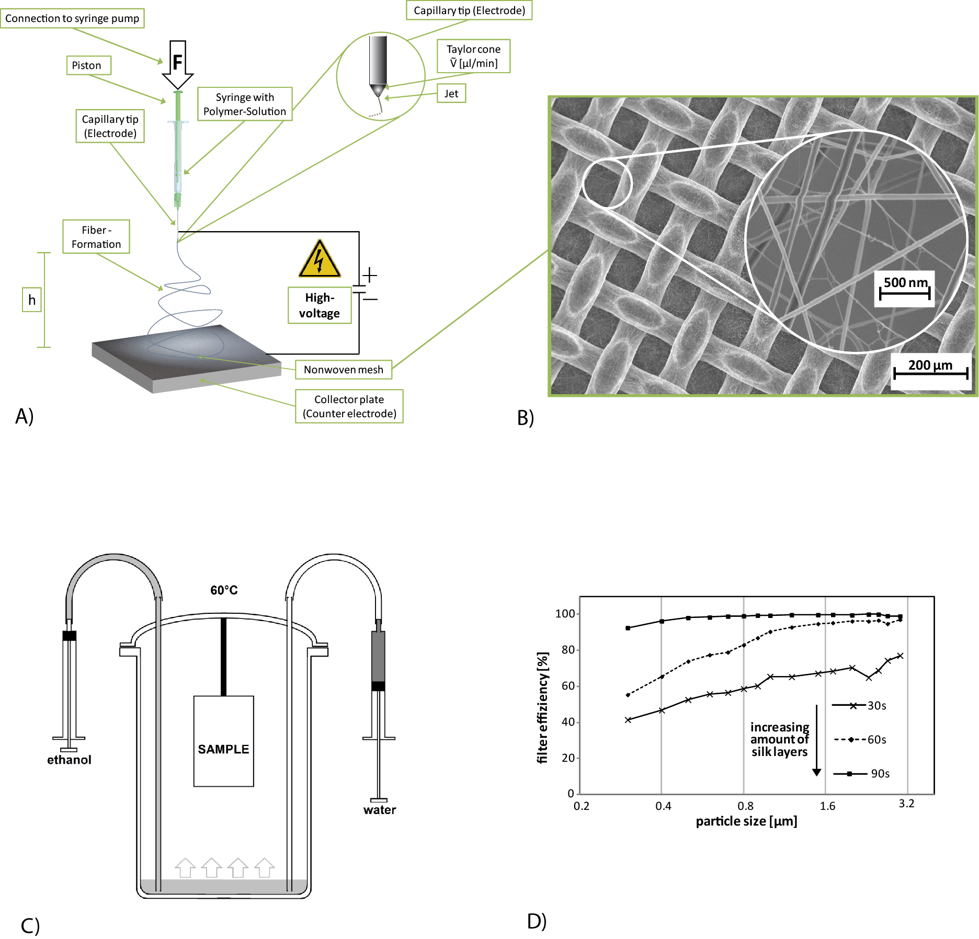

B. Interview: (Said by you on camera. Don’t forget to smile!)

Authors: Below are statements we would like you to complete that are complementary to the information contained within the schematic overview.
- Only one statement should be chosen and completed per author who will be on camera demonstrating the protocol.
- Enter the name of the individual who will say each line.
- Please choose and fill out the statement(s) that convey the most important fact(s) about your protocol. You may revise the given prompts as necessary to improve the sentence flow.
- If any individuals will be doing demonstrations on camera but are not assigned a speaking part in this interview section, please use statement 1.8 to introduce these demonstrators (for example, the PI introduces students)

  - Lang, Gregor: Compared to melt blowing of synthetic polymers, electrospinning provides fibers that are about ten times smaller in diameter, with a smaller size distribution. Importantly, using biocompatible biodegradable spider silk nanofibers lowers the putative health risks accompanied with other polymer fibers.
  - Scheibel, Thomas: Though this method can provide high potential in the field of technical filtration, it can also be applied to medical systems, such as wound coverage devices, where spider silk nonwoven meshes can support wound healing.
  - Jokisch, Stephan: We first had the idea for this method, when we tried to produce spider silk fibers wih different techniques. The low diameters obtained by electrospinning initiated the idea using them in air filtration devices.

Protocol (read by voice talent at JoVE):

Authors: In order to ensure that your protocol can be filmed in a single day, the protocol text must be limited to 30 steps – each step being defined as 3 lines of 12 pt text in our formatting style below. This amounts to 3 pages of protocol text. The scope of the scripted protocol text should include only those aspects of the procedure that require visualization in order to be well understood.

- Electrospinning
  - To 20 mg of lyophilized protein [Text over video: eADF4(C16) ], add 200 µl of HFIP and seal the vessel with Parafilm. Vortex the spinning dope suspension for 1 minute, shake to clear the solution and incubate at room temperature over-night.
    - CU: Talent weights 20 mg of eADF4(C16) recombinant spider silk protein
    - CU: Talent transfers 20 mg of eADF4(C16) to vessel
    - MED/CU: Talent adds 200 µl of HFIP to 20 mg of lyophilized protein and seals the vessel with Parafilm.
    - ECU: Talent vortexes the spinning dope suspension, shakes to clear the solution.
    - MED: Talent incubates sample at room temperature.

  - To prepare the electrospinning device, place the filter material on top of the counter electrode Preset the voltage of both the electrode and the counter electrode. Then set the volume flow. (TEXT: 250 µm/min, or 315 µl/h)
    - MED/CU: Talent places the filter material on top of the counter electrode.
    - CU: Talent presets the voltage of the electrode at -22.5 kV and the counter electrode at +2.5 kV.
    - ECU: Talent sets the volume flow to 250 µm/min, this equals 315 µl/h in this setting.

  - Since toxic HFIP will be evaporated, make sure the electrospinning device is connected to a fume hood.
    - MED-over-the-shoulder: Talent makes sure the electrospinning device is connected to a fume hood.

  - In order to generate a well-defined Taylor cone, grind the sharp tip of a 20-gauge needle to a residual length of 30 mm. Then connect the needle to a 1 ml syringe.
    - CU/ECU: With a hand grinder, Talent grinds the sharp tip of a 20-gauge needle to a residual length of 30 mm.
    - CU: Talent connects the needle to a 1 ml syringe. N

  - Load the entire spinning dope into the syringe. Then overlay the dope with 100 µl of air, in order to allow the complete solution to be extruded during the spinning process
    - ECU: Talent loads the entire spinning dope into the syringe.
    - ECU: Talent overlays the dope with 100 µl of air.

  - Next, attach the filled syringe to the syringe pump of the electrospinning device. Carefully press the piston onto the syringe until a droplet appears at the tip of the needle. Now lock the piston.
    - CU: Talent attaches the filled syringe to the syringe pump of the electrospinning device.
    - MED: Talent carefully presses the piston onto the syringe.
    - ECU: Droplet appears at the tip of the needle.
    - EC: Talent locks the piston.

  - Set the distance between the tip of the needle and the counter electrode to between 8 and 20 cm.
    - CU/ECU: Talent sets the distance between the tip of the needle and the counter electrode to between 8 and 20 cm.

  - After connecting the high voltage source, start the syringe pump and remove the droplet from the opening of the needle. Activate all safety installations of the electrospinning device immediately and start the high voltage source as soon as a new droplet appears.
    - Talent connects high voltage source
    - MED: Talent starts the syringe pump
    - CU: Talent removes the droplet from the opening of the needle.
    - MED/CU: Talent activates all safety installations of the electrospinning device immediately
    - CU/ECU: Talent starts the high voltage source as soon as a new droplet appears.

  - Use a stopwatch to control spinning duration. Since electrospinning of recombinant spider silk proteins depends on humidity and temperature, an adaptation of process parameters towards individual lab conditions might be necessary.
    - MED/CU: Talent monitors stopwatch to control spinning duration (show spinning if possible).

2.9.1.a / 2.9.1b / 2.9.1c / 2.9.1d: CU: Taylor cone (2.9.1b provides best shots of the jet)
    - LAB MEDIA: Figure 2.

  - After a defined time [Text over video: 30s / 60 s / 90 s] of electrospinning, switch off the syringe pump. After 10 seconds turn off the high voltage source.
    - MED-over-the-shoulder: Talent switches off the syringe pump.
    - CU: Talent turns off the high voltage source.

  - To produce a nonwoven mesh for subsequent stability experiments, use black paper instead of filter material. After 5 minutes of electrospinning, stop the process as shown earlier.
    - MED/CU: Talent produces a nonwoven mesh for subsequent stability experiments, using black paper instead of filter material.
    - /1 WIDE: Talent switches off syringe pump

2.11.2. /2. and high voltage source.

- Post-treatment of silk nonwoven meshes
  - In a pre-heated 60°C oven, vertically place the filter substrates with nonwoven meshes. Allow a minimum distance of 2 cm in a lockable glass container that has two openings for solvent introduction.
    - MED/CU: Talent vertically places the filter substrates with nonwoven meshes.
    - CU/ECU: Talent indicates a minimum distance of 2 cm in a lockable glass container, and teh two openings for solvent introduction.

  - Connect two 60 ml syringes, one filled with ethanol and one filled with water, with silicone tubes pointing into the interior bottom of the post-treatment container.
    - CU: Talent connects two 60 ml syringes, (show labels: ethanol and water), with silicone tubes pointing into the interior bottom of the post-treatment container.

  - Place the post-treatment container in the oven and add 60 ml of ethanol by extruding the syringe. Use a stopwatch to control treatment duration [Text over video: 90 minutes].
    - MED/CU: Talent places the post-treatment container in the oven.
    - CU: Talent adds 60 ml of ethanol by extruding the syringe.
    - CU: Ethanol flowing out of tube
    - MED-over-the-shoulder: Talent sets stopwatch (show set-up in the backgroup)

  - Remove the ethanol with the syringe from the glass. Now add 60 ml of water from the second syringe over another 90 minutes. Then remove the water, and switch off the oven. In order to avoid droplets by condensation, only remove the container from the oven when it has completely cooled down.
    - MED: Talent removes the ethanol with the syringe from the glass.
    - CU: Talent positions the 60 ml of water from the second syringe (Note to video-editor: show clock going 90 minutes).
    - CU: Water flowing out of tube.
    - MED: Talent removes the water.
    - CU: Talent switch off the oven.
    - MED: Talent removes the container from the oven when it has completely cooled down.

- Analysis of spider silk nonwoven meshes
  - For stability tests, use silk nonwoven meshes spun on black paper or any other removable support. Adjust double-sticky adhesive tape. Then cut two frames out of cardboard. Press one frame onto the silk nonwoven mesh deposited on black paper, then cut off the excess nonwoven mesh and carefully remove the frame.
    - MED/CU: Talent approaches bench with silk nonwoven meshes spun on black paper or any other removable support.
    - ECU: Talent adjusts sticky tape and cuts out frame of cardbord
    - CU: Talent cuts holes into frame.
    - ECU: Talent presses one frame onto the post-treated silk nonwoven mesh deposited on black paper, uses scalpel to cut off the excess of nonwoven and carefully removes the frame.
  - Then attach the second frame in the same way.
    - ECU: Talent presses one frame onto the non-treated silk nonwoven mesh deposited on black paper, uses scalpel to cut off the excess of nonwoven and carefully removes the frame. (note: in this scene, the nonwoven was damaged, because the frame was not pressed properly onto the nonwoven, so it didn’t stick enough to the frame)

  - For the Practical dip test, cut 1 cm² pieces of the post-treated and non-treated silk nonwoven mesh. and dip them into deionized water. Note how the non-treated silk nonwoven mesh immediately dissolves, while the treated nonwoven mesh is stable. Air dry the sample for SEM imaging.
    - MED/CU: Talent dips non-treated silk nonwoven into water and it dissolves immediately.
    - ECU: Talent dips post-treated silk nonwoven into water and it stays stable.
    - CU: Talent air dries the sample.

  - Apply Fourier transform infrared spectroscopy to gain information about the structural changes of the silk proteins upon post-treatment of the nonwoven meshes. Select for the Transmittance-mode, set scan from 800 to 4000 cm⁻¹, measure 60 accumulations with average for each spectrum, and one reference measure per spectrum.
    - MED-over-the-shoulder: Talent approaches instrument for Fourier transform infrared spectroscopy with post-treatment of the nonwoven meshes of silk protein (get good shot of instrument set-up).
    - SCREEN: Talent select for the Transmittance-mode, sets scan from 800 to 4000 cm⁻¹, sets measure for 60 accumulations with average for each spectrum (note: the reference measure is directly included in the procedure and can not be shown seperately).

  - For quantitative analysis of the data, employ Fourier self-deconvolution. Set the curves to the wavenumbers between 1590 and 1705 cm⁻¹ and also include a baseline correction. Then calculate a local least square fit as detailed by Xu and colleagues in 2006..
    - SCREEN: Talent selects Fourier self-deconvolution and sets the curves to the wavenumbers between 1590 and 1705 cm⁻¹ and also include a baseline correction.
    - SCREEN: Talent selects the correct peaks for calculation

  - Next, use SEM imaging to investigate fiber diameters and the morphology of silk fibers on different filter substrates and analyze the influence of the post-treatment on the fiber morphology Use magnifications of 5000x to 25000x in order to get sufficiently detailed images.
    - SCREEN: Talent opens SEM images of silk fibers on different filter substrates. To analyze the influence of the post-treatment on the fiber morphology,
    - SCREEN: Talent indicates magnifications of 5000x to 25000x on detailed images.
    - Use 50492_Lang_SEM-Pictures.pptx

- Determination of air permeability
  - First place a proper fitting part of the filter material on the measuring area of the device.
    - MED/CU: Talent places a proper fitting part of the filter material on the measuring area of the device.

  - Employ an Akustron air permeability device according to the manufacturer’s instructions and note the normed data [Text over video: l/(m²*s)].
    - WIDE: Talent starts measurement on an Akustron air permeability device (get good shot of instrument.
    - MED: Talent notes the shown data

  - After collecting data from at least 10 times different parts of the sample, calculate the arithmetic middle.
    - SCREEN: Talent shows data data curve from calculated middle

- Determination of filter efficiency
  - To determine filter efficiency, use a proper machine with pressure control and particle counter, such as a Universal particle sizer.
    - WIDE/MED: Talent approaches machine with pressure control and particle counter, such as a Universal particle sizer.

  - Place the filter samples in the device and measure particle retention.
    - CU/ECU: Talent places the filter samples in the device
    - MED/CU: Talent starts to measure particle retention.

  - Set the parameters of Aerosol; particle sizes; duration; liquid velocity and air flow.
    - SCREEN: Talent sets the parameters of Aerosol at DEHS; particle sizes at 0.3-3 µm; duration at 30 s; liquid velocity at 2350 cm∙s⁻¹ and air flow at 3400 m³∙h⁻¹ .

Author’s note: Shoots are not possible, device is situated at industrie partner, just photographs are obtainable. Provided picture is everything we have got,

6.1. To determine filter efficiency, use a proper machine with pressure control and particle counter, such as a Universal particle sizer.

6.1.1. LAB MEDIA: 6.1_Filter efficiency device.JPG
  - Talent: Handle the sample with care and do not touch the surface to prevent destruction of the nonwoven mesh and avoid any pollution. Be sure to create enough samples of equal quality for performance measurements.
    - Interview style.

- Results: Air Filter Devices
  - Electrospinning of recombinant spider silk solutions with concentrations of 10% HFIP resulted in smooth fibers with diameters ranging from 80 to 120 nm, allowing the formation of nonwoven meshes on different filter materials.
    - LAB MEDIA: Figure 8 top row (PA.PE and PP)

  - Post-treatment with ethanol vapor did not lead to conspicuous morphological changes, thus establishing as a proper way of silk nonwoven post-treatment.
    - LAB MEDIA: Figure 8: S1 and S2.

  - Structural changes were detected using FT-IR and subsequent FSD of amid I bands was performed to analyze single contribution peaks.

    - LAB MEDIA: Figure 6 (Add text heading “untreated” for 6A and “post-treatment” for 6B).

  - Interestingly, post-treatment leads to an increase in β-sheet structures, while the content of α-helical and random coil structures decreases.

    - LAB MEDIA: Figure 7.

  - This result can be practically proven by dipping a post-treated nonwoven mesh into water

    - LAB MEDIA: Figure 5. connection of 5A before dipping with 5B under water with arrow?)

  - The spinning duration is the most important parameter concerning the application of silk nonwoven meshes in filter materials. Extended spinning durations und thus a higher number of fiber layers result in an exponential decrease of air permeability.

    - LAB MEDIA: Figure 9. (add text 9A untreated 9B post treated)

  - Likewise, the filtering efficiency of the silk-containing filter materials of sub-micrometer particles increases.

    - LAB MEDIA: Figure 10.

INSTRUCTIONS FOR AUTHORS:
Please ensure that the representative results narration is appropriate and correctly describes your images, movies, or figures. Our editors have ensured that the results are written in our format.

We consider this section a critical aspect of the video, because here is where you provide validation for your experiments. For example, if this is a cell culture preparation, this section is where the video will show your cells at various time points following culturing. If this is an imaging prep, then this part is where you will show examples of your imaging experiments.

Please limit the extent of narration to no more than 2-3 lines of text per image or movie file being described. Figures with multiple panels submitted with the original protocol should be broken up so that each panel is a separate image. Like the schematic, each image or movie file supplied in the results should be referenced by annotation in parenthesis, however for the results, the specific filename should be given in parenthesis.

Below is an example of results text:

EXAMPLE REPRESENTATIVE RESULTS

5. Evaluation of Morpholino Injection and Knockdown
5.1 Representative results of both morpholino injection and mRNA injection are shown here. The
uninjected control at 48 hours post fertilization looks normal, as expected
-LAB MEDIA: 0123_PIname_Figure1.tif (Replace 0123 with your jove video #)

5.2 However, embryos injected with the morpholino heg_e3i3_egfr1, which knocks down Heg isoforms
containing the first of two EGF-like repeats, exhibit brain edema.
-LAB MEDIA: 0123_PIname_Figure2.tif

5.3 Injection of heart of glass mRNA also produced an obvious phenotype. At 24 hours post fertilization,
the heads of the uninjected controls look normal
-LAB MEDIA: 0123_PIname_Figure3.tif

5.4 Conversely, some of the embryos injected with the mRNA exhibit cyclopia
-LAB MEDIA: 0123_PIname_Figure4.jpg

Please visit the following URL to see an example of how the results will look when complete:
http://www.jove.com/video/1597/results-example-mably?access=ksw0bprj

- Conclusion (said by authors on camera)
Authors: Below are statements we would like you to complete that summarize and conclude the video. Only one statement should be chosen and completed per author who will be on camera demonstrating the protocol. In addition to choosing and filling out the appropriate statement, please enter the name of the individual who will say each line. You may revise the given prompts if necessary to better fit your protocol.

  - Scheibel, Thomas: After its development, this technique paved the way for researchers in the field of bio inspired materials to explore their high potential in technical applications.
  - Jokisch, Stephan: After watching this video, you should have a good understanding of how to process recombinant spider silk proteins into sub-micrometer nonwoven meshes useful for filtration of small particles.
  - Lang, Gregor: Don't forget that working with HFIP can be extremely hazardous and precautions such as the usage of a fume hood should always be considered while performing this procedure.

Provided Media

Authors, Please list all images, movie files, or 3-D rendered animations that can be included in the video per editor’s request. The step in the script/video where these images will be inserted should be specified. For example:

6.2 – 0123_PIname_Figure1.tif - dual color imaging of tumor angiogenesis at 40X

Formats: For static images we prefer .tiff, Illustrator, Powerpoint or Photoshop files at dimensions of at least 720X480 pixels and 300 dpi. The higher resolution, the better. Likewise any exported movie files should have at minimum these dimensions and be rendered to .mov, .mp4, or .avi files.

Insert your media filenames here.

- 2.9_Taylor Cone Video - close up video of taylor cone while electrospinning
- 6.1_Filter efficiency device.jpg - picture of filter efficiency measuring device (Summa, Lorenz - Sandler AG)
- 3.3_Post-treatment-Animation - animation of procedure (Lang, Gregor)

General Preparation

It’s critical for a smooth and organized shoot that all reagents are accounted for, in advance.

Any overnight or long incubation steps should be recognized and specimens/samples be prepared in advance so that prior steps can be recorded and shooting can continue with pre-prepared specimens/samples.

All tubes/flasks should be pre-labeled neatly before we arrive.

Ex. Luciferase assay done in 96 well plates should be labeled with negative/positive control wells and experimental samples are labeled accordingly.

You will receive more detailed preparation instructions, as well as an introduction to your videographer, closer to your filming date.

