Submission ID #: 50478

Editor Name: Steven Nilsen

Videographer name:

Film Date:

Authors and Affiliations:
Yixin Tang, Greg Herr, Wade Johnson, Ernesto Resnik, and Joy Aho

Yixin Tang

Antibody Development Department

R&D Systems, Inc

Yixin.Tang@RnDSystems.com

Greg Herr

Stem Cells and Developmental Biology Department

R&D Systems, Inc

Greg.Herr@RnDSystems.com

Wade Johnson

Stem Cells and Developmental Biology Department

R&D Systems, Inc

Wade.Johnson@RnDSystems.com

Ernesto Resnik

Antibody Development Department

R&D Systems, Inc

Ernesto.Resnik@RnDSystems.com

Joy Aho

Stem Cells and Developmental Biology Department

R&D Systems, Inc

Joy.Aho@RnDSystems.com

Corresponding Author: Joy Aho

Title: Induction and Analysis of Epithelial to Mesenchymal Transition

Schematic Overview (read by a voice talent at JoVE)

The overall goal of this procedure is to provide a simple, reproducible method for the induction of epithelial to mesenchymal transition, or EMT, in vitro. (Intro) This is accomplished by first plating the epithelial cell type of interest in the presence of the EMT Inducing Media Supplement. (P1) The second step of the procedure is to replace the culture media with fresh culture media containing the EMT Inducing Media Supplement, three days after the initial plating. (P2) The final step is harvest cells five days after the initial plating for downstream characterization such as immunostaining. (P3) Ultimately, results can show cells obtaining mesenchymal characteristics through light microscopy, immunocytochemistry, western blot analysis, array, or another analysis procedure of choice. (P4)

Video editor:
P1- use the provided graphic, remove the P1 label (do this for all), and first show the conical tube empty, then the drops enter the tube and it becomes full of just pink, then fade the yellow pellets at the bottom, then have the pellets move up into the solution and fade out, then have use an arrow to show that the solution is moved out of the conical, fade on the plate on the right but remove the yellow specks, then continue the arrow from the conical to the plate and fade the yellow specks onto the plate. Yes, this will have to go pretty quick, but it should work and it can run into the beginning of the narration for P2.
P2 – The only thing to do here is to remove the pink layer from the plate on P1, then use the drops to show a new pink layer added back and then fade the plate to the image of the plate for P2 (with the green spindly cells)
P3 – use an arrow that moves from the plate to the new conical (empty) then fade out the cells and pink from the plate and fade on the pink to the conical, then remove the empty plate, then fade on the green specks at the bottom of the conical
P4 – make room to add three arrows from the conical to the three graphics for P4, add the top graphic when the narration says “obtaining….” Then add the middle graphic when the narration says “western blot…” and then add the third graphic when the narration says “array, or…”

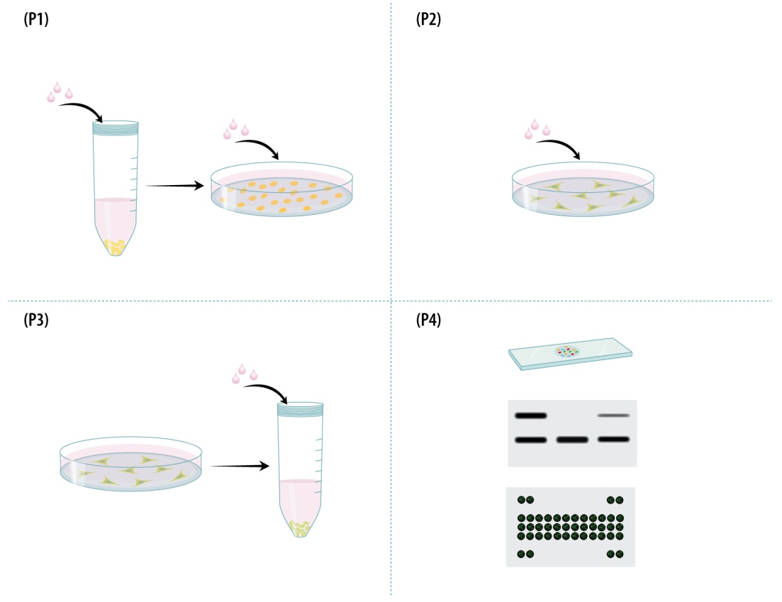
- Introductory Interview (spoken by you on camera. Don’t forget to smile!)
  - Joy Aho: The main advantage of this technique over existing methods, like TGFβ stimulation or genetic modification, is that this method is quick and easy, unlike genetic modification, and allows for EMT induction in a variety of cell types, some of which may not be responsive solely to TGFβ stimulation.
  - Ernesto Resnik: The implications of this technique extend to therapy and diagnosis of cancer metastasis. This technique allows researchers the ability to develop common expression signatures of metastatic cells that could be used in diagnosis. It also provides cells to be used for screening of drugs.
  - Joy Aho: Demonstrating the procedure will be Greg Herr a research associate in our laboratory.

Protocol Chapters (read by a voice talent at JoVE):
- Induction of EMT
  - Begin by warming the culture media for the cells of interest to 37 °C in a water bath.
    - WID: talent placing media into warm water bath
  - Next, harvest the cells using a dissociation solution, such as with TrypLE Express.
    - WID: talent arrives at hood with flask of cells
    - MED: talent using TrypLE Express to harvest cells, any representative step, such as pipetting cells from flask to tubes. Adding solution to flask and banging the flask to dissociate the cells.
  - Then, suspend the cells in pre-warmed culture media in a 15 mL conical tube and centrifuge the cell suspension at 400 x g for 5 minutes.
    - CU: cells pellet in 15 ml tube, media added into the tube and cells brought into solution
    - MED: loading centrifuge with tube of cells and balancer tube
  - Carefully remove the supernatant by pouring it into a waste container and suspend the cell pellet in pre-warmed culture media.
    - CU: pouring off supernatant from tube
    - MED: like 2.3.1 wider angle
  - Now, count the viable cells. Dilute a sample of the cell suspension in 0.4% Trypan Blue solution. Place 10 µL of the diluted sample on a hemocytometer and count viable cells – viable cells do not turn blue.
    - MED: taking an aliquot of cells into a tube with Trypan blue solution
    - CU: adding a 10 µL from Trypan/cells to hemocytometer plate
    - MED: talent places hemocytometer plate on microscope stage and focuses scope on cells
  - After calculating the cell density in your solution, plate nine to ten thousand cells per square cm in pre-warmed culture media containing 1X EMT Inducing Media Supplement. Use tissue culture treated plates or flasks.
    - MED: talent aliquotting cells into a tube.
    - MED: talent adds the EMT media supplement to the tube of cells and mixes.
    - CU: talent loads the media into the flask.
  - Culture the plated cells at 37 °C with 5% carbon dioxide and monitor their morphology daily using an inverted light microscope.
    - WID: loading the plates into an incubator
    - WID: talent, now has a next-day appearance, at microscope with cell plates, looking at plate with scope
  - Three days later, replace the media with fresh pre-warmed culture media containing 1X EMT Inducing Media Supplement.
    - WID: talent at hood, a new next-day appearance, removing media from plates
    - MED: adding media back to plates
  - Five days after plating, the cells are ready for analysis. Visualize the cell’s morphology under an inverted light microscopy. Cells can now be fixed or harvested for downstream studies.
    - WID: talent unloading the incubator, has another new appearance, and carries them to the scope
    - MED: talent places a plate under the scope and checks their appearance
    - CU: show a screen representation of the cells if monitor is hooked up to the cells, otherwise show the talent changing the plate of cells he/she is looking at under the scope from a wider angle
- Analysis of Protein Expression by Immunocytochemistry
  - Prepare sterile 12-mm coverslips for a 24-well plate by placing coverslips in a Petri dish containing 95% ethanol.
    - WID: talent pouring out ethanol into dish
    - MED: loading the dish with coverslips
  - Gently remove the coverslips from the ethanol using a curved forceps.
    - CU: lifting coverslip out of ethanol bath
  - Flame-sterilize each coverslip and transfer it into one well of a 24-well plate. Handling the coverslips requires care and practice.
    - CU: coverslip being sterilized in the flame
    - CU: coverslip gently set into well of plate
  - Next add 0.5 mL of pre-warmed culture media containing 1X EMT Inducing Media Supplement to the cells and plate 16 thousand cells per well.
    - MED: in hood, talent adding EMT media to cells in a tube.
    - CU: in hood, talent adding ½ a milliliter of cells + media to a well of the plate with culture media and cover slip, then repeating on the next well and the next well
  - Now, grow and feed the cells as previously described.
    - WID: loading the incubator with 24 well plate
  - Five days after plating the cells, remove the media and fix them with 300 µL per well of 4% paraformaldehyde in 1X PBS.
    - MED: at bench, removing media from plated cells
    - CU: adding 300 µL of fixative to a well, then the next and then the next
  - Allow the fixation to proceed for 20 minutes at room temperature. Then, remove the fixative and rinse the cells twice with 500 µL of 1X PBS per well.
    - MED: starting a 20 minute countdown on a timer and leaving the bench
    - MED: returning to the bench, stopping timer, removing solution from wells in plate
    - MED: adding PBS solution to the wells of the plate
  - Next, incubate the fixed cells in 400 µL of blocking buffer per well for an hour at room temperature. (TEXT: 1X PBS + 1% BSA + 10% normal donkey serum + 0.3% Triton-X-100; 1hr, RT)
    - CU: loading pipette from tube labeled “blocking buffer”
    - MED: ejecting solution from loaded pipette into well, then reloading pipette with “blocking buffer” and ejecting solution into the next well
  - After applying the block, prepare the primary antibody at the manufacturer’s recommended concentration in 400 µL of blocking buffer per well. Then remove the block solution from the wells and add the antibody mix to the cells.
    - WID: talent returns to the bench and stops a timer
    - MED: loading pipette with tube containing primary antibody and ejecting into a tube of blocking buffer, then mixing in the antibody, removes the block solution from wells, then taking sample from that mix and adding to a well of plate
  - Incubate the cells for either 3 hours at room temperature or overnight at 4 °C, and if the primary antibody is directly conjugated to a fluorchrome, incubate them in the dark.
    - MED: talent finishes adding last aliquot of Ab in buffer to plate, covers plate then adds a light cover to the plate
    - MED: starts a timer and walks away from the bench
  - Next, remove the primary antibody and wash wells three times with 500 µL per well of 1X PBS containing 0.1% BSA. Allow each wash to go for five minutes and, if needed, shield the cells from light. (TEXT: 3 washes, 5 min / wash)
    - MED: talent at hood, uncovers the plate and begins removing the Ab solution form the wells
    - CU: bottle of 1X PBS + 0.1% BSA, labeled, pipette takes an aliquot of this solution
    - MED: loading wells with new solution, from 1X PBS + 0.1% BSA bottle, then re-applying light shield to the plate
  - Now, if needed, incubate cells in a secondary antibody. At the manufacturer’s recommended concentration dilute the antibody in 400 µL per well of 1X PBS containing 1% BSA. Allow a one-hour incubation at room temperature, shielded from light.
    - WID: talent arrives to bench with tube of secondary antibody and makes a mix of it into a measured volume of 1X PBS+ 0.1% BSA
    - MED: talent removes solution from the wells of the plate and begins filling them with secondary antibody mixture on two wells.
    - MED: talent finishes applying the secondary mix, then covers up the plate to shield it from light and starts a countdown timer
  - After an hour, wash the cells three times, just as was done to remove the primary antibody. (TEXT: 3 washes in 1X PBS + 0.1% BSA, 5 min / wash) After the washes, if desired, apply a DAPI counter-stain to the cells.
    - Reuse 3.11.1, 3.11.2, 3.11.3
  - Lastly, rinse the cells in deionized water and mount the coverslips face down on slides using mounting media. Again, be careful in handling the coverslips.
    - MED: rinsing the cells in DI water,
    - CU: setting a coverslip down onto a slide with mounting media
    - MED: setting a second coverslip down onto the same slide with mounting media
- Characterizing EMT-induced Human Cells Lines
  - The EMT inducing culture conditions provide a robust method for the induction of EMT in a variety of cell types. This was tested on four different human cell lines. Cells that were treated with the EMT Inducing Media Supplement changed from a classical epithelial morphology….

LAB MEDIA: Figures 1A, 1B, 1C, 1D
  - …to a mesenchymal, spindle-shaped morphology.

LAB MEDIA: Figures 1E, 1F, 1G, 1H
  - Double staining for E-Cadherin and Fibronectin expression demonstrated the downregulation of the epithelial marker, E-cadherin, in red.

LAB MEDIA: Figure 2C
  - And the upregulation of the mesenchymal marker, Fibronectin, in green.

LAB MEDIA: Figure 2G
  - Uninduced MCF10A samples contained tightly packed clusters surrounded by more loosely packed cells. These clusters were E-cadherin positive, shown in red.

LAB MEDIA: Figure 2D
  - The clusters disappeared upon treatment with the EMT Inducing Media Supplement. This coincided with an increase in fibronectin expression, in green.

LAB MEDIA: Figure 2H
  - T98G was found to have an extremely low basal level of E-cadherin prior to EMT induction, which precluded its analysis with this marker. However, fibronectin levels were found to increase significantly with EMT induction in these cells.

LAB MEDIA: Fig 2A

LAB MEDIA: Fig 2E
  - The expression levels of E-cadherin and Fibronectin were further confirmed through western blotting of total cell lysates. Although the western blot does not show significant reduction of total E-cadherin protein levels in HT29 cells ...

LAB MEDIA: Figure 3
  - … there was a reduction in surface expression of E-cadherin seen by immunocytochemistry.

LAB MEDIA: Figure 2B

LAB MEDIA: Figure 2F
  - To further evaluate EMT status, mesenchymal markers characteristic of EMT, Vimentin, in green, and Snail, in red, were analyzed pre-and post-EMT induction.

LAB MEDIA: Fig 4A-C
  - Consistent with previous results, E-cadherin, in grey, was downregulated in all cell lines examined, indicating that EMT was induced. In addition there was upregulation of snail, in red, and Vimentin, in green, in A549, T98G, and MCF10A cells.

LAB MEDIA: Fig 4D-F
  - MCF7 human breast cancer cells and PANC-1 human pancreatic carcinoma cells are both reported not to enter EMT by TGF-β signaling alone.

LAB MEDIA: Figure 5A and 5B
  - These reports were confirmed with recombinant TGF-β1 alone, at the concentration within the EMT Inducing Media Supplement. The cells retained their epithelial morphology and surface E-cadherin levels similar to the control cells.

LAB MEDIA: Figure 5C and 5D
  - In contrast, cells stimulated with the EMT Inducing Media Supplement showed a drastic decrease in their surface E-cadherin levels. These cells also obtained a more mesenchymal morphology.

LAB MEDIA: Figures 5E and 5F
  - Another hallmark of mesenchymal cells is their ability to migrate and invade. This was analyzed using the 96 well BME Cell Invasion Assay according to the manufacturer’s instructions. Significant increases in cell migration were seen with both A549 and PANC-1 cells following EMT induction.

LAB MEDIA: Figure 6A
  - The same assay was performed with a basement membrane extract-coated filter to test invasion. EMT-induced cells showed a significant increase in invasion capabilities compared to untreated cells.

LAB MEDIA: Figure 6B
  - The robust induction of EMT is useful for the analysis of gene expression changes and signaling taking place in these cells. A commercial antibody-based array using lysates from MCF7 and A549 cells was used to analyze the levels of phosphorylated MAP-K family members.

LAB MEDIA: Figure 7A

LAB MEDIA: Figure 7B
  - Both cell types exhibited increased phosphorylation of CREB, ERK1 and ERK2 in EMT-induced cells, compared to the controls. A549 cells also showed an increase in GSK-3β phosphorylation.

LAB MEDIA: Figure 7C
  - MCF7 cells showed increased p70-S6K phosphorylation, in addition to the increased phosphorylation of CREB, ERK1 and ERK2.

LAB MEDIA: Figure 7D

- Conclusion Interview (spoken by you on camera)
  - Joy Aho: While attempting this procedure, it’s important to remember that there can be some variability in results from different cell types. Not all cells will use the same downstream pathways for EMT induction, leading to differences in marker expression between cell types. Additionally, many markers of EMT do not demonstrate strict on and off states and may have basal levels in epithelial cells. Such markers can show an increase and/or change of localization upon mesenchymal transition.
  - Ernesto Resnik: Following this procedure, other methods like drug screening can be used to answer additional questions like what compounds are able to modulate epithelial to mesenchymal transition. These compounds could be very useful in the treatments of cancer and fibrosis.

List of Provided Media Filenames and Descriptions (fill this in)

4.1 – 1_JAho_Figure1A-1D.tif - morphology images of the 4 cells lines tested without EMT induction
4.2 – 1_JAho_Figure1E-1H.tif - morphology images of the 4 cells lines tested after EMT induction
4.3 – 1_JAho_Figure2C.tif - dual color immunocytochemical image of control A549 cells
4.4 – 1_JAho_Figure2G.tif - dual color immunocytochemical image of EMT induced A549 cells
4.5 – 1_JAho_Figure2D.tif - dual color immunocytochemical image of control MCF10A cells
4.6 – 1_JAho_Figure2H.tif - dual color immunocytochemical image of EMT induced MCF10A cells
4.7 – 1_JAho_Figure2A.tif - dual color immunocytochemical image of control T98G cells
4.7 – 2_JAho_Figure2E.tif - dual color immunocytochemical image of EMT induced T98G cells
4.8 – 1_JAho_Figure3.tif - western blot image of protein expression
4.9 – 1_JAho_Figure2B.tif - dual color immunocytochemical image of control HT29 cells
4.9 – 2_JAho_Figure2F.tif - dual color immunocytochemical image of EMT induced HT29 cells
4.10 – 1_JAho_Figure4A-4C.tif - three color immunocytochemical image of control cells
4.11 – 1_JAho_Figure4D-4F.tif - three color immunocytochemical image of EMT induced cells
4.12 – 1_JAho_Figure5A,5B.tif - immunocytochemical images of control MCF7 and PANC-1 cells
4.13 – 1_JAho_Figure5C,5D.tif - immunocytochemical images of TGFb induced MCF7 and PANC-1 cells
4.14 – 1_JAho_Figure5E,5F.tif - immunocytochemical images of EMT induced MCF7 and PANC-1 cells
4.15 – 1_JAho_Figure6A.tif - bar graph of migration levels of control versus EMT induced cells
4.16 – 1_JAho_Figure6B.tif - bar graph of invasion levels of control versus EMT induced cells
4.17 – 1_JAho_Figure7A.tif - array image of control versus EMT induced A549 cells
4.17 – 2_JAho_Figure7B.tif - array image of control versus EMT induced MCF7 cells
4.18 – 1_JAho_Figure7C.tif - bar graph of quantitated array data of control versus EMT induced A549 cells
4.19 – 1_JAho_Figure7D.tif - bar graph of quantitated array data of control versus EMT induced MCF7 cells

General Preparation

It’s critical for a smooth and organized shoot that all reagents are accounted for, in advance.

Any overnight or long incubation steps should be recognized and specimens/samples be prepared in advance so that prior steps can be recorded and shooting can continue with pre-prepared specimens/samples.

All tubes/flasks should be pre-labeled neatly before we arrive.

Ex. Luciferase assay done in 96 well plates should be labeled with negative/positive control wells and experimental samples are labeled accordingly.

