Submission ID #: 50438

Editor Name: Melissa Ceo

Videographer name:

Film Date:

Authors and Affiliations:
Girish S Kulkarni, Zhaohui Zhong

Department of Electrical Engineering and Computer Science
University of Michigan - Ann Arbor
Ann Arbor, MI-48109, USA

Title: Fabrication of Carbon Nanotube High-frequency Nanoelectronic Biosensor for Sensing in High Ionic Strength Solutions

Corresponding Author:

Zhaohui Zhong: zzhong@umich.edu

Co-authors email: girishsk@umich.edu

Authors, please fill out the brief questionnaire below.

A. Will you require JoVE to record video microscopy, such as filming a complex dissection or microinjection technique? (Y/N) N
B. Does your protocol include detailed, step-by-step, descriptions of software usage? (Y/N) N
C. Which steps of your protocol will viewers benefit most from having filmed? Please list 4-6 steps. Protocol steps 5, 6, 7 and 8.
D. What is the single most difficult aspect of this procedure and what do you do to ensure success? The most difficult aspect of our procedure is securing a microfluidic flow channel which remains stable during fluid flow measurements. To address this we treat the PDMS flow channel with oxygen plasma before attaching it onto our devices, and we also operate the syringe pump system in withdrawal mode to pull the fluid through the channel rather than push it.

1. Introduction (Schematic Overview and Interview)

A. Schematic Overview (read by voice talent at JoVE):
Authors, please select from “Procedural Narrative” or “Conceptual Narrative” and complete the statements below. Please do not add additional steps. Then, attach your finished graphic overview. See accompanying instructions for details and examples.

Conceptual Narrative:
The overall goal of the following experiment is to demonstrate a new nanoelectronic sensing platform for point-of-care biomolecular detection in high ionic strength solutions. (Intro)

This is achieved by operating single-walled carbon nanotube field effect transistors at high frequency to mitigate the ionic screening effect. First, the nanotube transistors are fabricated and functionalized with receptor molecules. (P1, lower the turquoise blue structure with the purple oval onto the gray tube and make the arrow and word “biotin” appear).

As a second step, the devices are encapsulated with a microfluidic flow channel, which allows biomolecule sample solutions to be injected for real time sensing. (P2, lower the gray rectangle labeled “flow channel” onto the rectangular device and then raise it back up in C3).

Next, the single-walled carbon nanotube field transistors are operated as high frequency mixers in order to overcome an ionic screening effect. At high driving frequency, ions in solutions can no longer screen the nanotube sensor effectively, allowing the oscillating dipole moments of surface-bound biomolecules to be detected. (P3, have the two electrical diagrams on both sides of the rectangular device appear followed by the “flow” arrow and then have the “flow” arrow move across the “biotin” and nanotube).

The results show the detection of streptavidin-biotin binding in 100mM background solution based on monitoring changes in mixing current at 10 MHz driving frequency. (P4)

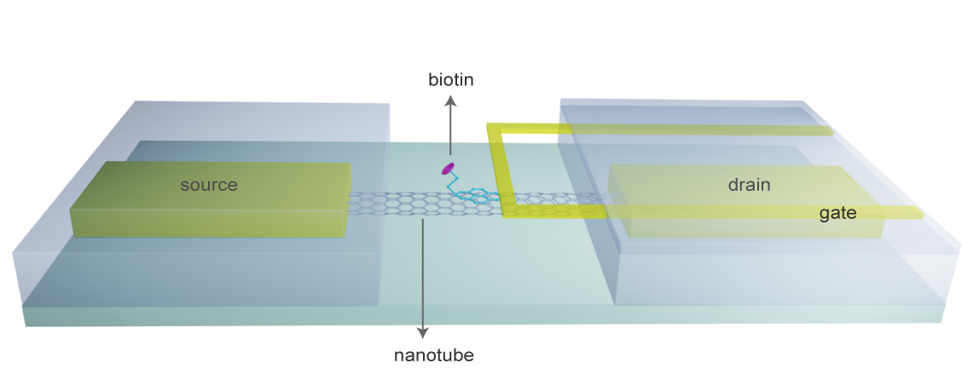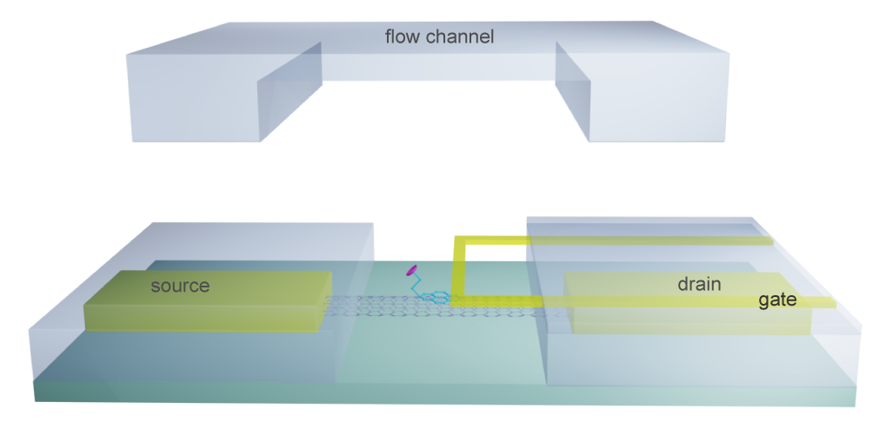
(C1) (C2)

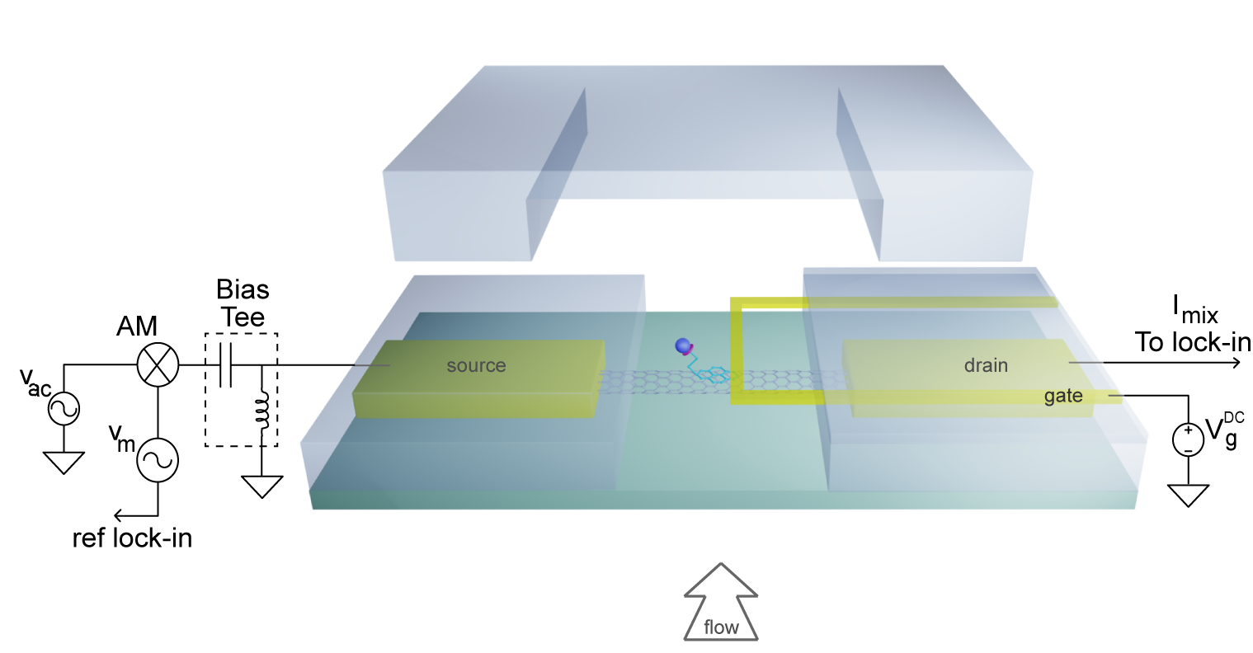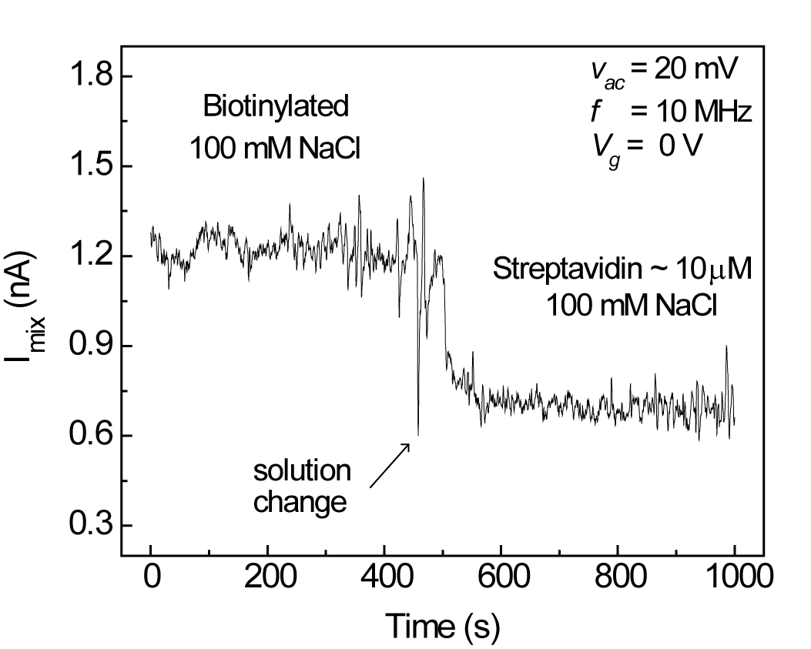

(C3) (C4)

B. Interview: (Said by you on camera. Don’t forget to smile!)

Authors: Below are statements we would like you to complete that are complementary to the information contained within the schematic overview.
- Only one statement should be chosen and completed per author who will be on camera demonstrating the protocol.
- Enter the name of the individual who will say each line.
- Please choose and fill out the statement(s) that convey the most important fact(s) about your protocol. You may revise the given prompts as necessary to improve the sentence flow.
- If any individuals will be doing demonstrations on camera but are not assigned a speaking part in this interview section, please use statement 1.8 to introduce these demonstrators (for example, the PI introduces students)

  - Author name Zhaohui Zhong: The main advantage of this technique over existing methods, like direct current detection, is that it overcomes the Debye screening effect which fundamentally impedes direct current detection in high ionic strength solutions.
  - Author name Girish S Kulkarni: In contrast to traditional charge-detection based sensors, our method detects the dipole moments of biomolecules by exploring the high frequency response of nanotube transistors.

Protocol (read by voice talent at JoVE):

Authors: In order to ensure that your protocol can be filmed in a single day, the protocol text must be limited to 30 steps – each step being defined as 3 lines of 12 pt text in our formatting style below. This amounts to 3 pages of protocol text. The scope of the scripted protocol text should include only those aspects of the procedure that require visualization in order to be well understood.

- Catalyst Patterning and Chemical Vapor Deposition Growth for Single-walled Carbon Nanotubes
  - First, place a photomask with rectangular pits for catalyst onto a photoresist coated silicon water and expose it to a UV irradiance of 300mJ/cm² (pronounced micro joule per centimeter squared) for 0.3 seconds (TEXT overlay: Use a silicon wafer with a low-pressure chemical vapor deposition grown 500 nm Si₃N₄/500 nm SiO₂ film).
    - WID: Talent places the photomask and silicon wafer on the bench.
    - WIDE: Talent places silicon wafer and photomask into cabinet for UV exposure.
    - MED: Talent exposes the wafer to UV light.
  - Load the developed wafer into an electron beam evaporation chamber and deposit 0.5 nm of iron at a chamber pressure of 10⁻⁶ torr.
    - MED: Talent places wafer into evaporation chamber.
    - MED-over the shoulder: Talent adds iron to the chamber and turns the vacuum on.
  - After cutting the catalyst coated silicon wafer from the chamber into smaller dies, place them on a quartz boat and load the boat into the CVD (pronounced C-V-D) growth furnace (TEXT overlay: CVD: Chemical Vapor Deposition).
    - MED: Talent places dies on a quartz boat.
    - Talent loads the boat into CVD growth furnace.
    - Added shot: Talent programs the furnace to establish growth conditions. {Here, we can use Figure 2b for growth conditions describing the voice over of steps 2.4, 2.5 and 2.6}
    - Added shot: Talent unloads the dies after the growth process is over.
  - Program the furnace to ramp up the furnace to 800 °C at the center of the tube, while maintaining a flow of 1 SLM (‘SLM’ pronounced S-L-M) (TEXT overlay: SLM: Standard Liter per Minute) of argon. Flow 0.2 SLM of hydrogen for 5 minutes to reduce the catalyst particles and convert iron oxide to iron. Then, 5.5 sccm (‘sccm’ pronounced S-C-C-M) of ethylene is introduced for 35 minutes to grow the SWNTs (‘SWNT’ pronounced S-W-N-T) (TEXT overlay: SWNTs: Single-walled Carbon Nanotubes, SCCM: Standard Cubic Centimeter per Minute). A hydrogen flow of 0.2 SLM is maintained throughout the process.
    - Use 2.3.3. Talent programs the furnace to establish growth conditions.
    - LAB MEDIA: figure 2b: growth conditions
  - After cooling to room temperature with a small argon flow, remove the die from the furnace.
    - Use 2.3.4. Talent unloads the dies after the growth process is over.
- SWNT Field-effect Transistor Fabrication
  - After defining the area for metal deposition for contacts, place the die in the evaporation chamber. Then deposit 0.5 nanometers of titanium and 50 nanometers of gold as the source and drain contact metals in an electron beam evaporation chamber at 10⁻⁶ torr. When finished, soak the die in acetone overnight for metal liftoff, then dip in isopropanol for 10 minutes and blow dry with nitrogen.
    - MED: Talent places die in evaporation chamber.
    - MED-over the shoulder: Talent deposits titanium and gold in the chamber and turns the vacuum on.
    - CU: Titanium/Gold coated die as talent removes it from the chamber

3.1.3/2 Added shot: Talent places titanium/gold coated die in acetone.
    - MED: Talent dips die in isopropanol.
    - ECU: Die as It is dried with nitrogen.
  - Next, place the die back in the evaporation chamber and deposit 500nm electron beam evaporated silicon dioxide at 10⁻⁶ torr.
    - Reuse shot 3.1.1: Placing die in chamber.
    - Reuse shot 3.1.2 – Use the part that shows turning the vacuum on.
    - CU: Die after silicon dioxide has been deposited.
  - Evaporate 50 nanometers of chrome and 50 nanometers of gold as the top gate electrode in the electron beam evaporator.
    - Reuse 3.1.1 or 3.1.2
    - CU: Die after top gate electrode has been deposited.
  - After patterning the photoresist, wet etch the evaporated silicon dioxide using a 1:20 buffered hydrofluoric acid solution for 3 minutes and 30 seconds.
    - ECU: Die as talent etches it using the buffered hydrofluoric acid solution.
- Chemical Functionalization of Carbon Nanotube Sidewalls
  - Now, prepare a solution of 6mM PBSE (‘PBSE’ pronounced P-B-S-E) (TEXT overlay: PBSE: 1-pyrenebutanoic acid succinimidyl ester) in dimethylformamide.
    - MED: Talent prepares PBSE solution.
  - Incubate the SWNT FET (pronounced F-E-T) (TEXT overlay: FET: field effect transistor) die in the PBSE linker molecular solution for 1 hour at room temperature.
    - CU: SWNT FET die in PBSE linker solution.
  - Following this, prepare a 20mg/ml solution of amine-PEG2-biotin in de-ionized water.
    - MED: Talent prepares amine-PEG2-biotin solution.
  - Incubate the die in this solution for 18 hours, thoroughly rinse the die in de-ionized water. Repeat the rinse 8 to 10 times, (TEXT overlay: Repeat rinse 8-10x) and then blow dry.
    - MED-over the shoulder: Talent places die in biotin solution.
    - MED: Die as talent removes it from the biotin solution.
    - MED: Talent rinses the die with water and dries it.
- Preparation of Polydimethylsiloxane Mold for Fluid Chamber
  - Place a new silicon wafer in a Petri dish and pour a degassed PDMS (‘PDMS’ pronounced P-D-M-S) (TEXT overlay: PDMS: Polydimethylsiloxane) mixture into the dish until the mixture is 5mm above the wafer. Next, place the Petri dish in an oven at 70 °C for 1 hour.
    - CU: Petri dish as talent places wafer in it and adds PDMS.
    - MED: Talent places Petri dish in oven.
  - Remove the Petri dish from the oven and allow the wafer to cool to room temperature. Use a scalpel to cut out a rectangular piece of PDMS and pull it out using a tweezer.
    - MED: Talent removes Petri dish from oven and places it to cool to room temperature.
    - MED-over the shoulder: Talent cuts out a piece of PDMS from the wafer.
    - CU: PDMS as talent pulls out the cut piece.
  - Then, place the rectangular die upside down and punch a hole through the flat side using a 3 mm biopsy punch.
    - MED: Talent turns die upside down.
    - CU: Die as talent punches a hole in it.
  - After placing the die under the microscope, carefully place the PDMS chamber on top of the die by aligning it on top of the active area of the fabricated SWNT FET devices.
    - SCOPE (or ECU): PDMS chamber is aligned on die.
- Preparation of Microfluidic Flow Channel
  - Place a silicon wafer with a SU-8 (pronounced S-U-8) mold in a Petri dish and add 2-3 drops of trichloro(3,3,3-trifluoropropyl)silane. Place the Petri dish in a vacuum chamber for 1 hour.
    - MED-over the shoulder: Talent places silicon wafer with SU-8 mold in Petri dish and adds silane to it.
    - MED: Talent places Petri dish in vacuum and turns it on.
  - After removing the Petri dish from the vacuum, pour the degassed PDMS mixture onto the wafer and heat it in an oven at 70 °C for 1 hour. When finished, remove the Petri dish from the oven and allow the wafer to cool to room temperature.
    - CU: Wafer as talent pours the PDMS mixture onto it.
    - MED-over the shoulder: Talent places the Petri dish in the oven.
    - MED: Talent removes Petri dish from oven and places it to cool to room temperature.
  - After cutting a rectangular PDMS stamp, place it upside down and punch a hole at each end of the flow channel using a 0.75mm biopsy punch.
    - MED: Talent turns die upside down.
    - CU: Die as talent punches holes in it.
  - After placing the die under the microscope, carefully place the PDMS flow chamber on top of the die by aligning it on top of the active area of the fabricated SWNT FET devices.
    - SCOPE (or ECU): PDMS chamber is aligned on die.
  - Next, push a polyethylene tube into each hole and connect one tube to a fluid source syringe barrel and the other tube to a drain syringe. Attach the syringe to a syringe pump to maintain a controlled fluid flow through the channel.
    - CU: Die as talent pushes a polyethylene tube into each hole.
    - MED: Talent connects one tube to fluid source barrel and other tube to drain syringe.
    - MED-over the shoulder: Talent attaches the syringe to a syringe pump.
- AC electrical measurement setup
  - To setup the AM modulated frequency output, connect the Ref-out signal from the lock-in amplifier to the external modulation signal port on the frequency generator.
    - MED: Talent connects the Ref-out signal to the external modulation signal port.
  - Next, connect the AM modulated RF output and DC voltage to a bias tee, and connect the output of the bias tee to the SWNT source contact. Then, connect the gate contact to the voltage port of the DAQ (pronounced ‘Dack’) card.
    - MED: Talent connects the AM modulated RF output and DC voltage to a bias tee. The output of the bias tee is connected to the SWNT source contact.
    - MED-over the shoulder: Talent connects the gate contact to the voltage port of the DAQ card.
  - To read the AC (pronounced “A-C”) current through the nanotube, connect the drain contact to a lock-in amplifier. Connect the amplitude and phase ports of the lock-in amplifier to the DAQ input ports.
    - MED-over the shoulder: Talent connects the drain contact to the lock-in amplifier.
    - MED: Talent connects the amplitude and phase ports of lock-in amplifier to the DAQ input ports. {Comment from the authors: Show the connections.}
  - Hold the source DC voltage at 0 volt and the AM signal frequency at 200 kilohertz. Sweep the gate voltage and measure the current from the drain.
    - MED: Talent sets the DC voltage and AM signal frequency. {Comment: Shown on the screen in the software}
    - MED-over the shoulder: Talent programs the gate voltage and measures the current.
- Electrical Measurements in Solution: No Flow and Real Time Flow
  - Fill the fluid chamber with de-ionized water using a pipette. Carry out the AC electrical measurement. Repeat with 1mM NaCl, 10 mM NaCl, and 100mM NaCl, and measure the device response for each solution.
    - MED: Talent adds de-ionized water to the fluid chamber.
    - MED-over the shoulder: Talent measures the AC electrical device response. Gate voltage sweep set in the program and run.
    - LAB MEDIA: Result of Figure 7e can be shown as representative result of what one sees for a good device
  - After placing the micro-fluidic flow channel on the device, connect one tube to an empty syringe placed on the syringe pump and connect the other tube to a syringe barrel and fill it with 100mM NaCl solution.
    - MED: Talent connects one tube to an empty syringe placed on syringe pump and the other tube to a syringe barrel and fills it with 100mM NaCl. {Comment: Similar to 6.5.2 and 6.5.3. Point to the connected empty syringe and fill the other syringe with 100mM NaCl.}
  - Set the syringe pump to withdrawal mode (TEXT overlay: flow rate = 0.4 ml/hour). 100mM NaCl solution is pulled into the tube. The current can be monitored on the computer. Then, switch the solution to 1mg/ml streptavidin in 100mM NaCl and monitor the real time current change for streptavidin-biotin binding.
    - MED: Talent sets the syringe pump to withdrawal mode.
    - Added shot: 100mM NaCl solution pulled into the tube and real time current being monitored in the program on the computer screen.
    - MED-over the shoulder: Solution is pipetted into the syringe barrel and real time current change is monitored on the screen}

- Results: Functionalized SWNT FETs for High-Frequency Sensing of Biomolecules in High Ionic Strength Solutions

  - A scanning electron microscope image of SWNT transistor with a suspended top gate is shown here. The gate electrode consists of 50nm Cr / 50nm Au, and a thick chrome layer adds strength to the suspended structure.
    - LAB MEDIA: Figure 7a
  - The suspended structure is confirmed by the absence of a leakage current between the top gate and the drain.
    - LAB MEDIA: Figure 7b
  - To characterize the success of sidewall functionalization, the changes in FET DC transfer curves in air after each functionalization step were monitored. The transfer curve for pristine nanotube FET shifts to the right after biotinylation and streptavidin binding.
    - LAB MEDIA: Figure 7c (Video Editor: Please highlight the black curve when pristine nanotube FET is mentioned, the red curve when biotinylation is mentioned, and the blue curve when streptavidin binding is mentioned).
  - Pictured here is the I_{mix} (pronounced mixing current) sensing signal measured as a function of gate voltage for a typical device in 100mM NaCl. The graph shows the curves for the I_{dc} (pronounced dc current), I_{mix}, and a theoretical I_{mix}. The data demonstrates that the mixing current results agree well with the theoretical model.
    - LAB MEDIA: Figure 7d (Video Editor: For the second sentence, please highlight the black curve when dc current is mentioned, the red curve when I_{mix} is mentioned, and the dotted black curve when theoretical I_{mix} is mentioned).
  - The representative results of static measurements and real time flow measurements are shown here. The I_{mix}-V_{g} (pronounced mixing current versus gate voltage) curves represent biotinylated and streptavidin-bound SWNT in 100mM NaCl. The mixing current changes upon binding of streptavidin in the real time flow experiment.
    - LAB MEDIA: Figure 7e (Video Editor: Please show both Figure 7e and 7f for the first sentence. Only show Figure 7e for the second sentence and highlight the black curve when biotinylated is mentioned and the red curve when streptavidin-bound is mentioned).
    - LAB MEDIA: Figure 7f (Video Editor: Please show Figure 7f for the last sentence).
  - Signal change was also measured before and after streptavidin binding in a SiO₂ passivated control device in de-ionized water at different frequencies. There was no change after binding, indicating that the detection mechanism arises due to the SWNT-biomolecule interaction at high frequencies.
    - LAB MEDIA: Figure 7g

INSTRUCTIONS FOR AUTHORS:
Please ensure that the representative results narration is appropriate and correctly describes your images, movies, or figures. Our editors have ensured that the results are written in our format.

We consider this section a critical aspect of the video, because here is where you provide validation for your experiments. For example, if this is a cell culture preparation, this section is where the video will show your cells at various time points following culturing. If this is an imaging prep, then this part is where you will show examples of your imaging experiments.

Please limit the extent of narration to no more than 2-3 lines of text per image or movie file being described. Figures with multiple panels submitted with the original protocol should be broken up so that each panel is a separate image. Like the schematic, each image or movie file supplied in the results should be referenced by annotation in parenthesis, however for the results, the specific filename should be given in parenthesis.

Below is an example of results text:

EXAMPLE REPRESENTATIVE RESULTS

5. Evaluation of Morpholino Injection and Knockdown
5.1 Representative results of both morpholino injection and mRNA injection are shown here. The
uninjected control at 48 hours post fertilization looks normal, as expected
-LAB MEDIA: 0123_PIname_Figure1.tif (Replace 0123 with your jove video #)

5.2 However, embryos injected with the morpholino heg_e3i3_egfr1, which knocks down Heg isoforms
containing the first of two EGF-like repeats, exhibit brain edema.
-LAB MEDIA: 0123_PIname_Figure2.tif

5.3 Injection of heart of glass mRNA also produced an obvious phenotype. At 24 hours post fertilization,
the heads of the uninjected controls look normal
-LAB MEDIA: 0123_PIname_Figure3.tif

5.4 Conversely, some of the embryos injected with the mRNA exhibit cyclopia
-LAB MEDIA: 0123_PIname_Figure4.jpg

Please visit the following URL to see an example of how the results will look when complete:
http://www.jove.com/video/1597/results-example-mably?access=ksw0bprj

- Conclusion (said by authors on camera)
Authors: Below are statements we would like you to complete that summarize and conclude the video. Only one statement should be chosen and completed per author who will be on camera demonstrating the protocol. In addition to choosing and filling out the appropriate statement, please enter the name of the individual who will say each line. You may revise the given prompts if necessary to better fit your protocol.

  - Author name Girish S Kulkarni: This measurement technique can be applied in general to nanotube, nanowire, or graphene based electronic biosensors, and can be performed directly in high ionic strength background solutions without the need for time consuming steps like desalting.

Provided Media

Authors, Please list all images, movie files, or 3-D rendered animations that can be included in the video per editor’s request. The step in the script/video where these images will be inserted should be specified. For example:

6.2 – 0123_PIname_Figure1.tif - dual color imaging of tumor angiogenesis at 40X
6.2 – 0123_PIname_Figure2.tif - dual color imaging of tumor angiogenesis at 100X

Formats: For static images we prefer .tiff, Illustrator, Powerpoint or Photoshop files at dimensions of at least 720X480 pixels and 300 dpi. The higher resolution, the better. Likewise any exported movie files should have at minimum these dimensions and be rendered to .mov, .mp4, or .avi files.

Insert your media filenames here.

General Preparation

It’s critical for a smooth and organized shoot that all reagents are accounted for, in advance.

Any overnight or long incubation steps should be recognized and specimens/samples be prepared in advance so that prior steps can be recorded and shooting can continue with pre-prepared specimens/samples.

All tubes/flasks should be pre-labeled neatly before we arrive.

Ex. Luciferase assay done in 96 well plates should be labeled with negative/positive control wells and experimental samples are labeled accordingly.

You will receive more detailed preparation instructions, as well as an introduction to your videographer, closer to your filming date.

