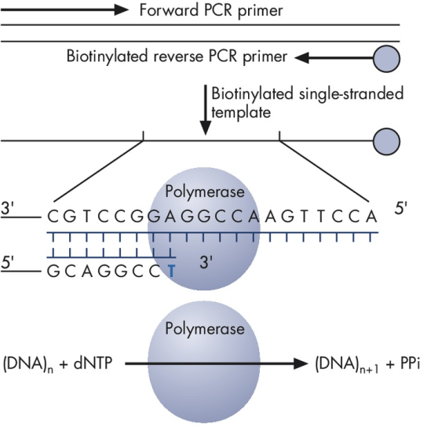
Figure 1. Biotinylated PCR product is used as a template to incorporate dNTPs by DNA polymerase, leading to the generation of pyrophosphate (PPi).

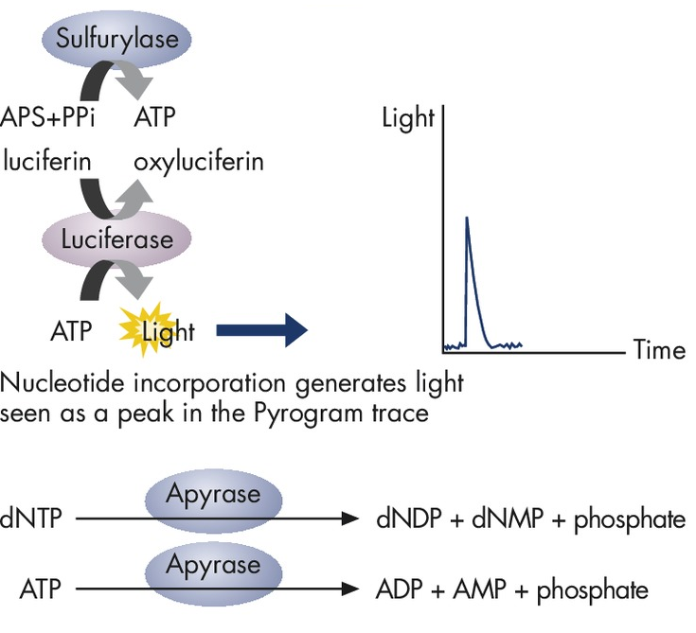
Figure 2. ATP sulfurylase proportionately converts pyrophosphate to ATP. ATP acts as a catalyst for the luciferase-mediated conversion of luciferin to oxyluciferin, which generates light that is proportional to the amount of ATP. The light is recorded as peak on the pyrogram trace and indicates nucleotide incorporation. The unincorporated dNTPs are degraded by apyrase before the next dNTP is added for continuation of the synthesis.

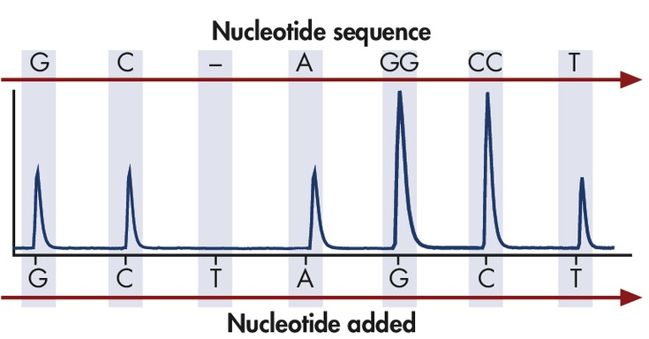
Figure 3. The intensity of light generated indicates if one or more specific dNTP’s (dATP, dTTP, dGTP, or dCTP) was incorporated onto the template strand sequentially.

Table 1 PCR Reaction Mixture
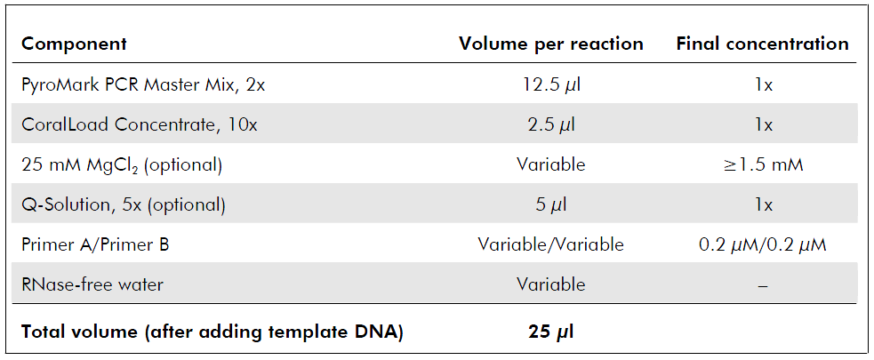

Table 2 PCR Cycle Specifications
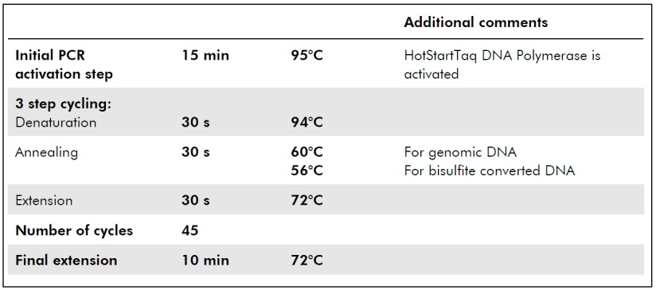

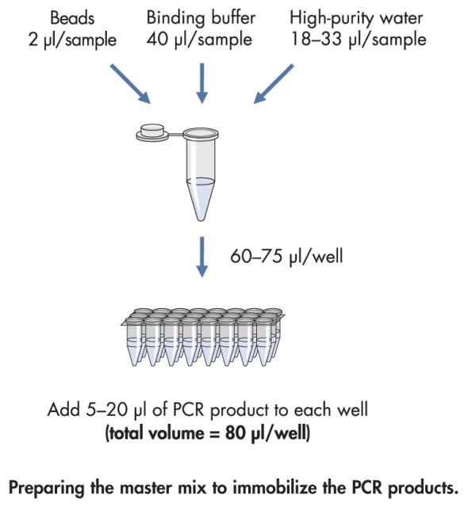
Figure 4. Flow chart for preparation of PCR master mix to amplify and immobilize the biotinylated PCR product.

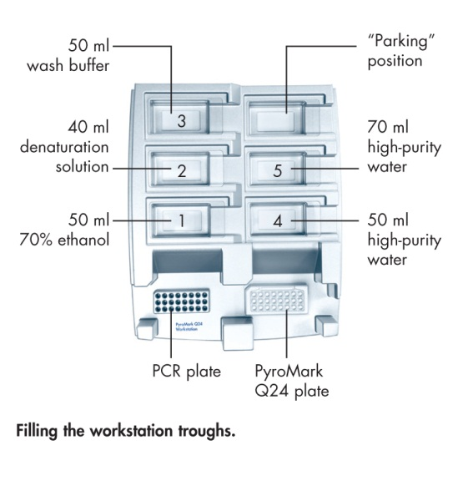
Figure 5. PyroMark workstation, with PCR plate, PyroMark plate, and trough locations.

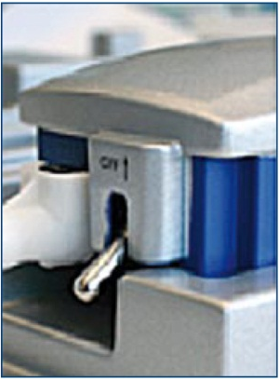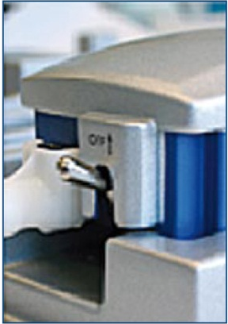
Figure 6. Locations of the Vacuum switch ON and OFF positions.

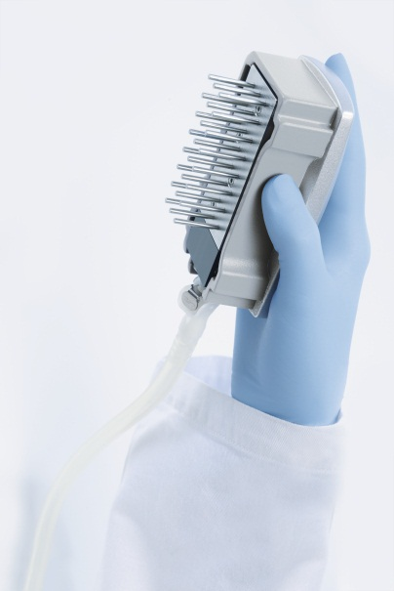
Figure 7. Vacuum tool. Proper handling of the vacuum tool.

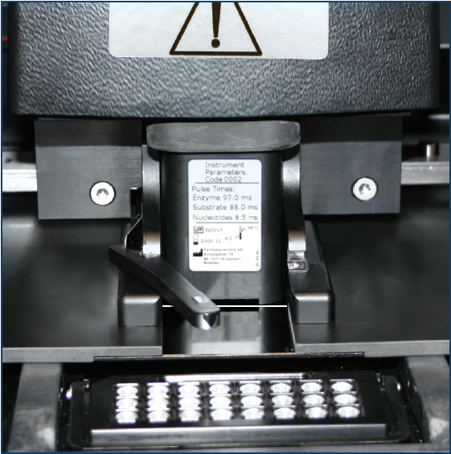
Figure 8. Cartridge gate opened with cartridge in place.

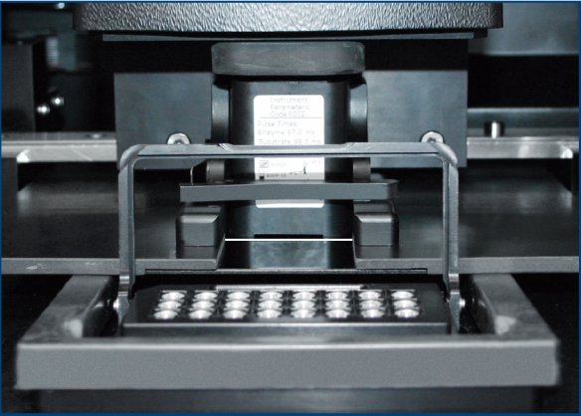
Figure 9. Cartridge properly inserted with gate closed

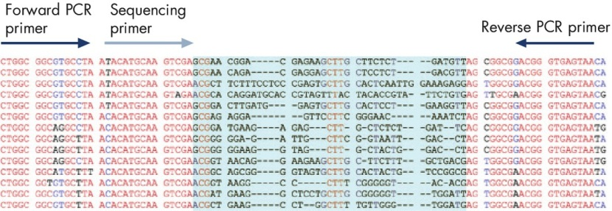
Figure 10: Pyrosequencing based bacterial identification results. PCR primers are designed for conserved regions of the DNA template, and the sequencing primer is positioned immediately upstream of a well-characterized identifying hypervariable DNA sequence within the amplicon (shown in blue).

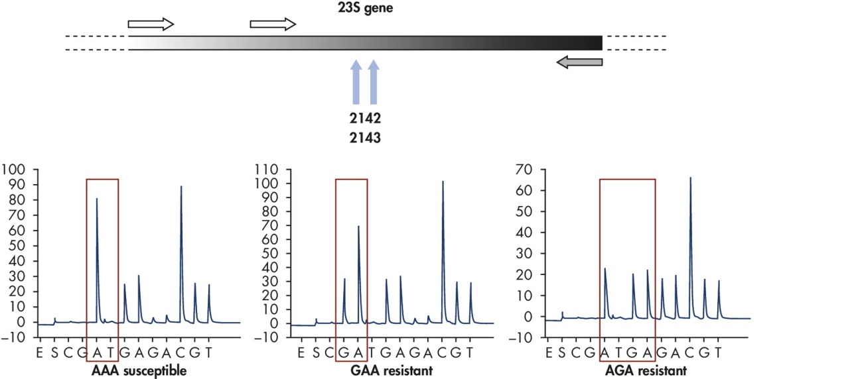
Figure 11. Detection of antibiotic drug resistance in Helicobacter pylori using pyrosequencing. Analysis of mutations in the 23S genes that confer antibacterial resistance in Helicobacter pylori containing GAA or AGA sequences.

