Submission ID #: 50294

Editor Name: Michael Linnes

Videographer name: Dave Allen

Film Date: Feb. 1, 2013

Authors and Affiliations: Marguerite K. McDonald¹, Kathryn E. Capasso¹, Seena K. Ajit¹

¹Dept. of Pharmacology & Physiology, Drexel University College of Medicine, Philadelphia, PA, USA

Title: Purification and microRNA profiling of exosomes derived from blood and culture media

Corresponding Author:
Seena K. Ajit PhD
Assistant Professor
Pharmacology & Physiology
Drexel University College of Medicine
245 North 15th Street, Mail Stop 488
Philadelphia, PA 19102
Tel.: +1 215 762 2218
Fax: +1 215 762 2299
E-mail: seena.ajit@drexelmed.edu
Additional Contacts:
kec57@drexel.edu
Marguerite.McDonald@DrexelMed.edu

Authors, please fill out the brief questionnaire below.

A. Will you require JoVE to record video microscopy, such as filming a complex dissection or microinjection technique? (Y/N) ____N___
B. Does your protocol include detailed, step-by-step, descriptions of software usage? (Y/N)____N____
C. Which steps of your protocol will viewers benefit most from having filmed? Please list 4-6 steps__________3.15-3.17 and also 4.1________________

D. What is the single most difficult aspect of this procedure and what do you do to ensure success? ___Step 3.4: Although quantitative RT-PCR is a standard molecular biology technique, making the master mix for cDNA synthesis in this protocol requires a lab environment that is uninterrupted and conducive to concentration. It involves making two master mixes per sample that require pipetting small volumes of expensive reagents and preparing enough to ensure that all samples will end up with the proper volume without making additional mix. Usually we add an extra volume as recommended by the vendor.
1. Introduction (Schematic Overview and Interview)

A. Schematic Overview (read by voice talent at JoVE):

Procedural Narrative:
The overall goal of this procedure is to identify and quantitate micro-RNAs present in exosomes obtained from blood or cell culture media. (Intro)

This is accomplished by first purifying exosomes from blood or cell culture media using differential centrifugation. (P1, use still showing the centrifuge tube from shot 2.8.1)

The second step is to purify total exosomal RNA using a mirVana micro-RNA isolation kit. After confirming the integrity and concentration of the purified RNA, it is converted to cDNA using reagents in the Megaplex reverse transcriptase reaction kit. (P2, use a still from 3.2.2 thru “purified RNA,” then use a still from 3.3.1)

Next, a preamplification step is performed using Megaplex PreAmp primers and a TaqMan PreAmp master mix to amplify the micro-RNAs. (P3, use a still from 3.5.2)

The final step is to run a real time PCR reaction using two 384-well microfluidic cards or TaqMan low density array cards containing dried TaqMan primer probes. (P4, use still from 3.7.1)

Ultimately, this procedure will enable the detection of up to 758 known micro-RNAs. (P5, figure 2)

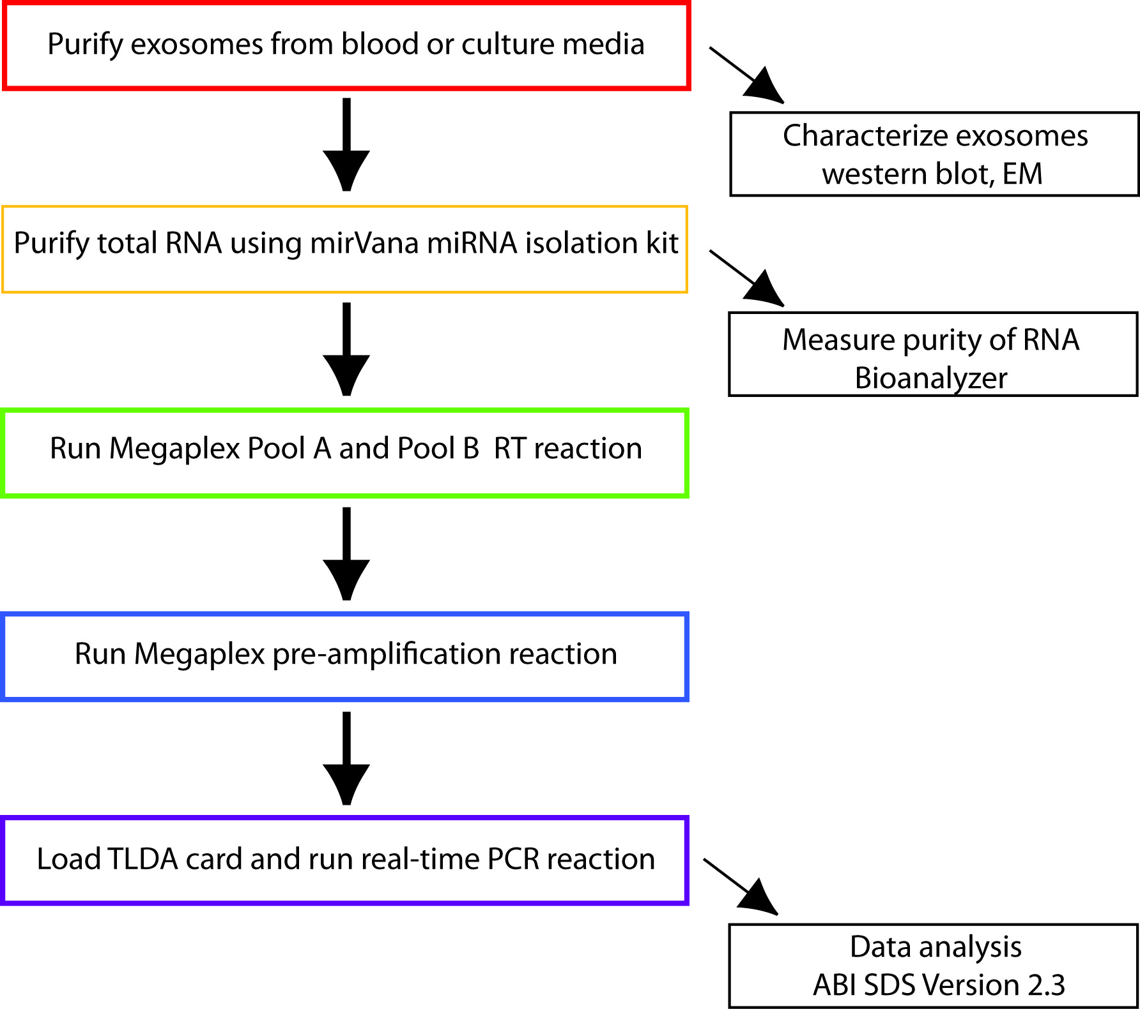

B. Interview: (Said by you on camera. Don’t forget to smile!)
  - Maggie: This technique measures variations in exosomal miRNA content that are dependent on the source and physiological conditions under which they are secreted. The implications of quantifying these unique signatures extend toward development of biomarkers and novel therapeutic intervention strategies.

Protocol (read by voice talent at JoVE):
- Exosome purification from blood
  - To begin this procedure, invert an EDTA coated tube containing 10 mL of whole blood 5 times to ensure mixing of the anticoagulant agent and place it upright at room temperature for 10 to 60 minutes.
    - MED: Talent inverts EDTA tube with blood and sets it into a tube holder.
  - Then, centrifuge the sample at 2000 x g and 4 °C for 15 minutes to separate the blood.
    - MED: Talent places tube into the centrifuge and starts it. (Videographer: Show the centrifuge settings this and every shot regarding the centrifuge.)
  - After 15 minutes, remove the tube from the centrifuge and collect the top layer of plasma in a new 15 ml tube.
    - CU: Talent removes the layer of plasma from the tube and places it into a new tube.
  - Place the plasma on ice and dilute it with an equal volume of PBS. Then, gently mix the sample and place it into the centrifuge. Centrifuge at 2000 x g and 4 °C for 30 minutes.
    - Misslated as 2.5.1 MED: Talent places the new tube on ice and then adds PBS.

    - MED: Talent stands next to the centrifuge, mixes it, and places it into the centrifuge.
  - Next, remove the sample from the centrifuge. Transfer the supernatant to a new centrifuge tube, add 1X PBS to 24 ml, and centrifuge at 12,000 x g and 4 °C for 45 min.
    - Misslated as 2.4.1 MED: Talent transfers the supernatant into a new tube and adds 1X PBS

    - MED: Talent places the sample into the centrifuge and starts it.
  - Then, transfer the supernatant to an ultracentrifuge tube and centrifuge at 110,000 x g and 4 °C for 2 hours.
    - MED: Talent transfers the supernatant to an ultracentrifuge tube.
    - MED: Talent places the sample into the centrifuge and starts it.
  - After 2 hours, remove the sample from the ultracentrifuge and pour off the supernatant. Resuspend the pellet in chilled PBS and place the sample back into the ultracentrifuge. Spin at 100,000 x g and 4 °C for 1 hour.
    - CU: Talent carefully pours off the supernatant.
    - MED: Talent resuspends the pellet
    - MED: Talent places the sample back into the ultracentrifuge and starts it.
  - Following centrifugation, pour off the supernatant and resuspend the pellet in 300 µL of RNA lysis buffer. Alternatively, the sample can be suspended in PBS or RIPA buffer for electron microscopy and western blot analysis, respectively.
    - CU: Talent pours off the supernatant.
    - MED: Talent resuspends the pellet in RNA lysis buffer.
- miRNA Profiling of Exosomes from Blood Using Taqman Low Density Array (TLDA) Cards
  - Prepare the area for isolating RNA by wearing personal protective equipment, wiping surfaces and pipets with RNase Zap, and using sterile filter tips and tubes.
    - MED: Talent wears the correct gear, wipes down the surfaces, and sets out the sterile tubes.
  - Then, determine if pre-amplification of RNA is necessary by quantifying the isolated RNA with a spectrometer. For samples with greater than 350 ng of RNA, no pre-amplification is necessary.
    - CU: Talent prepares a Nanodrop for the sample
    - MED: Talent adds the sample to the Nanodrop

  - Next, prepare cDNA from purified RNA using Megaplex Pools reverse transcriptase primers. Start by thawing the primers on ice. Pool A and Pool B contain primers for the micro-RNAs on microfluidic cards Array A and B.
    - MED: Talent shows primers to the camera and places them on ice.
    - MED: Talent displays the Array cards A and B for the camera. Moved to 3.14.2
  - While they thaw, label two RNase-free 1.5 ml tubes for the reverse transcription with Pool A primers or Pool B primers and prepare a mastermix for each separately from the components as described in the text protocol. Be careful to keep the Pool A and Pool B primers separate.
    - MED: Talent labels the tubes with “A” and “B”.
    - MED: Talent adds the components to the mastermix tube.
  - Then, invert the tubes with the master-mix 6 times and centrifuge briefly. Pipet 4.5 µl of the RT reaction mix into each tube of the MicroAmp 8-tube strips.
    - MED: Talent inverts the tubes while standing next to the microcentrifuge and then quickly spins them down.
    - CU: Talent pipettes the mastermix into the reaction tubes.
  - Next, add 100 ng of RNA in 3 µl of DEPC treated water to their respective wells, and stir them with the pipet tip. After capping the tubes, spin the samples down briefly and incubate them on ice for 5 min.
    - CU: Talent adds the RNA sample to the reaction tubes.
    - MED: Talent seals the tubes, then spins them down For this shot, B is the good shot.
  - After the incubation, load the reaction tubes into the PCR machine and run it under the following conditions.
    - MED: Talent loads the tubes into the PCR Machine.
    - MED over the Shoulder: Talent punches the cycle settings into the computer. (Video Editor: Display the cycle information below in 3.7.3 over this image.)
    - LABMEDIA: (Video Editor: Display the table below over the video image)
Stage | Temp | Time
Cycle (40x) | 16 °C | 2 min
Cycle (40x) | 42 °C | 1 min
Cycle (40x) | 50 °C | 1 sec
Hold | 85 °C | 5 min
Hold | 4 °C | ∞
  - When the PCR has completed, store the cDNA at -20 °C for up to one week or continue to pre-amplification.
    - MED: Talent takes the PCR tubes out of the PCR machine and places them into a tube rack.
  - For samples with initial RNA amounts of less than 350 ng, perform the following pre-amplification steps. Begin by thawing the PreAmp primers for Pool A and Pool B on ice and invert them to mix. Next, swirl the Taqman Pre-Amp master mix and keep it also on ice.
    - MED: Talent places the tube of cDNA and tubes of primers onto ice, then swirls the taqman master mix and also places it on ice.
  - Then, prepare the pre-amplification master mix. (TEXT overlay: 7.5 µl of nuclease-free water, 12.5 µl of the Taqman Pre-Amp master mix, 2.5 µl of the 10 x Megaplex PreAmp Primers A or B per sample).
    - Reuse shot 3.4.2
  - Next, pipet 2.5 µl of the cDNA product into MicroAmp 8-tube Strips and then add 22.5 µl of the pre-amplification reaction master mix.
    - CU: Talent pipetts the cDNA into the tubes followed by the master mix.Reuse 3.6.1
  - Finally, incubate the tubes on ice for 5 minutes. Then, load the sample into the PCR machine and run it under the following conditions.
    - MED: Talent takes the tubes from the ice and places it into the PCR machine.
    - MED over the Shoulder: Talent punches the cycle settings into the computer. (Video Editor: Display the cycle information below in 3.7.3 over this image.)
    - LABMEDIA: (Video Editor: Display the table below over the video image)

Stage | Temp | Time
Hold | 95 °C | 10 min
Hold | 55 °C | 2 min
Hold | 72 °C | 2 min
Cycle (12x) | 95 °C | 1 min
Cycle (12x) | 60 °C | 1 sec
Hold | 99.9 °C | 10 min
Hold | 4 °C | ∞

  - After the preamplification reaction is finished, briefly centrifuge the tubes and then add 75 µl of 0.1 X Tris EDTA, pH 8.0, to each tube.
    - MED: Talent removes the sample from the PCR machine and briefly centrifuges it.
    - CU: Talent removes the lids and adds Tris to each tube.
  - Next, mix the tubes briefly and spin them down. Continue on to load the TaqMan® MicroRNA Array or store the diluted product for up to one week at -20 °C.
    - MED: Talent mixes the tubes and spins them down.
    - MED: Talent takes out the MicroRNA Array and sets it on the bench next to the sample. Talent displays the Array cards A and B for the camera.
  - To prepare the samples for the Taqman MicroRNA Array, combine 450 µl of the Taqman Universal PCR Master Mix, 9 µl of the diluted preamplification product, and 441 µl of nuclease-free water to an RNase-free 1.5 ml tube on ice.
    - CU: Talent combines the mix components in a 1.5 mL tube on ice.
  - Then, mix the tube by inverting it 6 times and centrifuge the sample briefly. Dispense 100 µl of the PCR reaction mix into each port of the Taqman MicroRNA Array card.
    - MED: Talent inverts the tube several times, then places the tube into the centrifuge and closes the lid.
    - CU: talent dispenses the reaction mix onto the array card.
  - Next, centrifuge the card twice at 1000 x g for 1 min, and then seal the card. Next, load the array into the thermocycler.
    - MED: Talent centrifuges the card, then seals it.

    - MED: Talent loads the array into the thermocycler.
  - Next, run the samples using the default thermal-cycling conditions provided with the primers in the Applied Biosystems manual for the 384 well TaqMan Low Density Array.
    - MED Over the Shoulder: Talent sets up the last few thermocycler conditions and starts the program. This shot was called 3.18.2
- mRNA analysis by Taqman [Video Editor: Since section 4 only has one shot remaining, just add 4.1/4.1.1 to the end of section 3]
  - In order to run mRNA analysis in the Applied biosystems 7900HG Fast Real-Time PCR System, first change the heat blocks to run a 96-well plate.
    - MED: Talent trades out the 384 block for a 96-well one.
  - Next, prepare the quantitative PCR reaction mixture for each sample by adding 7 µl of nuclease-free water, 10 µl of the 2 x TaqMan Fast Master Mix, 1 µl of the 20x Taqman Primer Probes, and 2 µl of cDNA made from 100 ng of RNA.
    - MED: Talent prepares the samples for PCR in the order described by 4.2.
  - Amplify the samples using primer probes for the gene of interest as well as primers for the 18S ribosomal RNA, which is used as the normalizer gene for analysis.
    - CU: Talent holds up the vial containing the primers used to measure the gene of interest, followed by the 18S primers for the camera to see.
    - MED: Talent places the samples into the PCR machine.
  - For best results, run the samples using conditions specifically designed for your primer set.
    - MED Over the Shoulder: Talent adds the final few cycle specifics into the computer program and starts the program.
- Results: Exosome RNA and micro-RNA levels offer a unique platform for biomarker discovery
  - The transmission electron microscope image shown here is of exosomes isolated from mouse blood using the methods described in this video. Alternatively, they can also be isolated from culture media and urine. They typically range from 30 to 100 nm in diameter.
    - LABMEDIA: Figure 1a Left image only
  - The normalized micro-RNA array analysis results for samples isolated from rodent blood, human blood, and human aortic endothelial cell culture media are shown here. Positive delta Ct values indicate reduced expression and negative values indicate increased expression.
    - LABMEDIA: Figure 2 (Video Editor: Highlight the blue bars/label with the mention of “rodent blood”, the red bars/label with the mention of “human blood”, and the green bars/label with the mention of “aortic endothelial cell culture media”. Then, highlight all bars > 0 with the mention of “Positive delta Ct” and the bars < 0 with the mention of “negative values”.)
  - While miR-126 and miR-200c were absent in exosomes from rodent blood or HAOEC media respectively, the remaining four miRNAs are present in all three samples in varying amounts.
    - LABMEDIA: Figure 2 (Video Editor: Highlight the miR-126 and miR-200c when mentioned and the remaining four also when mentioned.)
  - Relative to exosomes purified from cell culture media, miR-223 is expressed at higher levels in exosomes from human and rodent blood samples.
    - LABMEDIA: Figure 2 (Video Editor: Highlight the miR-223 samples when mentioned.)
  - When compared with mRNA from whole blood, exosomal RNA showed similar expression of both TNF-alpha and vascular endothelial growth factor A. Although this protocol focuses on characterizing exosomal micro-RNAs, individual mRNA transcripts can also be quantified from exosomes using qPCR.
    - LABMEDIA: Figure 1D (Video Editor: Highlight the word “Exosomes” and “Whole blood” when mentioned by the text.)

INSTRUCTIONS FOR AUTHORS:
Please ensure that the representative results narration is appropriate and correctly describes your images, movies, or figures. Our editors have ensured that the results are written in our format.

We consider this section a critical aspect of the video, because here is where you provide validation for your experiments. For example, if this is a cell culture preparation, this section is where the video will show your cells at various time points following culturing. If this is an imaging prep, then this part is where you will show examples of your imaging experiments.

Please limit the extent of narration to no more than 2-3 lines of text per image or movie file being described. Figures with multiple panels submitted with the original protocol should be broken up so that each panel is a separate image. Like the schematic, each image or movie file supplied in the results should be referenced by annotation in parenthesis, however for the results, the specific filename should be given in parenthesis.

Below is an example of results text:

EXAMPLE REPRESENTATIVE RESULTS

5. Evaluation of Morpholino Injection and Knockdown
5.1 Representative results of both morpholino injection and mRNA injection are shown here. The
uninjected control at 48 hours post fertilization looks normal, as expected
-LAB MEDIA: 0123_PIname_Figure1.tif (Replace 0123 with your jove video #)

5.2 However, embryos injected with the morpholino heg_e3i3_egfr1, which knocks down Heg isoforms
containing the first of two EGF-like repeats, exhibit brain edema.
-LAB MEDIA: 0123_PIname_Figure2.tif

5.3 Injection of heart of glass mRNA also produced an obvious phenotype. At 24 hours post fertilization,
the heads of the uninjected controls look normal
-LAB MEDIA: 0123_PIname_Figure3.tif

5.4 Conversely, some of the embryos injected with the mRNA exhibit cyclopia
-LAB MEDIA: 0123_PIname_Figure4.jpg

Please visit the following URL to see an example of how the results will look when complete:
http://www.jove.com/video/1597/results-example-mably?access=ksw0bprj

- Conclusion (said by authors on camera)
Authors: Below are statements we would like you to complete that summarize and conclude the video. Only one statement should be chosen and completed per author who will be on camera demonstrating the protocol. In addition to choosing and filling out the appropriate statement, please enter the name of the individual who will say each line. You may revise the given prompts if necessary to better fit your protocol.

  - Maggie: Combining these techniques has paved the way for researchers in the field of RNA biology to explore the function of circulating RNAs in mediating gene expression changes and in identifying molecular signatures associated with exosomes in both normal and diseased states.

Provided Media

Authors, Please list all images, movie files, or 3-D rendered animations that can be included in the video per editor’s request. The step in the script/video where these images will be inserted should be specified. For example:

6.2 – 0123_PIname_Figure1.tif - dual color imaging of tumor angiogenesis at 40X
6.2 – 0123_PIname_Figure2.tif - dual color imaging of tumor angiogenesis at 100X

Formats: For static images we prefer .tiff, Illustrator, Powerpoint or Photoshop files at dimensions of at least 720X480 pixels and 300 dpi. The higher resolution, the better. Likewise any exported movie files should have at minimum these dimensions and be rendered to .mov, .mp4, or .avi files.

Insert your media filenames here.

5.1 - Fig1 exosome caracterization111012.ai

5.3 - Figure 2 qPCR miRNA levels 012613.ai

General Preparation

It’s critical for a smooth and organized shoot that all reagents are accounted for, in advance.

Any overnight or long incubation steps should be recognized and specimens/samples be prepared in advance so that prior steps can be recorded and shooting can continue with pre-prepared specimens/samples.

All tubes/flasks should be pre-labeled neatly before we arrive.

Ex. Luciferase assay done in 96 well plates should be labeled with negative/positive control wells and experimental samples are labeled accordingly.

You will receive more detailed preparation instructions, as well as an introduction to your videographer, closer to your filming date.

