Submission ID #: 50227

Editor Name: Melissa Ceo

Videographer name:

Film Date:

Authors and Affiliations:
Marcus D. Collins, Sharona E. Gordon

Department of Physiology and Biophysics
University of Washington

Title: Giant Liposome Preparation for Imaging and Patch-Clamp Electrophysiology

Corresponding Author:

Sharona E. Gordon: seg@uw.edu

Co-authors email: mdc713@uw.edu

Authors, please fill out the brief questionnaire below.

A. Will you require JoVE to record video microscopy, such as filming a complex dissection or microinjection technique? (Y/N) ___N____ If yes, please list make and model of your microscope: ______________________________
B. Does your protocol include detailed, step-by-step, descriptions of software usage? (Y/N)___N___
C. Which steps of your protocol will viewers benefit most from having filmed? Please list 4-6 steps__________________________
D. What is the single most difficult aspect of this procedure and what do you do to ensure success? Controlled dehydration of small liposomes is the most difficult aspect. We minimize the concentration of liposomes, minimize the size of the drops, and use heat to spread the high-surface tension drops more evenly on the surface of the ITO-coated slides. Remembering that different lipids, buffers, drop sizes, temperature, humidity, and other factors change the dehydration process helps us to remember to be flexible and continually screen for optimum conditions.

1. Introduction (Schematic Overview and Interview)

A. Schematic Overview (read by voice talent at JoVE):
Authors, please select from “Procedural Narrative” or “Conceptual Narrative” and complete the statements below. Please do not add additional steps. Then, attach your finished graphic overview. See accompanying instructions for details and examples.

Procedural Narrative:
The overall goal of this procedure is to prepare Giant Unilamellar Vesicles in a manner compatible with the functional integrity of membrane proteins incorporated into the vesicle membrane. (Intro)

This is accomplished by first depositing lipids or small liposomes onto a conductive surface, like an ITO coated glass slide. (P1, start with the upper left rectangle (the glass slide) and show yellow triangle appearing and moving towards it until the point meets the rectangle as shown. It slowly moves across the slide).

The second step is to evaporate the solvent in a controlled manner to achieve a uniform lipid film on the conductive surface. (P2, show the glass slide moving into large square chamber located in the top middle of the image. Have the >3h clock image appear).

Next, carefully rehydrate the lipid film in a suitable buffer and prepare the electroformation chamber. (P3, show the glass slide moving out of the chamber and a yellow triangle appears and moves towards the glass slide until the point meets the slide as shown, then slowly moves across the slide. As it moves, the background inside the red rectangle turns light blue).

The final step is to apply an oscillating voltage across the lipid film to generate giant unilamellar vesicles. (P4, the clear upper slide moves in over the original slide as shown in the lower left (note, the new slide touches the original slide but there is an overhang). Then show the green rectangle with black wires appearing and moving towards the glass slide until it meets the slide as shown. Once the two meet, the T>40 °C text box appears).

Ultimately, the vesicles will be imaged to determine their size and quality, and compared to vesicles formed using a classical technique. (P5, show right-hand image of Figure 2).

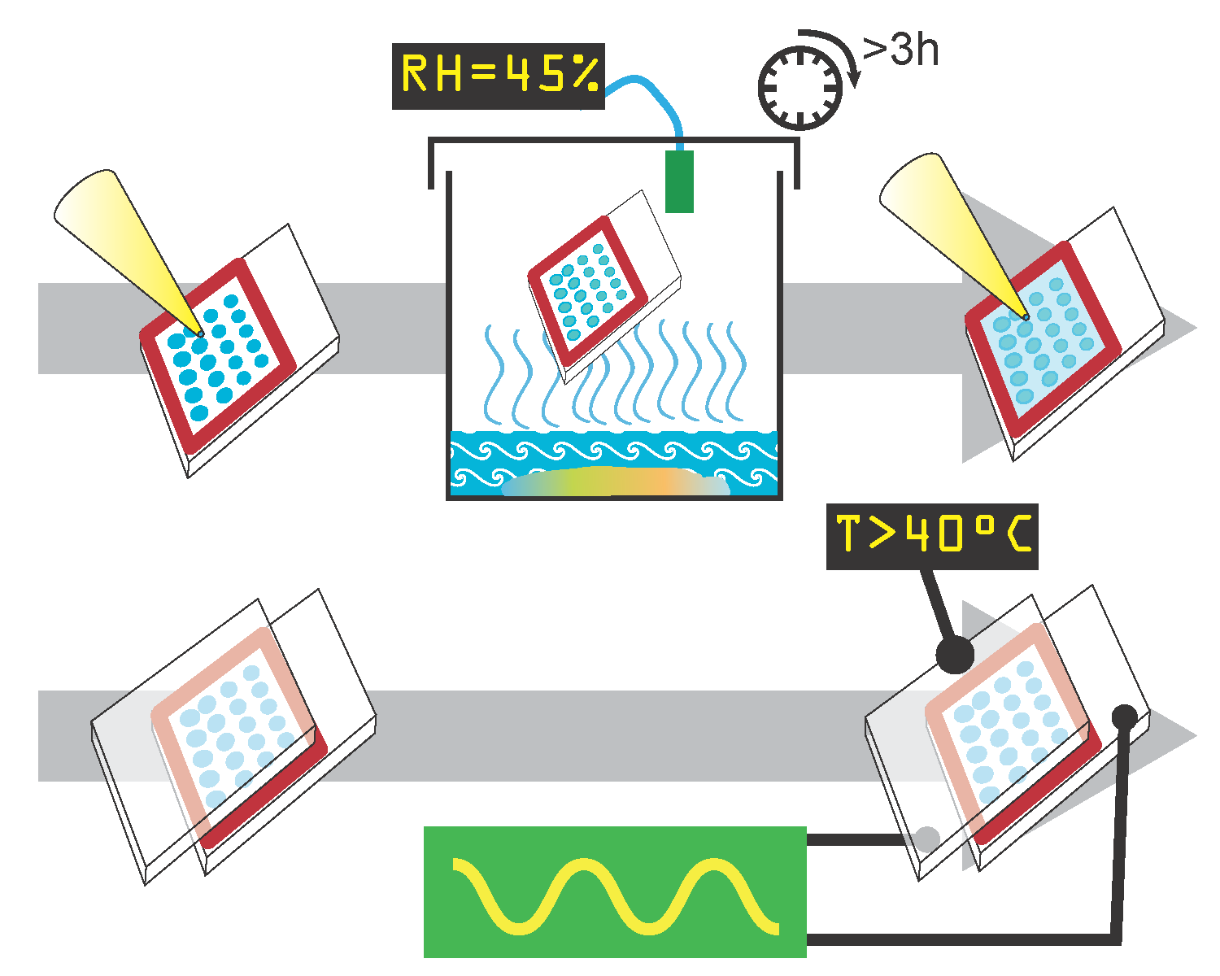

B. Interview: (Said by you on camera. Don’t forget to smile!)

Authors: Below are statements we would like you to complete that are complementary to the information contained within the schematic overview.
- Only one statement should be chosen and completed per author who will be on camera demonstrating the protocol.
- Enter the name of the individual who will say each line.
- Please choose and fill out the statement(s) that convey the most important fact(s) about your protocol. You may revise the given prompts as necessary to improve the sentence flow.
- If any individuals will be doing demonstrations on camera but are not assigned a speaking part in this interview section, please use statement 1.8 to introduce these demonstrators (for example, the PI introduces students)
  - Author name Marcus: Visual demonstration of this method is critical as the lipid deposition steps are difficult to learn, because they depend on many variables, and because proper lipid deposition is best assayed by visual appearance.

Protocol (read by voice talent at JoVE):

Authors: In order to ensure that your protocol can be filmed in a single day, the protocol text must be limited to 30 steps – each step being defined as 3 lines of 12 pt text in our formatting style below. This amounts to 3 pages of protocol text. The scope of the scripted protocol text should include only those aspects of the procedure that require visualization in order to be well understood.
- Deposition of lipids from organic solvents: classical protocol
  - Before starting this procedure, remove the lipids from storage at -20°C or -80°C and warm to room temperature.
    - WIDE: Talent walks up to refrigerator, removes the lipids, and places them on the lab bench.
  - If possible, perform the experiment in an inert gas atmosphere such as a glove box. (TEXT overlay: The glovebox is omitted in this demonstration for video purposes). Next, cover the lipids in dry argon or nitrogen gas and in all steps minimize exposure to air. (TEXT overlay: Caution: lipids are extremely hygroscopic, and many are sensitive to oxygen.
    - MED: Talent places the lipids in position for the gas flow.
    - MED: Talent opens the valve to inert gas and flows it over the lipids.
  - If the lipids are not supplied in organic solvent, suspend 0.3 mg of lipids in chloroform or cyclohexane at 10 mg/mL (TEXT overlay: 15-20µg lipids / 1cm² slide). Note that manufacturer’s stated concentrations are typically nominal only. (TEXT overlay: Wear protective equipment and work in a fume hood when using organic solvents.)
    - MED: Talent adds the appropriate solvent to the lipids.
  - Use ethanol to clean both sides of two 25mm x 37.5mm ITO (TEXT overlay: ITO: Indium-Tin Oxide) coated glass slides.
    - MED-over-the-shoulder: Talent cleans the glass slides with ethanol.
  - Then, add 0.1 mol% Texas Red-DPPE to the lipids for fluorescent imaging.
    - MED: Talent adds Texas Red-DPPE to the lipids.
  - Measure the surface resistance with a multimeter to verify that the ITO coated side of the glass slides is facing up, which is indicated by a resistance of a few hundred Ohms.
    - MED-over the shoulder: Talent places the probes of the multimeter on the glass slides. Videographer: Multiple takes, shot will be reused, don’t show measurement.
  - Aspirate the lipids into a solvent-resistant syringe. (TEXT overlay: No glues or plastics, other than PTFE, should contact the organic solvent).
    - MED: Talent places the needle tip into the lipid solution and pulls back to fill the syringe.
  - With the syringe needle not quite touching the ITO surface, slowly apply the lipid by moving the needle back and forth across the slide. Cover the surface evenly, looking for a “rainbow sheen” on the glass surface.
    - MED-over the shoulder: Talent glides the needle back and forth over the slide.
    - CU: Slide to show the “rainbow sheen”.
  - Following this, place the slides quickly into a vacuum desiccator and pump the chamber to less than 1 Torr vacuum for 0.5-1 h to remove any trace solvent. Release the vacuum with inert gas.
    - MED-over the shoulder: Talent places the slides into the vacuum desiccator and opens the valve to vacuum.
    - MED: Talent turns the valve to inert gas.
  - Apply a thin layer of silicone grease to both sides of a silicone gasket and then place the gasket on the slide. Leave at least 5mm of uncovered slide exposed at one end of the slide.
    - MED: Talent applies silicon grease to both sides of the silicon gasket.
    - CU: Slide as talent places the gasket on it.
    - ECU: Slide showing 5 mm uncovered section of slide
- Electroformation of giant liposomes
  - Next, carefully hydrate each well by placing a 27g syringe needle at the edge of the gasket and slowly apply buffer. (TEXT overlay: Buffers can include water, ≤200mM sucrose, ≤1M sorbitol and ≤5mM HEPES). Overfill each gasket well by approximately 10% with 3 mM HEPES. Once the lipids are hydrated, proceed quickly through the remaining steps, since lipid films begin to delaminate immediately.
    - MED-over-the-shoulder: Talent places the syringe needle at the edge of the gasket and applies the buffer.
    - CU: Gasket well as talent overfills it with buffer.
  - Verify the conductive side of the slide with the multimeter, then apply the second ITO slide, conductive face in, to the top of the gasket. Make sure to have at least 5mm of overhang outside the gasket area and opposite the first overhang and press gently to ensure a good seal.

3.2.0. Check to ensure conductivity
    - MED: Talent places a second slide to the top of the gasket
    - ECU: Show 5 mm overhang outside gasket
    - CU: Talent presses gently to form seal.
  - Clean the two overhangs using ethanol.
    - MED: Talent cleans the overhangs with ethanol.
  - Now, secure the ITO slide “sandwich” to electrical contacts, such as copper bars or gasket foam. This graphic shows an exploded view of the chamber and contact assembly as a reference; detailed plans can be found in the text protocol
    - MED: Talent connects the chamber to electrical contacts using the appropriate method.
    - LAB MEDIA: Figure 5 (Video Editor: On last sentence of 3.5, show fig 5, page 1, upper portion with gray-green background).
  - Using a multimeter, verify that there is no electrical short between the contacts, and that the contacts connect properly to the ITO surfaces.
    - MED: Talent places the probes of the multimeter on the contacts of the chamber.
    - CU: Show contacts touching the ITO surfaces.
  - Next, place the electroformation chamber in an oven and heat the chamber 10 °C above the highest melting temperature of any of the lipids present.
    - MED: Talent programs the temperature controller to the appropriate setting.
  - Measure the gap between the two ITO coated surfaces to determine the amplitude of the sine wave. The amplitude of the sine wave should be approximately 0.7 V_{rms} (pronounced volts-R-M-S) for each millimeter gap between the ITO surfaces. Apply a 10 Hz sine wave for 60-90 minutes. Connect the generator to the electroformation chamber and confirm the voltage with a multimeter.
    - CU: The two slides as talent measures the gap between the two surfaces with digital electronic calipers.
    - SCREEN: (SHOT?): Front of sine wave generator as talent selects the waveform (sine wave), selects the amplitude by pressing the V_{rms} button and entering 0.700, and sets the frequency to 10 Hz.
    - MED-over the shoulder: Talent connects the generator to the electroformation chamber and turns the generator on.
    - MED: Talent confirms the voltage with multimeter.
  - After 60-90 minutes of electroformation, Giant Unilamellar Vesicles should have formed. Use an inverted microscope equipped with a filter cube for Texas Red dye to image the liposomes. The liposome should be spherical, predominantly unilamellar by eye, and free of defects such as “strings” hanging off the liposome.
    - WIDE: Talent picks up the slides and carries them to a microscope
    - MED-over the shoulder: Talent sitting/standing at the microscope.
    - LAB MEDIA: Figure 2 (Video Editor: Show right-hand image only).
- Deposition of lipids by controlled dehydration of small liposomes
  - The preceding steps covered the classic preparation of giant liposomes from pure lipids. A more challenging preparation using small liposomes is shown next. First, prepare a saturated potassium carbonate solution of 44% relative humidity at 20 °C. (TEXT overlay: Potassium Carbonate, RH = 44% at 20 °C).
    - MED: Talent prepares the saturated salt solution. [Videographer: This shot should be at least 15 seconds long]
  - Use a plastic “yogurt-and-granola” container with a nesting upper cup that has been modified with holes in the upper cup. Place the saturated salt solution and excess salt in a tightly sealable container with an interior shelf. Replace the shelf after filling, and make sure the fluid is 5-10mm below the shelf. ‬‬‬‬ Place a humidity sensor in a notch in the side of the container. ‬‬‬‬‬
    - MED: Talent picks up a yogurt-and-granola container.
    - CU: Three holes in upper granola cup.

4.2.4. (move before 4.2.3) MED: Talent transfers the saturated salt solution to the container and replaces the shelf
    - CU: Talent placing a humidity sensor into the notch.
    - MED: Talent transfers the saturated salt solution to the container and replaces the shelf.
  - Clean both sides of ITO coated glass slides with ethanol. Use the multimeter to determine which side is conductive, and label the non-conductive side with the sample name.
    - Use shot 2.4.1.
    - Use shot 2.6.1.
    - MED: Talent labels the non-conductive side with the sample name.
  - Next, lightly grease both sides of a one- or multiple-holed silicone gasket(s).
    - Use shot 2.10.1.
  - Place the slides conductive side up on the bench, and apply the silicone gaskets to each slide to which lipid will be applied, making sure there is at least 5mm of exposed slide at one end to connect to the electroformation apparatus. Smooth the gasket to ensure a good seal.
    - MED: Talent places the slides on the lab bench.
    - MED-over the shoulder: Talent places the silicone gasket(s) to each slide and smooths the gasket(s).
  - Dilute the vesicle preparation in a low-salt isosmotic buffer to approximately 1-2 mg/mL. (TEXT overlay: See the text protocol for instructions on preparing small unilamellar liposomes.)
    - MED: Talent adds to buffer to the vesicle preparation.
  - Apply the lipid to the slide in 1-10µL drops.
    - CU: Slide as talent applies the lipid to it.
  - Place the slide on the interior shelf above the saturated salt solution and seal the container tightly. Leave at room temperature for 3 h to overnight.
    - MED: Talent places the slide on the shelf of the container and closes the lid.
  - The slide can now be used for the electroformation of giant liposomes as shown previously in the classic protocol. Note the rainbow appearance of the individual deposits.
    - MED: Talent removes the slide from the container in preparation for the next step.
    - CU showing rainbow appearance of individual deposits.
- Results: Electroformation of Giant Liposomes from Small Liposome Dispersions is Compatible with Reconstituted Ion Channel Function
  - This image shows liposomes electroformed from lipids deposited out of chloroform; the arrows point to giant liposomes. This image has very few fuzzy areas and thus indicates a good preparation. This next image has many fuzzy regions, and so indicates a generally poor preparation. Note that arrow 2 indicates a region with poorly distinguishable liposomes, and that no liposomes can be brought into focus in the area indicated by arrow 3.
    - LAB MEDIA: Figure 2 (Video Editor: Show the right-hand image alone for the first two sentences. For the third sentence, add the left-hand figure from Figure 2 to the screen (but place it to the right of the current image. Add labels “Good” and “Poor” to the first and second image. For the fourth sentence, remove the “good” (or first) image from the screen).
  - Shown here is a 10x magnification of liposomes successfully electroformed from lipids deposited by dehydration of small liposomes. The arrows indicate three good quality liposomes ranging in size from approximately 5-20µm. At 40x magnification, a clear “ring” can be seen at the edge of the liposome, which indicates a unilamellar or nearly unilamellar liposome.
    - LAB MEDIA: Figure 3 (Video Editor: Show the left-hand, 10x, image for the first two sentences. Switch to the right-hand image, 40x, for the final sentence. If there’s high enough resolution, zoom in to the liposome being pointed to by arrow 2).
  - The capsaicin-activated TRPV1 ionic currents recorded in lipid membrane patches excised from the formed giant liposomes are pictured here. The leak current indicated a 500 megaohm seal resistance before capsaicin was added. Saturating capsaicin activated a large TRPV1 current. The current returned to near baseline as capsaicin is washed out of the patch.
    - LAB MEDIA: Figure 4 (Video Editor: Please highlight or point to each trace as it is mentioned by the voiceover (trace A for the second sentence, trace B for the third sentence, trace C for the last sentence).

INSTRUCTIONS FOR AUTHORS:
Please ensure that the representative results narration is appropriate and correctly describes your images, movies, or figures. Our editors have ensured that the results are written in our format.

We consider this section a critical aspect of the video, because here is where you provide validation for your experiments. For example, if this is a cell culture preparation, this section is where the video will show your cells at various time points following culturing. If this is an imaging prep, then this part is where you will show examples of your imaging experiments.

Please limit the extent of narration to no more than 2-3 lines of text per image or movie file being described. Figures with multiple panels submitted with the original protocol should be broken up so that each panel is a separate image. Like the schematic, each image or movie file supplied in the results should be referenced by annotation in parenthesis, however for the results, the specific filename should be given in parenthesis.

Below is an example of results text:

EXAMPLE REPRESENTATIVE RESULTS

5. Evaluation of Morpholino Injection and Knockdown
5.1 Representative results of both morpholino injection and mRNA injection are shown here. The
uninjected control at 48 hours post fertilization looks normal, as expected
-LAB MEDIA: 0123_PIname_Figure1.tif (Replace 0123 with your jove video #)

5.2 However, embryos injected with the morpholino heg_e3i3_egfr1, which knocks down Heg isoforms
containing the first of two EGF-like repeats, exhibit brain edema.
-LAB MEDIA: 0123_PIname_Figure2.tif

5.3 Injection of heart of glass mRNA also produced an obvious phenotype. At 24 hours post fertilization,
the heads of the uninjected controls look normal
-LAB MEDIA: 0123_PIname_Figure3.tif

5.4 Conversely, some of the embryos injected with the mRNA exhibit cyclopia
-LAB MEDIA: 0123_PIname_Figure4.jpg

Please visit the following URL to see an example of how the results will look when complete:
http://www.jove.com/video/1597/results-example-mably?access=ksw0bprj

- Conclusion (said by authors on camera)
Authors: Below are statements we would like you to complete that summarize and conclude the video. Only one statement should be chosen and completed per author who will be on camera demonstrating the protocol. In addition to choosing and filling out the appropriate statement, please enter the name of the individual who will say each line. You may revise the given prompts if necessary to better fit your protocol.

  - Author name Marcus: While attempting this procedure, it’s important to remain flexible, since many factors affect how the lipids dehydrate, and their ability to form a uniform film: see our online troubleshooting section and vary temperature, lipid concentrations, drop sizes, humidities, et cetera, to achieve best results.

Provided Media

Authors, Please list all images, movie files, or 3-D rendered animations that can be included in the video per editor’s request. The step in the script/video where these images will be inserted should be specified. For example:

6.2 – 0123_PIname_Figure1.tif - dual color imaging of tumor angiogenesis at 40X
6.2 – 0123_PIname_Figure2.tif - dual color imaging of tumor angiogenesis at 100X

Formats: For static images we prefer .tiff, Illustrator, Powerpoint or Photoshop files at dimensions of at least 720X480 pixels and 300 dpi. The higher resolution, the better. Likewise any exported movie files should have at minimum these dimensions and be rendered to .mov, .mp4, or .avi files.

3.5.1— 50227_Gordon_Figure5.ai- (only p. 1 used in video) Plans for GUV electroformation chamber.
5.1.1— 50227_Gordon_Figure2.ai- Good and poor GUV preparations from chloroform-deposited lipids.
5.2.1— 50227_Gordon_Figure3.ai- Good and poor GUV preparations from dehydration-deposited lipids
5.3.1— 50227_Gordon_Figure4.ai- Ionic currents recorded from TRPV1 reconstituted into small liposomes which were then transformed into GUVs using the controlled-dehydration protocol.

General Preparation

It’s critical for a smooth and organized shoot that all reagents are accounted for, in advance.

Any overnight or long incubation steps should be recognized and specimens/samples be prepared in advance so that prior steps can be recorded and shooting can continue with pre-prepared specimens/samples.

All tubes/flasks should be pre-labeled neatly before we arrive.

Ex. Luciferase assay done in 96 well plates should be labeled with negative/positive control wells and experimental samples are labeled accordingly.

You will receive more detailed preparation instructions, as well as an introduction to your videographer, closer to your filming date.

