Submission ID #: 50179

Editor Name: Shanelle Ko

Videographer name:

Film Date:

Authors and Affiliations:

Samir Mujagić
Biological Cybernetics, CITEC -Cognitive Interaction Technology- Center of Excellence
Bielefeld University, Germany.
samir.mujagic@uni-bielefeld.de

Simon Michael Würth
Biological Cybernetics,
Bielefeld University, Germany.
simon_michael.wuerth@uni-bielefeld.de

Sven Hellbach
Biological Cybernetics, CITEC -Cognitive Interaction Technology- Center of Excellence
Bielefeld University, Germany.
hellbach@htw-dresden.de

Volker Dürr
Biological Cybernetics, CITEC -Cognitive Interaction Technology- Center of Excellence
Bielefeld University, Germany.
volker.duerr@uni-bielefeld.de

Title:
Tactile conditioning and movement analysis of antennal sampling strategies in honey bees (Apis mellifera L.)

Corresponding Author:
Samir Mujagić

Authors, please fill out the brief questionnaire below.

A. Will you require JoVE to record video microscopy, such as filming a complex dissection or microinjection technique? (Y/N) Yes
If yes, please list make and model of your microscope: Olympus Stereo lens SZ61 T with c-mount adapter.
B. Does your protocol include detailed, step-by-step, descriptions of software usage? (Y/N) No, but it describes the computational steps done by a software.
C. Which steps of your protocol will viewers benefit most from having filmed? Please list 4-6 steps: Capturing bees, Preparation of bees in the laboratory, Conditioning procedure, Antennal movement recording procedure, Data analysis in Matlab.

D. What is the single most difficult aspect of this procedure and what do you do to ensure success? Preparation and conditioning of the bees. Careful handling during fixation and occluding the eyes of the animal with paint. Following the exact timing during conditioning and testing as described in the protocol is very crucial.

1. Introduction

A. Schematic Overview:

Procedural Narrative:

The overall goals of this procedure are to show how to condition honey bees to tactile stimuli and to introduce a 2D motion capture technique for analyzing the kinematics of fine-scale antennal sampling patterns. (Intro)

At the beginning, the procedure requires capturing free flying bees in front of their hive. (P1)

The second step is to harness bees into metal tubes and to occlude their eyes with white paint. (P2)

Next, the bees are trained to a tactile stimulus using the classical conditioning procedure. (P3)

The final step is to record the antennal movement of the conditioned bee with a digital video camera. (P4)

Ultimately, 2D motion capturing in Matlab is used to analyze changes in antennal movement behavior in honey bees after both associative and non-associative tactile learning paradigms. (P5)

P1: 50179_Graphic overview.pptx, slide 1
P2: 50179_Graphic overview.pptx, slide 2
P3: 50179_Graphic overview.pptx, slide 3
P4: 50179_Graphic overview.pptx, slide 4
P5: 50179_Graphic overview.pptx, slide 5

Graphic overview

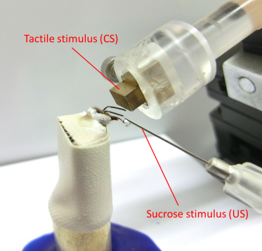
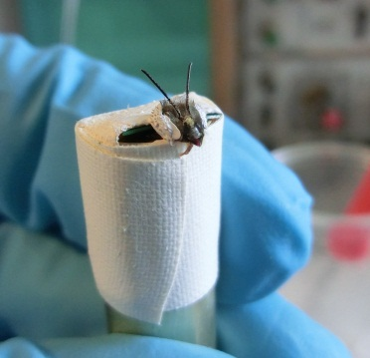
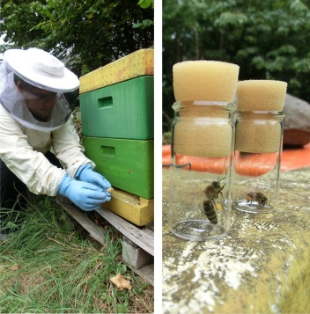

(P1) (P2) (P3)
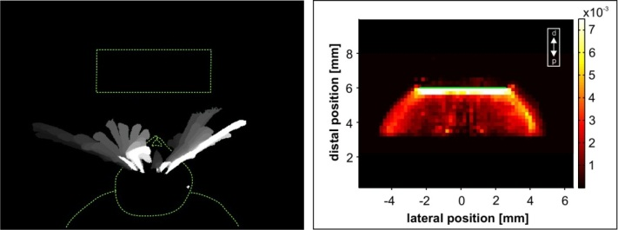
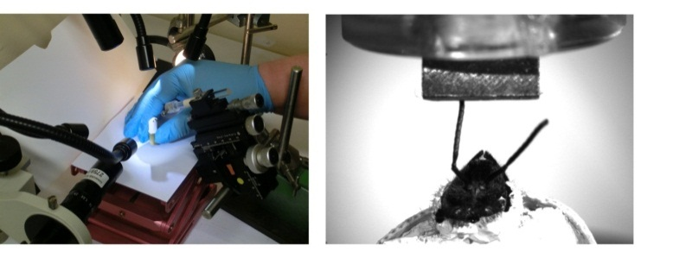
(P4) (P5)

B. Interview:

  - Samir Mujagic: This method can be used to study tactile discrimination and perception in various arthropod species. It can differentiate changes due to non-associative, tactile learning from changes occurring from associative learning, like during conditioning.
  - Simon Würth: Generally, individuals new to this method will struggle because the bees must be handled very carefully and the timing of the tactile conditioning procedure is critical
  - Volker Dürr: This method can help answer key questions in the field of active touch sensing. It uses a natural reflex behavior as a reporting behavior, allowing us to tell whether or not the animal can discriminate between two stimuli.

Protocol (read by voice talent at JoVE):

- Preparing the bees
  - To begin, collect bees directly from the hive entrance. Capture each bee in a glass vial closed with a foam plug and take it immediately into the laboratory for further handling.
    - WIDE: Talent walks toward hive
    - CU: Shot of bee in glass vial
2.1.4 WIDE: Talent leaves the hive

  - In the laboratory, briefly cool the bees in a 4°C refrigerator until they begin to show signs of immobility.
2.1.3 Talent walks into laboratory
2.1.5 CU: Putting the bees into the refrigerator
2.2.1 Talent retrieves bees from the refrigerator once they have stopped moving
{Comment: Changed step order!}
  - Samir Mujagić: The most difficult aspect of this procedure is the preparation of the bees, to ensure success, we handle them very carefully.
    - Talent looks up from lab bench and says the above

  - First, immobilize each bee onto a metal tube. Place adhesive tape around the head and thorax and over the abdomen. Confirm that the proboscis and antennae are freely movable.
    - CU: Talent grabs bee
2.4.4 CU: Talent places bee on metal tube
2.4.2 CU: Talent places tape over bee
2.4.3 CU: Shot of bees antennae, demonstrating that they are freely movable
{Comment: Changed step order!}

  - To occlude the bee’s vision, paint the compound eyes and Ocelli with white paint
    - CU: Talent paints the bee’s eye.

  - Place a small drop of melted wax between the head and the tape, to prevent the head from moving during recordings
2.6.2 ECU: Putting wax behind head

  - For easier identification, mark the tape of each bee with a number and place the tube into a humid atmosphere to prevent dehydration.
    - CU: Talent numbers the tape
    - CU: Talent places tube in humid atmosphere
    - MED: Shot of bees during their recovery

  - Lastly, use a syringe filled with 30 % sucrose solution to feed each bee for 5 seconds and let them recover for 30 min before starting the tactile conditioning protocol.
    - ECU: Bees being fed (This might be slated as 2.8.3)
2.7.3 MED: Shot of bees during their recovery
{Comment: Changed step order!}

- Tactile conditioning
  - Before conditioning, test each bee for the proboscis extension response or PER. To do this, apply a 30 % sucrose stimulus to the antennae. For a correct response, the tip of the proboscis has to cross a virtual line between the opened mandibles. Only bees with a correct PER are used for the study.
    - WIDE: Talent walks into laboratory
    - CU: Talent applies sucrose to the antennae
    - SCOPE: Shot of bee beginning to extend proboscis. Bee shows a correct PER

  - For tactile conditioning, brass cubes are used as the conditioned stimulus or CS. Their surface can be smooth or grooved to create a different texture
    - CU: Shot of brass cubes. Text Overlay (3 x 5 mm)
    - SCOPE: Shot to show textured surfaces

  - The unconditioned stimulus or US is a 30 % sucrose solution.
    - MED: shot of labeled sucrose solution

  - Place the brass cube into a holder on a micromanipulator, this will allow for exact positioning during the conditioning procedure.
    - CU: Talent places cube in holder

  - Once the tactile stimulus has been mounted, place a bee in front of the micromanipulator
    - CU: Talent places bee in front of CS

  - Next, slowly position the CS such that the surface of the tactile stimulus is parallel to the head of the bee. The bee should be able to scan the tactile stimulus in a comfortable position with both antennae.
    - CU: Talent lowers the micromanipulator
    - SCOPE: Talent positions the CS in front of the bee
    - SCOPE: Shot of the CS in relation to the head of the bee

  - To begin the conditioning procedure, allow the bee to scan the tactile stimulus for 5 seconds. After the first 3 seconds, use a syringe to present a droplet of the 30 % sucrose (US) solution under the proboscis. Use the tip of the syringe to gently raise the proboscis. This stimulation should elicit the unconditioned PER.
    - ECU: Shot of bee scanning the tactile stimulus
    - ECU: Talent presents sucrose solution
    - ECU: Talent raises proboscis
    - ECU: Shot of a PER
    - WIDE: Shot of the whole action 3.7

  - Allow the bee to lick the sucrose reward for 1 second.
    - SCOPE: Bee licks sucrose reward

  - Proceed with the conditioning procedure until the bee receives five pairings.
    - MED: Side shot of talent administering another pairing

  - After the first rewarded pairings, bees should start to respond to CS presentation by extension of their proboscis, indicating that they expect the forthcoming reward. A fully extended proboscis observed anytime during the first 3 seconds of tactile stimulus presentation, before sucrose presentation, is scored as a positive response.
    - ECU: Shot of conditioned bee responding to CS (please use 3.19.1.3/4)
    - MED: Talent writes positive/negative response into protocol

  - Finally, a learning curve is generated for a group of bees. For this, the percentage of bees showing the PER during CS presentation is plotted for each trial.
    - MED: Over the shoulder of Talent generating plot

- Kinematic recordings and data analysis
  - After conditioning, a digital video camera with a suitable macro lens is used to record the antennal movements. Here, we use a Basler A602f camera equipped with a TechSpec VZM 200 lens, operated at 50 frames per second via a fire-wire connection.
    - MED: Talent walk into frame and puts camera into position
    - CU: Talent points at camera
    - CU: Shot of the lens

  - Adjust the camera such that the harnessed bee and tactile stimulus will be visible.
    - Screen shot or MED: Talent adjusts camera to get the correct shot
    - CU: Adjusting the camera
{Comment: 4.2.1 and 4.2.2 is the same sequence!}

  - Next, calibrate the camera by taking single pictures of a calibrated checkerboard from different orientations. Use specialized software with a camera calibration tool to analyze the images.
    - MED: Talent takes pictures of checkerboard
4.3.4 CU: Button on monitor: single shot
4.3.3a. Lab Media: Picture of checkerboard with detected corners (50179_4-3-2_CalibCheckerboard.PNG).
4.3.3b Lab Media: Picture and video animation of calibration result (50179_4-3-3a_CalibResult.PNG and 50179_4-3-3b_CalibResult.avi).
    - CU: Picture of checkerboard
{Comment: Changed step order and deleted step 4.3.5!}

  - Once calibrated, place a single fixed bee below the camera lens and present the tactile stimulus as shown earlier. Record the antennal movement while the bee is scanning the object.
    - MED: Talent puts bee in place
    - Lab Media: Recording of the bee scanning object (50179_4-4-2_RecBeeScanning.avi).

  - Once the data have been collected, Matlab is used to define the image background. First, calculate the median greyscale value over time for each pixel. Static objects, like the fixed head of the bee and the tactile stimulus, will constitute the image background.
    - MED: Talent begins analyzing data
    - Lab Media: Picture of mean grey scale Background image result (50179_4-5-2_ImageBackground.PNG).
    - Lab Media (To be provided) or Screen shot: Talent defines background image.

  - By subtracting the image background from each frame, the moving parts in the video, ideally the antennae of the bee, are isolated as the only areas of non-zero values.
    - Lab Media: Video of antennae isolated as non-zero values (50179_4-6-1_IsolatedAntennae.avi).

  - For further processing, the two largest areas with non-zero pixel values are assumed to be the antennae. A mask is created to localize the antennal tips and for the entire image. To reduce the amount of error, a combination of image erosion and dilatation tools are applied. Once these techniques have reduced the noise level, a binary mask function is used to cluster the disjointed areas (See text protocol for more detail).
    - Lab Media: Video showing before and after optimization processing (50179_4-7-1_BeforeAfterProcess.avi).
    - Lab Media: Video of the moving antenna clusters (50179_4-7-2_AntennaCluster.avi).

  - The centre of gravity is calculated for the two largest of these clusters, in order to distinguish between the left and right antenna. Here they are colour-labelled in red and green. Finally, the antennal tip for each antenna can be defined as the pixel in a cluster with the highest value in the proximal-to-distal direction. A two-dimensional histogram is created that shows the spatial distribution of the antennal tip.
    - Lab Media: Video of colour labelled antennae and antennal tips (50179_4-8-1_CollorLabeledAntennae.avi).
    - Lab Media: Video of 2D-histogram for the left and right antennal tip (50179_4-8-2_2DHistogram.avi).
{Comment: Corrected narration text and presenting an additional video in step 4.8.2!}

- Tactile learning and antennal sampling behavior in bees
  - Shown here is the learning curve of tactile PER conditioning in Pollen foragers. The percentage of positive responses after the first pairing was significantly higher when compared to spontaneous behavior and the learning curve shows saturation after the 3rd reward.
    - Lab media: Figure 2, highlight Spont. And the increase in PER after the 3rd reward

  - In this example, the movement of the antennal tip in both the conditioned and the naïve group was recorded for 1 min in the presence or absence of the tactile stimulus (5.2.1). Seen here are spontaneous antennal movements before stimulus presentation. The abscissa shows the lateral position of the antennal tip while the ordinate shows the distal position. The color scale indicates the percentage of time that the antennal tip spent at any given location. Yellow indicates very frequent locations, red less frequent, and black locations are out of reach
    - Lab Media: Figure 3
    - Lab Media: Figure 3, focus on 3A1 and 3A2

  - This data show that both the naïve and conditioned group changed their antennal movement pattern in presence of a tactile stimulus compared to their spontaneous behavior. Note the rectangular yellow region near the surface of the stimulus, indicating that the antennal tip spent much time sampling the surface (5.3.1). Bees from the conditioned group spent significantly more time with their antennal tip in the area of the stimulus than the naïve bees.
    - Lab Media: Figure 3B1 and 3B2
    - Lab Media: Figure 3C1 and 3C2, label the left graph “Naïve” and the right “Conditioned”

- Conclusion

  - Simon Würth: Following this procedure, electrophysiological and pharmacological methods can be performed in order to answer additional questions like: “What is the neurophysiological basis for active touch behavior in honey bees?”.
  - Samir Mujagic: After its development, this technique of tactile conditioning paved the way for researchers in the field of active touch sensing to explore various aspects of tactile stimulus discrimination, but also of tactile learning and memory in arthropods.
  - Volker Dürr: After watching this video, you should have a good understanding of how to analyze active tactile searching and sampling behavior in insects. Note that the movement analysis can be expanded to a 3D analysis if at least one more camera is used in synchrony with the first one.

Provided Media
50179_Graphic overview.pptx
50179_4-3-2_CalibCheckerboard.PNG
50179_4-3-3a_CalibResult.PNG
50179_4-3-3b_CalibResult.avi
50179_4-4-2_RecBeeScanning.avi
50179_4-5-2_ImageBackground.PNG
50179_4-6-1_IsolatedAntennae.avi
50179_4-7-1_BeforeAfterProcess.avi
50179_4-7-2_AntennaCluster.avi
50179_4-8-1_CollorLabeledAntennae.avi

4-8-2_2DHistogram.avi

