Figure 1: Experiment Schema
Conduct UV Exposure
Prepare for UV Exposure
Assess MED

Legend: Figure 1 shows the experimental schema.
Figure 2: Daavlin UV Exposure Patch
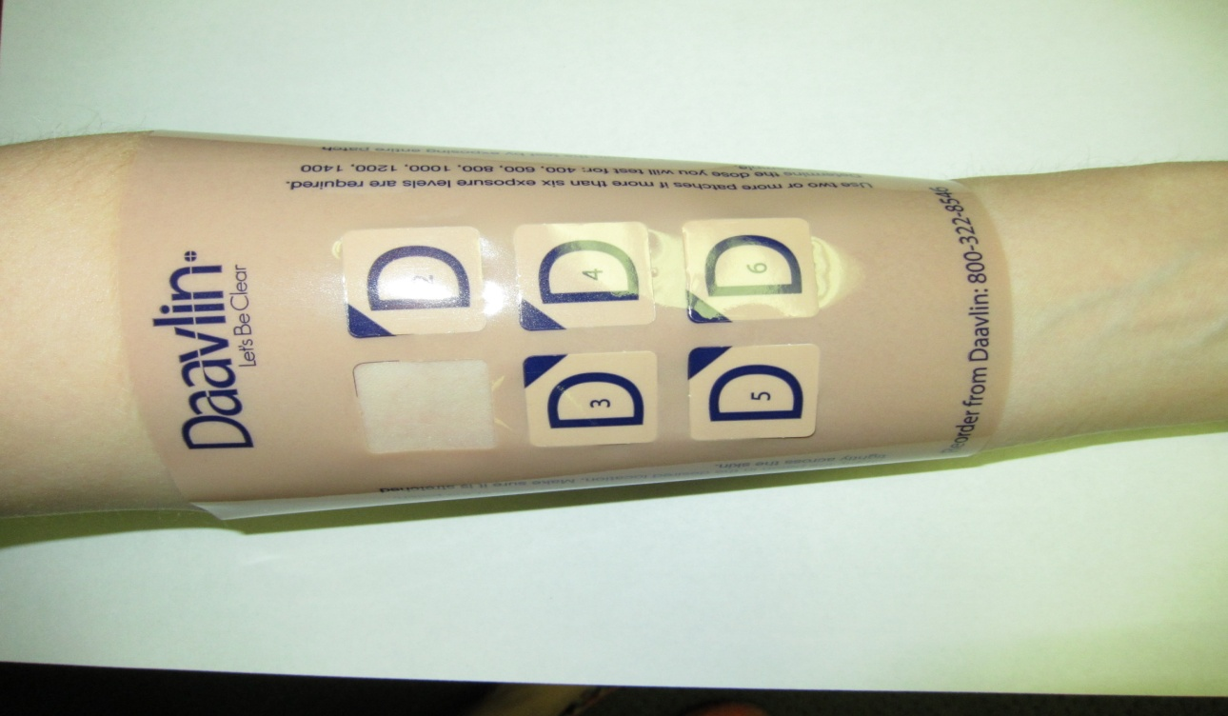
Legend: Figure 2 shows the Daavlin patch on a forearm.

Figure 3: Visible UV Exposure of the Arm
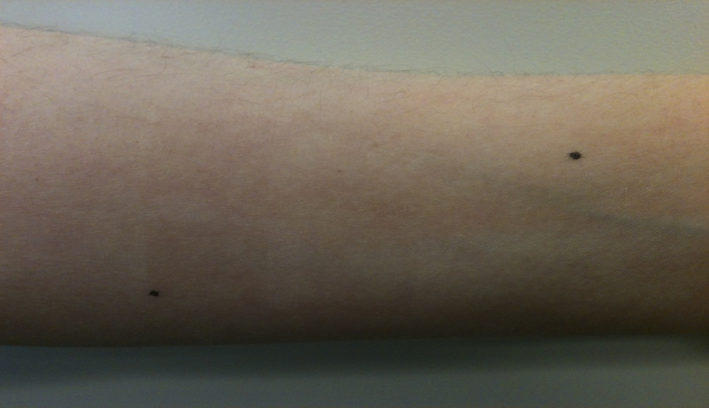
Legend: Figure 3 shows visible UV exposure on a forearm.

