Submission ID #: 50150

Editor Name: Steven Nilsen

Videographer name: Paul Donahue

Film Date: 23.10.2012

Authors and Affiliations:

Christof Rickert¹, Thomas Kunz¹, Kerri-Lee Harris², Paul M. Whitington², Gerhard M. Technau¹

1) Institute of Genetics, University of Mainz, 55099 Mainz, Germany.

2) Department of Anatomy and Neuroscience, University of Melbourne, Victoria 3010, Australia.

Title: Labeling of single cells in the central nervous system of Drosophila melanogaster

Corresponding Author:
Christof Rickert
rickert@uni-mainz.de
Phone: ++49-6131-394328

Gerhard M. Technau
technau@uni-mainz.de
Phone: ++49-6131-3925341

Videographer: Parts of this procedure will be filmed through a dissection microscope (Leica models with tubus - allows light splitting to oculars and camera). Cameras can be mounted via c-mount. Other parts will be filmed through an Olympus BX50 that also has a c-mount to attach a camera.

- What is the single most difficult aspect of this procedure and what do you do to ensure success?
The step that needs the most practice is labeling only single cells instead of small groups. Even an experienced person will not reach 100%. But by repeating the experiment the amount of successful labelings becomes better and better.

1. Introduction (Schematic Overview and Interview)

A. Schematic Overview (read by voice talent at JoVE):

The overall goal of this procedure is to label single neurons in the central nervous system of early stage 17 Drosophila embryos. (Intro) This is accomplished by collecting eggs and allowing them to develop to right stage. (P1) The second step, of the procedure, is to manually dechorionate and align the eggs. (P2) Following this, devitellinisation and filleting of the embryos makes the nerve chord accessible. (P3) The final step is to label single cells by iontophoretic application of the lipophilic dye, “dye-eye”. (P4) Ultimately, results allow the visualization of single neuron morphology, if desired in the context of known GPF expression patterns and/or in mutant background. (P5)

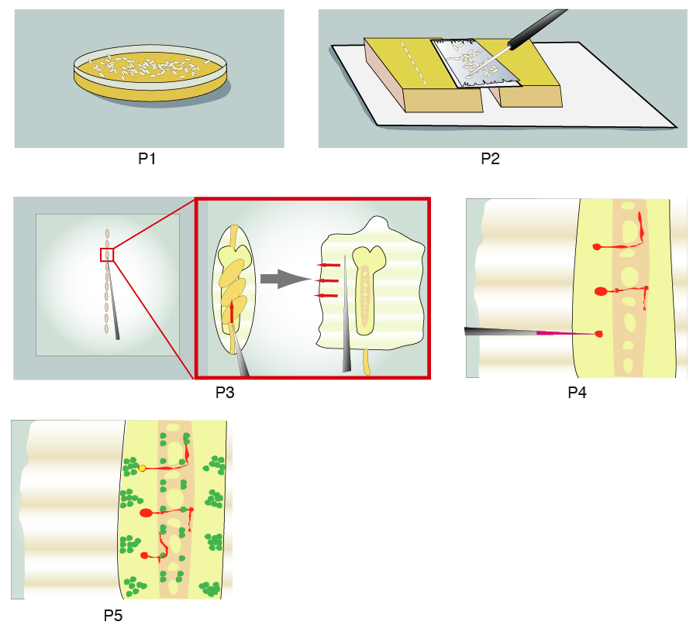
Video editor: The provided schematic accompanies the dialogue very effectively. In P1, small embryos/eggs are the white dots on the yellow lawn of the Petri dish. They are allowed to develop for a short while. Then, in P2, a fine brush is used to move the eggs to a microscope slide that is supported by two yellow blocks (essentially the microscope stage). They are manipulated into a neat row. Now, in P3, we have a top view of the aligned eggs on the slide and the zoom in shows how they are manipulated. The thin point is used to tear open their edge and “filet” them into a wide, flattened exposure. The red arrows show the motions of the thin point to animate. This could look very nice with a little effort. In P4, a needle containing red dye is poked into the central part of the filet from P3- the colors correspond to the location. Two cells have already been injected with dye and a third is being injected at the moment. Before the cells are injected they are essentially invisible, then the dye seeps through them beginning at the cell body where they are circular and then extending through the processes or the long, branch from the circle. You could animate P4 using these instructions. For P5, we see the same thing as the completed product of P4, however now other cells are made visible by fluorescent protein, GFP, under the right light. We also see the processes that the third cell injected in P4 has filled, which was not shown in P4. Essentially you could complete the P4 animation and fade into the P5 illustration. Have fun!

B. Interview: (Said by you on camera. Don’t forget to smile!)
  - Christof: The main advantage of this technique over existing single cell labeling methods, like MARCM, is that it works in the embryo and allows to visualize identified cells intentionally.
  - Thomas: Visual demonstration of this method is extremely helpful, as many steps are delicate and therefor difficult to learn.

Protocol (read by voice talent at JoVE):

Video Editor: Note from author: “All movie times refer to a quicktime movie that I combined from the two parts Paul uploaded to "we transfer". it is 55:15 minutes long (but has some black portions from 50:47 onwards).
Of course feel free to contact me if there are questions or requests. Christof”
- Embryo Collection and Preparation
  - Allow healthy flies to lay embryos on agar plates. Replace the plate every one and a half hours at 25°C and retain the embryos.
    - WID: talent enter fly room to change plate or opens fly incubator to change plate
    - MED: swapping plates
  - Incubate the embryos on their plates at 25 or 18 ºC, until they reach the required developmental stage.
    - ECU/CU: show the eggs collected on the plate that was just obtained
    - WID: talent covers and loads the plate with eggs into correct environment
  - When ready, transfer the embryos to a slide covered with double-sided sticky tape. Avoid transferring any agar with the embryos, as it will interfere with their adhesion to the tape. On the tape, allow the embryos to dry for 5 to 10 minutes.
    - CU: attaching tape to a slide
    - MED: transferring eggs, talent is seated at scope
    - SCOPE: talent placing eggs onto tape
  - While waiting, coat a 24 millimeter by 60 millimeter coverslip with heptane glue. Place a small drop of glue in the center of the slide and spread it into a very thin film using an 18 millimeter square coverslip.
    - MED: talent lifts glue from container and holds it over coverslip
    - ECU: coverslip as glue is applied and spread into film on it – get a good take
  - Place the coverslip on a microscope slide and frame it with adhesive tape.
    - MED: placing coverslip on a slide
    - CU: applying tape to edges of coverslip on slide, show finishing touches
  - Once the embryos have dried, gently touch them with a needle. The chorion will split open and the embryo will stick to the needle. Immediately transfer the dechorionated embryos to an agar block to prevent them from drying.
    - SCOPE: the talent uses a probe/poker to show how a slightly brittle embryo should respond to a poke ; lifting the embryos to move them to agar block
  - Align them there, 10 in a row, ventral sides up.
    - SCOPE: lifting the embryos to move them to agar block
    - ECU: eggs being added to agar block, finishing touches
  - Cut away the excess agar from the block with a scalpel.
    - ECU + SCOPE: cutting away excess agar
  - Then, gently touch the embryos with the heptane-glue-coated coverslip. They should adhere to the coverslip with their ventral sides down. Apply a frame of adhesive tape around the coverslip and attach it to a microscope slide, keeping the embryos on top of the coverslip.
    - MED: talent prepares to touch eggs to coverslip
    - ECU + SCOPE: contact between coverslip and eggs, the eggs should be lifted away
    - CU: applying tape to edges of coverslip on slide, show finishing touches (This was moved from step 2.5)
  - Cover the embryos with generous amounts of PBS.
    - ECU + SCOPE: solution applied over eggs, until completely submerged

LAB MEDIA: Figure 2, steps 4-6
  - On the dorsal side of each embryo near its posterior end, penetrate the vitelline membrane with a glass needle. Tear open the membrane along the dorsal midline and drag the embryo out of the membrane.
    - MED: talent places coverslip/eggs under dissecting scope and proceeds
    - SCOPE: focused on embryo’s posterior end, needle penetrates and tears along middle
  - Now, re-orient the embryo ventral side down elsewhere on the heptane-glue substrate.
    - SCOPE: moving the embryo around so it is ventral side down
  - Fillet the embryo with a glass needle by gently perforating the body wall and tearing along the dorsal midline.
    - SCOPE: needle is used to poke holes and makes a tear down the middle
  - Using the needle, push down on the body wall so that it sticks to the slide, tear through the gut at its anterior and posterior ends and lift the gut away.
    - SCOPE: needle forces side walls down and the guts are pulled away

LAB MEDIA: Figure 2, steps 7-8
  - Since several embryos will be filleted on the same slide, it is helpful to either be very accurate with their orientation or make a drawing of their orientation.
    - SCOPE: the complete process from 2.11 – 2.14 on the next embryo
    - CU: paper/pencil, talent completing a drawing/map of embyos
  - Next, the embryos may be lightly fixed for 10 to 15 minutes in 7.4 % formaldehyde in PBS, followed by four washes in PBS. Use extreme care to avoid touching the embryos to the surface of the solution - the surface tension forces will destroy them.
    - MED: talent exchanges PBS solution with fixative and starts timer.
    - MED + SCOPE: exchanges fixative with PBS.
    - ECU: have talent demonstrate how to avoid touching the embryos to the surface of the solution –
  - Author: This pre-fixation step is not strictly necessary, but is useful to prevent contraction of the body wall muscles in late stage embryos and to help stabilize embryonic tissues at young stages. Keep in mind that fixation does make the tissues of the embryo more opaque and so somewhat compromises image quality under DIC observation.
    - MED/WID: this is an interview shot with audio, performed on location of the previous step – get good audio
- Dye Injection of Individual Neurons
  - Under a 10 X objective, center of the field of view on a prepared embryo.
    - WID/MED: side angle of talent at microscope, adjust the objective to 10X and adjusts focus knobs
  - Increase the magnification and locate the cell of interest under DIC optics or under fluorescence if the target cell expresses GFP.
    - SCOPE: scans for cell using DIC optics or for green cell under fluorescents
  - Ensure that the field diaphragm of the microscope is opened just to the edge of the field of view, not beyond. A narrow illumination beam will aid positioning of the micropipette.
    - SCOPE: after finding cell of interest, adjust field diaphragm – changes the illuminated region of the slide
    - CU: adjusting the field diaphragm controls on the scope
  - Change back to the 10x objective and place the bath electrode for the DC amplifier into the solution far from the embryo and the path of the micropipette.
    - ECU: on the stage and objective area, objective is raised, then an electode is placed in the bath, apart embryos
  - Mount the injection micropipette, filled with lithium chloride solution, to the holder and attach it to the micromanipulator. (TEXT: Consult manuscript on loading the micropipette with DiI.)
    - CU: attaching the micropipette to the holder and then attaching holder to micromanipulator
  - Using the coarse controls, position the micropipette below the objective and well above the embryo.
    - ECU: under the optics, over the stage, the micropipette slowly moves into a position above the embryos
  - If the angle of the micropipette is too steep, the tip will not get in focus. If it is too shallow, the shaft will foul against the bath wall. Center the tip in the field of view.
    - SCOPE: centering the micropipette tip into the field of view
  - .Now lower the micropipette and the focus alternately until the pipette is in the PBS and not too far above the embryo.
    - ECU: side view of pipette above embryos, parallel to stage, it slowly moves into the beam of light from the optics and gets brightened
    - ECU: as above angle, but from a different position, to show movement of the pipette in opposite directional axis as it leaves the light
  - Now, change to high power objective and center the pipette within the field of view.
    - SCOPE: under high power, the shaft of the micropipette gets into focus
  - When the shaft is in focus, move the micropipette in the X-axis until its tip lies in the center of the field of view. The micropipette tip should be well above the level of the embryo.
    - SCOPE: the micropipette moves showing the shaft narrow to the tip
    - SCOPE: the focus is adjusted to show that the embryos are below the tip of the micropipette, then focus is returned to micropipette tip
  - Switch to fluorescence illumination and examine the tip. Check for leakage of dye-eye. Adjust the DC current so that dye-eye crystal does not build up at the tip.
    - SCOPE: fluorescent light is used, dye should be visible in pipette
    - CU: talent’s hand adjusting the DC current control
  - Now, lower the micropipette in the Z-axis towards the embryo, progressively adjusting the focus. As the embryo comes into focus switch to using the fine control.
    - SCOPE: fluorescent light off now, pipette is lowered to the embryos, slowly
  - With embryo surface in focus, move the tip to the edge of the field of view.
    - SCOPE: embryos and tip in focus, tip moved to edge (Video Editor: Per the comment at step 3.22, they authors may have footage to cover 3.13 thru 3.21. It also sounds like they are willing to leave out steps 3.13 and 3.15, so you can see if the footage fits with the narration or not.)
  - Focus the cell to be injected at the center of the field and then refocus on the micropipette tip.
    - SCOPE: focus adjust to a cell, then focus adjusted back to tip
  - Move the tip along the Y-axis until it is at the same level as the cell and then move the tip towards the cell in the X-axis while lowering it.
    - SCOPE: tip moves left/right to edge of cell, then move up/down while lowered to position for injection
  - At this point, use the stage controls to move the micromanipulator.
    - MED: using the micromanipulator’s stage controls
  - Bring the micropipette tip into contact with the cell and make a depression on its surface. Pass several nanoamps of depolarizing current for a few seconds. A small crystal of dye-eye will form on the cell.
    - SCOPE: tips contacts cell, presses on cell surface and dye leaches into the cell
  - To confirm that the cell has been labeled, briefly open the shutter to illuminate the field with fluorescent light. If the body of the cell shows signs of labeling, apply current for several more seconds.
    - SCOPE: fluorescent switched on to see the dye in the cell, before pipette pulled away
  - Then, turn off the current and quickly pull the embryo away from the micropipette using the stage controls.
    - CU: turning off the DC current
    - SCOPE: moving embryo away from tip
  - If no dye-eye labeling was evident, the micropipette may have been blocked and needs replacement.
    - MED: talent replaces the micropipette with a new one that is ready to use
  - If the tip of the pipette snags other tissues en route to the cell and stains that tissue, try withdrawing the micropipette slightly, and re-approach the cell before resorting to replacing the micropipette.
    - SCOPE: ask talent to snag the pipette tip in the tissue, staining it, and try and save the situation by withdrawing the micropipette slightly
  - As needed, continue labeling other cells in the same embryo or in other embryos on the same slide steps. Move the tip to the edge of the field of view and repeat the procedure.
    - SCOPE: this shot shows whole process of 3.17 to 3.19 being performed at a different location in the same embyo, show the movements of the micropipette between the repeating
    - SCOPE: this shot shows the pipette tip is moved to a whole new embryo
LAB MEDIA: Fig 4c
  - Remove most of the solution in the injection chamber, then fix the embryos by adding 7.4 % formaldehyde/PBS for 10 minutes followed by 4 washes with PBS. The preparation can now be photoconverted or mounted for confocal microscopy. (TEXT: See manuscript for details on mounting embryos.)
    - CU: sucking solution from dish that hold eggs being injected
    - MED: loading pipette with formaldehyde and injecting it into the dish from previous shot
    - MED: exchanging solutions in above dish
- DiI Labeled Neurons
  - Using the outlined protocol, a dye-eye filled interneuron was flawlessly photoconverted. Under DIC optics the spatial context of the labeled cell within the non-labeled surrounding tissue was well resolved. For example, the positions of the cell body within the cortex and of the fiber projection within the neuropil could both be seen.

LAB MEDIA: Figure 4a
  - In this preparation, the dye drop was a little too big. Several neighboring cells became labeled simultaneously, which makes it difficult to relate individual projections to distinct cell bodies. Also, notice that under the fluorescent microscope, the background resolution is much lower without photoconversion.

LAB MEDIA: Figure 4b
  - Multiple cells in neighboring segments can also be injected. In this preparation, an antibody against Fas2 stains of fascicles in the neuropile. Despite the clear cell bodies, the preparation shows a possible side effect of prolonged photoconversion periods: the more intensely labeled cells tend to get overstained and start to swell …

LAB MEDIA: Figure 4c
  - … as compared to labeling a single cell.

LAB MEDIA: Figure 4a
  - With confocal optics, dye-eye labeling in embryos that carry GFP reporter constructs can provide spatial context and identity of the dye filled cell within specific populations of GPF positive neuronal or glial cell types.

LAB MEDIA: Figure 4d

- Conclusion (said by authors on camera)
  - Christof: After watching this video, you should have a good understanding of how to prepare and perform labelings of single neurons in the embryonic CNS of Drosophila.
  - Thomas: But while attempting this procedure, please keep in mind that every single step is demanding so expect a couple of repetitions until the whole procedure runs smoothly.

Provided Media

procedural narrative.ai - 390.649 KB

2.10, 2.14 Fig2.pdf - 252.677 KB

4.1 Fig4a.psd - 4.582 MB

4.2 Fig4b.psd - 1.067 MB

4.3 Fig4c.psd - 4.413 MB

4.4 Fig4d.psd - 3.319 MB

