Submission ID #: 50139

Editor Name: Petti Pang

Videographer name: Rib Bolton

Film Date: Sep 17, 2012

Authors and Affiliations:
Debajit Saha
Department of Biomedical Engineering
Washington University in St. Louis, Saint Louis, MO
sahad@seas.wustl.edu

Kevin Leong
Department of Biomedical Engineering
Washington University in St. Louis, Saint Louis, MO
kevinleong@wustl.edu

Nalin Katta
Department of Biomedical Engineering
Washington University in St. Louis, Saint Louis, MO
nk1@wustl.edu

Baranidharan Raman
Department of Biomedical Engineering
Washington University in St. Louis, Saint Louis, MO
barani@wustl.edu

Title: Multi-unit recording methods to characterize neural activity in the locust (Schistocerca americana) olfactory circuits

Corresponding Author: Baranidharan Raman

Authors, please fill out the brief questionnaire below.

A. Will you require JoVE to record video microscopy, such as filming a complex dissection or microinjection technique? (Y/N) ____Y_____ If yes, please list make and model of your microscope: __________ Leica M80, Leica M205C ____________________
B. Does your protocol include detailed, step-by-step, descriptions of software usage? (Y/N)___N_____
C. Which steps of your protocol will viewers benefit most from having filmed? Please list 4-6 steps__________________________
We believe that the following steps will be most beneficial for viewers of the protocol:
- Selection of a locust from a crowded colony (Manuscript step 2.1)
- Preparation of an insect antenna for sensilla recording (Manuscript step 2.2, 2.3 and 3.1)
- Fabrication and placement of a glass microelectrode for sensilla recording (Manuscript steps 3.2 and 3.3)
- Locust dissection procedure (Manuscript steps 4.2 – 4.9)
- Placement of extracellular electrodes for multi-unit recordings from the locust brain (Steps 5.3 - 5.6)

D. What is the single most difficult aspect of this procedure and what do you do to ensure success? ______________________________
The following steps are crucial for the success of the described multi-unit recording protocols:
Placement of electrodes - described in steps 2.4, 4.2, and 4.4 in this script.
The stabilization and desheathing of the locust brain during the dissection process – described in 3.8 in this script.

1. Introduction (Schematic Overview and Interview)

A. Schematic Overview (read by voice talent at JoVE):
Authors, please select from “Procedural Narrative” or “Conceptual Narrative” and complete the statements below. Please do not add additional steps. Then, attach your finished graphic overview. See accompanying instructions for details and examples.

Procedural Narrative:
The overall goal of this procedure is to record odor-evoked multi-unit neural activity from the first three signal processing centers of the insect olfactory pathway. (Intro)

This is accomplished by first restraining a locust in a custom-designed chamber, and stabilizing one of its antennae for electrophysiological recordings. (P1(video editor, start with everything except the electrical tape, the batik wax and the odor tube. Add the electrical tape at “restraining,” add the batik wax at “stabilizing” and add the odor tube at “electrophysiological.”)

The second step is to fabricate a glass microelectrode and insert it at the base of a sensillum to monitor the odor-evoked responses (video editor, add the blue traces on the right and the texts “Extracellular Voltage Trace” and “4s” here) from the sensory neurons. (P2)

Next, to record neural activity from the locust brain, a multi-step dissection procedure is followed to expose the neural tissue, which processes the input from the olfactory sensory neurons. (P3)

The final step involves appropriate placement of the multi-electrode arrays (video editor, add the two orange/red electrodes, add the text “Kenyon cell” instead of “KC” and add “principal neuron” instead of “PN” here) to record ensemble neural activity from the locust antennal lobe and the mushroom body. (P4)

Ultimately, the extracellular recording methods demonstrated here are used to characterize odor-evoked responses (video editor, add blue traces in the upper and lower panel on the right and the texts “4s” here) at the first three processing centers along the insect olfactory pathway. (P5)

Paste a copy of your graphic overview here. The original file should be Adobe Illustrator (preferred) or Powerpoint (see instructions) and should be uploaded through your online submission on the JoVE website. Please keep all layers in the file (i.e., do not flatten the file).

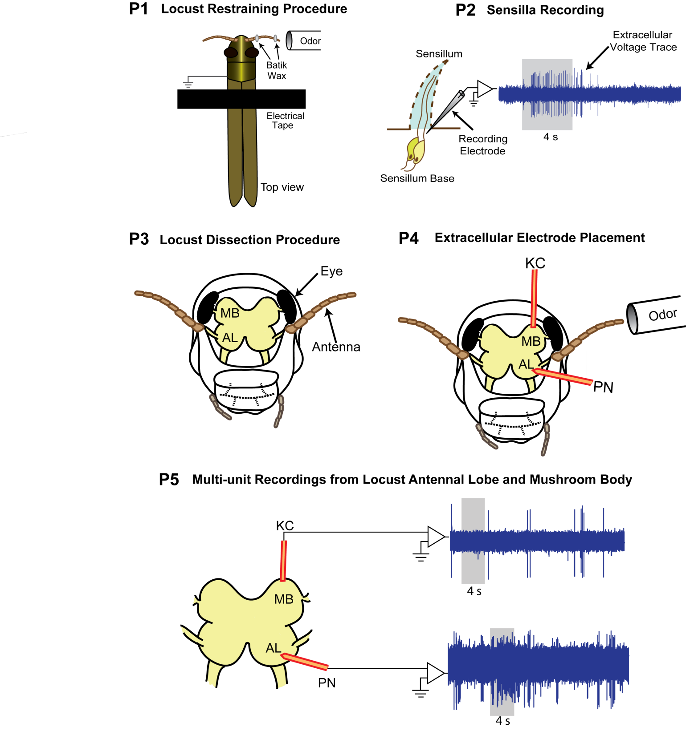
B. Interview: (Said by you on camera. Don’t forget to smile!)

Authors: Below are statements we would like you to complete that are complementary to the information contained within the schematic overview.
- Only one statement should be chosen and completed per author who will be on camera demonstrating the protocol.
- Enter the name of the individual who will say each line.
- Please choose and fill out the statement(s) that convey the most important fact(s) about your protocol. You may revise the given prompts as necessary to improve the sentence flow.
- If any individuals will be doing demonstrations on camera but are not assigned a speaking part in this interview section, please use statement 1.8 to introduce these demonstrators (for example, the PI introduces students)

  - Barani Raman: The extracellular recording methods described in this video are used to answer some key questions in the field of olfactory neural computation, such as how odors are represented at the level of population of sensory neurons, and how this information is transformed as it gets transmitted from one neural circuit to the next.
  - Kevin Leong: Though this method has been used here to characterize odor-evoked neural response in a relatively simple invertebrate olfactory system, it can also be easily adapted to examine ensemble activity in vivo in other neural systems as well.
  - Deb Saha: Visual demonstration of this method is critical as some of the key aspects of this procedure such as the electrode placement and certain dissection steps are difficult to learn. Additionally, the procedural descriptions are mostly qualitative and are perfected differently by different labs.

Protocol (read by voice talent at JoVE):

Authors: In order to ensure that your protocol can be filmed in a single day, the protocol text must be limited to 30 steps – each step being defined as 3 lines of 12 pt text in our formatting style below. This amounts to 3 pages of protocol text. The scope of the scripted protocol text should include only those aspects of the procedure that require visualization in order to be well understood.

- Single sensillum preparation for recording odor-evoked responses from olfactory receptor neurons
  - To begin this procedure, select a young-adult locust of either sex with fully-grown wings, but prior to the mating stage from a crowded colony. Next, restrain the locust by amputating its legs. Seal the amputation sites with tissue adhesive. Then, secure the locust to a custom designed chamber with a small piece of electrical tape draping around its thorax.
    - Omitted

2.1.1.a. CU: Talent showing too young locust. (video editor: add caption “ too young, underdeveloped wings”)

2.1.1.b. CU: Talent showing too old locust. (video editor: add caption “too old, pale yellow color”)

2.1.1.c. CU: Talent showing young-adult (right age) locust. (video editor: add caption “correct age, redish-brown with fully grown wings (post-fifth-instar)”)

    - CU: The locust as its legs are amputated.
    - CU: The locust as the amputation sites are sealed with tissue adhesive.
    - MED-over the shoulder: Talent secures the locust to a custom designed chamber with a small piece of electrical tape draping around its thorax.
  - Under a dissection microscope, make a shallow groove in the wax platform for antenna placement. Place the antenna into the groove and stabilize it using batik wax at the two ends of the antenna.
    - SCOPE: A movie to show that a shallow groove is made in the wax platform for antenna placement.
    - SCOPE: A movie to show that the antenna is placed into the groove and the two ends of the antenna are stabilized with batik wax.
  - After that, insert a ground electrode into the thorax. Use batik wax to seal the incision site and to hold the ground wire in place. Next, place the stabilized locust antenna under a stereomicroscope on a vibration isolation table. Connect the outlet lines of the odor bottles to the odor delivery tube. Position the odor delivery tube within a few centimeters of the antenna. Delivered odor vapors are removed by a vacuum funnel placed approximately 10 centimeters behind the locust antenna.
    - CU: Talent inserts a ground electrode into the thorax of the locust.
    - The locust as batik wax is used to seal the incision site and to hold the ground wire in place.
    - MED: Talent places the stabilized locust antenna under a stereomicroscope on a vibration isolation table.

2.3.3.a. MED: Talent connects the odor line and places the odor delivery tube close to the antenna.

  - Then, fabricate glass electrodes (Text overlay: tip diameter 1-3 µm) using a borosilicate glass capillary (Text overlay: O.D. 1.2 mm, I.D. 0.69 mm) with a micropipette puller. Fill the glass electrode with locust saline (Text overlay: electrode impedance 3-10 MΩ when filled with locust saline). Next, place the glass electrode into a micropipette holder that is attached to a motorized micromanipulator. Make sure that the base of the recording sensillum is clearly visible under the microscope. Gently insert the electrode into the base of a sensillum.
    - MED-over the shoulder: Talent pulls a glass electrode with a micropipette puller. Text overlay: tip diameter 1-3 µm. Text overlay: O.D. 1.2 mm, I.D. 0.69 mm.

2.4.1.a. CU: Talent fills the electrode with locust saline. Text overlay: Impedance 3-10 MΩ when filled with locust saline.
    - MED-over the shoulder: Talent places the glass electrode into a micropipette holder that is attached to a motorized micromanipulator.
    - SCOPE: A movie to show that the base of the recording sensillum is clearly visible.

    - SCOPE: A movie to show that the electrode is gently inserted into the base of a sensillum.
  - Subsequently, amplify the signal 10,000 times using an A.C. amplifier. Filter the signal between 0.3 – 10.0 kHz and acquire it at a 15 kHz sampling rate using a data acquisition system. The acquired signal from a single sensillum recording is shown in an oscilloscope. When the electrode is appropriately positioned spontaneous neural activity (Text overlay: ‘spikes’ or ‘action potentials’) can be detected. Stimulus-evoked responses can be monitored by delivering an odor pulse through the odor delivery tube positioned close to the antenna and tracking the change in the extracellular activity. Notice the differences in spike amplitude and shape, indicating that this is a multi-unit recording.
    - MED-over the shoulder: Talent adjusts the filter settings on the A.C. amplifier.

2.5.1.a. CU: Oscilloscope trace of a sensilla recording showing spontaneous activity.

2.5.1.b: CU: Oscilloscope trace of a sensilla recording as an odor pulse is delivered. (At approximately 17 seconds in this video, add the text overlay “Odor being delivered. Carrier gas flow rate: 750 sccm; Odor vapor flow: 100 sccm” when the click is heard).
- Locust dissection procedure for antennal lobe and mushroom body recordings
  - Follow the restraining procedures as described previously. Position the locust in a custom-designed chamber.
    - MED-over the shoulder: Talent showing the locust after amputation.
    - CU: The locust as it is positioned in a custom-designed chamber.
  - Begin the dissection process by building a wax cup around the locust head. Construct two wax towers, on either side of the locust head, reaching up to the height of the antennae. Next, insert each antenna through a small piece of polyethylene tubing (Text overlay: PE tubing: 5 mm long, I.D. 0.86 mm) that is tightly fit in a rubber gasket. Then attach the gaskets to the wax towers such that the plastic tubing can freely slide towards or away from the base of the antennae while preventing the antennae from moving.
    - SCOPE: A movie to show wax towers are built on both sides of the head
      - ECU: Completed wax towers on both sides of the head
    - CU: A movie to show that the rubber gasket is put on the plastic tubing. Text overlay: 5 mm long, I.D. 0.86 mm.
    - CU: A movie to show that the tubing is slid through the antenna and the rubber gasket is clamped to the wax tower.
  - Then, under the microscope, start building a wax cup around the locust head to allow saline perfusion during and after the dissection procedure. The wax cup should start just above the mouth parts, encompass both the wax towers, and extend beyond the compound eyes. Once the wax cup is fully constructed, attach the base of the antennae to the bottom end of the plastic tubing using epoxy resin; this will ensure that the antennae are held in place even after the surrounding cuticle is removed.

3.3.1. SCOPE: A movie to show that the wax cup starting just above the mouth parts, and extending beyond the compound eyes which encompasses the region between the two antennae.

3.3.2. SCOPE: A movie to show that the base of the antennae is attached to the bottom end of the plastic tubing using epoxy resin.

  - Keep the wax cup filled with saline solution from this point onwards. Now, remove the central rectangular region between the two antennae. Subsequently, remove the cuticle in the neighboring regions without disturbing the compound eyes or cuticle at the base of the antennae. Using fine forceps, gently remove the air sacs and fat bodies surrounding the brain.
    - CU: Talent showing the wax cup filled with saline solution.
    - SCOPE: A movie to show that the central rectangular region between the two antennae is removed.
    - SCOPE: A movie to show that the cuticle in the neighboring regions is removed without disturbing the compound eyes and cuticle at the base of the antenna.
    - SCOPE: A movie to show that the air sacs and fat bodies surrounding the brain are removed.
  - The locust brain should now be clearly visible. The brain regions that process the olfactory information are situated between the two antennae.
    - SCOPE: A movie to show the locust brain is clearly seen.
    - Omitted
  - Gently pull the foregut and cut it using fine scissors. Then, remove the wings and make a small incision in the abdomen just above the rectum. Remove the gut by pulling the hindgut with coarse forceps. This step ensures that gut movement does not destabilize the preparation.
    - SCOPE: A movie to show that the foregut is gently pulled and cut with scissors.
    - CU: A movie to show that the wings are cut.

3.6.2.a. CU: A movie to show that a small incision is made in the abdomen just above the rectum.
    - CU: A movie to show that the gut is removed by pulling the hindgut with a pair of coarse forceps.
  - To prevent saline leakage, tie the abdomen just anterior to the incision site with suture threads. Next, use a small platform made of a thin wire loop coated with a fine layer of wax to elevate the brain and stabilize it for electrophysiological recording.
    - MED-over the shoulder: Talent ties the abdomen just anterior the incision site with suture threads.
    - CU: A small platform as it is made.
    - SCOPE: A movie as the platform is inserted below the brain.

3.7.4. SCOPE: A movie as the brain is lifted using wire platform.
  - The brain is protected by a semi-transparent sheath, which must be removed prior to recordings. To weaken the sheath, partially drain the wax cup and carefully spread a small amount of protease over the surface of the brain. After approximately 5-10 s of enzyme application, rinse the brain thoroughly with saline. Then, very gently pinch and pull the sheath up with super-fine forceps to tear it open and expose the recording sites.
    - SCOPE: Talent applies a small amount of protease over the brain surface.
    - SCOPE: The brain as it is rinsed with saline.
    - SCOPE: A movie to show that the sheath is pinched and pulled up, then it is torn open with a pair of super-fine forceps.

- Multi-unit recordings from the antennal lobe and the mushroom body
  - In this procedure, place the locust preparation under a stereomicroscope on a vibration isolation table. Maintain a constant saline perfusion rate at about 40 mL/hour throughout the experiment. Use a chlorided silver wire immersed in the saline-filled wax cup as the ground electrode. Prepare the odor delivery setup similar to the single sensillum recording experiment.
    - MED: Talent places the locust preparation under a stereomicroscope suspended from a boom stand placed on a vibration isolation table.
    - MED-over the shoulder: Talent adjusts the perfusion rate on the pump.
    - CU: A silver wire as it is immersed in the saline-filled wax cup.

4.1.4. MED: Talent connects the odor bottles to the flow tube and places the flow tube close to antenna.
  - Prior to the experiment, electroplate the electrodes with gold to achieve the impedances in the 200-300 kΩ range. Use a 16-channel silicon probe for principal neuron recordings. Under the microscope, position the electrode close to the surface of the antennal lobe and gently insert it into the tissue using a manual micromanipulator.

4.2.2. Move 4.2.2 before 4.2.1 : MED-over the shoulder: Talent plates the electrodes with gold
    - CU: Talent places the 16 channel silicon probe in an IC socket.
    - MED-over the shoulder: Talent plates the electrodes with gold.
    - SCOPE: A movie to show the electrode being positioned close to the surface of the antennal lobe and is inserted into the tissue.
  - In an ideal recording site, extracellular signals will be picked up by multiple recording channels and will have a high signal-to-noise ratio.
    - Omitted
    - Moved to a different Section, after 4.5.3.
    - MED-over the shoulder: Talent shows the high signal-to-noise ratio on the oscilloscope.
  - For Kenyon cell recordings, a custom-made twisted wire tetrode is used. Electroplate the tetrode following the procedures for electroplating the silicon probe. Then, place the tetrode on the surface of the mushroom body since the somata of Kenyon cells are restricted to the superficial layer of this region.

4.4.2. Move 4.4.2 before 4.4.1: MED-over the shoulder: Talent plates the electrodes with gold.
    - CU: A tetrode as it is being placed in an electrode holder by the talent.
    - MED-over the shoulder: Talent plates the electrodes with gold.
    - SCOPE: A movie to show that the tetrode is being placed on the surface of the mushroom body.
  - Both principal neuron and Kenyon cell recordings can be made simultaneously from the same locust preparation. After identifying the recording location, wait at least 15 minutes to allow stabilization of the electrodes. Then, acquire the extracellular signal at 15 KHz, filter it between 0.3-6 KHz and amplify it using a 16 channel AC amplifier. Both, spontaneous and stimulus-evoked multi-unit neural activity from projections neurons in the antennal lobe can be observed.
    - CU: Positions of the two electrodes are shown in the recording chamber.
    - SCOPE: Both PN and KC electrode placement.
    - MED-over the shoulder: Talent adjusts the settings on the amplifier.

4.3.2. CU with audio: Acquired signal on an oscilloscope due to stimulation of projection neurons by an odor pulse. (At approximately 23 seconds in the original video, add the text overlay “Odor being delivered. Carrier gas flow rate: 750 sccm; Odor vapor flow: 100 sccm” when the click is heard).

- Results: Multi-unit recording methods to characterize neural activity in the locust olfactory circuits
  - Raw extracellular voltage traces showing responses of an olfactory receptor neuron to two different odors: 2-octanol and 1-hexanol are shown here.
    - LAB_MEDIA: 50139_ Raman_Figure 3D
  - A representative extracellular trace from a multi-unit antennal lobe recording is shown here. The action potentials or ‘spikes’ of varying amplitudes originating from different principal neurons can be observed in this voltage trace. Note that a 4 s odor pulse was applied during the time period indicated by the gray box.
    - LAB_MEDIA: 50139_ Raman_Figure 6A (Replace texts “PN recordings” with “Principal neuron recording”)
  - An example mushroom body extracelluar recording is shown here. Unlike olfactory receptor neurons and principal neurons, Kenyon cells in the insect mushroom body have lower baseline activity and respond to odors in a sparse and selective manner.
    - LAB_MEDIA: 50139_ Raman_Figure 6B (Replace texts “KC recordings” with “Kenyon cell recordings”)
  - To isolate single unit responses from these multi-unit recordings, we perform a spike sorting procedure using published software in an offline manner. Examples of principal neuron and Kenyon cell spike sorting are shown in C and D, respectively.
    - LAB_MEDIA: 50139_ Raman_Figure 6C and 6D

INSTRUCTIONS FOR AUTHORS:
Please ensure that the representative results narration is appropriate and correctly describes your images, movies, or figures. Our editors have ensured that the results are written in our format.

We consider this section a critical aspect of the video, because here is where you provide validation for your experiments. For example, if this is a cell culture preparation, this section is where the video will show your cells at various time points following culturing. If this is an imaging prep, then this part is where you will show examples of your imaging experiments.

Please limit the extent of narration to no more than 2-3 lines of text per image or movie file being described. Figures with multiple panels submitted with the original protocol should be broken up so that each panel is a separate image. Like the schematic, each image or movie file supplied in the results should be referenced by annotation in parenthesis, however for the results, the specific filename should be given in parenthesis.

Below is an example of results text:

EXAMPLE REPRESENTATIVE RESULTS

5. Evaluation of Morpholino Injection and Knockdown
5.1 Representative results of both morpholino injection and mRNA injection are shown here. The
uninjected control at 48 hours post fertilization looks normal, as expected
-LAB MEDIA: 0123_PIname_Figure1.tif (Replace 0123 with your jove video #)

5.2 However, embryos injected with the morpholino heg_e3i3_egfr1, which knocks down Heg isoforms
containing the first of two EGF-like repeats, exhibit brain edema.
-LAB MEDIA: 0123_PIname_Figure2.tif

5.3 Injection of heart of glass mRNA also produced an obvious phenotype. At 24 hours post fertilization,
the heads of the uninjected controls look normal
-LAB MEDIA: 0123_PIname_Figure3.tif

5.4 Conversely, some of the embryos injected with the mRNA exhibit cyclopia
-LAB MEDIA: 0123_PIname_Figure4.jpg

Please visit the following URL to see an example of how the results will look when complete:
http://www.jove.com/index/Details.stp?ID=1597

- Conclusion (said by authors on camera)
Authors: Below are statements we would like you to complete that summarize and conclude the video. Only one statement should be chosen and completed per author who will be on camera demonstrating the protocol. In addition to choosing and filling out the appropriate statement, please enter the name of the individual who will say each line. You may revise the given prompts if necessary to better fit your protocol.

  - Barani Raman: After watching this video, you should have a good understanding of how to perform extracellular multi-unit recordings to characterize ensemble neural activity in the first three processing centers along the insect olfactory pathway.

Provided Media

Authors, Please list all images, movie files, or 3-D rendered animations that can be included in the video per editor’s request. The step in the script/video where these images will be inserted should be specified. For example:

6.2 – 0123_PIname_Figure1.tif - dual color imaging of tumor angiogenesis at 40X
6.2 – 0123_PIname_Figure2.tif - dual color imaging of tumor angiogenesis at 100X

Formats: For static images we prefer .tiff, Illustrator, Powerpoint or Photoshop files at dimensions of at least 720X480 pixels and 300 dpi. The higher resolution, the better. Likewise any exported movie files should have at minimum these dimensions and be rendered to .mov, .mp4, or .avi files.

Insert your media filenames here.
Step 2.2_Figure 2B_Sensillum recording setup
Step 2.4_Figure 3B_Placement of an electrode for single sensillum recording
Step 3.3_Figure 4C_ Wax cup and antenna placement. (manuscript figure numbers are given)
Step 3.5 Figure 4F_Locust brain after dissection
Step 3.7_Figure 4D_Stabilizing the locust brain using a platform.
Step 4.2_Figure 5D_Placement of electrode array for multi-unit PN recording
Step 4.4_Figure 5E_Placement of electrode array for multi-unit KC recording

General Preparation

It’s critical for a smooth and organized shoot that all reagents are accounted for, in advance.

Any overnight or long incubation steps should be recognized and specimens/samples be prepared in advance so that prior steps can be recorded and shooting can continue with pre-prepared specimens/samples.

All tubes/flasks should be pre-labeled neatly before we arrive.

Ex. Luciferase assay done in 96 well plates should be labeled with negative/positive control wells and experimental samples are labeled accordingly.

You will receive more detailed preparation instructions, as well as an introduction to your videographer, closer to your filming date.

