Implantation of Total Artificial Heart in Congenital Heart Disease

  - We present a case of a 17-year-old male with a history of multiple surgeries for congenitally corrected transposition of the great arteries who developed profound dysfunction of his systemic right ventricle.
    - Case Presentation:
- 17-year-old male
- Congenitally corrected transposition of arteries (CC-TGA)
- Dysfunction of a systemic right ventricle
- Aortic insufficiency and obstruction of a left ventricle-pulmonary arterial conduit

  - Patent CT scans show congenitally corrected transposition of the great arteries. 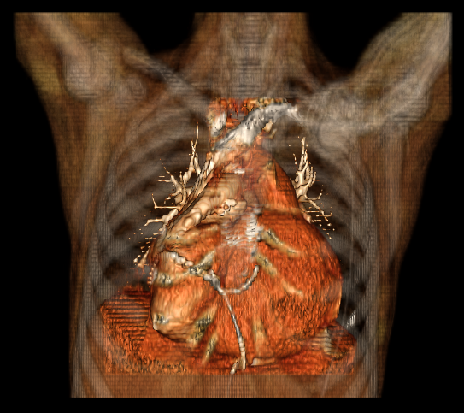 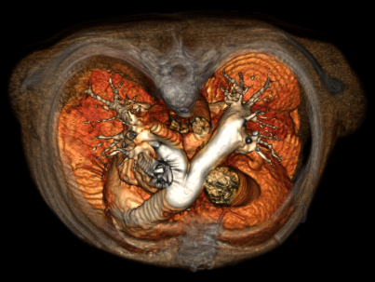
  - The patient has severe aortic insufficiency and obstruction of a left ventricle-pulmonary arterial conduit.

- Diagnosis and Treatment Plan
  - Given the complexity of cardiac lesions, Syncardia’s total artificial heart was deemed a preferred device over ventricular assist devices that would require multiple concomitant procedures.
    - Display Image of Syncardia total artificial heart system

  - Despite the unusual arrangement of ventricles and great arteries, the total artificial heart could be implanted successfully.
  - 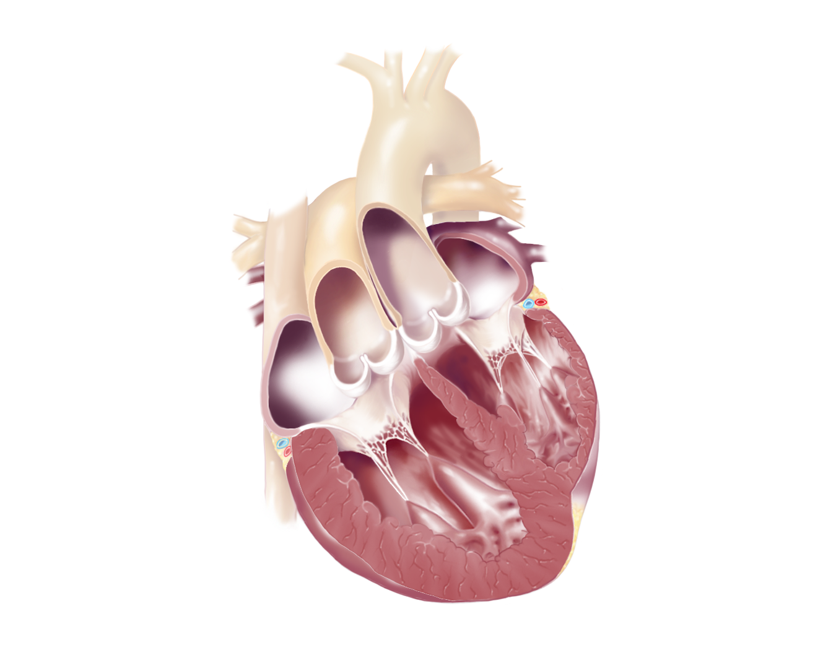
Figure 1-Panel A: Figure 2: CC-TGA anatomy
Note in normal anatomy of the adult human heart. The pulmonary artery connects to the Right Ventricle and aorta to the Left Ventricle. The model on the right shows congenitally corrected transposition of the great arteries.
- Procedure Summary
  - The procedure began with a 5th repeat median sternotomy, the heart was completely dissected out. Figure 3. 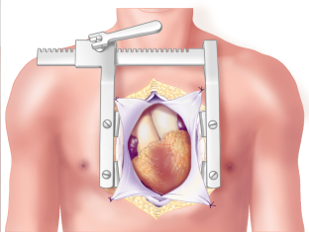

  - Cardiopulmonary bypass was established with bicaval cannulation. Cardiectomy was performed and after securing the anastamoses, the left and right pumps were separated and then attached to their respective connectors.
Figure 4:
3.3 This is the orientation of Syncardia total artificial heart in an adult heart with normal anatomy of the great vessels. Note that the LV and RV pumps are crossed as they correspond to the normal anatomy of the pulmonary artery and the aorta. Figure 1-Panel B:
  - In this patient, the PA graft was not in the normal criss-crossed orientation to the aortic graft due to the anatomical defect, the pumps were oriented parallel rather than crossed. Standard closure and post-operative review was conducted.
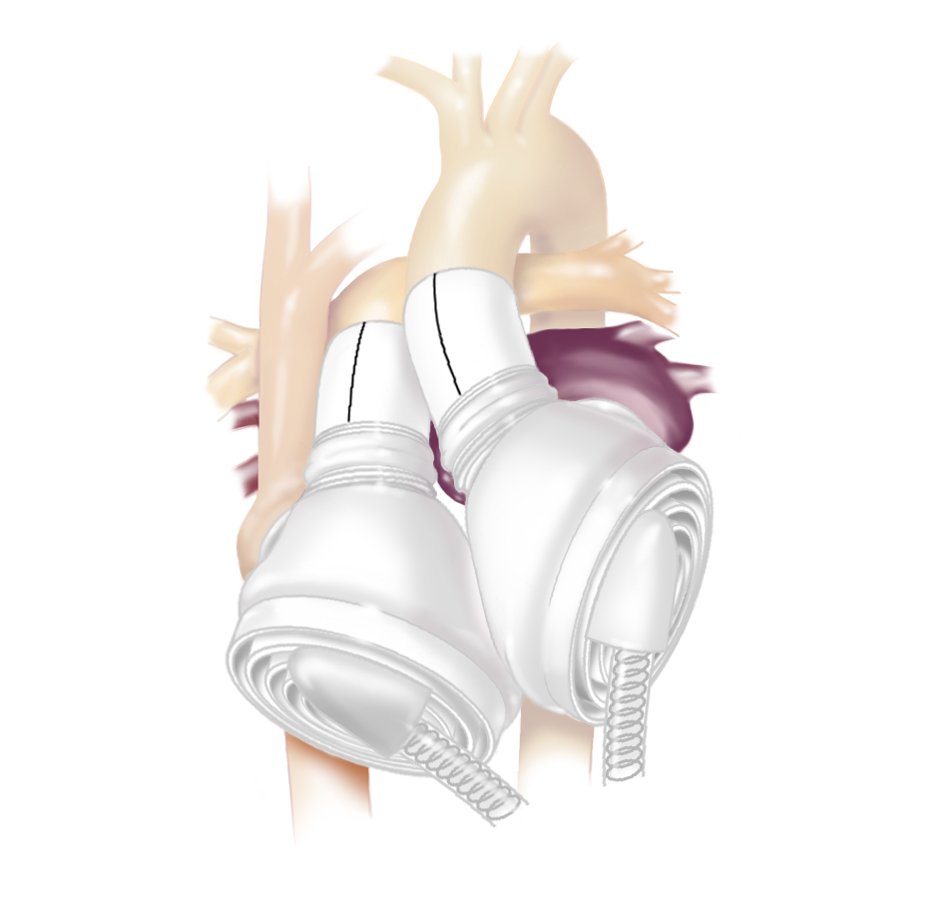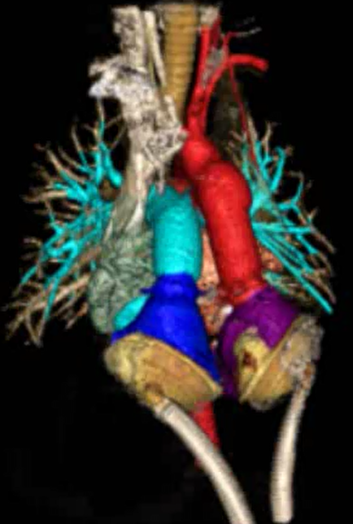
- Outcome
  - The patient tolerated the procedure well. He was discharged home with the Syncardia Freedom Driver 3 months after the device implantation. A suitable donor heart became available at 5 months and he was successfully bridged to transplantation. He is now 2 years out of transplant, in good health and is freshman with a major in bio-medical engineering.
    - Jordangoinghome_002 Video clip 2:01-2:07
    - Jordangoinghome_002 video clip 3:12-3:15

