Easy adaptable implantation method for flexible deep brain stimulating electrodes to rat brains
Authors: Anja Richter, Yijing Xie, Anett Schumacher, Susann Löffler, Jafaar Al-Hasani, Daniel H. Rapoport, Charli Kruse, Andreas Moser, Sandra Danner, Ulrich G. Hofmann*
Authors: institution(s)/affiliation(s) for each author:
Anja Richter
Graduate School for Computing in Medicine and Life Sciences, University Luebeck, Luebeck, Germany
and Fraunhofer Institution for Marine Biotechnology, Fraunhofer Society, Lübeck, Germany
anja.richter@emb.fraunhofer.de

Yijing Xie
Graduate School for Computing in Medicine and Life Sciences, University of Luebeck, Luebeck, Germany
and Institute for Signal Processing, University of Luebeck, Luebeck, Germany
xie@isip.uni-luebeck.de

Anett Schumacher
Department of Psychology, University of Toronto Scarborough, Toronto, Canada
anett.schumacher@utoronto.ca

Susann Löffler:
Department of Neurology, University of Luebeck, Luebeck, Germany
susiloeffler@googlemail.com

Jafaar Al-Hasani
Fraunhofer Institution for Marine Biotechnology, Fraunhofer Society, Lübeck, Germany
jaafar_al-hasani@gmx.de

Daniel H. Rapoport
Fraunhofer Institution for Marine Biotechnology, Fraunhofer Society, Lübeck, Germany
daniel.rapoport@emb.fraunhofer.de

Charli Kruse
Fraunhofer Institution for Marine Biotechnology, Fraunhofer Society, Lübeck, Germany charli.kruse@emb.fraunhofer.de

Andreas Moser
Department of Neurology, University of Luebeck, Luebeck, Germany
andreas.moser@neuro.uni-luebeck.de

Sandra Danner
Fraunhofer Institution for Marine Biotechnology, Fraunhofer Society, Lübeck, Germany sandra.danner@emb.fraunhofer.de

Corresponding author:
Ulrich G. Hofmann, Research Group for Neuroelectronic Systems, Department of Neurosurgery, University Medical Center Freiburg, Albert-Ludwigs-University, 79106 Freiburg, Germany, Phone: +49 4515005803, Email: hofmann@isip.uni-luebeck.de
Keywords: neuroscience, brain, implantation, flexible device, rat, deep brain stimulation
Short Abstract:
We here demonstrate an easy adaptable method for implantation of non-self-inserting, flexible electrodes to deep brain areas of rats. Some special methodical requirements were evaluated and demonstrated derived from classical stereotactic implantations that enable a precise insertion to the subthalamic nucleus (STN) with this implantation method.
Long Abstract:
Electrophysiological stimulation of diseased brain areas is an increasingly used treatment for neurological movement and affective disorders (Pizzolato and Mandat, 2012; Schlapfer and Bewernick, 2009). Associated with those relatively new treatment methods is the necessity to optimize the brain-device-interface as the clinically used rigid electrodes for deep brain stimulation (DBS) tethered to the skull provoke strong persistent shear forces upon the surrounding tissue (Biran et al., 2007; McConnell et al., 2009). The successful electrophysiological connection between implant and neural tissue consequently becomes often impaired by chronic gliosis on the implant´s surface due to this continuous irritation (Leach et al., 2010; Turner et al., 1999). To avoid this we tested flexible DBS-electrodes in rats fitting to the compliance-match-hypothesis (Hassler et al., 2011; Williams, 2008). In contrast to rigid ones, those implants are able to follow intrinsic movements of the brain in the liquor resulting from breathing, heart beat or body movements (Mercanzini et al., 2009; Rousche et al., 2001; Rubehn and Stieglitz, 2010). For testing these approx. 20 µm thick electrodes in vivo one practical question comes up immediately while planning these experiments which is: How to insert them with minimal invasive strategies? Rigid electrodes insert themselves and good protocols as well as precise equipment exist to implant them straight and stereotactic to specific brain areas but how to do that with a flexible foil strip? We developed a method that has the power to insert in our case polyimide-based, approx. 20µm thick, 350µm width and 1,5cm long electrode to the STN based upon commercial stereotactic equipment. Simple but important modifications of the standard stereotactic procedures are shown that enables us to perform meanwhile for 70 rats good stereotactic implantations over a whole distance of 8,5mm down to the STN. Exceptionally all animals showed no post-operative abnormalities in movement or behavior, no medical complications and survived the whole monitoring period up to 6 month. Thus we recommend this method for adaption and further development.
Protocol Text:
NOTE: We strongly recommend the exercising of this procedure with dead animals prior to in vivo application. A sensible feeling of the instruments and each handling step is necessary to have reproducible results.
- Preparation procedure
The preparation of the rat including disinfection, anesthesia and positioning in the stereotactic frame was performed according to the standardized stereotactic procedures.
As an insertion needle we clamped a 140µm Tungsten to the head of the stereotactic insertion arm. The length of the tungsten below the clamp head should be approx 2cm to have enough space for manipulations.
  - Skin incision and preparation of subcutaneous tissue for skull exposure
A median incision of approx 1,5 cm length starting in the neck up to the ears (approx. up to bregma) was made with an 2 ¾´´ scalpel. The subcutaneous tissue was prepared blunt with two Q-tips (walnut-sized) by vigorous but slow rubbing from the center to the periphery of the wound. This stretches the cutaneous und subcutaneous tissues and opens the operation area above the skull. It has to be performed until the necessary operation area size is rid of all tissues above the skull bone.
NOTE: A good prepared skull is indicated by a typical squeaking sound when rubbing on the bone. Test it while exercising with dead animals.
  - Stretching of the operation area
As we show later on, we need a flat operation area for successful implantation; consequently we cannot sufficiently open it with clamps or other surgical instruments. For stretching and fixation of the operation area surgical suture loops (5/0 Premilene-DS16) were drawn through the skin on the rostral end of the wound and in the middle of both wound sides, parallel to the interaural bars.
NOTE: We strongly recommend folding of the skin on the rostral end for fixation by a double penetration which is less injurious to the wound. If necessary such a loop can be used as well to fix the caudal end of the wound.
Then the loop ends can be fixed at the frame with a non-residue tape (Leukofix) under careful pulling of the wound boundaries to the periphery so that the anatomical orientation points are visible, in our case lambda and the interaural point. With that step the opening and determination of the operation area is finished.
  - Adjustment of the stereotactic frame and targeting
Prior adjusting the stereotactic frame we wash the wound area with Ringer solution and clean again the skull with Q-tips. Then the stereotactic frame was positioned so that the insertion needle is referenced to the anatomical reference points of choice.
NOTE: It is helpful to view from the top of the insertion arm in prolongation of the tungsten for precise addressing.
By a standardized calculation depending on the target area, the target coordinates are now determined according to the medial:lateral and anterior:posterior axes. The insertion head is now moved to the target point and the tungsten is lowered carefully until it touches the skull. Then the height of the skull is noticed and the target depth is calculated.
NOTE: Lifting the tungsten for movements or cleaning above the wound protects it against bending.
Then clean the wound with Ringer solution and lower again the tungsten to the target point short above the skull.
  - Trepanning the skull
For trepanning the skull we first marked the target point on the skull by careful circular scraping of the bone with a 20G needle directly under the tungsten. The implantation arm of the stereotactic frame was then screwed up maximal and flipped out of the operation area. The white bone splinters show the implantation side and the produced cavity is a perfect starting point for drilling – otherwise the skull is to slippery for precise drilling.
NOTE: This marking step and the following drilling step have to be exercised – otherwise a penetration with enormous brain tissue disruption can easily occur. We recommend fixing the marking and drilling hand by laying it on a stable ground.
Then put the driller with a small boring bit (here 0,9mm in diameter) in the marked cavity and start carefully drilling in intervals (depending upon the power of your driller). In between have a look for the depth of the hole.
NOTE: For inexperienced surgeons it might be helpful to push a blocker above the drilling tip ( spherical diamond tip of the driller). This can be easily done by slipping on an approx. 2mm height ring cut from a medical hose. The view is a bit reduced but it is easy to feel the cavity and the risk of rush through the skull and injure the brain is enormously minimal.
NOTE: When a bigger hole is needed, then open the small one with a series of drilling bits with increasing diameter, otherwise a loss of the stereotactic accuracy / centering of the hole may occur .
You feel the complete penetration by a sudden loss of resistance. Finally and very important is the washing of the trepanation side with Ringer-Solution to wash out the bone splitters.
  - Penetration of the meninges
With a look in the hole the meninges shimmered opaque. They now were penetrated by soft plucking with a 23G cannula. Therefore the tip of the cannula was carefully inserted to the hole following the bone boundary roughly in a 45° angle to the skull. By twisting the needle und pulling them out it was noticeable that an elastic resistance breaks down. When penetrating the pia mater it starts bleeding as well. This was normal and makes several washing steps necessary. The repetition of this step along the hole´s boundary was necessary until no more bleeding was visible and no more elastic resistance exists. After final washing the opaque meninges were not visible anymore.
  - Insertion of the agarose block in the operation area
As a matrix for insertion and folding of the device we used a 2 mm height block made upon 2% (w/v) low melt agarose diluted in phosphate buffered saline (PBS). The autoclaved solution was molded in a petridish with 0,2ml/cm² area to reach a height of 2 mm. After cooling sufficient pieces were cut directly at the operation desk and transferred to the operation area with a spatula. For this step one edge of the block was pushed under the anterior wound fold with close contact to the anterior wound shanks starting there. The posterior part of the gel block extends over the wound boundaries thus increasing the surface for application of the device and indirectly constitute a slope to the anterior edge. This facilitated the subsequent insertion. When the agarose block was inserted the space between it and the skull was fill with Ringer solution by peripheral injection with a cannula between the block and the skin. Eventual air bubbles were released by smooth lifting of the block at the posterior side. Finally some Ringer solution was deposited on the agarose block to half a slippery underground for device positioning.
- Insertion
- Positioning of the implant and insertion start
Now the device was put out of the sterile solution with a forceps grabbing the device´s head. No other part of it was touched to avoid foldings or disruptions. Then the device was laid on the block as precise as possible above the insertion site. A gentle correction of this position was performed after the insertion arm was flipped again above the hole and the tungsten was screwed down a few millimeters above the block. After ensuring of an optimally centered device shank position in the distal third of the device shank under the tungsten this was screwed down and pushed the device´s shank in the agarose. Now the visual control of a stable flip around the device was possible and some Ringer solution was deposited in the end of the device so that it floats on the liquid for an easier movement.
NOTE: Sometimes the tungsten is pushed to the anterior by the agarose matrix elasticity or less liquid under the device. Then it is helpful to push down the agarose blocks posterior tip carefully to counteract the forces at the other end and reposition the tungsten.
NOTE: During this procedure the device flipped tungsten seems optical to fail the hole. This is partially due to the diffraction index of the agarose. It is a matter of exercise to decide if the positioning is right or not in that case.
NOTE: In case of bleedings during the insertion the procedure should be stopped immediately so as no blood should enter the deeper regions of the brain by penetration of the device. Mostly the pia was not disrupted completely.
Now the device was inserted into the brain by continuous screwing down until approx. 2 mm of the device´s shank remains outside of the agarose block. Then a cut of the anterior part of the agarose gel directly in front of the tungsten was made with a scalpel parallel to the interaural line from one side to the other of the gel block.
- Removal of the agarose block and insertion finishing
The posterior gel block was now removed by pushing it backwards away from the tungsten. During this the device head was flipped to the tungsten and was fixed there by absolutely gentle pushing in this direction. The anterior triangle of the gel was flipped to the side out of the wound area.
NOTE: It is easier to handle the gel pieces with a sharp scalpel tip (#23) as they are too slippery for the forceps and easily pinned up by the blade.
When the agarose block is out of the operation field the insertion was finished until the target depth was reached.
- Finishing
- Mounting of the implant
To mount the implant we soaked the remaining Ringer solution and dried the skull with Q-tips. Then a small spot of medical glue was deposited minimal 5 mm posterior of the hole. The device´s head was now carefully flipped down into the glue using a sharp scalpel.
IMPORTANT NOTE: Use no forceps or other stuff for flipping the device at that point but everytime a scalpel. In case of contact with the glue, the forceps are fixed rapidly and the whole implantation is mostly lost by displacement/disruption of the device while freeing the forceps. The scalpel easily cuts itself free by gentle twisting.
Now a covering drop of glue is deposited on the first one. After its polymerization and testing the device´s fixation with the scalpel, the tungsten was removed from the brain by continuous pulling up.
Finally we cleaned the operation field by washing with Ringer-Buffer. All non-polymerized glue polymerized with this step. Then the boundaries of the glued area are controlled with a forceps. If there was fixed connective tissue into the glue the connection was quickly destroyed by grabbing this glue end with the forceps and pushing it away.
All procedures in vivo were approved by the corresponding local ethical committee.
Representative Results:
So far 70 animals were operated upon with this method and all of them behaved, moved and survived normally. Until now the longest postoperative lifetime is more than 4 months. The representative result is the successful implantation into deep brain regions with minimal tissue disruption (Fig.1).
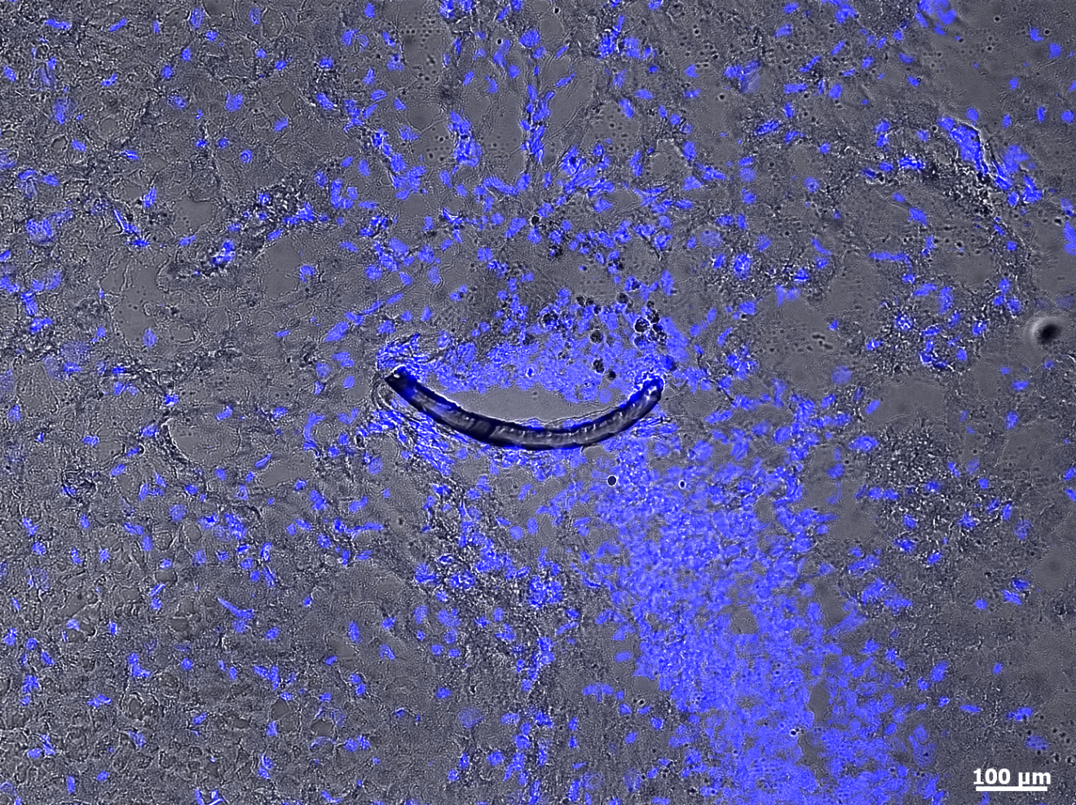
Figure 1: Implant (moon-shaped strip) in a horizontal section of subthalamic nucleus of an implanted rat 4 weeks post operation. Blue stained are nuclei with DAPI. Magnification 10x with an PlanApochromat-Objective at AxioObserver Z.1 (Carl Zeiss MicroImaging GmbH, Germany).
Discussion:
We developed this technique out of a need. There is no yet a described solution for minimal invasive insertion of a flexible device in the brain as far as we know Thus we started with the established technique for implantation of rigid electrodes and modified it to our needs. The animals implanted with this technique survived all the implantation without exception. Post operation no abnormalities of movements and/or behavior were visible. By histological examination we were able to confirm the successful positioning of the implant with less tissue disruption. For a good reproducibility and adequate need of time, in respect to the anesthesia, we strongly recommend exercising this procedure with dead animals before starting with living ones. There are several fine tuned handling steps which need a good feeling for the instruments, electrode and surgical technique. If exercising was done with two or three animals the time reduces in our experiment from 2-3 hours per operation to less than 1 hour. It has consequently a benefit for the animals’ health, when this time was shortened, because one initial anesthesia dosage (100µl/100gKetamin, 40µl/100gRompun) was sufficient for the whole operation time. The exercising also promotes a good feeling for the drilling step that contains obviously a risk for enormous tissue damaging. Similar to the most other operation techniques we hope for an evolution of this through the community by improvement of certain steps with new ideas, other experiences or existing solutions for similar handlings. This may include the positioning of the device, that needs some training and feeling for the sample. The type of insertion needle may be changed depending upon individual needs. The most optimization potential in our view has the design of the needle-electrode-connection. A better adaption of the electrode tip for anchoring the insertion needle precisely and sufficiently strong is desirable. For future experiments with recording and stimulation steps we need to develop an elegant anchoring technique of the electrode´s head above the skin. For this histological experiment we were able to demonstrate with relative simple adaption a precise implantation of these flexible electrodes to deep brain areas of rats. This technique may be applicable as well for minimal invasive delivery of other flexible implants to other parts of the body, e.g. in the field of hand or eye surgery.
Acknowledgments: We acknowledge for funding the Graduate School for Computing in Medicine and Life Sciences funded by Germany’s Excellence Initiative [DFG GSC 235/1]. This study was additionally funded by the German Research Ministry project „BiCIRTS“-13N9190, grants of the European Union (European Fund for regional development (EFRE)) and by the Business Development and Technology Transfer Corporation of Schleswig-Holstein (WTSH).
Disclosures: The authors have nothing to disclose.
Table of specific reagents and equipment:
Name of the reagent | Company | Catalogue number
Surgical disposable scalpel 2¾´´ #21 | Braun Aesculap AG | 5518075
Surgical disposable scalpel #23 | Braun Aesculap AG | 5518016
Q-tips, walnut-size | Henry Schein Medical GmbH | 9003187
5/0 Premilene-DS16 | Braun Aesculap AG | 2090212
Leukofix fixing tape | Henry Schein Medical GmbH | 220-544
Tungston Rod 0.008x4 inch | A-M Systems, Inc. | 7166
Loctite 4061 rapid glue | Henkel Loctite GmbH | 26085
0.9 mm drill bit | FineScienceTool, U.S.A. | 19007-09
Rechargeable Cordless Micro Drill | Stoelting Co., U.S.A. | 58610
Small Animal Stereotaxic Instrument | David Kopf Instruments, U.S.A. | Model 900

Statement of contributions:
The insertion process for all animals, histochemical staining, paper conception and writing was done by Anja Richter. The previous evaluation of the technique by Anja Richter was performed with technical ideas of Ulrich G. Hofmann, Daniel H. Rapoport, Sandra Danner and Charli Kruse at the Fraunhofer EMB. At the same institution the video (Jafaar Al-Hasani) and sound recording (Daniel H. Rapoport) was done. All animal experiments were carried out in the University of Luebeck under supervision of Ulrich G. Hofmann and Andreas Moser. In the experimental realization participated Yijing Xie, Anett Schumacher and Susann Löffler.

References:

Biran, R., Martin, D.C., and Tresco, P.A. (2007). The brain tissue response to implanted
silicon microelectrode arrays is increased when the device is tethered to the skull. J Biomed Mater Res A 82, 169-178.
Hassler, C., Boretius, T., and Stieglitz, T. (2011). Polymers for neural implants. Journal of Polymer Science Part B: Polymer Physics 49, 18-33.
Leach, J.B., Achyuta, A.K., and Murthy, S.K. (2010). Bridging the Divide between Neuroprosthetic Design, Tissue Engineering and Neurobiology. Front Neuroeng 2, 18.
McConnell, G.C., Rees, H.D., Levey, A.I., Gutekunst, C.A., Gross, R.E., and Bellamkonda, R.V. (2009). Implanted neural electrodes cause chronic, local inflammation that is correlated with local neurodegeneration. J Neural Eng 6, 056003.
Mercanzini, A., Colin, P., Bensadoun, J.C., Bertsch, A., and Renaud, P. (2009). In vivo electrical impedance spectroscopy of tissue reaction to microelectrode arrays. IEEE Trans Biomed Eng 56, 1909-1918.
Pizzolato, G., and Mandat, T. (2012). Deep brain stimulation for movement disorders. Front Integr Neurosci 6, 2.
Rousche, P.J., Pellinen, D.S., Pivin, D.P., Jr., Williams, J.C., Vetter, R.J., and Kipke, D.R. (2001). Flexible polyimide-based intracortical electrode arrays with bioactive capability. IEEE Trans Biomed Eng 48, 361-371.
Rubehn, B., and Stieglitz, T. (2010). In vitro evaluation of the long-term stability of polyimide as a material for neural implants. Biomaterials 31, 3449-3458.
Schlapfer, T.E., and Bewernick, B.H. (2009). Deep brain stimulation for psychiatric disorders--state of the art. Adv Tech Stand Neurosurg 34, 37-57.
Turner, J.N., Shain, W., Szarowski, D.H., Andersen, M., Martins, S., Isaacson, M., and Craighead, H. (1999). Cerebral astrocyte response to micromachined silicon implants. Exp Neurol 156, 33-49.
Williams, D.F. (2008). On the mechanisms of biocompatibility. Biomaterials 29, 2941-2953.

