Categorical perception and neuroimaging of physical and category change along the Uncanny Valley Hypothesis’ dimension of human likeness.
Marcus Cheetham* and Lutz Jäncke
Department of Neuropsychology, University of Zürich, Zürich, Switzerland

m.cheetham@psychologie.uzh.ch
l.jaencke@psychologie.uzh.ch

Correspondence to: Marcus Cheetham, Department of Neuropsychology, University of Zurich, Binzmühlestrasse 14/Box 25, CH-8050 Zürich, Switzerland. e-mail: m.cheetham@psychologie.uzh.ch

Keywords: uncanny valley, fMRI, categorical perception, virtual reality, avatar, human likeness, Mori
Short Abstract: Investigation of the Uncanny Valley Hypothesis and affective experience requires an understanding of the hypothesis' dimension of human likeness (DOH). This protocol allows representation of the DOH and examination of categorical perception. Use of the same stimuli to distinguish with fMRI brain regions responsive to physical and category change is illustrated.
Long Abstract: Mori's Uncanny Valley Hypothesis^{1,2} proposes that the perception of humanlike characters such as robots and, by extension, avatars (computer-generated characters) can evoke negative or positive affect (valence) depending on the object's degree of visual and behavioral realism along a dimension of human likeness (DOH) (Fig. 1). But studies of affective valence of subjective responses to variously realistic non-human characters have produced inconsistent findings, e.g. ^{3,} ^{4,} ^{5,} ⁶. One of a number of reasons for this is that human likeness is not perceived as the hypothesis assumes. While the DOH can be defined following Mori's description as a smooth linear change in the degree of physical humanlike similarity, subjective perception of objects along the DOH can be understood in terms of the psychological effects of categorical perception (CP) ⁷. Further behavioral and neuroimaging investigations of category processing and CP along the DOH and of the potential influence of the dimension’s underlying category structure on affective experience are needed. This protocol allows examination of CP along the DOH. For this, issues surrounding the use to-date in "uncanny" research of stimuli drawn from morph continua to represent the DOH are discussed. The application in neuroimaging of such morph stimuli to represent the DOH or aspects of it in order to disentangle brain regions neurally responsive to physical humanlike similarity from those responsive to category change and category processing is briefly illustrated.

- Place Figure 1 here -
Protocol
Stimuli, experimental conditions, and tasks
1 Forced choice classification task
Stimuli
1.1. Use avatar and human images as endpoints in the morphing procedure to produce linear morph continua to represent the DOH. We generated 32 continua using Funmorph 3.3 (Zealsoft Inc., Eden Prairie, MN), but other morphing software may also be used. Generate avatars using the modeling suite Poser 7 (Smith Micro Software, www.smithmicro.com), though other software is available.
1.2 Ensure potential confounds are not introduced into the morphing procedure. For example, we used as endpoints of each continuum images of unknown indistinctive male faces with neutral expression, direct gaze and no other salient features such as facial hair or jewellery, and the endpoint images were closely matched for age, configural cues and general facial geometry.
1.3 Use photo editing software to crop external features by using for example a black overlay in elliptic form; we used Adobe® Photoshop® CS3 (www.adobe.com). Before morphing, adjust the position of the images to ensure alignment between the endpoint images of configural cues, and adjust contrast levels, overall brightness and skin tone of each pair of endpoint stimuli of each continuum to match.
1.4 Each morph of a DOH continuum represents a difference in physical humanlike similarity at predefined increments. We generated 13 different morphed images and labeled these M0 to M12, that is, the two endpoints and 11 intermediate morphs (see Fig. 2B).
1.5 Use a two-alternative forced-choice classification task to determine which of these morphs are clearly categorized as avatars and as human and to define the position of the category boundary (see, e.g. ⁸).
1.6 Present trails beginning with a fixation point for 500ms (participants are required to maintain fixation) followed by a morph image for 750ms. We used Presentation® software (Version 14.1, www.neurobs.com) for stimulus presentation in all tasks in this protocol, but other stimulus presentation platforms may also be used.
1.7 Instruct the participant to identify the presented morph stimulus as either an avatar or human as quickly and precisely as possible by pressing one of two response keys.
Data Analysis
1.8 Summarize the avatar-human classification data using polynomial regression to describe the shape of the response function. Determine this by fitting logistic function models to the response data of each participant and continuum. First, analyze the individual continua across participants to ensure best fit of logistic functions. Then, test against zero in a one-sample t-test for a step-like shape in the avatar-human category response function across all continua using the parameter estimates derived from the logistic function of each continuum, averaged across participants. Estimate the position of the category boundary along each continuum by submitting the parameter estimates of the logistic function of each continuum to a logit transformation⁹. All analyses for the forced choice classification and the perceptual discrimination tasks were performed using SPSS Version 16 (www.ibm.com/software/analytics/spss)
- Place Figure 2 here -

2 Perceptual discrimination task
2.1 For this version of the same-different perceptual discrimination task (e.g. ¹⁰), select from each morph continuum two morphs categorized in the preceding classification task as avatars (e.g., M0 and M4) and two as human (e.g., M8 and M12). To control for physical differences between morphs, select morphs that represent equivalent increments of physical change along each continuum. We used increments of 33.33% (i.e. M0, M4, M8, M12) (see Fig. 2B).
- Place Figure 3 here -
2.2 Sort the selected morphs into pairs according to the three experimental morph-pair conditions (see Fig. 3): "same" (the morphs of a pair are identical representing no physical or category change), "within" (the morphs of a pair are drawn from within a category), and "between" (the morphs of a pair represent different categories).
2.3 To investigate discrimination performance between the morphs of the morph pairs in relation to the avatar category (here, each of these morph pairs are thus termed "avatar trails"), ensure that the first morph of each morph pair in the three conditions is always M4 (from the avatar category) (see Fig. 3A), resulting in morph pairs M4 - M4 for the "same", M4 - M0 for the "within" and M4 - M8 for the "between" conditions. The same procedure can be applied for morph pairs in relation to the human category (thus termed "human trails"), ensuring that the first morph is always M8: "same" (M8 – M8), "within" (M8 – M12), and "between" (M8 – M4) (see Fig. 3B).
2.4 Always ensure that both morphs of a morph pair are drawn from the same continuum in which they were originally morphed. Pseudo-randomize presentation of morph pairs so that no pairs from within the same continuum are shown in close sequence. Presentation of avatar or human trials from a given continuum is random but counterbalanced across all participants to ensure that each participant views either avatar or human trials from any given continuum but not both, and that an equal number of avatar or human trials are viewed.
2.5 Present a fixation cross for 500ms (participants are required to maintain fixation) followed by each face of a face pair for 500ms with an inter stimulus interval (ISI) of 300ms between the faces of a pair. We also used an ISI of 75 ms to verify whether different durations ISI would differentially influence discrimination performance. Present a variable inter-trial interval between trials of morph pairs: we used an interval averaging 2,500 ms.
2.6 Instruct participants to view each trail comprising a morph pair, the morphs being presented successively in the trial, and to indicate by button press as quickly and precisely as possible whether the faces of each face pair are the 'same' or 'different' in appearance.
Data Analysis
2.7 Discrimination accuracy is analysed for face pairs that cross the category boundary compared with face pairs from the same side of the boundary. For this, the 'different' responses (indicating that both faces of a pair are of different physical appearance) are computed as proportions of the total number of morph face pairs and subjected to a one factorial ANOVA, with the 3 face-pair trial types (within, between, same). The data for avatar trials and human trails are treated separately in analysis.
3 fMRI task
3.1 The stimulus conditions, i.e. the morph stimuli for the face pairs in the within, same and between conditions in the avatar and human trails, are the same as described in the preceding perceptual discrimination task.
3.2 Use a target monitoring task to examine implicit processing of physical and category-related change along the DOH while maintaining participants' attention to the stimuli of interest.
3.4 Instruct participants to press a response button upon detection of an up-turned rare target. We presented 15% of all morph pairs as targets. Use as targets one of four possible morphs (M0, M4, M8, or M12) selected at random from a morph continuum not used for stimulus presentation otherwise. Ensure that the up-turned target morph is presented as the first or second morph of a morph pair to avoid differential attention during monitoring for targets to the first or second morph of the morph pairs.
3.3 Each scanning session consists of two experimental runs of stimulus presentation counterbalanced in order across participants. The break between runs allows the participants a brief rest. Participants fixate a cross at the beginning of each run to establish a steady state in the MR signal.

Preparing the Subject for the Scan

3.4 All participants provide written informed consent before the experimental protocol is conducted. The protocol, all procedures and consent forms are approved by the local Ethics Committee. Avoid confounds in the lateralization of brain activations by scanning right-handed participants. Control for the potential impact of previous experience with avatars.

3.5 Before scanning, participants are familiarized with the laboratory, informed about the scanning procedures, given clear instructions as to the target monitoring task, total scanning time and how to alert staff if required.

3.6 For scanning, the participant lies supine on the scanning table. Head cushions are used to ensure comfort and minimize head movement during scanning. Participants are given earplugs and headphones to reduce the impact of scanner noise and to enable communication with the experimenter.

3.7 The participants' right hand is positioned over the response panel for the target monitoring task. The left hand is placed next to the emergency stop button should the participant want to stop scanning.

3.8 The visual stimuli may be presented on a projection screen placed in front or at the rear of the MRI scanner. We used an MRI-compatible head-mounted display ("VisuaStim – Digital", Resonance Technology Inc.). This has the advantage of excluding from sight all visual input other than the intended stimuli.

3.9 Before commencing data collection, ensure that stimulus presentation, the response panel and the emergency stop button are operating properly.

Data Recording and Processing

3.10 Scanning Parameters

We aquired structural and functional images of the entire brain using a 3-T whole-body MR unit (Philips Medical Systems, Best, The Netherlands). Structural images were registered using a T1-weighted 3D, spoiled gradient echo pulse sequence (180 slices, TR = 20 ms, TE = 2.3 ms, flip angle = 20°, FOV = 220 mm × 220 mm × 135 mm, matrix size = 224 × 187, voxel size = 0.98 mm × 1.18 mm × 0.75 mm, resliced to 0.86 mm × 0.86 mm × 0.75 mm). Functional images were acquired from 225 whole-head scans per run using a single-shot echo planar sequence (repetition time, TR = 2.6 s; echo time, TE = 35 ms; field of view = 220 mm × 220 mm × 132 mm; flip angle = 78°; matrix size = 80 × 80; voxel size = 2.75 mm ×2.75 mm × 4 mm, resliced to 1.72 mm × 1.72 mm × 4 mm).

Data Analysis

3.11 We used MATLAB 2006b (Mathworks Inc., Natick, MA, USA) and the SPM5 software package (http://fil.ion.ucl.ac.uk/spm) for preprocessing and MRI data analysis. Preprocessing typically entails alignment of images to the first recorded volume, motion correction, normalization into standard stereotactical space, and smoothing (e.g. 6 mm³ Kernel).

3.12 The fMRI data analysis makes use of a phenomenon referred to as repetition suppression (RS) (e.g. ^{11,} ^{13,} ¹⁴, for reviews see, ^{15,} ¹⁶). Considered in the context of the DOH, the morphs of a morph pair are presented in rapid succession. Repetition in the second morph of the stimulus or stimulus attributes presented in the first morph results in a decrease in activation (i.e. RS) in brain region's sensitive to that specific stimulus or its attributes (e.g. physical or category-related attributes). In this protocol, repetition of the stimulus or stimulus attributes between the first and second morph is manipulated in the "within", "between", and "same" conditions in terms of similarity or dissimilarity of physical and category-related attributes of the DOH. By contrasting these conditions, the fMRI data analysis identifies brain regions engaged in processing a particular stimulus or physical or category-related stimulus attribute on the basis of the extent of relative differences in signal decrease following stimulus repetition (e.g. ^{17,} ^{18,} ^{19,} ²⁰).
3.13 Identify brain regions responsive to physical and to category-related change along the DOH using the following contrast of the stimulus conditions (within, between, and same). These contrasts are defined here in terms of the morph used as the second face in the three face-pair conditions (note that the first morph is the same in the avatar and human trails, respectively). To detect sensitivity to physical change for the avatar trails, use the contrast M0 plus M8 > M4, and use M12 plus M4 > M8 for the human trials. To detect brain regions selectively responsive to category change across the boundary in the direction avatar to human (i.e. avatar trails), use the contrast M8 > M4 plus M0. For the direction human to avatar, use the contrast M4 > M8 plus M12.
3.14 For individual level analyses, the fMRI responses of each subject to the second morph of each morph pair in each of the six morph pair conditions (i.e. within, same, and between for avatar and human trials) may therefore be used to contrast brain activity between these conditions. These individual contrasts are then entered into group level analyses for inferential purposes.

2. Representative Results
2.1 Forced choice classification task
The data analyses confirm that the slope of the fitted regression curve of each individual continuum and across all continua has a logistic profile. This slope reflects a sigmoid step-like function consistent with the presence along the DOH of a categorical component in the responses of the participants to the morph faces of the continua. The slope of the curve (see Fig. 2 A) is thus characterized by lower and upper asymptotes of avatar or human categorization responses which approach 100% for avatars and 100% for humans. In contrast, the estimate of the mean category boundary value derived from the fitted logistic curve and the ordinate midpoint between the lower and upper asymptotes of the categorization responses indicates that the maximum uncertainty of 50% in categorization judgments is associated with the morph M6.

Taken together, the categorization response data thus confirm that the first criterion for the presence of CP is fulfilled, namely that there is a category boundary (for all criteria, see e.g. ¹¹).

2.2 Perceptual discrimination task

Using the example of the avatar trials (see Fig. 4), the data analyses show that there is enhanced discrimination accuracy for face pairs that cross the category boundary in the between condition compared with attenuated discrimination accuracy for face pairs in the within condition, this being consistent with the CP. The data also show that there is a significant difference in discrimination accuracy within the category in that there is greater discrimination accuracy for face pairs in the within condition than in the same condition. The variation in ISI of 75 and 300ms differentially affected participants' responses, but not in the human trails.

- Place Figure 4 here -

The categorization response data thus confirm the second criterion for the presence of CP in that there is better discrimination accuracy for pairs that cross the category boundary than for equidistant pairs drawn from within a category. This demonstrates that there is a so-called discrimination boundary at which there is enhanced sensitivity for the physical stimulus features close to the category boundary.

This variant of the perceptual discrimination task does not define the specific point of the discrimination boundary along the DOH. A much smaller morph distance between pairs of presented morphs could be used to resolve this. Here we show an example using a traditional ABX discrimination task ^{12,} ¹³. ABX discrimination entails sequential presentation of different face stimuli (Morph A and Morph B) followed by a second presentation of either A or B as the target stimulus X. After viewing images A, B and X, participants are required to indicate whether A or B is identical to X. In this example, a 2-step discrimination procedure between morphs (i.e., 1-3, 2-4, 3-5, etc.) is presented (see Fig.5B). Analyses are described in e.g. ⁸. Thus, as an example, the ABX discrimination task was performed on 24 participants using 4 morph continua, each with 11 morphs, using endpoint stimuli drawn from the study of Cheetham et al ⁷. Following the ABX discrimination task, a forced choice categorisation task was performed with the same participants. This sequence of task presentation is thought to minimise the influence of explicit category decision making on the ABX discrimination task (for the preceding forced choice categorisation and discrimination tasks, different participants were recruited). Figure 5B indicates clearly that there is a peak in perceptual discrimination sensitivity at the morph position predicted by and aligned with the category boundary (see Fig. 5A). Using the 2-step distance between morphs, the peak in discrimination performance can be clearly identified in the interval between morph pair M5-M7.

- Place Figure 5 here -

The ABX discrimination task can thus be used, in addition to the first discrimination task, to confirm that the third criterion for the presence of CP in showing that the discrimination boundary is aligned with the category boundary. In other words, the position of the category boundary predicts the position of the discrimination boundary.

The fourth criterion, which is not always applied in studies of CP (see, ^{14,13}) is that discrimination is at chance within the categories. These data indicate that discrimination is slightly above chance for those morphs located between the continua endpoints and the category boundary.

2.3 fMRI task
By comparing the condition in which there is a category change between the first and second morph of a morph pair with the conditions in which there is no such change, a brain region in the fusiform gyrus (see Fig. 6A) is shown to be sensitive to the presentation of fine-grained change along the DOH in the physical appearance of face morphs in the avatar trails. A similar result for human trials is not shown here. Together with the human trials, this finding is consistent with the reported response of areas in the to differences in facial physical attributes ²³, facial geometry ^{21,} ¹⁶ (see also ²⁴) and facial texture ²¹. Figure 6B shows, using the example of avatar trials, brain regions sensitive to category change along the DOH by comparing the conditions in which there is a physical change between the first and second morph with the condition in which there is no such change. The imaging data show that category change in avatar trails (i.e. a change from avatar-to-human direction along the DOH) revealed responsiveness of the hippocampus, amygdala, and insula. The category change in human trails (i.e. a change in the human-to-avatar direction along the DOH) revealed that the putamen, head of caudate, thalamus, and red nucleus are responsive to this condition. At a broad level, this pattern of differences between the avatar and human trials suggests that avatar and human faces represent different categorization problems, and that this likely relates to the degree of previous categorization experience with a given category (e.g. ²⁵); the participants are expert in human face processing but were especially selected on the basis that they report no explicit knowledge of previous experience with avatar faces (e.g. in video games, movies, second life) and, as confirmed at debriefing, had never seen faces of the kind we presented.
- Place Figure 6 here -
5. Discussion

The core prediction of the uncanny valley hypothesis is that positively or negatively valenced experience can be evoked as a function of perceived human likeness. Careful consideration of how the DOH is represented is thus critical for experiments in uncanny research. One approach is to represent human likeness using morph continua, as already implemented in "uncanny" research (e.g. ^{5,} ^{6, 26,} ^{27,} ²⁸). The advantage of morph continua is that they permit experimentally controlled fine-grained differences in humanlike appearance to be brought into relationship with behavioural measures of subjective perception and experience (e.g. category decisions, uncanny feelings) and with underlying neural processes ⁷. This fine-grained approach is particularly important because the hypothesis does not predict the actual degree of human likeness at which the transition between positively valenced and uncanny experience should occur.
To be able to interpret the investigated relationship between the DOH, as represented using morph continua, and other variables of interest, a single morph continuum (cf. ²⁹) rather than two or even three different juxtaposed continua should be used (^{5,28}). The juxtaposed continua fail to represent and in effect alter Mori's concept of human likeness by introducing discontinuities to the DOH. Furthermore, all morphs should be carefully controlled so that equivalent increments of physical change are represented along the entire continuum (^{5,28}). The latter is especially important in this protocol because experimental control of morph distance along the continua enables examination of whether sensory information relating to linear differences in human-like similarity along the DOH is cognitively represented in a nonlinear way. This nonlinearity is reflected in the step-like function in the slope of the categorization responses (see Fig. 2.A and Fig. 5A) and in differences in sensitivity to stimulus attributes along the DOH (see Fig. 4 and 5.B). Further studies of CP could examine for example how specific features such as eye realism compared with the realism of other facial features or manipulations of facial geometry compared with facial texture (cf. ³⁰) differentially influence category processing along the DOH. Use of stimuli drawn from morph continua representing fine-grained differences in human likeness and the methods shown in this protocol might be particularly valuable in seeking to better define the actual degree of human likeness at which uncanny experience is most likely to be experienced. The findings relating to CP along the DOH suggest that this is most likely to be at the category boundary where perceptual decision ambiguity is greatest.

The morphing procedure enables smooth blending together of corresponding features of the continuum's endpoints such as facial configural cues. Difficulty in morphing facial information like upper facial features and hair profile (²⁶) can potentially bias participant’s responses by drawing attention to disparities in the alignment of features during the morphing procedure. This bias is likely to be systematic in that morphing disparities are related to the morph distance from the continua endpoints, the disparities being greatest at the midpoint of morph continua. For our morph continua, the midpoint of the continua corresponds with the category boundary at which there is greatest perceptual sensitivity. Reanalysis of data from one of our pilot studies (a forced choice categorisation task) compared continua in which the eye region was either well or poorly morphed (poor morphing resulted in a very slight inconsistency in the alignment of eye texture between morphs). The reanalysis confirmed a systematic bias in the categorisation decision responses of the poorly morphed continua such that poor morphing effectively caused a relative shift of the category boundary toward the human end of the dimension. This was presumably because the morphing disparity was perceived as a “nonhuman-defining” feature.

A response bias might result also from using continua generated on the basis of endpoint stimuli in which non-facial information such as head attire and facial jewellery are only present in one stimulus (²⁷). In these cases, facial images could be cropped so that participants attend to the stimulus information of research interest rather than to other salient features presented in an image. A systematic response bias can result also from using an image as a continuum endpoint in which nonhuman attributes are presented together with human attributes, even though this image is intended to represent the human end of the DOH (⁶). In this case, any relationship between humanlikeness and variables such as subjective measures of uncanny experience are not interpretable in terms of Mori's conception of the DOH and of the hypothesized uncanny valley.

CP can occur along dimensions other than human likeness (e.g. ^{31,} ^{10, 22,} ^{32,} ^{33,} ^{34,} ³⁵), and category-relevant information can be automatically processed upon exposure to others (³⁶). In this protocol, care should be taken therefore to control for the effects of visual cues indicating differences along the DOH in terms of other category-relevant dimensions on participants' responses concerning human likeness. These cues might for example relate to ethnicity, gender, facial distinctiveness, familiarity and identity, and facial expression (cf. ^{26,} ^{27,} ^{5,} ²⁸). The present protocol seeks to minimize perception of biological motion between face morphs presented in rapid succession in the perceptual discrimination task and fMRI study by closely matching the facial geometry and configuration of facial features of images used as continuum endpoints. This approach (together with the relative position along the continua of morphs used in the stimulus conditions) helps also to minimize any perception of different identities between morphs of a continuum.

The forced choice classification task in this protocol determines which morphs of a continuum are clearly categorized as an avatar and as human in order to select morphs for use in the perceptual discrimination task and the fMRI study. We selected the four morphs M0, M4, M8 and M12 from each of the continua (see Fig. 2B and 2C). In addition to controlling for the degree of physical change along the DOH, the choice of M4 and M8 in this protocol is based on the following theoretical consideration. Mori described perceptual uncertainty (and associated uncanny experience) as occurring at levels of realism that correspond to the region along the DOH between the two positive peaks in the slope of the valence-human likeness relationship (see Fig. 1). At these peaks, objects are regarded as either nonhuman or human. In reframing his considerations in terms of the framework of CP, these peaks may be seen as reflecting degrees of human likeness at which correctly classified category instances (i.e. nonhuman and human) straddle the category boundary. But Mori did not specify how efficient this classification (i.e. perceptual certainty) must be at these peaks, though the identification of objects at each peak is clearly considered to be relatively efficient and effortless. For this reason, the two morph positions along the continua considered as defining the transition between the two categories and to reflect the two positive peaks was determined using a more conservative criterion than often otherwise used in CP research (e.g., 66%, as in ^{32,} ³⁴). Thus, morph M4 was identified on average as an avatar in more than 85% of trials and morph M8 as a human in more than 85% of trials. Please note that this criterion applies to both morphs of any one continuum. Using this approach, this choice of morphs seeks to capture a sense of category change along the DOH between nonhuman and human objects in accordance with both Mori’s description and an understanding of CP.

It should be pointed out that Mori’s hypothesis does not consider the possibility that physical features might actually vary along the DOH within the human category, as since shown in the study of Cheetham et al. (⁷) (see Fig. 2). For this reason, the second positive peak in the hypothesis’ original valence-human likeness relationship is located at the end of the DOH (see Fig. 1). The emphasis on the nonhuman aspect of the DOH has been influential in studies guided by the hypothesis, including studies that have not used morph continua (e.g. ^{4,} ³⁷), while other studies have used a single human face to represent the human aspect of the DOH (e.g. ³). Such studies have sought to examine uncanny experience, with unclear results. The findings relating to CP suggest that these studies may not have presented the stimuli needed to evoke implicit or explicit processes of perceptual decision making and processes of conflict resolution in response to category ambiguity along the DOH.

This protocol uses a variant of the same-different discrimination task (e.g. ¹⁰) to determine CP. For our continua, this task reveals enhanced discriminative sensitivity for stimuli that straddle the category boundary. In other words, the ability to distinguish physical features of facial stimuli varies as a function of perceived human likeness along the DOH. The choice of morphs for this particular discrimination task is based in this protocol on the preceding theoretical considerations, and this choice results in a task that requires discrimination between morphs that are four steps apart along the continuum (i.e. a four-step discrimination, see Fig. 2B). But this four-step degree of dissimilarity between morphs is too large to allow better specification of the actual morph position at which discrimination is most enhanced (i.e. the discrimination boundary) (see Fig. 5B). An important criterion for CP (for the other criteria, see e.g. ¹¹) is that there is alignment between the category boundary in the forced choice task and the discrimination boundary in the discrimination task. In other words, the morph position of the category boundary should predict the morph position of the discrimination boundary. One approach to verifying the specific point of alignment would be to use a discrimination task in which the morph distance between pairs of morphs is reduced. Figure 5B shows results of data using, as a possible alternative to the same-different discrimination task, a traditional ABX discrimination task (^{12,} ¹³). The figure indicates clearly that there is a peak in perceptual discrimination sensitivity at the morph position predicted by the category boundary. Such results in a study with a larger number of participants would further verify the finding of effects of CP along the DOH. The actual choice of stimuli for the continua endpoints, the number of morphs generated in a continuum, and the size of the step in morphs to be discriminated will strongly influence the cognitive demands placed on the participant and his or her ability to discriminate morphs along the continua.
This protocol illustrates an example of how morphs drawn from continua representing the DOH can be used to identify, with fMRI and using the effect of repetition suppression, brain regions sensitive to change in physical humanlike similarity and to change in category-related information. The effectiveness of the fMRI design is influenced strongly by careful generation and selection of the morph stimuli. The forced choice and perceptual discrimination tasks were thus used to ensure comparability between continua in the shape of the avatar–human classification curves (i.e. slope of the response function) and in discrimination performance. The advantage of this fMRI design is that it allows the stimulus conditions described by Mori (i.e. passive observation of novel non-human objects that are subtly different in physical appearance from that of their human counterpart) to be simulated within the constraints of fMRI methodology, using stimuli selected according to the hypothesis' definition of human likeness, and investigation of effects of category processing while controlling for effects of physical change along the DOH. Variations of this fMRI design could be applied to investigate other aspects of category processing and affective experience associated for example with the category boundary itself. This would be an important step toward examining in the brain the effects of category processing and category ambiguity in association with affective experience for stimuli drawn from the DOH.
6. Materials

Funmorph (Zealsoft Inc., Eden Prairie, MN)
Poser 7 (Smith Micro Software, www.smithmicro.com)
Adobe® Photoshop® CS3 (www.adobe.com)
Presentation® software (Version 14.1, www.neurobs.com)
SPSS Version 16 (www.ibm.com/software/analytics/spss)
MRI-compatible head-mounted display ("VisuaStim – Digital", Resonance Technology Inc.)
3-T whole-body MR unit (Philips Medical Systems, Best, The Netherlands)
MATLAB 2006b (Mathworks Inc., Natick, Massachusetts, USA)
SPM5 software package (http://fil.ion.ucl.ac.uk/spm)

7. Disclosures

No conflicts of interest declared.

8. Acknowledgements

This work is based on research supported by the European Union FET Integrated Project PRESENCCIA (Contract number 27731).

9. References

1. Mori, M. Bukimi no tani [The uncanny valley]. Energy 7, 33-35 (1970).
2. MacDorman, K. “Androids as an Experimental Apparatus: Why is There an Uncanny Valley and Can We Exploit it?”. Toward Social Mechanisms of Android Science: A CogSci 2005 Workshop 106–118 (2005).
3. Tinwell, A., Grimshaw, M., and Williams, A. The Uncanny Wall. International Journal of Arts and Technology 4, 326-341 (2011).
4. Tinwell, A. Uncanny as usability obstacle. HCI 12, 622-631 (2009).
5. MacDorman, K. F., and Ishiguro, H. “The uncanny advantage of using androids in cognitive and social science research”. Interaction Studies 7, 297-337 (2006).
6. Hanson, D., Olney, A., Prillman, S., Mathews, E., Zielke, M., Hammons, D., Fernandez, R., and Stephanou, H. E. Upending the Uncanny Valley. 20th National Conf. on Artificial Intelligence and the 17th Innovative Applications of Artificial Intelligence Conf 1728-1729 (2005).
7. Cheetham, M., Suter, P., and Jancke, L. The human likeness dimension of the "uncanny valley hypothesis": behavioral and functional MRI findings. Front Hum Neurosci 5, 126 (2011).
8. Campbell, R., Pascalis, O., Coleman, M., Wallace, S. B., and Benson, P. J. Are faces of different species perceived categorically by human observers? Proc Biol Sci 264, 1429-1434 (1997).
9. Finney, D. J. Probit analysis. (1964).
10. Angeli, A., Davidoff, J., and Valentine, T. Face familiarity, distinctiveness, and categorical perception. Q J Exp Psychol (Hove) 61, 690-707 (2008).
11. Studdert-Kennedy, M., Liberman, A. M., Harris, K. S., and Cooper, F. S. Theoretical notes. Motor theory of speech perception: a reply to Lane's critical review. Psychol Rev 77, 234-249 (1970).
12. Liberman, A. M., Hariris, K. S., Hoffman, H. S., and Griffith, B. C. The discrimination of speech sounds within and across phoneme boundaries. J Exp Psychol 54, 358-368 (1957).
13. Harnad, S. R.. Introduction: Psychological and cognitive aspects of categorical perception: A critical overview. In Categorical perception: The groundwork of cognition, Harnad, S. R., ed. (New York: Cambridge University Press. Haruno & Kawato), pp. 1-25 (1987).
14. Repp, B. H. Categorical perception: Issues, methods, findings. Speech Lang Adv Basic Res Pract 10, 243–335 (1984).
15. Grill-Spector, K., Henson, R., and Martin, A. Repetition and the brain: neural models of stimulus-specific effects. Trends Cogn Sci 10, 14-23 (2006).
16. Jiang, X., Rosen, E., Zeffiro, T., Vanmeter, J., Blanz, V., and Riesenhuber, M. Evaluation of a shape-based model of human face discrimination using FMRI and behavioral techniques. Neuron 50, 159-172 (2006).
17. Henson, R. N. Neuroimaging studies of priming. Prog Neurobiol 70, 53-81 (2003).
18. Grill-Spector, K., and Malach, R. fMR-adaptation: a tool for studying the functional properties of human cortical neurons. Acta Psychol (Amst) 107, 293-321 (2001).
19. Jiang, X., Bradley, E., Rini, R. A., Zeffiro, T., Vanmeter, J., and Riesenhuber, M. Categorization training results in shape- and category-selective human neural plasticity. Neuron 53, 891-903 (2007).
20. van der Linden, M., van Turennout, M., and Indefrey, P. Formation of category representations in superior temporal sulcus. J Cogn Neurosci 22, 1270-1282 (2010).
21. Jiang, F., Dricot, L., Blanz, V., Goebel, R., and Rossion, B. Neural correlates of shape and surface reflectance information in individual faces. Neuroscience 163, 1078-1091 (2009).
22. Rotshtein, P., Henson, R. N., Treves, A., Driver, J., and Dolan, R. J. Morphing Marilyn into Maggie dissociates physical and identity face representations in the brain. Nat Neurosci 8, 107-113 (2005).
23. Xu, X., Yue, X., Lescroart, M. D., Biederman, I., and Kim, J. G. Adaptation in the fusiform face area (FFA): image or person? Vision Res 49, 2800-2807 (2009).
24. Liu, X., Steinmetz, N. A., Farley, A. B., Smith, C. D., and Joseph, J. E. Mid-fusiform activation during object discrimination reflects the process of differentiating structural descriptions. J Cogn Neurosci 20, 1711-1726 (2008).
25. Poldrack, R. A., Prabhakaran, V., Seger, C. A., and Gabrieli, J. D. Striatal activation during acquisition of a cognitive skill. Neuropsychology 13, 564-574 (1999).
26. Ho, C. C., MacDorman, K. F., and Pramono, Z. A. D. Human emotion and the uncanny valley: A GLM, MDS, and isomap analysis of robot video ratings. In ACM/IEEE international conference on human–robot interaction. 169-176 (2008).
27. Seyama, J., and Nagayama, R. S. The Uncanny Valley: Effect of Realism on the Impression of Artificial Human Faces. Presence: Teleoperators and Virtual Environments 16, 337-351 (2007).
28. Hanson, D. Exploring the aesthetic range for humanoid robots. Paper presented at the CogSci Workshop: Toward Social Mechanisms of Android Science (2006).
29. Pastore, R. E. Categorical perception: Some psychophysical models. In Categorical perception: The groundwork of cognition, Harnad, S., ed. New York: pp. 29-52 (1987).
30. MacDorman, K. F., Green, R. D., Ho, C. C., and Koch, C. T. Too real for comfort? Uncanny responses to computer generated faces. Computers in Human Behavior 25, 695-710 (2009).
31. Levin, D. T. Race as a visual feature: using visual search and perceptual discrimination tasks to understand face categories and the cross-race recognition deficit. J Exp Psychol Gen 129, 559-574 (2000).
32. Beale, J. M., and Keil, F. C. Categorical effects in the perception of faces. Cognition 57, 217-239 (1995).
33. Calder, A. J., Young, A. W., Perrett, D. I., Etcoff, N. L., and Rowland, D. Categorical perception of morphed facial expressions. Visual Cognition 3, 81-117 (1996).
34. Etcoff, N. L., and Magee, J. J. Categorical perception of facial expressions. Cognition 44, 227-240 (1992).
35. Campanella, S., Quinet, P., Bruyer, R., Crommelinck, M., and Guerit, J. M. Categorical perception of happiness and fear facial expressions: an ERP study. J Cogn Neurosci 14, 210-227 (2002).
36. Macrae, C. N., and Bodenhausen, G. V. Social cognition: thinking categorically about others. Annu Rev Psychol 51, 93-120 (2000).
37. Schneider, E., Wang, Y., and Yang, S. Exploring the uncanny valley with japanese video game characters. Akira, B., pp. 546-549 (2007).

Figures

Figure 1
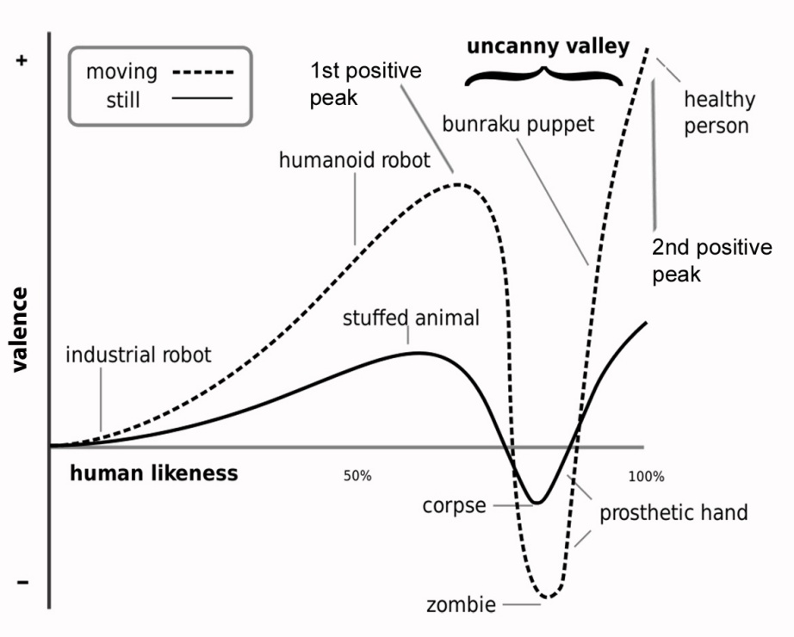

Figure 2

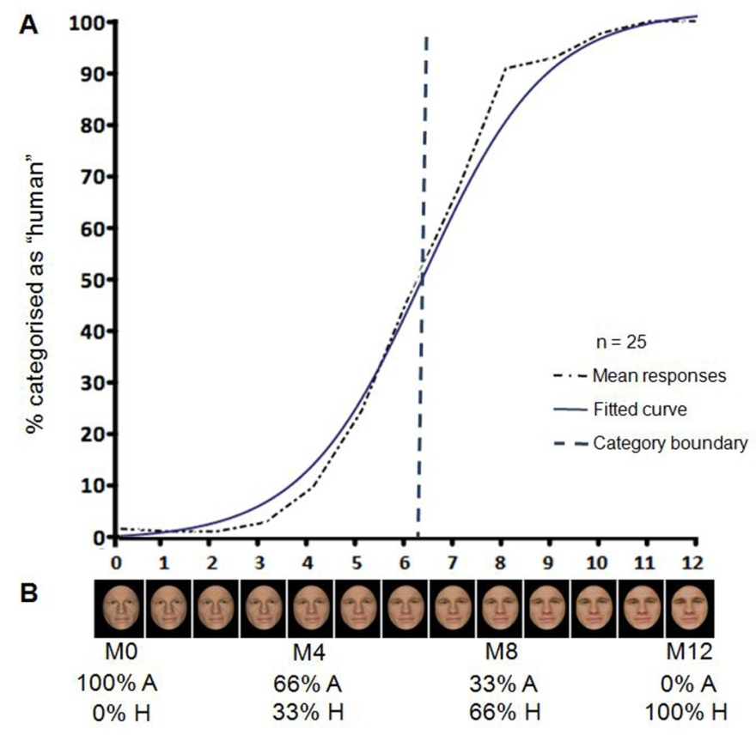

Figure 3

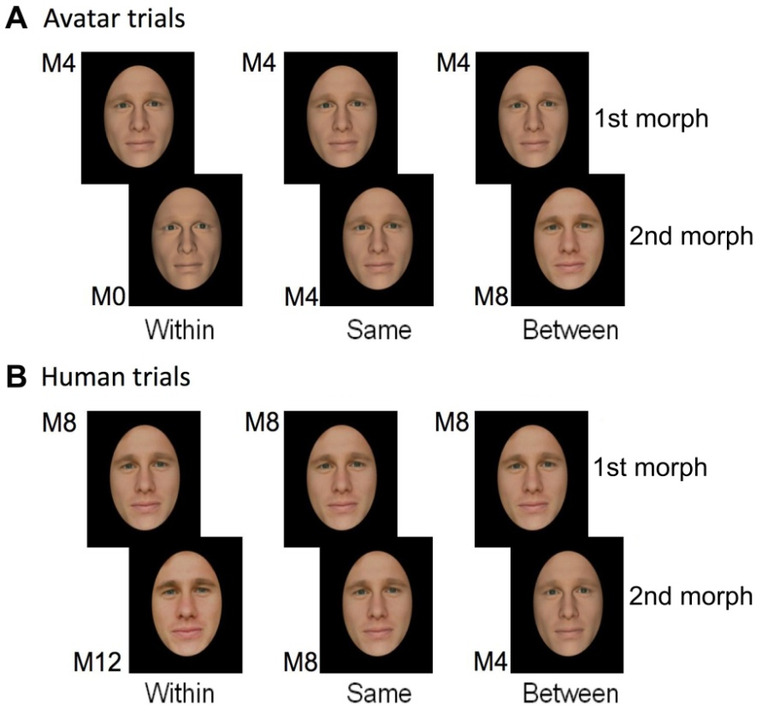

Figure 4

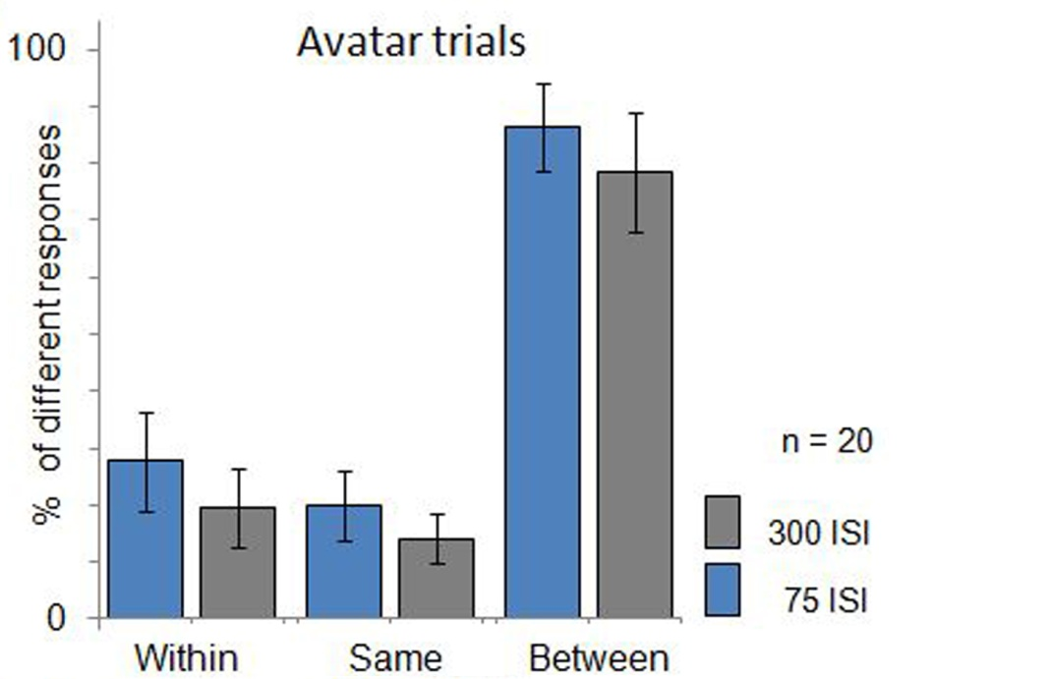

Figure 5

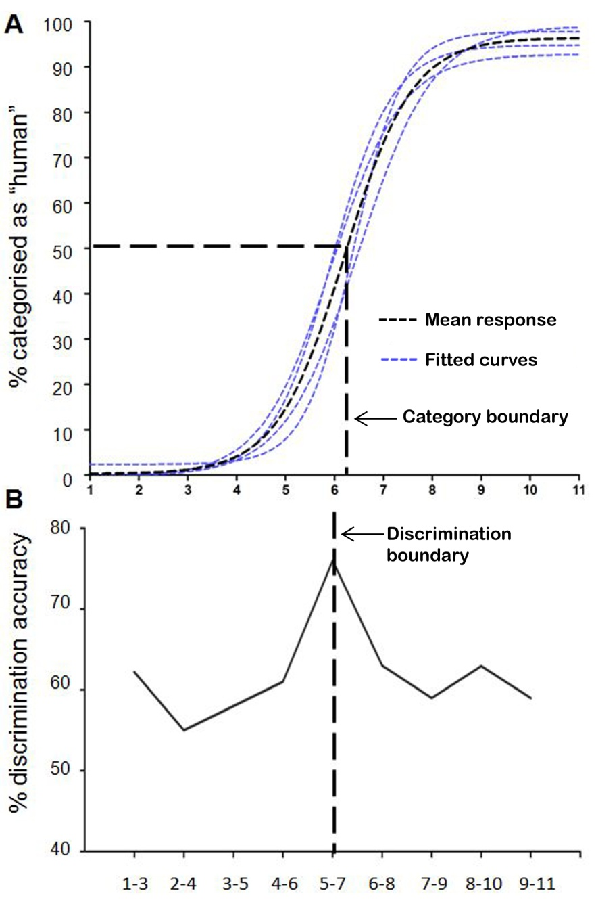

Figure 6

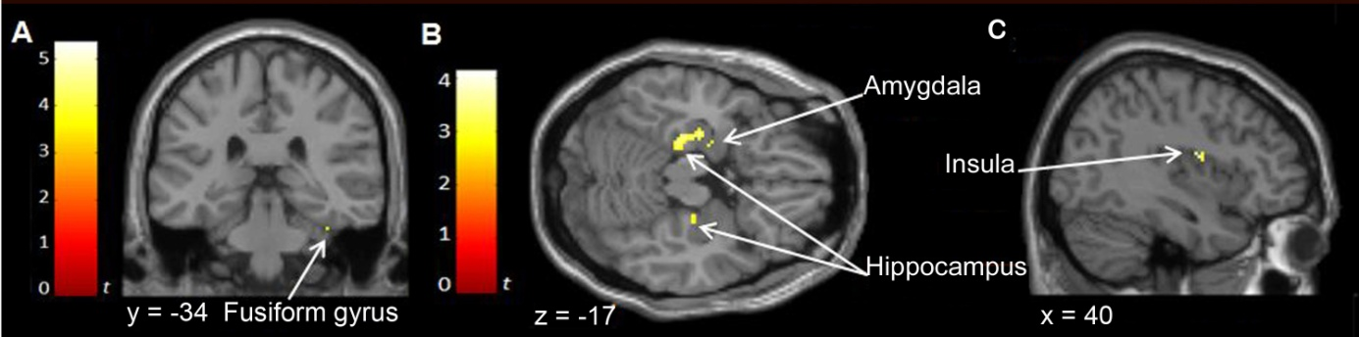

Legends

Figure 1. Illustration of the non-linear relationship between the experience of negative and positive affect (valence) and perceived human likeness. The otherwise positive relationship shows a sharp negative peak (i.e. uncanny valley) at the level of realism between the first and second positives peaks of the depicted curve at which subtle differences in the appearance and behavior of a highly realistic yet discernibly unnatural humanlike object is suggested to elicit a sense of strangeness and personal discomfort (i.e. an uncanny feeling). Illustration adapted from ².

Figure 2. Results from the forced choice categorisation task (A) and an example of a morph continuum (B). In B, the relative degree of linear physical transition along the 13 morph-continuum between the avatar and human endpoints is shown as a percentage. M0 and M4 were identified as avatars and M8 and M12 as human in the forced choice classification task (A).

Figure 3. Stimulus conditions for the "same-different" perceptual discrimination task. Morphs are selected to form pairs. The morphs of a pairs are drawn from within the same category (“within”), are identical (“same”), or they show a change in category between them (“between”). The morphs M0, M4, and M8 are used for avatar trials (A) and M4, M8, and M12 for human trials (B). Note that the first morph of a morph pair in avatar trials is always M4 and in human trials M8.

Figure 4. Results of the "same-different" perceptual discrimination task (avatar trails). Participants judged whether the morphs of a morph pair were the same or different in physical appearance. Controlling for relative distance of morphs along the continua, results show better discrimination accuracy for face pairs that crossed the category boundary (as determined in the forced choice classification task) than for pairs drawn from the same (avatar or human) side of the boundary, thus demonstrating categorical perception along our continua of human likeness.

Figure 5. Results of the ABX perceptual discrimination and forced choice categorization tasks. The 2-step discrimination procedure (i.e. 1-3, 2-4, 3-5, etc.) in the ABX perceptual discrimination task (B) shows that the peak in perceptual discrimination sensitivity is predicted by the category boundary determined in the forced choice categorization task (A). Panel A shows the logistic profile of the fitted regression curves of the four continua. Maximum uncertainty of 50% in categorization judgments as human is associated with morph M6.

Figure 5. Neural correlates of physical and of category change along the DOH in avatar trials. The activation maps are superimposed on the coronal (A), transversal (B) and sagittal (C) views of a single subject. The colour bars signify the gradient of t values of the activation maps (p < 0.005, 20 contiguous voxels).

