Isolation of lymphocyte from mouse genital tract mucosa
Authors:
Janina Jiang¹, Kathleen A. Kelly^{1,2}
Authors: institution(s)/affiliation(s):
¹Department of Pathology and Laboratory Medicine, David Geffen School of Medicine, ²California NanoSystems, University of California, Los Angeles.

Abstract
Mucosal surfaces, including in the gastrointestinal, urogenital, and respiratory tracts, provide portals of entry for pathogens, such as viruses and bacteria. Mucosae are also inductive sites in the host to generate immunity against pathogens, such as the Peyers patches in the intestinal tract and the nasal-associated lymphoreticular tissue in the respiratory tract. This unique feature brings mucosal immunity as a crucial player of the host defense system. Many studies have been focused on gastrointestinal and respiratory mucosal sites. However, there has been little investigation of reproductive mucosal sites. The genital tract mucosa is the primary infection site for sexually transmitted diseases (STD), including bacterial and viral infections. STDs are one of the most critical health challenges facing the world today. Centers for Disease Control and Prevention estimates that there are 19 million new infectious every year in the United States. STDs cost the U.S. health care system $17 billion every year (1), and cost individuals even more in immediate and life-long health consequences. In order to confront this challenge, a greater understanding of reproductive mucosal immunity is needed and isolating lymphocytes is an essential component of these studies. Here, we present a method to reproducibly isolate lymphocytes from murine genital tracts for immunological studies that can be modified for adaption to other species.
Protocol
- Remove entire genital tract
- Euthanize the mouse using approved guidelines. Make low midline incision and retract skin.
- Isolate and remove whole genital tract, from oviduct to vaginal opening.
- Open the entire tract longitudinally with scissors.
- Cut the genital tract into fine pieces in a flask with Complete RPMI-10/EDTA (see the formula below) and stir the tissue at room temperature on a magnetic stirrer set for 15min. This procedure is repeated twice and then the supernatant, which contains epithelium and other debris, is discarded.
Complete RPMI/10: RPMI (Gibco), 10% Fetal bovine serum (FBS), heat-inactivated, 5ml penicillin/streptomycin, 5ml 1M HEPES.
Complete RPMI-10/EDTA: 10%RPMI (as above) with 5µM EDTA
- Pour contents of flask through a cell strainer (40µm). Wash off EDTA residue with complete medium.
- Transfer tissue pieces to a new flask with fresh RPMI-10/collagenase (see the recipe below) and digest the tissue at 37°C for one hour on a magnetic stirrer set to vigorously stir the tissue.
Complete RPMI-10/collagenase: Right before use, reconstitute collagenase type VIII (Sigma; store at -20°C, or according to manufacturer’s instructions.), add into complete RPMI/10 to a final concentration of 450-500U/ml.
- After the first digestion, collect supernatants through 100 µm cell strainer, keep the cells on ice.
- Transfer the undigested tissue to a new flask and repeat step 4 two more times using fresh complete RPMI-10/collagenase for a total of 3 separate digestions. At this point, no visible tissue pieces should be in solution.
- Pool the all supernatants together from a sample and collect through 100 µm cell strainer. Spin the cells down. Cell pellets will be separated using Percoll gradients.
- Prepare each concentration of Percoll before use:
- 100% isotonic Percoll: mix 9:1 stock Percoll (Pharmacia Biotch) vs. 10× PBS. PH it to 7.4 using HCL.
- 40% Percoll solution: mix 40ml of 100% isotonic Percoll and 60ml of complete RPMI.
- 70% Percoll solution: mix 70ml of 100% isotonic Percoll with 30ml of complete RPMI.
- Resuspend each cell pellet from step 6 in 40% Percoll solutions. An equal volume of 70% Percoll will be used to make the gradients. There are two ways to set up gradient tubes:
1) Under-layer: add cell suspension with 40% Percoll into a gradient tube first, then carefully under-layer 70% Percoll.
2) Over-layer: add 70% Percoll into tube first, then carefully and slowly load 40% Percoll containing the cells on the top.
- Gradient samples will be centrifuged @ 2000RPM, room temperature, for 20min with the brake off.
- The lymphocytes will be at the interface layer of the 40% and 70% Percoll layers. Carefully harvest the interface layer, wash with RPMI 1:3 and spin down at 1800RPM. The lymphocytes will be in the cell pellet and are ready for further use.

Discussion
In this protocol, it is shown how to prepare lymphocytes from mouse genital tracts and is easily mastered. The most critical point of this process is to maintain cell viability by keeping the cells on ice. In many occasions, the lymphocytes will be used for further functional and/or flow cytometric analysis. This procedure is relatively long, but it can be simplified depending on the further use of the isolated lymphocytes. When the cells are used for non-functional assays such as flow cytometry analysis, the method can be shorted by skipping Percoll gradient step. This method provides a powerful tool with which to study mucosal lymphocytes and insight to study infectious disease and vaccine development.
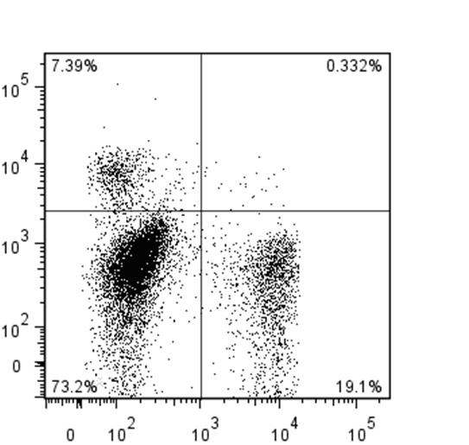
CD4+
CD8+

Fig1. Lymphocytes were isolated from genital tracts of mice infected with Chlamydia intravaginally 7 days after infection, using the method presented here. After the complete separation procedure, lymphocytes were stained with fluorochrome-conjugated CD3, CD4 and CD8. The quadrant data were gated on CD3+ lymphocytes, showing CD4+ versus CD8+ with and percentage of gated cells.

Reference:
- 2010 Sexually Transmitted Diseases Surveillance. Centers for Disease Control and Prevention (2012).
- Jain, S., Patrick, A.J., Rosenthal, K.L. Multiple tandem copies of conserved gp41 epitopes incorporated in gag virus-like particles elicit systemic and mucosal antibodies in an optimized heterologous vector delivery regimen. Vaccine, 28, 7070-7080 (2010).
- Tang, V.A., Rosenthal, K.L. Intravaginal infection with herpes simplex virus type-2 (HSV-2) generates a functional effector memory T cell population that persists in the murine genital tract. J Reprod Immunol. 87, 39-44 (2010).
- Gillgrass, A.E., Tang, V.A., Towarnicki, K.M., Rosenthal, K.L., Kaushic, C. Protection against genital herpes infection in mice immunized under different hormonal conditions correlates with induction of vagina-associated lymphoid tissue. J Virol. 79,3117-3126 (2005).
- Sajic, D., Patrick, A.J., Rosenthal, K.L. Immunology. 2005 Feb;114(2):213-24. Mucosal delivery of CpG oligodeoxynucleotides expands functional dendritic cells and macrophages in the vagina. J Virol. 79,393-400 (2005).
- Jiang, J.Q., Patrick, A., Moss, R.B., Rosenthal, K.L. CD8+ T-cell-mediated cross-clade protection in the genital tract following intranasal immunization with inactivated human immunodeficiency virus antigen plus CpG oligodeoxynucleotides. J Virol. 79,393-400 (2005).

