TITLE
Non-invasive Optical Imaging of the Lymphatic Vasculature of a Mouse
Authors:

Holly A. Robinson
SunKuk Kwon, PhD
John C. Rasmussen, PhD
Mary A. Hall, PhD
Melissa B. Aldrich, PhD
Eva M. Sevick-Muraca, PhD

Authors: institution(s)/affiliation(s) for each author:
Holly A. Robinson
Center for Molecular Imaging (CMI)
University of Texas Health Science Center-Houston
holly.robinson@uth.tmc.edu

SunKuk Kwon, PhD
Center for Molecular Imaging (CMI)
University of Texas Health Science Center-Houston
sunkuk.kwon@uth.tmc.edu

John C. Rasmussen, PhD
Center for Molecular Imaging (CMI)
University of Texas Health Science Center-Houston
john.rasmussen@uth.tmc.edu

Mary A. Hall, PhD
Center for Molecular Imaging (CMI)
University of Texas Health Science Center-Houston
mary.hall@uth.tmc.edu

Melissa B. Aldrich, PhD
Center for Molecular Imaging (CMI)
University of Texas Health Science Center-Houston
melissa.b.aldrich@uth.tmc.edu

Eva M. Sevick-Muraca, PhD
Center for Molecular Imaging (CMI)
University of Texas Health Science Center-Houston
eva.sevick@uth.tmc.edu
Corresponding author:
Eva M. Sevick-Muraca, PhD

Keywords:

Optical imaging, lymphatic imaging, mouse imaging, non-invasive imaging, near-infrared fluorescence

Short Abstract:
Recently developed imaging techniques using near-infrared fluorescence (NIRF) may help elucidate the role the lymphatic system plays in cancer metastasis, immune response, wound repair, and other lymphatic associated diseases.
Long Abstract:
The lymphatic vascular system is an important component of the circulatory system that maintains fluid homeostasis, provides immune surveillance, and mediates fat absorption in the gut. Yet despite its critical function, there is comparatively little understanding of how the lymphatic system adapts to serve these functions in health and disease.¹ Recently, we have demonstrated the ability to dynamically image lymphatic architecture and lymph “pumping” action in normal human subjects as well as in persons suffering lymphatic dysfunction using trace administration of a near-infrared fluorescent (NIRF) dye and a custom, Gen III intensified imaging system.²⁻⁴ NIRF imaging showed dramatic changes in lymphatic architecture and function with human disease. It remains unclear how these changes occur and new animal models are being developed to elucidate their genetic and molecular basis. In this protocol, approved by our animal care and use committee, we present NIRF lymphatic, small animal imaging^{5,6} using indocyanine green (ICG), a dye that has been used for 50 years in humans⁷, and a NIRF dye-labeled cyclic binding domain (NIRF-cABD) that preferentially binds mouse and human albumin for imaging protein lymphatic transport.⁸ Intradermal (ID) injections of 2 μL to 50 μL of NIRF dye solution are administered in the dorsal aspects of the hind paw and/or on the left or right side of the base of the tail of an isoflurane-anesthetized mouse. Immediately following injection, functional lymphatic imaging is conducted for up to 1 hr. As illustrated in figure 1, the NIRF small animal imaging system consists of a 785-nm laser diode outfitted with an aspheric lens, diffuser, and filter to create a uniform excitation field that illuminates the animal at incident fluence rate of less than 1.4 mW/cm².⁹ An EMMCD camera system with two 830 fluorescent filters is used to capture lymphatic images with integration times of 200-ms for dynamic imaging and 800-ms integration times for static imaging. White-light images for anatomical reference can also be acquired using a low-power lamp. Images are acquired using V++ software.

Protocol Text:
1) Preparation of Animals 24 Hours Prior to Imaging
The steps below must be done (as needed) the day before lymphatic imaging takes place.
1.1) Place animal in an induction box and sedate with isoflurane.
1.2) Once the animal is in a state of profound anesthesia (monitored with toe pinch maneuver), place sedated animal on a diaper/fluff pad and position nose in a nose cone connected to gas isoflurane.
1.3) Clip all hair (if any) around the area to be imaged.
1.4) Apply depilatory agent (NAIR) to the clipped area and leave it on the skin for up to 3 minutes.
1.5) Gently wipe off all depilatory agent with warm, damp gauze or paper towel.
1.6) Gently rinse the skin with warm water and gently dry the area with gauze or paper towel.
1.7) Allow animals to recover on a heating pad or under a heat lamp and return to their cage.

2) Day of Imaging
2.1) Reconstitute either ICG with sterile water to a concentration of 645.2 µM (5 μg/10 μL) or NIRF-cABD to a concentration of 200 µM (6.8 μg/10 μL). Keep solutions in dark conditions and use within 6 hours of reconstitution.

2.2) Place animal in an induction box and sedate with isoflurane.
2.3) Once the animal is in a state of profound anesthesia (monitored with toe pinch maneuver), place sedated animal on a diaper/fluff pad and position nose in a nose cone connected to gas isoflurane.
2.4) Turn off the lights (so the room is dark). You can use a small desk halogen light for a small amount of light to see.
2.5) Using an insulin syringe with a 31 gauge needle, inject 2 μL to 50 μL of ICG or NIRF-cABD ID in the dorsal aspects of the hind paw and/or on the left or right side of the base of the tail, as discussed more fully in the discussion. If animals are not under the imaging system for the injection(s), place the animal under the imaging system immediately after the injection(s).
2.6 If no dye uptake is seen in the lymphatics, step 2.5 will need to be repeated as needed per animal protocol.
2.7) Once lymphatics are seen, cover the injection site with black electrical tape or black paper.
2.8) Acquire lymphatic images for up to 1 hr using a NIRF imaging system.
2.9) If desired, allow animals to recover on a heating pad or under a heat lamp and return to their cage or euthanize.
2.10) Analyze images using ImageJ or Matlab software. See figure 6.
Representative Results:
Example of NIRF lymphatic imaging in mice
When ICG or NIRF-cABD is injected intradermally at the base of the tail of a normal mouse, the lymphatic vasculature between the injection site at the base of the tail and the inguinal lymph node (LN) should be immediately visualized. Shortly after injection (a few seconds to minutes), the lymphatic vessel between the inguinal LN and the axillary LN should be visualized as seen in figure 2. Since the lymphatics in mice vary from animal to animal as they do in humans, variation in architecture between animals may be seen as shown in figure 3. When ICG or NIFR-cABD is injected ID on the dorsal aspect of the hind paw of a normal mouse, two lymphatic vessels should be visualized draining to the popliteal LN as seen in figure 4. In some cases it is difficult to distinguish both vessels because of their proximity.
Precautions for NIRF Lymphatic Imaging Impacted
At times, visualization of the lymphatics is delayed, most commonly due to the injection being administered subcutaneously (SC) instead of intradermally. When SC injections are given, lymphatic transport will not be immediately visualized as seen in figure 5(a) because of the additional time required for the dye to reach and be taken up by the lymphatic capillaries in the skin. On occasion, abnormal lymphatic vessels are observed, as seen in figure 5(b), in the area of a wound such as a bite or cut from the hair clippers.
Generally, it takes the ID depot of ICG or NIRF-cABD up to 2 days to clear the liver and bladder and up to 3 days to clear the injection site. When residual fluorescent signal has cleared, the imaging protocol can be repeated allowing longitudinal lymphatic imaging to evaluate changes in architecture or lymph function after some intervention.
Analysis of lymphatic function
The acquired images can be loaded into ImageJ or MatLab for data analysis. Fixed circular regions of interest (ROIs) are selected along the entire length of the fluorescent lymphatic vessel as done for human⁹ and animal⁵ lymphatic imaging as shown in figures 6(a) and 6(d). The mean fluorescence intensity within each ROI is plotted as a function of imaging time to assess the propagation velocity and the frequency of “packet” of dye-laden lymph propelled along the lymphatic vessels as shown in figures 6(b) and 6(e). To assess the lymphatic propagation velocity and frequency of lymphatic propulsion, two ROI’s are selected and their fluorescent intensity profiles are plotted as shown in figures 6(c) and 6(f). Packets of lymph are shown as maxima or minima fluorescent intensity. The propagation velocity is computed by taking the ratio of the distance between the two ROI’s and the transit time for a packet of lymph to propagate between them. By assessing the number of fluorescent pulses or “packets” arriving at a single ROI per time, the contractile frequency is computed.

Table and Figures:
Figure 1. The near-infrared fluorescence (NIRF) imaging system is custom-built for small animal lymphatic imaging. The device consists of a 785-nm laser diode outfitted with an aspheric lens, diffuser, and filters to create a uniform excitation field that illuminates the animal and an EMCCD camera, focusing lens, and optical filters to capture images of fluorescent lymph.⁹

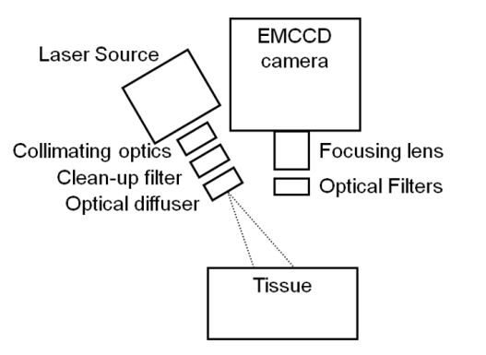

Figure 2. When ICG or NIRF-cABD is injected intradermally at the base of the tail of a normal mouse, the lymphatic vasculature between the injection site at the base of the tail and the inguinal lymph node (LN) should be immediately visualized. Shortly after injection (a few seconds to minutes), lymphatic vessels between the injection site and the inguinal lymph node (LN) and subsequently to the axillary lymph node (LN) region are visualized. The bright spot between the inguinal and axillary regions is the liver.

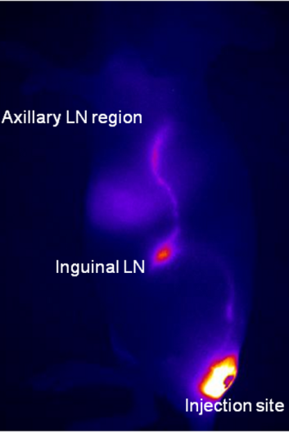

Figure 3. Since the lymphatics in mice vary from animal to animal as they do in humans, variation in architecture between animals may be seen and is stable over time.

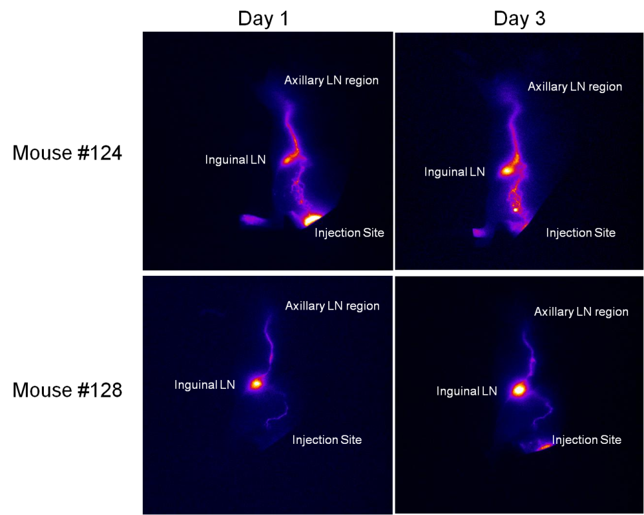

Figure 4. When ICG or NIFR-cABD is injected ID on the dorsal aspect of the hind paw of a normal mouse, two lymphatic vessels should be visualized draining to the popliteal lymph node (LN). In some cases it is difficult to distinguish both vessels because of their proximity as illustrated in the enlarged image represented by the dashed box.

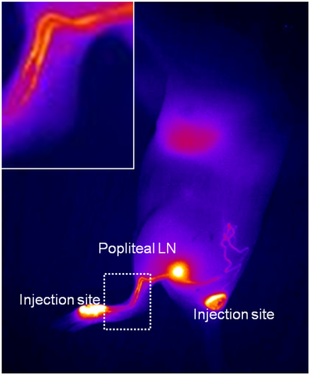

Figure 5. (a) Occasionally visualization of the lymphatics is delayed, most commonly due to the injection being administered subcutaneously (SC) instead of intradermally. When SC injections are given, lymphatic transport will not be immediately visualized because of the additional time required for the dye to reach and be taken up by the lymphatic capillaries in the skin. (b) Visualization of newly formed, abnormal lymphatic vessels resulting from wound healing processes following a bite or cut from the hair clippers.

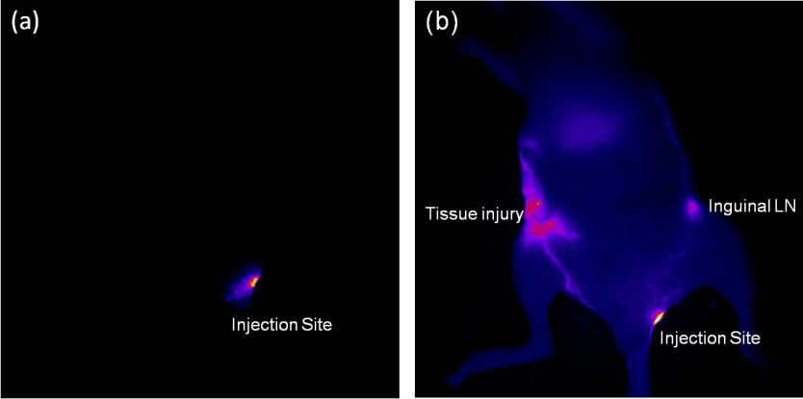

Figure 6. Quantitative analysis of lymphatic contractile function consists of selecting regions of interest (ROIs) along the lymphatic vessels draining from (a) the inguinal lymph node (LN) to the axillary LN and (d) the injection site to the popliteal LN. The plot of average fluorescence intensity of each ROI as a function of time is then plotted (b and e). The lines parallel to the arrows illustrate the propagation of packets of fluorescent lymph within the lymphatic vessels. The fluorescence intensity profile as a function of time is then plotted for two ROIs (c and f) to facilitate the identification of packets of propagating lymph and the extraction of the transit time and distance between the ROIs. Velocity is computed by taking the ratio of the distance between ROIs and the transit time.

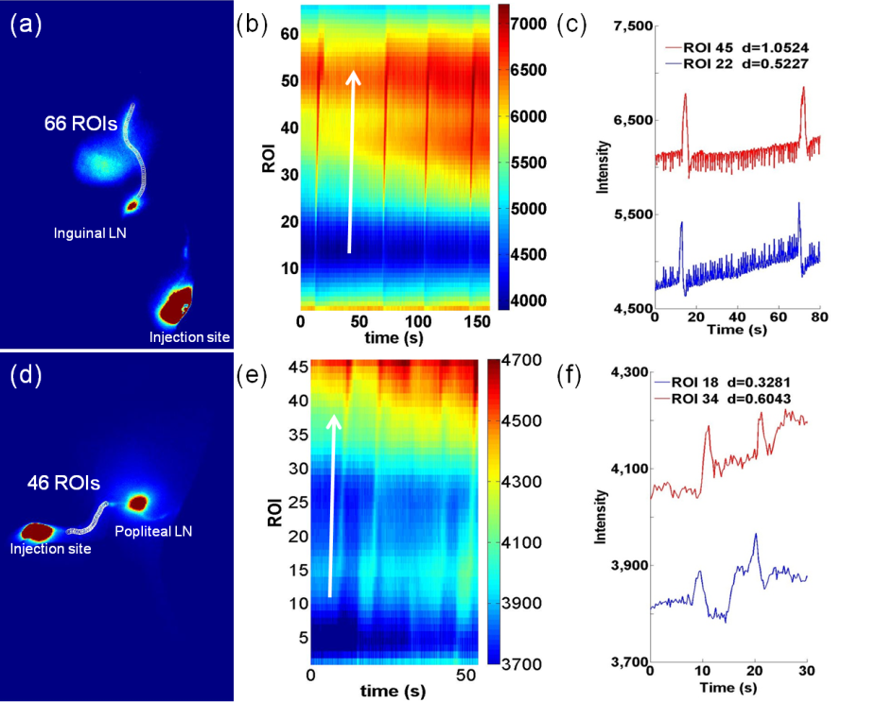

Figure 7. To visualize the lymphatics draining from the inguinal region to the axillary region, you will need to inject the left or right side of the base of the tail. To visualize the left side you will inject in location 5, 6, 9, or 10. To visualize the right side you will inject in location 7, 8, 11, or 12. Locations 1 through 4 are too low down on the tail and lymphatic drainage will not drain from the inguinal region to the axillary region.

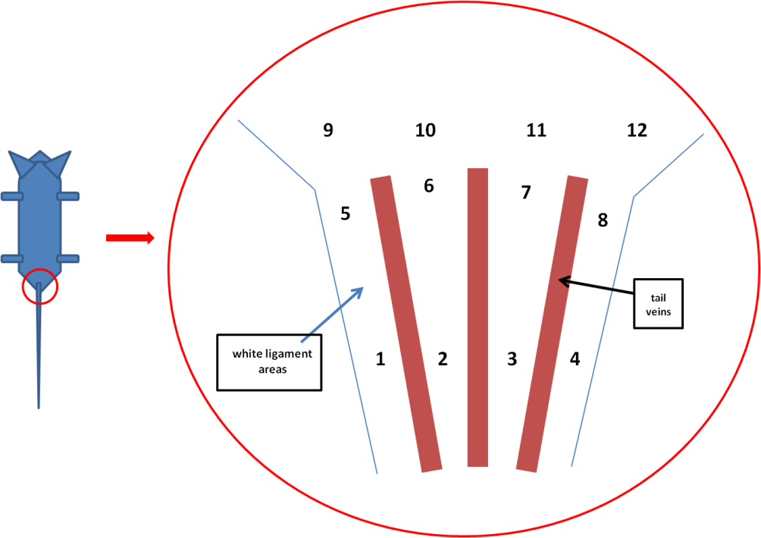
Discussion:
Determining where to inject depends on what lymphatics vessels you are interested in studying. To visualize the lymphatics draining from the inguinal region to the axillary region, you will need to inject the left or right side of the base of the tail, as shown in figure 7. To visualize the lymphatics draining from the palatial region, you will need to inject the dorsal aspect of the hind paw between the digits. It is essential to keep the animal’s body temperature within normal range, as changing body temperature can result in inconsistent lymphatic function. In addition, because of the limited dynamic range of most CCDs, the injection sites should be covered with black paper to block fluorescent light thereby enabling visualization of dimmer draining lymphatic vessels. Imaging should be performed in a dark room to reduce unwanted background signals due to emission of light in the fluorescence band from the room lights. The animal must also be lying on a black background while imaging is being performed to reduce the light backscatter. NIRF lymphatic imaging may enable a better understanding of lymphatic diseases and how lymphatic architecture and function changes with respect to disease or injury. Another method to visualize the lymphatics is intravital imaging in which the mouse is euthanized and skinned following injection of Evans Blue. However, this method does not provide functional or longitudinal imaging.^{10,11} Lymph node metastases can be imaged using a Siemens Inveon PET/CT, however this technique does not allow visualization of lymphatic structure or function.¹² To date NIRF imaging is the only means to non-invasively image lymphatic structure and function in small animals. All animal studies were performed in accordance with the standards of University of Texas Health Science Center (Houston, TX), Department of Comparative Medicine and Center for Molecular Imaging after review and approval of the protocol by their respective Institutional Animal Care and Use Committee (IACUC) or Animal Welfare Committee (AWC).

Acknowledgments:
This work was supported by the following grants to Eva Sevick: NIH R01 CA128919 and
NIH R01 HL092923.
Disclosures:
Authors have nothing to disclose, but some authors are listed on a patent.

Table of specific solutions, reagents and equipment:
Solutions, Reagents, and Equipment | Company | Catalogue number | Comments
Indocyanine green (ICG) | Patheon Italia S.P.A. | NDC 25431-424-02 | Reconstitute to 645.2 µM  (5 μg/10 μL)
Cyclic Albumin Binding Domain (cABD) | Bachem | Custom | Reconstitute to 200 µM (6.8 μg/10 μL)
Sterile Water | Hospira, Inc., Lake Forest, IL | NDC 0409-4887-10
NAIR | Church & Dwight Co., Inc. | Local Stores | www.nairlikeneverbefore.com
Imaging System (components below) | Center for Molecular Imaging | N/A | Custom-built in our laboratories.
Electron-multiplying charge-coupled device (EMCCD) camera | Princeton Instruments, Trenton, NJ | Photon Max 512
Nikon camera lens | Nikon Inc., Melville, NY | Nikkor 28mm
Optical filter | Andover Corp., Salem,NH | ANDV11333 | Two 830.0/10.0 nm bandpass filters are used in front of lens
785 nm laser diode | Intense Ltd, North Brunswick, NJ | 1005-9MM-78503 | 500 mW of optical output
Collimating optics | Thorlabs, Newton, NJ | C240TME-B | Collimates laser output prior to cleanup filter
Clean-up filter | Semrock, Inc., Rochester, NY | LD01-785/10-25 | Removes laser emission in fluorescence band
Optical diffuser | Thorlabs, Newton, NJ | ED1-C20 | Diffuses the laser over the animal
V++ | Digital Optics, Browns Bay, Auckland, New Zealand | Version 5.0 | Software used to control camera system and save images to computer. http://digitaloptics.net/
Analytic Software | Either of the following software packages can be used for image analysis.
ImageJ | National Institutes of Health, Bethesda, MD | Most current version available | Freeware available at http://rsbweb.nih.gov/ij/
Matlab | MathWorks, Natick, MA | Version 2008a or later | http://www.mathworks.com/

References:
1 Alitalo, K. The lymphatic vasculature in disease. Nat Med 17, 1371-1380, doi:10.1038/nm.2545 (2011).
2 Rasmussen, J. C., Tan, I. C., Marshall, M. V., Fife, C. E. & Sevick-Muraca, E. M. Lymphatic imaging in humans with near-infrared fluorescence. Curr Opin Biotechnol 20, 74-82, doi:10.1016/j.copbio.2009.01.009 (2009).
3 Rasmussen, J. C. et al. Human Lymphatic Architecture and Dynamic Transport Imaged Using Near-infrared Fluorescence. Transl Oncol 3, 362-372 (2010).
4 Sevick-Muraca, E. M. Translation of near-infrared fluorescence imaging technologies: emerging clinical applications. Annu Rev Med 63, 217-231, doi:10.1146/annurev-med-070910-083323 (2012).
5 Kwon, S. & Sevick-Muraca, E. M. Noninvasive quantitative imaging of lymph function in mice. Lymphat Res Biol 5, 219-231, doi:10.1089/lrb.2007.1013 (2007).
6 Kwon, S. & Sevick-Muraca, E. M. Mouse phenotyping with near-infrared fluorescence lymphatic imaging. Biomed Opt Express 2, 1403-1411, doi:10.1364/BOE.2.001403 (2011).
7 Marshall, M. V. et al. Near-infrared fluorescence imaging in humans with indocyanine green: a review and update. The Open Surgical Oncology Journal 2, 12-25 (2010).
8 Davies-Venn, C. A. et al. Albumin-Binding Domain Conjugate for Near-Infrared Fluorescence Lymphatic Imaging. Mol Imaging Biol, doi:10.1007/s11307-011-0499-x (2011).
9 Kwon, S. & Sevick-Muraca, E. M. Functional lymphatic imaging in tumor-bearing mice. J Immunol Methods 360, 167-172, doi:10.1016/j.jim.2010.06.016 (2010).
10 Galanzha, E. I., Tuchin, V. V. & Zharov, V. P. Advances in small animal mesentery models for in vivo flow cytometry, dynamic microscopy, and drug screening. World J Gastroenterol 13, 192-218 (2007).
11 Schramm, R. et al. The cervical lymph node preparation: a novel approach to study lymphocyte homing by intravital microscopy. Inflammation research : official journal of the European Histamine Research Society ... [et al.] 55, 160-167, doi:10.1007/s00011-006-0066-0 (2006).
12 Hall, M. A. et al. Imaging prostate cancer lymph node metastases with a multimodality contrast agent. Prostate 72, 129-146, doi:10.1002/pros.21413 (2012).

