4295 Annotated Schematic

Procedural Narrative Text:
The overall goal of this procedure is to assess bacterial pathogenicity against insect larvae, using Manduca (pronounced “Man-DOO-ca”) sexta as a model organism. (Intro) This is accomplished by first rearing the insect larvae from sterilized eggs to the fourth instar phase of development. (P1) In the second step, the bacterial samples are prepared for injection. (P2) Next, the bacteria are injected into the fourth instar Manduca sexta larvae. (P3) In the final step, the death of the insects over time after injection is monitored. (P4) Ultimately, the time to insect death is recorded and used to assess bacterial virulence. (P5)

Annotated Text:

- The overall goal of this procedure is to assess bacterial pathogenicity against insect larvae, using Manduca (pronounced “Man-DOO-ca”) sexta as a model organism. (Intro)
INTRO: Show title

- This is accomplished by first rearing the insect larvae from sterilized eggs to the fourth instar phase of development. (P1)
P1.1: Show a few Manduca sexta eggs (basically just translucent green balls).

P1.2: Fade to several (5-10) Manduca sexta larvae.

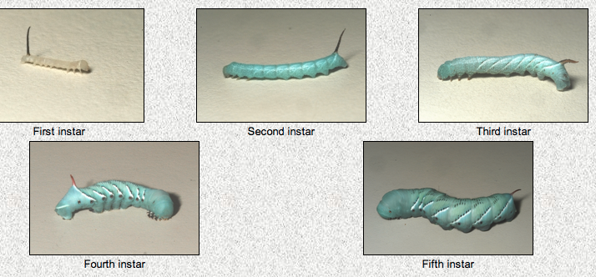
Above: Manduca sexta larvae. The only one we need illustrated is the “third instar” step, I just wanted to include the others to provide context in case it was helpful.

- In the second step, the bacterial samples are prepared for injection. (P2)
P2.1: Show bacteria (use stock image 4346 B subtilis, just the bacteria—dish isn’t really necessary). Have them go into a syringe (again, use a stock image).

- Next, the bacteria are injected into the fourth instar Manduca sexta larvae. (P3)
P3.1: The syringe shoots bacteria into the larvae.

- In the final step, the death of the insects over time after injection is monitored. (P4)
P4.1: One at a time, many of the larvae turn grey (can just make the image go black and white) to indicate “dying” as a result of infection.

- Ultimately, the time to insect death is recorded and used to assess bacterial virulence. (P5)
P5: Lab media as directed in script.

