Potential peer reviewers:
Charles Irvin, Ph.D. , University of Vermont, Charles.Irvin@uvm.edu
Peter Pare, M.D., University of British Columbia, Peter.Pare@hli.ubc.ca
Clarke Tankersley, Ph.D., Johns Hopkins University, ctankers@jhsph.edu
Rob Tepper, M.D., Indiana University, rtepper@iupui.edu
Jamie Lee, Ph.D., Mayo Clinic Scottsdale, jjlee @mayo.edu

TITLE: A simple method of mouse lung intubation
Authors:
Wayne Mitzner, Ph.D.
Department of Environmental Health Sciences
Program in Respiratory Biology and Lung Disease
Johns Hopkins Bloomberg School of Public Health
wmitzner@jhsph.edu

Herng-Yu Sucie Chang, Ph.D.
Department of Environmental Health Sciences
Program in Respiratory Biology and Lung Disease
Johns Hopkins Bloomberg School of Public Health
hsc2129@columbia.edu

Kelvin MacDonald, M.D.
Department of Pediatrics
Oregon Health Sciences University
macdonke@ohsu.edu

Corresponding author: Wayne Mitzner

Keywords: pulmonary function, chronic, longitudinal studies, airway resistance
Short Abstract: This paper describes a striaghforward and efficient method of intubating mice for pulmonary function measurements or pulmonary instillation, that allows the mice to recover and be studied at later times. The procedure involves an inexpensive fiberoptic light source that directly illuminates the trachea.

Long Abstract:
A simple procedure to intubate mice for pulmonary function measurements would have several advantages in longitudinal studies with limited numbers or expensive animal. One of the reasons that this is not done more routinely is that it is relatively difficult, despite there being several published studies that describe ways to achieve it. In this paper we demonstrate a procedure that eliminates one of the major hurdles associated with this intubation, that of visualizing the trachea during the entire time of intubation. The approach uses a 0.5 mm fiberoptic light source that serves as an introducer to direct the intubation cannula into the mouse trachea. We show that it is possible to use this procedure to measure lung mechanics in individual mice over a time course of at least several weeks. The technique can be set up with relatively little expense and expertise, and it can be routinely accomplished with relatively little training. This should make it possible for any laboratory to routinely carry out this intubation, thereby allowing longitudinal studies in individual mice, thereby minimizing the number of mice needed and increasing the statistical power by using each mouse as its own control.
1) Introduction:
In 1999, Brown et al published a paper describing a method for intubation of the mouse lung ¹. Such a technique has considerable utility in doing repeat pulmonary function or bronchoalveolar lavage in individual mice in longitudinal studies ². Since that original paper, there have been several other papers that have described different approaches to mouse intubation ³⁻⁹. While all of these methods can be used successfully, they usually require considerable training. One of the main issues with such intubation is that as the intubation cannula approaches nears the trachea pending insertion, the cannula itself blocks the light and hence the visualization of where it needs to go. Thus, the insertion becomes blind at the most critical time. In this paper we show how to simply eliminate this visualization problem, thereby ensuring successful intubation with relatively little training or experience.

2) Preparing for the procedure
One must first obtain and prepare the following items:
2.10. The cannula. For intubation of 20-35 g mice, we use a 1 or 1.5 inch long, 20 gauge IV catheter (BD Insylte, Sparks, MD or Jelco Optiva, Carlsbad, CA).

2.20. The fiberoptic cable. We use ≈70 cm of 0.5 mm optical cable from Edmund Optics, but the length is not critical. It is important to make sure the fiber has its edge smoothed, since after cutting the cable to length with a razor, the edge is left relatively sharp, and it does not take much effort to pierce the tracheal wall. However, it is very easy to smooth this edge by holding the fiber about 2 cm from the end and then making small circles for a few seconds with the edges of the tip touching a piece of 1000 grit emery paper (see Figure 1 of Macdonald, et al ¹⁰). The other end is inserted through a rubber stopper. This is most easily accomplished by first pushing a 18-gauge needle through the stopper, inserting the optical fiber through the needle bore, then withdrawing the needle. The rubber stopper is connected to a 150 watt halogen light source (e.g., NCL-150, Volpi USA, or any other or light source, even less than 150 watts). Since commercial light sources are not designed for rubber stoppers, it is necessary to find a way to make this connection. The cheapest way is to just tape in on, but we’ve used a short length (2 in) of aluminum or brass tubing matched to the rubber stopper size that fits over the light source’s connecting stub (Figure 1)¹⁰.

3) Performing the intubation.
3.10. See Figure 1. Insert fiber optic cable through a short piece of silicone rubber tubing (≈0.8 mm ID x 4 mm OD, Cole-Palmer, EW-96410-13). Tie this rubber tube fairly tight, while still allowing the cable to move. Insert the silicone tubing snugly in the Luer end of the cannula to hold the cable’s position inside the cannula. Adjust the position of the fiberoptic cable so that it extends through the cannula ≈4 mm in front of the cannula tip.
3.20. Place the anesthetized mouse on a vertical support, suspended by its upper incisors (Figure 2). Most investigators find the best visualization with the ventral side of the mouse facing themselves. Very gently pull out the tongue and hold with thumb and forefinger. The middle finger is placed between the neck and plastic support. Traction on the tongue with the index finger and thumb is used to open the mouth, and to straighten the intubation path, the angle of the head is adjusted with the middle finger behind the neck shown in Figure 2.
3.30. Using the fiber optic cable as a light source and introducer, push it through the visualized vocal chords. If the cords are not visible, gently pull harder on the tongue using the middle finger as support. When inserted, advance the cannula ≈5 mm further. Then, being very careful not to move the cannula, withdraw the fiber optic cable. Secure the cannula with a suture or tie.
3.40. The procedure in step c cannot be easily taught or even demonstrated, since it it a solo operation. However, by subtle adjustments of the traction on the tongue and the support behind the head nearly all who try this soon find the right way to position the mouse to visualize the vocal cords.

4) Representative Results. As an evaluation of the method, we used four 20 week old male BALB/c mice with average weight (± SEM) of 27.7 ± 0.40 g. They were studied on five consecutive weeks, where the lung resistance was measured using a system as previously described ¹¹. Each mouse was anesthetized with ketamine (100 µg/g BW) and xylazine (8 µg /g BW) in saline via IP injection. They were then intubated as described above. If there is any doubt whether the cannula is in the trachea and not the esophagus, this can be validated using a small dental mirror. Keep the mirror in a freezer, and when needed place in front of the Luer hub of the catheter. If the catheter is in the trachea, the exhaled breath will form a visible condensate on the mirror.
After intubation, we then connected the mice to the ventilator and measured Lung Resistance The mice were ventilated with a rate of 2 Hz and tidal volume of 0.2 mL, and respiratory resistance was measured by the inspiratory occlusion method as previously described¹¹. Figure 3 shows 5 weekly measurements in each of the 4 mice. Reproducibility is excellent, showing that, at least at weekly intervals, there is no effect of the prior measurement. This is consistent with previously reported weekly assessments of mechanics and BAL cell profiles in individual BALB/c mice with a more difficult and potentially traumatic procedure ².
5) Discussion.
The procedure described here has several advantages. First the apparatus is simple and relatively inexpensive.. The fabrication of the apparatus does not require any special tools or costly equipment. The use of a catheter introduces that also is the light source means that one never loses sight of the tracheal opening as the introducer approaches the tracheal opening. The use of a 0.5 mm introducer also serves to minimize trauma that might occur with an initial insertion of a larger cannula. We note here that a similar optical probe is available from a commercial vendor (Braintree Scientific, Braintree, MA). Their device uses a battery powered light source and optical fiber.
In the present work, we tested the procedure with repeat measurement of lung mechanics, but such intubation could just as easily be used to instill chemicals or cells into the lung, as has been described for repeated delivery of LPS ¹². In addition, a prior report with a more primitive intubation procedure described the ability to do repeated BAL in individual mice ², and this would be much more simply accomplished with the new intubation approach.
In practice, the method described here has been easily taught to fellows, students, and technicians who had never attempted intubation. In fact, during group training sessions, some of the students become sufficiently proficient to then teach some of the other students who had not yet tried it. This method thus has a considerable advantage as it minimizes the number of mice needed for practice and should allow minimal damage in repeated studies.
In doing the intubation, there are several practical issues that should be mentioned. It is important to be as gentle as possible with the retraction of the tongue in the initial opening of the mouth. If unprotected forceps are used it is easy to injure the tongue, and this can lead to death of the mouse. In first learning how to do the intubation, the most important thing is the use of the finger behind the neck to adjust the angle of the head to enable visualization of the tracheal opening. When done correctly, with sufficient traction on the tongue, the vocal cords can easily be seen. It is this initial visualization step that usually requires the most time, since once the tracheal opening is seen, it is relatively simple to insert the fiber cable and intravenous catheter. Initially if there is an issue with this visualization, the trainee is often not pulling on the tongue with sufficient force. Increasing this pull slightly will straighten the visualization path so the vocal cords can be seen. Hamacher, et al, described a unique intubation system with microscopic visualization ³. Their online video of this intubation is excellent and very instructive, although the means of positioning the head and neck is not entirely clear from the video and figure. While the system they describe seems to work very efficiently, it requires a dedicated microscope. Using the system and procedure we describe, the vocal cords and tracheal opening can be seen with the naked eye. In our original description of this method ¹⁰, we described a procedure to add a cone to the intubation cannula. This cone wedges into the narrow mouse pharynx and prevents the cannula from being inserted too deeply. We have found that this wedge is useful in teaching students the procedure, since it is very easy to insert the cannula to the carina or beyond, possibly penetrating through an airway wall. Simple instructions to fabricate the wedge can be found in that paper. However, once someone learns the procedure sufficiently well and where to position the cannula, this adaptation is no longer needed. Finally, with regard to insertion of the optical fiber as an introducer, it is important to make sure the fiber has its edge smoothed, since after cutting the cable to length with a razor, the edge is left quite sharp, and it does not take much effort to pierce the tracheal wall. However, it is very easy to smooth this edge (see Figure 1 of Macdonald, et al ¹⁰.

In summary, the intubation procedure describe here is inexpensive to fabricate and simple to use, and it should enable most investigators and laboratory technicians to quickly learn to successfully intubate mice with relatively little experience.
Acknowledgments: Supported by NIH HL-10342.
Disclosures: None of the authors have any conflicts of interest to disclose.

References

1 Brown, R. H., Walters, D. M., Greenberg, R. S. & Mitzner, W. A method of endotracheal intubation and pulmonary functional assessment for repeated studies in mice. J Appl Physiol 87, 2362-2365 (1999).
2 Walters, D. M., Wills-Karp, M. & Mitzner, W. Assessment of cellular profile and lung function with repeated bronchoalveolar lavage in individual mice. Physiol Genomics 2, 29-36 (2000).
3 Hamacher, J. et al. Microscopic wire guide-based orotracheal mouse intubation: description, evaluation and comparison with transillumination. Laboratory animals 42, 222-230 (2008).
4 Spoelstra, E. N. et al. A novel and simple method for endotracheal intubation of mice. Laboratory animals 41, 128-135 (2007).
5 Zhao, X. et al. A technique for retrograde intubation in mice. Lab animal 35, 39-42 (2006).
6 Rivera, B., Miller, S., Brown, E. & Price, R. A novel method for endotracheal intubation of mice and rats used in imaging studies. Contemporary topics in laboratory animal science / American Association for Laboratory Animal Science 44, 52-55 (2005).
7 Vergari, A. et al. A new method of orotracheal intubation in mice. European review for medical and pharmacological sciences 8, 103-106 (2004).
8 Vergari, A., Polito, A., Musumeci, M., Palazzesi, S. & Marano, G. Video-assisted orotracheal intubation in mice. Laboratory animals 37, 204-206 (2003).
9 Hastings, R. H. & Summers-Torres, D. Direct Laryngoscopy in Mice. Contemporary topics in laboratory animal science / American Association for Laboratory Animal Science 38, 33-35 (1999).
10 MacDonald, K. D., Chang, H. Y. & Mitzner, W. An improved simple method of mouse lung intubation. J Appl Physiol 106, 984-987 (2009).
11 Ewart, S. L., Levitt, R. C. & Mitzner, W. Respiratory system mechanics in mice measured by end-inflation occlusion. Journal of Applied Physiology 79, 560-566 (1995).
12 MacDonald, K. D., McKenzie, K. R., Mitzner, W. & Zeitlin, P. L. Lung Mechanics in Heterozygous CF Mice after Repeated LPS Dosing. Am J Respir Crit Care Med 175(4), A930 (2007).

Legends for Figures.

Figure 1. Picture showing items used for intubation. The fiberoptic cable is shown inserted into rubber stopper, with small piece of silicone rubber tubing tied near the opposite end. A short piece of aluminum tubing is used to connect the rubber stopper to the light source as shown in Figure 2.

Figure 2. Picture showing rubber stopper connected to light source with other end of fiberoptic cable inserted through the intubation cannula. A simple support stand to hold the mouse during intubation is also shown on the left.

Figure 3. Two perspectives showing the position of mouse readied for intubation.

Figure 4. Lung resistance from each of 4 mice (in different colors) measured at 5 weekly intervals.

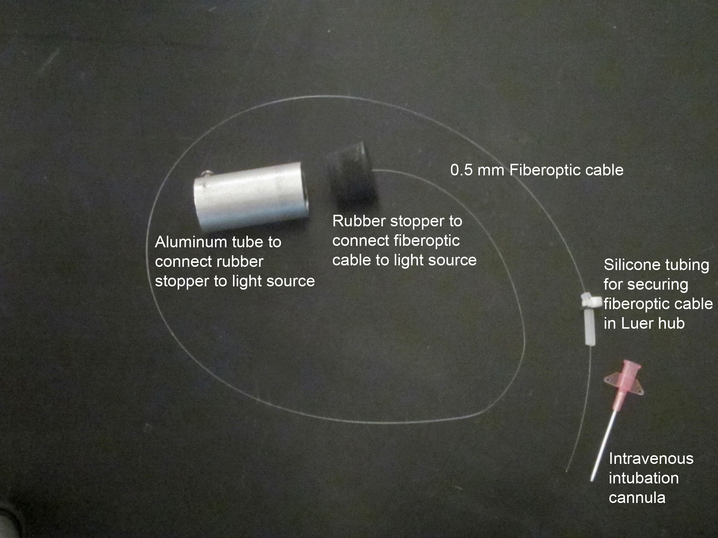

Figure 1. Picture showing items used for intubation. The fiberoptic cable is shown inserted into rubber stopper, with small piece of silicone rubber tubing tied near the opposite end. A short piece of aluminum tubing is used to connect the rubber stopper to the light source as shown in Figure 2.

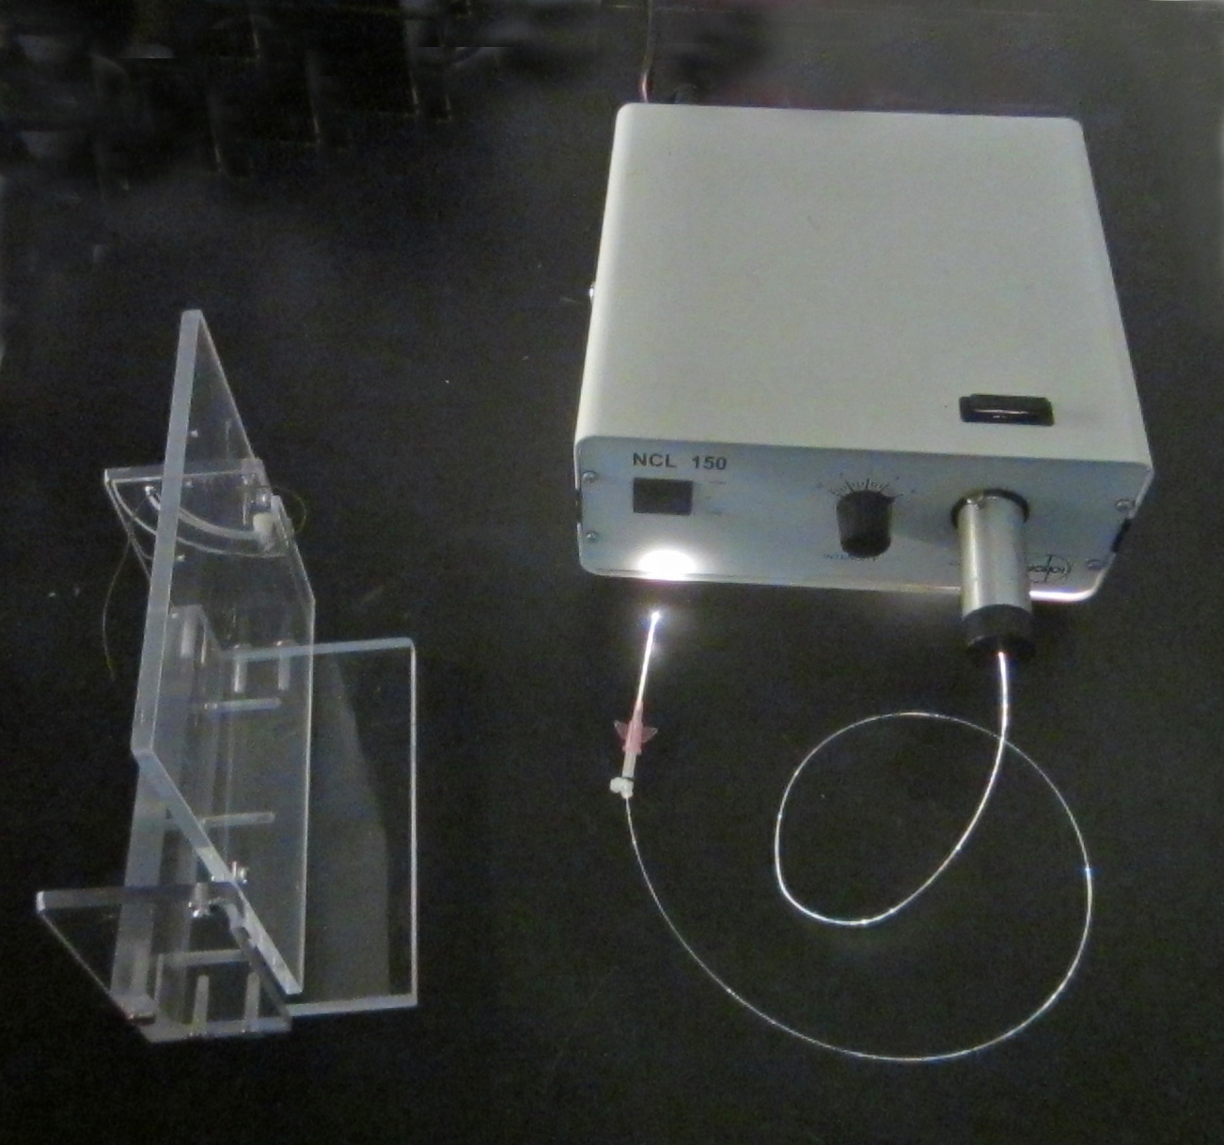

Figure 2. Picture showing rubber stopper connected to light source with other end of fiberoptic cable inserted through the intubation cannula. A simple support stand to hold the mouse during intubation is also shown on the left.

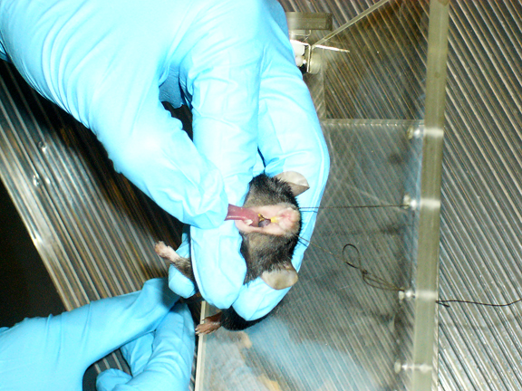
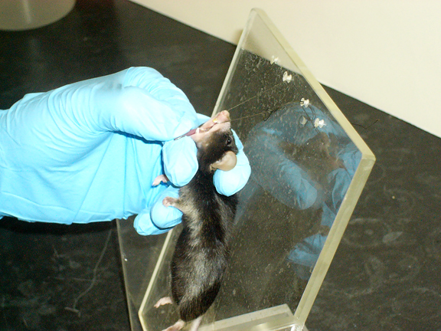

Figure 3. Two perspectives showing the position of mouse readied for intubation.

Lung Resistance
cmH₂0/mL/s

Figure 4. Lung resistance from each of 4 mice (in different colors) measured at 5 weekly intervals.

