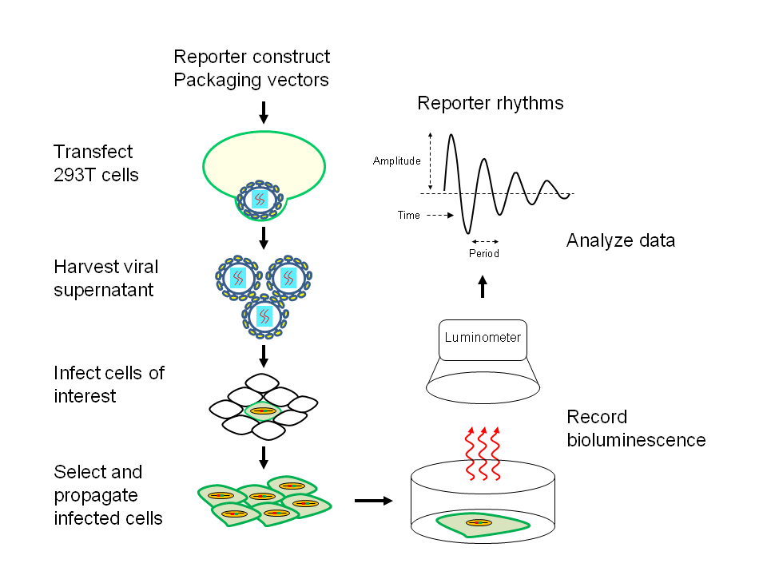
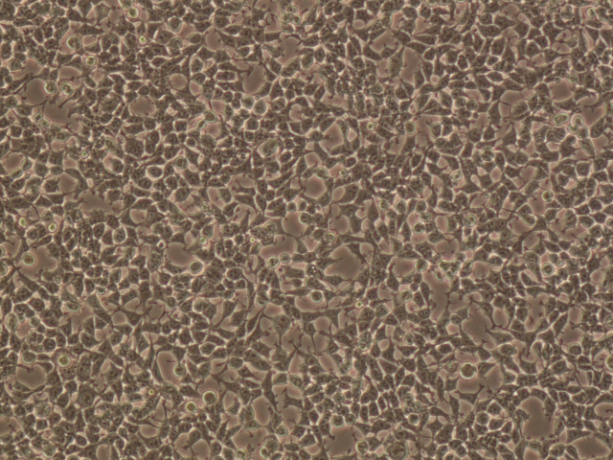
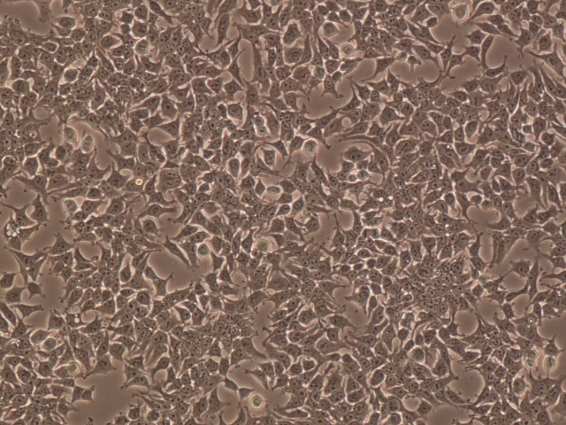
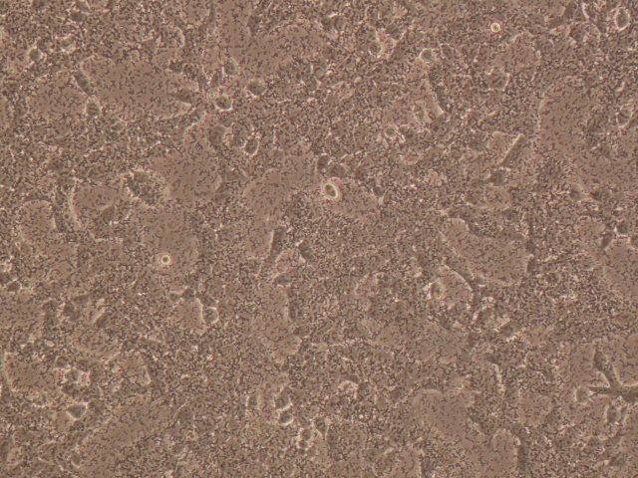
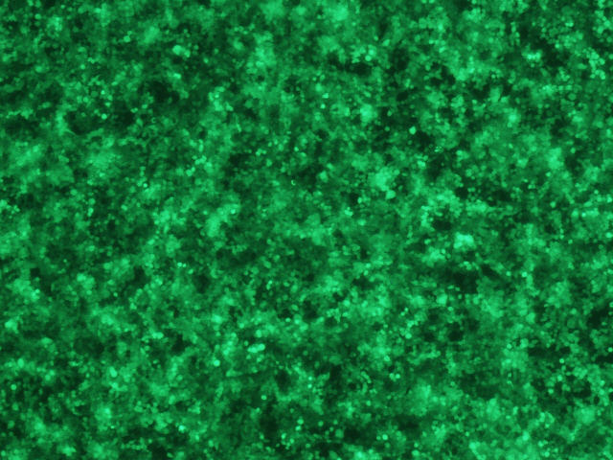
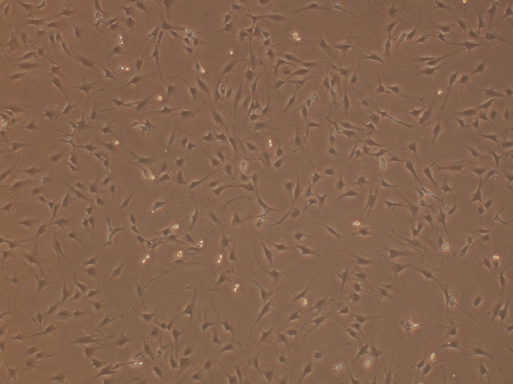
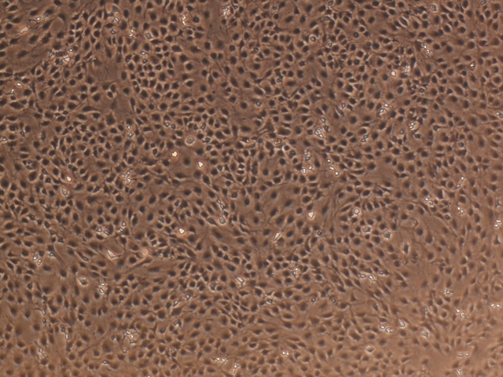
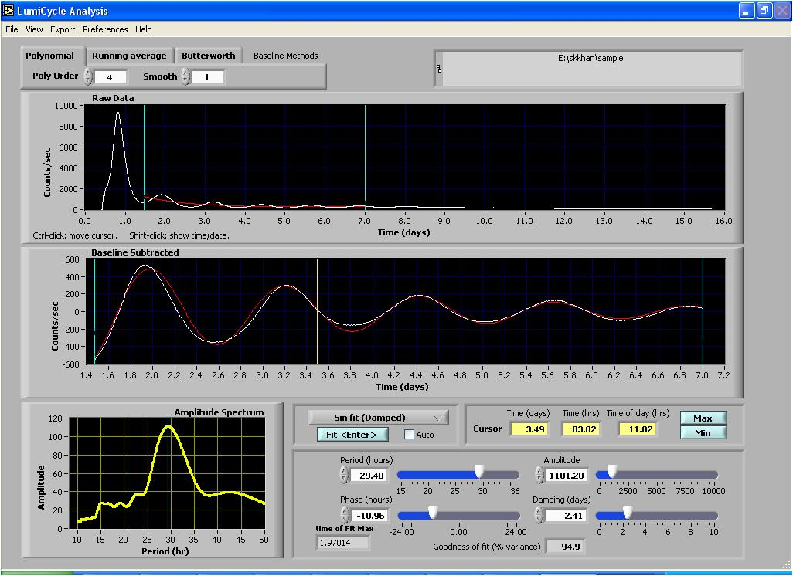
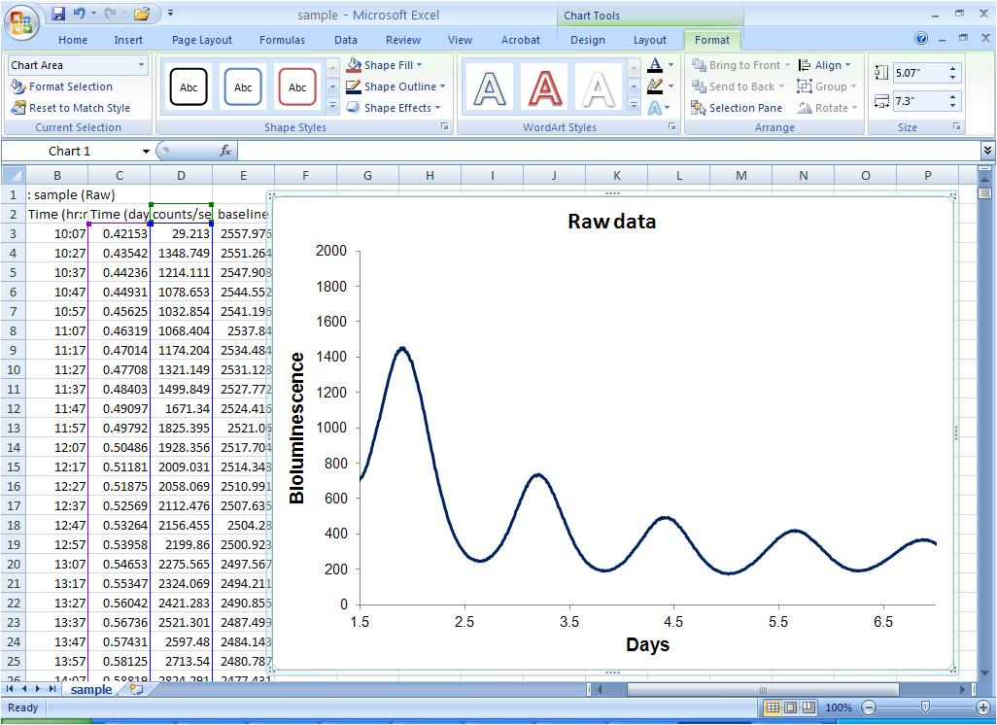
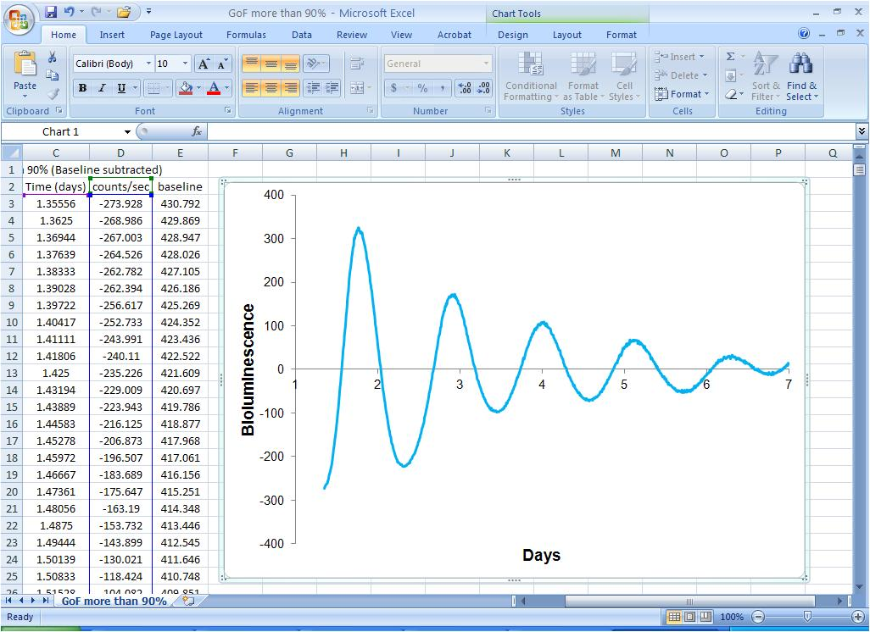
Submission ID #: 4234
Editor Name: Pallavi R. Devchand
Videographer name: Brent Wheeler
Film Date: 10 April, 2012
Authors and Affiliations: Chidambaram Ramanathan, Sanjoy K. Khan, Nimish D. Kathale, Haiyan Xu, Andrew C. Liu.
Department of Biological Sciences, The University of Memphis, Memphis, TN 38152 USA
Title: Monitoring Cell-Autonomous Circadian Clock Rhythms of Gene Expression Using Luciferase Bioluminescence Reporters
Corresponding Author: acliu@memphis.edu

Authors, please fill out the brief questionnaire below.

A. Will you require JoVE to record video microscopy, such as filming a complex dissection or microinjection technique? (Y/N) ___N_____ If yes, please list make and model of your microscope: ______________________________
B. Does your protocol include detailed, step-by-step, descriptions of software usage? (Y/N)____N___
C. Which steps of your protocol will viewers benefit most from having filmed? Please list 4-6 steps:
1. Efficient transfection of 293T cells for viral production (rapidly growing, low passage 293T cells, proper seeding, fine particle formation, and high GFP expression)
2. Proper handling of lentivirus (biosafety concern)
3. Infection efficiency (viral titer, ultracentrifugation if necessary, proper seeding of cells to be infected)
4. Bioluminescence recording (optimization of recording medium, synchronization, temperature control of recording device, sealing of dish/plate).
D. What is the single most difficult aspect of this procedure and what do you do to ensure success?
Preparation of reporter viral particles.
Make sure to use rapidly growing, low passage 293T cells and obtain proper seeding of cells, fine particle formation, and high GFP expression.

1. Introduction (Schematic Overview and Interview)

A. Schematic Overview (read by voice talent at JoVE):
Authors, please select from “Procedural Narrative” or “Conceptual Narrative” and complete the statements below. Please do not add additional steps. Then, attach your finished graphic overview. See accompanying instructions for details and examples.

Procedural Narrative:

This protocol details the generation of luciferase reporter cell lines, and the subsequent monitoring of cell-autonomous circadian rhythms of bioluminescence expression. (Intro) First construct the lentiviral luciferase expression reporters and produce lentiviral particles (1). Proceed to infect the cells of interest, and amplify selected cultures (2). Then monitor the bioluminescence expression in synchronized reporter cells using an appropriate recording device (3). Ultimately, bioluminescence recording is used to demonstrate cell-autonomous circadian rhythms (4).
1. Schematic figure: start upper left (transfect and harvest)
2. Schematic figure: infect and select
3. Schematic figure: right column (record bioluminescence – lower two images on right
4. Schematic figure: reporter rhythms graphs

B. Interview: (Said by you on camera. Don’t forget to smile!)

Authors: Below are statements we would like you to complete that are complementary to the information contained within the schematic overview.
- Only one statement should be chosen and completed per author who will be on camera demonstrating the protocol.
- Enter the name of the individual who will say each line.
- Please choose and fill out the statement(s) that convey the most important fact(s) about your protocol. You may revise the given prompts as necessary to improve the sentence flow.
- If any individuals will be doing demonstrations on camera but are not assigned a speaking part in this interview section, please use statement 1.8 to introduce these demonstrators (for example, the PI introduces students)

  - Chida Ramanathan: The main advantage of this technique over existing methods, like transient transfection and germline production, is that lentivirus-mediated gene delivery provides stable integration into the cell’s genome, as well as greater efficiency and versatility.
Original
  - Sanjoy Khan: This method can help answer key questions in the circadian clock field, such as presence and properties of cell type-specific clocks.
Revised
Sanjoy Khan: This method can help answer key questions in the field of circadian clock research. For example, are there tissue specific circadian clocks? If so, what are the properties of tissue-specific clocks?

  - Nimish Kathale: Though this method can provide insights into clock mechanisms, it can also be applied to other systems, such as the dynamics of cell cycle, tumorigenesis, etc.
  - Hedy Xu: We first had the idea for this method, when we decided to study tissue- or cell type-specific circadian clocks.
  - ** Andrew Liu: Demonstrating the procedure will be Dr. Chida Ramanathan, a postdoc fellow, and Sanjoy Khan, a graduate student from my laboratory.
    - Interview style: Author saying the above
    - The named technician, post doc, student looks up from workbench or desk or microscope and acknowledges the camera.

Protocol (read by voice talent at JoVE):

Authors: In order to ensure that your protocol can be filmed in a single day, the protocol text must be limited to 30 steps – each step being defined as 3 lines of 12 pt text in our formatting style below. This amounts to 3 pages of protocol text. The scope of the scripted protocol text should include only those aspects of the procedure that require visualization in order to be well understood.

- Construction of lentiviral luciferase reporters
  - Typically, a mammalian circadian reporter construct contains an expression cassette in which a circadian promoter is fused with the luciferase gene.
    - SECTION TITLE

  - In this lentiviral reporter, the destabilized luciferase is under control of the mouse Per2 promoter. To enhance gene expression, post-transcriptional regulatory element sequences from a woodchuck hepatitis virus are inserted immediately downstream of the expression cassette.
    - LAB MEDIA: Figure 1A, top construct only. (highlight Per2 and then the WPRE)

  - For detailed instructions on constructing reporter vectors by recombination reaction consult the accompanying manuscript.
    - LAB MEDIA: Figure 1A - both constructs

- Production of lentiviral particles: Seed cells (Day 1)

  - For efficient transfection, start with a culture of human embryonic kidney cells of low passage number that are 90 to 100% confluent [Text over video: HEK293T in complete DMEM]

    - WIDE/MED: Talent places 10cm culture dishes under scope.
    - SCOPE: Talent focuses on 90-100% confluent HEK293 cells

  - Now, to coat 6-well culture plates for the transfection, add 1 ml of 0.001% poly-L-lysine to each well, incubate at room temperature for 20 min and rinse once with PBS.

    - MED/CU: Talent adds 1 ml of 0.001% poly-L-lysine to a 6-well plate.
    - ECU: Talent sets timer for 20 min
    - CU: Talent rinses a well once with PBS.

  - Next, harvest the cells using trypsin, and seed the cells onto each well of the pre-coated plates [Text over video: 0.75 x 10⁶ cells / 2 ml DMEM]. Swirl the plates to obtain an even distribution of cells. Culture the cells overnight [Text over video: 5% CO₂, 37°C].

    - MED-over-the-shoulder: Talent harvests trypsinized cells from plate
    - ECU: Talent seeds the cells onto last well of the pre-coated plate, and swirls the plate.
    - MED: Talent places the plate in the incubator.

- Transient transfection: CaPO₄/DNA precipitation (Day 2)

  - Verify that the seeded cells have reached confluence of 80-90%.

    - SCOPE: Cells at 80-90% confluence

  - In a 1.5 ml microcentrifuge, prepare the plasmid transfection mix of a lentiviral reporter plasmid DNA and the three packaging vectors [Text over video: 2 µg pLV7-P(Per2)-dLuc, 1.3 µg Gag/Pol, 0.5 µg Rev, and 0.7 µg VSVG ].

    - CU/ECU: In a 1.5 ml microcentrifuge, Talent adds plasmid DNA.

  - As a control for both transfection and subsequent infection, include an additional well for a lentiviral GFP expression vector that harbors the enhanced green fluorescent protein under control of the CMV promoter.

    - LAB MEDIA: Figure 1A, and highlight EGFP on bottom construct

  - Next, add 100 µl of 0.25 M CaCl₂ to the plasmids and mix thoroughly. Then add 100 µl of 2x BBS solution [Text over video: 50 mM BES, 280 mM NaCl, 1.5 mM Na₂HPO₄, pH 6.95] and mix gently but thoroughly. Incubate the DNA mix at room temperature for 15 min.

    - ECU: Talent adds 100 µl of 0.25 M CaCl₂ to the plasmids and mix thoroughly.
(4.4.1 comment: filmed too much, use only CaCl₂ addition which is the first part)
    - ECU: Talent adds 100 µl of 2x BBS solution and mixes gently.
    - CU: Talent sets tube down and starts timer at 15 min.

  - While waiting, replace the medium from the 293T cells with 2 ml fresh medium. Return the plate to the incubator for at least 10 minutes to equilibrate medium pH.

    - MED/CU: Talent replaces the medium from the 293T cells with 2 ml fresh medium.
    - MED/CU: Talent places plate in the incubator

  - Next, in a dropwise fashion, add the transfection mix to the cells. Swirl the plate gently. Observe particle formation under a microscope, and then place the cells in an incubator overnight.

Original
    - ECU: Talent adds the transfection mix to the cell, in a dropwise fashion and swirls the plate gently
    - ECU: Talent swirls the plate gently.

    - MED: Talent focuses microscope on plate to observe particle formation

    - WIDE/MED: Talent places cells in the incubator.

- Harvest viral particles (Days 3-4)

  - About 16 hours post-transfection, [Text over video: cells 100% confluent], replenish the medium with 2 ml of fresh DMEM, and culture overnight.

    - MED/CU: Talent replenishes the medium with 2 ml of fresh DMEM,
    - MED/CU: Talent places cells in incubator.

Note to Editor: two shots were taken for 5.1.1; please use first part of take 1 and last part of take 2.

  - Next, to assess transfection efficiency, evaluate the EGFP expression in the transfection control cells [Text over video: day 4]. Transfection efficiency of 90-100% with high EGFP expression is a reliable predictor of a good viral prep.

    - Reuse shot 4.6.3: Talent places cells under fluorescent scope.

    - SCOPE: Talent focuses on field of cells with transfection efficiency of 90-100%

  - Harvest the medium containing secreted, infectious viral particles. Centrifuge [Text over video: >2,000 g, 5 min] to remove the residual 293T cells, and collect the virus-containing supernatant.

    - MED/CU: Talent harvests the medium containing viral particles.
    - MED/CU: Talent removes tubes from centrifuge.

    - ECU: Talent collects the virus-containing supernatant.
Note to Editor: double shots were taken for 5.3.3 (ECU and MED). Use both shots for 5.3.3
    - CU/ECU: Talent passes some viral supernatant through a 0.45 µm membrane filter.

- Infection of clock cells (Day 3 onward)

  - On day 3, seed ~12,000 3T3 cells on a 12-well plate. Culture overnight to 20-30% confluency and observe the cells on day 4.

    - SECTION TITLE
    - MED/CU: Talent seeds 3T3 cells on a 12-well plate.
    - SCOPE: Talent focuses on field of 3T3 cells at 20-30% confluency.

  - Still on day 4, add polybrene [Text over video: final concentration: 5 µg/ml] to the collected medium containing viral particles and mix well by pipetting. Now aspirate the medium from 3T3 cells, and add 1 ml of viral mixture per well. Incubate at 37°C overnight.

    - ECU: Talent adds polybrene to the collected medium containing viral particles and mixes by pipetting.
Note to Editor: for 6.2.1, shot was taken when talent added the polybrene in three tubes; we suggest that only the last tube part be used in final video.

    - MED/CU: Talent aspirates the medium from 3T3 cells,
    - ECU: Talent adds 1 ml of viral mixture per well.
    - Reuse shot 4.6.3 MED/CU Talent places cells in incubator.

  - After washing cells once with PBS, replenish the medium and incubate the cells at 37°C overnight for recovery and growth. When confluent [Text over video: 1-2 days later], split the cells and culture overnight.

    - MED/CU: Talent adds medium to washed cells
    - MED/CU: Talent places the cells in incubator.
    - SCOPE: Confluent 3T3 cells.

  - The following day [Text over video: cells 50% confluent], to start selection for stably transduced cells, add fresh medium containing 10 µg/ml Blasticidin.

    - MED/CU: Talent adds fresh medium containing 10 µg/ml Blasticidin.

  - Talent: The blasticidin kill-curve needs to be empirically determined for each cell line.

    - Interview style: Author saying the above

  - Replenish the medium containing Blasticidin every 2-3 days, for continuous selection of antibiotic-resistant cells expressing clock reporters [Text over video: 4-6 days total[.

    - MED/over/the/shoulder: Talent replenishes the medium containing Blasticidin

- Synchronization and change to recording medium

  - After propagating the Blasticidin-resistant reporter cells, culture into 35 mm culture dishes until confluent. We usually prepare ≥3 dishes for each reporter cell line under each condition for circadian phenotyping.
    - MED/CU: Talent removes 35 mm cultures from incubator (show label of cells)

  - Talent: We usually prepare ≥3 dishes for each reporter cell line under each condition for circadian phenotyping.
    - Interview style: Author saying the above.

  - After one wash with PBS, add DMEM containing 10 µM forskolin or 200 nM dexamethasone. Incubate at 37°C for 1 hour to synchronize the cells.
    - MED/CU: Talent adds DMEM containing 10 µM forskolin to washed cells.
    - MED/CU: Talent places plates in incubator.

  - Now place the cells in freshly made recording medium. Cover the culture dishes with 40 mm sterile coverslips and seal in place with vacuum grease to prevent evaporation. Alternatively, parafilm can be used to seal the dishes to prevent evaporation.
    - CU: Talent adds recording medium to cells.
    - ECU: Talent covers the culture dishes with 40 mm sterile coverslips and seals in place with vacuum grease.

- Bioluminescence recording of reporter cells

Original

  - Load the dishes onto the LumiCycle luminometer, [Text over video: incubator: 36°C without H₂O or CO₂ ], and start the real-time bioluminescence recording.

    - MED/CU: Talent loads the dishes onto the LumiCycle luminometer,

  - Start the real-time bioluminescence recording.

    - CU/ECU: Talent starts the real-time bioluminescence recording.

Original
  - Talent: For recording of 96-well plates with the Synergy SL2 recording device see the accompanying manuscript. We usually record rhythms for 5-7 days.

    - Interview style: Author saying the above

- Data analysis and presentation

  - In the LumiCycle Analysis program, first baseline-fit the raw data. Then use the baseline-subtracted data to fit to a sine wave, and determine the required parameters.

    - SCREEN: Talent baseline-fits some raw data in LumiCycle Analysis program

  - Talent: For samples that show persistent rhythms, goodness-of-fit of >90% is usually achieved. Due to high transient bioluminescence upon medium change, we usually exclude the first cycle of data from analysis.

    - Interview style: Author saying the above

  - For the data presentation, plot raw data against time. When necessary, plot the baseline-subtracted data to compare amplitude and phase.

    - SCREEN: Talent plots raw data against time.

    - SCREEN: Talent shows plot of baseline-subtracted data, and indicates amplitude and phase.
Note to Editor: we took ECU shot for 9.3.2 where talent points out amplitude and period.
- Results: Phase-specific circadian reporters.
  - In both transient transfection of 293T cells and in infection of cell lines, fluorescent images of the transfected and transduced GFP-expressing cells indicate that the lentiviral mediated gene delivery system is highly efficient.
    - LAB MEDIA: Figure 1A (lower construct) and Figure 1B.

  - The core feedback loop of a circadian clock consists of transcriptional factors (Text over video: Activators: BMAL1 and CLOCK, Repressors: PERs and CRYs ], that act on the circadian enhancer elements to produce rhythmic gene expression. Here, four different reporter constructs in 3T3 cells produce distinct phases of reporter expression.
    - LAB MEDIA: Figure 2 (put in arrows with last sentence)

  - Novel intermediate phases can be generated with combinatorial regulation by multiple circadian elements using gene knockdown via RNAi and pharmacologically active compounds.
    - LAB MEDIA: Figure 3

  - This experiment used the LumiCycle luminometer for bioluminescence recording of cells in 35 mm dishes. In U2OS cells, siRNA was used to illuminate the knock-down effects of Cry1 and Cry2 genes [Text over video: Zhang, E. E. et al. 2009].
    - LAB MEDIA: Figure 3A

  - Here, a Synergy luminometer was used for bioluminescence recording of cells in a 96-well plate. In 3T3 reporter cells, shRNAs were used to evaluate the effects of Cry2 knockdown on cellular rhythms.
    - LAB MEDIA: Figure 3B

  - In this example, the ViewLux system and a Tecan luminometer were used for bioluminescence recordings of cells in 384-well plates. As indicated, selected small molecules can pharmacologically target and perturb protein function in cellular rhythms of U2OS reporter cells.
    - LAB MEDIA: Figure 3C. Highlight Chir99021 (GSK3 inhibitor) assay and Roscovitine (CDK inhibitor) assay with last sentence.

INSTRUCTIONS FOR AUTHORS:
Please ensure that the representative results narration is appropriate and correctly describes your images, movies, or figures. Our editors have ensured that the results are written in our format.

We consider this section a critical aspect of the video, because here is where you provide validation for your experiments. For example, if this is a cell culture preparation, this section is where the video will show your cells at various time points following culturing. If this is an imaging prep, then this part is where you will show examples of your imaging experiments.

Please limit the extent of narration to no more than 2-3 lines of text per image or movie file being described. Figures with multiple panels submitted with the original protocol should be broken up so that each panel is a separate image. Like the schematic, each image or movie file supplied in the results should be referenced by annotation in parenthesis, however for the results, the specific filename should be given in parenthesis.

Below is an example of results text:

EXAMPLE REPRESENTATIVE RESULTS

5. Evaluation of Morpholino Injection and Knockdown
5.1 Representative results of both morpholino injection and mRNA injection are shown here. The
uninjected control at 48 hours post fertilization looks normal, as expected
-LAB MEDIA: 0123_PIname_Figure1.tif (Replace 0123 with your jove video #)

5.2 However, embryos injected with the morpholino heg_e3i3_egfr1, which knocks down Heg isoforms
containing the first of two EGF-like repeats, exhibit brain edema.
-LAB MEDIA: 0123_PIname_Figure2.tif

5.3 Injection of heart of glass mRNA also produced an obvious phenotype. At 24 hours post fertilization,
the heads of the uninjected controls look normal
-LAB MEDIA: 0123_PIname_Figure3.tif

5.4 Conversely, some of the embryos injected with the mRNA exhibit cyclopia
-LAB MEDIA: 0123_PIname_Figure4.jpg

Please visit the following URL to see an example of how the results will look when complete:
http://www.jove.com/video/1597/results-example-mably?access=ksw0bprj

- Conclusion (said by authors on camera)
Authors: Below are statements we would like you to complete that summarize and conclude the video. Only one statement should be chosen and completed per author who will be on camera demonstrating the protocol. In addition to choosing and filling out the appropriate statement, please enter the name of the individual who will say each line. You may revise the given prompts if necessary to better fit your protocol.

  - Chida Ramanathan: After its development, this technique paved the way for researchers in the field of circadian biology to explore clock mechanisms and physiology in different cell and tissue types.
  - Sanjoy Khan: After watching this video, you should have a good understanding of how to generate luciferase reporter cell lines and monitor the bioluminescence rhythms.
  - Chida Ramanathan: Don't forget that working with lentivirus can be extremely hazardous and precautions such as personal protection and viral decontamination should always be taken while performing this procedure.

Provided Media

Authors, Please list all images, movie files, or 3-D rendered animations that can be included in the video per editor’s request. The step in the script/video where these images will be inserted should be specified. For example:

6.2 – 0123_PIname_Figure1.tif - dual color imaging of tumor angiogenesis at 40X
6.2 – 0123_PIname_Figure2.tif - dual color imaging of tumor angiogenesis at 100X

Formats: For static images we prefer .tiff, Illustrator, Powerpoint or Photoshop files at dimensions of at least 720X480 pixels and 300 dpi. The higher resolution, the better. Likewise any exported movie files should have at minimum these dimensions and be rendered to .mov, .mp4, or .avi files.

Insert your media filenames here.

General Preparation

It’s critical for a smooth and organized shoot that all reagents are accounted for, in advance.

Any overnight or long incubation steps should be recognized and specimens/samples be prepared in advance so that prior steps can be recorded and shooting can continue with pre-prepared specimens/samples.

All tubes/flasks should be pre-labeled neatly before we arrive.

Ex. Luciferase assay done in 96 well plates should be labeled with negative/positive control wells and experimental samples are labeled accordingly.

You will receive more detailed preparation instructions, as well as an introduction to your videographer, closer to your filming date.

