Submission ID #: 4226

Editor Name: Nina Nandy MD

Videographer name:

Film Date:

Authors and Affiliations:

Allyson K. Friedman¹
Jessica J. Walsh²
Dipesh Chaudhury¹
Barbara Juarez²
Vincent Vialou²
Scott Russo²
Ming-Hu Han^{1,2}

¹Mount Sinai School of Medicine
Department of Pharmacology and Systems Therapeutics
New York, New York

²Mount Sinai School of Medicine
Department of Neuroscience
Friedman Brain Institute
New York, New York

Title: Social Defeat Stress Paradigm: A mouse model of Depression

Corresponding Author: Ming-Hu Han

Authors, please fill out the brief questionnaire below.

A. Will you require JoVE to record video microscopy, such as filming a complex dissection or microinjection technique (Y/N, please specify steps by number. Also, please list make and model of your microscope)? ______N____
B. Does your protocol include detailed, step-by-step, descriptions of software usage (Y/N, please specify steps by number)? ___N______
C. Which steps of your protocol will viewers benefit most from having filmed? Please list 4-6 steps__3.1-3.4,5.3-5.5,____
D. What is the single most difficult aspect of this procedure and what do you do to ensure success? ___Setting up the social defeat cage and aggressor is very crucial to the success of the paradigm. To ensure success, screening of the aggressor mice, proper bedding and sensory cues is very important.

1. Introduction (Schematic Overview and Interview)

A. Schematic Overview (read by voice talent at JoVE):
Authors, please select from “Procedural Narrative” or “Conceptual Narrative” and complete the statements below. Please do not add additional steps. Then, attach your finished graphic overview. See accompanying instructions for details and examples.

Conceptual Narrative:
The overall goal of the following paradigm is to establish an animal model to study the neurobiological mechanisms underlying stress-related psychiatric disorders such as major depressive disorder ____. (Intro)

This is achieved by repeated exposure to social defeat stress, which induces two robust behavioral phenotypes – clear depressive-like and resilient behaviors._ (P1.)

The second step, a social interaction test, is performed to measure social avoidance. (P2. Can you have the two mice move from the first image into the partitioned-box of the second image?)

Next, a social interaction ratio is determined in order to segregate two long-lasting depressive and resilient behavioral phenotypes in mice. (P3)

Ultimately, a clear depressive-like and resilient phenotype can be obtained in which to explore therapeutics for stress-related psychiatric disorders. (P4)

Paste a copy of your graphic overview here. The original file should be Adobe Illustrator (preferred) or Powerpoint (see instructions) and should be uploaded through your online submission on the JoVE website. Please keep all layers in the file (i.e., do not flatten the file). 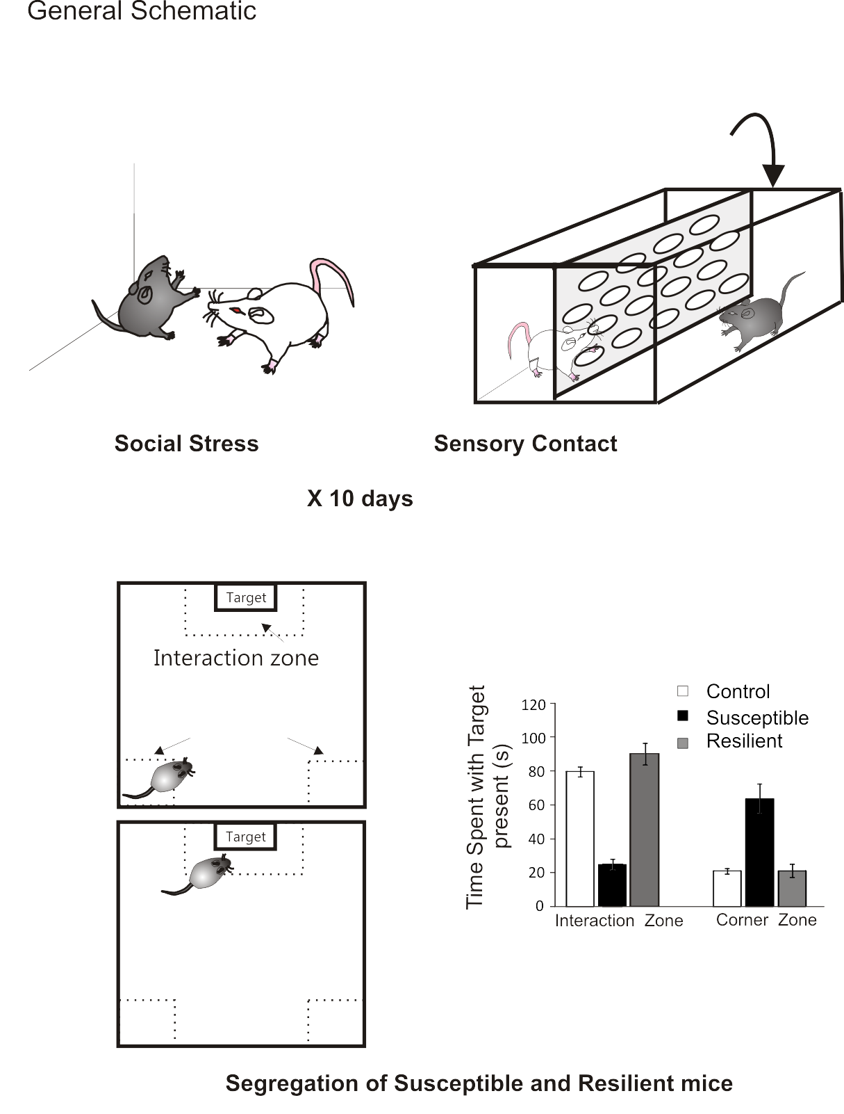
Corner zone

B. Interview: (Said by you on camera. Don’t forget to smile!)

Authors: Below are statements we would like you to complete that are complementary to the information contained within the schematic overview.
- Only one statement should be chosen and completed per author who will be on camera demonstrating the protocol.
- Please choose and fill out the statement(s) that convey the most important fact(s) about your protocol. Revise the given prompts if necessary to improve the sentence flow.,
- Enter the name of the individual who will say each line.
- If any individuals will be doing demonstrations on camera but are not assigned a speaking part in this interview section, please use statement 1.8 to introduce these demonstrators (for example, the PI introduces students)

  - Author name _ Allyson Friedman____: This protocol can help answer key questions in the mood and anxiety disorder__ field, such as _understanding the molecular mechanisms underlying depressive-like disorders____________.

Protocol (read by voice talent at JoVE):

Authors: In order to ensure that your protocol can be filmed in a single day, the protocol text must be limited to 30 steps – each step being defined as 3 lines of 12 pt text in our formatting style below. This amounts to 3 pages of protocol text. The scope of the scripted protocol text should include only those aspects of the procedure that require visualization in order to be well understood.

- Three Day CD1 Mouse Territorial Response Screening
  - Before starting the screening process, place all CD1 retired breeder mice to be screened in a new cage containing wood-chip bedding and allow for acclimation to the new environment. This ensures a territorial response.
    - MED: Talent places CD1 breeder mice in a new cage with wood-chip bedding.
  - On the first day of screening, place one naïve C57 screener mouse, approximately 7-8 weeks in age, into each home cage of the CD1 retired breeder mouse. Observe 5 cages at a time and using a stopwatch, record the time it takes for the CD1 mouse to display an aggressive territorial response toward the newcomer. Remove the screener mouse from the CD1 cage after 5 minutes.
    - MED: Talent places C57 mouse in home cage of CD1 mouse.
    - MED: Talent observes cage and uses stopwatch to record time to aggressive response
    - CU: Talent removes screener mouse from cage after 5 minutes.
    - Show Figure 1A
  - Repeat this screening and recording procedure for the next 2 days. CD1 mice that do not exhibit a consistent aggressive behavior within 1 minute on the 3rd day of screening should NOT be used for this experiment. On average, about 50% CD1 mice qualify for use. CD1 mice can be used for multiple rounds of defeat. The aggressors should be re-screened before the next round of social defeat experiments.
    - MED: Talent repeats screening and recording process (can use footage from 2.2.1 to 2.2.3)
    - MED: Show CD1 mouse not exhibiting aggressive response (acting normally)
- Ten Day Chronic Social Defeat
  - First, let the C57 test mice get used to their new environment for one week. Set up rectangular hamster cages with a steel wire top, two water bottles, wood-chip bedding and a perforated plexiglass divider for each of the 10 C57 test mice and 10 control mice. Make sure each plexiglass divider fits precisely within the cage and exactly fits with the cage top, so the CD1 aggressor cannot pass through the barrier.
    - MED: Talent sets up rectangular hamster cage with steel wire over the top.
    - CU: Show cage with 2 water bottles, wood-chip bedding and plexiglass divider.
    - MED: Talent ensures divider fits in cage and fits exactly with the top of the cage.
  - Next, place the previously- screened aggressor mice in the clear hamster cage on one side of the divider for 24 hours, to ensure establishment of a territorial response.
    - Show Figure 2A
    - CU: Talent places CD1 aggressor mouse in hamster cage on one side of plexiglass divider.
  - On the first day of defeat, place one C57 mouse, about 8-10 weeks in age, into each hamster cage on the same side as the CD1 mouse for 5-10 minutes.
    - CU: Talent places C57 mouse into hamster cage on same side as CD1 mouse.
  - After 5-10 minutes, move the C57 mouse to the opposite side of the plexiglass divider in the same hamster cage in order to allow for continual stressful sensory cues for 24 hours.
    - CU: (Text over video: After 5-10 minutes) Talent moves C57 mouse to opposite side of plexiglass divider in cage.
  - Handle the control mice the same way. Transfer each control mouse from hamster cage to another hamster cage. Control mice should only receive sensory cues from another C57 mouse and should NOT have any interaction with the CD1 aggressor.
    - MED: Talent takes control mouse from hamster cage into another cage containing C57 mouse.
  - The next day, move each C57 mouse to a different hamster cage to interact with a new CD1 aggressor for 5-10 minutes. Then place the C57 mouse across the barrier from its immediate aggressor to receive sensory cues until the next day.
    - CU: (Text over video: The next day) Talent moves C57 mouse to a different cage to interact with a new CD1 mouse, on the same side of the divider as the CD1 mouse.
    - CU: (Text over video: After 5-10 minutes) Talent places C57 mouse on the opposite side of the barrier from the CD1 mouse.
  - Repeat this procedure once a day for ten days. Each day the C57 mouse encounters a novel aggressor for 5-10 minutes. A cohort of 10 animals is the minimum number of defeats recommended for one round of social defeat.
    - MED: (Text over video: Repeat once a day for 10 days) Show prior footage of C57 mouse encountering CD1 mouse ie 3.3.1.
  - On day 10, after the final 5-10 minute interaction time, all C57 test mice, including the control C57 mice should be housed individually.
    - MED: Talent places C57 test mice and control mice into separate cages.
- Sub-threshold Social Defeat Paradigm:
  - To create an alternate sub-threshold social avoidant phenotype, use a one-day social defeat paradigm. Place previously screened aggressor CD1 mice in a shoe-cage for 24 hours to develop a territorial response.
    - Show Figure 2B
    - MED: Talent places CD1 mouse in shoe-cage.
  - The next day, place a C57 mouse on the same side of the divider as the CD1 mouse, and let them interact for 2-5 minutes.
    - CU: Talent places C57 mouse on same side of divider as CD1 mouse.
  - After that, transfer the C57 mouse to the other side of the Plexiglass barrier to receive stressful sensory cues from the CD1 mouse on the other side, for 15 minutes.
    - CU: Talent places C57 mouse on opposite side of Plexiglass barrier.
  - Next, move the C57 mouse to different CD1 mouse cage, and place it on the same side of the barrier as the CD1 mouse, for another 2-5 minutes. This procedure can be repeated 2-3 times to reach a sub-threshold social avoidance.
    - CU: (Text over video: 15 minutes later,) Talent moves C57 mouse to different CD1 cage, placing it on the same side of the barrier as the CD1 mouse (Text over video: for 2 to 5 minutes).
  - When finished, place the C57 mice back in their individual standard mouse cages and give them ad libitum access to food, water and bedding.
    - MED: Talent places C57 mice back in individual cages. (or use prior footage or BROLL mice in cage)
- Social Interaction Test
  - On day 11 following chronic social defeat, or day 2 following sub-threshold social defeat, move the individually-housed C57 test mice and one previously novel un-used CD1 mouse to the behavioral test area 1 hour prior to testing, in order for the mice to acclimate to the red light conditions.
    - MED: Talent moves C57 test mice and one un-used CD1 mouse to behavioral test area.
  - Divide the open field arena into an interaction zone and two opposing corner zones using the Ethovision tracking software. This program measures time spent in each zone, distance travelled, entrances to different zones and travel velocity, which can be used for further comparison.
    - Show Figure 3A
    - MED: Talent divides open field arena into interaction zone and 2 opposing corner zones.
    - SCREEN: Show Ethovision tracking software.
  - Next, place a mesh-plastic target box in the interaction zone. Then, place the first individually-housed test animal in the corner of the open field arena opposite from the empty metal mesh-plastic target box for 2.5 minutes. Record time spent in each zone and distance travelled via video-tracking.
    - CU: Talent places mesh-plastic box in interaction zone.
    - CU: Talent places test animal in corner of open field arena opposite from empty target box
    - Show Figure 3C
    - SCREEN: Talent uses video tracking software to record time and distance.
  - Then remove the C57 mouse from the arena and put it back in its home cage. Wipe the arena clean with Virkon disinfectant solution to remove odor cues and feces.
    - MED: Talent removes C57 mouse and places it back in home cage
    - MED: Talent wipes arena with Virkon disinfectant solution.
  - Next, place a novel CD1 mouse in the metal mesh-plastic target box as a social target in the interaction zone. Make sure this CD1 mouse has not previously interacted with any of the C57 test mice and that the metal mesh is large enough to allow for visual and odor cues. Ensure it has a plastic upper portion to avoid escape- climbing behavior of the CD1 mouse.
    - MED: Talent places novel CD1 mouse in target box as social target in interaction zone.
    - CU: Talent makes sure box is large enough and has plastic upper part to avoid escape-climbing.
  - Now put the C57 mouse back in the arena, at the same corner opposite the target box containing the CD1 mouse. Again, use video tracking to measure the amount of time spent in each zone, for 2.5 minutes.
    - CU: Talent places C57 mouse back into arena, at same corner opposite target box containing CD1 mouse.
    - SCREEN: Talent uses video tracking to measure time spent in each zone.
  - Return the C57 mouse and the CD1 social target mouse to their respective home cages. Be sure to wipe the arena with Virkon solution between each interaction trial. This procedure is repeated for each mouse that underwent social defeat, and each control mouse.
    - MED: Talent returns C57 mouse and CD1 mouse to respective home cages (use prior footage)
    - MED: Talent wipes arena with Virkon (use footage from 5.4.2)

- Social Interaction Ratio and Sucrose Preference
  - To determine the interaction ratio, divide the time the C57 mouse spends in the interaction zone with the target CD1 mouse present by the amount of time spent in the interaction zone with the target CD1 absent, and normalize to 100. (Text over video: Social interaction time= (Time spent in Interaction zone target present/ Time spent in Interaction zone target absent) * 100) C57 mice with scores below 100 are termed susceptible. Those with scores equal to or greater than 100 are termed unsusceptible or resilient. (Text over video: Scores < 100 susceptible. Scores = to or > 100 unsusceptible or resilient.) About 2/3 will be susceptible, with an interaction ratio below 100. Non-stressed control C57 mice typically find social interaction rewarding and will spend significantly longer amounts of time in the interaction zone when it contains a social target.
    - Note: this step is not filmed, just explained with VO and text over video.
  - After the social interaction test, acclimate the C57 test mice to a two-bottle choice by giving access to a two bottles for 24 hours. Acclimation can be done with either 2 water bottles or with 1 of the 2 bottles containing a 1% sucrose solution.
    - CU: Talent gives C57 mice access to two bottles of either water or 1 with water and 1 with sucrose solution.
  - On day 12, weigh or mark fluid levels of each bottle at the beginning of the sucrose preference test period.
    - CU: Talent marks fluid levels at each bottle (Text over video: On Day 12)
  - At either a 6, 12 or 24-hour period measure sucrose consumption, either by weight or level of fluid change. After each measurement, interchange the bottle locations to avoid a side preference. Sucrose preference is represented as percent of sucrose solution consumed by total water consumed.
    - CU: Talent checks weight of mice on scale
    - CU: Talent checks level of fluid in bottle
    - CU: Talent interchanges bottle locations
- Results
  - Typical results of the social defeat paradigm, represented by the time spent in the interaction and corner zones with target and social interaction ratio are shown here. In chronic social defeat, susceptible mice, as depicted by the black bars, spend significantly less time in the interaction zone and significantly more time in the corner zone with the target present.
    - CU: Show entire Figure 4, then pan in and only show Part A of Figure 3
  - Social interaction ratio can also be used as a measure of social avoidance by representing the relative time spent in the interaction zone with and without a social target. Susceptible mice have a significantly lower social interaction ratio, as can be seen here, represented by the black bar. Resilient mice, depicted by the grey bars, behave similarly to control mice, represented by the white bars.
    - CU: Show only Part B of Figure 4
  - Mice that undergo the sub-threshold social defeat, represented by the back bar, or control conditions, represented by the white bar, show no significant difference in the time spent in the interaction zone or corner zone with the target present, as depicted here
    - CU: Show only Part C of Figure 4
  - As can be seen here, there is no significant difference in the interaction ratio between mice that undergo control or sub-threshold social defeat conditions.
    - Show only Part D of Figure 4

INSTRUCTIONS FOR AUTHORS:
Please ensure that the representative results narration is appropriate and correctly describes your images, movies, or figures. Our editors have ensured that the results are written in our format.

We consider this section a critical aspect of the video, because here is where you provide validation for your experiments. For example, if this is a cell culture preparation, this section is where the video will show your cells at various time points following culturing. If this is an imaging prep, then this part is where you will show examples of your imaging experiments.

Please limit the extent of narration to no more than 2-3 lines of text per image or movie file being described. Figures with multiple panels submitted with the original protocol should be broken up so that each panel is a separate image. Like the schematic, each image or movie file supplied in the results should be referenced by annotation in parenthesis, however for the results, the specific filename should be given in parenthesis.

Below is an example of results text:

EXAMPLE REPRESENTATIVE RESULTS

5. Evaluation of Morpholino Injection and Knockdown
5.1 Representative results of both morpholino injection and mRNA injection are shown here. The
uninjected control at 48 hours post fertilization looks normal, as expected
-LAB MEDIA: 0123_PIname_Figure1.tif (Replace 0123 with your jove video #)

5.2 However, embryos injected with the morpholino heg_e3i3_egfr1, which knocks down Heg isoforms
containing the first of two EGF-like repeats, exhibit brain edema.
-LAB MEDIA: 0123_PIname_Figure2.tif

5.3 Injection of heart of glass mRNA also produced an obvious phenotype. At 24 hours post fertilization,
the heads of the uninjected controls look normal
-LAB MEDIA: 0123_PIname_Figure3.tif

5.4 Conversely, some of the embryos injected with the mRNA exhibit cyclopia
-LAB MEDIA: 0123_PIname_Figure4.jpg

Please visit the following URL to see an example of how the results will look when complete:
http://www.jove.com/index/Details.stp?ID=1597

- Conclusion (said by authors on camera)
Authors: Below are statements we would like you to complete that summarize and conclude the video. Only one statement should be chosen and completed per author who will be on camera demonstrating the protocol. In addition to choosing and filling out the appropriate statement, please enter the name of the individual who will say each line. You may revise the given prompts if necessary to better fit your protocol.

  - Author name _Jessica Walsh_______: Following this procedure, other methods like elevated plus maze and open field test_____________ can be performed in order to answer additional questions regarding anxiety _____________.
  - Author name Allyson Friedman________: After its development, this protocol paved the way for researchers in the field of mood disorders to explore neurobiological mechanisms of depression____________ (subdivision of field, disease, natural phenomenon) in _mice_________( model organism, patient demographic, organ system).

Provided Media

Authors, Please list all images, movie files, or 3-D rendered animations that can be included in the video per editor’s request. The step in the script/video where these images will be inserted should be specified. For example:

6.2 – 0123_PIname_Figure1.tif - dual color imaging of tumor angiogenesis at 40X
6.2 – 0123_PIname_Figure2.tif - dual color imaging of tumor angiogenesis at 100X

Formats: For static images we prefer .tiff, Illustrator, Powerpoint or Photoshop files at dimensions of at least 720X480 pixels and 300 dpi. The higher resolution, the better. Likewise any exported movie files should have at minimum these dimensions and be rendered to .mov, .mp4, or .avi files.

Insert your media filenames here.

General Preparation

It’s critical for a smooth and organized shoot that all reagents are accounted for, in advance.

Any overnight or long incubation steps should be recognized and specimens/samples be prepared in advance so that prior steps can be recorded and shooting can continue with pre-prepared specimens/samples.

All tubes/flasks should be pre-labeled neatly before we arrive.

Ex. Luciferase assay done in 96 well plates should be labeled with negative/positive control wells and experimental samples are labeled accordingly.

You will receive more detailed preparation instructions, as well as an introduction to your videographer, closer to your filming date.

