High-throughput assay for quantitative measurement of cleaved PARP-1 in adherent or suspension cells using an infra-red imaging method – In Cell ELISA (ICE).

Hájek P, Bhamrah-Sehmi M, Schwartz D, Murray J,

Authors Affiliations –

- Dr. Petr Hájek
Senior Scientist
Abcam, plc
petr.hajek@abcam.com

- Dr. James Murray
General Manager R&D
Abcam, plc
james.murray@abcam.com

- Dr. Mandeep Bhamrah-Sehmi
Marketing Coordinator
Abcam, plc
mandeep.bhamrah-sehmi@abcam.com

- Daniel Schwartz
Product Manager
Abcam, plc
daniel.schwartz@abcam.com

Keywords:
In-Cell ELISA, Odyssey, apoptosis marker, PARP-1

Short Abstract: (10 words minimum, 50 words maximum)

Quantitative measurement of cleaved PARP-1 in fixed adherent or suspension cells by high-throughput In-Cell ELISA for using infra-red Li-Cor imaging system.

Long Abstract: (150 words minimum, 400 words maximum)

This protocol describes an In-Cell ELISA (ICE) methodology for the quantification of proteins and post-translational modifications in cells by immunocytochemistry with near infrared (IR) fluorescent dye-labeled detection. In this example, the cellular apoptosis marker cleaved PARP-1 is measured in Staurosporine treated human HeLa, HepG2 and HL-60 cells to determine half maximal effective concentration (EC₅₀). The process involves seeding cells in a 96-well microplate where they are grown and treated. Following paraformaldehyde fixation and crosslinking to the plate, cells are then permeablized and blocked. Cleaved PARP-1 is detected using an In-Cell ELISA from the MitoSciences product range (Abcam-Eugene, USA) which contains an anti-cleaved PARP-1 mouse monoclonal antibody validated for specificity and sensitivity.

Quantification of cleaved PARP-1 is achieved by detection with IRDye®-labeled secondary antibody and imaging achieved using LICOR® Odyssey® or Aerius® system. Methods for both cultured adherent and suspension cells are also described in addition to a colorimetric detection method. In-Cell ELISA is advantageous over traditional Western blotting since this technique generates quantitative data, minimizes sample handling, allows high throughput analysis due to simultaneous treatments in a 96 well microplate, and allows a greater dynamic range and sensitivity.

Adherent cells can detach from a solid surface during apoptosis leading to an underestimation of the apoptotic cell proportion. The novel In-Cell ELISA methodology described here was specifically developed to eliminate the loss of apoptotic cells and therefore provides a method for analysis of both adherent and suspension cells. Additionally, the measured analyte signal can be normalized to cell amount determined by Janus Green whole cell staining, to further increase the assay precision.

In general, the rapid fixation of cells in situ, allows stabilization of in vivo protein levels and their post-translational modifications, eliminating the potential for error that could occur during preparation of protein extracts in Western blotting. The entire process is requires approximately 5 hours total assay time divided by an overnight incubation. Commercial kits include all materials, biologicals and reagents for sample analysis.
Protocol

- Seed cells in 96-well plates (Day 1) - Sterile and aseptic techniques should be used for the following steps

The cell line specified below and the cell concentration are provided only as a typical example. The cell line and the seeding concentration are defined by the user. If suspension cells are used, grow and treat the cells in your plate of choice. Suspension cells should transferred to a fresh 96 well plate prior to fixing as described in 4.1. Note that cells should be seeded in concentrations that they do not become over-confluent within the course of their culturing.

  - Seed HeLa cells in provided black-walled clear-bottom 96-well plate at 50,000 cells/well in 50 µl cell culture medium.

  - Cover the plate and leave it at room temperature for 1 hour. This step will help reduce edge effects.

  - Incubate the plate overnight in a 5% CO₂, 37°C incubator.

2. Prepare serial dilution of compound in media (Day 2) - Sterile and aseptic techniques should be used for the following step

The concentrations of the compounds of interest, the gradient of their dilutions and the length of treatment are defined by the user. Staurosporine was used only as a typical example of apoptosis inducer. Prepare sufficient amount of each dilutions to treat cells in triplicates.

2.1 To prepare Staurosporine dilution series prepare a stock of Staurosporine solution at 4.8 mM, 400X the highest tested concentration in DMSO.

2.2 Dilute 4.8 mM Staurosporine 200X in culture media to 24 μM, 2X the final highest tested concentration. The DMSO concentration in this solution is now 0.5%.

2.3 The remaining of the 11-points 3-fold dilution series is than prepared using the 24 μM Staurosporine and media already supplemented with 0.5% DMSO. As the 12th point, include zero Staurosporine (0.5% DMSO in media) control. In this way all dilutions, including the zero compound control have the same concentration of the vehicle (DMSO).

- Treat cells (Day 2) - Sterile and aseptic techniques should be used for the following steps:

The length of treatment is defined by the user. The 6 hours Staurosporine treatment of HeLa cells was used only as typical example.

  - Treat the cells by adding 50 µl/well each of the 12 point Staurosporine dilutions in triplicates. Take care not to dislodge the cells. In this way, the final highest tested Staurosporine concentration is 12 μM and the DMSO concentration in all wells is 0.25%.

  - Place the plate in the 5% CO₂, 37°C incubator for 6 hours.

4. Fix, permeabilize, and block cells (Day 2) -It is essential that the cells are not left to dry at any of the steps described below.

  - Centrifuge the plate with cells at 500 x g for 8 minutes at room temperature. If using suspension cells the grown and treated cells must be transferred from their original vessel to the provided black-walled clear-bottom 96-well plate in 100 µL of media just prior the centrifugation.

  - Fix the cells by adding 100 µl of 8% paraformaldehyde solution in PBS to each well. (Steps 4.2 to 4.4 should be done in a fume hood since paraformaldehyde is toxic.)

  - Immediately centrifuge the plate with cells at 500 x g for 8 minutes at room temperature. Then incubate the plate for additional 15 minutes at room temperature.

  - Gently remove the paraformaldehyde solution, and wash the cells 3 times briefly with PBS. For each wash, rinse each well of the plate with 300 μl PBS.

  - If desired, the plate can be stored for several days at this point. In this case, add 100 μl of PBS to each well of the plate and store the covered plate at 4°C.

  - Gently remove PBS and permeabilize the cells by adding 200 µl of Permeabilization Buffer to each well then incubate plate with shaking at room temperature for 30 minutes.

  - Gently remove the permeabilization buffer and add 200 µl of Blocking Solution to each well then incubate plate with shaking at room temperature for 2 hours.

5. Fluorescent Immunocytochemical staining of cells and Infrared Imaging (Day 2 and 3)

  - Gently remove the blocking solution and add 100 µl of the primary antibody solution to each well. (Note it is recommended to omit primary antibody solution from three wells of each experimental condition to establish a background control.) Cover the plate with provided seal. Incubate the plate with shaking overnight, at 4ºC.

  - After overnight incubation, gently remove the primary antibody solution and wash the cells briefly 3 times. For each wash, rinse each well of the plate with 250 μl Wash Buffer. This step will remove unbound primary antibody.

  - Gently remove the last wash buffer and add 100 µl of the secondary antibody solution to each well. Cover the plate and incubate it with shaking at room temperature for 2 hour protected from light.

  - Gently remove the secondary antibody solution and wash the cells briefly 5 times. For each wash, rinse each well of the plate with 250 μl Wash Buffer. This step will remove unbound secondary antibody. Leave the last wash in the well to prevent the cells from drying.

  - Wipe the bottom of the plate and the reader surface with isopropanol. Place the plate on the scan surface of the LI-COR® Odyssey® or Aerius® near-infrared imaging system.

  - Using LI-COR® Odyssey® imager set image acquisition parameters

Select
- BD Falcon TC plate
- Resolution – 169 mM
- Quality – medium
- Focus offset – 3.5 mm
- 800 channel at Intensity 6.

  - Pre-scan the plate. (White pixels indicate saturation, usually from fibers or other surface contaminants in the 800 channel. Wipe to remove and if necessary reduce the 800 channel intensity.)

  - Scan the plate. (This will take about 10 minutes.)

  - In the Odyssey application software manually adjust the intensity settings. (These adjustments will only change the appearance of the scanned image but do not affect the numerical values of integrated intensities). Export and save the plate image.

  - In the Odyssey application software manually add a grid to the analysis. A grid with custom well diameter 7.0 is recommended to capture the entire well surface from each well of a 96 well plate.

  - Show the raw values of integrated intensities of 800 channel in spreadsheet display. Export and save the data.

6. Whole cell staining

Janus Green whole cell staining is used to normalize immunocytochemical IR signal to correct for differences in cell density caused by variability in the amount of seeded cells or by an effect of drug on cell growth.

  - Gently remove the last wash buffer and add 50 µl of Janus Green stain to each well. Cover the plate and incubate it at room temperature for 5 minutes.

  - Gently remove the stain and wash the cells briefly 5 times in deionized water or until excess dye is removed.

  - Gently remove the last wash, blot to dry and add 200 µl of 0.5 M HCl to each well. Cover the plate and incubate it with shaking at room temperature for 10 minutes.

  - Measure using a LI-COR® Odyssey® scanner in the 700 nm channel or measure OD595 nm using a standard microplate spectrophotometer.

7. Data analysis

  - Correct the raw integrated intensities for the background signal by subtracting the mean integrated intensities of wells incubated in the absence of the primary antibody from all other readings.

  - Divide the background-subtracted integrated intensities by the OD595 values of the corresponding wells. The resulted Janus Green-normalized intensities are corrected to cell amount.

8. Alternate Colorimetric Immunocytochemical staining of cells and imaging

  - Gently aspirate the Blocking Solution and add 100 µl of the Primary Antibody Solution to each well. (Note it is recommended to omit primary antibody solution from some wells to establish a background control. Cover the plates with the lids and seal. Incubate the plates overnight, at 4ºC.

  - After overnight incubation, gently aspirate the Primary Antibody Solution and wash the cells by adding 250 µl of 0.05% Tween-20 in PBS three times to each well. This step will remove unbound primary antibodies.

  - Gently aspirate the last wash and add 100 µl of an HRP conjugated Secondary Antibody Solution to each well. Cover the plates and incubate them at room temperature for 1 hour protected from light.

  - Gently aspirate the Secondary Antibody Solution and wash the cells by adding 250 µl of 0.05% Tween-20 in PBS four times to each well. Leave the last wash in the well to prevent the cells from drying.

  - Immediately before us prepare fresh streptavidin/HRP in Incubation Buffer and add 50 µL to each well and incubate at room temperature for 1 hour at room temperature.

  - Aspirate each well and wash, repeat this once more for a total of two washes. Wash by aspiration or decanting the liquid form the wells then dispensing 300 µL of wash buffer into each well as described above.

  - Add 50 µL of TMD Development solution to each well and immediately record the blue color development over elapsed time in a microplate reader.

Representative Results:

Figure 1. Determination of Staurosporine EC₅₀ of the PARP-1 cleavage. As described in the protocol, adherent cells (HeLa and HepG2) were seeded at 50,000 per well, allowed to attach overnight and treated for 6 hours with Staurosporine. Suspension cells (HL-60) were treated for 6 hours with Staurosporine as indicated in a 96 well plate, and about 300,000 of treated cells was directly transferred (in media containing 10% serum) from each well into wells of the provided assay plate. The treated cells were then fixed and the plates were analyzed by ICE to measure the cleaved PARP-1 using ab110215. Mean and standard error of the mean (n=3) of the cleaved PARP-1 normalized to cell amount is shown. The Staurosporine EC₅₀ of PARP-1 cleavage in HeLa and HL-60 cells are, respectively, 0.34 μM and 0.41 μM. Note HepG2 cells are resistant to undergoing apoptosis when treated for 6 hours with up to 12 μM Staurosporine, consistent with all of our previous observations.

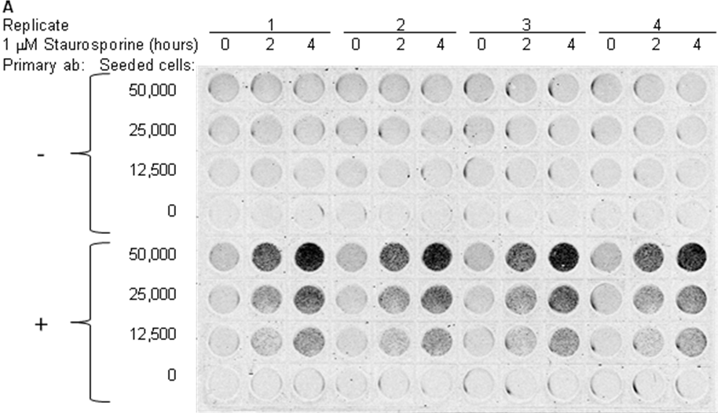
Figure 2. Cell number- and treatment time-dependence of PARP-1 cleavage in adherent cells induced to undergo apoptosis. HeLa cells were seeded as indicated, allowed to attach overnight, treated with Staurosporine (STS) and fixed. The plate was analyzed by ICE to measure cleaved PARP-1 using ab110215 protocol. Image of the scanned assay plate at 800 channel is shown.

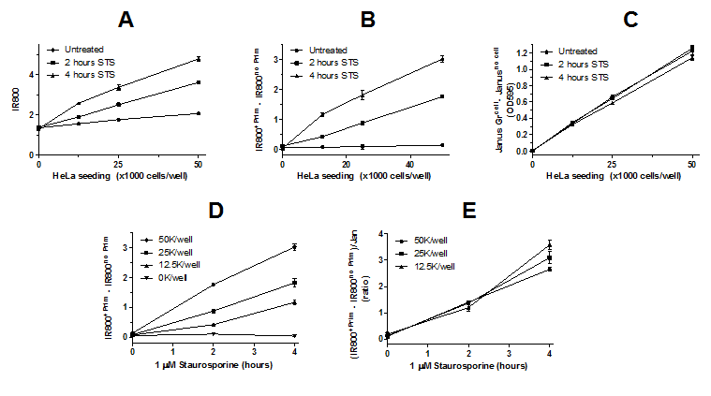

Figure 3. Sequential stages of data analysis and various plots of experiment described in Figure 2. Mean and standard error of the mean (n=4) is shown. (A) Raw values of
IR800 signal (Integrated Intensities). (B and D) Cleaved PARP-1 IR800 signal after subtraction of background signal (signal in the absence of primary antibody [Prim]). (C) Cell amount measured by Janus Green whole cell stain. Note no or very small differences between Janus Green staining of treated and untreated cells indicating that the treated cells undergoing apoptosis are efficiently cross-linked to the assay plate. (E) Cleaved PARP-1 normalized to cell amount as ratio of IR800 signal (after background signal subtraction) to Janus Green. Note that the normalized cleaved PARP-1
signal is independent of number of cells seeded.

Disclosures:

The authors are employees of Abcam, Plc.

Table of specific reagents and equipment:

Reagent or Material | Company | Catalogue # | Comments
PARP-1 (cleaved) In-Cell ELISA Kit (IR): | Abcam | ab110215
10X Phosphate Buffered Saline (PBS) |  |  | Part # 8209706
100X Triton X-100 (10% solution) |  |  | Part # 8209707
400X Tween – 20 (20% solution) |  |  | Part # 8209708
500X Primary Antibody |  |  | Part # 8209737
1000X IRDye®800-labeled Secondary Antibody |  |  | Part # 8209724
1X Janus Green Stain |  |  | Part # 8209709
Sterile 96-well Assay Plate |  |  | Part # 8200010
Plate Seals |  |  | Part # 5201089
10X Blocking Solution |  |  | Part # 8203023
Odyssey® or Aerius® Infrared imaging system | LI-COR | - | -
Microplate Centrifuge | - | - | Any
Paraformaldehyde | Sigma | 47608 | Or similar
Deionized water | - | - | -
Multichannel and standard pippettes | - | - | -
Hydrochloric acid | Sigma | H1758 | Or similar

