High-throughput assay for quantitative measurement of cleaved PARP-1 in adherent or suspension cells using infra-red imaging method.

Hajek P, Murray J, Schwartz D, Bhamrah-Sehmi M

Authors Affiliations –

- Dr. Petr Hajek
Senior Scientist
Mitosciences, Inc.
Petr.hajek@abcam.com

- Dr. James Murray
General Manager R&D
Mitosciences, Inc.
james.murray@abcam.com

- Dr. Mandeep Bhamrah-Sehmi
Marketing Coordinator
Abcam, plc
mandeep.bhamrah-sehmi@abcam.com

- Daniel Schwartz
Product Manager
Mitosciences, Inc
daniel.schwartz@bcam.com

Keywords:
In-Cell ELISA, Odyssey, apoptosis marker, PARP-1

Short Abstract: (10 words minimum, 50 words maximum)

Quantitative measurement of cleaved PARP-1 in fixed adherent or suspension cells by high-throughput In-Cell ELISA using infra-red Li-Cor imaging system.

Long Abstract: (150 words minimum, 400 words maximum)

This protocol describes a method In-Cell ELISA technology for the quantification of post-translational modifications in cells by immunocytochemistry with near IR fluorescent dye-labeled detection. In this example, cleaved PARP-1 is measured in Staurosporine treated HeLa, HepG2 and HL-60 cells to determine EC₅₀. The process involves seeding of cells in a 96-well microplate where they are grown and treated. Following paraformaldehyde fixation and crosslinking to the plate, cells are then permeablized and blocked. Cleaved PARP-1 is detected using monoclonal antibodies developed by MitoSciences (Abcam Eugene) highly validated for specificity and sensitivity. Quantification of cleaved PARP-1 is performed by detection with IRDye®-labeled secondary antibody and imaging achieved using LICOR® Odyssey® or Aerius® system. Alternative methods for both cultured adherent and suspension cells are described in addition to an alternative colorimetric detection method. The advantages of In-Cell ELISA over traditional methods such as Western blotting are that this technique generates quantitative data, allows high throughput analysis due to simultaneous treatments in a 96 well microplate and utilizes a greater dynamic range and sensitivity of direct detection.

The In-Cell ELISA of cleaved PARP-1 was specifically developed to eliminate the loss of apoptotic cells as adherent cells undergoing apoptosis readily detach from a culture plate. This cell detachment often leads to their loss and thus underestimation of apoptotic cell proportions. Using an alternate optimized method, suspension cells may also be measured. Additionally, the measured analyte signal can be normalized to cell amount, measured by the provided Janus Green whole cell stain, to further increase the assay precision.

In general, the rapid fixation of cells in situ, allows stabilization of in vivo protein levels and their post-translational modifications, eliminating the potential for error that could occur during preparation of protein extracts in Western blotting. The entire process requires approximately 5 hours total assay time divided by an overnight incubation. Commercial kits include all materials, biologicals and reagents for sample analysis.
A) Length – JoVE is not able to film an unlimited amount of content for a single video article. Though there is no limit to the length of the protocol text in your submission, JoVE will only be able to film three pages of text formatted according to the example below. If your protocol will exceed 3 pages, please highlight the steps and sections that you think are essential for filming.
B) Style – Your text protocol submission should be a step-by-step description of the experimental procedure. Background information about the procedure should be introduced into the long abstract and not be included into the protocol text.
Describe procedure in sufficient detail so that the work can be reproduced. Please use complete sentences, and write with a style similar to the example below, so that the protocol sounds natural when read. Ultimately we will create a voiceover from this protocol for your video.
C) Format – Your protocol should be formatted to closely match the example below, with major sections being given a single digit number and individual steps within each section being given a two digit number. Single steps should not exceed 6 lines of text and a space should be inserted between steps of the protocol. 12 pt Arial, Calibiri, or Times New Roman font should be used throughout the document.

Protocol

- Seed cells in 96-well plates (Day 1) - Sterile and aseptic techniques should be used for the following steps

The cell line specified below and the cell concentration are provided only as typical example. The cell line and the seeding concentration are defined by the user. If suspension cells are used, grow and treat the cells in your plate of choice. The suspension cells can’t be grown and treated in the provided plate to achieve optimum results. Note that cells should be seeded in concentrations at which they do not become over-confluent within the course of their culturing.

  - Seed HeLa cells in provided black-walled clear-bottom 96-well plate at 50,000 cells/well in 100 µl cell culture medium.

  - Cover the plate and leave it at room temperature for 1 hour. This step will help reduce edge effects.

  - Incubate the plate overnight in a 5% CO₂, 37°C incubator.

2. Prepare serial dilution of compound in media (Day 2) - Sterile and aseptic techniques should be used for the following step

The concentrations of the compounds of interest, the gradient of their dilutions and the length of treatment are defined by the user. Staurosporine was used only as a typical example of apoptosis inducer. Prepare sufficient amount of each dilution to treat cells in triplicates.

2.1 To prepare Staurosporine dilution series prepare a stock of Staurosporine solution at 2.4 mM, 200X the highest tested concentration in DMSO.

2.2 Dilute the Staurosporine stock 200X in culture media to final 12 μM, the final highest tested concentration. The DMSO concentration in this media is now 0.5%.

2.3 The remaining of the 11-point 3-fold dilution series is then prepared using the 12 uM Staurosporine and media already supplemented with 0.5% DMSO. As the 12th point, include zero Staurosporine (0.25% DMSO in media) control. In this way all dilutions, including the zero compound control have the same concentration of the vehicle (DMSO).

- Treat cells (Day 2) - Sterile and aseptic techniques should be used for the following steps:

The length of treatment is defined by the user. The 4 hours Staurosporine treatment of HeLa cells was used only as typical example.

  - Remove the cell culture medium from all wells and add 100 µl/well each of the 12 point Staurosporine dilutions in triplicates. Take care not to dislodge or dry out the cells.

  - Place the plate in the 5% CO₂, 37°C incubator for 6 hours.

4. Fix, permeabilize, and block cells (Day 2) -It is essential that the cells are not left to dry at any of the steps described below.

  - Centrifuge the plate with cells at 500 x g for 8 minutes at room temperature. If using suspension cells the grown and treated cells must be transferred from their original vessel to the provided black-walled clear-bottom 96-well plate in 100 µL of media just prior the centrifugation.

  - Fix the cells by adding 100 µl of 8% paraformaldehyde solution in PBS to each well. (Steps 4.2 to 4.4 should be done in a fume hood since paraformaldehyde is toxic.)

  - Immediately centrifuge the plate with cells at 500 x g for 8 minutes at room temperature. Then incubate the plate for additional 15 minutes at room temperature.

  - Gently remove the paraformaldehyde solution, and wash the cells 3 times briefly with PBS. For each wash, rinse each well of the plate with 300 μl PBS.

  - If desired, the plate can be stored for several days at this point. In this case, add 100 μl of PBS to each well of the plate and store the covered plate at 4°C.

  - Gently remove PBS and permeabilize the cells by adding 200 µl of Permeabilization Buffer to each well then incubate plate with shaking at room temperature for 30 minutes.

  - Gently remove the permeabilization buffer and add 200 µl of Blocking Solution to each well then incubate plate with shaking at room temperature for 2 hours.

5. Fluorescent Immunocytochemical staining of cells and Infrared Imaging (Day 2 and 3)

  - Gently remove the blocking solution and add 100 µl of the primary antibody solution to each well. (Note it is recommended to omit primary antibody solution from three wells of each experimental conditions to establish a background control.) Cover the plate and incubate overnight with shaking, at 4ºC.

  - After overnight incubation, gently remove the primary antibody solution and wash the cells briefly 3 times. For each wash, rinse each well of the plate with 250 μl Wash Buffer. This step will remove unbound primary antibody.

  - Gently remove the last wash buffer and add 100 µl of the secondary antibody solution to each well. Cover the plate and incubate it with shaking at room temperature for 2 hour protected from light.

  - Gently remove the secondary antibody solution and wash the cells briefly 5 times. For each wash, rinse each well of the plate with 250 μl Wash Buffer. This step will remove unbound secondary antibody. Leave the last wash in the well to prevent the cells from drying.

  - Wipe the bottom of the plate and the reader surface with isopropanol. Place the plate on the scan surface of the LI-COR® Odyssey® or Aerius® near-infrared imaging system.

  - Using LI-COR® Odyssey® imager set image acquisition parameters

Select
- BD Falcon TC plate
- Resolution – 169 mM
- Quality – medium
- Focus offset – 3.5 mm
- 800 channel at Intensity 6.

  - Pre-scan the plate. (White pixels indicate saturation, usually from fibers or other surface contaminants in the 800 channel. Wipe to remove and if necessary reduce the 800 channel intensity.)

  - Scan the plate. (This will take about 10 minutes.)

  - In the Odyssey application software manually adjust the intensity settings. (These adjustments will only change the appearance of the scanned image but do not affect the numerical values of integrated intensities). Export and save the plate image.

  - In the Odyssey application software manually add a grid to the analysis. A grid with custom well diameter 7.0 is recommended to capture the entire well surface from each well of a 96 well plate.

  - Display the 800 channel raw values of integrated intensities in a spreadsheet. Export and save the data.

6. Whole cell staining

Janus Green whole cell staining is used to normalize immunocytochemical IR signal to correct for differences in cell density caused by variability in the amount of seeded cells or by an effect of drug on cell growth.

  - Gently remove the last wash buffer and add 50 µl of Janus Green stain to each well. Cover the plate and incubate it at room temperature for 5 minutes.

  - Gently remove the stain and wash the cells briefly 5 times in deionized water or until excess dye is removed.

  - Gently remove the last wash, blot to dry and add 200 µl of 0.5 M HCl to each well. Cover the plate and incubate it with shaking at room temperature for 10 minutes.

  - Measure OD595 nm using standard microplate spectrophotometer.

7. Data analysis

  - Correct the raw integrated intensities for the background signal by subtracting the mean integrated intensities of wells incubated in the absence of the primary antibody from all other readings.

  - Divide the background-subtracted integrated intensities by the OD595 values of the corresponding wells. The resulted Janus Green-normalized intensities are corrected to cell amount.

Representative Results: – What happens when the protocol is done correctly? What is the purity of your nucleic acid sample? After performing a cell culture prep, how will the cells look in optimal conditions? What do your labeled cells look like when imaged in vivo using 2-photon laser microscopy? Please add a “representative” outcome to the protocol to show a viewer what a “good” or even “bad” result looks like.

Figure 1. Determination of Staurosporine EC₅₀ of the PARP-1 cleavage. As described in the protocol, adherent cells (HeLa and HepG2) were seeded at 50,000 per well, allowed to attach overnight and treated for 6 hours with Staurosporine. Suspension cells (HL-60) were treated for 6 hours with Staurosporine as indicated in a 96 well plate, and about 300,000 of treated cells were directly transferred (in media containing 10% serum) from each well into wells of the provided assay plate. The treated cells were then fixed and the plates were analyzed by ICE to measure the cleaved PARP-1 using ab110215. Mean and standard error of the mean (n=3) of the cleaved PARP-1 normalized to cell amount is shown. The Staurosporine EC₅₀ of PARP-1 cleavage in HeLa and HL-60 cells are, respectively, 0.34 μM and 0.41 μM. Note HepG2 cells are resistant to undergoing apoptosis when treated for 6 hours with up to 12 μM Staurosporine, consistent with all of our previous observations.

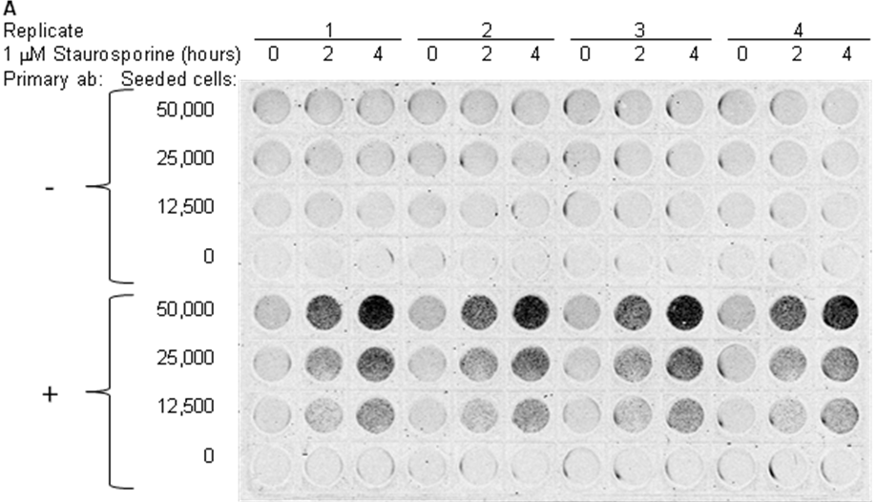
Figure 2. Cell number- and treatment time-dependence of PARP-1 cleavage in adherent cells induced to undergo apoptosis. HeLa cells were seeded as indicated, allowed to attach overnight, treated with Staurosporine (STS) and fixed. The plate was analyzed by ICE to measure cleaved PARP-1 using ab110215 protocol. Image of the scanned assay plate at 800 channel is shown.

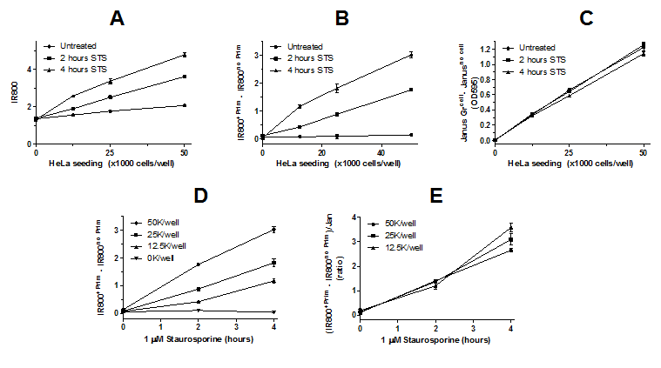

Figure 3. Sequential stages of data analysis and various plots of experiment described in Figure 2. Mean and standard error of the mean (n=4) is shown. (A) Raw values of
IR800 signal (Integrated Intensities). (B and D) Cleaved PARP-1 IR800 signal after subtraction of background signal (signal in the absence of primary antibody [Prim]). (C) Cell amount measured by Janus Green whole cell stain. Note no or very small differences between Janus Green staining of treated and untreated cells indicating that the treated cells undergoing apoptosis are efficiently cross-linked to the assay plate. (E) Cleaved PARP-1 normalized to cell amount as ratio of IR800 signal (after background signal subtraction) to Janus Green. Note that the normalized cleaved PARP-1
signal is independent of number of cells seeded.

Discussion: Short discussion on critical steps, possible modifications, applications, significance, etc…

NA

Acknowledgments: List acknowledgements and funding sources.

Disclosures:

Nothing to disclose.

Table of specific reagents and equipment:

Reagent or Material | Company | Catalogue # | Comments
10X Phosphate Buffered Saline (PBS) | Mitosciences | 8209706 | -
100X Triton X-100 (10% solution) | Mitosciences | 8209707 | -
400X Tween – 20 (20% solution) | Mitosciences | 8209708 | -
500X Primary Antibody | Mitosciences | 8209737 | -
1000X IRDye800-labeled Secondary Antibody | Mitosciences | 8209724 | -
1X Janus Green Stain | Mitosciences | 8209709 | -
Sterile 96-well Assay Plate | Mitosciences | 8200010 | -
Plate Seals | Mitosciences | 5201089 | -
10X Blocking Solution | Mitosciences | 8203023 | -
Odyssey® or Aerius® Infrared imaging system | LI-COR | - | -
Centrifuge | - | - | Any
Paraformaldehyde | Sigma | 47608 | Or similar
Deionized water | - | - | -
Multichannel and standard pippettes | - | - | -
Hydrochloric acid | Sigma | H1758 | Or similar

References:

