Generation of Blast Waves from a Compressed Air-Driven Shock Tube
Authors:
Daniel Kirk
Mark Pereira
Hector Gutierrez
Stanislav I. Svetlov
Kevin Wang
Ronald Hayes
Authors: institution(s)/affiliation(s) for each author:
Daniel Kirk, PhD
Mechanical and Aerospace Department
Florida Institute of Technology
dkirk@fit.edu

Mark Pereira, Graduate Student
Mechanical and Aerospace Department
Florida Institute of Technology
pereiram@my.fit.edu

Hector Gutierrez, PhD
Mechanical and Aerospace Department
Florida Institute of Technology
hgutier@fit.edu

Stanislav Svetlov, MD, PhD
Associate Director
Banyan Biomarkers, Inc.
Alachua, FL 32615
ssvetlov@banyanbio.com

Kevin Wang, PhD
Banyan Biomarkers, Inc.,
Alachua, Florida, 32615
kwang@psychiatry.ufl.edu

Ronald Hayes, PhD
Banyan Biomarkers, Inc.,
Alachua, Florida, 32615

Keywords:
Shock Tubes, open-ended shock tube, Blast waves, Traumatic Brain Injury, Blast simulator, TNT Equivalence
Short Abstract:
This paper presents a novel methodology to simulate blast waves for blast injury studies, using an open-ended shock tube. The artifact is designed to effectively produce blast waves external to the tube and scale experimental data to TNT equivalence.
Long Abstract:
Shock tubes provide means to investigate blast phenomena without the use of explosives. A literature review has shown that several previously reported shock tubes intended for blast wave injury studies were improperly configured, and specimens were often subject to pressure-time artifacts inherent to the device’s operation, rather than pure blast waves. This paper discusses an open-ended shock tube specially designed for blast injury studies, and develops a methodology and guidelines for conducting blast wave experiments and data analysis. It is shown that locating test articles downstream the axis of the shock tube results in pressure-time data significantly contaminated by venting of operational gases. Venting pressure spikes can produce total impulse in an order of magnitude larger than the impulse associated to the intended blast wave, creating an experimental artifact that makes questionable to attribute specimen injury to the blast wave itself. By locating the specimen off-axis the shock tube at various distances away from the exit, blast waves with a wide range of peak overpressures, durations, and impulses can be achieved. This paper also presents a methodology for scaling shock tube generated blast wave data to a TNT equivalent.

Introduction:
The explosion of a conventional bomb generates a blast wave that spreads out spherically from the origin of the explosion. Both the overpressure and time duration of the blast event decrease exponentially with distance from the origin of the explosion, as shown in Fig. 1. Although the physics of blast waves are complex and nonlinear, a blast wave may be broadly characterized by its peak overpressure and the duration of the positive phase of the over pressure event, as shown in Fig. 2. Depending on the type of explosive and the proximity to the target, the positive phase duration can vary between a few microseconds up to several milliseconds [ (1)]. Studies on blast related injuries have shown that peak overpressure, positive phase duration, and transmitted impulse are key parameters that relate to the magnitude of injury. Injury correlations to these parameters have been developed for various organs, such as eardrums and lungs, as well as likelihood of fatality curves for animals and humans in various orientations to the blast waves [ (1) (2) (3) (4)]. Reproducing realistic blast wave signatures in the laboratory without the use of explosives, as well as being able to assess the relative effect of different blast features on injury, is of critical importance to developing an understanding of how blast related injuries occur, and to develop improved protective gear.
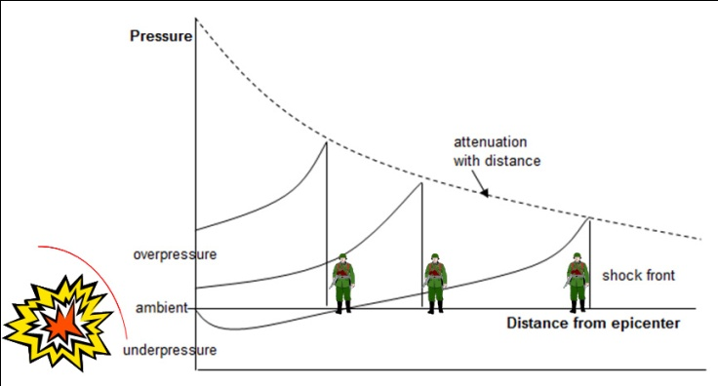 | 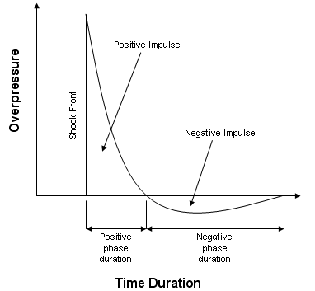
Fig. 1: Pressure decay versus distance to a blast wave. The intensity of the blast wave’s shock front decays exponentially with distance to the explosion. | Fig. 2: Typical pressure-time curve for an explosive blast wave, showing peak overpressure (relative to ambient) and positive phase duration

Shock tubes provide means to investigate blast related phenomena without the use of explosives. A blast wave can be formed by the spherical expansion of an expelled shock from an open-ended shock tube. By varying initial tube pressure settings and specimen locations, a wide range of overpressures, durations, and impulses may be simulated [ (5) (6)]. A recent review of the literature has shown that many shock tubes intended for blast wave studies were not configured properly. As a result specimens located either inside or outside the shock tube were not truly exposed to pure blast wave, but rather subjected to pressure-time artifacts inherent to the device’s operation such as venting [ (7) (5) (8) (3) (9) (10)]. This paper presents a novel methodology for blast wave simulation for injury studies, based on a specially configured open-ended shock tube.

Protocol text:

- Setup of shock tube
  - Set the piston height of Variable Length Driver (VLD) to 10.16 cm that provide a driven-to-driver length (L_{Driven}/L_{Driver} ) ratio = 15 using a driven length of 152.4cm.
  - Set the cross blade distance of the cutter assembly from the diaphragm to 0.84 cm by adjusting the screws
  - Cut the diaphragm from a sheet of foil with a thickness of 0.05 mm into a square of length 6.35 cm

- Operation of shock tube for external pressure field measurement of diaphragm pressure ratio P₄/P₁ = 52.02 and L_{Driven}/L_{Driver} ratio = 15. Make sure all the safety valves are turn off and people around the have safety equipment on i.e. earmuffs and safety glasses.

  - Turn on the data acquisition system and the computer. Open the program that controls the shock tube. Enter in the temperature of the room into the program.
  - Place the diaphragm on top of the cutter section between the two bolts.
  - Set the Variable length Driver (VLD) on top of diaphragm and tighten the bolts.
  - Place the external sensor at the desired radial distance (R) and angle (θ) from the shock tube axis.
  - Set the regulator pressure to 750 psi and open the safety valves
  - Activate the solenoid through the computer that opens the valve and fills up the driver chamber.
  - On successfully firing, record the Mach number of the wave inside the tube and pressure at the sensor located externally, placed at a radial distance (R) and an angle (θ) from the shock tube axis.
    - The computer calculates the Mach number of the shock wave inside the shock tube using two pressure transducers in the driven section, spaced Δd = 20.3 cm apart.
  - Close the safety valves.
  - Repeat the procedure of radial distance (R) of 2.54 cm to 10.16 cm, and angle (θ) of 0, 30, 45 and 60 deg from the shock tube axis.

Representative Results
Characterization of the blast field produced at the exit of a shock tube is critical to understanding the device’s performance. Viscous losses, shock tube end geometry, and other environmental effects contribute to deviations from theory that relates peak blast overpressure and duration at the exit of a shock tube. Characterization involved exposing a pressure transducer to blasts along the shock tube axis (θ = 0°) and at several angles off axis (θ =0, 30°, 45°, 60°) at several distances from the driven exit. A sample data set is shown in Fig. 3 , for P₄/P₁ = 52.02, average Mach number of 2.01 and L_{Driven}/L_{Driver} ratio = 15, for various transducer angles, θ, relative to the axis of the shock tube.
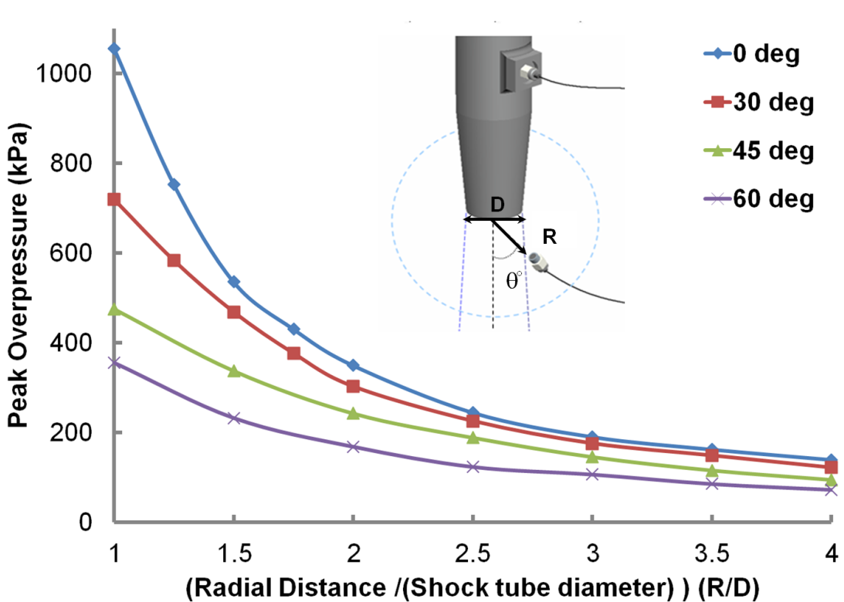
Fig. 3: Peak blast overpressure vs. D for P4/P1 = 52.02 and LDriven/LDriver = 15 at various angles, θ, relative to shock tube axis.

Discussion
Several modifications to a conventional constant area shock tube have been made to facilitate the generation of blast waves over a range of overpressures, durations, and impulses suitable for blast trauma research. The modifications include the driver section, diaphragm cutter section, and pressure sensor probe. The driver section consist of a variable length driver (VLD) assembly that has an adjustable piston to allow the increase or decrease of the volume of the driving gas as shown on the top of Fig. 4. In addition, this variability adjusts the driven-to-driver length ratio that controls the intensity of the spherical blast wave outside the shock tube. Moreover, a critical feature when using a shock tube for blast wave testing is the repeatability of the generated blast events. To improve repeatability, a cutter assembly directly in front of the diaphragm was used (Fig. 4(bottom)). As much as 50% of the predicted incident shock Mach number can be lost due to improper diaphragm opening, whereas up to 90% of the theoretical value can be achieved if the diaphragm opens cleanly [ (5) (11)]. The proposed cutter assembly punctures the diaphragm in a manner that facilitates clean opening. Coarse adjustment of the diaphragm burst pressure can be achieved by changing the diaphragm material or thickness, while fine adjustments can be made by adjusting the spacing between the cutter blades and the diaphragm. Stainless steel diaphragms were used over the course of this study - the diaphragms exhibited a clean opening pattern over the entire range of pressures used.

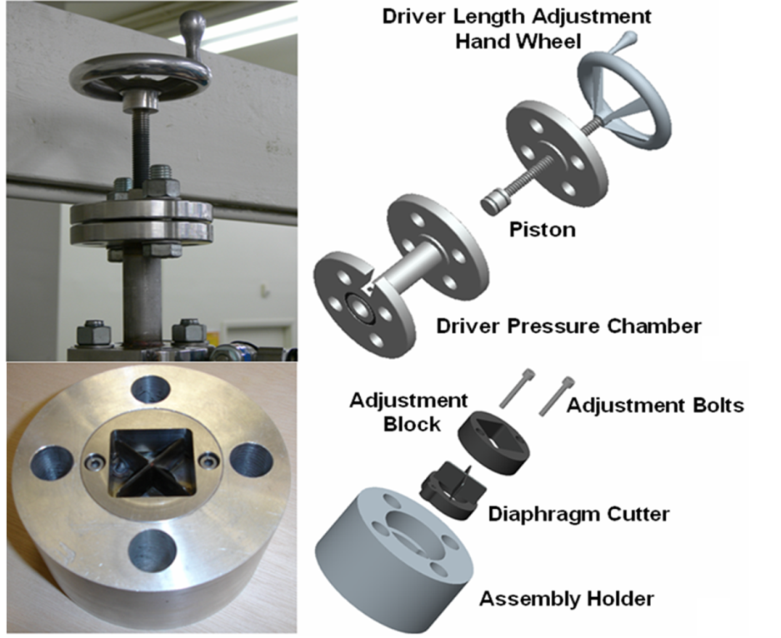
Fig. 4 Adjustable length driver (2.54 cm to 10.16 cm (Top), Adjustable diaphragm cutter assembly (bottom)

A PCB Piezotronics piezoelectric pressure transducer, mounted in a custom made tapered holder (designed to facilitate the propagation of the blast wave) was used, as shown in Fig. 5.Often in the literature only blast wave static pressure is reported. However, the dynamic pressure of the ensuing air blast may have the same or greater magnitude [4, 6, 9]. Future experiments should measure both the dynamic (normal to the wave) and static (perpendicular to the wave) pressure signatures of the blast [19].

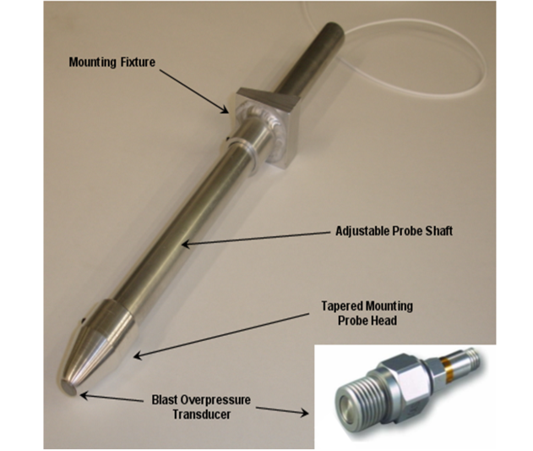
Fig. 5 Piezoelectric pressure transducer (PCB Model: 102A05) and custom tapered transducer mounting probe.

Special consideration was given to properly shaping the exit of the driven section. The blast wave flow field at the end of the shock tube is substantially influenced by the geometry of the end segment of the driven section. Several researchers that used shock tubes for blast testing, used driven sections with flanges of various sizes and geometries welded to their ends. Such flanges tend to introduce reflections of the blast wave at the exit of the shock tube, producing a pressure history at the target that does not accurately mimic a true blast signature. To minimize disturbances of the flow field that can affect achieving the desired pressure history, it is important that the exit of the driven section be tapered as shown in the picture in Fig. 6. This allows free propagation of the blast wave around the end of the driven section, minimizing reflections.
For this study, the one-dimensional blast Mach number was measured using two pressure transducers in the driven, spaced Δd = 20.3 cm apart, near the exit of the tube. The Mach number of the shock wave is calculated using equation (1). Fig. 6 describes the parameter of equation (1) ; Δt the time the shock wave travels from sensor 1 to sensor 2, R_{air} is the ideal gas constant for air and γ is the specific heat ratio of air and T is the temperature of the room.
$$M=\frac{∆d}{∆t*\sqrt{γR_{air}T}}$$ | (1)
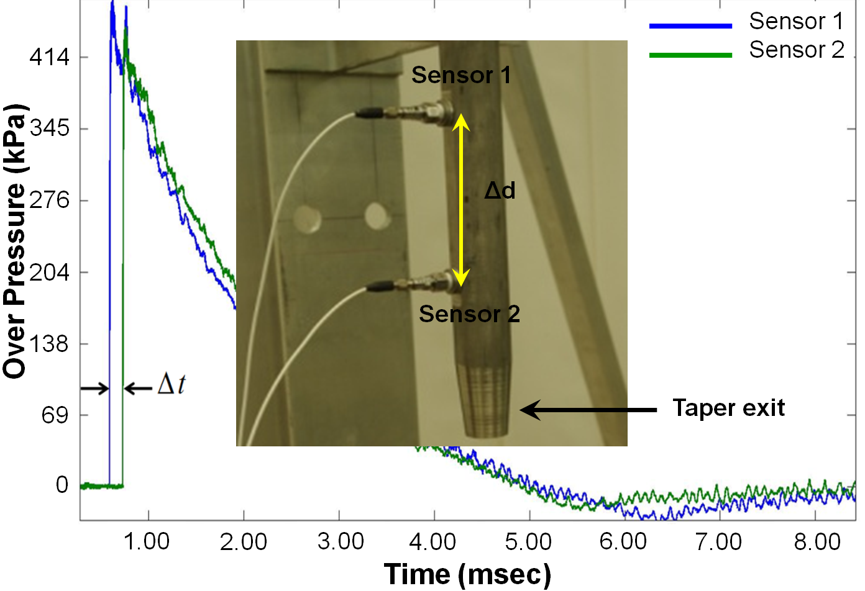
Fig. 6 Graph of internal pressure trace of sensor 1 and sensor 2 used to measure Mach number of the shock wave

In an open-ended shock tube with sufficiently small driven-to-driver length (L_{Driven}/L_{Driver}) ratio, an incident shock wave will exit the driven section and spherically expand. As the shock wave immediately exits the tube, the shape of the wave is in planar form, i.e. one-dimensional. This is depicted on Fig. 7 at point A of the Schlieren image measured at a radial distance to diameter of the shock tube ( R/D) = 0.76 on the axis of the shock tube (i.e. θ = 0 deg) . The sensor registered a peak overpressure of 418 kPa that is identical to the peak overpressure registered inside the tube [(12)(13)]. As the wave opens into three-dimensions, the spherical expansion changes the structure of the flow field behind the wave from a one-dimensional region of uniform pressure and temperature to a region comprised of expansion waves and three-dimensional fluid flow. The expansion waves decrease fluid pressure behind the expanding wave front increasing fluid velocity at the exit of the shock tube and attenuating the expansion of the shock front. At point B of Fig. 7 the sensor placed further from the exit registers a peak overpressure of 130 kPa at a distance of R/D = 3.5 on axis of the shock tube.

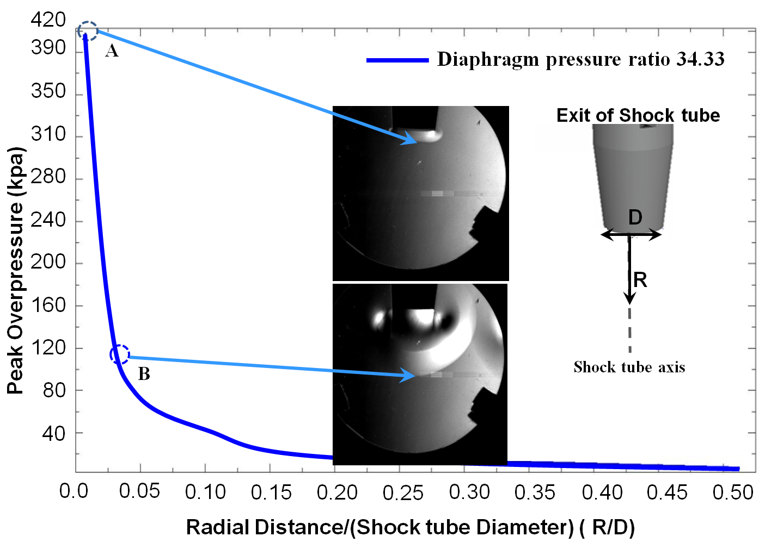
Fig. 7 Peak overpressure of sensor located perpendicular to the flow, on axis ( i.e. at 0 deg from shock tube axis) with a P4/P1=34.33, LDriven/LDriver ratio of 15,and Schlieren images of description of flow
Blast waves originated from explosions are highly complex events that include multiple secondary wave fronts. For simplicity, the present study considers the blast wave at the exit of a shock tube as having only two parts, a primary shock front and a trailing series of expansion waves. If the shock tube has a sufficiently large driven-to-driver length ratio, the reflected expansion will gradually overtake the incident shock, forming a blast wave inside the driven section of the shock tube as shown on Fig. 8. Since the motion of the generated wave is constrained to one-dimension by the walls of the driven section, it attenuates at a much slower rate than a spherical blast wave of the same initial Mach number. Such wave is commonly referred to as a one-dimensional blast wave. When the one-dimensional blast wave exits the tube, it undergoes an expansion similar to that of a shock exiting the driven section, transforming it into a spherical blast wave. Since the original structure of the blast wave was determined prior to the one-dimensional wave exiting the driven, the required distance for spherical blast formation outside the shock tube is smaller compared to the case of a shock [(5)(6)]. The intensity of the spherical blast at the exit of a shock tube formed by a one-dimensional blast can be varied by adjusting both the driven-to-driver length ratio and the diaphragm pressure ratio. Greater flexibility is achieved by varying test conditions at a chosen target location, as compared to a spherical blast formed from a purely incident shock wave. An important factor to consider when designing a shock tube for blast studies is finding the appropriate driven and driver lengths needed to generate the desired blast overpressure at a location outside the shock tube. The driven-to-driver length ratio required to allow the expansion head in the driver to catch up to the incident shock wave when forming a one-dimensional blast is primarily determined by the diaphragm pressure ratio, P₄/P₁, required to create the desired pressure effect at the end of the shock tube. The higher the desired overpressure outside the shock tube, the higher the initial driver pressure required, which corresponds to faster incident shock speeds and, therefore, longer driven lengths. Fig. 9 shows the minimum theoretical driven-to-driver length ratio (L_{Driven}/L_{Driver}) required to allow the reflected expansion head to catch up to the incident shock as a function of diaphragm pressure ratio (P₄/P₁), as illustrated by the wave diagram of Fig. 8

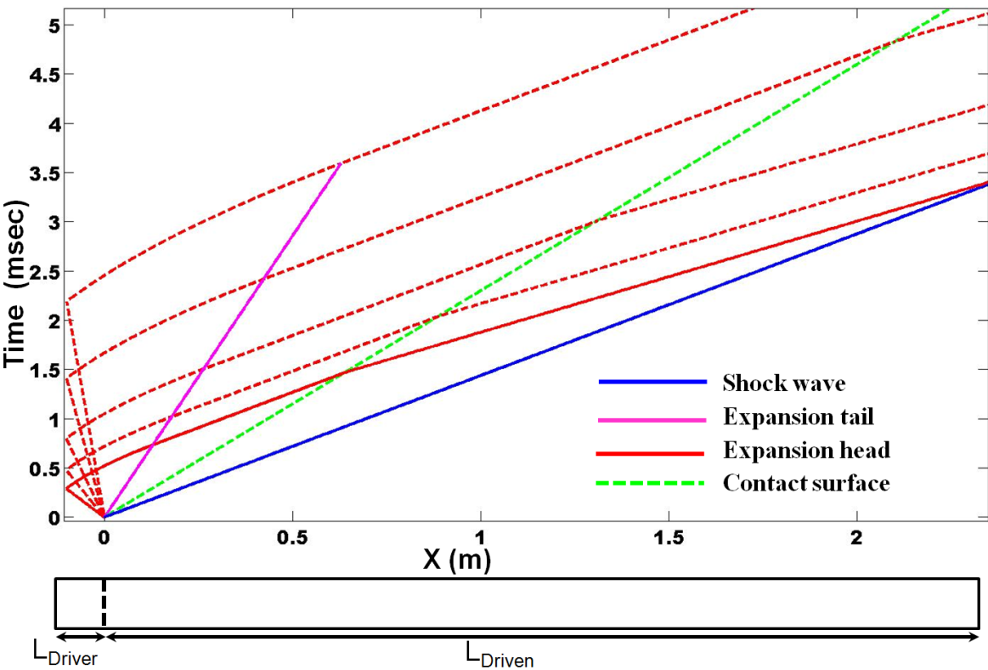
Fig. 8: Wave diagram illustrating blast wave formation inside a shock tube.
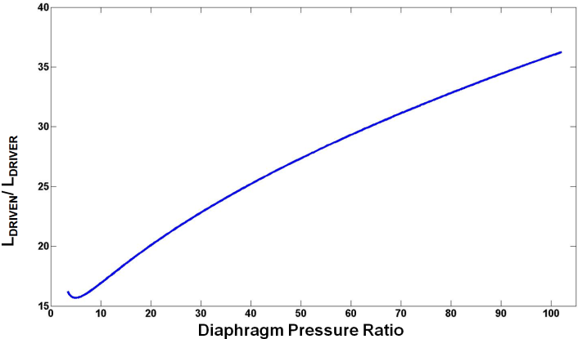
Fig. 9: LDriven/LDriver vs. P4/P1 for an air-air shock tube.

A common yet critical error often found in the literature describing the use of shock tubes for blast studies stems from the location of the specimen relative to the shock tube during testing. While it might seem obvious to place a target specimen along the axis of the shock tube, the exhaust of high-pressure gas used to create the blast wave results in a significant alteration of the desired pressure history and total impulse experienced by the specimen, as a result of the secondary mass flow that hits the target. The effect of exhaust gas in creating a secondary pressure artifact is demonstrated in Fig. 10 that shows two significant pressure spikes. The first is attributable to the blast wave, while the second is due to the venting of exhaust high-pressure driver gas.

.
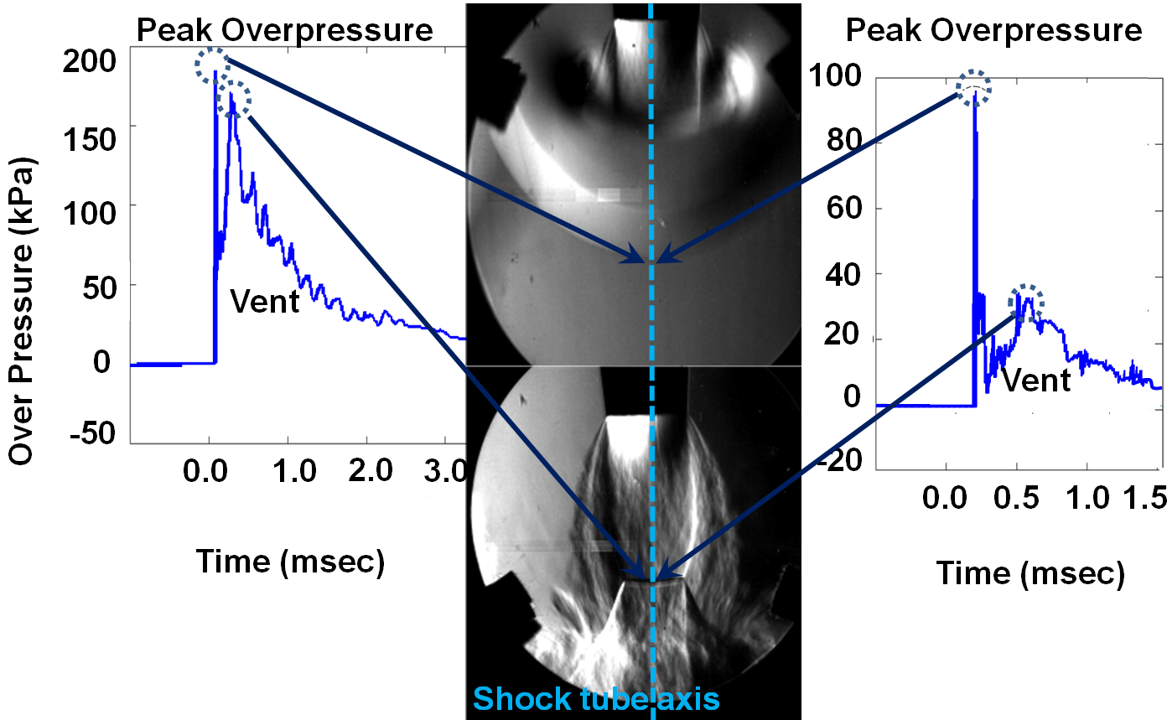
Fig. 10 Pressure vs time for P4/P1 = 6.78 and L_{Driven}/L_{Driver} = 15.76 at 7.62 cm from shock tube exit (left), Pressure vs time for P4/P1 =6.78 and L_{Driven}/L_{Driver} = 80 at 7.62 cm from shock tube exit (right)

Any test specimen located along the shock tube axis will be exposed to two rapid pressure spikes. The total impulse experienced by the specimen due to venting of exhaust gas is actually larger than the impulse associated to the corresponding blast wave. Placing the specimen in such manner makes it impossible to separate the effect of the blast wave from that of the exhaust gas jet. While it might seem reasonable to reduce the overall volume of high-pressure gas used to produce the initial overpressure event to reduce the amount of gas that exits the shock tube, doing so does not eliminate the exhaust venting effect. Furthermore, reducing the driver gas volume decreases the driver’s length, causing more of the reflected expansion fan to overtake the incident shock, which results in a greater reduction of peak overpressure, as shown in the graph on the right of Fig. 10. Note the different pressure scales (Fig. 10) for the same P₄/P₁ settings. The shock tube equations do not account for this effect, and are independent of the lengths of both the driver and driven sections. To minimize the effect of exhaust gas venting, a target can be placed outside the jet’s cone as illustrated in Fig. 11. Due to the relatively large semi-spherical shape of the blast wave at the exit of the shock tube (compared to the conical shape of the corresponding exhaust jet), placing a target at a location that minimizes exposure to the exhaust jet is relatively easy to achieve.

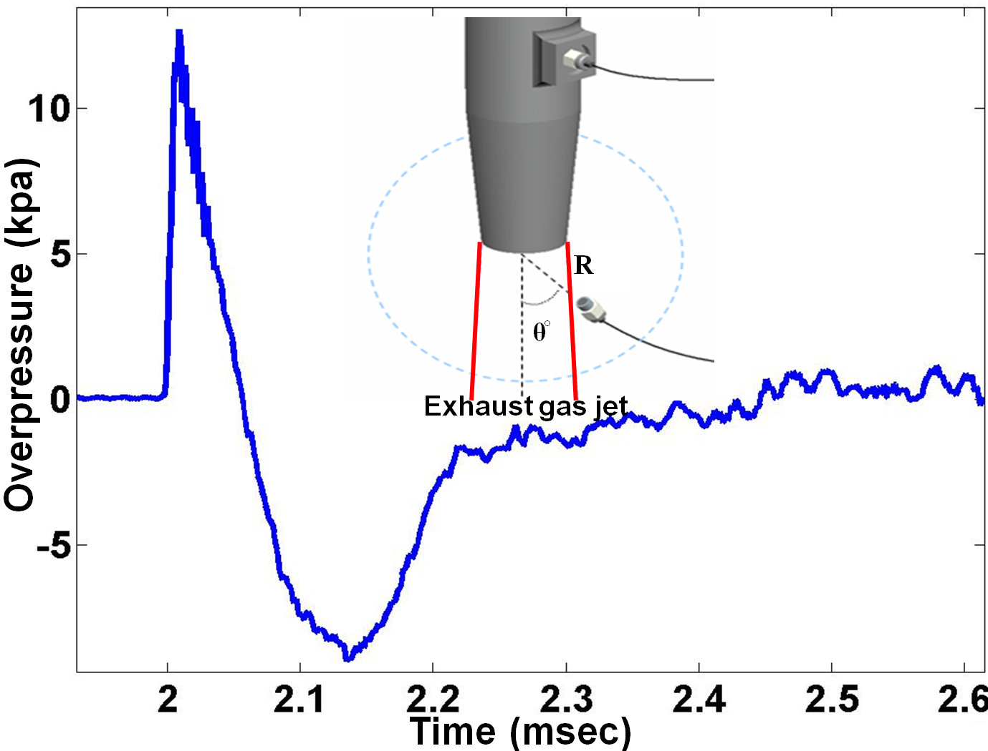
Fig. 11: Overpressure vs. time for P4/P1 = 52.02 and LDriven/LDriver = 15 measured at 10.16 cm from shock tube exit and θ = 60 deg.

Experimental and theoretical means have been used to obtain characteristic parameters associated with blast waves, such as peak overpressure, duration, and impulse scaling with distance. A theoretical analysis for peak overpressure follows the same mathematical approach as the one used for a normal shock wave, although it must take into account spherical divergence as well as the transient nature of the blast event. For example, values for peak overpressure produced by a blast wave generated from a one-pound spherical charge of TNT versus distance are shown in Fig.12 [ (14)]. This plot shows that at a distances far from the center of the explosion, the blast wave behaves as a sound wave and its energy-distance relation follows an inverse square law. But the intensity of sound energy is proportional to the square of sound pressure, therefore, at distances sufficiently great, the blast wave overpressures approaches zero. On the log-log plot this is indicated by the (-1) slope approached at large distances. Fig.12 also shows the peak overpressure expected at various distances, if the one-pound spherical TNT charge had been considered a point source. By comparing both curves, it can be seen that the effect of finite size of the explosive charge is at first to spread out the energy, reducing peak overpressure. This effect holds out to some appreciable distance from the center of the explosion ~ around 5 charge diameters. At intermediate distances, the large amount of gas produced by the explosion begins to become evident in the peak overpressure curve. At greater distances, losses due to dissociation and ionization become evident in the point source and tend to reduce the energy available from a point source so that peak overpressures observed far from a point source are somewhat less than those from TNT with the same initial energy release. This demonstrates that although the total energy release is important, it is inadequate to completely characterize a blast event [ (14)]. Such data, along with an appropriate scaling model, may be used to determine the equivalent TNT explosion and related distance for any shock tube test. More details about the influence of the charge diameter and shape of the charge, as well as experimental results which show that blast overpressure collapses to a single curve when plotting against a scaled distance/TNT weight ratio (R/W^{1/3}) have been previously compiled [ (2) (4) (14)].

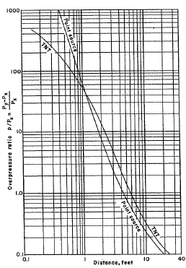
Fig.12: Peak overpressure ratio versus distance for explosions with yield equivalent to one pound of TNT, [(14)]

Fig.12 shows the pressure-distance decay for a one pound spherical TNT charge. To apply this general behavior to explosives of various sizes and total energies, a geometrical similarity scaling law was used. Two explosions can be expected to give identical blast wave intensities at distances proportional to the cube root of the respective energy release. Assuming identical atmospheres through which various explosive yields propagate, the following scaling law may be employed:

(2)

The energy release factor is given by the (W/W₀)^{1/3} ratio, where W is the energy release, or weight of TNT, in the explosion, and W₀ is that of a reference amount of TNT, such as the 1 lb (0.454 kg) explosion shown in Fig.12. By using this scaling law, the distance at which a given peak overpressure is produced by a reference explosion may be scaled up or down to provide a corresponding distance for other explosions. For example, Table 1 shows the equivalent distance (in both exit diameters, D, and centimeters) at which a 0.454 kg (1 lb) TNT spherical charge would have to be located to provide the same peak overpressure measured at the test location. To illustrate this, consider the 45° degree case with the transducer located radial distance to shock tube diameter (R/D) of 2.5 (6.35 cm) away from the exit of the shock tube. The peak overpressure for the settings shown in Table 1 is 189 kPa, and the peak overpressure normalized to the atmospheric pressure is 1.87. From the plot of Fig.12, a peak overpressure ratio of 1.87 corresponds to a 0.454 kg (1 lb) TNT charge peak overpressure at a distance of 1.39 meters away from the blast center. Therefore, for the settings shown in Table 1, a shock tube test with the specimen located 45 degrees off-axis at 6.35 cm (2.5 R/D) away from the tube exit will experience an identical peak overpressure as that of a 0.454 kg (1 lb) spherical TNT charge at 1.39 meters away from the blast center.

To determine whether a universal curve for peak overpressure versus distance could be established for blast waves generated by the shock tube, the data shown in Fig. 3 was scaled based on the TNT versus distance curve shown in Fig.12. The peak overpressure was normalized to ambient pressure, and the data plotted against the 1 lb (.454kg) TNT distance shown in Fig.12. The result is shown on Fig. 13 - the curve collapses onto a single line for all data shown in Table 1 since peak overpressure is not affected by the contamination from the driver gas venting jet.
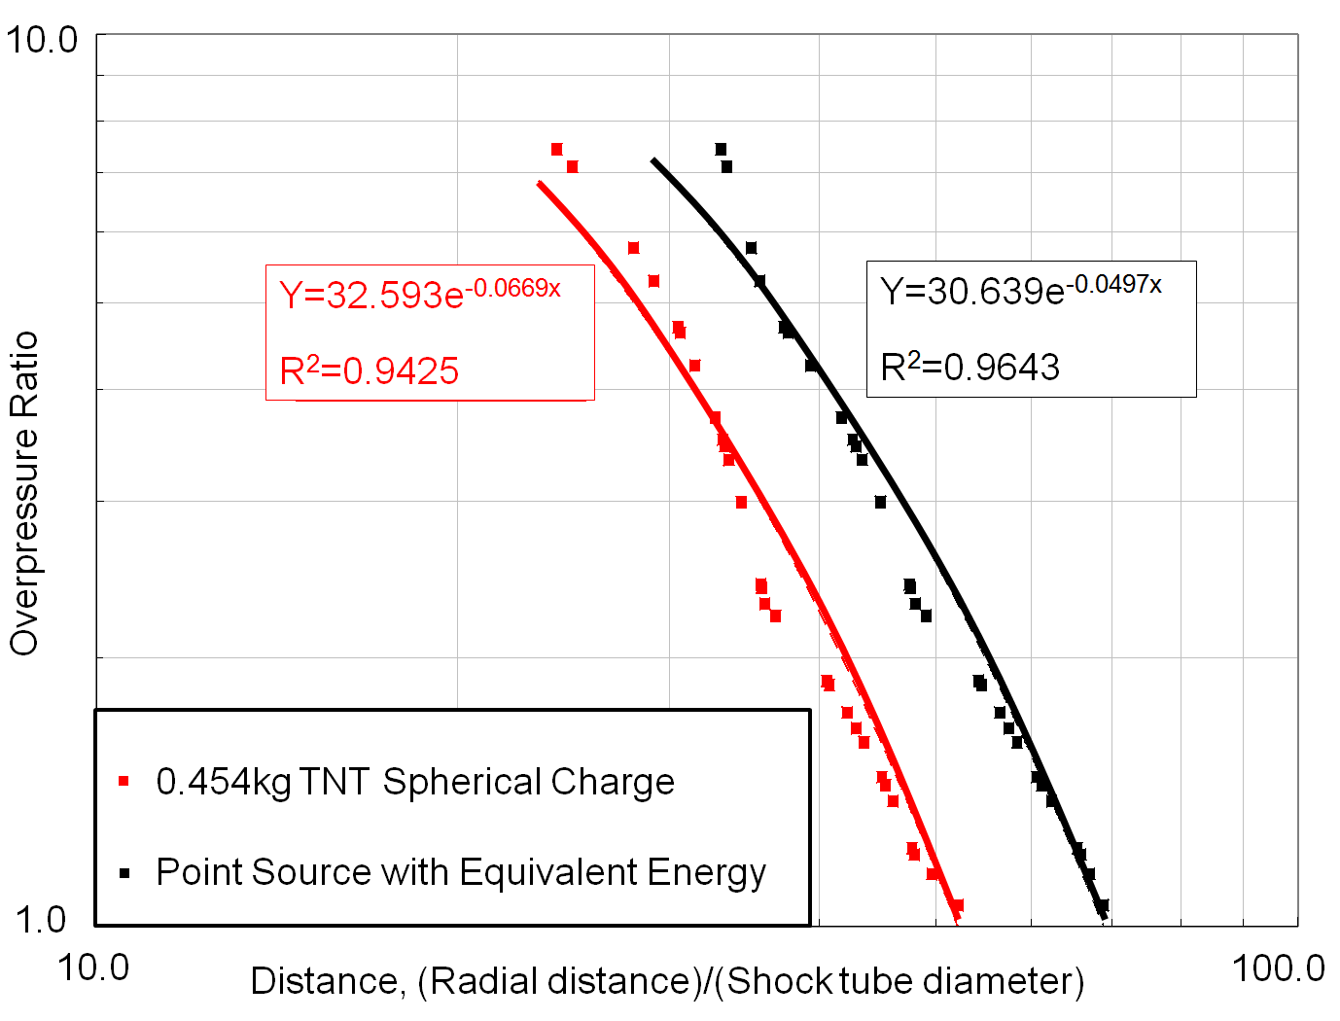
Fig. 13 Scaled blast tube data based on spherical charge of 0.454 kg (1 lb) TNT and point source.

The duration of a blast wave is an important aspect of its ability to cause damage since it is a measure of how long the force (pressure integrated over the specimen frontal area) acts on a target. The duration can be taken to be the duration of the positive phase of the blast wave (a negative phase is also present, in which the local pressure is lower than the ambient). The positive phase is the more damaging one, and its duration can be measured more precisely. Positive pressure duration can therefore be taken as a descriptor of the duration of the blast event, even though the negative phase typically lasts at least twice as long as the positive phase.
The relationship between the speed associated with the initial shock front and the changing local speed of sound as the blast wave propagates, causes the duration of the blast wave to increases with distance from the center of the explosion, reaching a maximum value and vanishing as the shock front degenerates into a sound wave. This relationship can also be observed in Table 1. For example, consider the 45 degree angle data varying from 2 to 4 R/D away from the exit. The duration of the positive phase increases from 53.1 to 85.3 µs. Table 1 also shows how positive phase duration can vary while maintaining constant peak overpressure. For example, by drawing a horizontal line through the data in Fig. 3, it is possible to get identical peak overpressures for different specimen locations (both angle offset and distance away from the shock tube exit). However, a set of such cases in Table 1 shows that the positive phase duration will be different, and thus overpressure can be kept constant while duration varies.

Impulse is an important metric of damage-causing ability of the blast, and may become the dominant effect in some situations, as for example in blast waves of relatively short duration observed in explosions with small yields. The significant portion of the blast impulse is associated to the positive pressure phase [(1)(14)]. Blast overpressure appears at first to follow a typical logarithmic decay, however, it drops to zero and below in finite time. An empirical expression that follows a quasi-exponential form has been proposed. It includes a decay parameter, α, and the time, t, measured from the instant the shock front arrives. The pressure can be given as equation (3) [(15)]

(3)
Where p is the instantaneous overpressure at time t, p₀ is the peak overpressure when t is zero and, t_{d}, the time duration. The decay rate, α, characterizes the blast wave by curve fitting the data with equation (3) and performing an error analysis. After post-processing data by digital filtering, the data can be curve fit and an error analysis performed to assess the goodness of the fit. The criteria used was minimization of the average residual error,
E=$\sum{\frac{{(smoothed data point – curve fit)}^{2}}{(number of samples)}}$. Fig. 14 shows an example of the curve fit using equation (4) applied to the positive phase duration data taken at an angle of 30° and a distance of 7.62 cm, or 3 R/D.
(4)

A best fit for this data set gives a decay factor, α, of 0.01 and E of 32.55x10⁻³. The error is used to assess the goodness of the data and curve fit, as well as the “quality” of the blast waves. Fig. 15 compares two pressure traces with very similar peak overpressures, but different positive phase durations. The cases shown in the figure are θ = 30° at D = 6.35cm with a peak overpressure of 124 kPa and t_{d} of 32.9 µs, and θ=45° at D = 5.08cm, with a peak overpressure of 169 kPa and t_{d} of 37.1 µs. The curve fit is quite good in both of these cases, and for the same peak overpressure the impact of different duration on injury can be assessed.
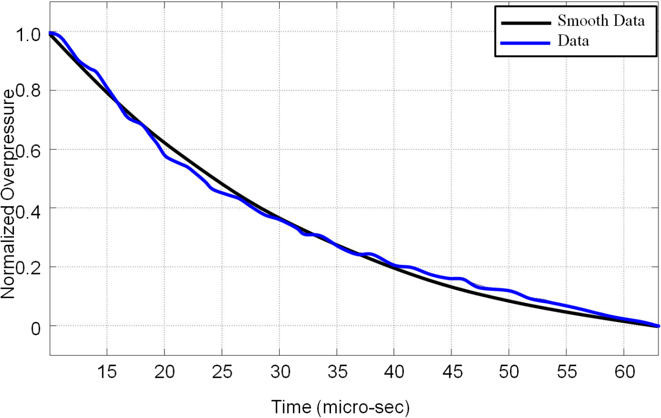
Fig. 14: Example of flittered transducer data and curve fit (equation (4)) for θ=30° and R/D=3, α=0.01 and E=32.55x10⁻³.
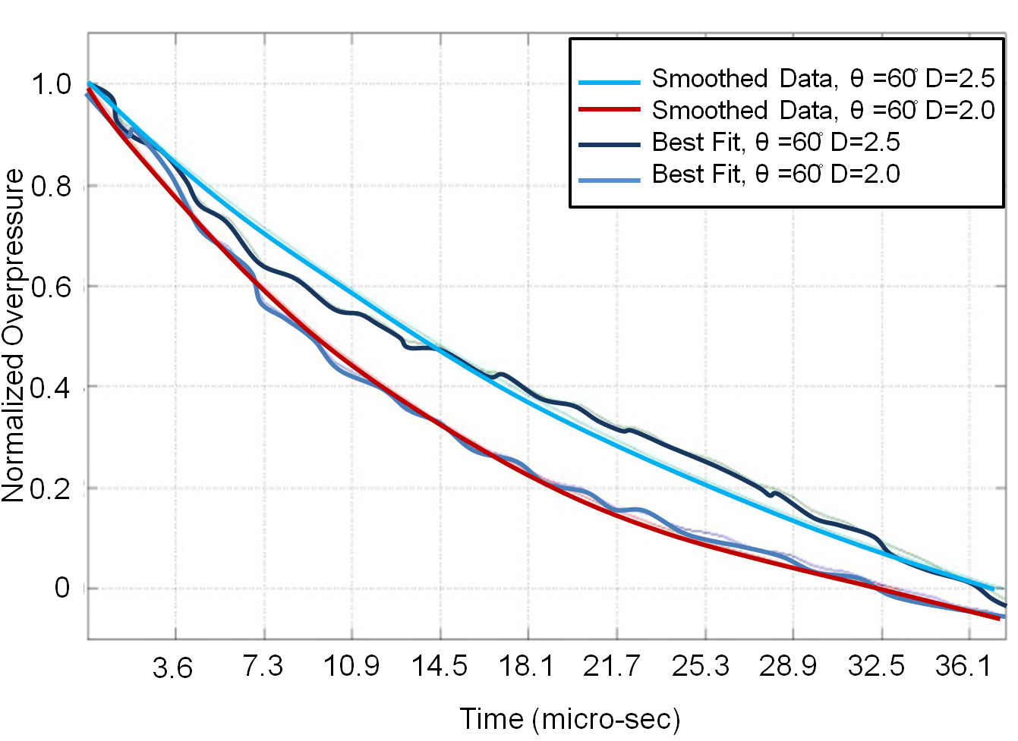
Fig. 15: Curve fit for two pressure-time traces with approximately identical peak overpressure but different durations. θ = 30° and R/D = 2.5, with α = 0.01 and E = 21.97x10⁻³, and θ = 45° and R/D = 2, with α = 0.63 and E = 1.09x10⁻³

The impulse is obtain through simple integration of equation (1) to obtain equation (3). However, the parameter of the equation are required i.e Decay constant parameter, α and the positive phase duration t_{d}
Impulse = | (3)

The positive phase duration and integrated impulse for each data point shown in Fig. 3 is summarized in Table 1 . Locations marked with “NA” represent regions not applicable for testing as effects of the exhausting gas jet at those locations can be substantial. The contour plots show peak overpressure (Fig. 16), duration of the positive phase of the blast wave (Fig. 17), and impulse per unit area (Fig. 18). The shaded region on each plot corresponds to specimen locations that should be avoided due to contamination of the pressure-time trace from driver gas venting.
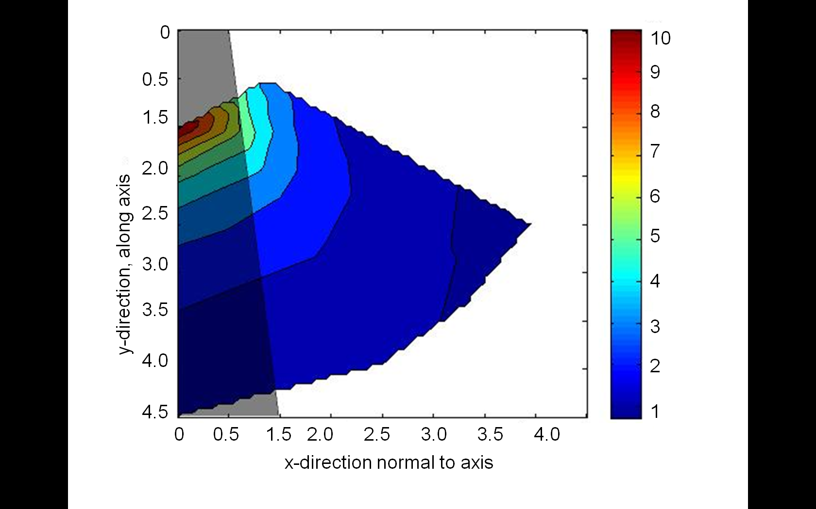
Fig. 16: Peak overpressure contour plot with shaded NA test area.
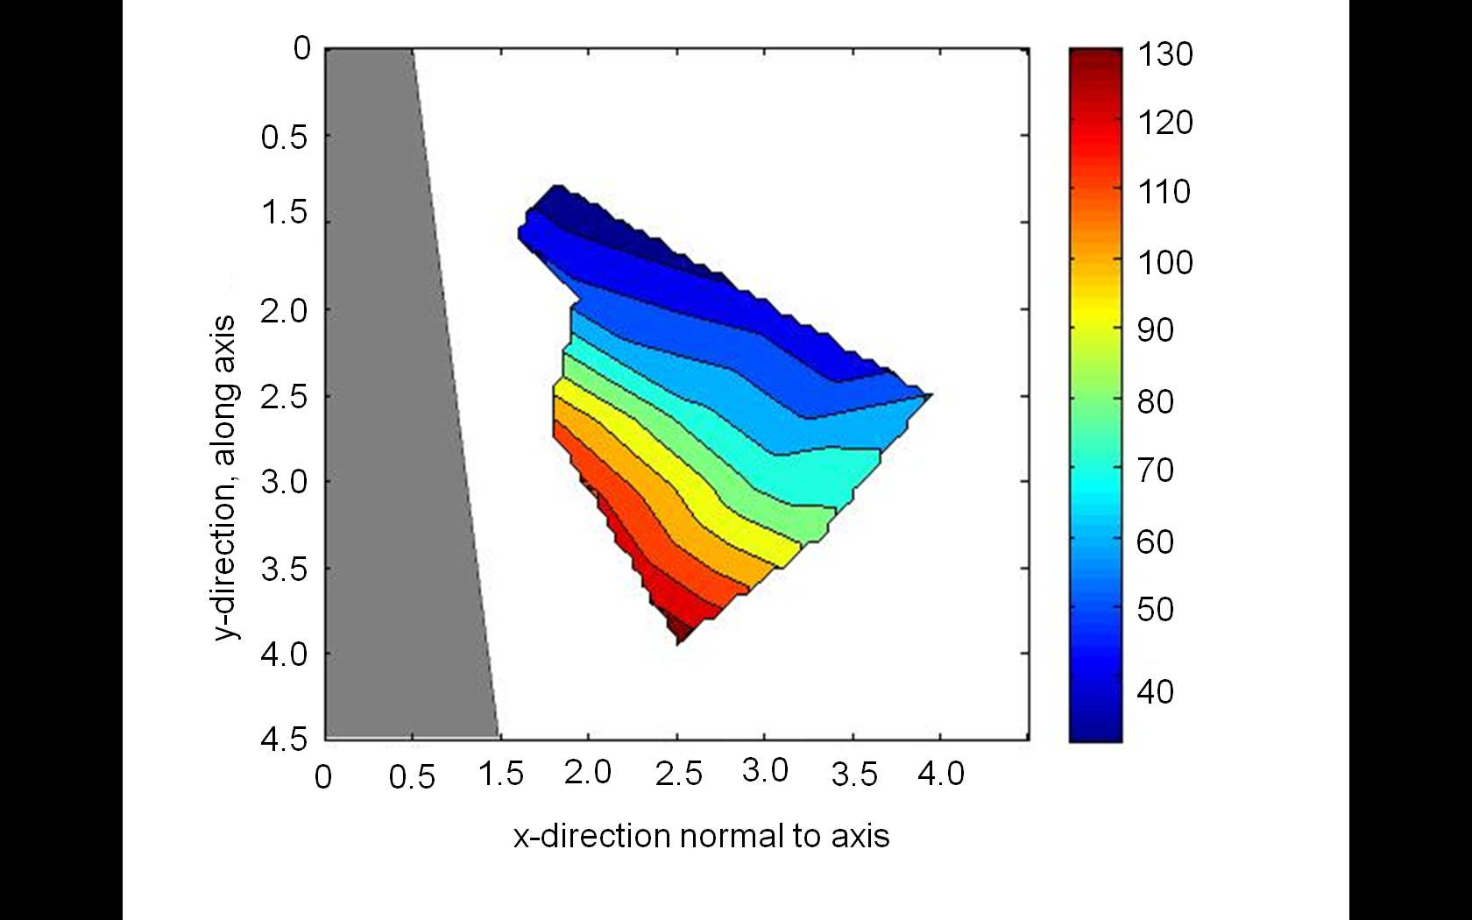
Fig. 17: Positive phase duration contour plot (µs)
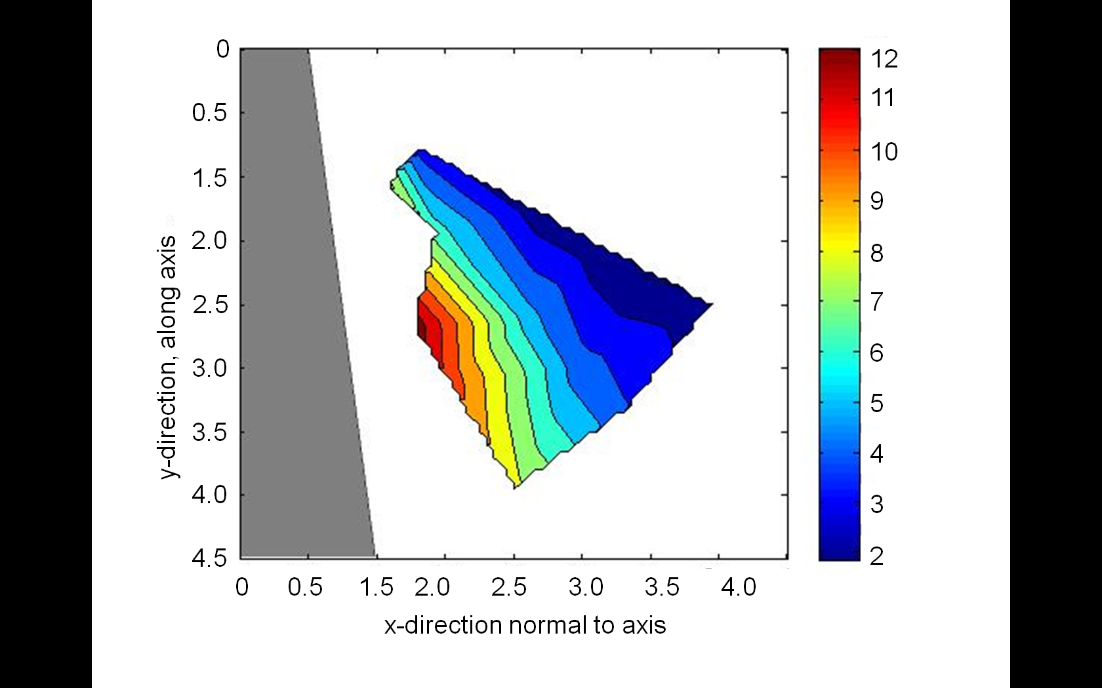

Fig. 18: Impulse per unit area contour plots (kPa-s)

As can be seen in Table 1, for a fixed diaphragm pressure ratio and driven-to-driver length ratio, the further a specimen is placed from the exit, the lower the overpressure and longer the duration of the blast wave. For a fixed driven-to-driver length ratio, increasing the diaphragm pressure ratio (with the corresponding increase in the one-dimensional blast Mach number) increases the peak overpressure and decreases the duration of a blast event at a fixed location.

Table 1 Data for P4/P1 = 52.02, average internal Mach number 2.01 and L_{Driven}/L_{Driver} = 15 measured at various angles, θ, and distance D
θ | Distance |  | Peak Over-pressure (kPa) | σ, Peak Over-Pressure (kPa) | Peak Over-pressure Ratio | Positive Phase Duration (µs) | σ, Positive Phase Duration (µs) | Impulse/Unit Area (kPa-s) | Curve Fit Parameters (Equation 4) |  | 0.454 kg (1 lb) TNT  Equivalent Distance |  | Point Source Equivalent Distance (cm)
θ | R/D | cm |  |  |  |  |  |  | α | E x 10⁻³ | cm | D | cm | D
0 | 1 | 2.54 | 1056 | 97.15 | 10.4 | NA | NA | NA | 9.67 | 10.69 | 29.5 | 75 | 23.3 | 59
0 | 1.25 | 3.18 | 753 | 59.47 | 7.4 | NA | NA | NA | 6.74 | 20.04 | 33.1 | 84 | 24.2 | 61
0 | 1.5 | 3.81 | 536 | 12.99 | 5.3 | NA | NA | NA | 5.47 | 25.59 | 35.7 | 91 | 29.1 | 74
0 | 1.75 | 4.45 | 431 | 25.28 | 4.3 | NA | NA | NA | 3.63 | 30.05 | 39.3 | 100 | 31.5 | 80
0 | 2 | 5.08 | 350 | 7.51 | 3.5 | NA | NA | NA | 2.61 | 35.59 | 42.9 | 109 | 33.3 | 85
0 | 2.5 | 6.35 | 245 | 12.58 | 2.4 | NA | NA | NA | 1.66 | 61.33 | 47.5 | 121 | 35.7 | 91
0 | 3 | 7.62 | 191 | 7.15 | 1.9 | NA | NA | NA | 0.86 | 138.49 | 54.2 | 138 | 40.5 | 103
0 | 3.5 | 8.89 | 163 | 7.06 | 1.6 | NA | NA | NA | 1.04 | 373.91 | 58.4 | 148 | 43.5 | 111
0 | 4 | 10.16 | 140 | 2.76 | 1.4 | NA | NA | NA | 0.18 | 459.13 | 62.4 | 158 | 46.0 | 117
30 | 1 | 2.54 | 720 | 25.96 | 7.1 | NA | NA | NA | 2.31 | 8.96 | 33.5 | 85 | 24.9 | 63
30 | 1.25 | 3.18 | 584 | 8.86 | 5.8 | NA | NA | NA | 2.18 | 8.82 | 35.1 | 89 | 28 | 71
30 | 1.5 | 3.81 | 469 | 10.02 | 4.6 | NA | NA | NA | 4.79 | 8.61 | 37.7 | 96 | 30.6 | 78
30 | 1.75 | 4.45 | 377 | 23.92 | 3.7 | NA | NA | NA | 2.47 | 8.09 | 41.7 | 106 | 32.7 | 83
30 | 2 | 5.08 | 303 | 16.89 | 3.0 | NA | NA | NA | 1.67 | 6.10 | 44.9 | 114 | 34.4 | 87
30 | 2.5 | 6.35 | 226 | 5.28 | 2.2 | 113.8 | 0.0 | 12.89 | 0.01 | 21.97 | 49.1 | 125 | 36.8 | 93
30 | 3 | 7.62 | 176 | 6.28 | 1.7 | 124.0 | 0.5 | 10.87 | 0.01 | 32.55 | 56.5 | 143 | 42.1 | 107
30 | 3.5 | 8.89 | 149 | 6.37 | 1.5 | 126.0 | 13.4 | 9.40 | 0.13 | 33.59 | 60.6 | 154 | 45.1 | 114
30 | 4 | 10.16 | 122 | 4.19 | 1.2 | 138.0 | 9.8 | 8.37 | 0.73 | 15.68 | 66.0 | 168 | 48 | 122
45 | 1 | 2.54 | 476 | 10.52 | 4.7 | NA | NA | NA | 5.24 | 1.81 | 37.3 | 95 | 30.5 | 77
45 | 1.5 | 3.81 | 338 | 11.51 | 3.3 | 50.1 | 0.4 | 8.59 | 0.25 | 1.01 | 43.4 | 110 | 33.6 | 85
45 | 2 | 5.08 | 243 | 11.82 | 2.4 | 53.1 | 0.2 | 6.46 | 0.63 | 1.09 | 47.6 | 121 | 35.8 | 91
45 | 2.5 | 6.35 | 189 | 5.72 | 1.9 | 62.4 | 1.9 | 5.89 | 1.04 | 1.29 | 54.5 | 139 | 40.7 | 103
45 | 3 | 7.62 | 146 | 1.67 | 1.4 | 72.7 | 3.1 | 5.32 | 1.34 | 1.57 | 61.2 | 155 | 45.4 | 115
45 | 3.5 | 8.89 | 116 | 4.99 | 1.1 | 75.4 | 1.6 | 4.36 | 1.65 | 1.65 | 67.1 | 170 | 49.6 | 126
45 | 4 | 10.16 | 95 | 2.25 | 0.9 | 85.3 | 4.0 | 4.04 | 1.94 | 2.16 | 71.3 | 181 | 55.5 | 141
60 | 1 | 2.54 | 356 | 13.42 | 3.5 | 29.2 | 2.3 | 5.19 | 0.01 | 1.31 | 42.6 | 108 | 33.2 | 84
60 | 1.5 | 3.81 | 233 | 12.46 | 2.3 | 29.3 | 1.7 | 3.41 | 0.24 | 0.24 | 48.0 | 122 | 36 | 91
60 | 2 | 5.08 | 169 | 9.38 | 1.7 | 32.9 | 1.9 | 2.76 | 0.82 | 0.19 | 57.5 | 146 | 42.9 | 109
60 | 2.5 | 6.35 | 124 | 5.17 | 1.2 | 37.0 | 4.9 | 2.30 | 1.24 | 0.24 | 65.5 | 166 | 47.7 | 121
60 | 3 | 7.62 | 107 | 3.79 | 1.1 | 42.5 | 251.4 | 2.27 | 1.39 | 0.44 | 68.9 | 175 | 52.1 | 132
60 | 3.5 | 8.89 | 86 | 3.14 | 0.8 | 41.3 | 1.8 | 1.78 | 1.79 | 0.75 | 74.5 | 189 | 58 | 147
60 | 4 | 10.16 | 73 | 4.02 | 0.7 | 60.3 | 0.4 | 2.20 | 1.95 | 0.81 | 80.6 | 205 | 63.1 | 160

Although the venting jet is confined to a narrow cone, as shown in Fig. 16, its effects can still be felt when measurements are made near the jet, and alterations of the blast wave signature have been observed for those entries in Table 1 that boarder 'NA' conditions. By curve fitting the data, a threshold 'E' criterion can be established for which the blast wave pressure-time history is considered acceptable. For example, the average residual error for blast traces contaminated by the venting jet can be several hundred times larger than those associated with pure blast wave signals. To achieve exposure to a blast wave Fig. 19 (left) depict a Schlieren image showing the appropriate testing area by placing a specimen off axis in the area unaffected by the vent of the gas. Furthermore, shown on the bottom left of Fig. 19 is an example of placing a specimen at 78.86 deg from the shock tube axis, and 7.81cm (R/D =3.1). The top left of Fig. 19 shows a Schlieren image that verifies the specimen is located off-axis of the shock tube unaffected venting cone.

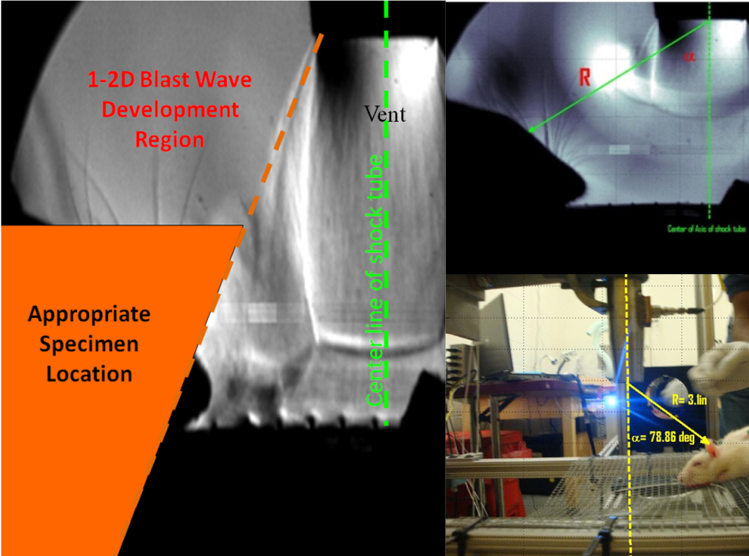
Fig. 19 Placement of the Specimen on appropriate location outside the shock tube
Any measurement device placed directly in the path of the blast wave disturbs the flow field. If sensors are placed near a target subject to a blast event, it is not possible to measure the actual pressure-time history at the target location without disturbing the flow field at the target itself. To improve pressure measurements at the target location, the proposed method is based on first capturing data at the desired location outside the shock tube (without the target present), followed by removing the sensors and repeating the test with the target present. Despite the high repeatability introduced by the proposed diaphragm cutter, verifying that the event-taking place at the target is the same as the pressure event actually measured is crucial to accurately assess the target’s response to a specific blast event. An accurate method to ensure repeatability consists of measuring the one-dimensional blast Mach number in the driven during both the measurement of the blast event and the target’s exposure. Since the one-dimensional blast Mach number inside the driven section provides the initial conditions for the blast wave at the exit of the shock tube, a given one-dimensional blast Mach number inside the driven section corresponds to a single blast event at a fixed location outside shock tube. By recording the one-dimensional blast Mach number both during the measurement of the blast field and during testing on a target at the same location, it can be determined whether or not the same blast event took place during both tests.

Conclusions
Preliminary testing of the proposed blast trauma shock tube has demonstrated its ability to produce a large, repeatable range of injury levels in different specimens through varying peak overpressure, duration, and impulse. The results demonstrate that specially designed shock tubes can be used effectively to accurately mimic the most important features of a blast wave, while presenting a safe and inexpensive alternative to free field experiments that offers the unprecedented repeatability required to establish meaningful correlations between blast data and the level of trauma experienced by a specimen. This study also shows that shock tubes designed for blast trauma studies should employ driver sections that allow adjustment of driven-to-driver length ratio. This allows proper formation of one-dimensional blast waves in the driven section of the shock tube, yielding greater flexibility in varying blast conditions at the tube exit. Test sections should be designed to eliminate the interaction between the exhausting gas jet and a specimen during experiments while locating the specimen at a place where can be exposed to a properly formed spherical blast. To do so, it is suggested that the specimens be located off the axis of the tube, and desired overpressure and duration settings be controlled by location (angle and distance) relative to the axis of the tube.
The blast tube and experimental methodology outlined in this paper is currently being used to perform blast-induced polytrauma experiments at Banyan facilities.

Reference
1. Cooper, Paul W. Explosives Engineering. s.l. : Wiley-VCH, 1996.
2. Modeling Environmental Effects in the Simulation of Explosive Events. Clutter, J.Keith, Mathis, James T. Stahl, Michael W. s.l. : International Journal of Impact Engineering, 2007, Vol. 34.
3. A Laboratory Model for Studying Blast Overpressure Injury. Jaffin, J, H. McKinney, L. 349-356, s.l. : Journal of Trauma, 1987.
4. Kingery, C.N Bulmash,G. Airburst Parameter from spherical burst and emispherical surface burst. s.l. : U.S Army Armament Research and Development center Technical Report ARBRL-TR-02555, 1984.
5. Atkinson, J. Generation and Analysis of Blast Waves from a Compressed Air Driven Shock Tube. s.l. : Masters Thesis, Florida Institute of Technology, 2008.
6. "Generation of Blast Waves by means of Normal Shock Tube" H.R.Yu, J.H Gu, Z.F. Li and Z.H.Li. Yu, H.R. Sendai, Japn : Shock Waves: Proceeding of the 18th international Symposiums on Shock waves, 1991.
7. Abe, A. Takayama, K. 17th International Symposium on Shock Wave and Shock Tube, American Institute of Physics. Shock Wave Diffraction from the Open End of a Shock Tube. 1990.
8. Guy, R.J. p 983-987, s.l. : Journal Of Trauma, 1998, Vol. 45.
9. Formation and Diffraction of Spherical Shock Waves in Shock tube. Takayama, K. Sekiguchi, H. 336, s.l. : Institute of high Speed Mechanics, Tohoku University, 1981, Vol. 43.
10. Air-Blast and the Science of Dynamic Pressure Measurements. Walter, P. L. New York and Texas Christian University Fort Worth : PCB Piezotronics, 2004, S.V. Sound and vibration, pp. 10-17.
11. Kerwin, John. Design of a Shock Tube for Jet Noise Research. Masters Thesis. s.l. : Cambridge MIT, 1996.
12. Schmidt, E M . Duffy, S. J. Noise From Shock Tube Facilities. AIAA . 23rd Aerospace Science Meeting, 1985.
13. Bertrand, Brian P. Matthews, William T. Overpressure and Durations of Shock Waves Emerging From Open Ended Shock Tubes. Aberdeen,Maryland : Ballistics Research Laboratories, 1965.
14. Kinney, Gilbert Ford. Explosive Shocks in air. New york : Macmillan Company, 1962.
15. A Simplied Analysis of Spherical and Cylindrical Blast Waves. Friedman, M.P. s.l. : Journal of Fluid Mechanics, 1961, Vol. 11.
16. Kirk, D. R. Aeroacoustic Measurement and Analysis of Transient Supersonic Hot Nozzle Flows. Masters Thesis. s.l. : Cambridge: MIT, 1999.
17. Haselbacher, A. Balachandar S. Open Ended Shock Tube Flows: Influence of Pressure Ratio and diaphragm Position. Gainsvillie : AIAA Journal, 2007.
18. Blast Wave from a Spherical Charge. Brode, Harold L. 1959, The Physics of Fluids , pp. 217-229.
19. Anderson Jr, John D. Modern Compressible Flow. Maryland : McGraw-Hill Publishing Company, 1990.

