Human Neutrophil HUVEC and Purified Ligand Flow Chamber Adhesion Assay

Authors:
Yebin Zhou, Dennis F. Kucik, Daniel C. Bullard, Alexander J. Szalai, Jeffrey C. Edberg

Authors: Institutions/Affiliations
Yebin Zhou
Genetics and Genomic Sciences Graduate Program
University of Alabama at Birmingham
bestzhou@uab.edu

Dennis F. Kucik
Department of Pathology
University of Alabama at Birmingham
kucik@uab.edu

Daniel C. Bullard
Department of Genetics
University of Alabama at Birmingham
dcbullard@genetics.uab.edu

Alexander J. Szalai
School of Medicine
University of Alabama at Birmingham
AlexSzalai@uab.edu

Jeffrey C. Edberg
School of Medicine
University of Alabama at Birmingham
JEdberg@uab.edu

Corresponding Author:
Jeffrey C. Edberg

Key words:
Neutrophil adhesion, Flow chamber, human umbilical vein endothelial cell (HUVEC), Purified Ligand

Short Abstract:
A method of quantitating neutrophil adhesion is reported. This method creates a dynamic flow environment similar to the blood vessel. It allows the investigation of neutrophil adhesion to adhesion molecules (purified ligand) or endothelial cell substrate (HUVEC) in a context similar to the in vivo environment with sheer stress.

Long Abstract:
Genetic variants in both β₂ integrins and in ICAM ligands are now recognized to be associated with the development of autoimmune disease^{1, 2}. The determination of the functional consequences of these variants (functional genomics) in cells derived from individuals with these variants is necessary for our understanding of autoimmune disease pathogenesis and future therapy. Such functional studies allow for the determination of the mechanisms by which naturally occurring genetic variants shape the immune response in both health and disease. In the specific example of SLE, we now know that variants in ITGAM (CD11b) and its ligand, ICAM-1, strongly associate with development of disease^{1,2}. Because neutrophils are critical in inflammatory responses, the quantitative study of neutrophil adhesion may provide mechanistic insights into how genetic variants in ITGAM/ICAM alter inflammation.

Neutrophil firm adhesion to endothelial cells (EC) is a highly regulated process and plays essential role in inflammatory reaction^{3, 4}. The firm adhesion of neutrophil follows neutrophil rolling and leads to transmigration in vivo. The process involves many different kinds of adhesion molecules, including ICAM-1, ICAM-2, P-Selectin, E-Selectin on the endothelial cells and β₂ integrins on the neutrophil^{5, 6, 7, 8, 9}. Thus, carful quantization of neutrophil adhesion from donors with different adhesion molecule genetic backgrounds will be important to understand the functional and pathological consequences of these genetic differences.

Experimental use of a flow chamber can create an environment with fluid shear stress similar to that observed in the blood vessel environment in vivo, which is ideal for in vitro adhesion analysis^{10, 11, 12}. A flow chamber assay coupled with human umbilical vein endothelial cell (HUVEC) can mimic the environment of blood vessel. Using this method, one can study the overall cellular adhesion property towards endothelial cell. Also flow chamber can be used with purified adhesion ligand such as ICAM-1, alone to study specific receptor-ligand interaction.

We present here a method using flow chamber assay system to study the adhesive properties of human peripheral blood neutrophils to HUVEC and to purified ligand substrates. Using this method with cells from donors with varying adhesion molecule genotypes allows us to assess how genetic variants affect neutrophil adhesion.

Protocol Text: (We would like the video record start from step 2.2)

- HUVEC Initial Culture and Subculture

  - The original HUVEC cryovial (>500,000 cells/vial) is purchased from Lonza Inc. Complete growth medium is needed for HUVEC culture. To make complete growth medium, thaw all supplement vials (hEGF, Hydrocortisone, GA-1000, FBS, VEGF, hFGF-B, R³-IGF-1, Ascorbic Acid, Heparin) from EGM-2 (Lonza Inc.) at 37℃ and add all those supplements into the basal medium EBM-2 (Lonza Inc.) according to the manufacture’s instruction. Store the complete growth medium at 4℃ and use within a month.

  - For the initial culture, seeding density of the original HUVEC cells is 2,500 – 5,000 cells/cm². Calculate the number of vessels needed based on seeding density and vessel surface area. Add appropriate amount of growth medium to the vessels (1 ml/5CM²) and allow the vessels to equilibrate a 37℃, 5% CO2, humidified incubator for at least 30 min.

  - Quickly thaw the original HUVEC cryovial in a 37℃ water bath. Remove the cryovial as soon as it is completely thawed. Resuspend cells in the cryovial and dispense cells into the vessels set up earlier. Gently rock the vessels to evenly distribute the cells and return to the incubator. These cells are the 1st passage. Change the medium every two days for continued HUVEC culture maintenance.

  - Subculture the cells until 70 – 80% confluence. Store some 1st passage cells in FBS with 10% DMSO at -80℃.

  - Aspirate the medium from the culture vessel. Rinse the cells with PBS once to wash away complex protein and calcium from the medium. Add Trypsin/EDTA. Exam the cell layer using a microscope. Continue trypsinization until 90% cells are rounded up. The Trypsinization should take about 2 – 6 min.

  - Stop the Trypsinization by adding 2X Trypsin inhibitor. To facilitate the harvest of cells, add an equal amount of complete growth medium. Transfer the detached cells to a sterile 15 ml centrifuge tube. Centrifuge at 800 rpm for 5min to pellet the cells. Aspirate the supernatant, and then dilute the cells to a final volume of 2 to 3 ml of complete EGM-2 medium. Determine cell count and viability using hemacytometer and Trypan Blue.

  - Determine the number of vessels for subculture based on the seeding density of 10,000 cells/CM². These cells are the 2nd passage. When these cells reach 80-90% confluence, store them in 10% DMSO FBS at -80℃ . These cells can be revived later for the preparation of HUVEC layer used in flow chamber assay.

- HUVEC Layer Preparation

2.1) Revive a vial of the stored 2nd passage HUVEC cells. Thaw the cryovial quickly in a 37 ℃ water bath. Transfer cells from the cryovial to a 15 ml sterile centrifuge tube and add 10 ml growth medium. Centrifuge at 200g for 5 min and aspirate the supernatant to remove the residual DMSO. Resuspend the cell pellet with growth medium and transfer the cells into a 75 CM² flask. Add growth medium to a total volume about 20-25 ml and put the flask in the incubator.

2.2) Visually exam the cell culture for confluence each day with media change every two days. Usually within 2 – 4 days, the confluence will reach 80-90 % and the cells are ready for flow chamber HUVEC layer preparation.

2.3) Coat 35mm covered tissue culture dishes (Corning Inc.) with 10μg/ml Fibronectin and 0.05% (w/v) Gelatin. Add 1 ml of 10μg/ml Fibronectin and 0.05% (w/v) Gelatin to a 35mm Corning tissue culture dish and pipette several times to make sure the whole plate surface is coated. Remove the Fibronectin and Gelatin and air dry the plate for at least 30 min to optimize the protein matrix formation. The Fibronectin and Gelatin solution can be reused.

2.4) Harvest the HUVEC cells in step 2.2 using Trypsin as described in step 1.5 and 1.6. Determine the cell count and viability using a hemacytometer and Trypan Blue. Seed 500,000 cells into each coated Corning tissue culture dish. Add growth medium to 2 ml volume in each dish and put all dishes in the incubator.

2.5) Exam the cell confluence each day and change medium every two days. When the cells reach 100% confluence, they are ready for the flow chamber assay. Prior to the flow chamber assay, prime the HUVEC with 20ng/ml human TNF-α (Invitrogen) for 4 to 6 hours to stimulate adhesion molecules expression.

3) Purified Ligand Coating

3.1) Draw a circle of 0.5cm diameter with a marker pen at the center of a 35 mm tissue culture dish (Corning Inc.).

3.2) Plate 20 μl of 20 μg/ml Protein A in the marked area. Use the pipette tip to spread the protein A solution to cover the whole area but do not touch or scratch the surface of the dish. Incubate at 37℃ for 1 hour,

3.3) Wash 3 times with 1 mL of PBS (PH8.0).

3.4) Plate 50 μl 1% BSA in the marked area. Incubate for 2 hours at 4℃ to block the nonspecific binding.

3.5) Wash 3 times with 1 ml of PBS the same as step 3.3).

3.6) Prepare solutions of substrates for coating. In our example, we use an ICAM-1 solution at 25μg/ml and P-Selectin at 0.5μg/ml in PBS (PH8.0).

3.7) Coat the marked area with 50 μl of substrate. Incubate overnight at 4℃. The dish should be used within two days and the coated area should not be dried out. Add PBS if necessary.

4) Neutrophil Separation (All steps performed at room temperature)

4.1) After informed consent, participant blood is collected by phlebotomy into an anticoagulant blood collection tube or vacutainer (EDTA or heparin). After blood collection, dilute 50 ml blood 1:1 with PBS before separation.

4.2) Make a two layer ficoll for separating PBMC and neutrophils in 50 ml centrifuge tubes. First add 15 ml heavy ficoll (Histopaque-11191, Sigma, ρ=1.118-1.120), and then carefully layer 10 ml light ficoll (Lymphocyte separation medium, Mediatech Inc., ρ=1.077-1.080) on top of the heavy ficoll. There should be a straight border between the light ficoll and heavy ficoll layers. Carefully layer 25ml diluted blood on top of the light ficoll without disturbing the ficoll layer.

4.3) Centrifuge at 750g for 30 min without breaking at room temperature. After centrifuge, from the top to the bottom, there should be a plasma layer, PBMC layer, light ficoll layer, neutrophil layer with few red blood cells, heavy ficoll layer and red blood cells.

4.4) Transfer the neutrophil layer into a new 50 ml tube and add PBS to 50 ml volume. Centrifuge at 225g for 10 min. After centrifugation, there may still be red blood cells mixed with the neutrophils. Aspirate the supernatant down to the 10ml mark. Vortex and wash again with PBS.

4.5) After the second wash, aspirate all the supernatant. To remove the contaminated red blood cells, add 25 ml H₂O and vortex 10 – 15 seconds to lyse, and then add 25 ml 1.8% NaCl, mix, and centrifuge at 225g for 10 min. There should be a white neutrophil cell pellet.

4.6) Wash the neutrophil cell pellet with PBS once before resuspend neutrophil in RPMI medium with 10% FBS at a density of 500,000 cells/ml.

5) Neutrophil HUVEC Flow Chamber Assay

5.1) Assemble the flow chamber. Put the 35mm Corning dish with HUVEC layer or purified ligand on the microscope table. Connect the parallel plate flow chamber (Glyco Tech) with syringe pump, vacuum system and leave one line for neutrophil input. Insert the Glyco Tech chamber on top of the plate and fasten the flow chamber assembly¹³. (See Figure 1.)

5.2) Start the video recording program (for example, Turtle Beach Video Advantage capture system) on the computer connected with microscope. Adjust the field and focus of the microscope until a clear field with fully grown HUVEC cells or a field within the ligand coating region is visible.

5.3) Rinse the flow chamber with RPMI medium. Make sure there are no air bubbles within the chamber or the neutrophil input line.

5.4) If desire, prime the neutrophil with 10⁻⁸ M fMLP for 10 min. This will match the activation status between different donors and exclude effects due to differential basal neutrophil activation.

5.5) Use the syringe pump to withdraw neutrophils into the flow chamber at defined speeds. Record the video. Because neutrophil adhesion happens rapidly, a video with a length of 4 – 5 min usually allows for sufficient adhesion events for analysis.

5.6) An adherent cell is defined as a cell that moves less than one cell diameter within 5 seconds on the HUVEC or ligand coated surface. Count the total adherent cells number on the recorded video using this rule. By recording similar length videos with different donors’ neutrophil, one can calculate the adherent cells/min to compare the adhesion properties between different donors.

Representative Result:

Examples of neutrophil binding to a HUVEC coated flow chamber assay (Figure 2) or of neutrophil binding to purified ligand (ICAM-1/P-Selectin) coated flow chamber (Figure 3) are shown. As shown in the figures, neutrophils continue to accumulate/adhere to the coated surface or HUVEC under conditions of the continuous flow. Under our usual experiment conditions, there are typically 50-70 neutrophils adhering to the coated surface or HUVEC during a four-minute recording period for neutrophils form a healthy donor. However, when using cells derived from different donors, considerable inter-individual differences may be observed. For example, there is increasing recognition of the importance of common genetic variants (SNPs) in adhesion molecules in contributing to immunologic disease and such variation in adhesion receptors/ligands on either the neutrophil or the substrate (purified ligand or HUVEC) could substantially alter leukocyte adhesive properties.

We have also assessed the time dependence of the neutrophil adhesion events observed in our studies. While we are maintaining constant flow conditions, it is possible that the adhesive properties of the cells change over time. However, over the relatively short time courses in our studies, we do not observe any consistent differences in the rate of adhesion over time. For example, assessing adhesion between the 1-2 minute time points compared to adhesion observed between the 3-4 minute time points are not consistently different (Table 1). Of course, if cells are being stimulated during the adhesion experiment, changes in adhesive properties over time could be expected. In our studies, we controlled for neutrophil activation by priming cells with a low dose of fMLP (10⁻⁸M) for 10 minutes prior to study. Endothelial cells (HUVEC in our studies) can be stimulated by TNFα (20ng/ml for 4-6 hours) to induce expression of a number of adhesion molecules and dramatically increase adhesive interactions with the neutrophils. IL-1β and LPS can also be used to pre-treat endothelial cells¹³. In the absence of pre-treatment, endothelial cells (HUVECs) will support very little neutrophil adhesion¹³.

Discussions:

This protocol guides the separation and isolation of minimally activated neutrophils for the careful quantization of neutrophil adhesion. Several steps in this method need extra caution to achieve ideal results. In the HUVEC preparation, it is critical to attain 100% confluence of cells before using them in the flow chamber. For purified ligand coating, the substrate coating area should never be allowed to dry out to avoid denaturing the ligand. Throughout the procedure, handle neutrophil gently to avoid activation. The whole separation process should be performed at room temperature. In addition, neutrophil isolation should be carried out in a timely manner; typically, one should start the adhesion assay within 6 hours of phlebotomy. As neutrophils are extremely sensitive to handling, prolonged waiting between the blood drawn and isolation could affect isolation and adhesion results. Careful neutrophil counting prior to the flow chamber assay is also necessary to assure accurate results. During the flow chamber assay, monitor the video recording carefully to assure that the flow speed is consistent and there is no turbulence through the whole experiment. If either occurs, one should stop recording and redo the experiment. After the experiment, check the remaining neutrophil again under the microscope to make sure there is no cell clumping which could affect neutrophil density in the experiment.
The flow chamber creates a near homogeneous sheer stress within the chamber (τ=6Qμ/(wh²), where Q=flow rate, μ=dynamic viscosity, and w=width of the flow chamber, h=height of the flow chamber¹⁴). In our experiment, we use 350μl/min flow rate for neutrophil adhesion which creates a sheer stress of 1.5 dynes/cm² (w=0.25cm, h=0.01in, the viscosity of water at 37°C (0.007 poise) was used as an approximation of the viscosity of RMPI media). For a specific flow chamber, one can change the flow rate to get different sheer stresses to mimic different physiological conditions with typical physiologic shear stresses are roughly 0.5–5.0 dynes/cm² ¹⁵.
This method is not limited to neutrophils as it could easily be applied to adhesion or rolling studies of other cells types with simple modifications.

Acknowledgements:
This work is sponsored by the Lupus Research Institute (NY, NY), NIH P01-AR49084, NIH R21-DA026956 and NIH 5UL1-RR025777-04. We thank Dr. Robert P. Kimberly for his continued support.

Disclosure:
The authors have nothing to disclose.

Table 1. Time Dependence of Neutrophil Adhesion to HUVECs and to purified ICAM-1.

Time Period | HUVAC based Adhesion* | ICAM-1 based Adhesion*
1-2 minutes | 12.9 + 3.7 | 17.2 + 2.8
3-4 minutes | 13.3 + 2.9 | 16.0 + 3.5

*Data represent the mean + standard deviation of the number of neutrophils adhered to substrate during the indicated 1 minute time period (n=10 for each determination). No significant differences in adhesion at the indicated time points were observed (p>0.05)
Figures

Figure 1. Flow chamber configuration. Left panel: overall configuration of the injector and microscope. Right Panel: View of the adhesion chamber on the microscope stage. (We would like to consult with the videographers to obtain optimal images to represent our experiential setup)

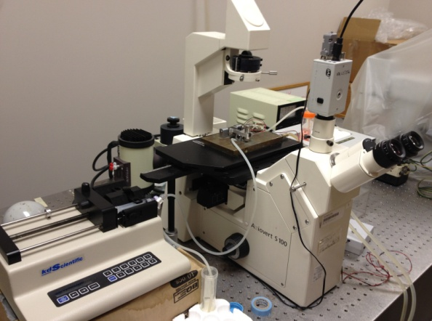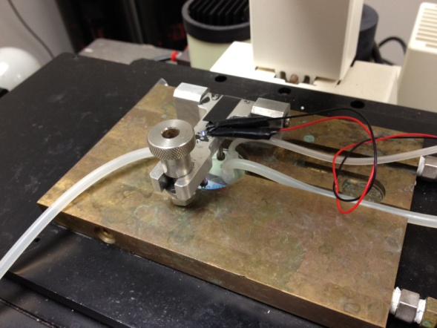

Figure 2. Screen shots from a sample video of neutrophils adhering to ICAM-1/P-Selectin surface at different time points. The concentration of ICAM-1 is 25μg/ml and P-Selectin is 0.5μg/ml. Neutrophil flow speed is 350μl/min with neutrophils at 500,000cells/ml.

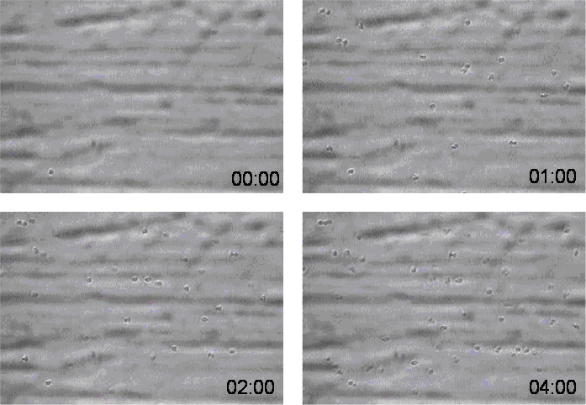

Figure 3. Screen shots from a sample video of neutrophils adhering to HUVEC surface at different time points. Neutrophil flow speed is 350μl/ml with neutrophils at 500,000cells/min.

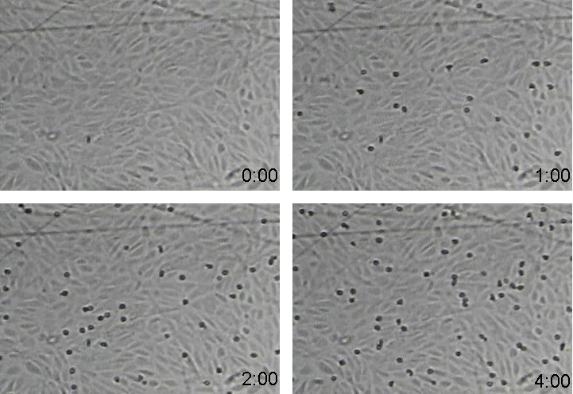
Table of specific reagents and equipment:

Name of reagent | Company | Catalogue number | Comments (Optional)
35mm tissue culture dish | Corning Inc. | 430165
75CM² tissue culture flask | Corning Inc. | 430641
CCD camera | Dage-MTI | Model 300T-RC
EBM-2 | Lonza Inc. | CC-3156 | Basal medium
EGM-2 | Lonza Inc | CC-4176 | Growth factors
Gelatin | Sigma | G9391
Fibronectin | Sigma | F2006
Flow chamber | Glyco Tech | 31-001 | Circular flow chamber
fMLP | Sigma | 47729
Histopaque-11191 | Sigma | 11191 | Heavy ficoll
HUVEC | Lonza Inc. | CC-2517A
ICAM-1 | R&D systems | 720-IC | Fc chimera
Lymphocyte separation medium | Mediatech Inc. | 25072CV | Light ficoll
Microscope | Zeiss | Axiovert 100
RPMI | Invitrogen | 11875
Protein A | Sigma | P6031 | Dissolve in PBS
P-Selectin | R&D systems | 137-PS | Fc chimera
Syringe pump | KD Scientific
TNF-α | Invitrogen | PHC3015 | Recombinant Human
Trypsion/EDTA | Invitrogen | 25200056
Trypsion inhibitor | Invitrogen | R002100

References:
- SLEGEN., Harley J.B., et al. Genome-wide association scan in women with systemic lupus erythematosus identifies susceptibility variants in ITGAM, PXK, KIAA1542 and other loci. Nat. Genet. 40, 204 - 210 (2008).
- Kim, K., Brown, E.E., et al. Variation in the ICAM1-ICAM4-ICAM5 Locus Is Associated with Systemic Lupus Erythematosus Susceptibility in Multiple Ancestry Populations. Arthrit. Rheum. 63(10 supplement), S657 (2011).
- Ley, K. Molecular mechanism of leukocyte recruitment in the inflammatory process. Cardiovasc. Res. 32(4), 733-742 (1996).
- Korthuls, R.J., Anderson, D.C., & Granger, D.N. Role of neutrophil-endothelial cell adhesion in inflammatory disorders. J. Crit. Care. 9(1), 47-71 (1994).
- Albelda, S.M., Smith, C.W., & Ward, P.A. Adhesion molecules and inflammatory injury. FASEB J. 8(8), 504-512 (1994).
- Smith, C.W., Marlin, S.D., Rothlein, R., Toman, C., & Anderson, D.C. Cooperative interactions of LFA-1 and Mac-1 with intercellular adhesion molecule-1 in facilitating adherence and transendothelial migration of human neutrophils in vitro. J. Clin. Invest. 83(6), 2008-2017 (1989).
- Marlin, S.D. & Springer, T.A. Purified intercellular adhesion molecule-1 (ICAM-1) is a ligand for lymphocyte function-associated antigen 1 (LFA-1). Cell. 51(5), 813-819 (1987).
- Lawrence, M.B. & Springer, T.A. Leukocytes roll on a selectin at physiologic flow rates: Distinction from and prerequisite for adhesion through integrins. Cell. 65(5), 859-873 (1991).
- Smith, C.W. Possible steps involved in the transition to stationary adhesion of rolling neutrophils: A brief review. Microcirculation 7:385-394 (2000).
- Usami, S., Chen, H.H., Zhao, Y., Chien, S., & Skalak, R. Design and construction of a linear shear stress flow chamber. Ann. Biomed. Eng. 21(1), 77-83 (1993).
- van Kooten, T.G., Schakenraad, J.M., Van der Mei, H.C., & Busscher, H.J. Development and use of a parallel-plate flow chamber for studying cellular adhesion to solid surfaces. J. Biomed. Mater. Res. 26(6), 725-738 (1992).
- Munn, L.L., Melder, R.J., & Jain, R.K. Analysis of cell flow in the parallel plate flow chamber: Implications for cell capture studies. Biophys. J 67:889-895 (1994).
- Kucik, D. F. Measurement of Adhesion Under Flow Conditions. Current Protocols in Cell Biology. 9.6.1–9.6.10. (2003).
- Bacabac, R.G., Smit, T.H., Cowin, S.C., Van Loon, J.J.W.A., Nieuwstadt, F.T.M., Heethaar, R., & Klein-Nulend, J. Dynamic shear stress in parallel-plate flow chambers. J. Biomech. 38(1):159-167 (2005).
- Kucik, D. F., & Wu, C. Cell-Adhesion Assay. Methods in Molecular Biology. 294(II): 43-54 (2005).

