Advertisement based around a production of ours, 3842, for a company called Orflo.

The VO is arranged in tabular format. Each sound bite should be saved as something like, "1_Orflo_dd_mm_yy", where the first number is the sound bite number from the first column on the table.

Audio Clip # | Time Stamp | Script | Notes
0. |  | No script | Splash logo created from orflo logo. I’m picturing the Orlfo logo spinning and hearing a whoosh sound.
1. | NONE- use images. | It takes Moxi to revolutionize the world of cell counting. | “It takes Moxi to…” wipes in from left. Keep in center of frame. 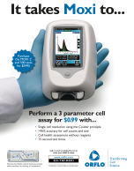
2 | NONE- use images | Orflo has done just that with the Moxi-Z; a miniature, easy-to-use, affordable cell counting device. | Text is bumped to the top of frame. Hand with instrument appears.  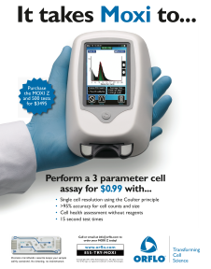
3 | NONE-use images | With Moxi, you can  perform highly accurate cell counts, determine cell size, and assess cell health- all in under 15 seconds and for just $1.29 per test. | Text at top of frame scrolls off. Bullet list appears next to fingers, timed with audio, that says, “-cell counts, -cell size, -cell health, < 15s @ $1.29 per test”
4 | None-Use Images | At under $3000, the ultra-small Moxi-Z can be easily accommodated in your laboratory and your laboratory’s budget. | Bullet list fades off and in larger font “<$3000” appears in large font and we hear cash register sounds.
5 | 8-24 seconds  *42-47s | The Moxi-Z benchtop instrument performs precision cell and particle counts by combining the *gold-standard Coulter Principle with a patented thin-film sensor technology.
6 | 2:44-2:49 | This technology is incorporated into Moxi Z’s unique patent-protected disposable cassettes. | 2:44-2:49 (the last shot (an image) will need to be extended to accommodate the narrative.
7 | 2:49-3:00 | The cassettes can be used to analyze solutions containing 3,000 to 2.5 million cells or particles per ml with diameters of 3 to 30 microns. | 2:44-2:49 (the last shot (an image) will need to be extended to accommodate the narrative.
8 | 2:44-2:49 | The cassette’s microfluidics sensors keep the sample contained, eliminating the need to clean the instrument and saving valuable research time. | 2:44-2:49 (the last shot (an image) will need to be extended to accommodate the narrative.
9 | 2:13-2:33 | Performing cell analysis with the Moxi-Z is simple. For example, to count freshly-detached HEK-293 cells, dilute them in a physiologically conductive solution such as Orflo diluent or PBS, and gently triturate.
10 | 3:11-3:51 | Next, press the tray down and insert an empty cassette.
11 | 3:11-3:51 | To ensure homogeneity of the sample, slowly invert it several times. Then holding the pipette at a 45-degree angle, dispense 75 µL of the sample into the fill port of the cassette.
12 | 3:11-3:51 | Touch the screen to start counting. After 8 seconds, the test is complete and the Moxi-Z will report the results, complete with cell number, size, and the Moxi Population Index - a measure of cell health-. | Delete the big red X from video for ad.
13 | NONE- use images | The Moxie-Z: a revolutionary new tool for rapid cell culture analysis. In Moxie window show a wide shot of the product in operation. | 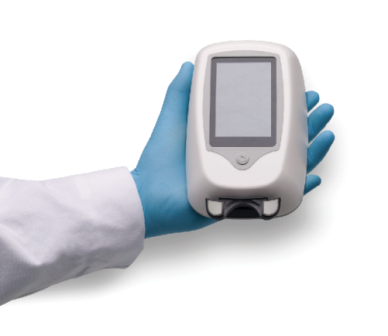
14 |  | Orflo has Moxi! Call Orflo at 1-855-879-6694, or email us at info@orflo.com to learn more, or to purchase your instrument today! |   1-855-879-6694 info@orflo.com  Add the above text to the orflo logo

