
Department of Pharmacology,
Physiology and Neuroscience
School of Medicine

August 23rd, 2011

Dr. Nandita Singh
Science Editor
Journal of Visualized Experiments

Dear Nandita:

I have uploaded my JOVE article as we discussed on the phone. I apologize for the delay. Thanks for giving me the opportunity to submit. I hope that you and the reviewers find this article acceptable to JOVE.

Sincerely Yours,

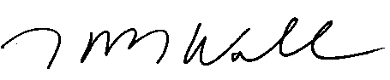

Kenneth B. Walsh, Ph.D.
Associate Professor

University of South Carolina ● Columbia, South Carolina 29209 ● (803) 216-3500 ● FAX (803) 216-3538

