Title: Alginate microcapsule as a 3D platform for propagation and differentiation of human embryonic stem cells to different lineages
Reviewer 1:
Summary:
The present article describes a method of encapsulating for proliferation and differentiation of ES cells. This method of encapsulation is definitely useful to wider scientific community, provided similar results are observed with other cell types. The procedure is adequately and clearly explained.

Major Concerns:
- Is the method equally suitable for other stem cells or differentiated cell types such as islets?

The following method has previously been applied on mouse embryonic stem cells (Dean et al. 2006), human embryonic stem cells (Chayosumrit et al. 2010) and is equally suitable for other cell types like skin-derived neuroprogenitors (unpublished observation).

Minor Concerns:
- Is there any particular reason for substituting calcium alginate with barium alginate? Or are there any disadvantages of using calcium alginate? It would be good to discuss that in the article.

We have previously used barium alginate to encapsulate embryonic stem cells (Dean et al. 2006). With further optimisation, it has been found that hESC showed a higher viability when encapsulated with calcium alginate (Siti-Ismail et al. 2008) compared with barium alginate.
- Can you provide how many cells are present per microcapsule and what is the maximum number of cells it can hold without compromising viability of those cells?

It is technically difficult to count the number of cells inside the capsule. Therefore, we have estimated this by counting the total number of cells used divided by the number of capsules obtained per run, which is approximately $5.0×{10}^{4}$ cells per capsule. From this, we found that the maximum number of cells the capsule can hold without compromising the viability is $1.0×{10}^{5}$ cells per capsule.
- What is viability of cells after decapsulation and what is the efficiency of decapsulation?

The viability of cells after decapsulation is generally >90% with100% efficiency in depolymerising the capsules to release the entrapped cells.
- Is there any spontaneous differentiation of ES cells in the microcapsules and does this method prevent teratoma formation in vivo?

The spontaneous differentiation within the capsules does occur and expected and as undifferentiated hESC continue to proliferate within the capsules, the cells would eventually breakout of the capsules and form teratomas in transplantation experiments (Methichit et al. 2010).
Reviewer 2:
Summary
This is a succinct manuscript that describes the encapsulation of human embryonic stem cells (hESC) and their differentiation to two cell types. These are definitive endoderm, and cells positive for tyrosine hydroxylase, which are probably ectodermal in nature. The technique of encapsulation, and the data on formation of definitive endoderm have been published previously (reference 1) whereas the data on the TH+ve cells are new. The technique of encapsulation is well described, as are the methods to induce differentiation of the human embryonic stem cells. The method to induce differentiation of encapsulated hESC is different from that used to differentiate non-encapsulated hESC in that a ROCK inhibitor is added to reduce apoptosis. The information in the manuscript would be of interest to others who wish to culture hESC in microcapsules.

Major Concerns
Limitations of the technique are not discussed. Some are:
-Efficiency in producing numbers of the desired cell population c.f., more conventional 2D system. Please provide these data. This has relevance to the field of transplantation where cell numbers are likely to be very important.

Approximately >90% of cells were positive for TH after 21 days of differentiation under 3D conditions (encapsulation) while <60% of TH-positive cells were observed under 2D conditions.

-Loss of cells during decapsulation. What is this in %age terms? If large, this will negatively influence the use of encapsulation for purposes of differentiation.

The cells were not lost during the decapsulation and remain viable afterwards.

-The authors suggest that encapsulation of encapsulated hESC to TH+ve cells is more efficient than with non-encapsulated cells. This is based on the earlier expression of the protein (Figure 5C) – day 14 vs. 21, but not the level of expression on days 21 and 28. More data are needed before this conclusion would be accepted. Please provide the number of times these data were observed, and at least name the other neuronal markers examined, and whether differences also were observed for these markers too.

Both qPCR and Western Blot data analyses were carried out with n=3 (Fig 5). A neuroprogenitor marker, PAX6 was also investigated which was down-regulated in 3D differentiated cells, indicating that the cells are differentiating to mature neurons. On the contrary, 2D differentiated cells maintained high expression level of PAX6 throughout the differentiation stage which suggests that the cells are maintained in neuroprogenitor stage.

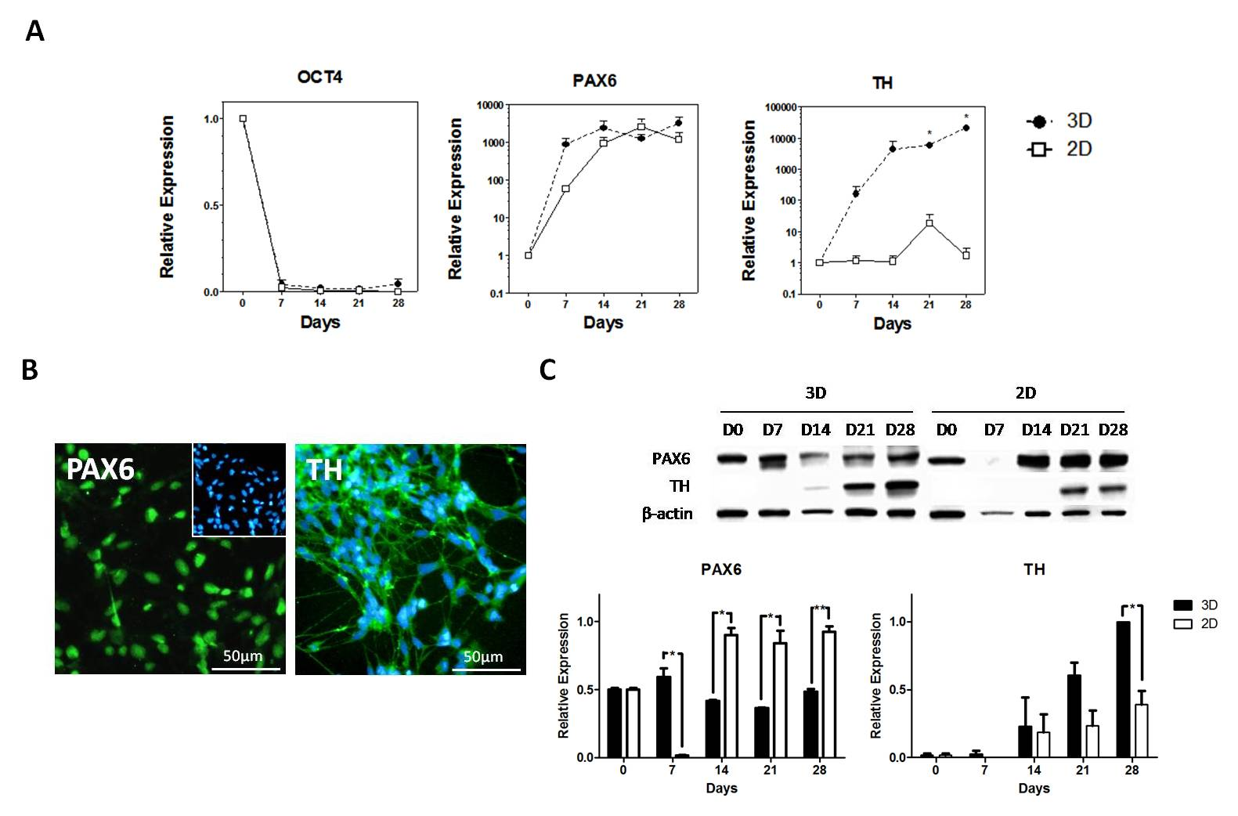

-Transplantation. The authors suggest that this technique can be used to encapsulate cells for purposes of transplantation. Whilst it is well known that microencapsulation can be used for this purpose, there are no data provided to show that current protocol would be helpful in this area. Transplantation usually utilizes higher concentrations of alginate than the 1.1% described here (Calafiori et al Diabetes Care 2006; 29: 137-8; and reference 2 of the manuscript). The technique described in the manuscript is more relevant to in vitro culture.

We have not yet tried transplanting hESC encapsulated in 1.1% calcium /barium alginate hence the lack of data regarding this.

Minor Concerns
-Some technical details are missing. These relate to the actual bead generator and the syringe pump used.

- Type J1 bead generator (Nisco engineering Inc, cat. no. SPA-0447)
- Multi-Phaser syringe pump (New Era Pump Systems Inc, cat. no. Model NE-1000)
- Ezi-Flow Medical Flowmeter (Gascon Systems, cat. no. G0149)

-Why is an IV catheter, which contains both a metal insert and a plasticcatheter needed to aspirate cells?

Only the soft plastic tubing of the catheter was used in order to physically mix and resuspend the cell pellet with alginate.

-Include in the text the period of time after decapsulation before neuronal-type cells are
seen (Figure 4).

The decapsulated and seeded cells were cultured for 2-3 days to observe the neuronal morphology.

-Figure 5A. What are the two lines describing (squares vs circles)? If this is 3D vs 2D
culture, was the ROCK inhibitor added to the culture medium for the 2D to allow a true
comparison?

Black circles represent 3D while white squares represent 2D differentiated cells (relative to day 0 samples). RI was also added for 2D differentiation system in the same manner as 3D differentiation for comparison (pre-treatment for 2 hours and post-treatment for 3 days).

