The ex vivo isolated skeletal microvessel preparation for investigation of vascular reactivity and passive wall mechanics
Authors:
Joshua T. Butcher, Adam G. Goodwill, Jefferson C. Frisbee
Authors: institution(s)/affiliation(s) for each author:
Jefferson C. Frisbee Ph.D
Department of Physiology and Pharmacology
Center for Cardiovascular and Respiratory Sciences
West Virginia University
Email: jfrisbee@hsc.wvu.edu

Adam G. Goodwill
Department of Physiology and Pharmacology
Center for Cardiovascular and Respiratory Sciences
West Virginia University
Email: agoodwill@hsc.wvu.edu

Joshua T. Butcher M.S.
Department of Physiology and Pharmacology
Center for Cardiovascular and Respiratory Sciences
West Virginia University
Email: jbutcher@hsc.wvu.edu
Corresponding author:
Jefferson C. Frisbee , Ph.D.
Keywords: isolated microvessel preparation, skeletal muscle arterioles, resistance arteriole, microcirculation, arteriolar wall mechanics
Short Abstract:
An ex vivo preparation is described for isolation of the largest gracilis muscle resistance arterioles for interrogation of both vascular responses to vasoactive stimuli and the assessment of structural properties via passive wall mechanics.
Long Abstract:
The isolated microvessel preparation is an ex vivo preparation that allows for examination of the different contributions of factors that control vessel diameter, and thus, perfusion ¹⁻⁵. This preparation will specifically refer to the gracilis arteriole in a rat as the microvessel of choice, but the preparation has been applied, but not limited to, cerebral, cardiac, and mesentery microvessels in a rat, as well as in mice ⁶⁻¹⁰. The changes in the diameter of the microvessel in response to physiological (e.g., hypoxia, intravascular pressure, or shear), or pharmacological dose response curves allow for insight and elucidation of processes and mechanistic elements impacting the regulation of perfusion resistance at a defined location. The significance of this method is that it allows for facile manipulation of the influences on the integrated regulation of microvessel diameter, while also allowing for the control of many of the contributions from other sources, including intravascular pressure (myogenic), autonomic innervation, hemodynamic (e.g., shear stress), endothelial dependent or independent stimuli, hormonal, and parenchymal influences, to provide a partial list. Under appropriate experimental conditions and with appropriate goals, this can serve as an advantage over in vivo or in situ tissue/organ preparations, which do not readily allow for the facile control of broader systemic variables.
The major limitation of this preparation is essentially the consequences of its strengths. By definition, the behavior of these vessels is being studied under conditions where many of the most significant contributors to the regulation of vascular resistance have been removed, including neural, humoral, metabolic, etc. As such, the investigator is cautioned to avoid over-interpretation and extrapolation of the data that are collected utilizing this preparation. The other significant area of concern with regard to this preparation is that it can be very easy to damage cellular components such as the endothelial lining or the vascular smooth muscle, such that variable source of error can be introduced. It is strongly recommended that the individual investigator utilize appropriate measurements to ensure the quality of the preparation, both at the initiation of the experiment and periodically throughout the course of a protocol.
Protocol:
1) Prior to the Experiment
1.1) Prior to the experiment day, glass capillary tubes of the appropriate dimensions for the station are pulled into micropipettes a puller (horizontal or vertical). These are then bent to the appropriate configuration using a butane flame. Micropipette tips are physically broken to the approximate diameter (with fine forceps) for the microvessel in question and can be polished smooth if necessary. Two micropipettes are then placed in opposition into the pipette holders for the microvessel chamber. These must be oriented such that the tips are in the same vertical and horizontal plane within the vessel chamber.
1.2) Prepare a physiological salt solution (PSS; outlined below) and ensure pH is set to appropriate levels for the specific experimental conditions. The PSS solution may be prepared beforehand and refrigerated but must be checked at the appropriate temperature for pH prior to use.
1.3) The digital video calipers used to measure vessel diameter should be calibrated using a hemocytometer or microscope stage micrometer.
1.4) Tie loops for attaching the microvessel to the pipettes should be prepared and be readily accessible for subsequent use. These can readily be prepared from 8-0 or smaller ophthalmic suture.
2) Day of the Experiment
2.1) All supporting equipment should be turned on and checked for proper function. This includes the anti-vibration/floating table and the circulating heated water bath (set to provide the appropriate temperature in the vessel bath – commonly 37 ºC), all pressure transducers and the vessel chamber drain pump (Figure 1A and 1B). Turn on the equilibration gases in the vessel chamber and in the perfusate and superfusate reservoirs.
2.2) Fill all of the reservoirs, tubes, and chambers with the PSS solution. The perfusate line leading to the inflow pipette must be completely filled to avoid the presence of air bubbles in this line which could dislodge and damage the vascular endothelium (Figure 1C). If needed, use a syringe to push the PSS solution all the way through the pipette to insure that it is completely full and without any blockage that could impede perfusate flow. The inflow pressure should be kept within reasonable limits to avoid damaging the pressure transducers (Figure 2).
3) Microvessel Harvesting
3.1) Following anesthetizing of the animal from which the microvessel is to be taken, the vessel in question should be isolated according to the procedures that are most appropriate to the vasculature to be studied. In some cases, this may require removal of the organ itself (e.g., cerebral or coronary microvessels), while in others, vessels can be removed directly from the anesthetized animal (e.g., muscle). Prior to removal of the vessel from the animal/organ, it can be very helpful to perform one final check to make certain that the vessel chamber is ready and functioning properly (including all tie loops in place).
3.2) Remove the vessel from the animal/organ by grasping the side of the vessel at one end with fine forceps and cutting along it until it is free, minimizing any tugging or pulling on the vessel. Once freed, immediately place it in a 1.7 mL centrifuge tube filled with PSS but do not let go of the vessel. This is to remember the orientation, such that perfusate direction in the bath will be identical to blood flow direction in the animal.
4) Cannulating the Vessel
4.1) Place the vessel in the bath and cannulate the proximal end on the inflow pipet. This can best be accomplished with a modest perfusion rate through the cannula (~50 mmHg pressure) and two fine forceps for each side of the proximal vessel lumen wall. Slip the vessel on the cannula tips and advance the vessel on the tip to the point where two tie loops can secure the vessel.
4.2) Raise the inflow pressure to ~75 mmHg to further inflate the vessel and facilitate cannulation on the distal pipette tip. Flow through the vessel should be seen as a distortion in the superfusate reservoir at the distal outflow of the vessel (under the microscope). Cannulate the distal end of the vessel on the outflow pipet and secure it with two tie loops (which must be in place prior to the cannulation)(Figure 3).
4.3) Adjust the micrometer until there is minimal distortion in the vessel, and the vessel approximates the in vivo length. Raise the inflow pressure until it is approximates the percentage of mean arterial pressure normally experienced by that vessel segment.
4.4) Place a small bubbling stone delivering the appropriate gas mixture into bath and place parafilm or plastic wrap over the chamber (if necessary) to avoid splashing the microscope lens. Release the clamp on the outflow pipet and allow flow through the vessel for 30 minutes. Periodically, the flow can be clamped at the outflow tubing to determine if the vessel is developing resting tone. Once the vessel has developed satisfactory tone and is responsive to the inclusion criteria for the experiment in question, the vessel is ready for subsequent study.

Tables and Figures (Required):
Figure 1A: This is the microvessel setup. A = television for viewing vessel. B = digital calipers. C= syringe for pushing superfusate through inflow pipette. D = hydrostatic column for changing pressure. E = microscope. F = water bath. G = reservoir. H = pressure monitor. I = drain pump. J = 21% oxygen tank. K = waste beaker. L = water heater. M = floating table.
Figure 1B: This is a closer view of the microvessel setup. In it can still be seen E = microscope. F = water bath. H = pressure monitor. I = drain pump. N = tubing attached to the very beginning of the inflow pipet. O = tubing attached to the very beginning of the outflow pipet.
Figure 1C: The closest view of the water bath itself. N = tubing attached to the very beginning of the inflow pipet. O = tubing attached to the very beginning of the outflow pipet. P = the horizontal and vertical controls for the inflow pipet. Q = the drain for the water bath. R = the inflow for the water bath coming from the reservoir.
Figure 2: This is a schematic of the flow of fluids and gases in the system.
Figure 3 represents an image of a double cannulated, pressurized vessel with the pipet tips and tie loops clearly seen.
Figure 4 is representative of a measurement of a vessel diameter using the digital calipers, in this case the diameter is 112 µm, as seen in the upper left hand corner. As shown in the Figure 4, a quality vessel will have clearly defined walls and uniform diameter, with brisk mechanical responses to appropriate vasoactive stimuli (physiological or pharmacological).
Discussion and Results:
The protocol presented describes the isolation, removal and double cannulation of a generic microvessel (Figure 4). A critical step is insuring that the inflow and outflow pipets that are used to cannulate the vessel remain clear and allow flow and pressure to be maintained. Often, when the pipets become clogged due to the PSS solution it is necessary to break off very small pieces of the tips to restore flow. Pipets can be reused until they reach a point where they cannot be unclogged or the diameters become so large that cannulation of the vessel is difficult. In addition, passage of an air bubble from the inflow pipet through the vessel will denude the endothelium. With mastery of this preparation, investigators can readily evaluate dilator and constrictor responses of the vessel during a myriad of challenges and interventions or the mechanics of the vessel wall in response to changes in intravascular pressure (for which calcium-free PSS must be used – see below). An excellent presentation of the basic protocols and analyses for vascular wall mechanics is presented by Baumback and Hajdu¹¹.
Acknowledgments: This work was supported by the American Heart Association (EIA 0740129N) and NIH T32 HL90610.
Disclosures: none
Reagents and Equipment | Company | Comments/Catalogue #
Vessel Chamber | Custom | Dave Eick (MCW)
Heated Circulating Water Bath | PolyScience and Haake | Haake DC 10
Pipets | Frederick Haer & Co. | Capillary Tubing 2.0 mm OD x 1.0 mm ID (27-33-1)
Pressure Monitor | World Precision Instruments
Water Jacketed Reservoir | Custom
External Light Source | World Precision Instruments | Novaflex
Pipet Puller | MicroData Instruments | PMP102 Micropipet Puller
Full complement of surgical tools | Fine Science Tools | Dumont
Ultra Fine Forceps | Fine Science Tools | Inox #5
Silk Suture Thread | Ethilon | #10-0 or 9-0
Stereo Microscope | Olympus | Olympus SZ-11
Analog Video Calipers | Boeckeler | Via Controller (Via-100)
High Resolution Analog Camera | Panasonic | GP-MF 602
Oxygen Tank | Regional | 21% balance nitrogen and 5% CO2 balance nitrogen
Tubing | Tygon
Drain Pump | Cole Parmer Instrument Co.
Modified Rat PSS | See recipe below
Van Breemen’s Relaxant PSS | See recipe below

Comments on Recipe: Make 2L of Salt Stock and 2L of Buffer Stock. These can be refrigerated when not being used, but shake them well and often before preparing PSS.
Modified Rat PSS Recipe | To make two liters of PSS | 20X Salt Stock (2L) | 20X Buffer Stock (2L)
NaCl |  | 278.0 g
KCl |  | 14.0 g
MgSO₄-7H₂O |  | 11.5 g
CaCl₂-H₂O |  | 9.4 g
NaHCO₃ |  |  | 80.8 g
EDTA |  |  | 0.4 g
NaH₂PO₄ | 0.28 g
Glucose | 1.98 g
20X Salt Stock | 100 mL
20X Buffer Stock | 100 mL
Distilled Water | 1800 mL

Comments on Recipe: Make 1L of Salt Stock and 1L of Buffer Stock. These can be refrigerated when not being used, but shake them well and often before preparing PSS.
Van Breemen’s Relaxant PSS | To make 2 liters of PSS | 20X Salt Stock (1L) | 20X Buffer Stock (1L)
NaCl |  | 107.4 g
KCl |  | 7.0 g
MgSO₄-7H₂O |  | 5.76 g
MgCl₂-6H₂O |  | 81.32 g
NaHCO₃ |  |  | 40.4 g
EDTA |  |  | 0.2 g
EGTA |  |  | 15.22
NaH₂PO₄ | 0.28 g
Glucose | 1.98 g
20X Salt Stock | 100 mL
20X Buffer Stock | 100 mL
Distilled Water | 1800 mL

References:
1. Goodwill,A.G., Frisbee,S.J., Stapleton,P.A., James,M.E., & Frisbee,J.C. Impact of Chronic Anticholesterol Therapy on Development of Microvascular Rarefaction in the Metabolic Syndrome. Microcirculation.1-18 (2009).
2. Goodwill,A.G., James,M.E., & Frisbee,J.C. Increased vascular thromboxane generation impairs dilation of skeletal muscle arterioles of obese Zucker rats with reduced oxygen tension. Am. J. Physiol Heart Circ. Physiol 295, H1522-H1528 (2008).
3. Samora,J.B., Frisbee,J.C., & Boegehold,M.A. Growth-dependent changes in endothelial factors regulating arteriolar tone. Am. J. Physiol Heart Circ. Physiol 292, H207-H214 (2007).
4. Samora,J.B., Frisbee,J.C., & Boegehold,M.A. Hydrogen peroxide emerges as a regulator of tone in skeletal muscle arterioles during juvenile growth. Microcirculation. 15, 151-161 (2008).
5. Samora,J.B., Frisbee,J.C., & Boegehold,M.A. Increased myogenic responsiveness of skeletal muscle arterioles with juvenile growth. Am. J. Physiol Heart Circ. Physiol 294, H2344-H2351 (2008).
6. Durand,M.J., Raffai,G., Weinberg,B.D., & Lombard,J.H. Angiotensin-(1-7) and low-dose angiotensin II infusion reverse salt-induced endothelial dysfunction via different mechanisms in rat middle cerebral arteries. Am. J. Physiol Heart Circ. Physiol 299, H1024-H1033 (2010).
7. LeBlanc,A.J. et al. Nanoparticle inhalation impairs endothelium-dependent vasodilation in subepicardial arterioles. J. Toxicol. Environ. Health A 72, 1576-1584 (2009).
8. Jernigan,N.L. et al. Dietary salt enhances benzamil-sensitive component of myogenic constriction in mesenteric arteries. Am. J. Physiol Heart Circ. Physiol 294, H409-H420 (2008).
9. Stapleton,P.A., Goodwill,A.G., James,M.E., & Frisbee,J.C. Altered mechanisms of endothelium-dependent dilation in skeletal muscle arterioles with genetic hypercholesterolemia. Am. J. Physiol Regul. Integr. Comp Physiol 293, R1110-R1119 (2007).
10. Goodwill,A.G., Stapleton,P.A., James,M.E., D'Audiffret,A.C., & Frisbee,J.C. Increased arachidonic acid-induced thromboxane generation impairs skeletal muscle arteriolar dilation with genetic dyslipidemia. Microcirculation. 15, 621-631 (2008).
11. Baumbach,G.L., Hadju,M.A. Mechanics and composition of cerebral arterioles in renal and spontaneously hypertensive rats. Hypertension 21. 816-826. (1993)

Figure 1A

Figure 1B

Figure 1C

Figure 2

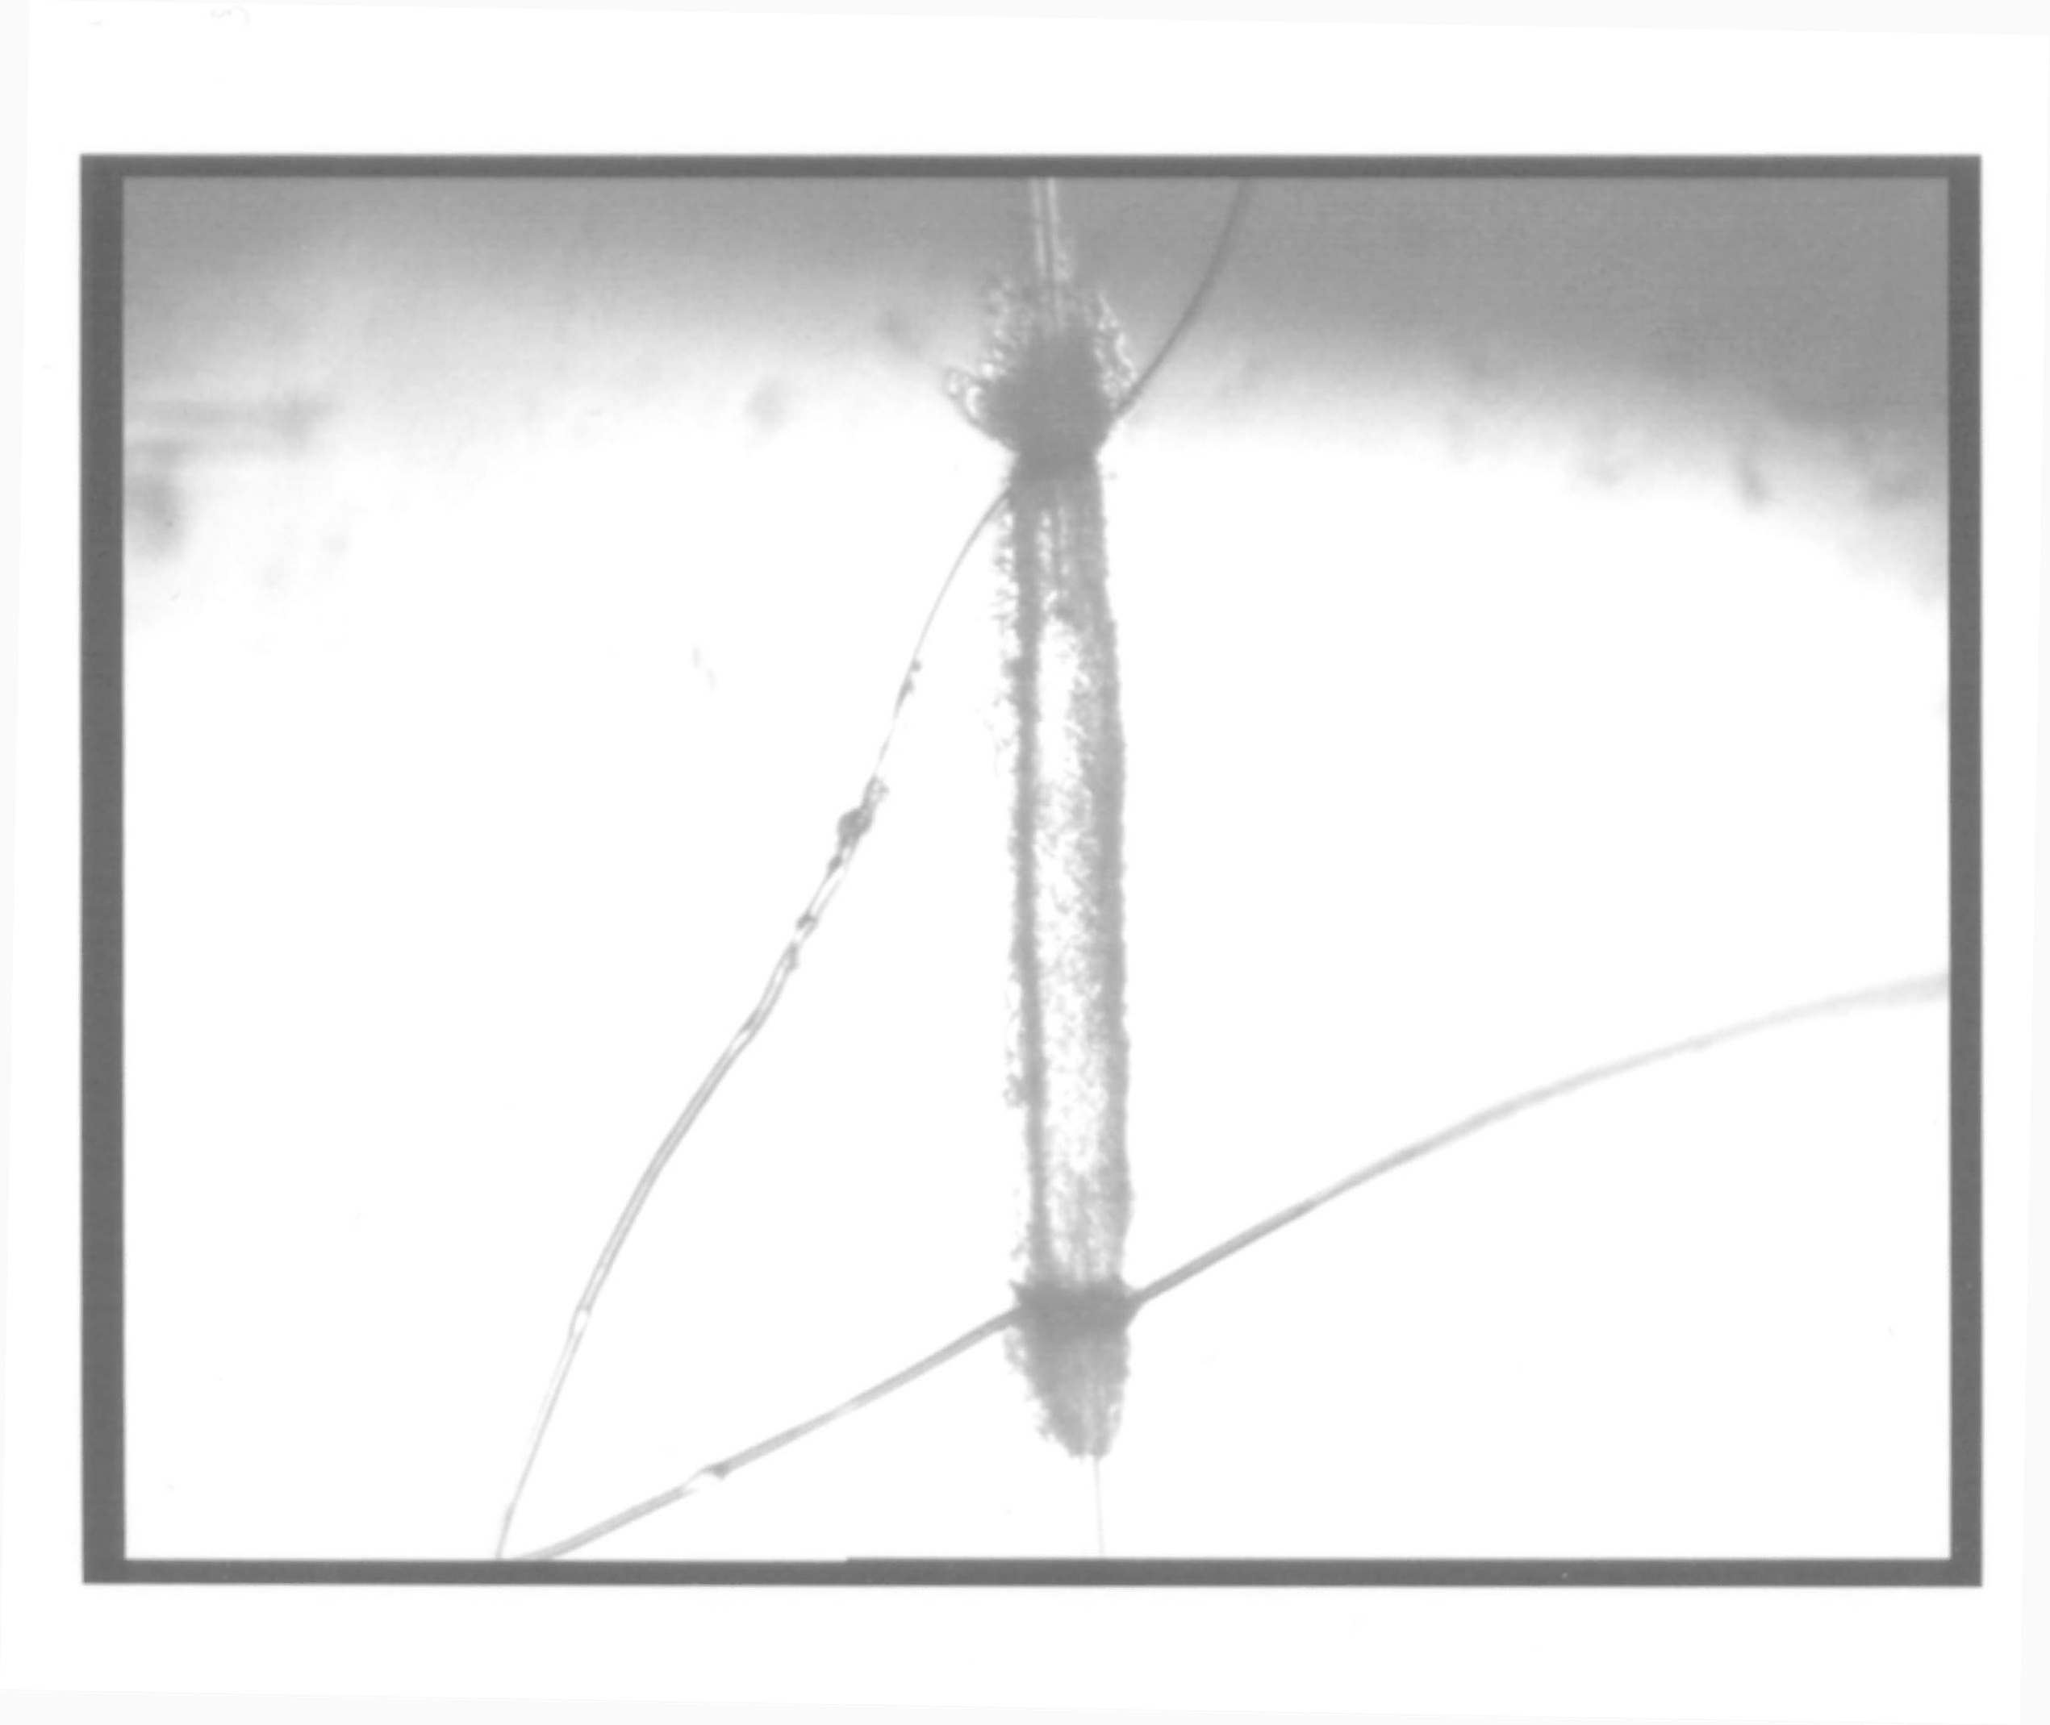

Figure 3

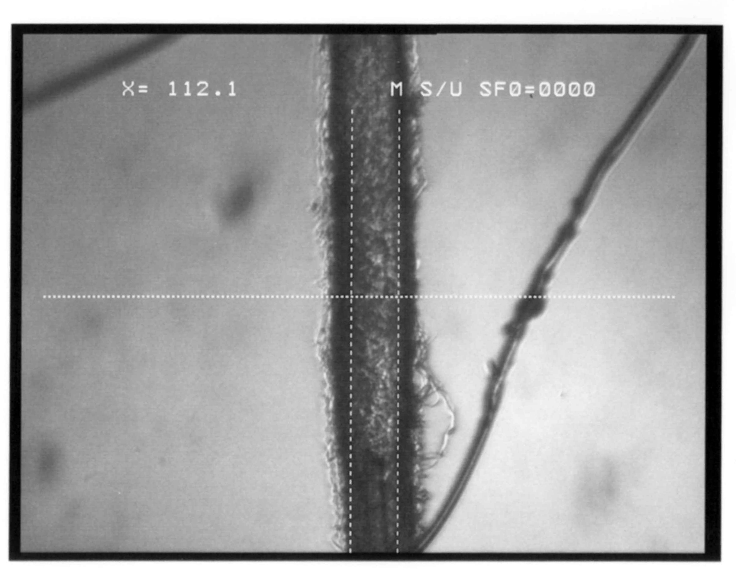
Figure 4

