Gabriel S. Dichter, Ph.D.
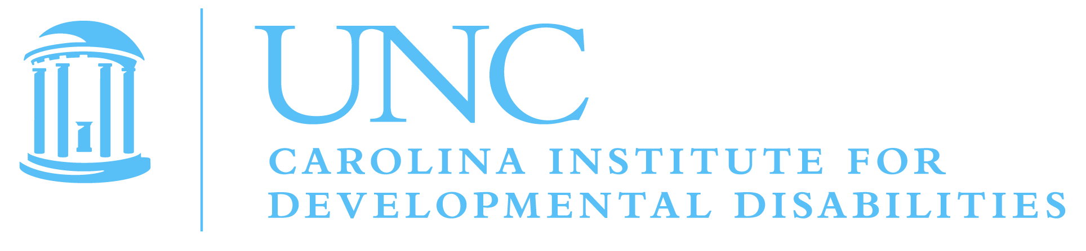
Assistant Professor of Psychiatry and Psychology, UNC-Chapel Hill

We recommend the following five reviewers:

Cameron Carter, M.D.
Director, UC Davis Imaging Research Center
Professor of Psychiatry and Psychology
cameron.carter@udmc.ucdavis.edu
916-734-7783

Gary H. Glover
Professor of Radiology
Professor in Neurosciences & Biophysics
Director, Radiological Sciences Lab
Stanford University School of Medicine
phone: 650-723-7577
gary.glover@stanford.edu

BJ Casey, PhD
Director of Sackler Institute for Developmental Psychobiology
Professor of Developmental Psychobiology
Sackler Institute for Developmental Psychobiology
Weill Medical College of Cornell University
212.746.5832
bjc2002@med.cornell.edu

Deanna Barch
Professor of Psychology
Professor of Radiology
Washington University in St. Louis
(314) 935-8729
dbarch@wustl.edu

Nora M. Raschle
Visiting Scholar
Department of Developmental Medicine, Children’s Hospital Boston
nora.raschle@childrens.harvard.edu

Nadine Gaab, PhD
Assistant Professor of Pediatrics
Children's Hospital Boston

