Gabriel S. Dichter, Ph.D.
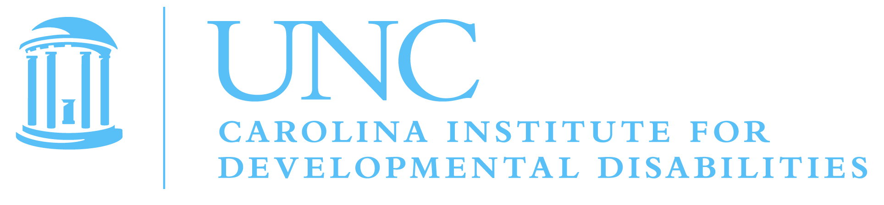
Assistant Professor of Psychiatry and Psychology, UNC-Chapel Hill

Leiam Colbert
Editor for Neuroscience
Journal of Visualized Experiments

May 4th, 2011

Dear Dr. Colbert -

Enclosed please find our invited JoVE manuscript submission , "Functional Neuroimaging Treatment Effects in Neurodevelopmental Disorders."

Thank you for considering our manuscript
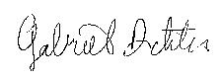
Gabriel S. Dichter, Ph.D.
Assistant Professor
University of North Carolina Departments of Psychiatry and Psychology
Duke-UNC Brain Imaging and Analysis Center
dichter@med.unc.edu
919-923-2932

