Title: Stretching Short Sequences of DNA with Constant Force Axial Optical Tweezers
Authors: K. Raghunathan, J. N. Milstein and J.-C. Meiners
Krishnan Raghunathan
LSA Biophysics,
University of Michigan
krish@umich.edu

Joshua N. Milstein
LSA Biophysics, Department of Physics,
University of Michigan
milsteij@umich.edu

Jens-Christian Meiners
LSA Biophysics, Department of Physics,
University of Michigan
meiners@umich.edu

Corresponding Authors: K. Raghunathan
Keywords:
DNA stretching, Axial Optical Tweezers, Single-Molecule Biophysics

Short Abstract:
We illustrate the use of a constant force axial optical tweezers to explore the mechanical properties of short DNA molecules. By stretching DNA axially we minimize steric hindrances and artifacts arising in conventional lateral manipulation, allowing us to study DNA molecules as short as ~100 nm.
Long Abstract:
Single-molecule techniques for stretching DNA with contour lengths of less than a kilobase are fraught with experimental difficulties. However, many interesting biological events such as histone binding and protein-mediated looping of DNA^{1,2}, occur on this length scale. In recent years, the mechanical properties of DNA have been shown to play a significant role in fundamental cellular processes like the packaging of DNA into compact nucleosomes and chromatin fibers^{3,4}. Clearly, it is then important to understand the mechanical properties of short stretches of DNA. In this paper, we provide a practical guide to a single-molecule optical tweezing technique that we have developed to study the mechanical behavior of DNA with contour lengths as short as a few hundred basepairs.
The major hurdle in stretching short segments of DNA is that conventional optical tweezers are generally designed so that a force is applied in a direction lateral to the stage^{5,6} (see Fig. 1). In this geometry, the angle between the bead and the coverslip, to which the DNA is tethered, becomes very steep for submicron length DNA. Another source of error is that the microspheres are not perfectly spherical and large errors in force-extension measurements can result due to rotations of the microsphere within the optical trap.
We circumvent this fundamental problem by directly pulling the DNA away from the coverslip by using a constant force axial optical tweezers^{7,8}. This is achieved by trapping the bead in a linear region of the optical potential, where the optical force is constant—the strength of which can be tuned by adjusting the laser power. Trapping within the linear region also serves as an all optical force-clamp on the DNA that extends for nearly 350 nm in the axial direction. We simultaneously compensate for thermal and mechanical drift by finely adjusting the position of the stage so that a reference microsphere stuck to the coverslip remains at the same position and focus, allowing for a virtually limitless observation period.

Protocol Text:

Tweezer Setup
- The beam from a 1064 nm laser is split into two orthogonally polarized beams. One is used to manipulate the biomolecule while the other is used for calibration purposes (see Fig. 2).
- The intensity of the manipulation beam is controlled by an acousto-optic deflector (AOD), while the position and focus of each beam is independently controlled by beam steering mirrors and optical telescopes, respectively.
- The beams are then recombined with another polarizing beam splitter and conditioned further by a final set of telescoping optics to slightly overfill the back aperture of the microscope objective. A 50% overfill for the calibration beam leads to a tight optical trap, while a slightly smaller factor for the manipulation beam, approximately 20%, gives a shallower focus that translates into a larger workable region of the linear potential. Finally, the beams are tightly focused with a PlanApo 60x/1.4 oil immersion microscope objective onto the sample cell.
- This tweezer setup is combined with a home built brightfield microscope that provides illumination from a Halogen lamp focused onto the sample chamber by a condenser. The brightfield image is separated from the laser light by a dichroic and then imaged on two CCD cameras. One CCD acts as our primary means of acquiring data and is software triggered to yield precise sampling rates, while the other CCD serves as part of a feedback-control system that compensates for drift in the microscope.
- The sample is coarsely positioned with respect to the objective by an XY stage, and can then be precisely positioned by an embedded three dimensional piezo-stage.
- The forward-scattered and transmitted laser light is collected by the brightfield condenser and focused onto a photodetector. The resulting signal is filtered through an anti-aliasing filter at 100 kHz, amplified and acquired at 200 kHz using a DAQ card.
Calibrating Apparent Size to Axial Position
- Load a sample chamber⁹ with a disperse solution of 800 nm diameter polystyrene microspheres diluted in phosphate buffer saline buffer. Let sit for 10-15 minutes and then lightly flush with buffer to remove excess microspheres.
- Locate a microsphere randomly stuck to the coverglass and adjust the height of the sample chamber until the microsphere is approximately 1µm below the focus to generate a defocused image.
- To measure the apparent size of the image, first find the centre of the microsphere using the geometric pattern matching function in LabView.
- Next, generate a radial intensity profile of the microsphere by averaging 360º about the center of each cross section. The radial profile, which corresponds to a white ring in each of the brightfield images, can be fitted with a quadratic function to find a brightness peak. The distance between this peak and the center can be used as a measure of the apparent size of the bead.
- Using the calibrated piezostage, gradually increase the axial position of the microsphere and acquire with the CCD camera an image at each axial position.
- Repeat the image analysis for each successive image to correlate the apparent size of the microsphere with its axial location (see Fig. 3).
Mapping the Optical Potential of the Manipulation Beam
- Begin by collinearly aligning the manipulation beam and the calibration beam. The calibration beam should be around 50 mW at the back aperture of the objective while the manipulation beam should be of much weaker, say 10 mW.
- With the manipulation beam switched off, confine a free microsphere within the much stiffer trap of the calibration beam.
- Now, turn on the manipulation beam. Since the manipulation beam is much weaker than the calibration beam, the axial position of the microsphere will be slightly perturbed. The resulting change in axial position can be measured from defocused brightfield image as already described.
- Turn off the manipulation beam and, with the microsphere still trapped in the calibration beam, shift the axial focus of the calibration beam by adjusting the telescopic lens. Turn on the manipulation beam and measure the subsequent displacement of the microsphere and repeat.
- The displacements ΔX can be plotted against the axial position of the focus of the calibration beam. The axial position corresponding to the largest displacement of the microsphere determines the center of the linear region of the optical trap (see Fig. 4).
- The final step in obtaining the optical force of the manipulation beam as a function of axial position requires a careful measurement of the stiffness of the calibration beam. To obtain this, move the microsphere, trapped by the calibration beam, to the center of the linear region by adjusting the telescopic lens while the manipulation beam is switched off.
- Record the thermal axial motion of the microsphere by measuring the intensity of transmitted light with a photodetector.
- The autocorrelation of the signal can be fitted to a single exponential decay function to give the time constant of the fluctuations$τ_{z}$.
- The hydrodynamic friction coefficient $ζ$ of the microsphere can be corrected for the microspheres proximity to a surface^{5,10} . The stiffness of the calibration trap is then given by $k_{z}=ζ/{τ_{z}}$ (see Supplementary Materials A).
- Knowing the stiffness of the calibration trap allows one to convert the previously measured axial displacements into a force$f_{z}=- k_{z} ΔX$. Integration of this curve yields a spatial mapping of the axial optical potential of the manipulation beam (see Fig. 4).

Stretching a DNA sample
- Mount the chamber⁹ containing surface tethered DNA molecules (< 1 kbp) and, while observing the brightfield image, place the focus of the manipulation beam slightly above the unstretched microspheres by adjusting the telescope. Then adjust the position of the stage until one of the microspheres gets trapped.
- Roughly position the microsphere in the center of the XY plane of the optical trap. A series of square waves can be generated in LabView and sent to the AOD to repetitively turn the laser beam on and off. The intensity of the laser and the duration of the on state should be carefully controlled to prevent heating of the sample chamber. Typically, we use around 2 mW of laser power (measured at the back aperture of the objective) and send pulses of 200 ms (on) and 500 ms (off). The amplitude of the square wave sent to the AOD is 0.5 V.
- Watch the microsphere as the trap is repeatedly turned on and off and note if the laser induces any preferential direction to the microsphere’s motion. While iteratively adjusting the microsphere position in both the X and Y direction, by controlling the piezostage, the random motion of the microsphere should become isotropic in the XY plane, though noticeably restricted when the laser is on.
- Next, one should align the bead in the Z direction. The laser beam should again be pulsed on and off while, this time, simultaneously measuring the microspheres axial displacement in real time. The stage should be centered within the linear region, which is the point where the Z displacement is greatest.
- After a careful alignment in the Z direction, it is imperative to check that the trap is still centered in the XY plane. If the XY alignment has changed, both the XY and Z alignment must be repeated until the microsphere is centered properly along all 3 axes.
- For stretching the DNA, we ramp the laser intensity by sending a voltage signal to the AOD, from 0 V to 0.5 V in steps of 0.025 V. In each step, we record 400 frames at 100 fps and average them to obtain the axial displacement.
- The force extension curves can now be plotted and fit to a modified WLC model¹¹ (see Supplementary Materials B).

Representative Results:
The data and the corresponding fits of a force extension curve are shown in Fig. 5 for a random 1298 bp sequence of dsDNA as well as for a 247 bp sequence, which is the shortest length of DNA we have been able to stretch.

Conclusion:

Axial optical tweezers can manipulate short stretches of DNA that are inaccessible to manipulation by conventional optical methods. They have been used to study the elasticity of short DNA molecules as small as a few hundred base pairs¹², probe the effects of elastic tension on short protein-mediated DNA loops^{13,14}, and uncover sequence dependent effects on DNA elasticity¹⁵. They are proving to be a valuable new technique in the single-molecule toolbox.

Acknowledgements:

We thank Yih-Fan Chen for help with the axial optical tweezers and for contributing some of his stretching data to this manuscript.
References:

1 Halford, S. E., Welsh, A. J. & Szczelkun, M. D. Enzyme-mediated DNA looping. Annu Rev Biophys Biomol Struct 33, 1-24 (2004).
2 Allemand, J. F., Cocco, S., Douarche, N. & Lia, G. Loops in DNA: an overview of experimental and theoretical approaches. Eur Phys J E Soft Matter 19, 293-302 (2006).
3 Kaplan, N. et al. The DNA-encoded nucleosome organization of a eukaryotic genome. Nature 458, 362-366 (2009).
4 Garcia, H. G. et al. Biological Consequences of Tightly Bent DNA: The Other Life of a Macromolecular Celebrity. Biopolymers 85, 115-130 (2006).
5 Neuman, K. C. & Block, S. M. Optical trapping. Rev Sci Instrum 75, 2787-2809 (2004).
6 Moffitt, J. R., Chemla, Y. R., Smith, S. B. & Bustamante, C. Recent advances in optical tweezers. Annu Rev Biochem 77, 205-228 (2008).
7 Chen, Y. F., Blab, G. A. & Meiners, J. C. Stretching submicron biomolecules with constant-force axial optical tweezers. Biophys J 96, 4701-4708 (2009).
8 Chen, Y. F., Wilson, D. P., Raghunathan, K. & Meiners, J. C. Entropic boundary effects on the elasticity of short DNA molecules. Phys Rev E 80, 020903 (2009).
9 A detailed protocol for chamber construction and sample preparation can be found on our website: http://meiners.biop.lsa.umich.edu/Data/Sites/7/userfiles/tpm-protocol.pdf.
10 Brenner, H. The slow motion of a sphere through a viscous fluid towards a plane surface. Chem Eng Sci 16, 242-251 (1961).
11 Marko, J. F. & Siggia, E. D. Stretching DNA. Macromolecules 28, 8759-8770 (1995).
12 Chen, Y. F., Wilson, D. P., Raghunathan, K. & Meiners, J. C. Entropic boundary effects on the elasticity of short DNA molecules. Phys Rev E 80, 020903 (2009).
13 Chen, Y. F., Milstein, J. N. & Meiners, J. C. Protein-mediated DNA loop formation and breakdown in a fluctuating environment. Phys Rev Lett 104, 258103 (2010).
14 Chen, Y. F., Milstein, J. N. & Meiners, J. C. Femtonewton entropic forces can control the formation of protein-mediated DNA loops. Phys Rev Lett 104, 048301 (2010).
15 Raghunathan, K., Milstein, J. N., Juliar, B., Blaty, J. & Meiners, J. C. Sequence Dependent Effects on the Elasticity of Short DNA Molecules (in process, 2011).

Tables and Figures:

Figure 1: Principle of Axial Optical Tweezers. (Left) Conventional optical tweezers trap near the focus. The bead is then moved lateral to the coverslip to exert tension. (Right) In axial optical tweezers, a microsphere is trapped away from the focus, in the linear region of the optical potential. In this configuration, the polymer is held under constant tension for a range of extensions. Moreover, increasing the laser intensity moves the microsphere in the axial direction.

Figure 2: Schematic Representation of Axial Optical Tweezers. Laser light (1064nm Nd:YvO₄) is split into two beams by passing through a polarizing beam splitter (PBS) from which one, the manipulation beam, passes through an acousto-optical deflector (AOD) while the other, the calibration beam, can be adjusted independently using telescopic lenses. The two beams are then recombined using another PBS, reflected by a dichroic lens and focused onto the sample by a high N.A. objective. Simultaneously, brightfield illumination, used to track the microsphere, passes through the sample, is Infra Red (IR) filtered and is then imaged by two CCD cameras, one of which takes measurements while the other acts as part of a feedback control system.

Figure 3: Axial Position Calibration. To calibrate the axial position, we acquire defocused images of a bead stuck to the chamber coverslip at varying axial positions of the stage. The size of the microsphere is given by the distance between its center and the position of peak intensity about the bright ring formed around the image of the microsphere.

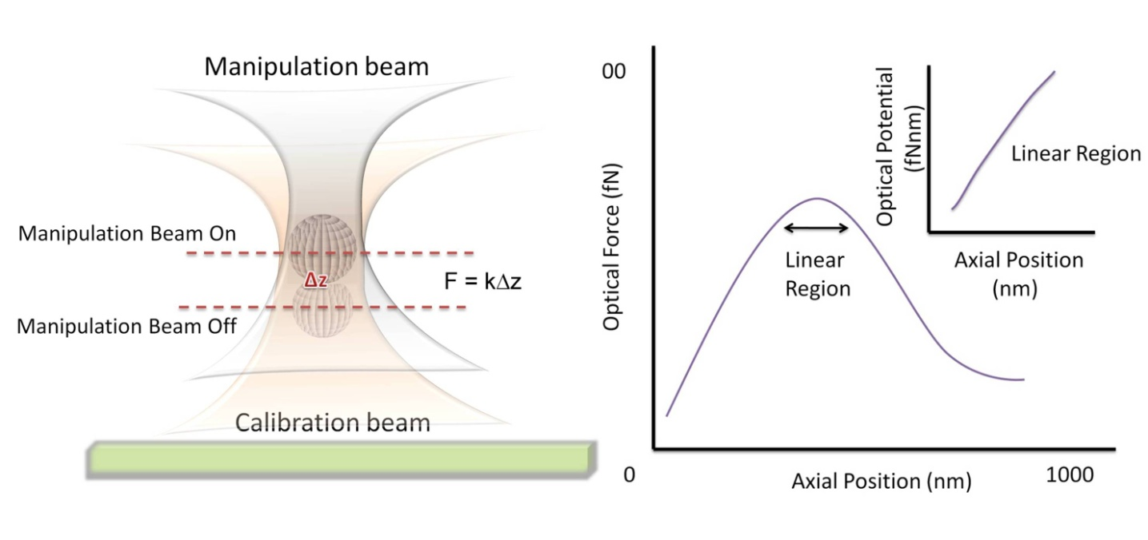
Figure 4. Principal Behind Mapping the Optical Potential. To map out the optical force of the manipulation beam, one measures the axial displacement that it induces on a microsphere trapped within a much stronger calibration beam. One can locate the center of the linear region where this displacement is a maximum. The Optical Force vs. Axial Position curve can be integrated to find the optical potential.
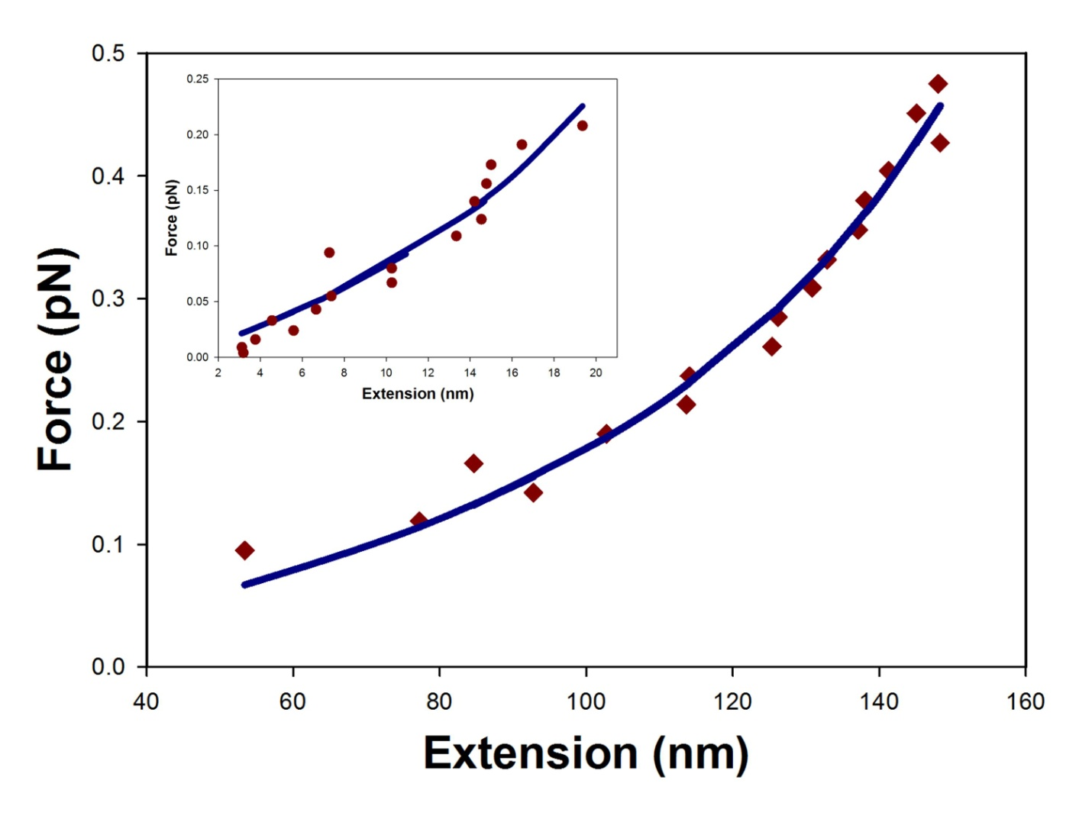

Figure 5: Force Extension Curve. Data is shown for a random 1298 bp and 247 bp (inset) segment of dsDNA stretched by axial optical tweezers. The data points were fit to the modified WLC model of Eq. 3 (solid lines) and yielded effective persistence lengths of 34 nm and 25 nm, respectively.

Table of specific reagents and equipment:

Reagent/Equipment | Company | Catalog number | Comments
Nd:YVO4 laser | Spectra Physics | T40-Z-106C
Acousto-optic deflector | IntraAction | DTD-274HA6
Microscope Objective | Olympus | PlanApo | 60X, NA 1.4
Piezo stage | Mad City Labs | Nano-LP100 | XYZ stage
CCD camera | PixeLink | PL-A741
Photodetector | Electro-Optics Tech | ET-3020
Polystyrene Beads | Spherotech | SVP-08-10 | 800nm, streptavidin coated
Anti-digoxigenin | Roche | 11333089001 | From sheep
Primers | MWG operon | Custom oligos | One primer: biotin  Other : digoxigenin
PCR reagents | New England Biolabs | TAQ polymerase, dNTPs
Coverglass | Fisher Scientific
Other chemicals for buffer | Fisher Scientific

Supplementary Materials

A. Hydrodynamic Friction Coefficient

For determining the hydrodynamic friction coefficient of the microsphere near a surface one can use the following expansion:

$ζ=6πηr\frac{4\sinh{α}}{3}\sum_{n=1}^{∞}{\frac{n\left(n+1\right)}{\left(2n-1\right)\left(2n+3\right)}}\left[\frac{2\sinh\left(2n+1\right)α+\left(2n+1\right)\sinh{2α}}{{\left(2sinh{\frac{\left(n+1\right)α}{2}}\right)}^{2}-{\left[\left(2n+1\right)\sinh{α}\right]}^{2}}\right]$, (1)

where the following shorthand has been introduced:
$α=\cosh^{-1}{\frac{h}{r}}=\ln\left[\frac{h}{r}+{\left({\left(\frac{h}{r}\right)}^{2}-1\right)}^{1/2}\right]$ . (2)
The friction coefficient is defined in terms of the fluid viscosity $η$ and the radius $r$of the microsphere, with the microsphere’s center located a distance $h$ above the surface. The summation converges reasonably well when expanded to about ten terms.

B. Modified Worm-Like Chain (WLC) model
The force extension curves can be fit to a modified WLC model that accounts for volume exclusion effects at zero optical force as follows:
$F_{OPT }= F_{WLC}\left(x_{o}+x_{opt},l_{p}^{*},L\right)-F_{WLC}\left(x_{o},l_{p}^{*},L\right)$, (3)
where $F_{OPT }$ is the optical force, $x_{o}$ is a fit parameter for the zero force extension,$x_{opt}$ is the extension under force, $L$ is the contour length of the DNA, and $l_{p}^{*}$ is a second fit parameter for an “effective” persistence length. $F_{WLC}$ is given by the usual WLC model

${ F}_{WLC} =\frac{k_{b}T}{l_{p}^{*}}\left[\frac{1}{4{(1-ε)}^{2}}- \frac{1}{4}+ε\right]$, (4)
where $ε$ is the relative DNA extension.

