JoVE Article Template
TITLE: Direct miRNA Target Quantitation from Plasma, Blood Lysates and Tissue Homogenates using the QuantiGene® 2.0 miRNA Assay
Authors: First name, middle initial, last name
Yunqing Ma, Jessie Wu
Authors: institution(s)/affiliation(s) for each author:
- Department: R&D
- Institution: Affymetrix
- e-mail: Yunqing_ma@affymetrix.com; Jessie_wu@affymetrix.com

Corresponding author: Yunqing Ma

Keywords: (minimum 4, maximum 10) Authors, please add/delete keywords as you see fit
microRNA, miRNA, expression, cancer, analysis, profiling, quantitation, gene regulation
Short Abstract: should include a general description of the article (10 words minimum, 50 words maximum)
This protocol describes the direct quantitation of microRNA (miRNA) targets without cDNA synthesis and PCR amplification, directly from plasma, blood lysates and tissue homogenates. The hybridization-based assay employs novel oligonucleotide chemistry and probe design for specific and efficient capturing of mature target miRNA followed by branched DNA (bDNA) signal amplification.

Long Abstract (150 words minimum, 400 words maximum)
Since the discovery of miRNAs in the early nineties¹, studies have revealed that they serve a major role in regulating the development and physiology of complex organisms⁴⁻¹¹. It is estimated that these small non-coding RNA molecules regulate approximately 30 percent of all protein-coding genes^{2,3}, covering an extensive range of developmental and physiological mechanisms in the cell. Such mechanisms include protein translation inhibition, ribosomal RNA processing, alternative splicing, and mRNA degradation⁴⁻¹¹. The analysis of the small non-coding RNAs is faced with a variety of challenges due to the miRNAs small size, binding of the miRNA to the target mRNA, loss of the small RNAs during RNA isolation, amplification bias during cDNA synthesis and PCR amplification, and limited specificity.

The QuantiGene 2.0 miRNA Assay allows direct detection and quantitation of mature miRNA targets with single-base specificity. Quantitation of specific miRNA targets can be performed in any samples, including cultured cell lysates; whole blood or PAXgene blood lysates; plasma; fresh, frozen, or Formalin-Fixed, Paraffin-Embedded (FFPE) tissue homogenates; and purified miRNA. The validated probe sets based on proprietary chemistry enable high assay specificity. The assay technology provides accurate results by avoiding biases inherent to miRNA purification and amplification by using clinically proven branched DNA (bDNA) technology, which relies on signal amplification directly from lysate without miRNA purification, cDNA synthesis or PCR amplification.

Described here is the direct quantitation of miRNA targets from plasma, blood lysates and tissue homogenates. On the first day, the sample is lysed to release the miRNAs and incubated overnight with the target specific probe sets in a 96-well plate containing the universal capture probes. On the second day the signal amplification tree is built via sequential hybridization of PreAmplifier (PreAmp), Amplifier (Amp) and Alkaline phosphatase label probe (AP-LP). The signal is detected by adding chemiluminescent substrate and using a microplate luminometer for the read out.

Protocol Text:
- Assay design & preparation

  - The QuantiGene 2.0 miRNA assay is performed in 96-well format. When designing the experiment, keep in mind that all assay samples should be run in duplicate at a minimum and ideally in triplicate. Technical replicates are used to calculate assay precision or %CV.

  - Furthermore, each plate should include an Assay Background Control, which is a sample well that contains all assay components except for the target miRNA. This control is used to determine the limit of detection (LOD). Data below the LOD should not be used for quantitation.

  - Each plate should also include miRNA assay positive controls which are provided by Affymetrix. This control is used to determine the absolute number of miRNA copies/sample/well, a control which improves data accuracy and precision for inter-day and inter-site experiments.

  - As a final assay control, a normalizing small RNA should be included to determine the relative fold changes or to normalize gene expression data across samples or experiments. The selected gene should be stably expressed under all experimental conditions evaluated and have a relative luminescent signal that is similar to test samples so that no dilution factor is required.

Examples of recommended small RNAs:

  - Prior to the start of the experiment, thaw the Probe Set(s) and Blocking Reagent. Once thawed, vortex briefly to mix. Then briefly centrifuge to collect the contents at the bottom of the tubes. Keep the reagents on ice until use. Also re-dissolve any precipitates in the Lysis Mixture by incubating at 37 °C for 30 minutes followed by gentle swirling.

  - Remove the Capture Plate from 4 °C and place it on the benchtop to warm completely to room temperature (approximately 30 minutes). Do not remove the plate from the sealed foil pouch. Proceed to target miRNA capture from the chosen sample.

- Target miRNA capture from cultured cell or blood lysates

  - To begin analysis on cultured cell or whole blood/PAXgene blood lysate(s), thaw the samples at room temperature. Once thawed, incubate the sample at 37 °C for 15 – 30 minutes. Following incubation, vortex briefly and then leave at room temperature until use.

  - Next, estimate the sample input according to table 1 and the LOD of the miRNA target-specific probe set from the package insert.

Table 1: Recommended sample input for cultured cell or blood lysates (based on LOD = 3,000 Copies of miRNA Probe Set)
miRNA (copies per cell) | Cultured Cells  (number of cells) | Whole Blood/PAXgene  Blood Lysate (μL)
<10 | 6,000 | 80ª
100 | 600 | 80
>1,000 | 60 | 8
ªMay not have sensitivity required

  - If appropriate, based on the expression level of target miRNA of interest, dilute the sample with Diluted Lysis Mixture (1 volume of Lysis Mixture plus 2 volumes of nuclease-free water, prepared fresh) so that the final desired amount of sample is present in a volume of 80 μl/assay well.

  - Next, prepare an appropriate volume of the Working Probe Set by combining the reagents in the order listed in Table 2. Scale according to the number of assays to be run. NOTE: Include 3 wells for assay background controls.

Table 2: Preparation of Working Probe Sets for cultured cell or blood lysates
Reagent | 1 Well (μL) | 48 Wellsª (μL) | 96 Wellsª (μL)
Nuclease-free Water | 11.7 | 786.0 | 1,573.0
Lysis Mixture | 6.7 | 447 | 893.0
Blocking Reagent | 1.0 | 67.0 | 134.0
Capture Extenders (CE) | 0.3 | 20.1 | 40.2
Label Extenders (LE) | 0.3 | 20.1 | 40.2
Total | 20.0 | 1,340.2 | 2,680.4
ªIncludes 40% coverage

  - After the Capture Plate reaches room temperature (minimum of 30 minutes at room temperature), open the sealed foil pouch and remove the Capture Plate. Vortex the Working Probe Set briefly to mix.

  - The next step is to dispense the reagents into the Capture Plate without the introduction of bubbles. If using fewer than 48 wells, use a single channel pipette and a new tip for each transfer to dispense 20 μL of Working Probe Set into each assay well.

  - For 48 wells or more, a single channel pipette can be used to transfer the Working Probe Set to a 25-mL divided reagent reservoir (NOTE: Do not pour or reagent shortage will occur). Then, utilize a multichannel pipette to dispense 20 μL of Working Probe Set into each assay well, using new tips for each transfer.

  - Keep in mind that the Capture Probe oligonucleotides are conjugated to the surface of Capture Plate wells, and care should be taken not to scratch Capture Plate wells with pipette tips.

  - Following addition of the Working Probe set, the sample can be added to the Capture plate. Using a new pipette tip for each transfer, add 80 μL of sample to each well of the Capture Plate containing the Working Probe Set. Do not mix the sample.

  - Then, add 80 μL of the Diluted Lysis Mixture to 3 wells for the assay background controls for each Probe Set used.

  - To bind the target miRNA, place an adhesive Plate Seal squarely on the plate and seal tightly. Complete and uniform sealing of the overnight hybridization plate is essential and is achieved through use of a soft rubber roller or the QuantiGene CTC Plate Sealer. Letters and numbers on the Capture Plate should be clearly defined beneath the Plate Seal.

  - Centrifuge the Capture Plate at 240 x g for 20 seconds at room temperature to ensure the contents contact the bottom of the well.

  - Immediately place the Capture Plate in a 46 ± 1 °C incubator to begin the overnight (16.–20 hour) hybridization. Because the temperature must be 46 ± 1 °C for miRNA assay, it should be verified using a QuantiGene Incubator Temperature Validation Kit.

- Target miRNA capture from plasma lysates
  - If plasma samples have been refrigerated or frozen, thaw on ice. Mix each sample well by inverting 5-10 times before use.
  - Prewarm Lysis Mixture at 37 °C for 30 minutes, followed by gentle swirling.
  - Prepare an appropriate volume of Plasma Working Lysis Mixture by combining, in the order listed, the following reagents per assay well:
- 27 μL Lysis Mixture
- 6 μL nuclease-free water
- 2 μL Proteinase K
Vortex briefly to mix.
  - Combine 35 μL Plasma Working Lysis Mixture and 45 μL plasma for each assay well. Do not exceed 45 μL of plasma/assay well as incomplete lysis and non-linear results may occur. Vortex immediately for 30-60 seconds.
Scale volumes according to the number of assays to be run. Include 20% overage. For example, for 10 assay wells, combine 420 μL (10 assay wells + 20% = 12 assay wells * 35 μL/assay well = 420 μL) of Plasma Working Lysis Mixture with 540 μL (10 assay wells + 20% = 12 assay wells * 45 μL/assay well = 540 μL) of plasma.
3.5) Incubate at 60 °C for 1 hour with shaking at a minimum of 275 rpm.
3.6) Use plasma lysates immediately in a QuantiGene 2.0 miRNA assay, or store at –80 °C for future use.
3.7) Determining Complete Plasma Exosome Lysis . We strongly recommend that you validate the sample preparation process by performing a serial dilution of the lysate and running a QuantiGene 2.0 miRNA assay on the dilution series. Dilutions of samples should be prepared using diluted Lysis Mixture (1 volume of Lysis Mixture plus 2 volumes of nuclease-free water, prepared fresh). Verify that the expected fold change matches the observed fold change. For example, a 3-fold dilution should generate a 3-fold change (± 20%) in the signal (background subtracted) of the target.
3.8) Recommended Sample Input. We recommend starting with the maximal sample input of 80 μL/well. If necessary, dilutions of the sample can be prepared using diluted Lysis Mixture (1 volume of Lysis Mixture plus 2 volumes of nuclease-free water, prepared fresh).
  - Next, estimate the sample input according to table 1 and the LOD of the miRNA target-specific probe set from the package insert.

Table 3: Recommended sample input for plasma lysates (based on LOD = 3,000 Copies of miRNA Probe Set)
miRNA (copies per cell) | Plasma Lysate (μL)
<10 | 80ª
100 | 80
>1,000 | 8
ªMay not have sensitivity required

  - If appropriate, based on the expression level of target miRNA of interest, dilute the sample with Diluted Lysis Mixture (1 volume of Lysis Mixture plus 2 volumes of nuclease-free water, prepared fresh) so that the final desired amount of sample is present in a volume of 80 μl/assay well.

  - Next, prepare an appropriate volume of the Working Probe Set by combining the reagents in the order listed in Table 2. Scale according to the number of assays to be run. NOTE: Include 3 wells for assay background controls.

Table 4: Preparation of Working Probe Sets for plasma lysates
Reagent | 1 Well (μL) | 48 Wellsª (μL) | 96 Wellsª (μL)
Nuclease-free Water | 11.7 | 786.0 | 1,573.0
Lysis Mixture | 6.7 | 447 | 893.0
Blocking Reagent | 1.0 | 67.0 | 134.0
Capture Extenders (CE) | 0.3 | 20.1 | 40.2
Label Extenders (LE) | 0.3 | 20.1 | 40.2
Total | 20.0 | 1,340.2 | 2,680.4
ªIncludes 40% coverage

  - After the Capture Plate reaches room temperature (minimum of 30 minutes at room temperature), open the sealed foil pouch and remove the Capture Plate. Vortex the Working Probe Set briefly to mix.

  - The next step is to dispense the reagents into the Capture Plate without the introduction of bubbles. If using fewer than 48 wells, use a single channel pipette and a new tip for each transfer to dispense 20 μL of Working Probe Set into each assay well.

  - For 48 wells or more, a single channel pipette can be used to transfer the Working Probe Set to a 25-mL divided reagent reservoir (NOTE: Do not pour or reagent shortage will occur). Then, utilize a multichannel pipette to dispense 20 μL of Working Probe Set into each assay well, using new tips for each transfer.

  - Keep in mind that the Capture Probe oligonucleotides are conjugated to the surface of Capture Plate wells, and care should be taken not to scratch Capture Plate wells with pipette tips.

  - Following addition of the Working Probe set, the sample can be added to the Capture plate. Using a new pipette tip for each transfer, add 80 μL of sample to each well of the Capture Plate containing the Working Probe Set. Do not mix the sample.

  - Then, add 80 μL of the Diluted Lysis Mixture to 3 wells for the assay background controls for each Probe Set used.

  - To bind the target miRNA, place an adhesive Plate Seal squarely on the plate and seal tightly. Complete and uniform sealing of the overnight hybridization plate is essential and is achieved through use of a soft rubber roller or the QuantiGene CTC Plate Sealer. Letters and numbers on the Capture Plate should be clearly defined beneath the Plate Seal.

  - Centrifuge the Capture Plate at 240 x g for 20 seconds at room temperature to ensure the contents contact the bottom of the well.

  - Immediately place the Capture Plate in a 46 ± 1 °C incubator to begin the overnight (16.–20 hour) hybridization. Because the temperature must be 46 ± 1 °C for miRNA assay, it should be verified using a QuantiGene Incubator Temperature Validation Kit.

- Target miRNA capture from plasma exosome lysates
  - If plasma samples have been refrigerated or frozen, thaw on ice. Mix each sample well by inverting 5-10 times before use.
  - Combine 400 μL of plasma with 100.8 μL of ExoQuick Exosome Precipitation Solution for each assay well. Vortex to mix well and refrigerate overnight (at least 12 hours).
Scale volumes according to the number of assays to be run. Include 20% overage. For example, for 10 assay wells, combine 4800 μL (10 assay wells + 20% = 12 assay wells * 400 μL/assay well = 4800 μL) of plasma with 1209.6 μL (10 assay wells + 20% = 12 assay wells * 100.8 μL/assay well = 1209.6 μL) of ExoQuick Exosome Precipitation Solution.
  - After overnight refrigeration, centrifuge ExoQuick/plasma mixture at 1500 x g for 30 minutes. After centrifugation, the exosomes may appear as a beige or white pellet.
  - Aspirate supernatant. Spin down residual ExoQuick solution by centrifugation at 1500 x g for 5 minutes. Remove all traces of solution by careful aspiration and avoid disturbing the precipitated exosome pellet.
  - Pre-warm Lysis Mixture at 37 °C for 30 minutes, followed by gentle swirling.
  - Prepare an appropriate volume of Exosome Working Lysis Mixture by combining, in the order listed, the following reagents per assay well:
- 27 μL Lysis Mixture
- 51 μL nuclease-free water
- 2 μL Proteinase K
Vortex briefly to mix.
  - Use 80 μL of Exosome Working Lysis Mixture to resuspend the exosome pellet for each assay well. Vortex to disturb and resuspend the pellet completely.
Scale volumes according to the number of assays to be run. Include 20% overage. For example, for 10 assay wells, use 960 μL (10 assay wells + 20% = 12 assay wells * 80 μL/assay well = 960 μL) of Exosome Working Lysis Mixture to resuspend the exosome pellet precipitated from 4800 μL (10 assay wells + 20% = 12 assay wells * 400 μL/assay well
= 4800 μL) of plasma.
  - Incubate at 60 °C for 1 hour with shaking at a minimum of 275 rpm.
  - Use exosome lysates immediately in a QuantiGene 2.0 miRNA assay, or store at –80 °C for future use.
  - Determining Complete Plasma Exosome Lysis . We strongly recommend that you validate the sample preparation process by performing a serial dilution of the lysate and running a QuantiGene 2.0 miRNA assay on the dilution series. Dilutions of samples should be prepared using diluted Lysis Mixture (1 volume of Lysis Mixture plus 2 volumes of nuclease-free water, prepared fresh). Verify that the expected fold change matches the observed fold change. For example, a 3-fold dilution should generate a 3-fold change (± 20%) in the signal (background subtracted) of the target.
  - Recommended Sample Input. We recommend starting with the maximal sample input of 80 μL/well. If necessary, dilutions of the sample can be prepared using diluted Lysis Mixture (1 volume of Lysis Mixture plus 2 volumes of nuclease-free water, prepared fresh).
  - Next, estimate the sample input according to table 1 and the LOD of the miRNA target-specific probe set from the package insert.

Table 5: Recommended sample input for plasma exosome lysates (based on LOD = 3,000 Copies of miRNA Probe Set)
miRNA (copies per cell) | Plasma Lysate (μL)
<10 | 80ª
100 | 80
>1,000 | 8
ªMay not have sensitivity required

  - If appropriate, based on the expression level of target miRNA of interest, dilute the sample with Diluted Lysis Mixture (1 volume of Lysis Mixture plus 2 volumes of nuclease-free water, prepared fresh) so that the final desired amount of sample is present in a volume of 80 μl/assay well.

  - Next, prepare an appropriate volume of the Working Probe Set by combining the reagents in the order listed in Table 2. Scale according to the number of assays to be run. NOTE: Include 3 wells for assay background controls.

Table 6: Preparation of Working Probe Sets for plasma exosome lysates
Reagent | 1 Well (μL) | 48 Wellsª (μL) | 96 Wellsª (μL)
Nuclease-free Water | 11.7 | 786.0 | 1,573.0
Lysis Mixture | 6.7 | 447 | 893.0
Blocking Reagent | 1.0 | 67.0 | 134.0
Capture Extenders (CE) | 0.3 | 20.1 | 40.2
Label Extenders (LE) | 0.3 | 20.1 | 40.2
Total | 20.0 | 1,340.2 | 2,680.4
ªIncludes 40% coverage

  - After the Capture Plate reaches room temperature (minimum of 30 minutes at room temperature), open the sealed foil pouch and remove the Capture Plate. Vortex the Working Probe Set briefly to mix.

  - The next step is to dispense the reagents into the Capture Plate without the introduction of bubbles. If using fewer than 48 wells, use a single channel pipette and a new tip for each transfer to dispense 20 μL of Working Probe Set into each assay well.

  - For 48 wells or more, a single channel pipette can be used to transfer the Working Probe Set to a 25-mL divided reagent reservoir (NOTE: Do not pour or reagent shortage will occur). Then, utilize a multichannel pipette to dispense 20 μL of Working Probe Set into each assay well, using new tips for each transfer.

  - Keep in mind that the Capture Probe oligonucleotides are conjugated to the surface of Capture Plate wells, and care should be taken not to scratch Capture Plate wells with pipette tips.

  - Following addition of the Working Probe set, the sample can be added to the Capture plate. Using a new pipette tip for each transfer, add 80 μL of sample to each well of the Capture Plate containing the Working Probe Set. Do not mix the sample.

  - Then, add 80 μL of the Diluted Lysis Mixture to 3 wells for the assay background controls for each Probe Set used.

  - To bind the target miRNA, place an adhesive Plate Seal squarely on the plate and seal tightly. Complete and uniform sealing of the overnight hybridization plate is essential and is achieved through use of a soft rubber roller or the QuantiGene CTC Plate Sealer. Letters and numbers on the Capture Plate should be clearly defined beneath the Plate Seal.

  - Centrifuge the Capture Plate at 240 x g for 20 seconds at room temperature to ensure the contents contact the bottom of the well.

  - Immediately place the Capture Plate in a 46 ± 1 °C incubator to begin the overnight (16.–20 hour) hybridization. Because the temperature must be 46 ± 1 °C for miRNA assay, it should be verified using a QuantiGene Incubator Temperature Validation Kit.

- Target miRNA capture from fresh, frozen or FFPE tissue homogenates

  - To prepare the tissue homogenates, thaw at room temperature. Then incubate the sample at 37 °C for 15 – 30 minutes. Following incubation, vortex briefly, then leave at room temperature until use.

  - Estimate sample input based on table 3 and the LOD of the miRNA target-specific probe set from the package insert.

Table 7: Recommended Sample Input for Tissue Homogenates
(based on LOD = 3,000 Copies of miRNA Probe Set)
miRNA (copies per cell) | Tissue Homogenate (μL)
<10 | 40ª
100 | 40
>1,000 | 4
ªMay not have sensivity required.

  - Based on the expression level of the target miRNA of interest, dilute tissue homogenates with Homogenizing Solution to reach a volume of 40 μl/assay well.

  - Prepare the Working Probe Set by combining the reagents in the order listed in table 4. Scale according to the number of assays to be run, and include 40% overage. Also, include 3 wells for assay background controls.

Table 8: Preparation of Working Probe Sets for Tissue Homogenates
Reagent | 1 Well (μL) | 48 Wellsª (μL) | 96 Wellsª (μL)
Nuclease-free Water | 25.1 | 1,682.0 | 3,363.0
Lysis Mixture | 33.3 | 2,233.0 | 4,467.0
Blocking Reagent | 1.0 | 67.0 | 134.0
CE | 0.3 | 20.1 | 40.2
LE | 0.3 | 20.1 | 40.2
Total | 60.0 | 4,022.2 | 8,044.4
ªIncludes 40% overage

  - Prepare the Capture Plate as described above.

  - For fewer than 48 wells use a single channel pipette and a new tip for each transfer to dispense 60 μL of the Working Probe Set into each assay well.

  - If using 48 or more wells, use a multichannel pipette to dispense 60 μL of the Working Probe Set into each assay well from a 25-mL divided reagent reservoir, employing a new pipette tip for each transfer.

  - Then add 40 μL of the tissue homogenate sample to each well of the Capture Plate containing the Working Probe Set without introducing bubbles or mixing.

  - Also add 40 μL of Homogenizing Solution to 3 wells for assay background controls for each Probe Set used.

  - To bind the target miRNA, place an adhesive Plate Seal squarely on the plate and seal tightly as before.

  - Centrifuge the Capture Plate (240 x g, 20 sec, RT) to ensure contact with the contents to the bottom of the well.

  - Immediately place the Capture Plate in a 46 ± 1 °C incubator to begin the overnight (16.–20 hour) hybridization.

- Capture Plate wash

  - Following target miRNA capture from the chosen sample, the unbound material must be washed away. To prepare the wash buffer, add 400 mL of double-distilled water (ddH2O), 1.5 mL of Wash Comp 1, and 2.5 mL of Wash Comp 2 to a 500-mL graduated cylinder, and bring volume to 500 mL with ddH2O (500mL for each Capture Plate).

  - Transfer the buffer to a 500-mL bottle and invert to mix. The Wash Buffer must be made fresh daily.

  - Prepare to wash the Capture Plate by removing the Capture Plate from the incubator and removing the Plate Seal. Add Wash Buffer to the wells at 200 μL/well.

  - Invert the Capture Plate over an appropriate receptacle (for example, a BioHazard container) and expel the contents forcibly. Firmly tap the inverted plate on a clean paper towel to dry.

  - Repeat the washing steps two more times using 300 μL/well of Wash Buffer.

  - Next, all traces of Wash Buffer are removed by placing the inverted plate with a dry paper towel into the centrifuge and centrifuging at 240 x g for 1 minute at room temperature. Use maximum acceleration and brake settings available.

- Signal Amplification

  - Before signal amplification, the 2.0 PreAmp, 2.0 Amp, and Label Probe Working Reagents are prepared. Centrifuge each thawed reagent briefly to collect the contents at the bottom of the tube. Then add 11 μL of each reagent to a separate aliquot of 11 mL Amplifier/Label Probe Diluent, and invert to mix. Keep the reagents at room temperature until use.

  - Immediately following plate washing, add 100 μL of the 2.0 PreAmp Working Reagent to each well of the Capture Plate. Then seal the Capture Plate with a Plate Seal and incubate at 46 ± 1°C for 60 minutes

  - Remove the Capture Plate from the incubator, remove the Plate Seal, and wash as described in section 4.

  - Directly after washing the plate, add 100 μL of the 2.0 Amp Working Reagent to each well of the Capture Plate. Seal the Capture Plate with a Plate Seal and incubate at 46 ± 1 °C for 60 minutes.

  - Following incubation, wash the Capture Plate again as described in section 4.

  - Then, right away add 100 μL of the Label Probe Working Reagent to each well of the Capture Plate. Again, seal the Capture Plate and incubate at 46 ± 1 °C for 60 minutes. During this incubation, remove the 2.0 Substrate from 4 °C and allow it to warm to room temperature.

- Signal Detection

  - Prior to signal detection, ensure that the 2.0 Substrate is at room temperature and that the luminometer is ready for use.

  - Remove the Capture Plate from the incubator and wash the plate (section 4).

  - Proceed to the next step immediately. Add 100 μL of the 2.0 Substrate to each well of the Capture Plate. Seal the Capture Plate with a Plate Seal and incubate at room temperature for 5 minutes.

  - Remove the Plate Seal, place the Capture Plate in the luminometer, and read. Set the integration (read) time to 0.2 seconds. For best results, read plate within 15 minutes. NOTE: Depending upon luminometer used, some adjustments in integration time may be required to obtain better signal to background ratio and linearity.

Authors – did you want to include a section on Data Analysis?
Data Analysis Section – How to – Yunqing please provide details
- Normalizing gene expression data
  - Calculate Average Signal - Background (S-B) for samples and normalization RNAs. Note that background is defined as well containing all assay components except for target miRNA or samples.
  - Calculate Normalized Signal = S-B of sample/S-B of normalization RNAs.
  - If multiple normalization RNAs are measured, the geometric mean of background subtracted AVG housekeeping RNA signals may be used for data normalization.
- Calculating relative fold change of miRNA expression
  - Normalize miRNA expression data as described above.
  - Divide the normalized value for the treated sample by the normalized value for the untreated sample.
- Calculate the absolute miRNA copy number/well using a miRNA positive control. An example is provided to demonstrate how to determine copy number of miR-145 in 8,000 HeLa cells:
  - Use Affymetrix miR-145 Positive Control at 250 pMol (150 million copies/μl) to create an 8-point standard curve in triplicate.
- Dilute miR-145 Positive Control in nuclease-free water plus 10 ng/μl Yeast tRNA (Invitrogen # 15401-011) with a final volume of 20 μl/assay well
- Include one background point of 0 copies miR-145 Positive Control
- Prepare the lowest dilution point at 2 times above the LOD of miRNA probe set (refer to product insert). For miR-145, the probe set LOD is 30,000 copies, so that the lowest dilution point would be 60,000 copies.
  - Run standard curve dilutions and sample lysates.
  - Determine (signal – background) for standard curve dilutions and samples. Background is assay wells of 0 copies miR-145.

Table 9. Determination of AVG (signal – background) for standard curve dilutions and samples.
  - Plot a graph of the signal-background (y-axis) and miRNA copy number (x-axis).
Standard curve for miR-145 Positive Control:
  - Using linear regression curve fitting (Microsoft Excel or other program) to determine the linear equation and regression coefficient (R2). Note that the R2 must be equal or greater than 0.96.
To calculate miR-145 copy number /cell using linear curve fitting equation:
Y = 0.6576X – 25773
X = (Y+25773)/0.6576
If Y value: 4,819,496 (signal – background)
Then X value: 4,819,496 + 25773/0.6576 = 7,720,907 copies/ 8,000 cells
Therefore, copy number/cell = 7,720,907 copies/8,000 cells = 965 copies/cell

Note: Three replicate assay (n=3) were performed for all described assay samples. For all samples, background signals were determined in the absence of miRNA targets. The sample net signals were the background subtracted signals. The limit of detection (LOD) was determined as the amount of target miRNA added to the assay that gave a net signal 3 times higher than the standard deviation (SD) of the blank control.

Representative Results:
Avoid purification biases with direct-from-lysate analysis
To compare QuantiGene® 2.0 miRNA Assay performance directly between cell lysates and purified RNAs, miRNA miR-31, miR-34a, miR-145, miR-181a, and miR-222 assays were performed on RNA purified from 16,000 HeLa cells using an Ambion mirVana™ miRNA Isolation Kit and cell lysates of the same number of cells. The results were normalized to the direct lysate data for each miRNA assay. The signal of the test miRNAs in cell lysates was 1.8-fold higher than the signal of pure RNAs, indicating that miRNA was lost during the purification step, leading to purification bias in the assay (Figure 2). Similar data were obtained using MCF-7 cells (Figure 3).

High specificity to mature target miRNA
The ability of the QuantiGene 2.0 miRNA Assay to distinguish highly homologous targets with a single-base difference was evaluated with synthetic miRNAs of the hsa-let-7 family, miR-18a/b, and the miR-30 family (Table 5) and other miRNAs (data not shown). Very low levels of non-specific signal were observed for many miRNAs differing by one or two bases. For analysis, assay signals were normalized to the perfect match combination of probe and target for each assay.

Furthermore the assay can differentiate mature miRNA from longer precursor pre-miRNA. miRNA probe sets were designed and assayed with mature23 nt miRNA, pre-miRNA, and a 25 nt synthetic miRNA target molecules. The miRNA probe sets showed less than 2 percent signal with the pre-miRNA target and 7 percent signal with the 25 nt synthetic miRNA. These results indicated that the miRNA probe design is highly specific for mature miRNA (Figure 4).

Accurate miRNA quantitation from plasma and tissue lysates
The QuantiGene 2.0 miRNA Assay offers excellent quantitation of miRNA targets directly from plasma (Figure 5), cryoreduced plasma (data not shown), and exosome precipitated plasma pellet (Figure 5). For a low expressing miRNA (such as Let-7 a in the liquid plasma sample) the enrichment step (exosome precipitation) was necessary to obtain a higher signal. For higher expressing miRNAs (such as miR-21 and miR-16 in plasma) the enrichment step was not necessary to increase signal (for miR-16 and miR-21 the 51 μl lysis only sample showed significantly higher signals then the 50 μl exosome precipitation and lysis – Figure 6). For plasma samples the maximum sample amount that can be loaded per well is 51 μl. When dealing with low expressing miRNAs more sample can be loaded by performing a concentration step (exosome precipitation).

QuantiGene 2.0 miRNA Assay provides accurate determination of miRNA copy number directly from FFPE or fresh frozen tissues. Equivalent amounts of breast tissues (normal and tumor) were used to analyze expression levels of miR-155. Using a linear standard curve, the absolute copy number of miR-155 in the two tissues samples was determined (Figure 6).

Tables and Figures: Please make sure that text in all tables or figures is made in Arial font. Figures should be submitted separately as vectorized .ai, .eps, or psd files. Layerd .tiff files at 300 dpi. Are also acceptable. All tables and figures should be given an appropriate title and should have a corresponding figure legend. We recommend at least one figure that graphically depicts the overall scheme of the experiment.
All tables are located in the Excel file named: “tables”
Table 1: Recommended sample input for cultured cell or blood lysates (based on LOD = 3,000 Copies of miRNA Probe Set)
Table 2: Preparation of Working Probe Sets for cultured cell or blood lysates
Table 3: Recommended sample input for plasma lysates (based on LOD = 3,000 Copies of miRNA Probe Set)
Table 4: Preparation of Working Probe Sets for plasma lysates
Table 5: Recommended sample input for plasma exosome lysates (based on LOD = 3,000 Copies of miRNA Probe Set)
Table 6: Preparation of Working Probe Sets for plasma exosome lysates
Table 7: Recommended Sample Input for Tissue Homogenates (based on LOD = 3,000 Copies of miRNA Probe Set)
Table 8: Preparation of Working Probe Sets for Tissue Homogenates
Table 9. Determination of AVG (signal – background) for standard curve dilutions and samples.
Table 10: Ability of the QuantiGene 2.0 miRNA Assay to discriminate between closely related family members

Figure 1: (QG miRNA_How it Works”) The QuantiGene 2.0 miRNA Assay workflow. The assay has four main steps: sample preparation, hybridization with target specific probe sets in a 96-well plate, signal amplification using bDNA technology, and detection.
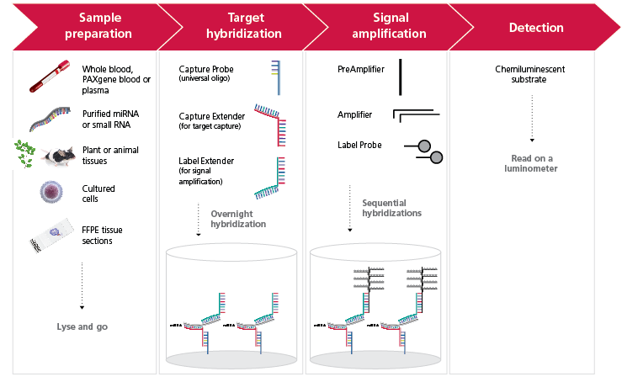
Figure 2: Comparison of miRNA levels in purified RNA and in direct cell lysate from 16,000 HeLa cells. (Figure 2. miRNA in HeLa)
Figure 3: Comparison of miRNA levels in purified RNA and direct cell lysate from 16,000 MCF-7 cells.
(Figure 3. miRNA in MCF7)

Figure : High specificity to mature miRNA.
Probe sets designed to the mature form (23-nt long) of hsa-miR-93 miRNA were used t to recognize synthetic 23-nt wild type target (has-miR-93 miRNA) and two different miRNAs of varying lengths- or extensions on 5’/3’-end(s) – a 25-nt and a 60-nt pre-miRNA construct. The data shows that the probe sets against the mature form of has-miR-93 miRNA very specifically detect the mature form of the miRNA and not the ~60 mer pre-miRNA or the 25-nt long synthetic miRNA.
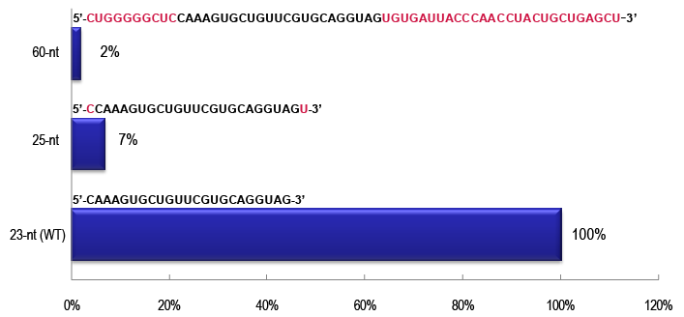

Figure 5: miRNA detection in human plasma. Human plasma obtained from Stanford blood center was assayed for the expression of three miRNAs of various expression levels (Let-7a, miR-21 and miR-16). Lysis only is sufficient to quantitate miRNAs from plasma and for the lower expressing miRNAs, exosome precipitation followed by lysis showed better results.
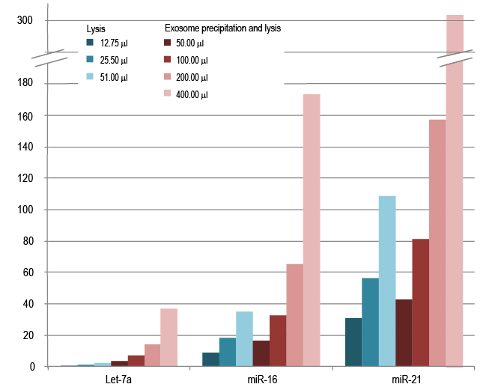

Figure 6: Absolute miRNA copy number determination directly from tissue homogenates. Equivalent amounts of normal and tumor breast tissues were lysed and used to measure miR-155 expression. A synthetic miR-155 control was used to generate the standard curve and the miR-155 expression was calculated based on a linear curve fit. The miR-155 expression in normal tissues was 488,476 copies and in the cancer tissue was 4,900,241 copies.
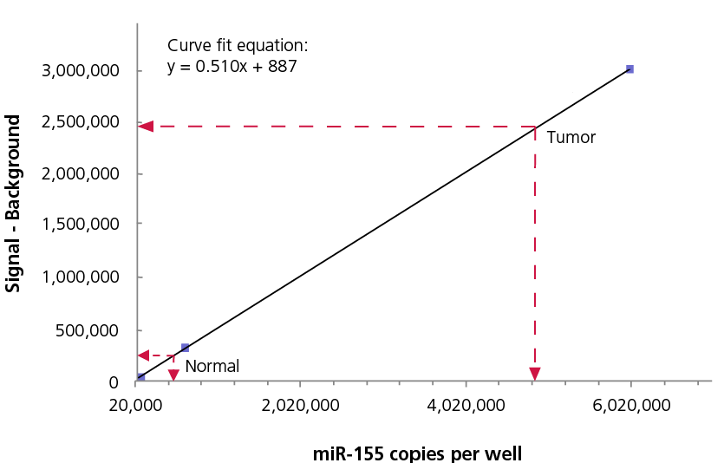
Discussion:
The QuantiGene 2.0 miRNA Assay provides direct quantitation with excellent specificity to mature target miRNA. Based on proprietary chemistry for probe sets and branched DNA (bDNA) signal amplification, the assay provides accurate and precise miRNA quantitation. This technique is powerful relative to existing methods because it avoids biases inherent to miRNA purification and amplification. The samples can be analyzed directly without any modification of the original miRNA population. The method is based on clinically proven bDNA technology, which relies on signal amplification without miRNA extraction, cDNA synthesis or PCR amplification. The assay has been proven to provide accurate results directly from any sample including cultured cells, plant tissues, whole blood, plasma, fresh frozen and FFPE tissues, as well as purified miRNA or small RNA, and more.

Acknowledgments: List acknowledgements and funding sources. We thank our colleagues at Affymetrix/Panomics for their excellent support.
Disclosures: describe potential conflicting interests or state “I have nothing to disclose”. “I have nothing to disclose”
Table of specific reagents and equipment:
Name of the reagent | Company | Catalogue number | Comments (optional)
QuantiGene 2.0 Assay Kit | Affymetrix | QS0008 - QS0011 | Kit is dependent on assay size
QuantiGene Sample Processing Kit | Affymetrix | QS0100 – QS0112 | Kit is dependent on assay size and sample type
QuantiGene miRNA Probe Set(s) | Affymetrix | QS0049 – QS0055 | Kit is dependent on assay size
QuantiGene 2.0 Assay Controls Kit | Affymetrix | QS0519
QuantiGene Incubator Temperature Validation Kit | Affymetrix | QS0517 | Highly recommended for temperature validation of incubator every 6 months.
Adjustable single- and multi-channel  precision pipettes for dispensing 1 – 20 μL,  20 – 200 μL and 200 – 1000 μL | Major laboratory  supplier (MLS)
Reagent reservoirs:  25-mL capacity  100-mL capacity | VistaLab  Technologies | (P/N 3054-1002) or  equivalent  Corning Costar (P/N CLS4873) or equivalent
Microcentrifuge | Eppendorf | 541D or equivalent
Microplate centrifuge that can achieve  240 x g | Eppendorf | 5804R and rotor A-2 DWP or  Equivalent
Vortex mixer | MLS
Nuclease-free water | MLS
Luminescence detector with the following  features:  -Sensitivity > 3 x 10-21 moles of luciferase  -Dynamic range > 8 logs  -Well-to-well uniformity ± 5%  -Cross-talk < 5 x 10-5  -Fluorescent detection module (optional for  DNA stain); Ex 480 nm/Em 520 nm  NOTE: Make sure your luminometer meets or  exceeds minimum performance specifications. | Turner BioSystems  Molecular Devices | Modulus Microplate  Luminometer P/N 9300-001  LMAX or equivalent
Incubator or oven with the following  specifications:  -Maintain a constant temperatures of  46 ± 1 °C  -Temperature does not vary more than ± 1 °C  -Uniform temperature throughout entire incubator | Affymetrix | QS0700, QS0701 (120V)  QS0710, QS0711 (220V)
4 inch soft rubber roller or  QuantiGene CTC Plate Sealer | Affymetrix | QS0515  QG0400

References:
- Lee RC, Feinbaum RL, Ambros V. The C. elegans heterochronic gene lin-4 encodes small RNAs with antisense complementarity to lin-14. Cell. 75, 843–54 (1993).

- Marin-Muller, C., Yao, Q. and Chen, C. MicroRNAs and Human Disease. eLS. Published online October 2010

- Bentwich I, Avniel A, Karov Y, Aharonov R, Gilad S, Barad O, Barzilai A, Einat P, Einav U, Meiri E, Sharon E, Spector Y, Bentwich Z. Identification of hundreds of conserved and nonconserved human microRNAs. Nat. Genet. 37, 766–7 (2005).

- He L, Hannon GJ. MicroRNAs: small RNAs with a big role in gene regulation. Nat. Rev. Genet. 5, 522–31 (2004).

- Lim LP, Lau NC, Garrett-Engele P, Grimson A, Schelter JM, Castle J, Bartel DP, Linsley PS, Johnson JM. Microarray analysis shows that some microRNAs downregulate large numbers of target mRNAs. Nature 433, 769–73. (2005).

- Brennecke J, Hipfner DR, Stark A, Russell RB, Cohen SM. "bantam encodes a developmentally regulated microRNA that controls cell proliferation and regulates the proapoptotic gene hid in Drosophila". Cell 113, 25–36 (2003)

- Cuellar TL, McManus MT. MicroRNAs and endocrine biology. J. Endocrinol. 187, 327-32 (2005)

- Poy MN, Eliasson L, Krutzfeldt J, Kuwajima S, Ma X, Macdonald PE, Pfeffer S, Tuschl T, Rajewsky N, Rorsman P, Stoffel M. A pancreatic islet-specific microRNA regulates insulin secretion. Nature. 432, 226–30 (2004)

- Chen CZ, Li L, Lodish HF, Bartel DP. MicroRNAs modulate hematopoietic lineage differentiation. Science. 303, 83–6 (2004).

- Wilfred BR, Wang WX, Nelson PT. Energizing miRNA research: a review of the role of miRNAs in lipid metabolism, with a prediction that miR-103/107 regulates human metabolic pathways. Mol. Genet. Metab. 91, 209–17 (2007).
- Harfe BD, McManus MT, Mansfield JH, Hornstein E, Tabin CJ. The RNaseIII enzyme Dicer is required for morphogenesis but not patterning of the vertebrate limb. Proc. Natl. Acad. Sci. U.S.A. 102, 10898–903 (2005).

